WORK INSTRUCTIONS

Process | Order to Cash
DTP Name | McLane Claims Validation Documents

CURRENT VERSION HISTORY
Removed customer check requests information for Campbells in Client Specific Section (475050). | 07/06/26 | Dawn Regan

Link to Complete version history: Complete Version History

DEDUCTION TYPES COVERED
Sl. No. | Deduction Type
 | Customer General Information
 | Backup Retrieval Information
 | Client Specific
1 | Bill Back
2 | Ad
3 | Scan
4 | Slotting
5 | Rebate
6 | Damages/Unsaleables
7 | Pricing
8 | Shortages
9 | Service Fee/Penalty
10 | Sam’s Demo
11 | Post Audit
12 | Retail Merchandising
13 | Returns nontrade
14 | Freight/Backhaul (Non-Trade)
 | BPS Team Information

Is the customer a wholesaler/distributor, direct or indirect customer? Direct

Note: McLane has different Sign-ons used to work in ACOSTA Relay for McLane based on the Division (running POP). Attached is the list of Sign-on used for the customer McLane. The sign-on should be updated to the correct sign-on. If unable to locate documentation under MCLAMST in Backup Documentation search with the division sign on as well. The sign-on MCLAMST should be used to search in Event Scheduler.

Link to customer signon job aid:
https://acostaonline.sharepoint.com/sites/AS_Reporting/Claims_Reports/Forms/AllItems.aspx?web=1

Does this customer subscribe to IRI/NIELSEN data for price point verification? NO

CUSTOMER GENERAL INFORMATION

Customer Invoice Info:
- Is line level detail indexed on the customers documentation (customer invoice, customer check request, unsalable/spoils, post audit, EDI 812/820 or client deduction notice if one of these documents is included)? No

- The customer invoice reference number prefix indicates the division being billed for. The division is also referenced in the header of the invoice. This information is needed to locate the correct contract for certain claim types. The McLane sign-on job aid can help identify the division by using the prefix. Additional details is provided in the claim type sections.

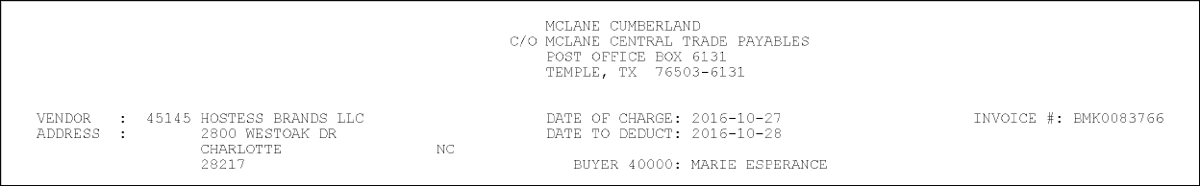

- The following document is an explanation of the type of deductions:

Contract Info:
- McLane contracts are mainly entered using Event Scheduler. Contracts for all McLane claims should be searched for and linked using Event Scheduler, including check request rebate claims. The sales team enters the event numbers into Quick Keys. There may be occasions when sales enter a contract into backup documentation.

BACKUP RETRIEVAL INFORMATION

GENERAL BACKUP RETRIEVAL INFORMATION

Is GCIT responsible for obtaining backup from the customer? Yes
- If yes, is there a customer portal? Yes
- If yes, does GCIT request backup? Yes

Is check remittance information required to request backup? N.

- Customer invoice maybe included with the check remittance.
- Customer invoices are sent to the client. If unable to find the backup in ACOSTA Relay, request from client before requesting backup.
  - If backup needs to be requested from the customer note the claim “unable to obtain backup from the client”.

Coca Cola
- If backup is not in McLane's portal or Relay, step to CRA. If the backup is not received from CCNA after CRA has requested it, request backup from Cap.research@mclaneco.com. There are some deductions that require more backup than is provided in the deduction support file. This detail has to be requested from Cap.research@mclaneco.com.. There will be no fee if done within 90 days for any requested backup.

Edgewell
- Acosta is a valid contact on the Edgewell Personal Care account. If backup cannot be located in the McLane portal, is not in AR, or cannot be obtained from Edgewell, request backup from Cap.research@mclaneco.com. There are some deductions that require more backup than is provided in the deduction support file. This detail has to be requested from Cap.research@mclaneco.com. There will be no fee if done within 90 days for any requested backup.
- Any invoice/back up doc requests for WAWA do not incur the $50.00 research fee
Smucker’s Natural Foods Inc
- Request backup from Cap.research@mclaneco.com. There are some deductions that require more backup than is provided in the deduction support file. This detail has to be requested from Cap.research@mclaneco.com. There will be no fee if done within 90 days for any requested backup.

GCIT SPECIFIC BACKUP RETRIEVAL INFORMATION

Portal:

Customer Invoice or Note Identifier | Request From
Customer invoices that begin with R | Pulled from the CLS Portal or the RMS portal. Some divisions of McLane use CLS for reclamation, others use RMS. There is a list in the GCIT instructions.

Non - Automated:

Customer Invoice or Note Identifier | Request From
All formats | Acosta Sales, enter note “unable to obtain backup from the client”
Post Audit – Reference begins 1 or 2 | Request backup from mcaudit@mclaneco.com

CLIENT SPECIFIC VALIDATION

Client
Barilla
Campbell’s
Coca Cola
J.M. Smuckers
Nissin

BARILLA
- This customer receives a swell allowance. Spoils/unsaleables are considered invalid.

CAMPBELL’S –
- Backup is received via email from the Client. Invoices come in batches with the check remittance. Must search for check remittance by check # from the claim header. If the check remit is not in Acosta Relay send an email to
Deduction_Team@campbellsoup.com and state: Please forward McLane Check remittance check ########## dated xx/xx/xxxx received into the deduction team mailbox from McLane Deduction Support (Administrator).
- Military invoices will be cleared to trade.
- Pepperidge Farm for McLane frozen is not handled by Acosta. Claims are closed with the note "transfer to another branch recode to reason code 014”.
- Heavy Liquid Distribution Fee claims are coded to Supply Chain. Step in AR as non-trade other with the note: Please recode to Supply Chain per David Worley. These are fees for transportation. It is Heavy Liquid Fees which is a logistics charge.
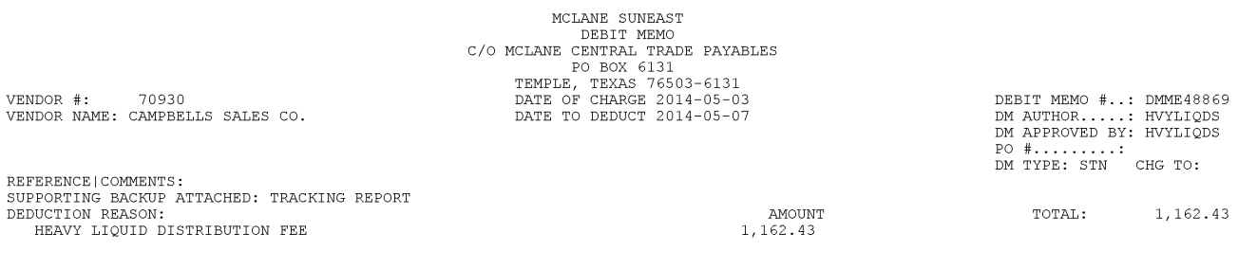

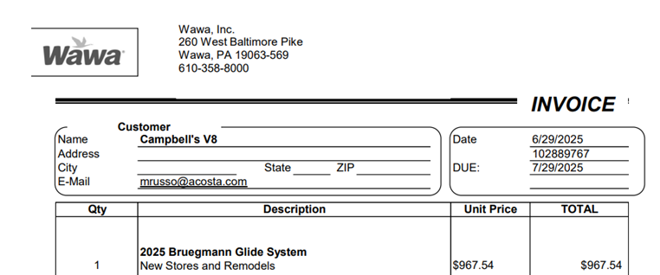

- For WaWa Bruegmann Glide System (New Store & Remodels) invoices, there will be no contract, Client will clear internally, to be stepped as Non-Trade/Retail Merchandising/Ready to Clear CCA.

COCA COLA –
- DO NOT change the customer sign-on to the direct warehouse sign-on, leave claim under MCLAMST.

- For McLane Qtr Rebate
  - CRA will obtain an item breakdown from the National Account Executive (NAE/regional manager) as well as the Deduction List from the client.
  - Check with sales to see if these documents have already been sent to them. The CRA will need to obtain all the Check Remits pertaining to these deductions since they will help identify which claims will be needed to include in a Reverse Split.
  - All quarterly rebate invoices will have no further description listed on them.
Example 1

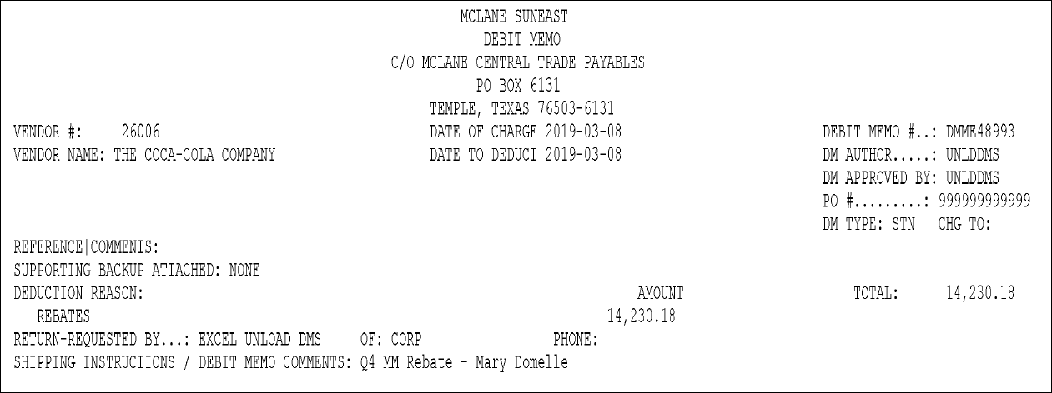
Debt Memo will indicate what quarter they are deducting for.
Invoice #: The prefix of “DM” indicates that this is for a Quarterly Rebate.

Example 2
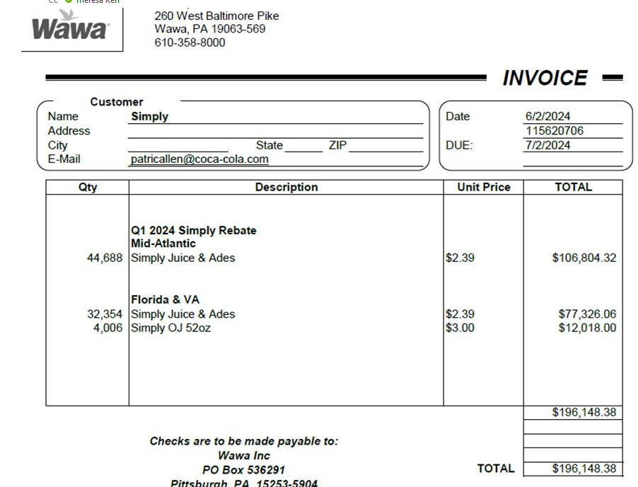
- For WAWA Rebates Mid- Atlantic is direct and Florida and Virginia (VA) are via McLane

- The CRA will use the Deductions List to identify all of the individual claims that add up to the Quarterly Rebate amount on the Item Breakdown.
- The CRA will compile all Relay Claim numbers and all I-Many Deduction ID’s and send a Reverse Split request to the client. NOTE: Deductions not found in Relay are due to being under tolerance. The CRA will still need to gather I-Many Deductions ID’s for these.
- The client will confirm when the Reverse Split is completed and note which deduction the full Quarterly amount has been combined into. The CRA needs to link the email to the claim. The Item Breakdown needs to be linked to the claim as “CSD” and step as Customer Invoice Attached so the GCC can create the DBW and split the lines. The DBW will be prepared using one UPC from each PPG provided on the breakdown. The rate will be $0.15 ($0.13 rebate + $0.02 Merch. Fund). The CRA will close all other claims that are part of the Reverse Split and note which claim these were combined into.
  - GCC should not close reverse split claims as the CRA will close these once they are completed.
- Acosta handles claims for military drayage.
- For Quarterly Rebates - the invoice rate and the contract rate will show $.135 but the event is setup in TPM as $.14 due to rates cannot go out more than 2 digits past the decimal. Enter the rate from the Event Detail Report on the DBW. Do not use the customer invoice or contract rates due to the rounding issues.

- McLane/7-11
  - If the customer is deducting for single serve OJ or Ades and the invoice states 24 @ $0.64, when doing the conversion on the DBW, use a conversion of 6, not 12, to ensure the correct case rate shows on the Category report .If the invoice is for single serve Fairlife milk and states 15 @ $0.98, the conversion will be done as 6, not 12, to ensure the correct cases and case rate is provided on the Category report for the CCA to process.

- McLane/Family Dollar Check Request:
  - To prepare the DBW, use one UPC from each brand code provided from sales. Enter the unit rate, total dollar amount, and let the system generate the qty. The DBW should be converted from units to cases.

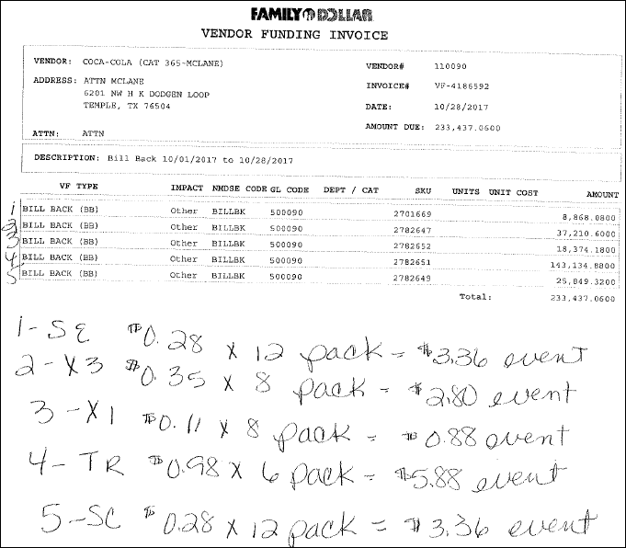

- McLane/Speedway Rebate DBW Process:
  - The rebate invoice may show a promo unit amount/promo rate and a non-promo unit/non-promo rate. The UPC must be entered twice into the DBW, one line for the promo data and one line for the non-promo amount.

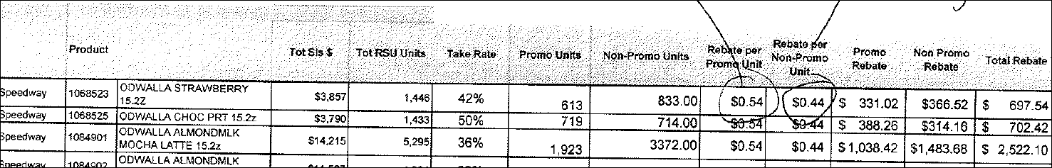

- McLane/Stripes Shelving Fees
When completing a DBW and splitting a claim for shelving fees, use this process to complete the DBW and split the claim. Choose one UPC from the PPGs provide on the customer invoice and the corresponding event to enter on to the DBW. These are stepped as Trade – Other with a header note stating, “Claim is for lump sum, shelving fee.”

McLane/Circle K
  - There are 2 Divisions which will have their own contract.
  - Client event name will differentiate between the two divisions by containing the following – MDW or SW
- MDW – Great Lakes, Heartland, MDW, New England
- SW – South Atlantic, SouthEast, Gulf Coast, Florida, Carolina, Franchise Stores
- Post Audits
  - No longer will do reverse splits.
  - McLane is deducting per division.
  - All of the information is on the Post Audit invoice will be

J.M. SMUCKER
- Mclane Claims that start B. i.e BMW0146672
  - Separate Line for Admin Fee
  - Separate Line for Walmart as Not Acosta
  - Separate Line for amount to send to Telus minus the Walmart Amount
  - The program id will be required.
- For rebate claims (i.e MWJMHOSTESSQ2GSK202, MIJM5MUCKERQ2G5K2025, or M0Q2Z025UNCRUSTABLE) send to CSM for invoice breakdown.

NISSIN –
- Family Dollar claims will not create from an ATB. If a claim is created via ATB, code as Not Acosta. If any assistance is needed, Nissin will reach out to Acosta to manually create a Client Deduction Notice. These deductions are to be worked and validated as normal.
- The client clears McLane quarterly rebates internally

PROCESS STEPS

Deduction Type: Bill Back

A Bill Back claim is a per case allowance offered for a specific performance requirement. A per case bill back allowance is claimed by the direct buying customer for product purchased from the client, or by the indirect customer for product purchased from the direct customer. This is an allowance the customer will bill the client for. This is not an automatic discount given off the face of the invoice.

Bill Back Billing Period
McLane bills Bill Back invoices weekly on Thursdays. The billing period is for the previous Thursday thru Wednesday. For example, if the Date of Charge on the customer invoice is 4/10/14, McLane is billing for 4/3/14 – 4/9/14.

When we present a new Bill Back promotion to McLane and there is an existing promotion with the same data (ie. Items, amount), McLane will extend the existing promotion already in their system. The Date of Change needs to be used when validating a claim against a contract. In the below example, the Date of Charge is 3/12/14. This means McLane is billing for 3/6/14 – 3/11/14. However, the Buy Dates are shown as 2/1/12 – 3/11/14. This means that this promotion has not changed in McLane’s system since 2012, only the promotion has been extended from year to year.

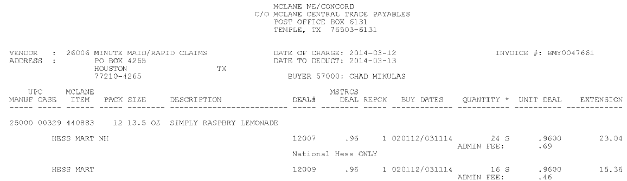

As long as the contract covers the billing period, it can be used to validate the customer invoice. In the example above, the billing period is 4/3/14 – 4/9/14. As long as the contract covers this date frame, it is not required for it to cover the Buy Date of 2/1/12 – 3/11/14 due to McLane extending contracts as described above.

Contract Information

There are 3 things to look at on a contract to make sure it is the correct contract for a claim: is it a national deal (all divsions), is it for one or more divsions, but not all of them (uncommon) or is the contract for a certain store/indirect of McLane for all divsions.

National – This portion of the contract is for all National deals. This is for any deal on a customer invoice that is national and does not state a store/indirect.

Invoice – ex 1
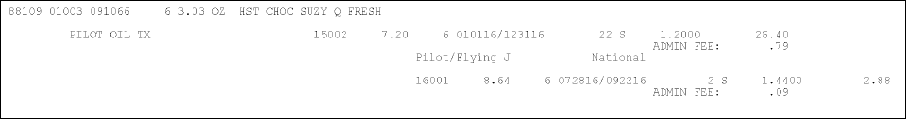

Invoice – ex 2
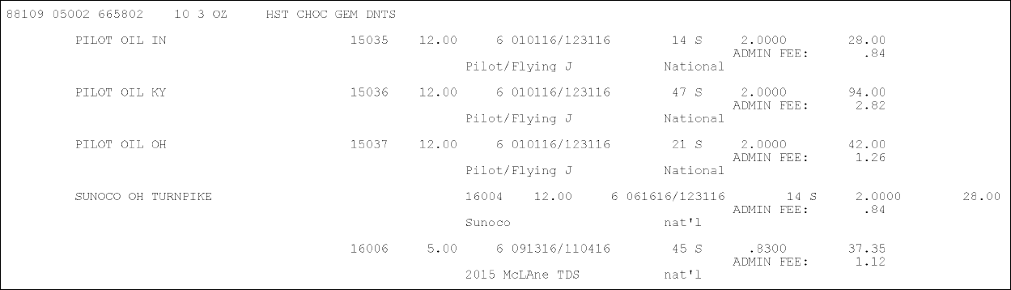
TDS – This stands for trade show. This is an allowance offered at a trade show.

Contract
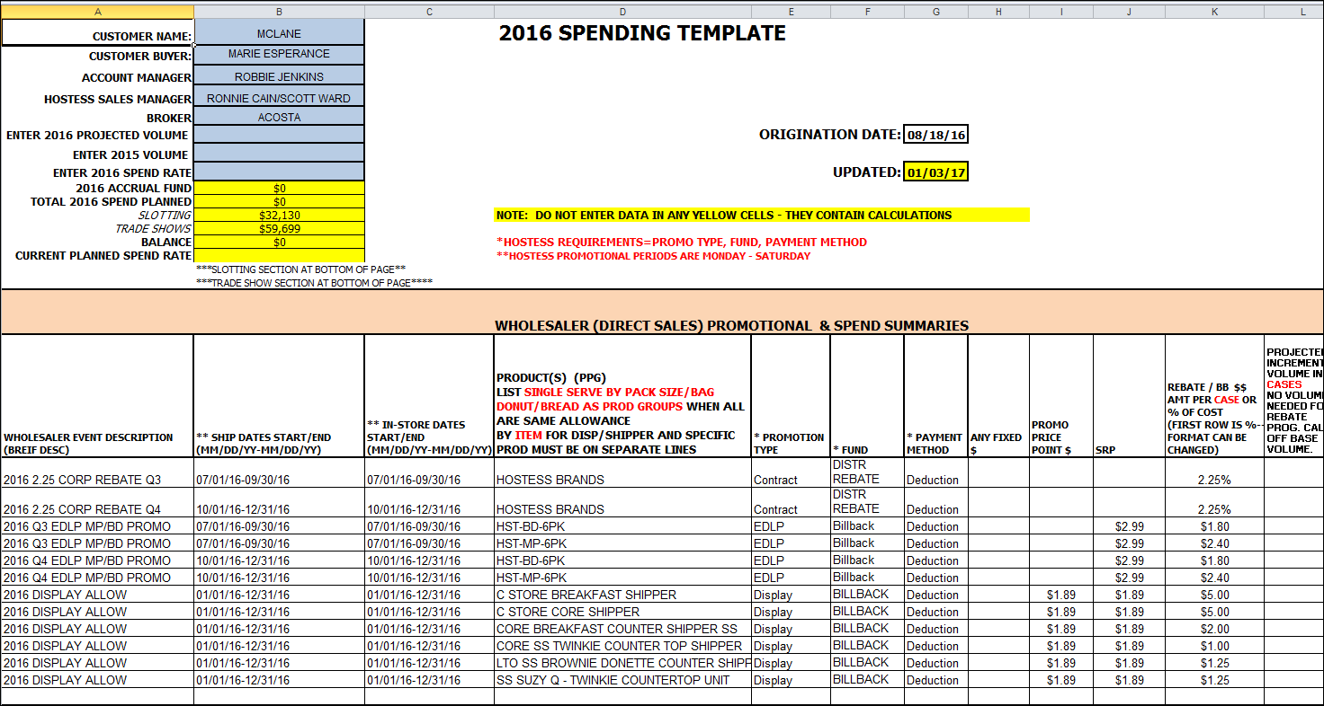

National/Store Specfic

Invoice

Contract – ex 1
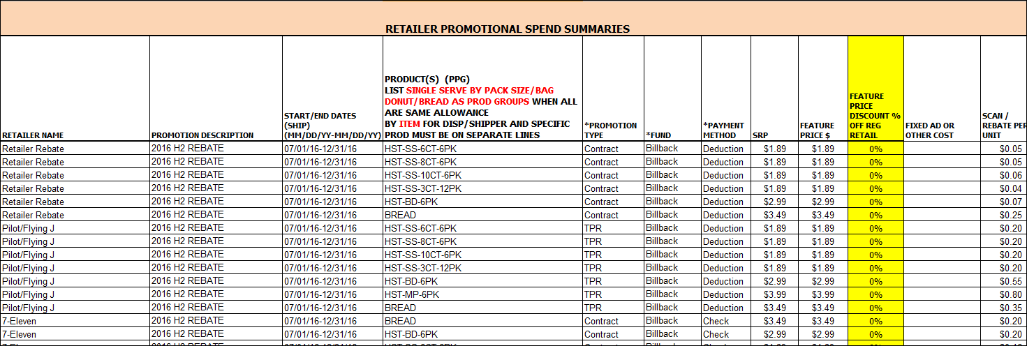

-OR-
Contract – ex 2
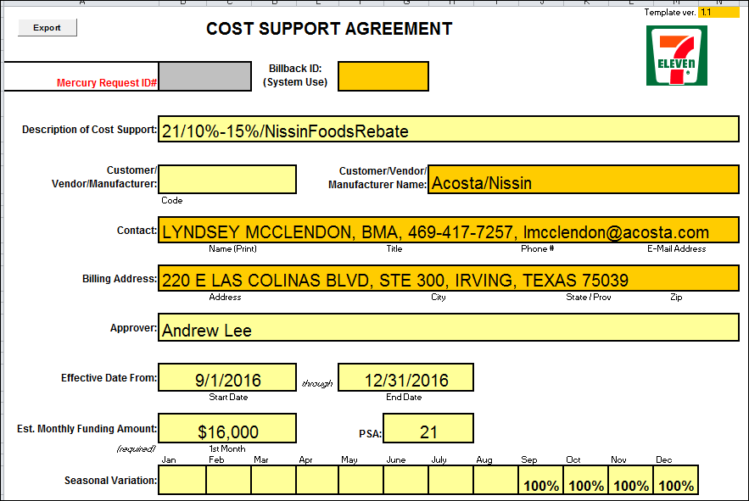
This is a contract specifically for 7-Eleven.

  - Customer Invoice for Bill Back:
Invoice # –.The first three Alphabets BMY indicates the region of Mclane and the Sign-on to be used. The signon list is attached on the second page of SOP.

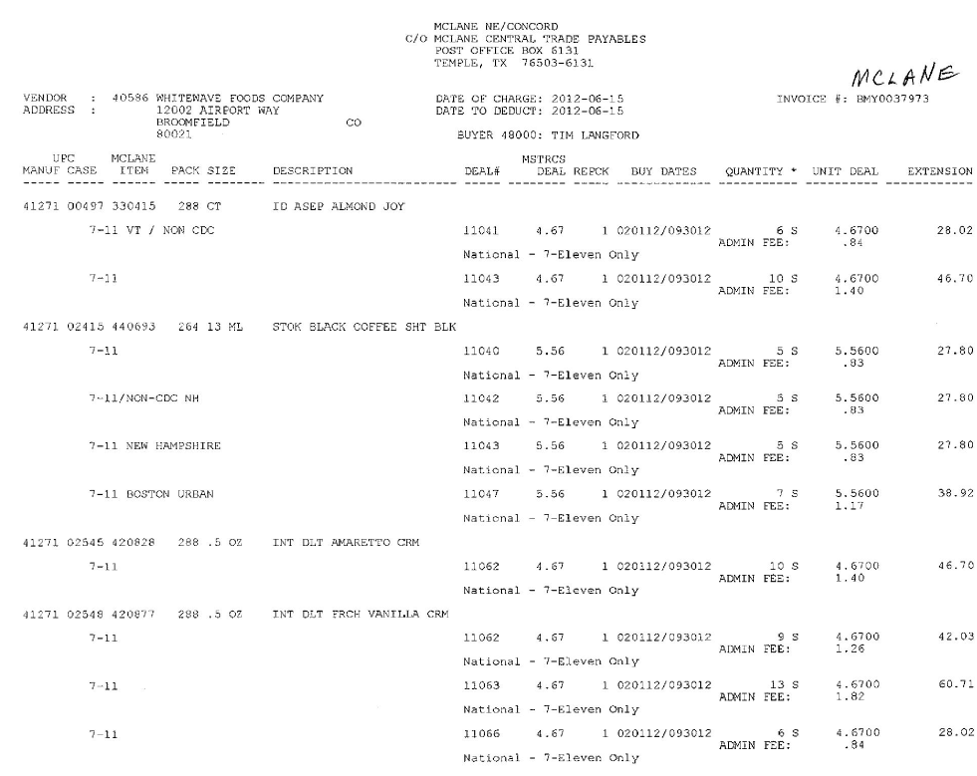
Bill Back Billing Period: See customer specific section on billing period for invoice/contract date information.

Admin Fee: This is a 3% admin fee taken on every item being deducted for. The 3% admin fee should be supported by the corresponding customer contract.
This is a National - store/indirect promo that is being billed for. This needs to be matched with the contract.

Bill back by Case – This is the rate per case for Bill Back allowance. This amount should match with the Customer Contract.
.

Qty: For the highlighted quantity, customer is claiming the BB Allowance. This number needs to be validated with Memo Tracking Report.
This description would
UPC and Product description: UPC and product description should match with customer Contract.

1.2 Customer Contract for Bill Back (Look under Promotions first):
Page1#

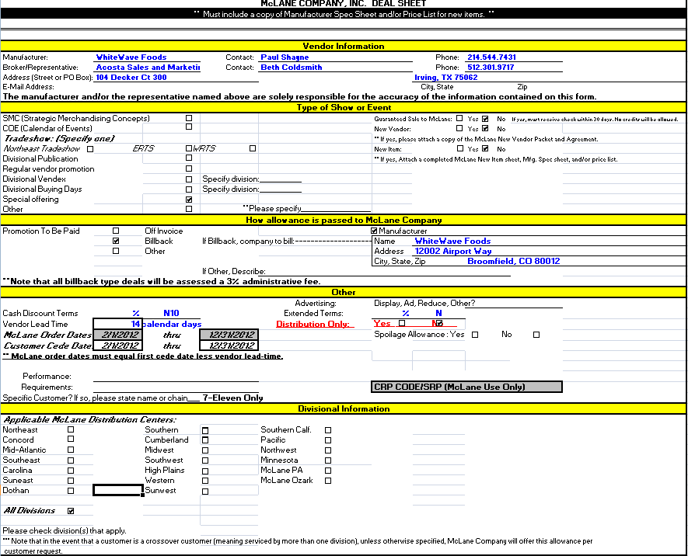
This store/indirect which needs to be matched to the customer invoice.
Billing Period: See customer specific section on billing period for invoice/contract date information.

All billback types will be assessed a 3% Admin Fee. This supports the Admin fee that is on the customer invoice for all of the items.
This indicates that the contract is valid for All Divisions. If this was not checked, we must have a check in one of the division locations above this to be a valid contract.
Identification: We have the check box marked against Bill back which lets us know this is for Bill back.

1.2 Customer Contract for Bill Back:
Page2#

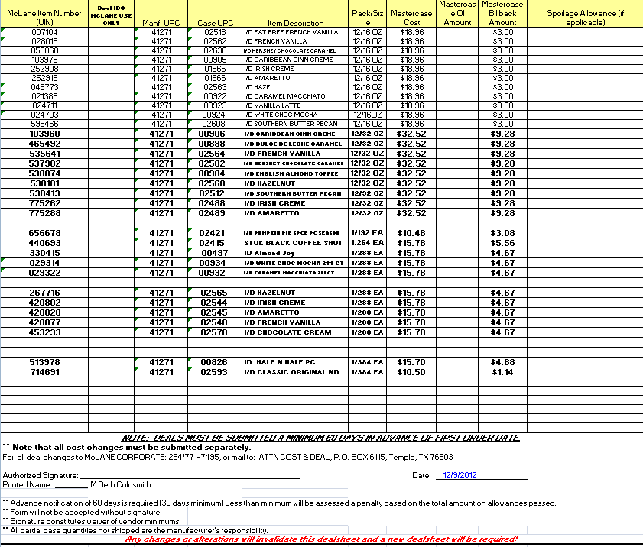
UPC and description: UPC and product description should match with customer invoice.
Bill back by Case – This is the rate per case for Bill Back allowance. This amount should match with the Customer invoice.

Refer to the SOPs/Generic Help File for POP requirements

2. Deduction Type: Ad

A fee for featuring a client's products in an advertisement.

Copy of ad will be included with the customer invoice. If ad is not included with the customer invoice it will need to be requested from the sales team.

2.1 Customer Invoice for Ad: Example 1
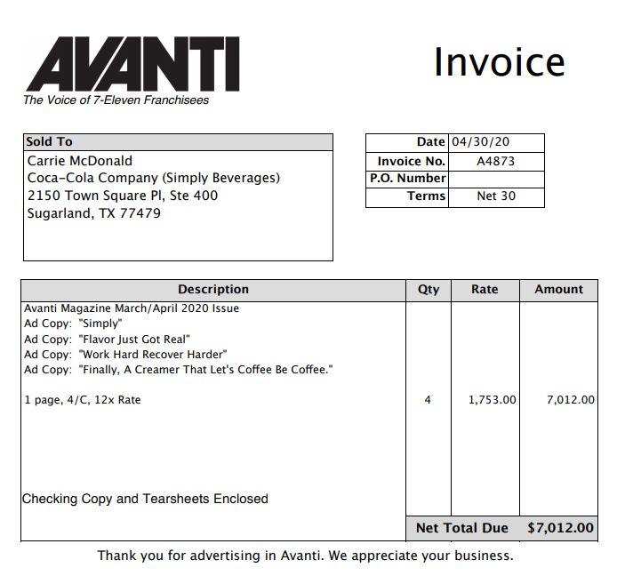

2.1 Customer Invoice for Ad: Example 2

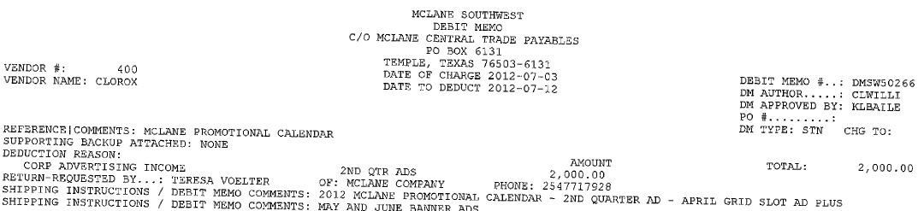
Lump sum Amount – Amount ($2000) is claimed by the customer for the Ad allowance. This needs to be matched with the customer Contract.

Invoice # –.The first four Alphabets DMSW indicates the region of Mclane and the Sign-on to be used. The signon list is attached on the second page of SOP.

Identification: The word Advertising on the invoice indicates that the deduction is for Ad.

Performance date –This is the Ad date needs to fall within the Contract date. (2nd Qtr. April to June)

Product description: Highlighted description needs to be matched with the contract and the POP (Ad Copy).

2.2 Customer Contract for Ad: Example 2

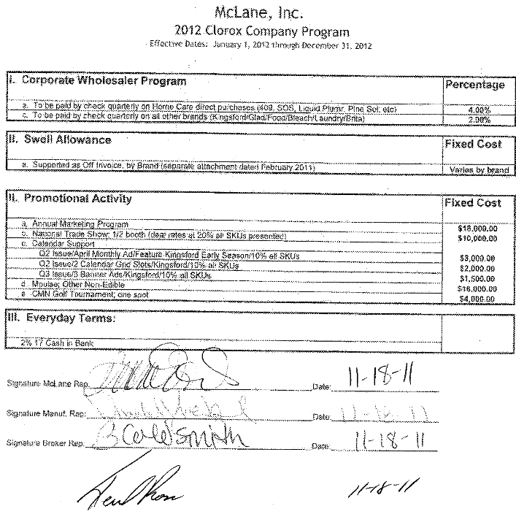
Product description: Ad promotion needs to be performed for the products highlighted on the contract and description Kingsford should be also validated with the AD.

Performance date: The performance date on invoice (April to June Q2 as mentioned on the invoice) should fall within the contract date.
AD Amount –The Highlighted Lump sum amount should be validated with the customer invoice.

Refer to the Proof of Performance Reporting Ads job aid for searching for ads.

3. Deduction Type: Scan

Scan allowances are for product scanned at the store register and are usually billed in eaches, not cases.

3.1 Customer Invoice cover sheet for Scan:
Page1#

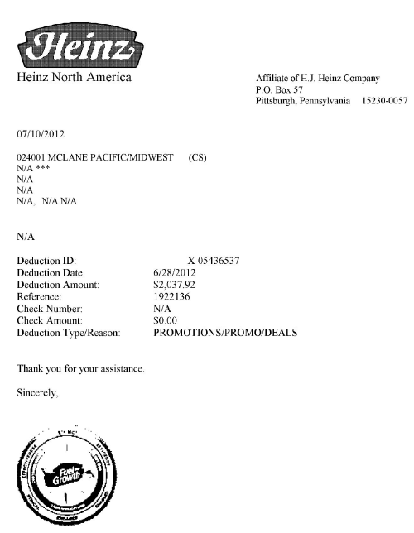
This indicates the region of McLane and the Sign-on to be used. The signon list is attached on the second page of SOP.

3.1 Customer Invoice for Scan:
Page2#

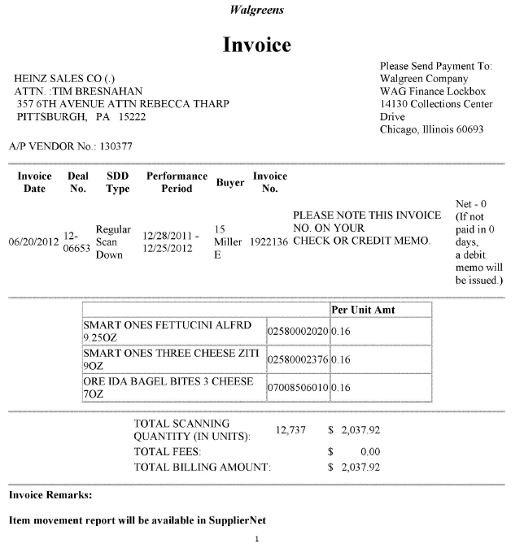
This invoice is for Walgreens as an indirect of McLane.
Quantity: The number of units the store is claiming per UPC.

Allowance amount: (Total scanning in Units) 12,737 X (Scan Per unit) 0.16 =2037.92

Scan per unit – The highlighted rate indicates the per unit rate for scan deduction.
UPC and description: UPC and description should match with customer Contract.
Performance Date: Dates needs to fall within the contract period.

3.2 Customer Contract for Scan:
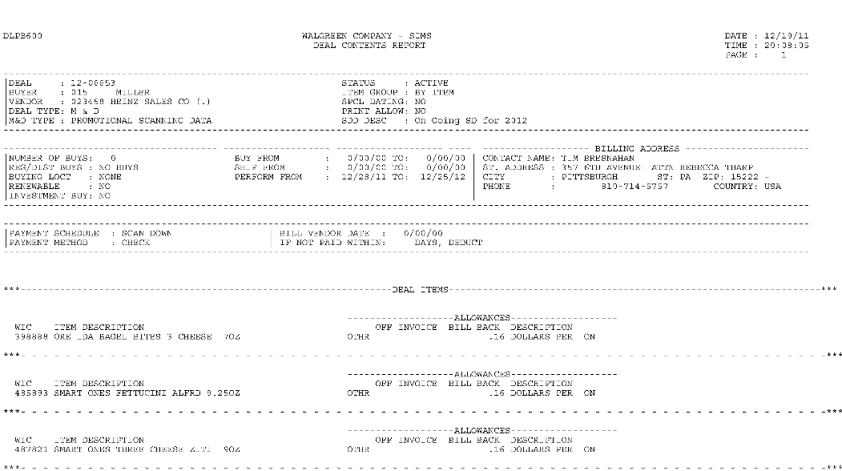
NOTE: Contracts for Walgreen’s will be found using the WALGCH sign on
Item Code and description: Item code of the customer helps to identify the matching UPC from the Genweb. Description should match with customer invoice.
Identification: The word Scan Down on the contract indicates that the contract is for Scan.
Performance Date: The Performance date needs to match with the customer invoice.
Scan per unit – The highlighted rate indicates the per unit rate for scan which needs to be match with the customer invoice.

3.1 Customer Invoice for Scan: example 2

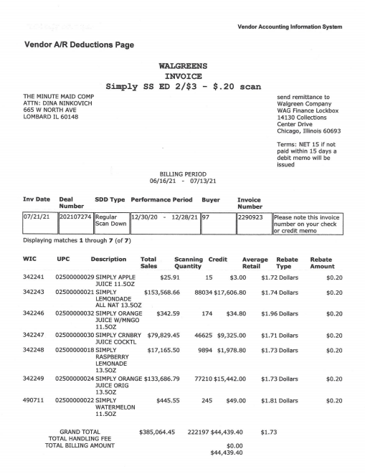

4. Deduction Type: Slotting

A Slotting allowance is offered to the customer to purchase an item not currently stocked. A slotting lump sum allowance can be offered for each item and/or an off invoice can be offered as an introductory allowance for the first 30 days.

4.1 Customer Invoice for Slotting:

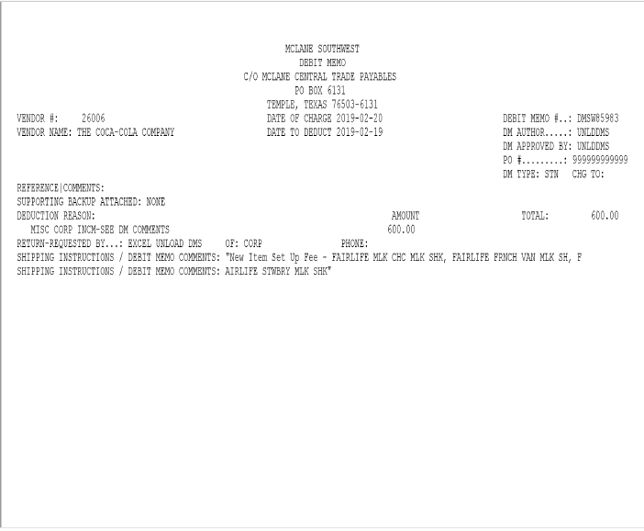
Customer Reference

Total (Lump sum Amount) - The lump sum amount of $600 is for Slotting.

Debit Memo Comment- New item set up fee=Slotting

Notes: In this example, the customer invoice for slotting does not have the item code or the UPC.

Explanation of set up fee charge per item.

5. Deduction Type: Rebate

Agreement between client and the customer for shelf placement, number of items stocked/purchased or other performance defined in the rebate agreement

5.1 Customer Invoice for rebate:
The highlighted date of charge is the date when the invoice was created and the date of deduct is the date when the invoice was billed.
Example1

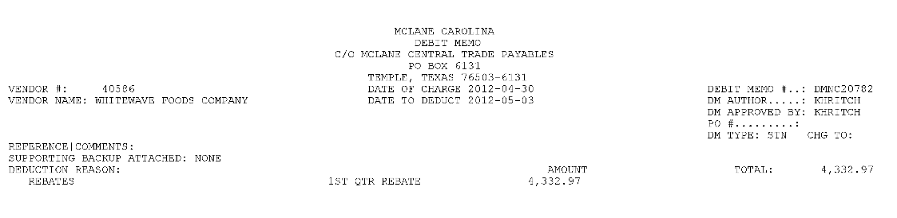
Highlighted amount is the Rebate amount.
Invoice # –.The first four Alphabets DMNC indicates the region of Mclane and the Sign-on to be used. The signon list is attached on the second page of SOP.

Identification: The word Rebate on the invoice indicates that the deduction is for Rebate.
Performance date –This is the Ad date needs to fall within the Contract date Q1 (January to March).

5.2 Supporting Backup and POP:
Example 1

- McLane will not send supporting backup with these types of deductions. Backup has to be requested from the Acosta sales team. GCC will need to escalate this as ESCALATE – CUSTOMER INVOICE due to the lack of backup provided with the invoice.
- CRA will have to request the sales information that was originally provided to McLane from the sales team/client in order to validate a rebate claim.

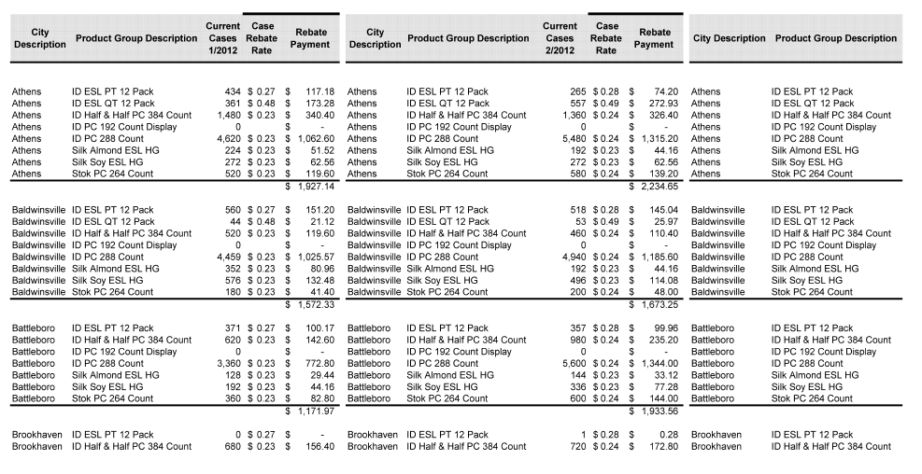

5.3 Contract for Rebate:
Example 1

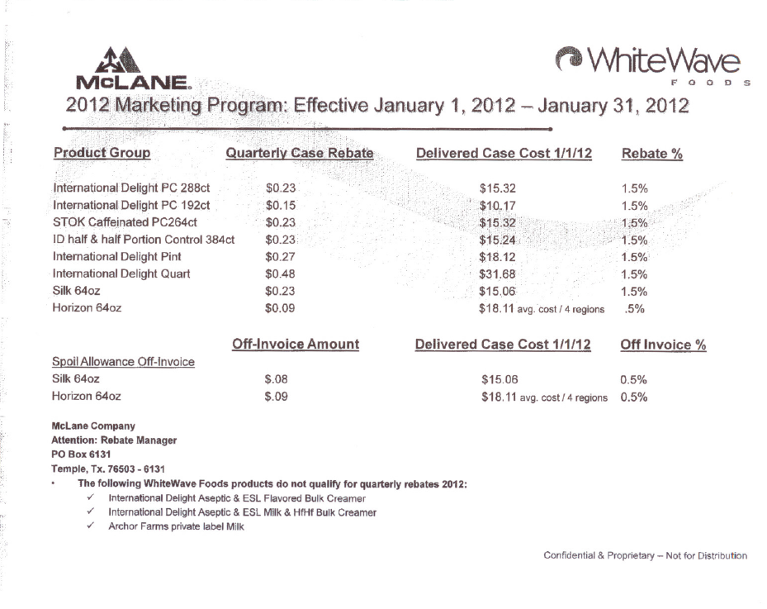
Performance date – This is the dates of the rebate contract

5.4 Customer Invoice for rebate:
Example2
Check Request

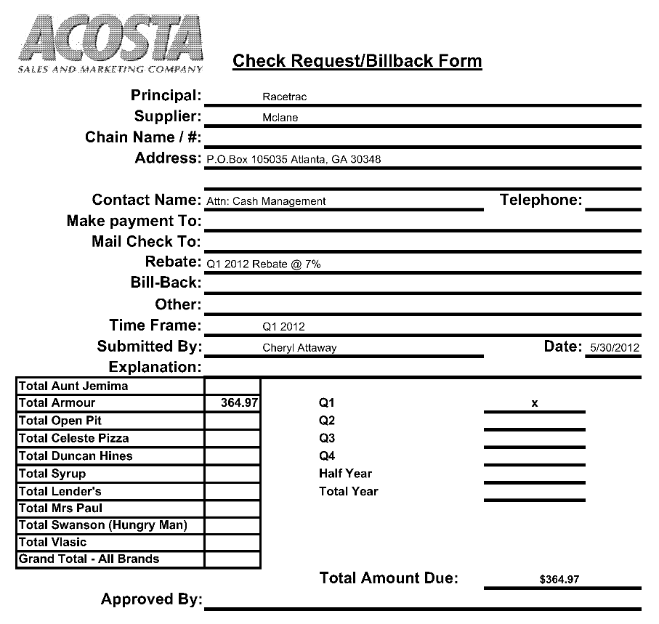
Highlighted amount is the Rebate amount.
Identification: The word Rebate on the invoice indicates that the deduction is for Rebate.
Performance date –This is the Ad date needs to fall within the Contract date. (January to March)

5.5 Check Request for rebate:
Example3

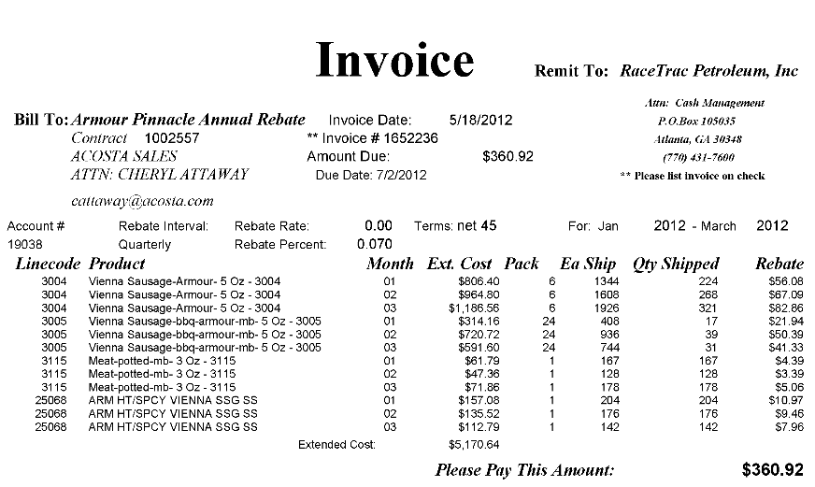
Performance dates: These are the performance dates for this Rebate.
Identification: The word Rebate on the invoice indicates that the deduction is for Rebate.

Note: Contracts for Rebates are found under Back Up Documents.

6. Deduction Type: Damages/Unsaleables

6.1 Customer Invoice for Damages/Unsaleables:
Example 1

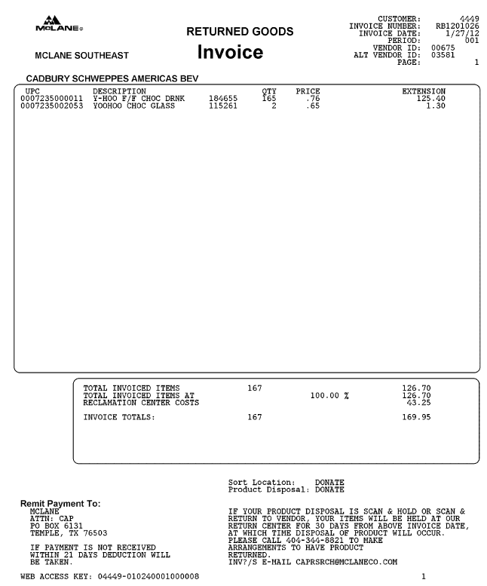
Identification: The word “returned goods” on the invoice indicates that the deduction is for damages.

6.2 Customer Invoice for Damages/Unsaleables:
Example 2

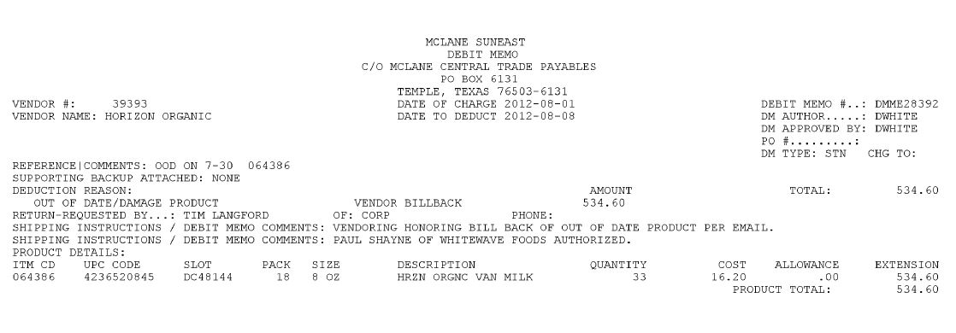
Identification: The word” out of date /damaged product” on the invoice indicates that the deduction is for damages

6.3 Customer Invoice for Damages/Unsaleables:
Example 3

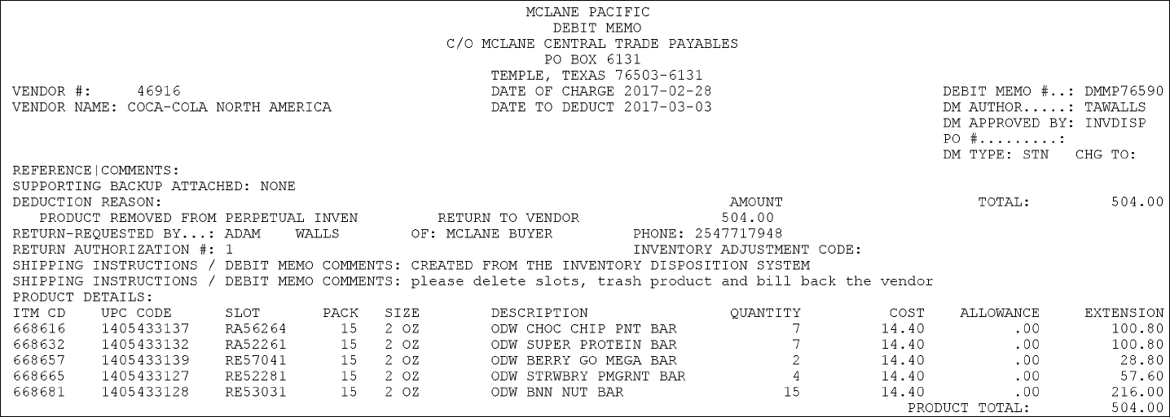

Identification: The word” product removed from perpetual invent” indicates this invoice is for damages/unsaleables.

6.4 Customer Invoice for Damages/Unsaleables:
Example 4

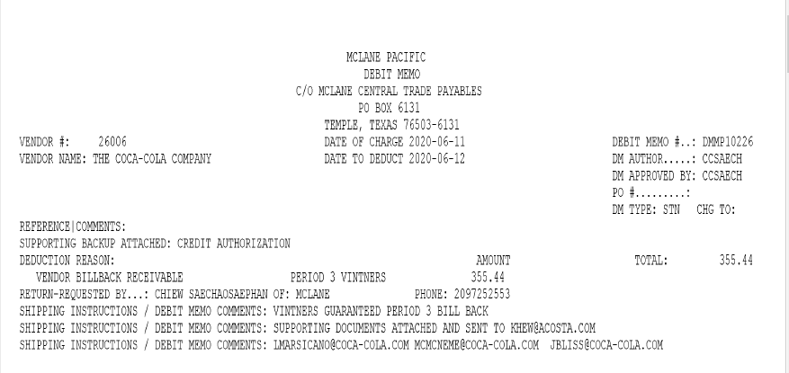

Identification: Debit Memo: Vintners Guaranteed Period/Billback Receivable indicates this invoice is for damages/unsaleables.

7. Deduction Type: Pricing

7.1 Customer invoice for Pricing

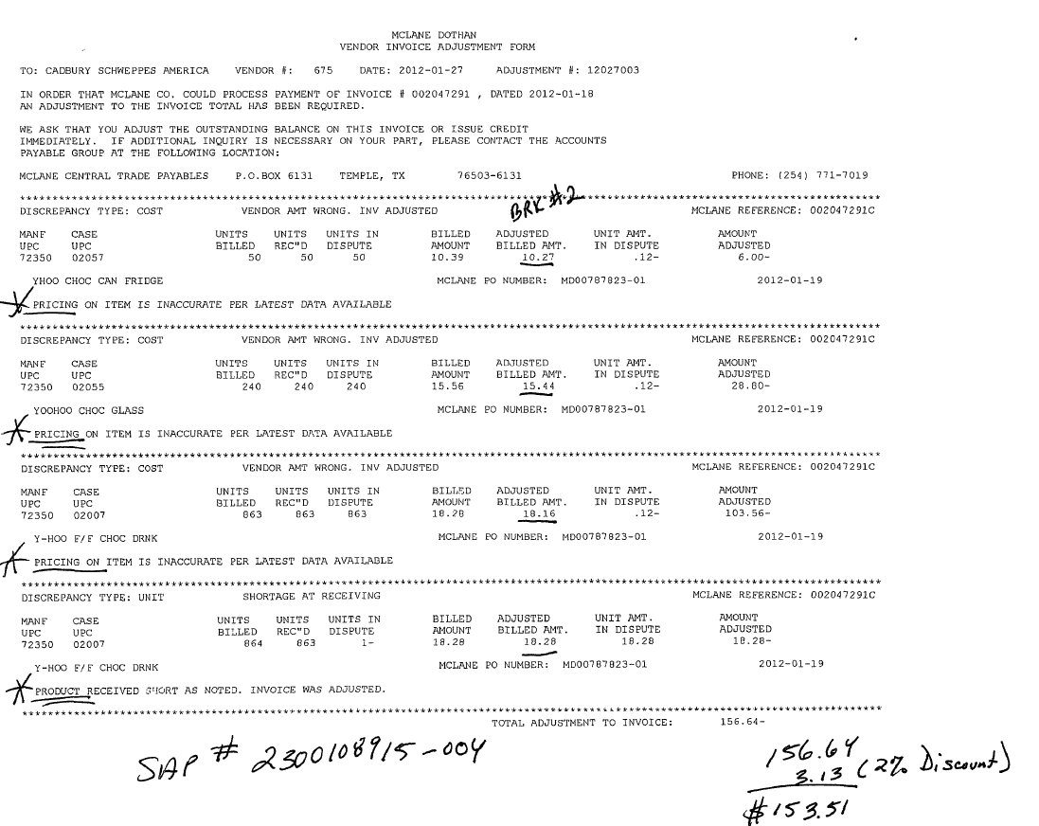
Identification: The Highlighted word “Pricing” indicates that the deduction is for pricing.
Identification: The Highlighted word “cost and vendor amount wrong” indicates that the deduction is for pricing.

8. Deduction Type: Shortages

It is a deduction for shorted product on an order that the client billed the customer for.

8.1 Customer invoice for Shortages:

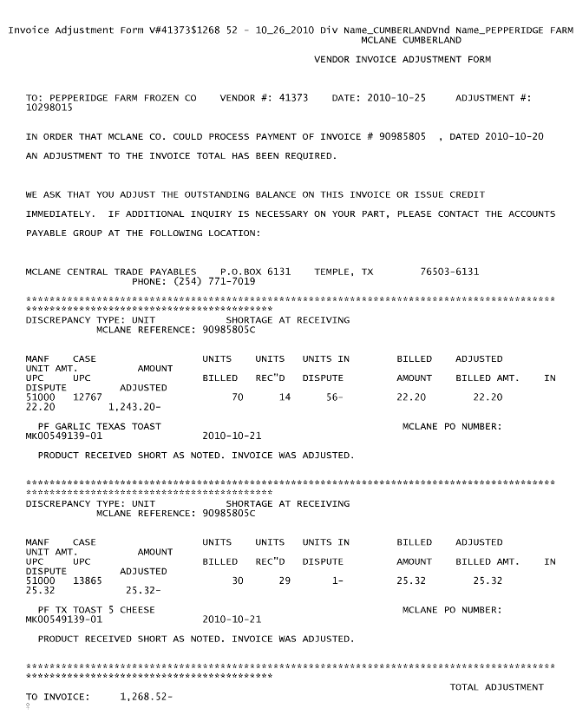
Identification: The Highlighted word shortage at receiving indicates that the deduction is for Shortages.

9: Fees/Penalty/ Policy Vs Policy
Fees charged for various reasons and can include late delivery, miss delivery appointment or lumper/driver fees.

Document Name | Source of the Document | Action by Accenture
Customer Invoice | ACOSTA Relay – search for the invoice under Backup Documentation, document type 2. | Step up the claim to Acosta for research
Client Order Invoice | ACOSTA Relay – search for this document within the Order/Invoice/PO search.

9:1 Handling Charge Refused Customer Invoice

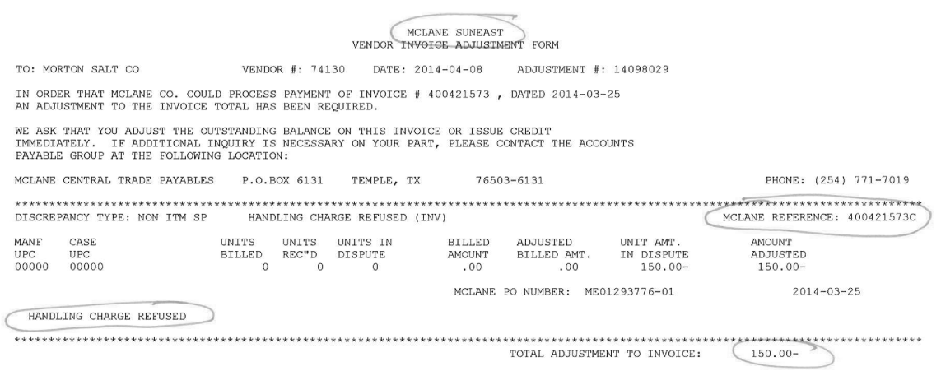
Customer PO Number: The order/client order invoice for this PO needs to be linked to the claim.
Identification: Handling Charge Refused indicates that this is a penalty on a PO.

9:2 No Call No Show

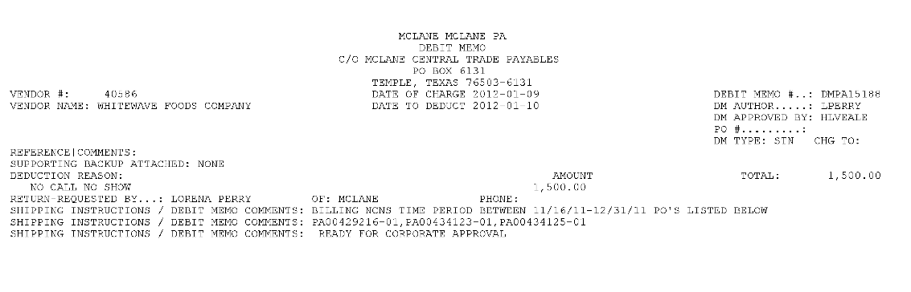
POs provided on the invoice should be linked to the claim.
Identification: The Highlighted word no call no show means this is for a missed appointment/delivery.

10 Sam’s Demo
In-store demonstration of client's product to consumers. Time, resources and product charges are billed back to the client.

10.1 Sam’s Demo Invoice
Demo Amount- This is the total amount the customer is claiming for the demo that was performed. This amount needs to match the amount on the contract.
Page 1
This is the customer reference number and can be used to pull out the customer invoice from search info link within ACOSTA Relay.
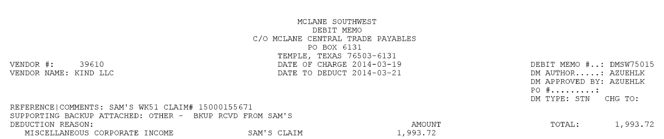
This reference’s Sam’s Invoice number. This needs to be matched to Demo Information.

Page 2 – If the second page (Demo Information) is not attached with page 1, use the request form linked below to request the 2nd page from GSSNADR@wal-mart.com.

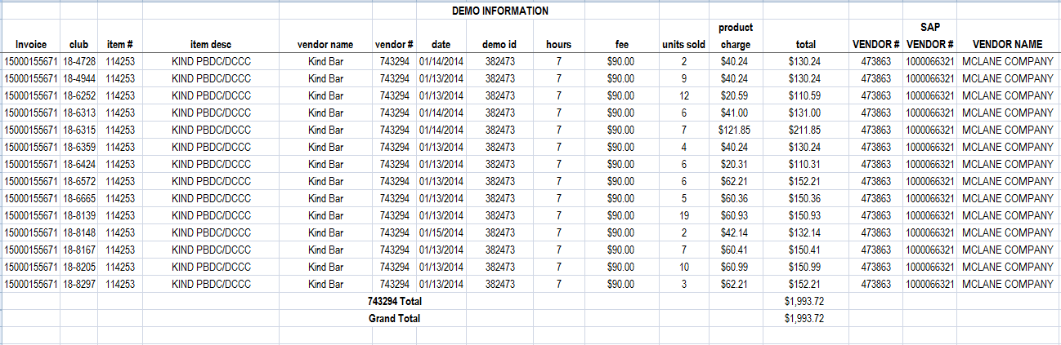
This reference’s Sam’s Invoice number. This needs to be matched to the McLane invoice.
Demo Amount- This is the total amount the customer is claiming for the demo that was performed. This amount needs to match the amount on the contract.
10.2 Sam’s Demo Contact
This is one example of a contract; different clients may have different contracts.

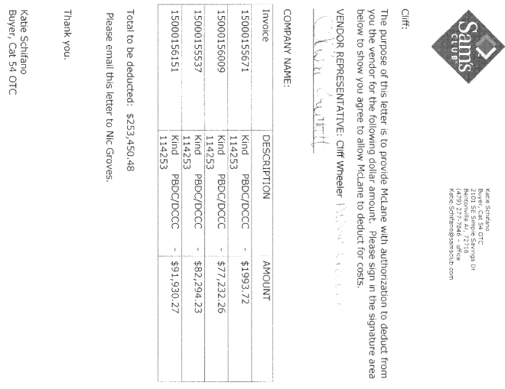
The Sam’s Club invoice number needs to be listed along with the correct invoice amount.
Vendor Approval needs to be provided.

***POP is what is required by the client, per Generic Help.

11. Deduction Type: Post Audit:
NOTE: The post audit claim must first be researched to ensure the customer has not already billed for the allowance before the normal validation process can begin.

Once the post audit claim has been researched to ensure the customer has not already billed for the allowance refer to the appropriate allowance section of the SOP to continue with validation. If the post audit is for an allowance not defined in an allowance section of the SOP refer to the post audit example for validation information.

Internal/external auditors find claims that the customer is entitled to but did not take from previous years. Post Audits should be researched in the same manner as other claims by accessing previous year’s files.

11.1 Customer Invoice Post Audit

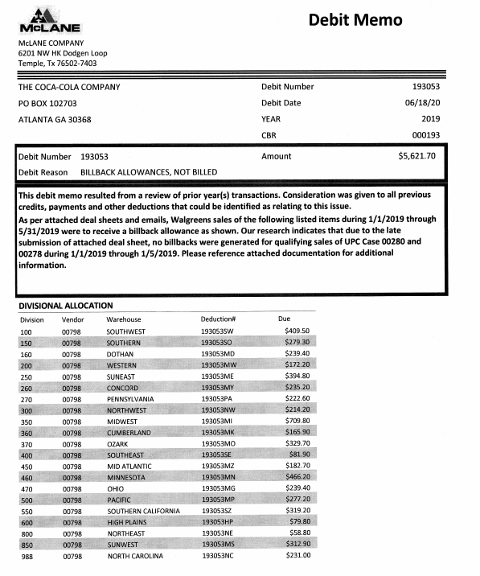
List of deductions taken by division and they may all be deducted individually. Will need to used the deducted amount divided by the rate to determine quantity.
Verbiage box that contains details on the cause of the post audit and is used along with subsequent pages to assist with validation. The actual allowance amount my be included in this verbiage, or in the subsequent pages of the customer invoice
Post Audit reference numbers begin with 1 or 2 and end with the division abbreviation.
The Debit Reason is the cause for the post audit. For example, Billback Allowances, Not Billed is a missed billback. Wrong Price, Early Increase is an issue with pricing and cut products.

12.1 Retail Merchandising – Reset Fees

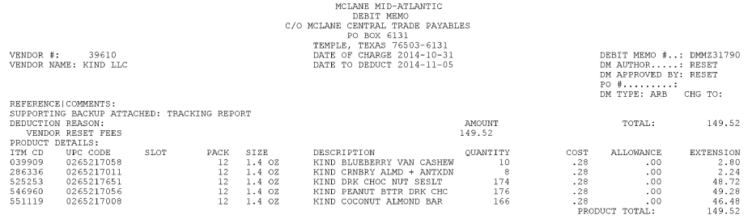
Deduction reason; vendor reset fees=Retail Merchandising

Customer Reference number .

- The following document is the Customer Agree for Reset Initiative. This may be used as a contract.

13 Deduction Type: Returns(Non-Trade):

It’s a deduction for the product returned by the customer to the client.

Document Name | Source of the Document | Action by Accenture
Customer Invoice | ACOSTA RELAY – search for the invoice under Backup Documentation, document type 2. | Step to Acosta for further research.
Client Order Invoice | ACOSTA RELAY – search for this document within the Order/Invoice/PO search if one is present.

13.1 Customer Invoice for Returns, Example 1:

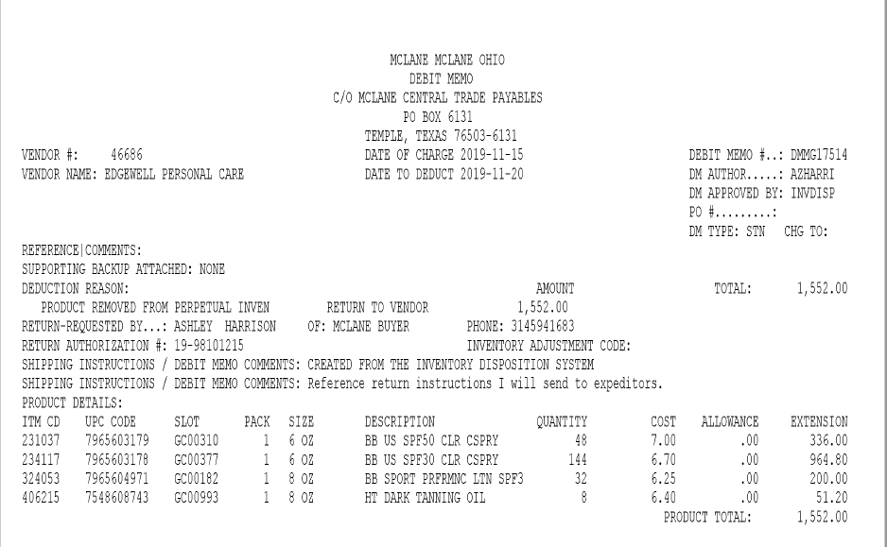
Product Removed: Customer Invoice indicates this is for Returned Goods.
Debit Memo: Customer Invoice number.

14 Freight/Backhaul – Transportation Fees.

14.1 Example of transportation fee for Heavy Liquid Distribution:

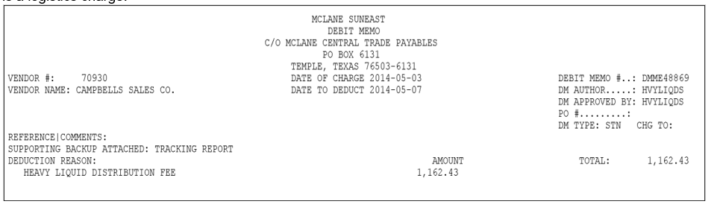

BPS TEAM INFORMATION

REPAY INFORMATION SECTION

Repay requests are sent to cap.research@mclaneco.com. Their team will forward to the correct department.

CCA CLEARING INFORMATION SPECIFIC

CCA Client Specific

COCA COLA –
- BOGO case rate promotions can be cleared to a lump sum event. BOGO events can be determibed by the contract.

HOSTESS –
- McLane Billback Blended Rates – For 2016 McLane rebates, Hostess is using blended rates based off of the quantity of product that is being moved. Due to this, the rate on the customer invoice may not always match the rate provided in the clients system. Approval from Hostess finance has been given to clear the Billback claims to the event with the blended rate as long as the product and time frame of the event match the product and time frame on the customer invoice that is being cleared to the event.

NISSIN –
- For FAMILY DOLLAR deductions, email Laura Briones LBriones@nissinfoods.com, and copy Kevin Lennox klennox@nissinfoods.com. “McLane / Family Dollar claim number ####### is not processed by Acosta. Please process the claim and forward payment to customer.”

COMPLETE VERSION HISTORY
UPDATE DESCRIPTION | DATE | AUTHOR
First draft of the McLane SOP | 09/27/2012 | Asif/Sapna
Final review by Trainer | 10/05/2012 | Geoffrey Van Syckle
Updated Billback section to include callout on 3% Admin Fee language on customer invoice and customer contract | 11/13/2012 | Geoffrey Van Syckle
Removing verbiage from Rebate section. Valid-Trade Rebates can be validated by the GCCs | 02/27/2013 | Heather Blackwell
Updated note on “all divisions” page #5 | 03/18/2013 | Heather Blackwell
>Updated page 17 and 18 with information on Walgreens indirect example. (3629) | 06/17/2013 | Heather Blackwell
>Added valuation process to rebate Example 1 (4295)  >Changed POP for indirect BB from memo tracking report to sales summary  *Added customer sign-on listing | 7/22/2013  *10/02/2013 | Caitlin Goodnight  *Caitlin Goodnight
> Added additional information on where to locate ads in ad section (5681) | 10/14/2013 | Caitlin Goodnight
> Added MCLANE Ozark to sign-on list (6148)  > Added return example (Query 1890) | 11/25/2013 | Caitlin Goodnight
> Added Hostess specific section, promotions and sign-on (7235)  > Added Kind specific section – Walmart (5508)  > Added information on BB bill period and contracts to customer specific. (7909) | 04/14/2014 | Caitlin Goodnight
> Added info about Walgreens 2014 contract to Hostess section and changed ES to be done under MCLAMST (8618)  > Added Handling Charge invoice example (8483)  > Campbell’s Heavy Liquid Fee example added (8723)  > Added McLane reset fee letter (7937)  > Campbell’s check remit info (9266) | 07-21-2014 | Caitlin Goodnight
> Sam’s Demo invoice added (9282) | 08-18-14 | Caitlin Goodnight
> Added Sam’s Demo request form (9879)  > Kind info on UPC #17819 (9327) | 09-01-14 | Caitlin Goodnight
> Added BB example 2 (9582)  > All McLane contracts need to be linked from event scheduler, including rebate contracts in order to link events in quick keys (10440)  > No sales summary data (POP) is available in ACOSTA Relay from 4/2014 – 9/2014 for Hostess (10775) | 10-27-14 | Caitlin Goodnight
> Campbell’s c-store rebate check info added (9531) | 01.19.2015 | Caitlin Goodnight
> Coca Cola - do not change sign-on (11307)  > Coca Cola – 7 Eleven event information involving other distributors (11307)  > added Kind/ WalMart Markdowns example (11802)  > Pfizer - Back up is indexed under the master signon, MCLAMST (12165) | 02.02.2015 | Caitlin Goodnight
> TradePro report can be ran and used as POP, Kind (12163)  > Added vendor reset fee invoice example with the letter explaning the fee (12247)  > Coca Cola admin fee directions added (12378) | 03.02.2015 | Caitlin Goodnight
> Kingsford – rebate information added (12058)  > Running sales from ACOSTA Relay instructions for Hostess (12529)  *Rephrased stating that McLane is a direct (13429) | 03.16.2015  *04.22.15 | Caitlin Goodnight
> COCACH – contract linking information (12768)  > Deleted freight section and moved no call no show invoice to fee section. Added COCAH no call no show requirments (12788)  > Kind/Walmart BB do not require POP (13217) | 05.11.2015 | Caitlin Goodnight
> Hostess - Customer invoices deducting for Family Dollar should be worked for McLane. (13445)  > Clorox/Burt’s Bees - Deductions which have the wording “Loss on Returns” are for spoilage (13460)  > On Return example, changed “RR” to a “R” indicating return invoice. There are several “R” prefixes for each division. (13858) | 06.08.2015 | Caitlin Goodnight
> Clean up and reorganization of information (14730)  > Added COCACH 2nd half 2015 admin fee events (14764)  *> Added line level data info (15509) | 09.14.2015  *10.12.15 | Caitlin Goodnight
> COCACH - For 7/11 check request thru Mclane, if the customer is deducting for single serve OJ or Ades info (15051)  > COCAH – Completing a DBW and splitting a claim for shelving fees (15164)  > PFIZER - For rebate invoices, detailed backup is indexed under Doc. Type 10 (15215)  > COCACH - McLane 2015 Qtr Rebate info added (14953) | 10.26.15 | Caitlin Goodngiht
> Added additional infor in sign-on note (15713)  > BPS team info section added woth Acosta contact listing. (15720) | 11.09.15 | Caitlin Goodnight
> HOSTESS - National deals vs indirect deals on MCLAMST contracts (16223)  > Updated BPS team template (16491) | 01.18.16 | Caitlin Goodnight
> COCACH – Added 2016 Shelving Fee breakdown percentages (16680)  > Moved BB billing info customer invoice billing info | 02.29.16 | Caitlin Goodnight
> Update sign-on per listing (17337)  > COCACH – Removed - No Call No Show invoices info (16983)  > COCACH – Added 2016 1st half admin fee events (16990) | 03.14.16 | Caitlin Goodnight
> Updated BB POP type to memo tracking (17524) | 03.28.16 | Caitlin Goodnight
> HOSTESS - Deductions for Gondola Shelf and/or risor kits (17615) | 05.09.16 | Caitlin Goodnight
> Updated CRA backup retrival info per customer invoice matrix | 06.20.16 | Caitlin Goodnight
> Updated sign on listing at top of page to include division number. Updated backup request process in BPS section and removed Acosta contacts. (17895)  > HOSTESS clearing infotmation add to BPS section for blended rates (18761) | 07.04.16 | Caitlin Goodnight
> KINDHS – Walmart info update in client specific and CCA clearing info section (18314) | 08.01.16 | Caitlin Goodnight
> HOSTESS – spend templates in VPFs validation info added (18999)  > Added Post Audit Section (19056)  > Added Post Audit example (19249) | 08.29.16 | Caitlin Goodnight  Christen Ledford
> Added Coke 2nd half 2016 event information (19011) | 09.02.16 | Caitlin Goodnight
> Removed duplicated contract exmaples & added genric statement for POP (19418) | 09.30.16 | Caitlin Goodnight
> Added customer invoice info section to the generic section to help example the invoice divisions. Added “contract information” to billback section. Billback 1:1, updated store call out bubble. Removed billback example 2 invoice and contract, document examples no longer relevant. (20338) | 01.16.17 | Caitlin Goodnight
> Add McLane to Client Spcific section: Family Dollar claims are Not Acosta, Add to BPT Team Info section CCA Client Specific: CCA to email Laura Brions and cc Kevin Lennox(20439) | 02.27.17 | Laurinda Ogburn
> NISSIN – Family dollar claims are CDN now (20918)  > COCACH – “AWARD” invoices are coded NT-Other (20558)  * > GCIT update (21433) | 04.24.17  *05.08.17 | Caitlin Goodnight
> Damages/unsaleables examples added (21397) | 06.19.17 | Caitlin Goodnight
> COCACH – Family Dollar claim DBW info added (20970) NISSIN – Added additional info on Family Dollar claim process (21551) Removed return section – inv. example in dam/uns section (21365) | 07.03.17 | Caitlin Goodnight
> HOSTESS – Rebate POP process added (21676) | 08.28.17 | Caitlin Goodnight
> COCACH – Removed 2015 from rebate process (22220) HOSTESS – Chevron contact info added (22619) | 09.25.17 | Caitlin Goodnight
> Updated sign-on listing (22802) | 10.23.17 | Caitlin Goodnight
> HOSTESS – no item breakdown needed for quarterly rebates (22573) | 12.04.17 | Caitlin Goodnight
> CAMPBL – Removed POP info from rebate process (22355) | 01.15.18 | Caitlin Goodnight
> Removed COCACH 2015 Admin fee info, removed PHIZER 2015 rebate event (23745) Check Request Rebate DBW Process added for COCACH/Speedway (23655) COCACH/Family Dollar DBW info added (23637) Updated hyperlink (23751) | 02.02.18 | Caitlin Goodnight
> Hostess: Added DBW report requirement. Removed info outside of post audit time frame: Walgreens 2013/2014 info. No POP info from 2014. (24500) | 04.07.18 | Caitlin Goodnight
> Added Barilla swell info (25269) | 07.30.18 | Caitlin Goodnight
> Update to customer backup request information/realignment of information. No process changes. | 08.13.18 | Caitlin Goodnight
> Added COCACH clearing info for BOGO lump sum events (25604) | 09.24.18 | Caitlin Goodnight
Added Campbell’s to the CCA Clearing Information for military deductions (26671) | 01/14/19 | Carlos Ocasio
Added Acosta doesn’t represent Superior Cake to Hostess section (26883) | 02/25/2019 | Carlos Ocasio
Added explanation of deductions letter and new item letter to the customer general information (26793) | 03/25/2019 | Carlos Ocasio
Removed document location and version history. | 04/30/2019 | Carlos Ocasio
Updated the CCNA Quarterly Rebate information and added an invoice example (27752)  Removed Clorox specific information as Acosta no longer represent (28157) | 06/17/2019  07/01/2019 | Carlos Ocasio
Added Backup Retrieval section. Transferred backup retrieval information from BPS Team section, customer is moving to the GCIT customer backup request process(28951)  Ad section updated information about ad location (29654) | 11/18/19  3/9/20 | Ca-Tonya Barnwell
Client Specific Validation section added the process for Military invoices to be cleared to (29713) | 3/13/20 | Ca-Tonya Barnwell
Deduction Types Covered section added Returns and under Process Steps added an invoice example(29436) | 5/22/20 | Ca-Tonya Barnwell
Client Specific Validation section removed Pfizer specific as of 6/24 no longer rep (30408) | 6/29/20 | Ca-Tonya Barnwell
In Campbell’s section, removed claim line breakdown info (30595). | 7/27/20 | Kristin Jones
Client Specific Validation section for Campbells added additional instructions for FY21 deductions.(30763) | 9/7/20 | Ca-Tonya Barnwell
Updated signon-ons in the embedded document on page 2 (30864)  Client Specific Validation section for Campbells added percentages to each Tactic ID (30862) | 10/5/20 | Ca-Tonya Barnwell

Client Specific Validation section removed and updated verbiage to align with clients process for Coca Cola (30964) | 10/9/20 | Ca-Tonya Barnwell
Client Specific Validation section added email contact for Coca Cola if unable to retrieve backup in AR (31269)  Client Specific Validation section added information on how invoices will identifyif the claim is for MDW or SW or if mixed the portion will state which division they are for(31286) | 12/18/20 | Ca-Tonya Barnwell
Deductions Types Covered section added another example of Damages/Unsaleables for Vintners Guaranteed Period (31362) | 1/15/21 | Ca-Tonya Barnwell
Client Specific Validation section updated email contact for Coca Cola if unable to retrieve backup in AR (32308) | 7/12/21 | Maria Ovalles
Backup Retrieval Information: Added CCNA process under Non-Automated (32929) | 12/13/21 | Brianna Ritchie
Client Specific Validation: Updated Coca Cola Qtr Rebate verbage (32981) | 1/10/2022 | Brianna Ritchie
Client Specific section removed Coca Cola backup retrieval information as must request from customer(33109), | 2/21/2022 | Mary Kay Dressman
Retail Merchandising section added Reset Initiative agreement(33339). Added Ken’s Client Specific information that events are not needed to complete validation(33337). | 3/21/22 | Mary Kay Dressman
Client Specific section for Campbell’s added information on how to obtain missing check remits that include customer invoices(33357). | 3/28/22 | Mary Kay Dressman
Client Specific section for Campbell’s added information on military claims being cleared to trade(33630). | 3/28/22 | Mary Kay Dressman
Added Client Specific section for Edgewell that contains information on an additional Campbell’s added information on military claims being cleared to trade(33630). | 3/28/22 | Mary Kay Dressman
Backup Retrieval Information section added information for Edgewell(34313). | 1/17/23 | Mary Kay Dressman
Backup Retrieval Information section updated information for Smucker’s Natural Foods(35062). | 7/27/23 | Mary Kay Dressman
Backup Retrieval Information section updated information for post audit backup requests. Deduction Types covered sections updated information on refence numbers on post audits and updated customer invoice example(35309). | 8/21/2023 | Mary Kay Dressman
Backup Retrieval Information section updated information for backup for Coca Cola(35347). | 8/28/2023 | Mary Kay Dressman
BPS Team Information section added Repay Information(35651). | 10/30/2023 | Mary Kay Dressman
Backup Retrieval information for Edgewell added detail for WaWa backup(35651). | 10/30/2023 | Mary Kay Dressman
Client Specific section added Coca Cola post audit information and updated post audit section with additional validation information (36214). | 10/30/2023 | Mary Kay Dressman
Client Specific for Coca Cola added military drayage information. (385094). | 5/20/2024 | Mary Kay Dressman
Client Specific for Camplbell’s added information about Pepperidge Farm frozen. (387805) | 5/28/2024 | Mary Kay Dressman
Client Specific for Campbell’s added information about heavy liquid distribution fees. (391865) | 5/28/2024 | Mary Kay Dressman
Client Specific for Coca Cola added WAWA rebate information. (397428) | 5/28/2024 | Mary Kay Dressman
Client Specific information removed Hostess. (402814) | 10/14/2024 | Mary Kay Dressman
Updated Client Specific Section for Nissin rebates (417388). | 03/10/25 | Pam Jaeger
Updated the backup section to Yes for Portal and included instructions in the GCIT specific instructions. (420920) | 4/7/25 | Pam Jaeger
Removed Client Kens from Client Specific Section (426821). | 6/2/25 | Dawn Regan
Added Deduction Type for Freight/Backhaul with example invoice. (436661) | 8/11/25 | Pam Jaeger
Updated Client Specific Section for Coca Cola regarding quarterly rebates. (440577). | 9/22/25 | Pam Jaeger
Added JM Smucker to the Client Specific Validation section. (443724) | 11/10/25 | Pam Jaeger
Added information for Campbells in Client Specific Section (458648). | 02/16/26 | Dawn Regan

