WORK INSTRUCTIONS

Process | Order to Cash
DTP Name | Mitchell Grocery Claims Validation Documents

CURRENT VERSION HISTORY

UPDATE DESCRIPTION | DATE | AUTHOR
Added SAS Retail Letter. (464243). | 4/6/2025 | Michael Huml

Link to Complete Version History: Complete Version History

DEDUCTION TYPES COVERED

Sl. No. | Deduction Type
 | Customer General Information
 | Backup Retrieval Information
 | Client Specific
1 | Off Invoice
2 | Billback
3 | Count-Recount
4 | Ad
5 | Pricing (Non Trade)
6 | Slotting
7 | Unsalable (Non Trade)
8 | Freight (Non Trade)
9 | Returns (Non Trade)
10 | Shortages (Non Trade)
11 | Cash Discount (Non Trade)
12 | Other (Non-Trade) Shelf Tags and Postage
13 | Other (Trade) Survey Printing Charges

Is the customer a Wholesaler/Distributor, Direct or Indirect customer? Direct

Note: MITCBI is the Sign-on used to work on ACOSTA Relay for Mitchells Grocery (for example to search a document and to refer the customer on ACOSTA Relay)

Link to customer sign on job aid:
https://acostaonline.sharepoint.com/sites/AS_Reporting/Claims_Reports/Forms/AllItems.aspx?web=1

Does this customer subscribe to IRI/Nielsen for price point verification? No

CUSTOMER GENERAL INFORMATION

Customer Invoice Info:

- Is line level detail indexed on the customer’s documentation (customer invoice, customer check request, unsaleable/spoils, post audit, EDI 812/820) or client deduction notice if one of these documents is included? YES
- For EFT payments, find the deduction in the payment detail section by the Reference ID. Below will be multiple individual invoice numbers that added together make up the claim total and will be used to validate.
- A customer invoice will not be provided when the check remit lists SAS Vendor Deduction, as this signifies the claim is for Retail Merchandising.
- Mitchell may cut off the first one or two digits from the client order invoice number on PO related claims. Backup may be located using wildcards and the last six digits.

Contract Info:

- There are no Contracts for Pre-Paid Deposit claims.

POP Info:

- There is no POP for Pre-Paid Deposit claims.
- 2025 Ad Calendar:

BACKUP RETRIEVAL INFORMATION

GENERAL BACKUP RETRIEVAL INFORMATION

Is GCIT responsible for obtaining backup from the customer? Yes
- If yes, is there a customer portal? No
- If yes, does GCIT request backup? Yes

Is check remittance information required to request backup? Yes

GCIT SPECIFIC BACKUP RETRIEVAL INFORMATION

Non - Automated:

Customer Invoice or Note Identifier | Request From
All formats, if not found in repository | Sales

CLIENT SPECIFIC VALIDATION INFORMATION

Client
Barilla
Nestle Coffee
Raos

BARILLA
- Special Pricing claims through Dot Foods are cleared as Trade Other to an event-2025 Mitchell EDLP Rates-1000053179 - Jen, 1 2025- through Dec 31,2025

NESTLE COFFEE
- SAS claims are also called Homestore and a contract is not needed to validate. Embedded document contains 2023 and 2024 events.

RAOS
- Customer Ad Calendar must be attached to the claim line as POP – Movement/TPR (Doc Type 7) for proof of performance.

PROCESS STEPS

1. Deduction Type: Off Invoice

A per-case off invoice allowance is given to the customer as an automatic discount for product purchased from the client. If the customer does not receive the allowance off the face of the invoice they will deduct for it. If the customer requested an allowance that is not valid, the CSC will send a notification to the customer in writing. Customers view purchase orders as contracts. If they are not notified of allowance discrepancies, they will pay according to their purchase order total.

1.1 Customer Invoice Cover Sheet for Off Invoice: Example 1
Vendor Reference #: This is the Client Order Invoice number. This would be used to retrieve the Client Order Invoice from the Review Order/View Document link within ACOSTA Relay. This number also needs to be matched with the Client Order Invoice.
In this case the invoice number is 3964562.
Note: The Client Order Invoice must be pulled first to determine the rate per case Off Invoice allowance.

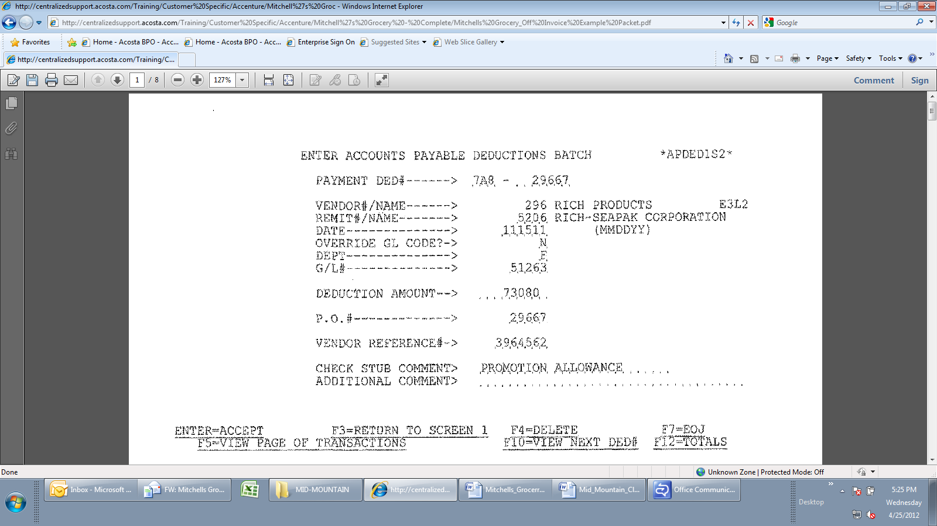
DEDUCTION AMOUNT – Customer is claiming $730.80. However, this amount includes the claim for the OI allowance due and for the price variance that occurred because of a variance in the quantity that was ordered and what was actually shipped. Hence, calculation for OI claim (using OI rate alone) does not show the amount $730.80.
CHECK STUB COMMENT – Mitchells Grocery describes the deduction type in this section.
Promotional Allowance means the deduction is for Off-Invoice.

PO Number – This will be used to search for information regarding the order within ACOSTA Relay. This data is needed to validate if the particular product was ordered and invoiced with the off invoice allowance.
E.g.: In this case the PO # is 29667
Claim Amount - This is the total amount customer is requesting for a billback allowance. This document doesn’t have detailed information regarding UPC/Product to match with contract. Look for the invoice breakdown if available to continue validation.
i
Identification - To start with claim validation; look into Description to confirm deduction type. In this case “SOLO BILLBACK” reflects bill back.
i

INV DT: This indicates the Client Order Invoice is dated 11/7/11 – Invoice Number: 93964562

  - Customer Invoice for Off Invoice: Example 2 EDI copy

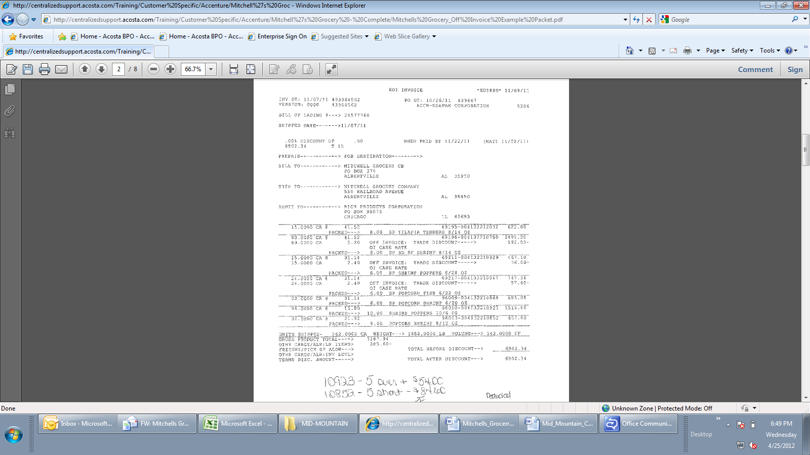
In this section the customer has stated that for –:
UPC#10923 – Shipment was over by 5 cases.
UPC#10852 – Shipment was short by 5 cases.

Note: The customer used the Client Order Invoice to indicate the adjustments they were making.

Bill Of Lading #: The Bill of Lading number provides us with the document number of the papers what were signed once the order was delivered. These papers are proof of what was actually delivered to the customer’s warehouse and signed for. You will find a copy of this BOL on page 8.

Shipped Date –– The Shipped date mentioned on the Customer Invoice should fall within the Ship Dates on the Customer Contract and also should match with the Customer Invoice.

1.1 Customer Purchase Order Copy – Example 2 EDI Version:

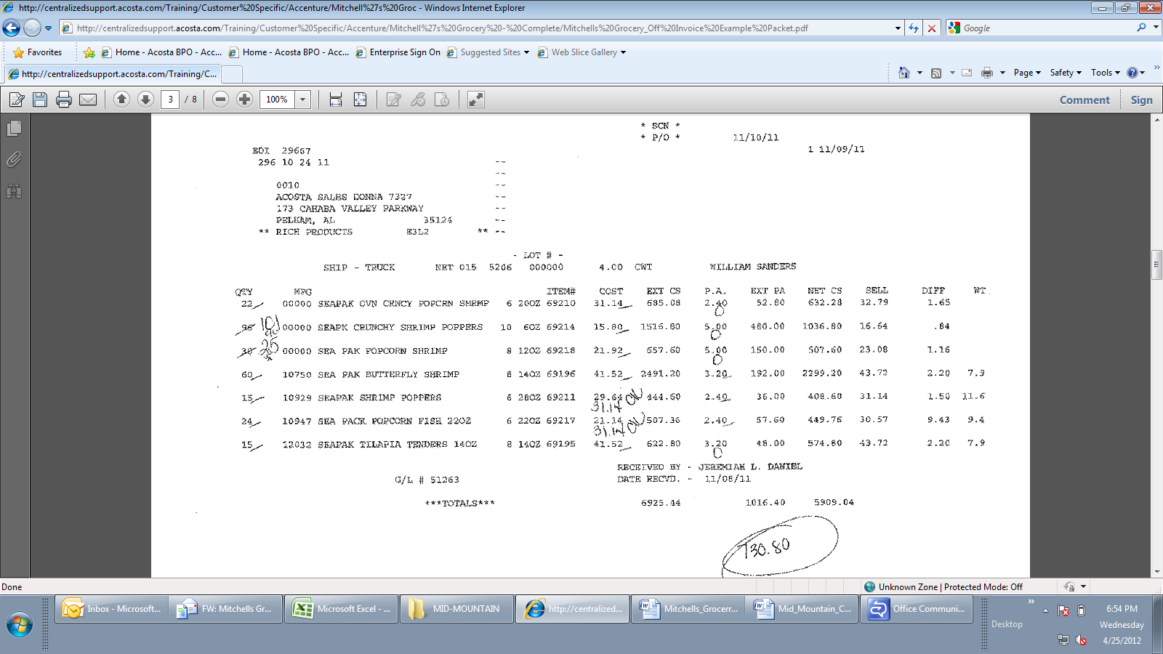
PO Number – This will be used to search for information regarding the order within ACOSTA Relay. This data is needed to validate if the particular product was ordered and invoiced with the off invoice allowance.
E.g.: In this case the PO # is 29667
Quantity discrepancy.
OI Rate – At the rate of $5.00/case, customer is asking for the OI allowance. This needs to be validated with the Customer Contract and Client Order Invoice details.
Product Description:

This indicates the product description for the items the customer is expecting the Off-Invoice allowances. The Item #’s that appear are not the actually UPC’s for this Client but are numbers the customer has assigned to these products. We would need to use the product description to derive and validate the UPC’s involved in the claim.

- CRUNCHY SHRIMP POPPERS (UPC#10852) - Order was for 96 cases; customer was shipped and invoiced for 101 cases.
- POCORN SHRIMP (UPC#10923) - Order was for 30 cases; customer was shipped and invoiced for 25 cases.

To support this discrepancy, customer has provided the Client Order Invoice with notations.

While claiming the Off-Invoice allowance, customer has made the adjustment on the quantity discrepancy for both items.
For the UPC#10852, claim is only for 96 cases and not for 101 cases.
For the UPC#10923, claim is only for 30 cases and not for 25 cases.

Note - this needs to be validated with the Client Order Invoice details.

1.1 Customer Copy of Purchase Order – Example 3 - Non-EDI Copy:

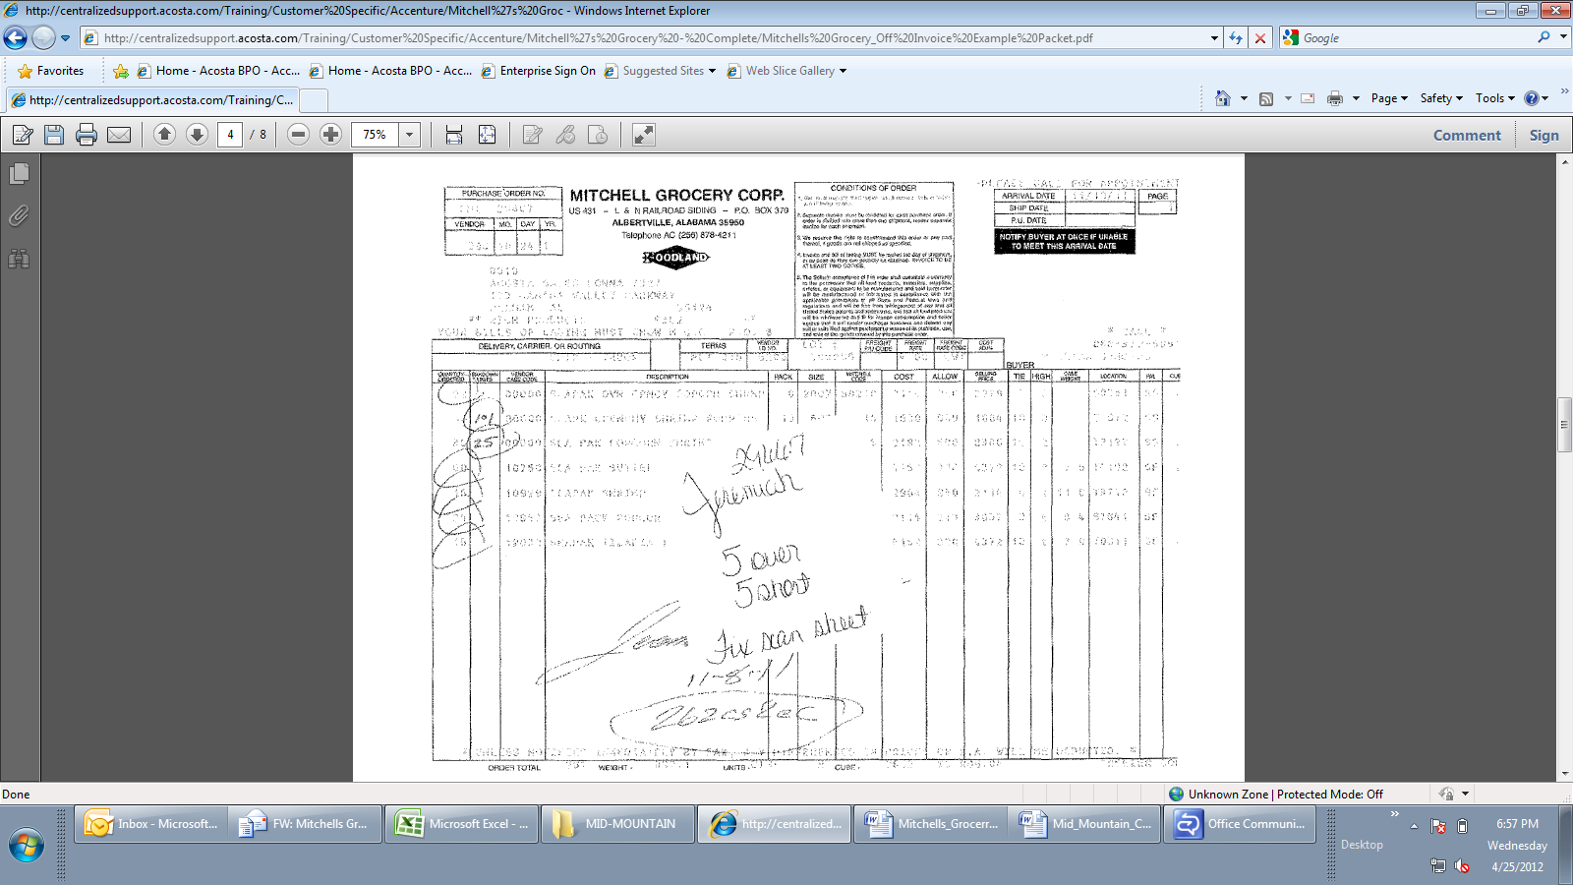

This copy is not clear; however, only information that could be identified is in regards to the quantity discrepancy.

1.1 Bill of Lading: Example 2

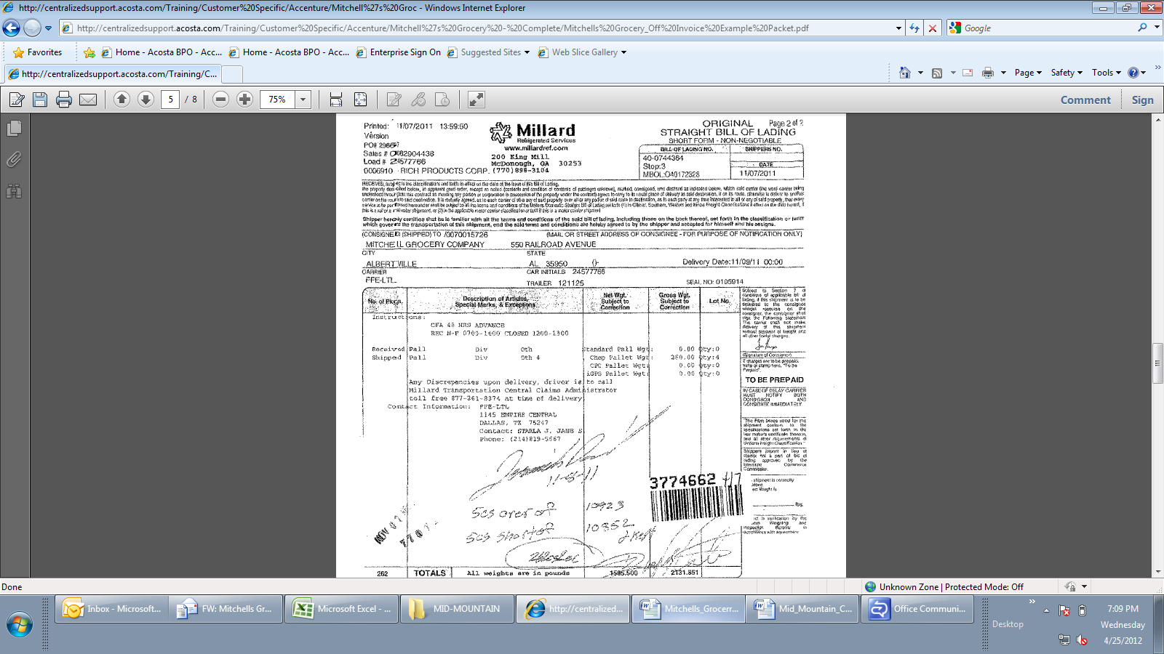

This hand written note on the Bill of Lading states there was a discrepancy in the quantity received at the time the products were delivered to the warehouse.

1.2 Customer Contract for Off-Invoice: Found via Search For: Event Scheduler.

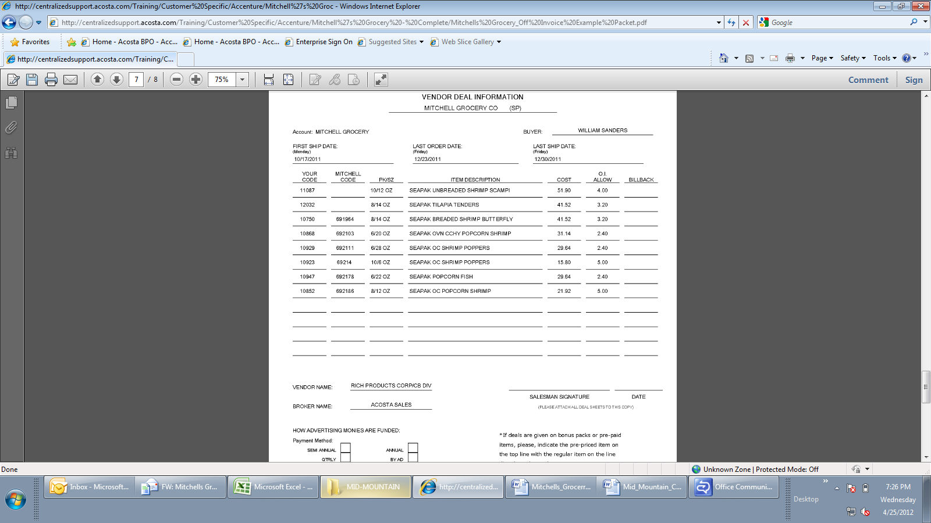
OI Rate – At the rate of $5.00/Case, an OI Allowance is being offered. This needs to be validated with the Customer Invoice.
For the highlighted UPC (10923 & 10852), an OI allowance was offered @$5.00/case.
This needs to be validated against the Customer Invoice.
Performance Date – Order date of the Client Order Invoice details should fall within these dates to have the eligibility for the OI allowance.

2. Deduction Type: Billback

A Billback claim is a per-case allowance offered for a specific performance requirement. A per-case billback allowance is claimed by the direct buying customer for product purchased from the client, or by the indirect customer for product purchased from the direct customer. This is an allowance the customer will bill the client for. This is not an automatic discount given off the face of the invoice.

2.1 Customer Invoice for Billback: Example 1

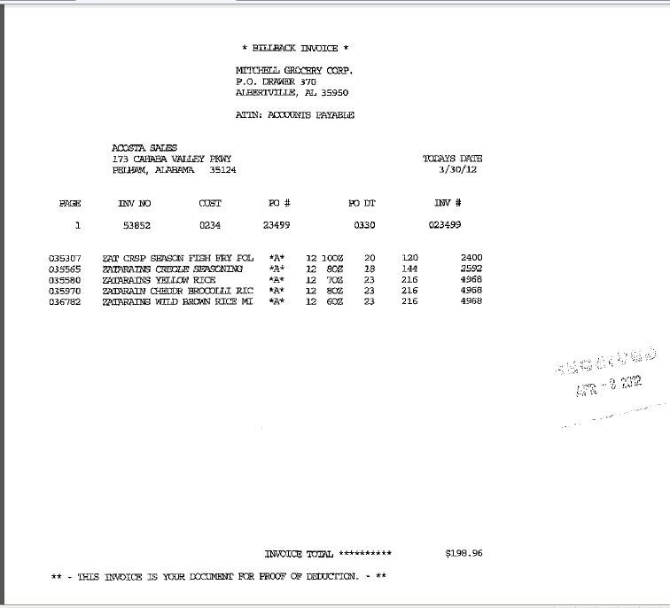
BB allowance – This is the per-case BB allowance the customer has deducted as part of the BB deduction.
A decimal needs to be placed after 1st digit to get actual rate to match the Customer Contract, e.g. 120 should be read as 1.20.
Multiply this amount by the total number of Qty (cases) listed to get the total deduction amount (also found under the Extension column – e.g. 2400 should read 24.00).
PO DT: This is the date of the PO – 0330 means 03/30/12. This PO date needs to fall within the order dates indicated on the Customer Contract.

Billback Invoice: This identifies the customer is claiming for a Billback Allowance due.

Additional Allowance Due – This is the total amount of the deduction taken by the customer as a Billback Allowance due.
In this case the deduction amount is $198.96.

Qty –The Qty as per the Customer Invoice needs to match with the Client Order Invoice.

PO Number – The PO number needs to be validated on the Client Order Invoice to see if the particular product was ordered and invoiced with the Billback allowance.
E.g.: - In this case the PO # is 23499.

Item Code –This is the customer’s internal code which should match with Customer Contract to validate the claim.

2.2 Customer Contract for Billback: Found via Search For: Event Scheduler

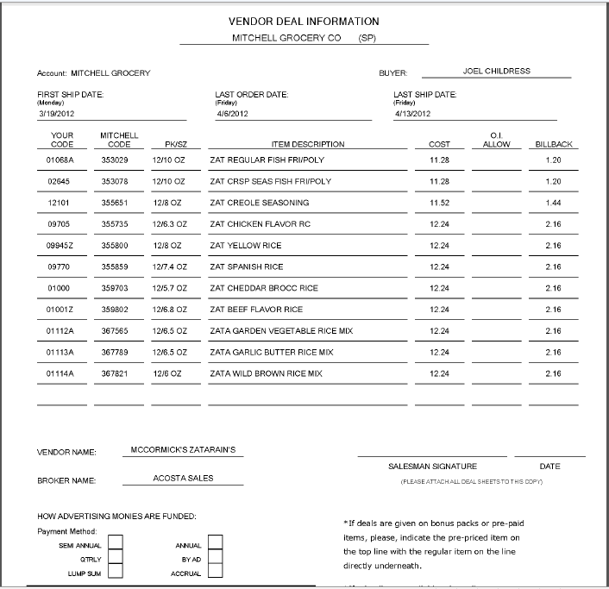
Your Code: These are the actual UPC codes for the items listed on the contract. As noted within the explanation of the Mitchell Code, the contract lists both as references to each item.
E.g. UPC 02645 is the same as Mitchell’s Code 353078 for CRSP SEAS FISH FRI/POLY
Mitchell Code – This is the code the customer has assigned to each of the products. These codes need to be used to compare to the codes on the Customer Invoice.
E.g.: - In this case we would match the Mitchell Code (internal) with Customer Invoice excluding last digit i.e. 35307 for 353078.
Billback – This is the per case Billback allowance amount being offered. This amount should match with the Customer Invoice and verified against the Client Order Invoice.

First Ship date – Last Order Date – Last Ship Date: –– The Order date on the Customer Invoice should fall within these dates.

3. Deduction Type: Warehouse Withdrawal/Count Recount
Warehouse Withdrawal/Count Recount is for cases shipped to stores from the main customer’s warehouse.

3.1 Customer Invoice for Count-Recount:

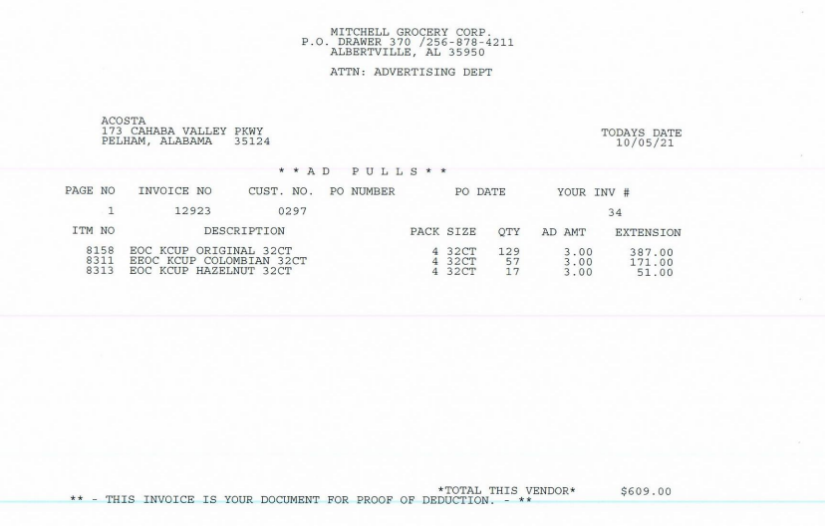
Identification: AD PULLS on the customer invoice indicates the deduction is for a Count-Recount. Mitchell’s Grocery is a direct customer who sells to various independent customers. Those independent customers will be the ones actually running the Ad for the product they have pulled from Mitchell’s.
Ad Amount: This is the per case amount the Customer has deducted as a Count-Recount allowance due. Multiply this amount by the total Qty to get the total deducted amount by item. This is what we then see in the “Extension” column.
Your Invoice No.: For Ad Pull Customer Invoices, the Ad Pull week will be indicated here. Contracts can be located by using the Mitchell Ad Calendar to determine deduction week dates and locate applicable contract.
Qty - This is the movement Quantity that will need to be validated against the Proof of Performance.
Item No. - Description - These are the codes Mitchell’s assigns to each of the products as we see in the Description area. These are the products in which the customer is stating there is a Count-Recount allowance due.

3.2 Customer Contract for Count-recount: Found via Search For: Event scheduler

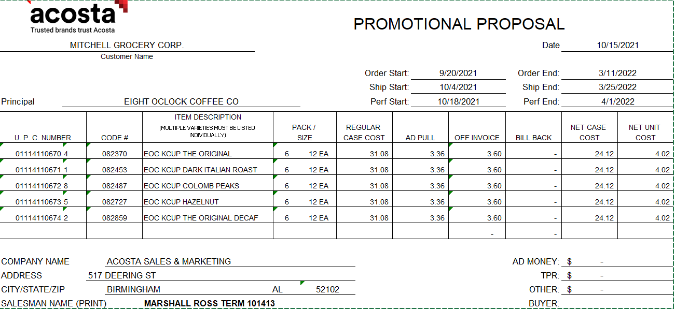
Order/Ship Start Order/Ship End Dates: - The Customer Invoice ad pull week dates from the Mitchell Grocery Ad Calendar must fall within the contract dates.

Ad Pull: This indicates the available rates offered for Count-Recount which should match with the Customer Invoice in order to validate the claim.
Mitchell Item # - These codes are ones the Customer internally assigned to each products and are not the actual UPC’s. These codes are used to validate key data elements on the Customer Invoice and POP. This is the product in which the customer is stating there is a Count-Recount allowance due.

3.3 Refer to the Client SOPs/Generic Help File for POP requirements.

4. Deduction Type: Ad

A fee for featuring a client's products in an advertisement.

4.1 Customer Invoice for Ad:

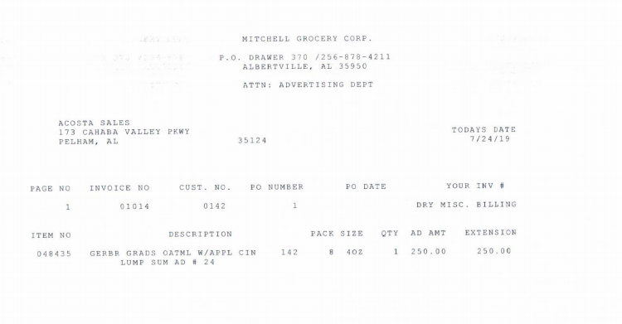
Product Description- This indicates the product description of the product that was offered on promotion.
This needs to match with the Customer Contract to be considered to be a valid claim.
Lump sum Amount – Amount ($250) claimed by customer for the Ad allowance.
This needs to be matched with the Customer Contract to be considered a valid claim.

4.2 Customer Contract for Ad:

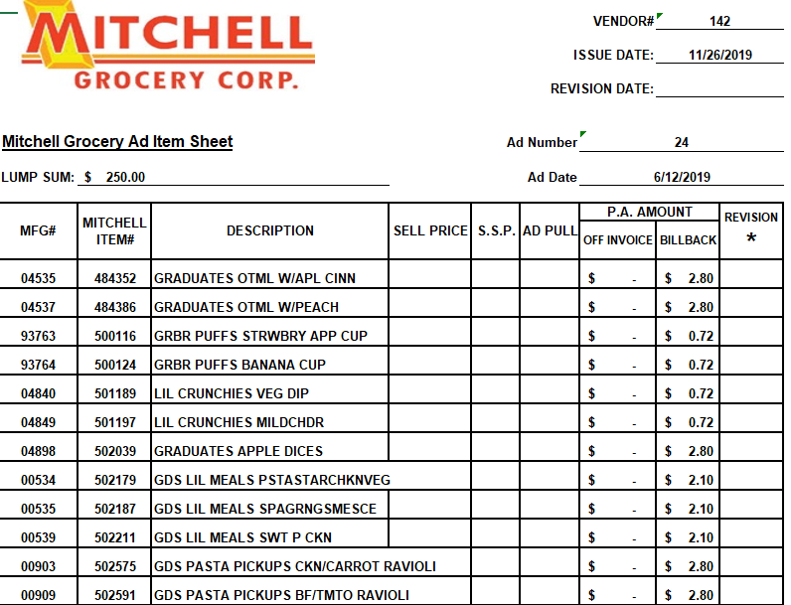
Ad Date (performance date) – This indicates the date on which the Ad should be published.
This needs to match with the Invoice and the POP to be considered to be a valid claim.
Product Description: This indicates the product description of the product that is being offered to run in an Ad.
This needs to match with the Customer Invoice to be considered as a valid claim.

4.3 Refer to the Client SOPs/Generic Help File for POP requirements.

5. Deduction Type: Pricing (Non Trade)

A pricing deduction occurs when the customer's requested price on the original purchase order differs from the client's invoice.

Documents required for validating a Pricing claim:

Document Name | Source of the Document | Action by Accenture
Customer Invoice | ACOSTA Relay – search for the invoice under Backup Documentation, document type 2. | Step the claim to Acosta for research
Client Order Invoice | ACOSTA Relay – search for this document within the Order/Invoice/PO search.

5.1 Customer Invoice for Pricing:
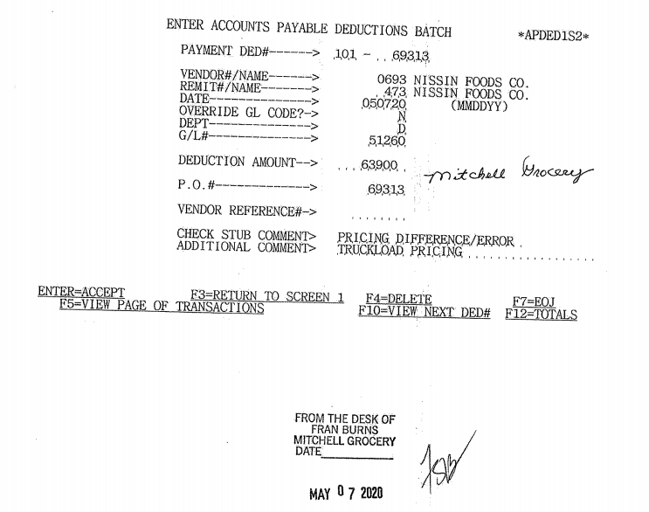
Identification – This indicates there is a price difference on PO# 69313 and – it confirms this is for a Pricing Deduction.
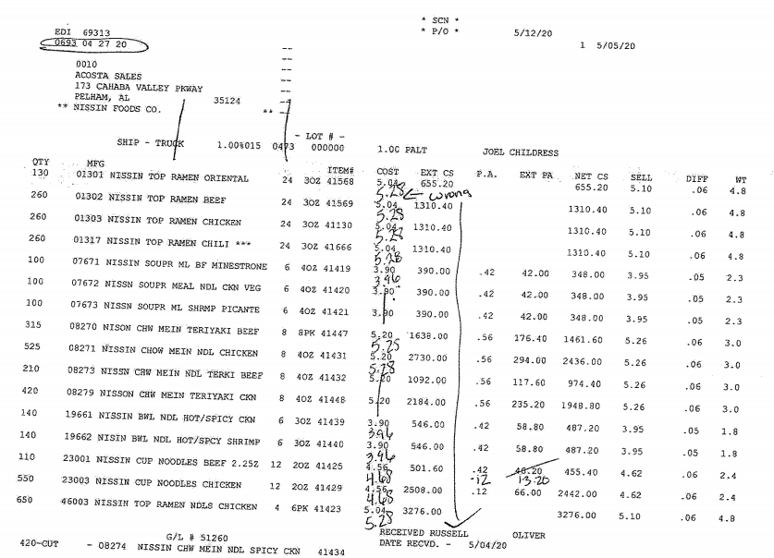
UPC/Product: This indicates the product on which the pricing discrepancy is identified.
Manufacture’s Code / UPC is 79224
Customer Code is 133801

6. Deduction Type: Slotting

A Slotting allowance is offered to the customer to purchase an item not currently stocked. It is a kind of promotional money offered to a customer as incentive to buy a new item and create a “slot” for that product on their warehouse storage shelves. It is a Trade Deduction. A slotting lump sum allowance can be offered for each item and/or an off invoice can be offered as an introductory allowance.

6.1 Customer Invoice for Slotting: Example 1

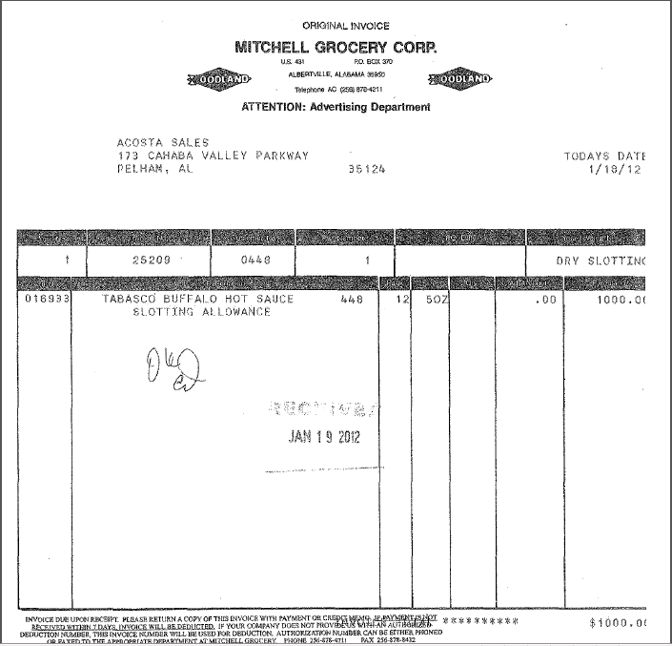
Notice the date of the customer invoice. See next page - blue box - explaining approval on date differences.
Lump sum Amount – This is the amount the customer has claimed for a Slotting Allowance. This needs to be validated against the Customer Contract.
Identification – This indicates the deduction type. In this example, customer has clearly mentioned this is for a Slotting Allowance.
Product Description – This area would list the product details which we should match to the Customer Contract. In this example, the customer is claiming for a “Tabasco Buffalo Hot Sauce” Slotting Allowance.

6.2 Customer Contract for Slotting: Example 1

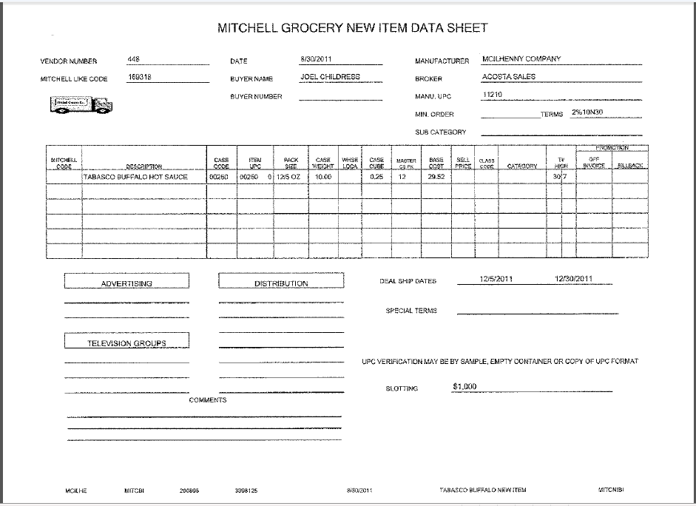
This area would list the lump sum amount agreed upon for the “Slotting Allowance”.
Description – This area would list the product description which should match with the product description on the Customer Invoice.

NOTE: The invoice date for slotting does not need to be indicated on the slotting contract. Slotting contracts are created prior to the customer actually ordering; therefore, the customer’s invoice may be dated after the dates that appear on the contract. As long as the customer has only deducted once against the contract, it can be used.

6.1 Customer Invoice for Slotting: Example 2
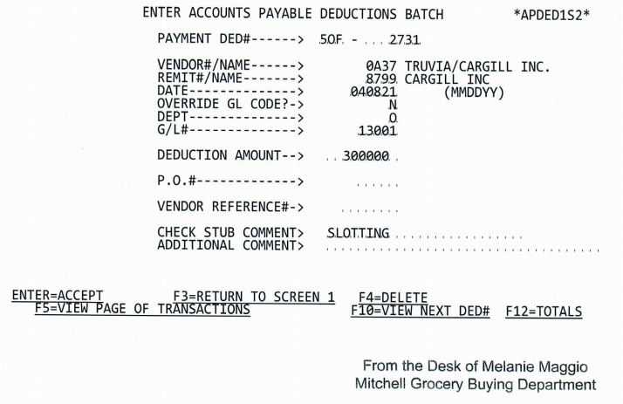
This area would list the lump sum amount agreed upon for the “Slotting Allowance”.

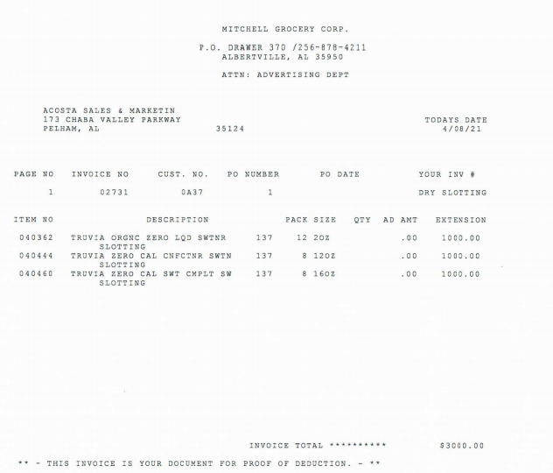

6.2 Customer Contract for Slotting: Example 2
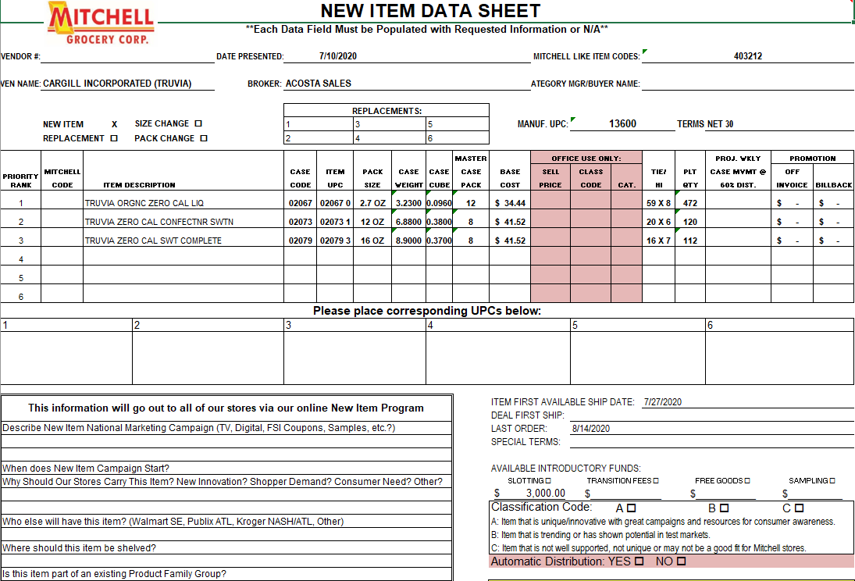

6.3 Refer to the Client SOPs/Generic Help File for POP requirements.

7. Deduction Type: Unsaleable/Reclamation (Non-Trade Claim)

An Unsaleable claim is taken for product that cannot be sold at the stores due to damages (and short coded product).
Documents required for validating an Unsaleable claim:

7.1 Customer Invoice for Unsaleable / Reclamation:

This is the total being claimed by the customer for the products being claimed as Damages/Unsaleables.
Qty: This area list the quantity for each item being claimed as Damages/Unsaleables.
This area lists the various products and the UPC related to those products whereby the customer is claim them to be Damages/Unsaleables
ATTENTION: Reclamation Department: This indicates this claim is for Damages/Unsaleable.

8. Deduction Type: Freight / Back Haul:

A Freight allowance is given to the customer for picking up the product via their own transportation services.

Documents required for validating a Freight claim:

Document Name | Source of the Document | Action by Accenture
Customer Invoice | ACOSTA Relay – search for the invoice under Backup Documentation, document type 2. | Step up the claim to Acosta for research
Client Order Invoice | ACOSTA Relay – search for this document within the Order/Invoice/PO search.

8.1 Customer Invoice for Freight / Back Haul:

Deduction Amount: This indicates that deduction amount towards a freight claim.
Amt is $15.86
Check Stub Comment : This indicates this claim is for a Freight issue.

9. Deduction Type: Returns

Products returned by the customer to the client.

Documents required for validating a Returns claim:

Document Name | Source of the Document | Action by Accenture
Customer Invoice | ACOSTA Relay – search for the invoice under Backup Documentation, document type 2. | Step the claim to Acosta for research
Client Order Invoice | ACOSTA Relay – search for this document within the Order/Invoice/PO search if one is present.

9.1 Customer Invoice for Returns: Example 1
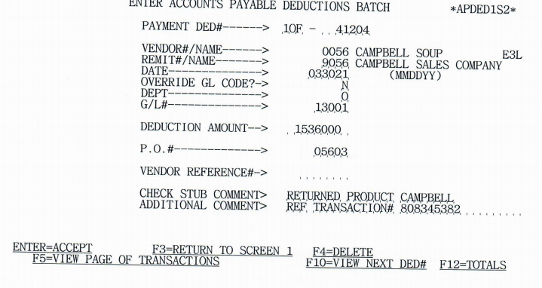
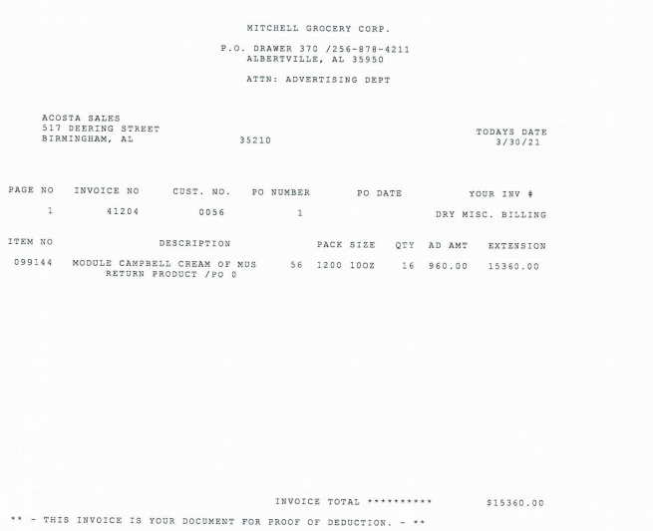

9.1 Customer Invoice for Returns: Example 2

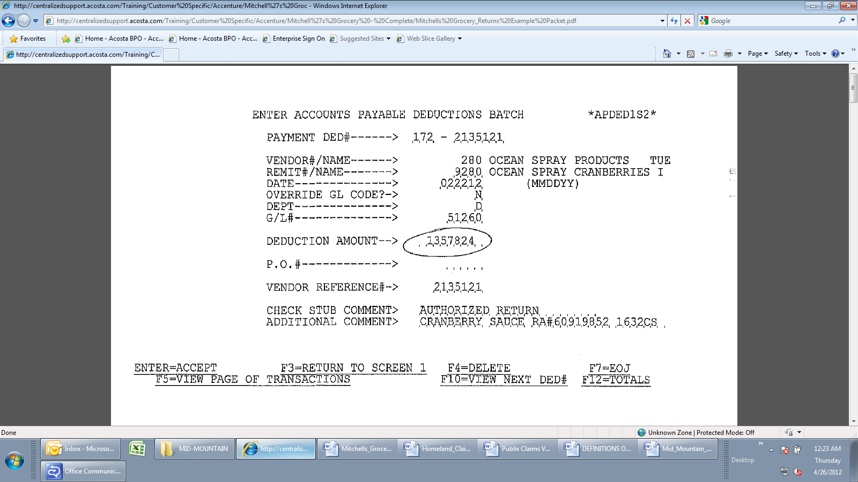
RA# - Return Authorization number is issued by the Client once they approve for the Return

RA# 60919852
CHECK STUB COMMENT – This tells us what the claim is for; in this example,
AUTHORIZED RETURN means the deduction is for Returns.

DEDUCTION AMOUNT – Customer is claiming $13,578.24 for Returns

9.1 Customer Invoice for Returns: Example 2

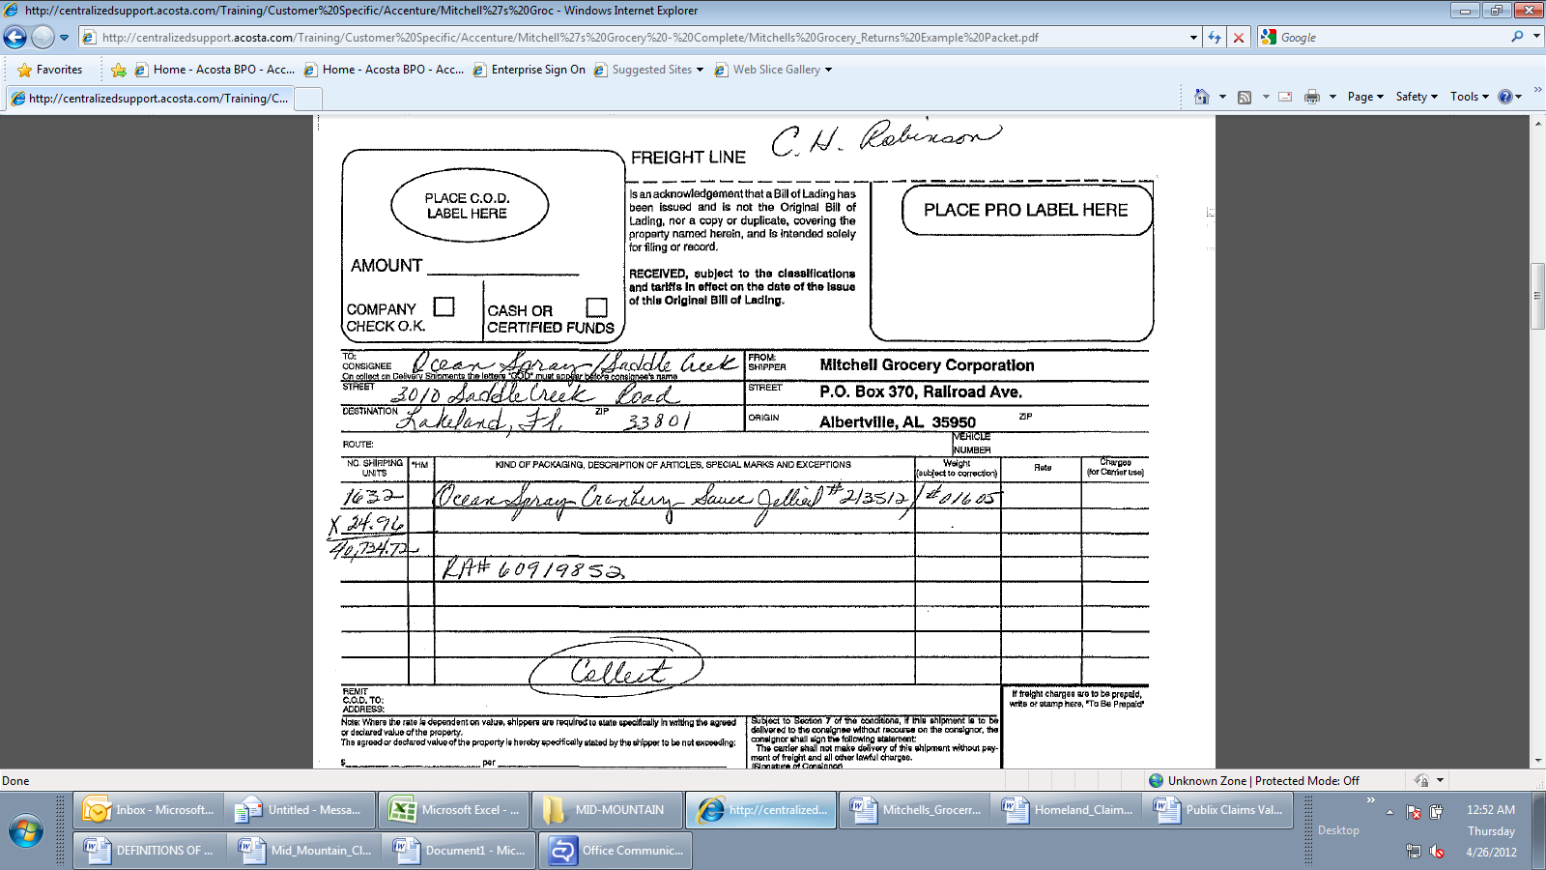
On the Customer Invoice, when we see “RA#”, it means the claim is for Returns. The customer has made note of the number the Client assigned the authorized Return.

10. Deduction Type: Shortage

It is a deduction for shorted product on an order that the client billed the customer for.

Documents required for validating a Shortage deduction:

Document Name | Source of the Document | Action by Accenture
Customer Invoice | ACOSTA Relay – search for the invoice under Backup Documentation, document type 2. | Step the claim to Acosta for research
Client Order Invoice | ACOSTA Relay – search for this document within the Order/Invoice/PO search.

10.1 Customer Invoice for Shortage:
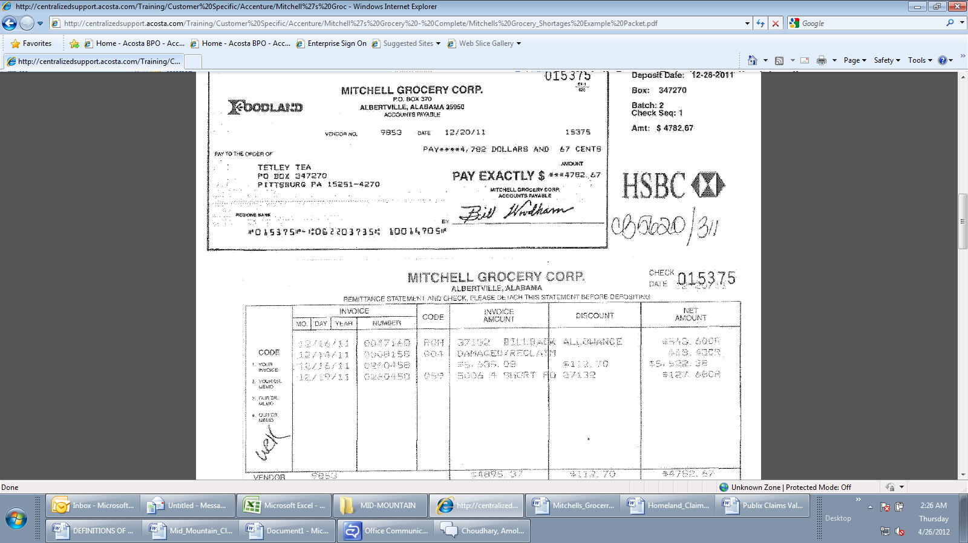
This is indicating on the check remittance for this customer the claim is for Shortages. As soon as we identify this is for Shortages, we need to step the claim up to Acosta.

11. Customer Check Remittance for Non-Trade Cash Discount

Mitchell Groceary calculate cash discount from the gross, not the net that includes the promotional allowance. It will be reflected on the check remittance.

11.1 Check remittance showing cash discount

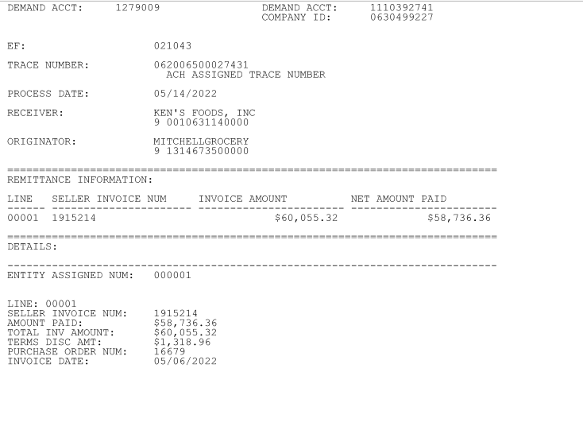
Cash discount amount calculated on the gross versus net listed as Terms Disc Amt on the check remittance.

12. Deduction Type: Other (Non-Trade)

12.1 Client Deduction Notice for Other: Non-Trade Example 1
On this Client Deduction Notice, they indicate the customer deducted a total of $503.76.

12.1 Customer Check Remittance for Other: Example 2
This is the Check Remittance that was attached to the Client Deduction Notice.

This tells us $486.06 was deducted for Damages/Reclaims. We would need to find the Damage/Unsalable invoice to support this portion of the deduction.

It also tells us $17.70 was deducted for Shelf Tags and Postage which we would code the claim line as Non-Trade – “Other”.

13. Deduction Type: Other (Trade)

13.1 Client Deduction Notice for Trade - Other: Example 1

On this Client Deduction Notice, they indicate the customer deducted a total of $175.00

13.1 Check Remittance for Valid- Trade - Other: Example 1
On this Check Remittance, we see a deduction for “New Item/Survey Booklets” for a total of $175.00

13.1 Customer Invoice for “Other” (Trade) Example 1
On this Customer Invoice, they are claiming 5 Christmas Surveys at $35.00 each for a total of $175.00.

In this example, the customer is charging for the printing of these surveys

13.1 Survey Sheet for “Other” (Trade) Example 1
This page and the next are copies of the survey sheets that were printed. The claim is for the printing of these surveys for the various “Christmas” candy items.

Survey Sheet for “Other” (Trade) Example 2

COMPLETE VERSION HISTORY
UPDATE DESCRIPTION | DATE | AUTHOR
First draft of the Mitchells Grocery SOP | 04/25/12
Final Updation of Flowcharts and Definitions | 07/12/12 | Sebin Paul
Reviewed – Moved to Final | 7/13/12 | Janell Rhoden
Updated notes on the Ad dates. (also added Ad Calendar to SOP folder) | 8/21/12 | Heather Blackwell
Update IRI/Nielsen for price point pg. 2 | 9/11/12 | Rick Smith
Updated hyperlinks to deduction types | 09/16/12 | Nagesh Kumar
Corrected Count/Recount Example – had incorrect contract in example. Added how to indicate Ad Pull week/date on customer invoice and how to help search for contract that goes with that customer invoice (#4012) | 7/22/13 | Janell Rhoden
Added “Other” – Valid-Trade example (#4514) | 8/12/13 | Janell Rhoden
Added National Toolbox Link. Added link to customer sign on job aid. | 9/27/13 | Janell Rhoden
Added verbiage to slotting example (#4063) | 10/28/13 | Janell Rhoden
Added Client Specific link and section with Kings Hawaiian and bullet (#4779) | 3/17/14 | Janell Rhoden
Note has been added regarding no contracts will be available for prepaid deposit claims (#11950) | 3/2/15 | Janell Rhoden
Added question regarding customer type: Wholesaler/Distributor, Direct or Indirect customer (#13429) | 4/27/15 | Janell Rhoden
Moved information to new format (14730) | 10/5/15 | Amy Bedor Salmey
In Customer General Info – Customer invoice section, added Q/A about line level indexing (15509). | 10/23/15 | Amy Bedor Salmey
Tyson requires all ad claims to have a copy of the ad, regardless of date of claim (16362) | 1/4/16 | Amy Bedor Salmey
No contract required for prior broker claims for Tyson (16612), reformatted BPS specific section (16491) | 2/1/16 | Amy Bedor Salmey
Information on Clorox incentive with Lowes (15465) | 2/29/16 | Amy Bedor Salmey
Added to BPS Team Info - CRA Cleint Specific Section for Clorox contact for b/u requests (17977) | 5/23/16 | Laurinda Ogburn
Acosta no longer reps Kings Hawaiian as of 8/15/2016 (19677) | 10/24/16 | Laurinda Ogburn
Acosta no longer reps Kings Hawaiian as of 8/15/2016 (19677); Remove extra contract examples from each allowance type example and remove POP examples if they follow normal process, replace with statement “Refer to the Client SOPs/Generic Help File for POP requirements” (19418) | 10/24/16 | Laurinda Ogburn
Updated links for SPO (23751) | 2/26/18 | Whitney Eiss
Added client specific section for Pinnacle (23994) | 3/26/18 | Whitney Eiss
Added client specific section for Pinnacle under the CCA section (24317) | 6/4/18 | Whitney Eiss
Added client specific section for Nestle Nutrition (25027) | 7/2/18 | Whitney Eiss
Updated customer invoice info section (24805), Update to customer backup request information/realignment of information, no process change. | 7/16/18 | Whitney Eiss
Added Noosa specific swell allowance. (25559) | 9/10/18 | Christian Estevez
Removed Nestle Nutrician information from the client specific section – spin reports no longer needed (26581). | 12-17-18 | Pam Trimble
Updated email address for backup for Clorox in the CRA Validation Specific section. (27060) | 02/25/19 | Carlos Ocasio
Colgate specific, simplified customer DBW instructions added (27462). | 4/22/19 | Pam Trimble
Removed Noosa from client specific section (28689) | 10/21/19 | Suzy Fields
Created Backup Retrieval section (29002) | 11/22/19 | Suzy Fields
Backup Retrieval Information section updated Is check remittance information required to request backup? from No to Yes (30362) | 6/19/20 | Ca-Tonya Barnwell
Count-Recount section updated as Ad Pull claims contracts may need to be located by date. (32669) | 9/20/2021 | Mary Kay Dressman
Update Customer General Information section for deductions taken on EFT payments that encompass mutlipe invoices. (32734) | 10/18/21 | Mary Kay Dressman
Updated Count-Recount section with invoice and contract examples and information on how to marry up invoice with contract. Removed verbiage on AD pull week in contract description.(33085) | 1/24/2022 | Mary Kay Dressman
Client Specific section for Ken’s added dressing reset event (33769). Deduction Type section added information and example for cash discount(33846). | 8/8/22 | Mary Kay Dressman
Client Specific section added Nestle Coffee and information Homestore deductions. (36205) | 4/8/2024 | Mary Kay Dressman
Rao’s client-specific: Ad Calendar is to be attached to the claim line as POP-Movement/TPR for POP. (422181)  Added 2025 Ad Calendar. (422366) | 4/21/2025 | Michael Huml
Removed Kens client specific section (427710) | 6/16/25 | Katy Dolan
Added Barilla to Client Specific Validation Information Section for special pricing. (427165). | 6/23/2025 | Pam Jaeger

