WORK INSTRUCTIONS
Process | Order to Cash
DTP Name | OK Grocery Co/Giant Eagle

CURRENT VERSION HISTORY
UPDATE DESCRIPTION | DATE | AUTHOR
Removed Mars Foods from BPS Team Information section (467535) | 5/4/2026 | Dawn Regan

Link to complete version history: COMPLETE VERSION HISTORY

DEDUCTION TYPES COVERED
Sl. No. | Deduction Type
 | Customer General Information
 | Backup Retrieval Information
 | Client Specific
1 | Off Invoice
2 | Scan
3 | Ad
4 | Pricing (Non Trade)
5 | Slotting
6 | Unsaleable / Swell Allowance (Non Trade)
7 | Warehouse Withdrawal/Count Recount
8 | Food Shows
9 | Coupons (Non Trade)
10 | Fees (Trade Related)
11 | Freight/Backhaul (Non Trade)
12 | Returns, Recalls (Non Trade)
13 | Shortages (Non Trade)
14 | Post Audit
15 | OI Claimed on Shorted Product
16 | Loyalty Card (Fuel Perks)
17 | TPR & TPR Fee
18 | Demo
19 | Floor stock
20 | Penalty Non Trade
21 | Markdowns
22 | Other (Vendor Up)
23 | Retail Merchandising Program
 | BPS Team Information

Is the customer a wholesaler/distributor, direct or indirect customer? Direct

OKGEPI is the sign-on used to work on Acosta Relay for OK Grocery and Giant Eagle (for example to search a document and to refer the customer on Acosta Relay).

ZZGETGPI is the sign-on used to work on Acosta Relay for Get Go. GetGo is an indirect for OK Grocery.

OK Grocery Co /Giant Eagle purchases products through L&R Distributors for some clients.

Link to customer signon job aid:

https://Acostaonline.sharepoint.com/sites/AS_Reporting/Claims_Reports/Forms/AllItems.aspx?web=1&id=%2Fsites%2FAS%5FReporting%2FClaims%5FReports%2F%5FCustomer%20Signon%20Listing

Does this customer subscribe to IRI/Nielsen for Price Point Verification? Yes

CUSTOMER GENERAL INFORMATION

Customer Invoice Info:

Is line level detail indexed on the customers documentation (customer invoice, customer check request, unsalable/spoils, post audit, EDI 812/820 or client deduction notice if one of these documents is included)? Yes

Customer doesn’t provide coupon Customer Invoices beginning with “C”, “CI” and “CC”, the client will have to contact the clearing house Carolina Services (Inmar) for backup by emailing carolinasvcscouponops@inmar.com. The clearing house will not provide the backup to Acosta.

SBNB American Seaway customer invoice number format may be cut off in the customer reference # field. To search for the invoice use the 7 digits shown highlighted in yellow in the below example:
Claim shows the customer reference # as 0006582003 amount $201.65
Invoice shows SBNB0100065820151210 the amount for Line 3 $201.65
Check Remittance shows SBNB010006582003 the amount $201.65

Giant Eagle non-compliance fees invoices:
- The customer invoice reference number doesn’t contain all the numbers provided on the check remit. It will only contains the first 5 digits of the reference number. (Ex. below 81663)
- Giant Eagle’s Traverse system will shows the charge number as 81663.

Check Remit

Customer invoice
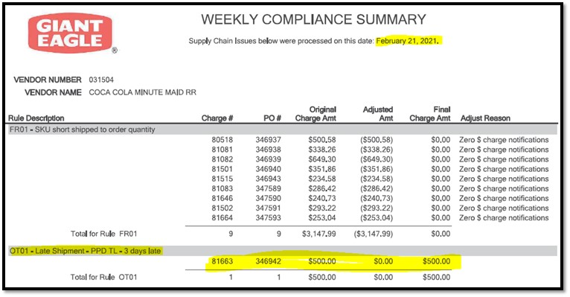
Effective 8/26/24, Giant Eagle has stopped sending AR Settlement Letters to clients.

Other General Info:

Customer Policy is to deduct for OI on Shorted Product – See Policy below. Verify Client SOP or Client SOP Matrix to see if Client allows the allowance.

Giant Eagle has implemented a Non-Compliance Policy wherein they charge a fee for EDI Data Errors, Fill rate and On time deliveries. See policy below:

Customer contacts:

BACKUP RETRIEVAL INFORMATION

GENERAL BACKUP RETRIEVAL INFORMATION

Is GCIT responsible for obtaining backup from the customer? Yes
- If yes, is there a customer portal? No
- If yes, does GCIT request backup? Yes

Is check remittance information required to request backup? Yes, a copy of the check remittance is required.

  - If the client says they did not get a copy, please contact any warehouse AP contacts below to assist with “where are the notifications going” for Invoice Reconciliation. The contacts below can make email distribution updates if needed (the settlement letters can only be send to 1 email address)
Deborah.Younkins@gianteagle.com
Deborah.Gerardi@gianteagle.com
Kris.Calorio@gianteagle.com
Pam.Ratti@gianteagle.com
Nicole.Kerr@gianteagle.com
Vicki.Berdis@Gianteagle.com

CCNA:
- Note the claim: “Need to determine if missing backup is for OK Grocery or Get Go”

GCIT SPECIFIC BACKUP RETRIEVAL INFORMATION

Non-Automated:

Customer Invoice or Note Identifier | Request From
All format | Request backup from Sales
Compliance Backup – invoices with 6 digits followed by OT01 or FR01. | Pull from Traverse
Campbells/Pepperidge Farm | GCIT can request for backup, see attached document for directions/contacts.
CCNA | rscott@acosta.com  The claim must be noted per the instructions above.  If response is that the claim is for OK Grocey or states not for “Get Go”, request backup from Sales.
J.M. Smucker Company | GCIT can request for backup, see attached document for directions/contacts.

CLIENT SPECIFIC VALIDATION INFORMATION
Client
ALVA-AMCO Pharmacal | Lighthouse
Beiersdorf | Mars Foods
Bush | McIlhenny Co
Campbell/Pepperidge Farms | Merisant
Coca Cola | Nestle USA
GoJo | Noosa
Harvest Hill | Sunny D
J.M. Smuckers Company | Sunsweet Growers
Kens | Vogue International

ALVA-AMCO PHARMACAL CO
- Checks will not be issued for OK Grocery, the customer must deduct.

BEIERSDORF, INC.
- Swell allowance is to be stepped as Trade/Other and cleared to event 25GEI007.

BUSH
- This customer receives a swell allowance via Off Invoice. Spoils/unsaleables are considered invalid.

CAMPBELL/PEPPERIDGE FARMS
- Customer reference number needs to be updated to the entire invoice number including the line number.
- PEPPFF CAMPBL claims change the customer # in the claim header to: CUST:1000009098.
- CAMPBL claims, if invoice notes for American Seaway Foods, change the customer # in the header to: CUST:1000009186.
- American Seaway Foods (ASF) has Wednesday - Tuesday AD / TPR Date.
  - American Seaway Foods Invoices will have Wednesday - Tuesday dates.
  - F25 ASF contracts will have Thursday - Wednesday dates but are good to use to clear F25 deductions with a 1 day mismatch. 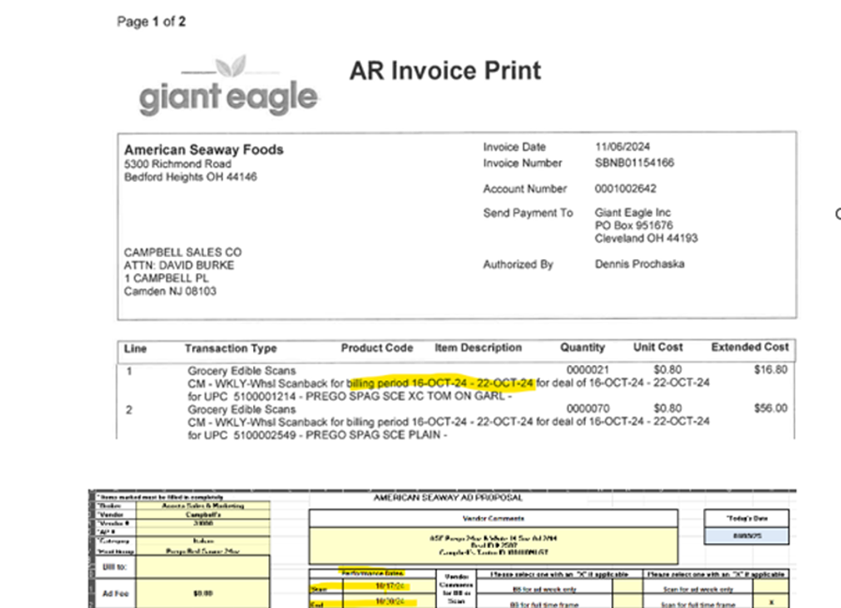

- American Seaway Foods (ASF) F26 Contracts and Invoices will have a 1 day mismatch.
- For Repay deduction updates, send email to Dina Stickel - Dina.Stickel@gianteagle.com, cc: David Burke- David_Burke@campbells.com and Jessica Dick – jdick@acosta.com .

COCA COLA
- Loyalty Card or Buy X Get Y Free invoices require additional invoice breakdown from Sales. After the initial invoice is received the GCC will step the claim as Escalate Cust Inv Invld Data to request the additional detail. The CRA will then request both the detail and event breakdown from Sales. Once the detail is provided the document will be indexed and attached to the claim, this document will be used as the POP and stepped as Customer Invoice Attached. The GCC will continue with validation and split the claim according to the event breakdown provided by sales. The DBW will be created by selecting 1 UPC per Category/PPG (Brand Code) and the rate 1 listed as a lump sum. If not already attached within the VPF the document provided by sales needs to be linked for POP.
- Check remittances are not required when requesting B/U from Sales for CCNA.

Get Go Customer Invoices:
- If the invoice is determined to be for Get Go, the sign on must be change to ZZGETGPI.
  - Note: Tampa handles OKGEPI, Denver handles ZZGETGPI.

- Invoices that are from Digital Media Sales and Attn: Joanna Conn are for DSD.
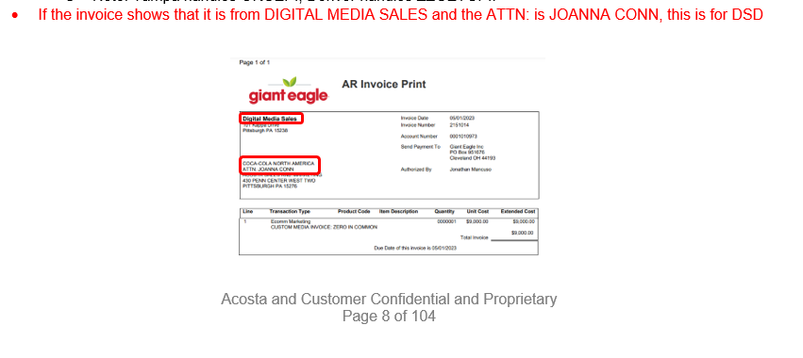

HARVEST HILL
- See below the In-Store Execution Reset Agreement for Harvest Hill.

KENS
- Deductions starting with CC or CI are for coupons, no invoice is needed they will be cleared internally by Kens. Claim should be stepped as Non-Trade Coupons RTC-CCA. Include header note “Coupons Ken’s clears internally”.

J.M. SMUCKERS COMPANY
- Review the check remit for the invoices that make up the deduction amount.
- For process changes and/or unique customer specific information:
- Promotional invoices:
- External ref number: looks something like this - SB0000694780.
- Sometimes the last 3 digits of this ext ref number get cut off in High Radius/in the ext ref number field.
- JMS DRS to go in and manually add the last 3 digits using information in the cash app tab of High Radius.
  - Based on the updated ext reference numbers and back up, JMS DRS may need to split the deduction.
  - JMS DRS does this prior to sending deduction to Acosta.
- Net Settlements:
- GE Netting settlement letters were discontinued on 8/23/24.
- No longer need the net settlement spreadsheet attached – All remit info will be in the AP remit details.
- Invoice Related Deductions:
  - Acosta is receiving invoice related back up via mail: INVOICERECONCILIATION@GIANTEAGLE.COM.
  - Every GE invoice also has cash discount that is not noted on the back up.
  - If each deduction amount is more than the backup or there is no back up/ this is typically cash discount.
      - Please code as Action Code – RRV, Reason Code: Cash discount.
      - JMS DRS will have to research to determine if earned or unearned.
  - If the back up has a shortage, or a missing promo, and will have cash discount, code Actions Code - RSP because JMS DRS will have to split.
      - Please remember JMS DRS has to split first before Acosta can resolve – otherwise Acosta will have to re resolve after the split.

LITEHOUSE
- OK Grocery/Giant Eagle is deduct only fro Litehouse. No check requests should be process for this customer.

MARS FOODS
- This customer is on the approved Retail Merchandising Program list for Mars Foods US LLC.

MCILHENNY CO
- McIlhenny offers OK Grocery Co Giant Eagle a swell allowance of 1.39%.

MERISANT
- All "SB" lines on the check remit for the same SB # less the last 3 digits, will be lumped into a single deduction by the client.
- There is no under tolerance level for this customer
- The DBW needs to mirror the customer invoice and the claim needs to be split to match the DBW.

NESTLE USA
- Contracts for scans with deal type: EDLP/EDLC, do not require POP.
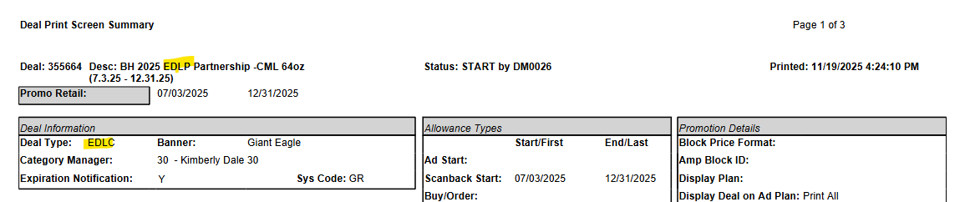

NOOSA
- Client has approved a note from the BM is ok to validate claims if an ad is not available.

SUNNY D
- Retail Merchandising claim:
  - GCC needs to escalate to CRA to request approval from Regional.

SUNSWEET GROWERS
- Invoices for all dried fruit (Sunsweet) are not handled by Acosta, to be stepped as Unknown/Not Acosta.

VOGUE INTERNATIONAL
- This customer receives a swell allowance.

PROCESS STEPS

      - Deduction Type: Off Invoice (OI)
A per case off invoice allowance (OI) is given to the customer as an automatic discount for product purchased from the client. If the customer does not receive the allowance off the face of the invoice they will deduct for it. If the customer requested an allowance that is not valid, the CSC will send a notification to the customer in writing. Customers view purchase orders as contracts. If they are not notified of allowance discrepancies, they will pay according to their purchase order total.

  - Customer Invoice for Off Invoice (OI), Example 1: If not provided under View Document, this can be found via Search For: Backup Documentation, Doc Type 2-Customer Invoice.
i
P.O.: The PO number needs to be validated with the client order invoice to see if the particular product was ordered and invoiced with the OI allowance. Note: The PO number may have leading zeroes not shown on this document.

INV: This is the customer reference number. This is also the client order invoice number used to find the invoice via an Orders/Inv/PO search.
Note: The invoice number may show leading zeroes that are not included in the customer reference number on the claim.
4

Order Date: This is the date the order was placed and is helpful in searching for the contract.

5

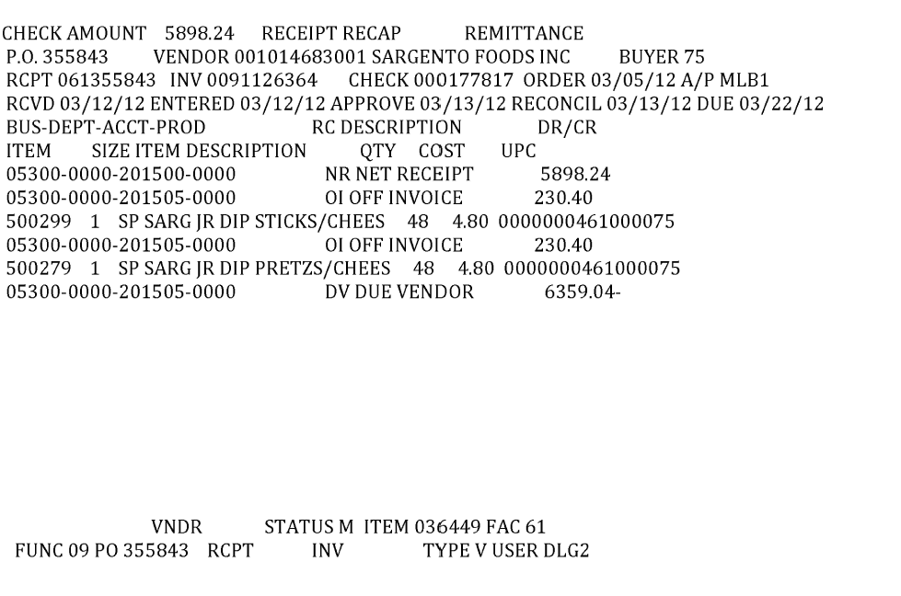
Item: This is the customer’s item code. It is used to find the UPC in the contract and validate key data elements regarding the customer invoice and client order invoice on the Review Order/view documents link within Acosta Relay. This is the product for which the customer is stating that an OI allowance was not given.
Note: If necessary, use the APL or contract to get the case UPC, and then match that to the client order invoice.

21
OI Rate: This is the rate per case deducted for the off invoice. The rate has to match the contract OI rate to validate a claim.
Note: If the client order invoice shows a $4.80 OI for UPC 00751, the claim is invalid.

This represents the case UPC, but in this example they have failed to include the last digit of the case UPC. The case UPC is 00751. See the customer code number on the left and match that up to the case UPC on the contract.

1
Case Quantity: The case quantity must match with the client order invoice for a valid claim.

31
This indicates that this is for an off invoice allowance that was not given on the client order invoice.

i
1

1.1 Customer Invoice for Off Invoice (OI), Example 2: If not provided under View Document, this can be found via Search For: Backup Documentation, Doc Type 2-Customer Invoice.
1
P.O.: The PO number needs to be validated with the client order invoice to see if the particular product was ordered and invoiced with the OI allowance. Note: The PO number may have leading zeroes not shown on this document.

Item: This is the customer’s item code. It is used to find the UPC in the contract and validate key data elements regarding the customer invoice and client order invoice on the Review Order/view documents link within Acosta Relay. This is the product for which the customer is stating that an OI allowance was not given.
Note: If necessary, use the APL or contract to get the case UPC, and then match that to the client order invoice.

4
i
INV: This is the customer reference number. This is also the client order invoice number used to find the invoice via an Orders/Inv/PO search.
Note: The invoice number may show leading zeroes that are not included in the customer reference number on the claim.

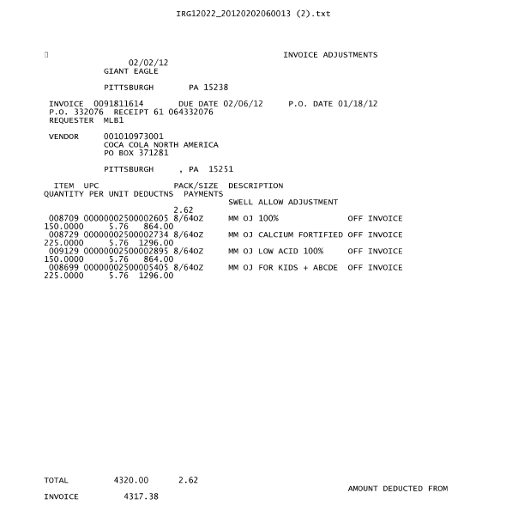
21
1
Product: This is case UPC. It must match the contract and client order invoice.
OI Rate: This is the rate per case deducted for the off invoice. The rate has to match the contract OI rate for a valid claim.
Note: If the client order invoice shows a $5.76 OI for UPC 02605, the claim is invalid.

i
Off Invoice: This indicates that this portion of the claim is for an off invoice not given allowance.

Case Quantity: The case quantity must match with the client order invoice for a valid claim.

3

  - Customer Contract for Off Invoice, Example 1: Found via Search For: Promotions. For OK Grocery and Giant Eagle contracts, use sign-on OKGEPI. For American Seaway contracts, use sign-on ZZAMERPI.

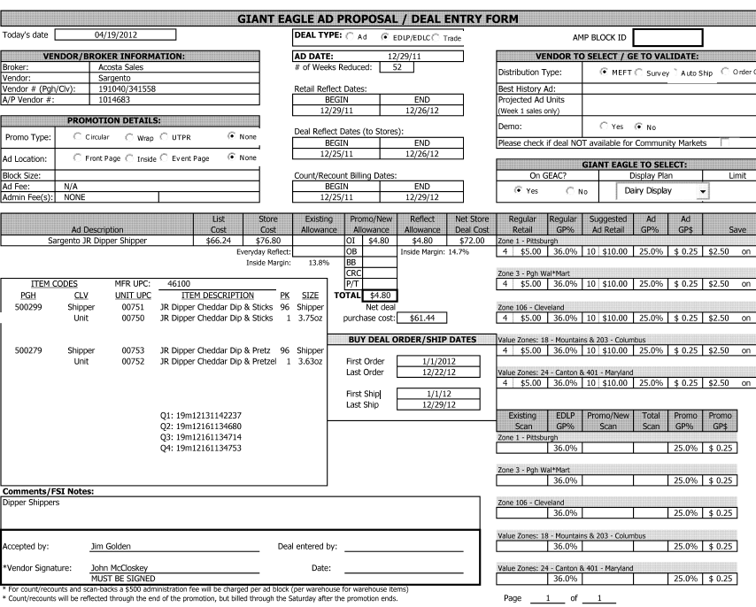
5
2
Item Codes and Unit UPC: The Item Codes are the customer’s internal codes for the UPCs listed. The Unit UPCs are the shipper/case and unit/package UPCs for the items the customer is being offered an OI on. Since the customer invoice drops the last digit of the UPC, use the customer code number to identify the UPC. The item referenced on the customer invoice, contract and client order invoice must match.
1
Promo/New Allowance: This is the OI allowance being offered to the customer. Compare to the customer invoice and the client order invoice. The amount shown must match the customer invoice amount. If the amount is shown on the client order invoice, the claim is invalid.
Buy Deal Order/Ship Dates: This is the date range for the promotion. The customer’s purchase order date must fall within these dates for a valid claim. The client order invoice date must also fall within these dates for a valid claim.
i
Retail Reflect Dates, Deal Reflect Dates and Count/Recount Billing Dates: These dates are related to other types of deductions and should not be considered for OI claims.

1.2 Customer Contract for Off Invoice, Example 2: Found via Search For: Promotions. For OK Grocery and Giant Eagle contracts, use sign-on OKGEPI. For American Seaway contracts, use sign-on ZZAMERPI.
5
Performance Dates: This is the date range for the promotion. The customer’s purchase order date must fall within these dates for a valid claim. The client order invoice date must also fall within these dates for a valid claim.

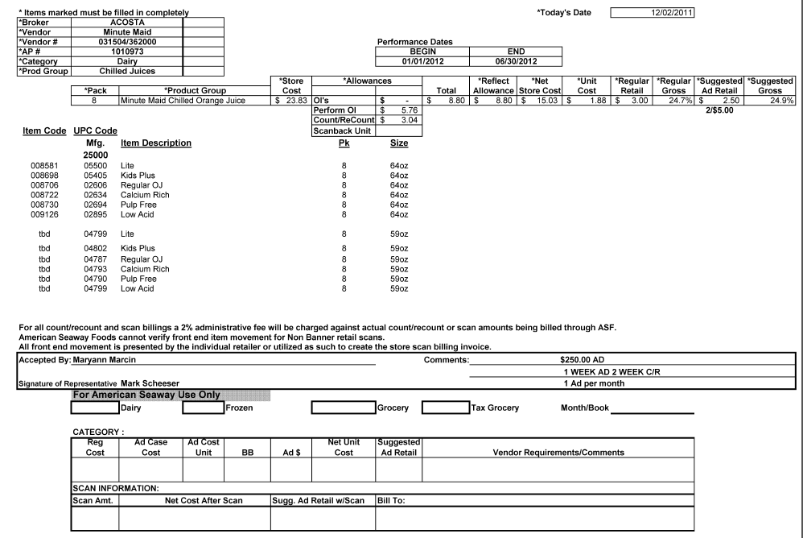
2
Item Codes, UPC Code and Item Description: The Item Codes are the customer’s internal codes for the Pucks listed. The UPC Codes are the case UPCs for the items the customer is being offered an OI on. If necessary, use the customer code number on the customer invoice to identify the UPC. The item referenced on the customer invoice, contract and client order invoice must match.
1
Allowances: This is the OI allowance being offered to the customer. Compare to the customer invoice and the client order invoice. The amount shown must match the customer invoice amount. If the amount is shown on the client order invoice, the claim is invalid.
2. Deduction Type: SCAN
An allowance for products scanned at the store through the register and are usually billed in eaches, not cases. The customer should not be referencing a purchase order on a scan allowance.

  - Customer Invoice for Scan, Example 1: If not provided under View Document, this can be found via Search For: Backup Documentation, Doc Type 2-Customer Invoice.
Line: The last 3 numbers on the claim customer reference # will be the line on that invoice.
(Ex SB0000127945001 – Is on invoice SB0000127945 line 1)
i
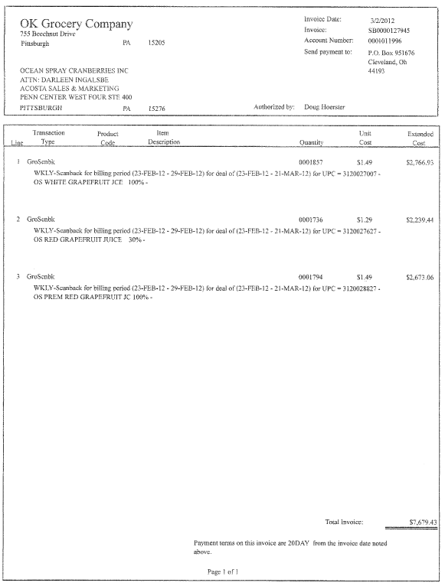
i
i
Invoice: This will match the beginning portion of the customer reference number on the claim. Remove the last 3 numbers in the customer reference field when searching for invoice. (Ex SB0000127945001 – search SB0000127945)
The description may say “EDLP Scanback”, “Seasonal Scanback”, etc. Regardless of verbiage, all scan claims are processed the same.
4
Product Code: This is the UPC that the customer is claiming a scan allowance on. This code must match the contract and sales analysis report.
E.g. In this case, the UPC is the last 5 digits shown: 3120027007.
Quantity: This indicates the units they are billing for the scan allowance. This quantity needs to be converted to case quantity to verify purchases shown on the sales analysis report.
1
2
Scan Rate - This indicates the cost per unit for the scan allowance. Match this to the contract.
3
Dates: These dates indicate the dates they are billing for the scan allowance. These dates must fall within the contract dates.

Note: Each line item of the OK Grocery customer invoice will be a separate claim in Acosta Relay. The claim will have the line number listed after the customer reference number. For example, the customer reference number on the claim will be SB0000127945001, SB0000127945002, and so on for the line items on the customer invoice.

2.1 Customer Invoice for Scan, Example 2: If not provided under View Document, this can be found via Search For: Backup Documentation, Doc Type 2-Customer Invoice.

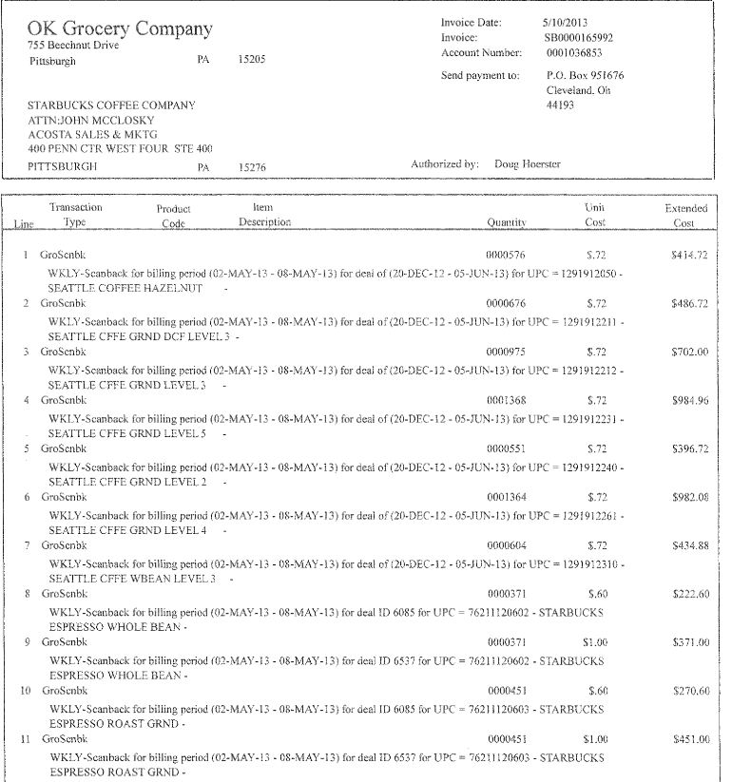
2
3
1
Product Code: This is the UPC that the customer is claiming a scan allowance on. This code must match the contract and sales analysis report.
E.g. In this case, the UPC is the last 5 digits shown: 76211120603
Quantity: This indicates the units they are billing for the scan allowance. This quantity needs to be converted to case quantity to verify purchases shown on the sales analysis report.
Dates: These dates indicate the dates they are billing for the scan allowance. These dates must fall within the contract dates.
4
Deal # – This is the contract number if provided this number must match the deal # listed on contract.

i
i
Line: The last 3 numbers on the claim customer reference # will be the line on that invoice.
(Ex SB0000165992011 – Is on invoice SB0000165992 line 11)
Invoice: This will match the beginning portion of the customer reference number on the claim. Remove the last 3 numbers in the customer reference field when searching for invoice. (Ex SB0000165992011 – search SB0000165992)
Scan Rate - This indicates the cost per unit for the scan allowance. Match this to the contract.
i

2.1 Customer Invoice for Scan, Example 3: If not provided under View Document, this can be found via Search For: Backup Documentation, Doc Type 2-Customer Invoice.

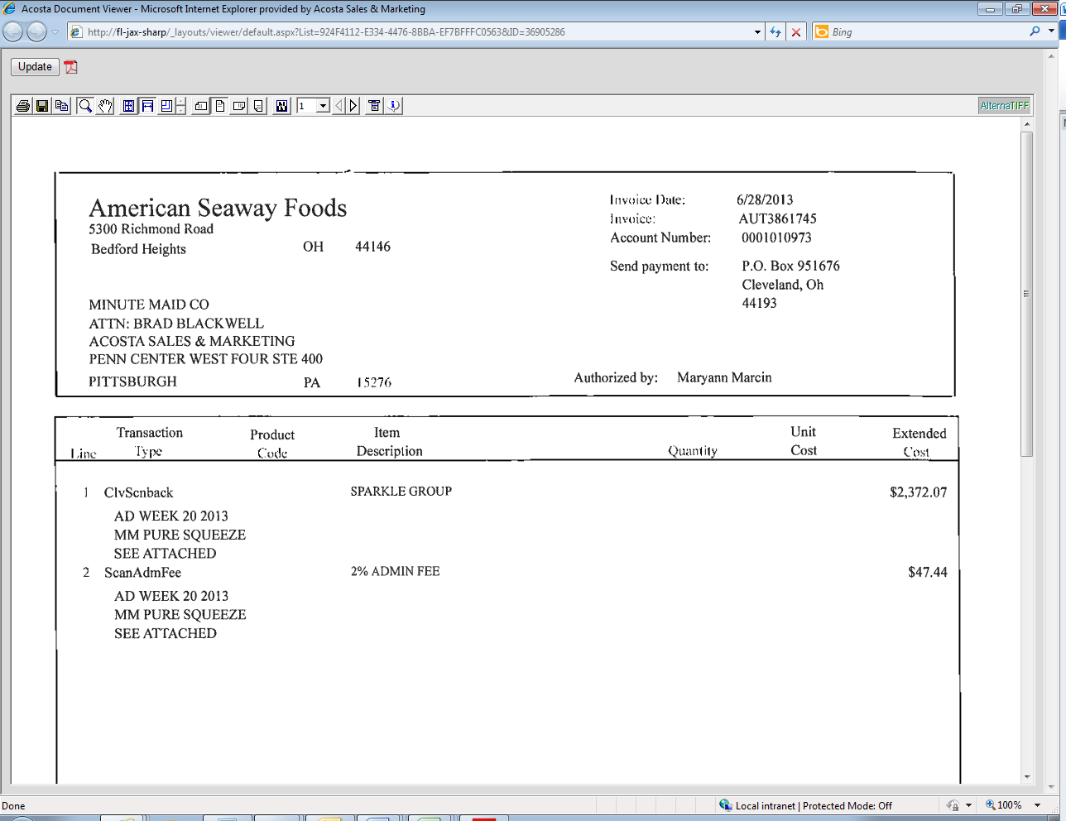
TOTAL INVOICE: This is the amount they are deducting for the Count/Recount.
Sparkle Group indicates this is for Sparkle a division of OK Grocery. Contract may reference American Seaway. Found under customer signon ZZAMERPI.
i
3
i
Line: The last 3 numbers on the claim customer reference # will be the line on that invoice.
(Ex AUT3861745001 – Is on invoice AUT3861745 line 1)
i
Invoice: This will match the beginning portion of the customer reference number on the claim. Remove the last 3 numbers in the customer reference field when searching for invoice. (Ex AUT3861745001 – search AUT3861745)

**Split Image**
Dates: These dates indicate the dates they are billing for the scan allowance. These dates must fall within the contract dates.
4
Page 2
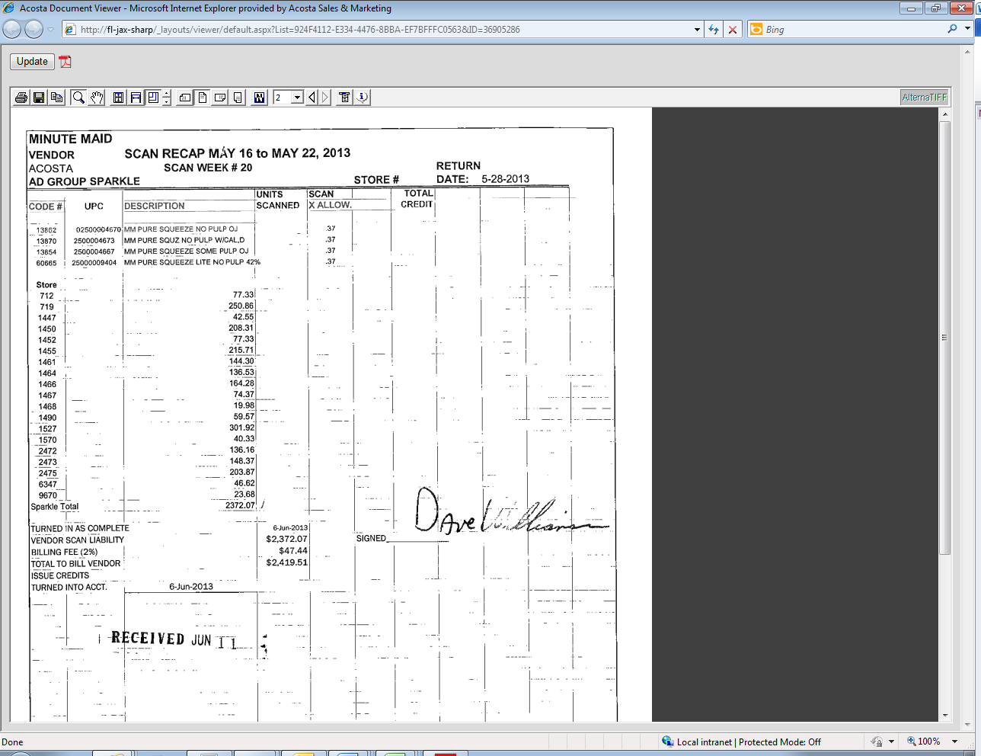
Quantity Subtotal – The quantity is not listed by item, instead provides total amount by each store. This would be entered on to the DBW as the subtotal divided by the scan rate to find the quantity.
Product Code: This is the UPC that the customer is claiming a scan allowance on. This code must match the contract and sales analysis report.
E.g. In this case, the UPC is the last 5 digits shown: 2500004670. If all items are part of the same PPG then use one UPC for the UPC input on the DBW.
3
1
2
Scan Rate - This indicates the cost per unit for the scan allowance. Match this to the contract.

Note: If the Client clears by UPC/or if the invoice provides more than one category for the same rate then this claim would need to escalated to Sales to provide a percentage breakdown per category.

If the invoice provides more than one category but each category has different rates then use the total per store divided by each scan rate to determine the quantity. (This invoice is just an example for multiple rates but is not used in the remainder of this example for validation).

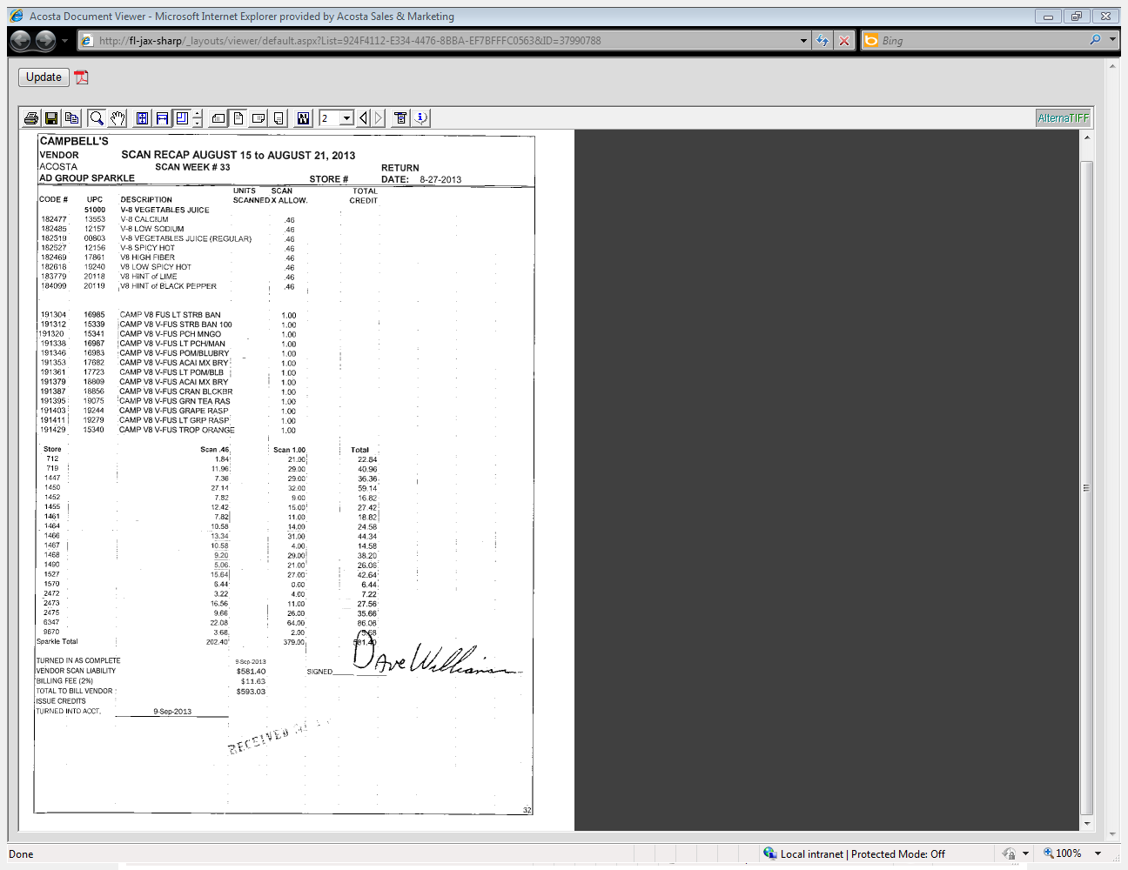
1
Quantity (Subtotal divided by rate)– The quantity is not listed by item, instead breakdown provides total amount by each store. This would be entered on to the DBW as the subtotal divided by the scan rate to find the quantity. In this example store 712 4 @ $.46 = $1.84 & 21 @ $1.00 =$21.00 Store 712 total $1.84 + $21.00 = $22.84
Product Code: This is the UPC that the customer is claiming a scan allowance on. If all items are part of the same PPG then use one UPC for the UPC input on the DBW.
3
2
Scan Rate - This indicates the cost per unit for the scan allowance. Match this to the contract.

2.1 Customer Contract for Scan, Example 1: Found via Search For: Promotions.

4
Begin and End Dates: This is the time period during which the customer can claim the scan allowance.
Scan/Unit* - This is the scan allowance being offered per unit. This must match the customer invoice.
1
Item Codes, UPC Code and Item Description: The Item Codes are the customer’s internal codes for the UPCs listed. The UPC Codes are the case UPCs for the items the customer is being offered a scan on. If necessary, use the customer code number on the customer invoice to identify the UPC. The item referenced on the customer invoice, contract and POP must match.
2

Note:For a scan if the Ad date and Retail reflection date are the same and no money was offered for an Ad fee than no Ad is required as part of POP (see example 3).

  - Customer Contract for Scan, Example 2: Found via Search For: Promotions.

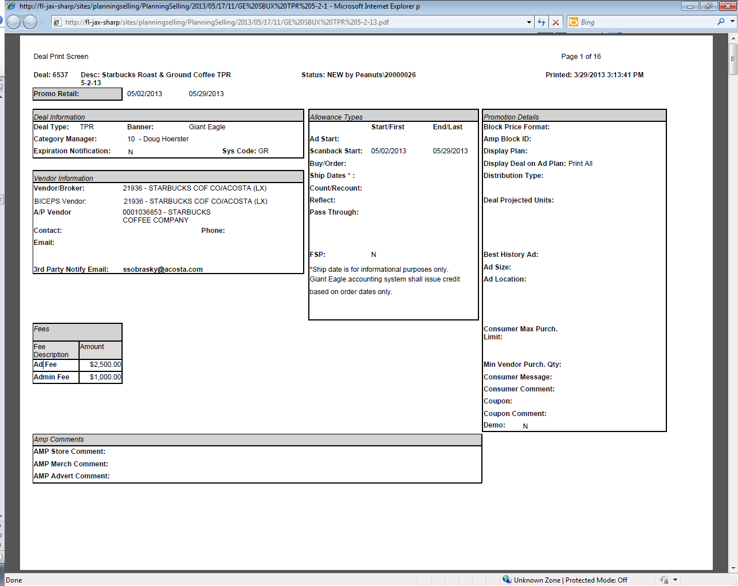
4
Begin and End Dates: This is the time period during which the customer can claim the scan allowance.
i
Deal # – This is the contract number if provided on the invoice must match the contract.
i
**Split Image**
Item Summary – This is the listing of all UPC’s that are part of this contract

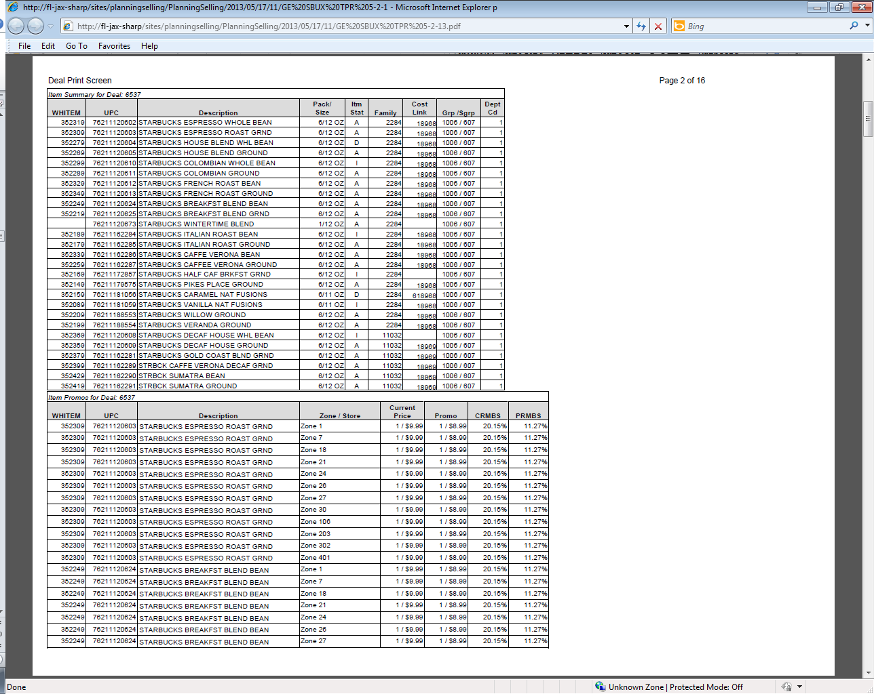
1
Item Codes, UPC Code and Item Description: The Item Codes are the customer’s internal codes for the UPCs listed. The UPC Codes are the case UPCs for the items the customer is being offered a scan on. If necessary, use the customer code number on the customer invoice to identify the UPC. The item referenced on the customer invoice, contract and POP must match.

**Split Image**
Item Scans – This is the listing of allowances by UPC’s that are part of this contract
i
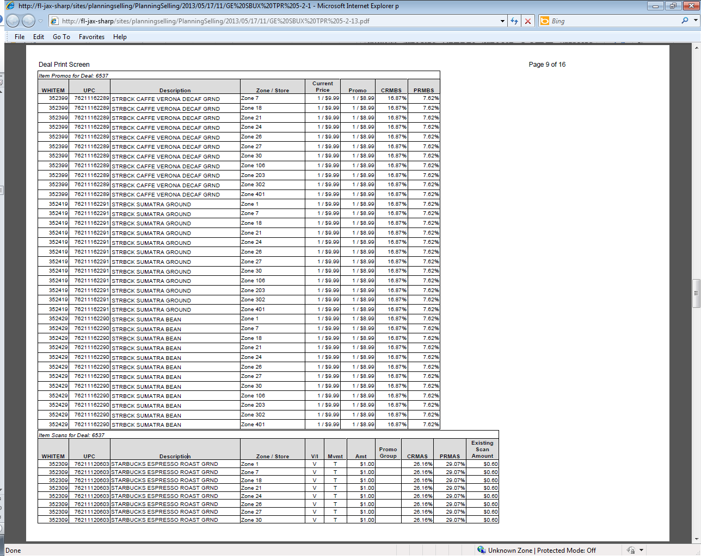
Scan/Unit* - This is the scan allowance being offered per unit. This must match the customer invoice.
2
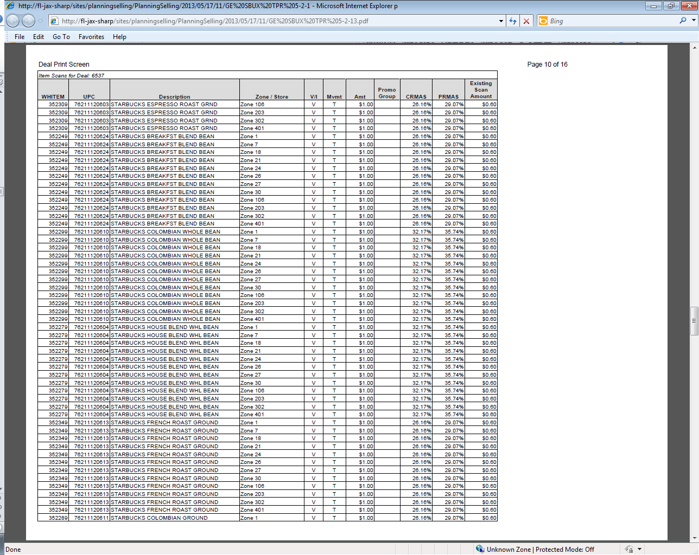
1
Item Codes, UPC Code and Item Description: The Item Codes are the customer’s internal codes for the UPCs listed. The UPC Codes are the case UPCs for the items the customer is being offered a scan on. If necessary, use the customer code number on the customer invoice to identify the UPC. The item referenced on the customer invoice, contract and POP must match.

2.2 Customer Contract for Scan, Example 3: Found via Search For: Promotions.
i
Deal # – This is the contract number if provided this number must match the deal # listed on contract.

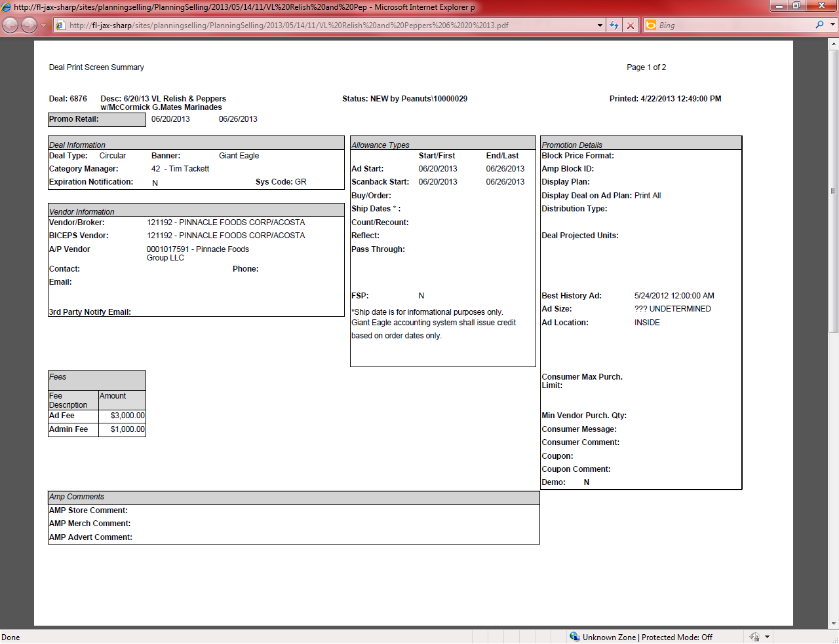
4
Begin and End Dates: This is the time period during which the customer can claim the scan allowance.
**Split Image**
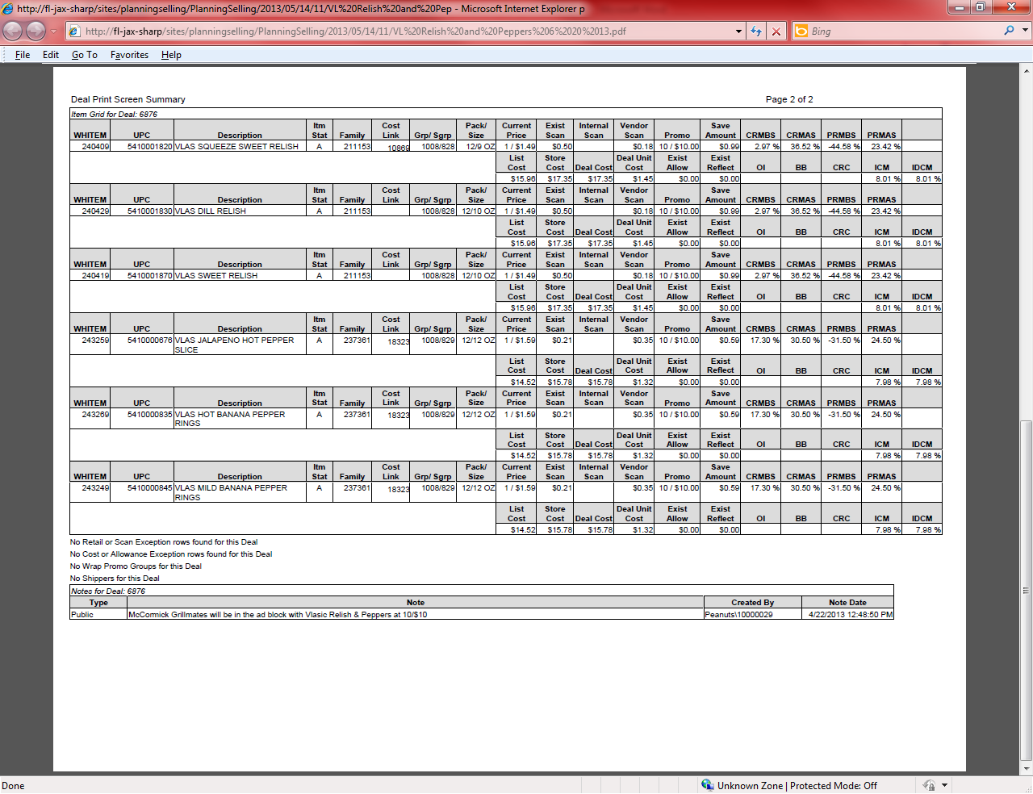
Scan/Unit* - This is the scan allowance being offered per unit. This must match the customer invoice.
2
Item Codes, UPC Code and Item Description: The Item Codes are the customer’s internal codes for the UPCs listed. The UPC Codes are the case UPCs for the items the customer is being offered a scan on. If necessary, use the customer code number on the customer invoice to identify the UPC. The item referenced on the customer invoice, contract and POP must match.
1

2.2 Customer Contract for Scan, Example 4: Found via Search For: Promotions.
1
2
Scan/Unit* - This is the scan allowance being offered per unit. This must match the customer invoice.
Item Codes, UPC Code and Item Description: The Item Codes are the customer’s internal codes for the UPCs listed. The UPC Codes are the case UPCs for the items the customer is being offered a scan on. If necessary, use the customer code number on the customer invoice to identify the UPC. The item referenced on the customer invoice, contract and POP must match.
4
Begin and End Dates: This is the time period during which the customer can claim the scan allowance.

Note:For a scan if the Ad date and Retail reflection date are the same and no money was offered for an Ad fee than no Ad is required as part of POP.

2.2 Contract for American Seaway Foods Scan, Example 5: Found via Search For Promotions by searching ZZAMERPI for American Seaway.
4
2
Scan/Unit* - This is the scan allowance being offered per unit. This must match the customer invoice.
1
Item Codes, UPC Code and Item Description: The Item Codes are the customer’s internal codes for the UPCs listed. The UPC Codes are the case UPCs for the items the customer is being offered a scan on. If necessary, use the customer code number on the customer invoice to identify the UPC. The item referenced on the customer invoice, contract and POP must match.
Begin and End Dates: This is the time period during which the customer can claim the scan allowance.

2.3 Refer to the SOPs/Generic Help File for POP requirements.

3. Deduction Type: Ad
A fee for featuring a client's products in an advertisement.

Note: In September 2015 Giant Eagle/OK Grocery made a policy changes for ads. If the invoice and contract indicate the promotion is for a circular but the item cannot be located in an ad, check the contract comments to see if a display is mentioned. If mentioned the contract is being offered as a display instead of a Ad. If the comments do not mention a display it must be verified thru Sales to confirm the offer is for a display.

  - Customer Invoice for Ad, Example 1: If not provided under View Document, this can be found via Search For: Backup Documentation, Doc Type 2-Customer Invoice.

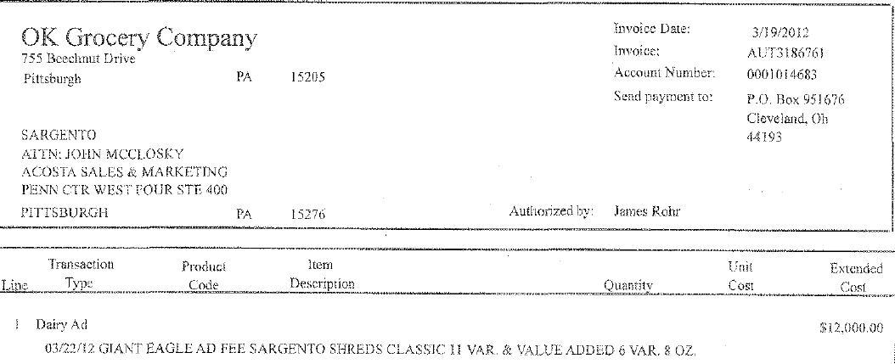
Line: The last 3 numbers on the claim customer reference # will be the line on that invoice. (Ex AUT3186761001– Is on invoice AUT3186761 line 1)

i
Invoice: This will match the beginning portion of the customer reference number on the claim. Remove the last 3 numbers in the customer reference field when searching for invoice. (Ex AUT3186761001 – search AUT3186761)

i
2

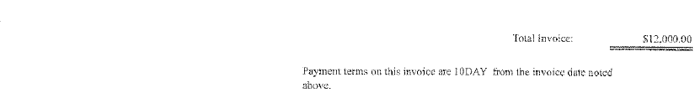
33
TOTAL INVOICE: This is the amount they are deducting for the ad. This must match the contract.

Transaction Type: This indicates that the customer is deducting for an ad that ran on 3/22/2012. This needs to match the contract and proof of performance.

1
Product Code / Item Description – This is the product /product group in the customer ad. In this example it is Giant Eagle ad for Sargento Shreds 6 & 8 oz varieties. This needs to match the contract and POP. Note: They do not provide a UPC number for reference.

3.1 Customer Invoice for Ad, Example 2: If not provided under View Document, this can be found via Search For: Backup Documentation, Doc Type 2-Customer Invoice.

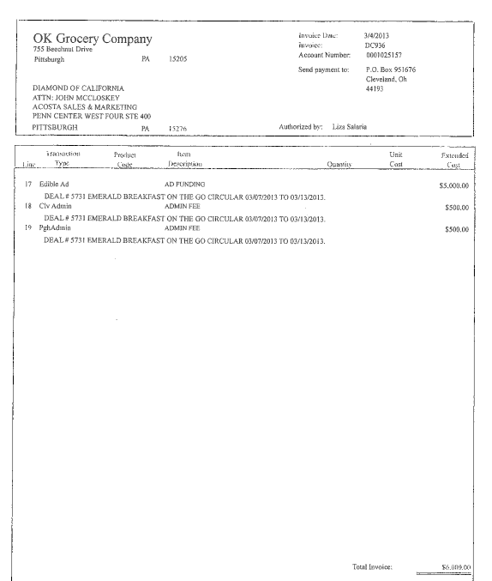
Ad Fee: This is the amount being offered to the customer for running the ad. This amount must match the customer invoice.
3
i
Invoice: This will match the beginning portion of the customer reference number on the claim. Remove the last 3 numbers in the customer reference field when searching for invoice. (Ex DC936017 – search DC936)
2
Transaction type: Circular indicates that the customer is deducting for a print ad that ran on 3/7/2013 to 3/13/2013. This needs to match the contract and proof of performance.

i
Line: The last 3 numbers on the claim customer reference # will be the line on that invoice that claim is for.
(Ex DC936018 invoice DC936 line 17)

3.1 Customer Invoice for American Seaway Foods ad, Example 3: If not provided under View Document, this can be found via Search For: Backup Documentation, Doc Type 2-Customer Invoice.

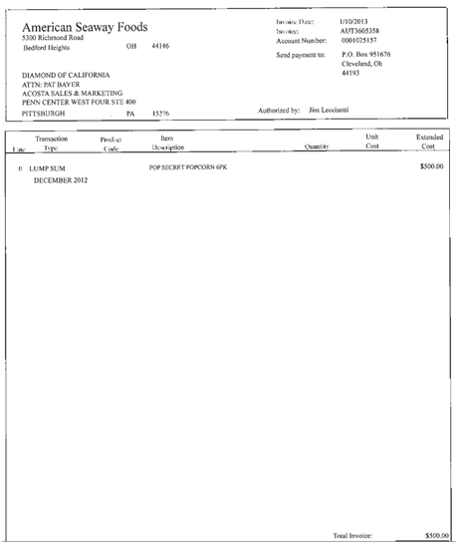
i
Invoice: This will match the beginning portion of the customer reference number on the claim. Remove the last 3 numbers in the customer reference field when searching for invoice. (Ex AUT3605358001 – search AUT3605358)

2
Transaction Type: This indicates that the customer is deducting a lump sum amount for an ad that ran December 2012. This needs to match the contract and proof of performance.

1
Product Code / Item Description – This is the product /product group in the customer ad. In this example it is an American Seaway Foods ad for Pop Secret Popcorn. This needs to match the contract and POP. Note: They do not provide a UPC number for reference.

  - Customer Invoice for Ad, Example 4: If not provided under View Document, this can be found via Search For: Backup Documentation, Doc Type 2-Customer Invoice.

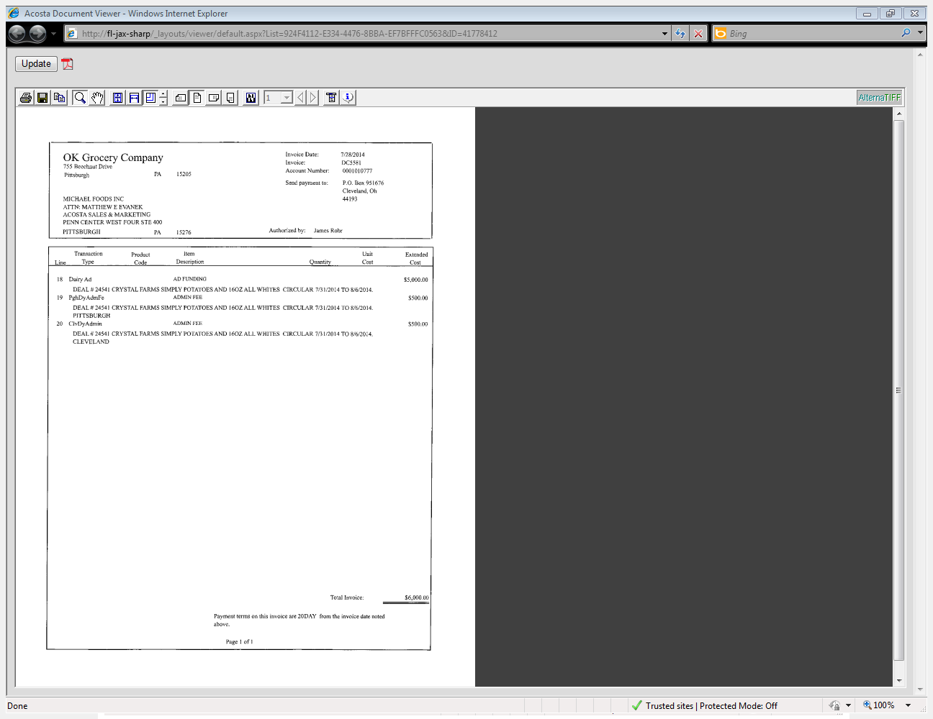
2
Dates: These dates indicate the dates they are billing for the AD allowance. These dates must fall within the contract dates.
i
Identification - This identifies the claim as AD lump sum.
i
Deal # – This is the contract number if provided this number must match the deal # listed on contract.

Product Code / Item Description – This is the product /product group in the customer ad.
1
33
LUMP SUM AMOUNT: This is the amount they are deducting for the ad. This must match the contract.

3.1 Customer Invoice for Ad, Example 5: If not provided under View Document, this can be found via Search For: Backup Documentation, Doc Type 2-Customer Invoice.

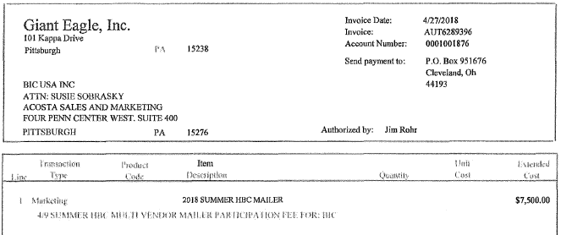
i
Line: The last 3 numbers on the claim customer reference # will be the line on that invoice. (Ex AUT6289396001– Is on invoice AUT6289396 line 1)

2
Transaction Type: This indicates that the customer is deducting for an ad that ran on 4/9/2018. This needs to match the contract and proof of performance.

Invoice: This will match the beginning portion of the customer reference number on the claim. Remove the last 3 numbers in the customer reference field when searching for invoice. (Ex AUT6289396001 – search AUT6289396)

i
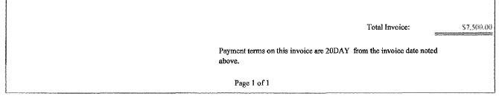
1
33
TOTAL INVOICE: This is the amount they are deducting for the ad. This must match the contract.

Product Code / Item Description – This is the product /product group in the customer ad. In this example it is Giant Eagle Mailer for Bic. This needs to match the contract and POP. Note: They do not provide a UPC number for reference.

  - Customer Contract for Ad, Example 1: Found via Search For: Promotions.

i
Deal Type: This indicates that the contract is for an ad.

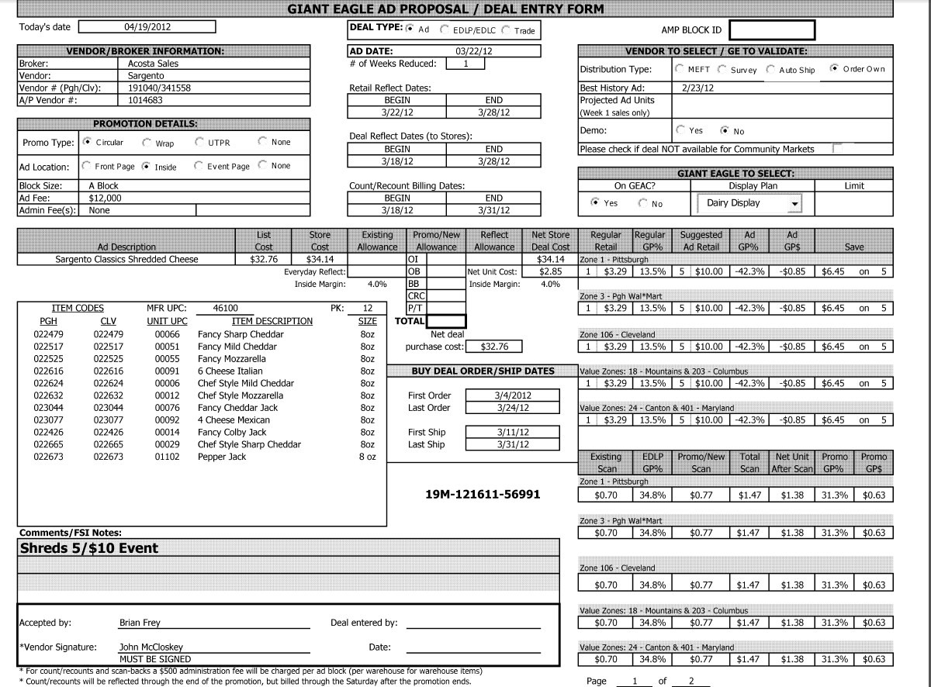
Ad Date: This is the date requested for the ad to be run. This must match the date on the customer invoice and on the ad.
Product: This area lists the items that are to be featured in the ad. Since the customer invoice does not provide UPC numbers, use the product description and pack/size to match to the customer invoice and the ad.

Comments/FSI Notes: This area indicates the suggested retail price for the ad product.
i
Ad Fee: This is the amount being offered to the customer for running the ad. This amount must match the customer invoice.
3
2
1

  - Customer Contract for Ad, Example 2: Found via Search For: Promotions.
2
Ad Date: This is the date requested for the ad to be run. This must match the date on the customer invoice and on the ad.
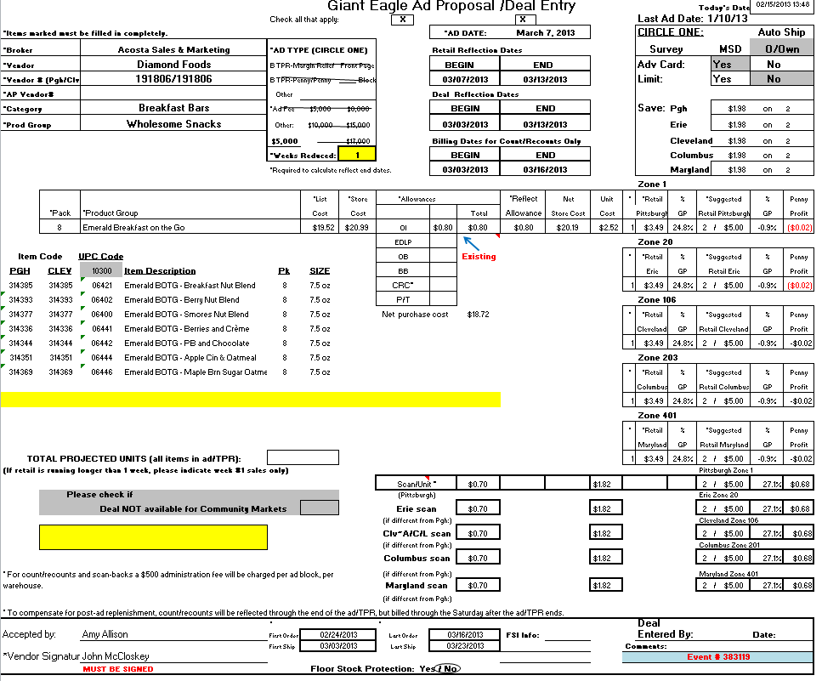
3
1
Product: This area lists the items that are to be featured in the ad. Since the customer invoice does not provide UPC numbers, use the product description and pack/size to match to the customer invoice and the ad.

Ad Fee: This is the amount being offered to the customer for running the ad. This amount must match the customer invoice.

3.2 Contract for American Seaway Foods ad, Example 3: Found via Search For Promotions by searching ZZAMERPI for American Seaway.

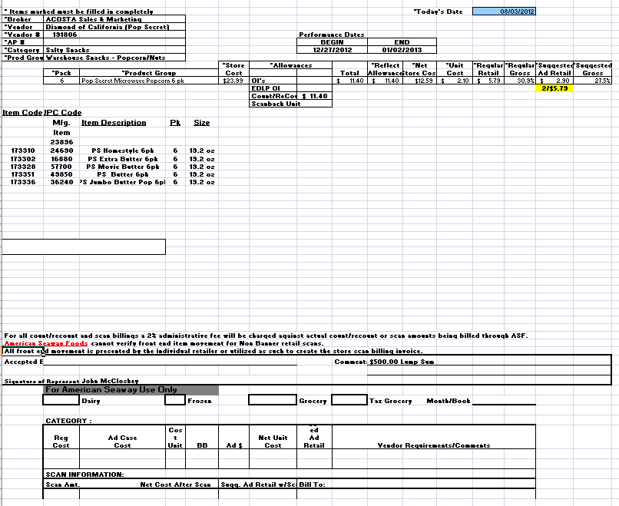
2
3
Comment: This is amount being offered to the customer for the ad. This must match the customer invoice.
Performance Dates: The customer ad has to run during the dates specified. This must match the ad date shown on the customer invoice and the date shown on the ad copy.
1
Product Code / Item Description – This is the product /product group in the customer ad. In this example it is an American Seaway Foods ad for Pop Secret Popcorn. This needs to match the contract and POP. Note: They do not provide a UPC number for reference.

3.2 Customer Contract for Ad, Example 4: Found via Search For: Promotions.
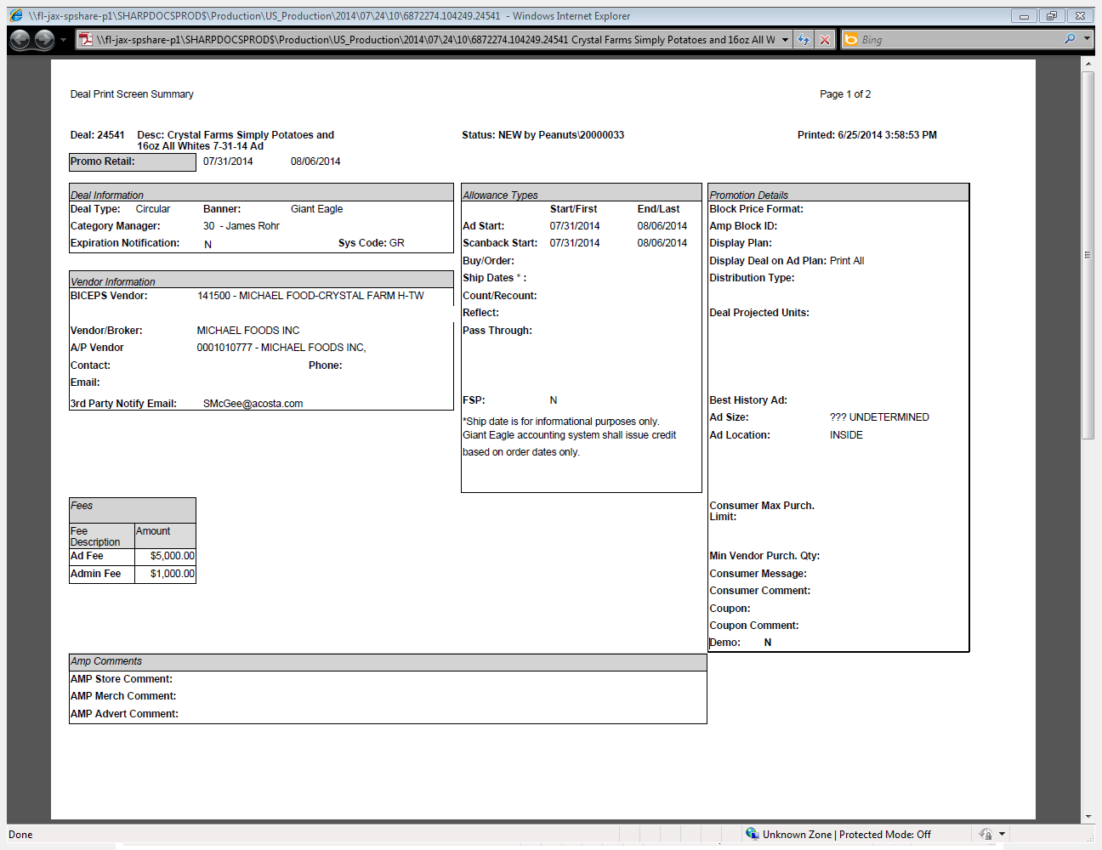
2
Dates: These dates indicate the dates they are billing for the AD allowance. These dates must fall within the contract dates.
33
LUMP SUM AMOUNT: This is the amount they are deducting for the ad. This must match the contract.

i
Identification - This identifies the claim as AD.
i
Deal # – This is the contract number if provided on the invoice must match the contract.
Product Code / Item Description – This is the product /product group in the customer ad.
1
**split image**
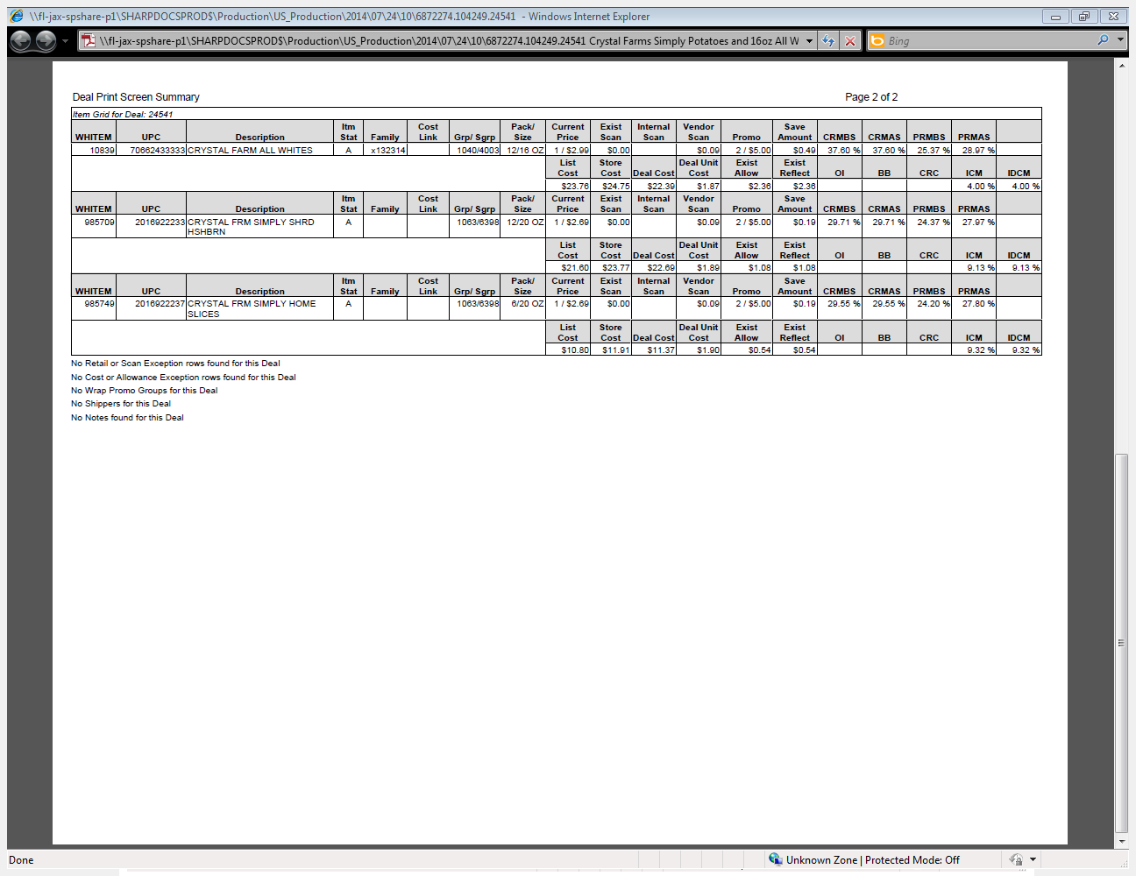

3.2 Customer Contract for Ad, Example 5: Found via Search For: Promotions.

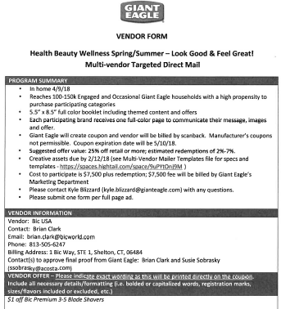
33
LUMP SUM AMOUNT: This is the amount they are deducting for the ad.

Dates: This date indicate the date they are billing for the AD allowance.
2
1
Product Code / Item Description – This is the product /product group in the customer ad.
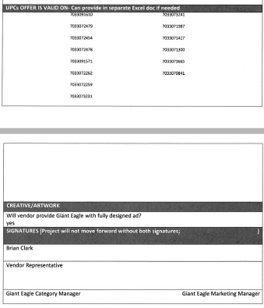

3.3 Proof of Performance for Ad: Found via Feature Vision.

Proof of Performance for Ad: American Seaway. Found via Search For: Back-up Documentation. Use ADCLIENT/ADCUST, Document Type 6, and put %SPARKLE or %ZATSICK in the Customer Ref # field.
4. Deduction Type: Pricing
A pricing deduction occurs when the customer's requested price on the original purchase order differs from the client's invoice.

Documents required for validating a pricing claim:

Document Name | Source of the Document | Action by Accenture
Customer Invoice | Acosta Relay – search for the invoice under Backup Documentation, document type 2. | Step up the claim to Acosta for research
Client Order Invoice | Acosta Relay – search for this document within the Order/Invoice/PO search.

4.1 Customer invoice for Pricing: If not provided under View Document, this can be found via Search For: Backup Documentation, Doc Type 2-Customer Invoice.

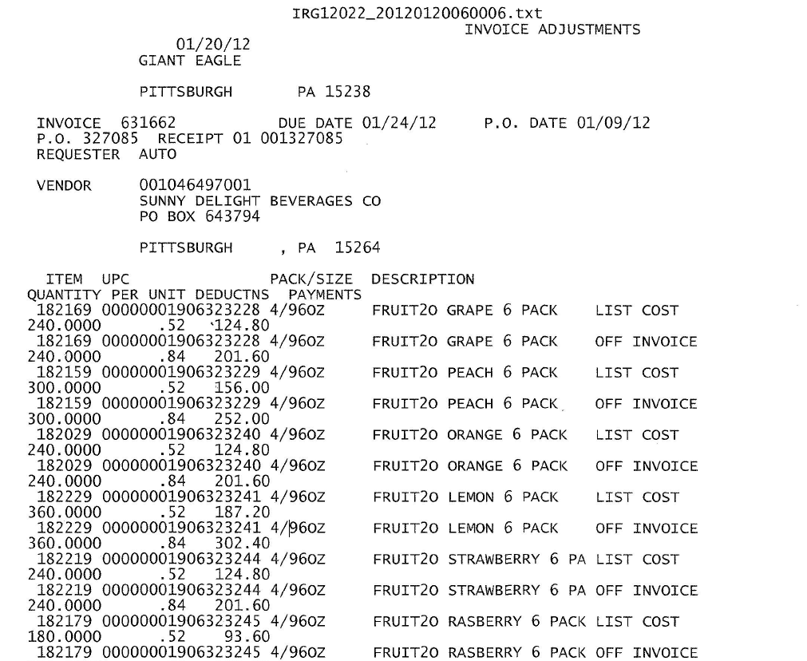
Invoice/P.O.: This is the client order invoice number and the customer’s purchase order number. These can be used to find the order record and invoice via an Orders/Inv/PO search.

i
i
This area will indicate “LIST COST” when they are deducting for pricing.

5. Deduction Type: Slotting

A slotting allowance is offered to the customer to purchase an item not currently stocked. A slotting lump sum allowance can be offered for each item and/or an off invoice can be offered as an introductory allowance for the first 30 days.

5.1 Customer Invoice for Slotting, Example 1: If not provided under View Document, this can be found via Search For: Backup Documentation, Doc Type 2-Customer Invoice.
Invoice: This will match the beginning portion of the customer reference number on the claim. Remove the last 3 numbers in the customer reference field when searching for invoice. (Ex AUT2858708002 – search AUT2858708)

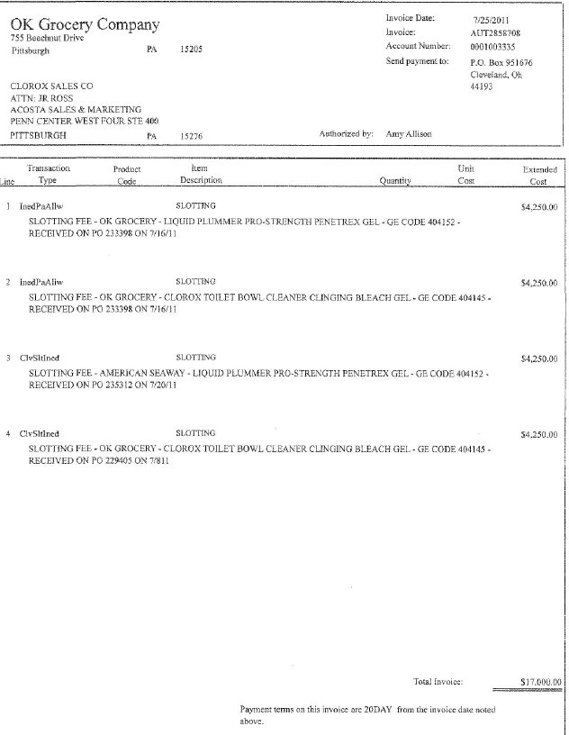
i
Line: The last 3 numbers on the claim customer reference # will be the line on that invoice. (Ex AUT2858708002– is on invoice AUT2858708 line 2)

This indicates that the customer invoice is for slotting.

2
Extended Cost: This is the slotting amount the customer is claiming, listed by item.
NOTE: The contract offers $8500 in slotting for customer code 404145. That item is listed twice @ $4250 each, for a total claim of $8500.00

1
This is the Giant Eagle code number for the item they are claiming slotting on. They do not list a UPC when billing for slotting. Use the contract or the APL to cross-reference the customer code to the UPC.

i
This is the customer purchase order number on which the customer ordered the new product for the first time.

i
i

5.1 Customer Invoice for Slotting, Example 2: If not provided under View Document, this can be found via Search For: Backup Documentation, Doc Type 2-Customer Invoice.
1
Description: This is the product for slotting and it has to match with the customer invoice and customer contract for a valid claim.

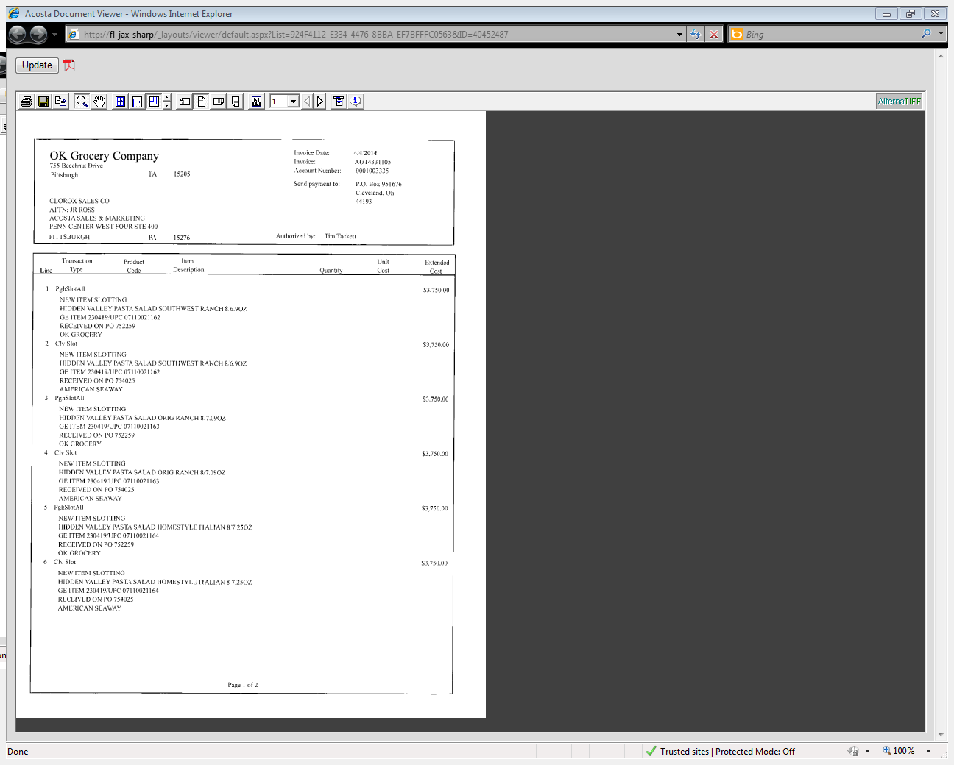
5.2 Customer Contract for Slotting, Example 1: Contracts can be found via Search For: Promotions.
i
This indicates that the customer invoice is for slotting.

i
This is the customer purchase order number on which the customer ordered the new product for the first time.

Extended Cost: This is the slotting amount the customer is claiming, listed by item.
NOTE: The contract offers $8500 in slotting for UPC 21162. That item is listed twice @ $3750 each, for a total claim of $7500.00

2
1
Product Code: This is the UPC that the customer is claiming a scan allowance on. This code must match the contract and sales analysis report.
E.g. In this case, the UPC is the last 5 digits shown: 07110021162

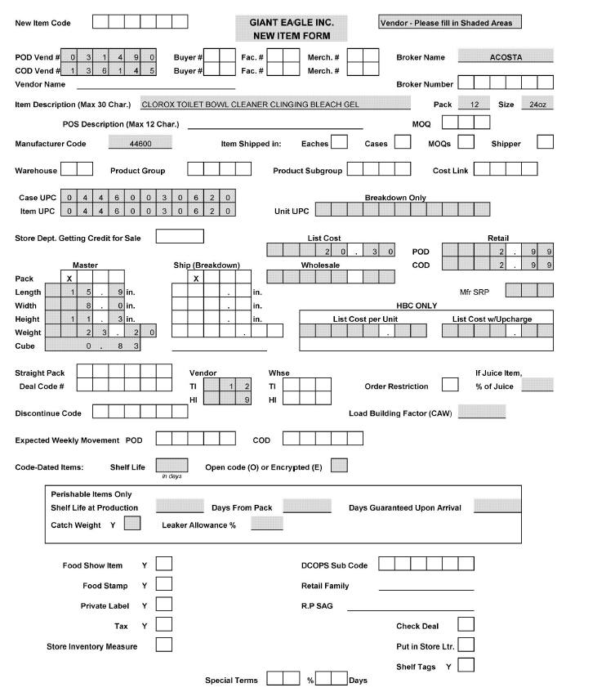
This is the UPC #. Match this to the customer invoice and client order invoice. The case UPC # 30620 relates to the GE code # 404145 on the customer invoice.
1

Page-2
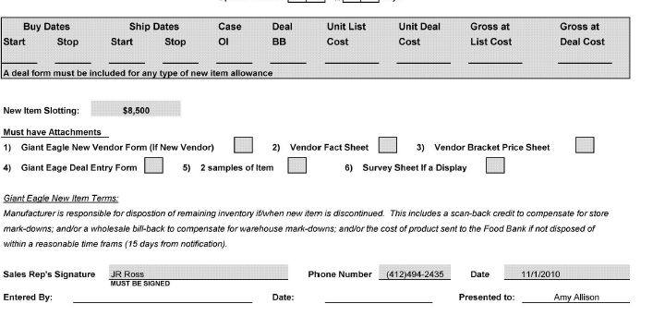
2
New Item Slotting: This is the slotting allowance offered and needs to match with the customer invoice for validating a claim. 4250 +4250 =$ 8500.

5.2 Customer Contract for Slotting, Example 2: Contracts can be found via Search For: Promotions.
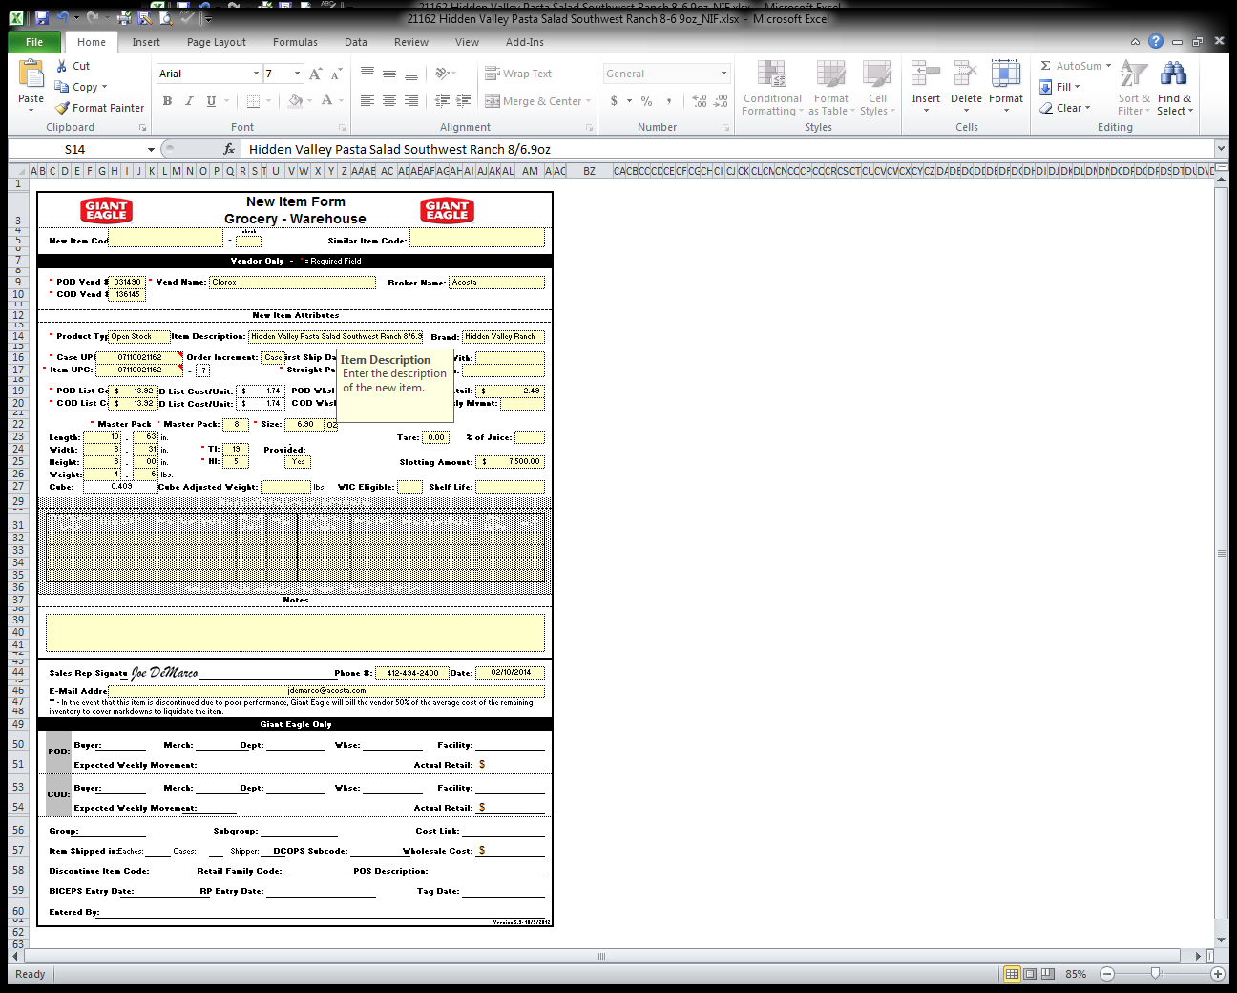
Slotting: This is the slotting allowance offered and needs to match with the customer invoice for validating a claim.
2
1
Product Code: This is the UPC that the customer is claiming a scan allowance on. This code must match the contract and sales analysis report.
E.g. In this case, the UPC is the last 5 digits shown: 07110021162

5.3 Refer to the SOPs/Generic Help File for POP requirements.
6. Deduction Type: Unsalable / Swell Allowance (Non Trade Claim)
An Unsalable claim is taken for product that cannot be sold at the stores due to damages (and short coded product).

Swell Allowance: It is an allowance provided on the unsalable products. It indicates the Unsalable Deduction. And we need to have Client order invoice to attached on the claim request and step it as Unsaleable.

6.1 Customer Invoice for Unsalable / Swell Allowance, Example 1: If not provided under View Document, this can be found via Search For: Backup Documentation, Doc Type 2-Customer Invoice.

Invoice Number- This will be the Customer Reference Number when searching for the Invoice.

i
i
Swell allowance indicates this is for unsalable product. The do not list any UPC#’s.

6.1 Customer Invoice for Unsalable / Swell Allowance, Example 2: If not provided under View Document, this can be found via Search For: Backup Documentation, Doc Type 2-Customer Invoice.

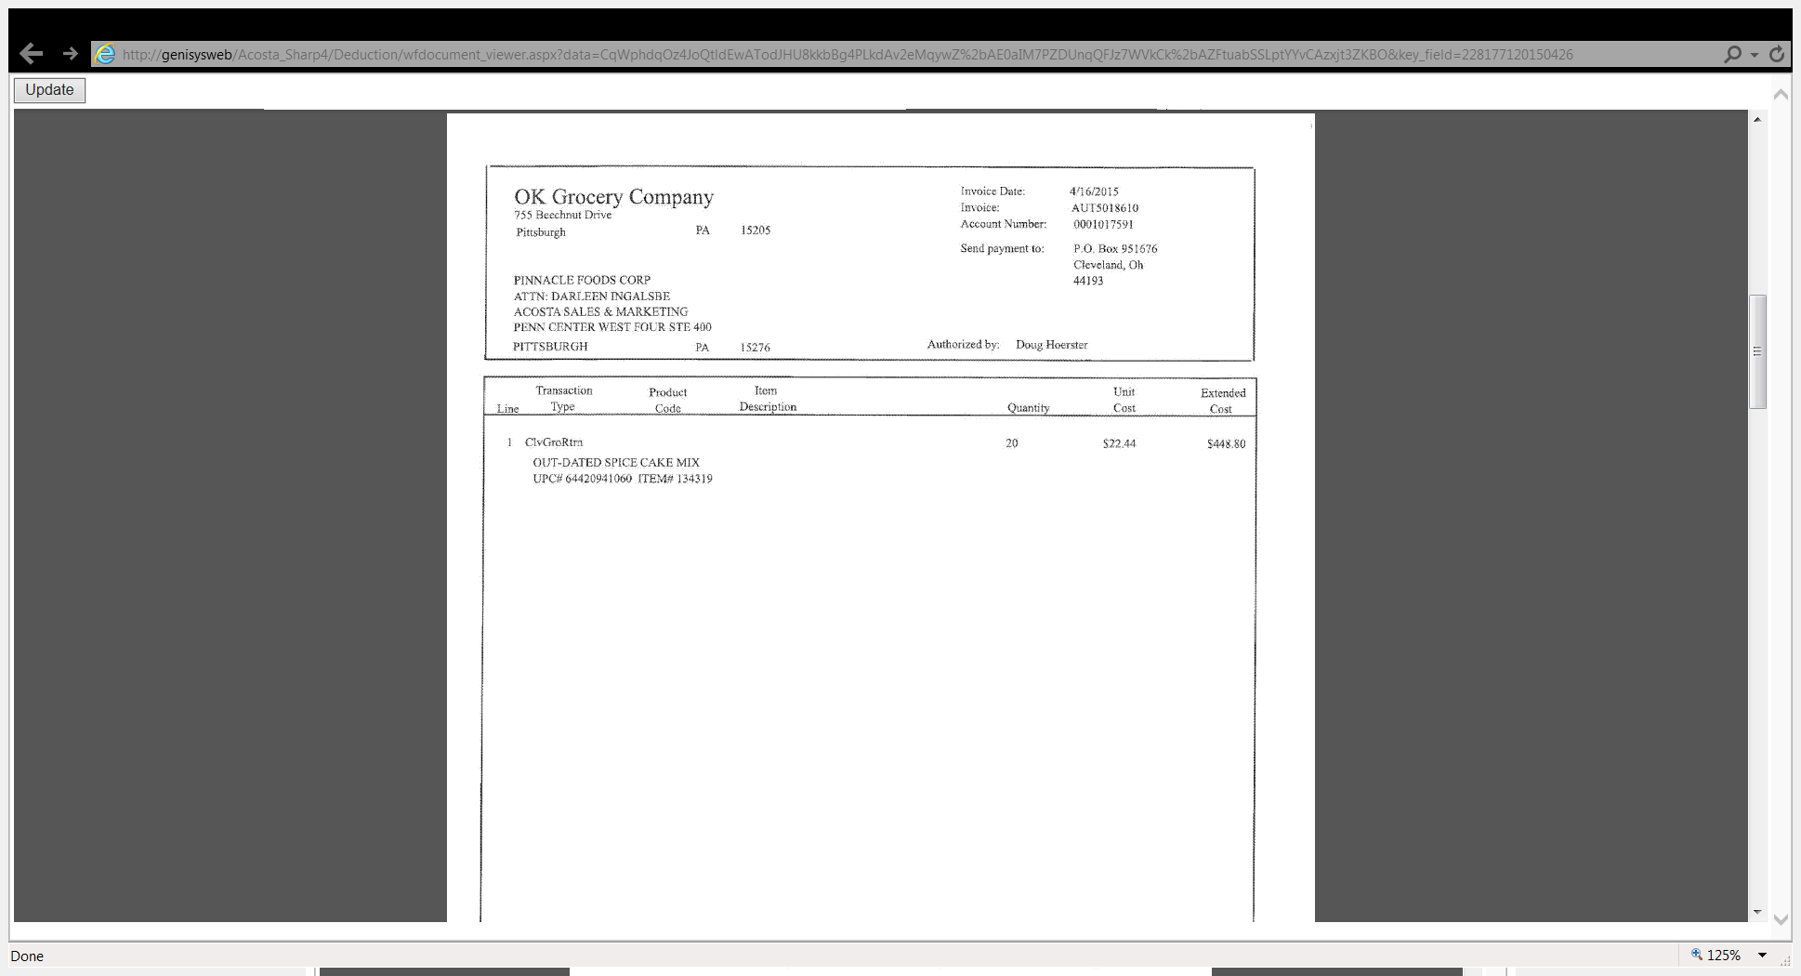
i

Out-Dated allowance indicates this is for unsalable product.

7. Deduction Type: Warehouse Withdrawal/Count Recount
For cases shipped to stores from the main customer’s warehouse during a specified period of time per the contract. The customer should not be referencing a purchase order number when deducting for a warehouse withdrawal/count recount allowance.

7.1 Customer Invoice for Warehouse Withdrawal / Count Recount, Example 1: If not provided under View Document, this can be found via Search For: Backup Documentation, Doc Type 2-Customer Invoice.
i
Line: The last 3 numbers on the claim customer reference # will be the line on that invoice. (Ex AUT3594971004– is on invoice AUT3594971 line 4)

Invoice: This will match the beginning portion of the customer reference number on the claim. Remove the last 3 numbers in the customer reference field when searching for invoice. (Ex AUT3594971004 – search AUT3594971)

i
i
“Valu King” or “VK” indicates this is for Valu King a division of OK Grocery. Contract should references this division. Found under customer signon OKGEPI.
4
2
Count Recount Rate - This indicates the cost per case for the Count Recount allowance. Match this to the contract.
These dates indicate the dates they are billing for the Count Recount allowance. Match this to the contract and sales analysis report.

7.1 Customer Invoice for Warehouse Withdrawal / Count Recount, Example 2:
i
Invoice: This will match the beginning portion of the customer reference number on the claim. Remove the last 3 numbers in the customer reference field when searching for invoice. (Ex AUT3435040001 – search AUT3435040)

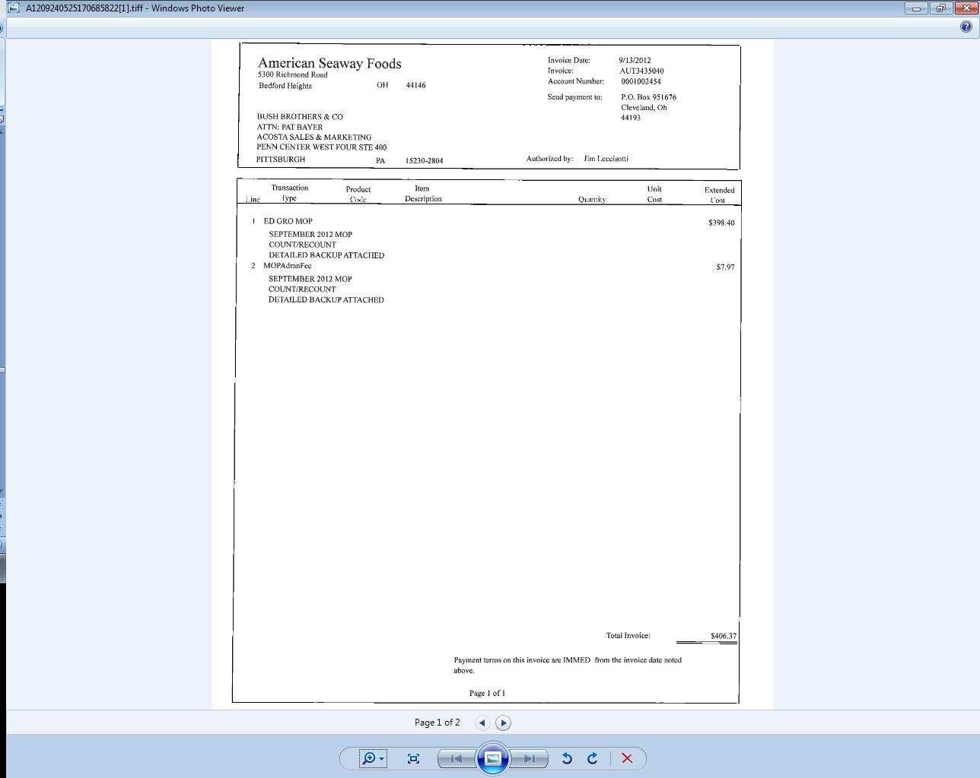
These dates indicate the dates they are billing for the count recount allowance. Match this to the contract and sales analysis report.
4
Line: The last 3 numbers on the claim customer reference # will be the line on that invoice. (Ex AUT3435040001 – is on invoice AUT3435040 line 1)

i
3
TOTAL INVOICE: This is the amount they are deducting for the Count/Recount.

7.1 Customer Invoice for Warehouse Withdrawal / Count Recount, Example 2: Page 2

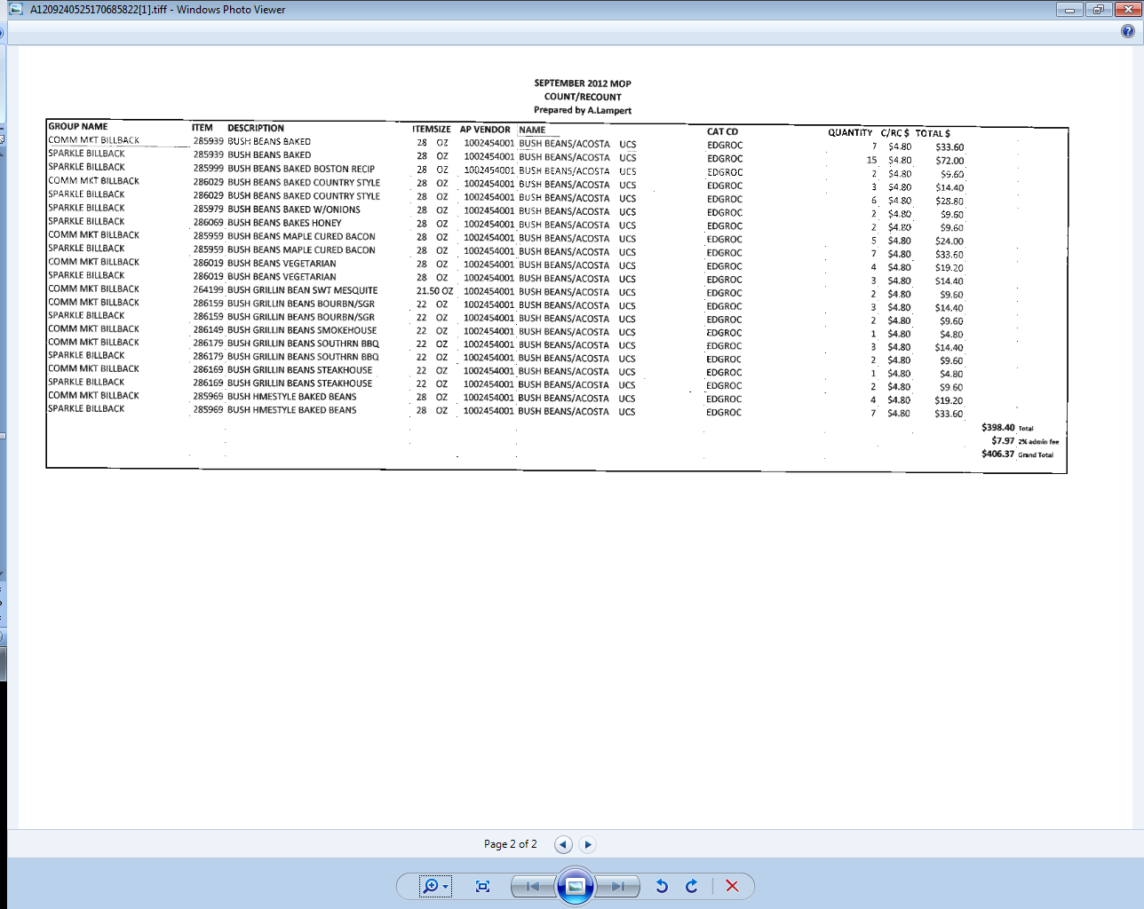
2
Count Recount Rate - This indicates the cost per unit for the Count/Recount allowance. Match this to the contract.

7.1 Customer Invoice for Warehouse Withdrawal / Count Recount, Example 3: If not provided under View Document, this can be found via Search For: Backup Documentation, Doc Type 2-Customer Invoice.
Line: The last 3 numbers on the claim customer reference # will be the line on that invoice. (Ex AUT3977499001– is on invoice AUT3977499 line 1)

i
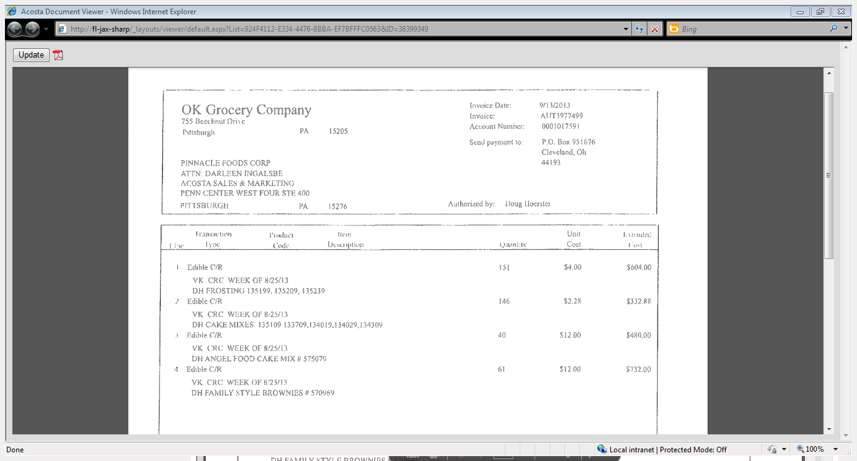
Item Code –.This is the customer code. Match this to the contract and the sales analysis or scan data report.
1
i
“Valu King” or “VK” indicates this is for Valu King a division of OK Grocery. Contract should references this division. Found under customer signon OKGEPI.
4
3
3
Cases: This is the number of cases purchased during the report period. The quantity on the customer invoice must be less than or equal to the ship quantity on the sales report.
Since the customer purchased more than they are claiming on this deduction, it is valid.
2
Count Recount Rate - This indicates the cost per case for the Count Recount allowance. Match this to the contract.
These dates indicate the dates they are billing for the Count Recount allowance. Match this to the contract and sales analysis report.
4
i
Invoice: This will match the beginning portion of the customer reference number on the claim. Remove the last 3 numbers in the customer reference field when searching for invoice. (Ex AUT3977499001 – search AUT3977499)

7.2 Customer Contract for Warehouse Withdrawal / Count Recount, Example 1:
i
“Valu King” or “VK” indicates this is for Valu King a division of OK Grocery. Contract should references this division. Found under customer signon OKGEPI.

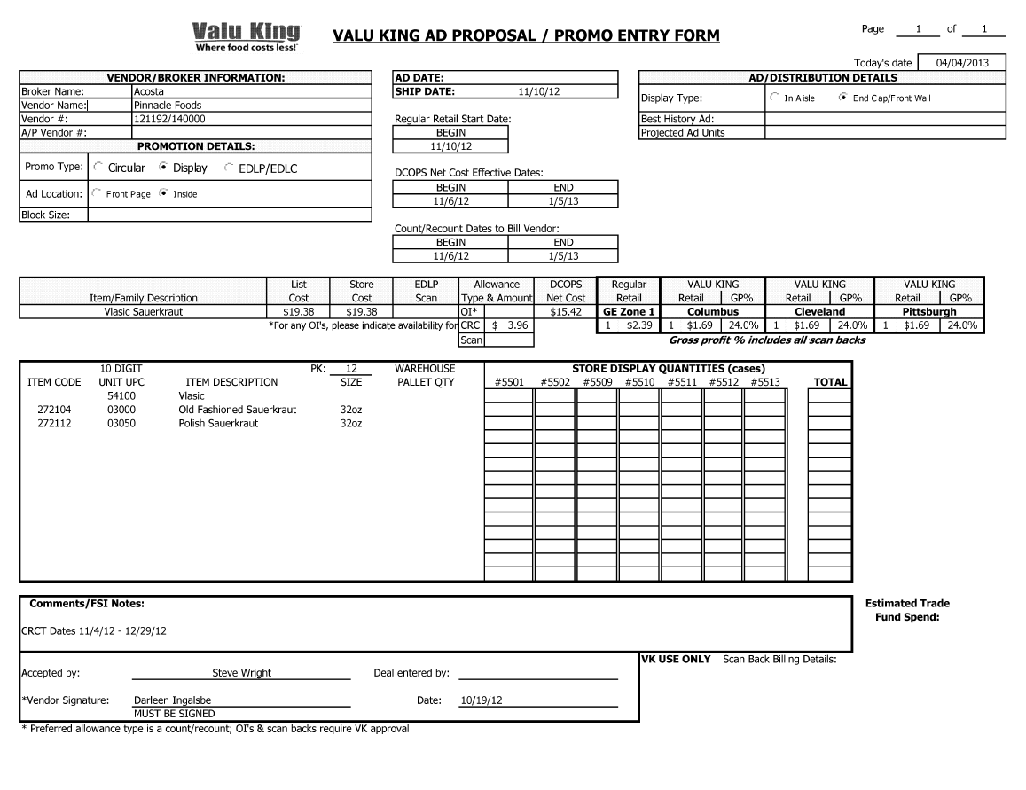
2
1
4
Count Recount - This indicates the cost per case for Count Recount allowance. Compare to the customer invoice.
Begin and End Dates – This is the date during which the customer can claim the Count Recount allowance. Compare to the sales analysis or scan data report.
i
Promotion Type –Count Recount indicates that the contract is for Warehouse Withdrawal Allowance.

UPC Code –.This is the UPC case code. Match this to the customer invoice and the sales analysis or scan data report.

Note: In cases where the begin and end dates on the customer invoice and contract don't match, look in the comment section of the contract because it may reflect different dates for the count/recount.

7.2 Customer Contract for Warehouse Withdrawal / Count Recount, Example 2:

Begin and End Dates – This is the date during which the customer can claim the Count/Recount allowance. Compare to the sales analysis or scan data report.

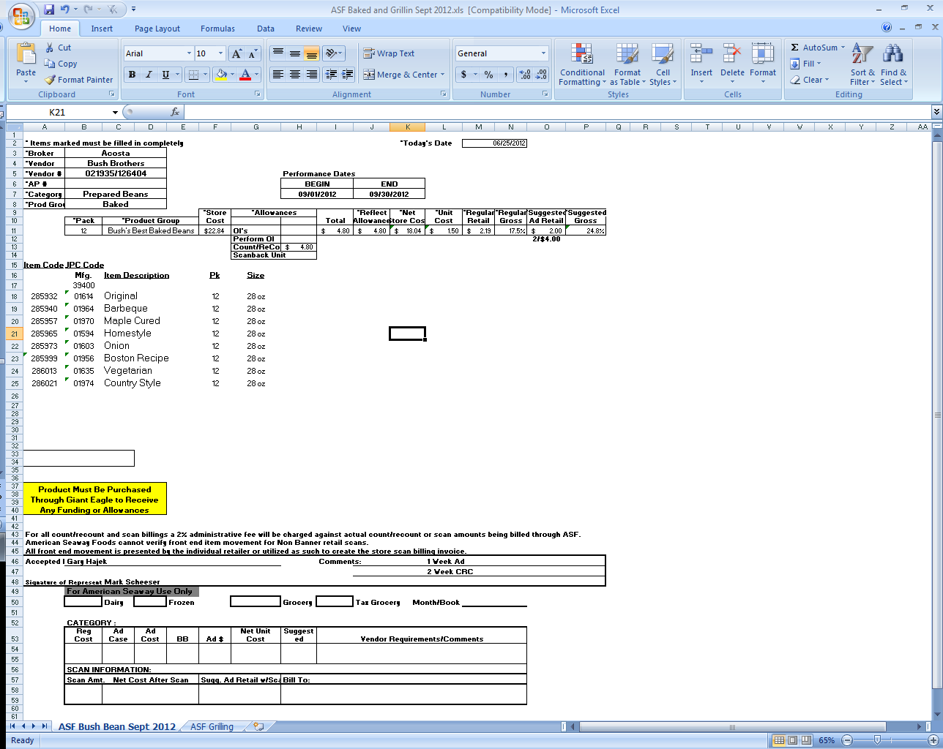
Customer Name/Acosta Rep Name: If this contract was DTC’d, it is required for it to have the Customer Name, Acosta Rep’s name, and a presentation date. This is where those names will be located on OK Grocery contracts. If they do not include these names, the claim should be stepped as Escalate – Contract Issue.
22
Count Recount- This indicates the cost per case for Count Recount allowance. Compare to the customer invoice.
1
Item Code –.This is the Item case code. Match this to the customer invoice and the sales analysis or scan data report.

7.2 Customer Contract for Warehouse Withdrawal / Count Recount, Example 3:
Promotion Type –Count Recount indicates that the contract is for Warehouse Withdrawal Allowance.

i
“Valu King” or “VK” indicates this is for Valu King a division of OK Grocery. Contract should references this division. Found under customer signon OKGEPI.
i
4
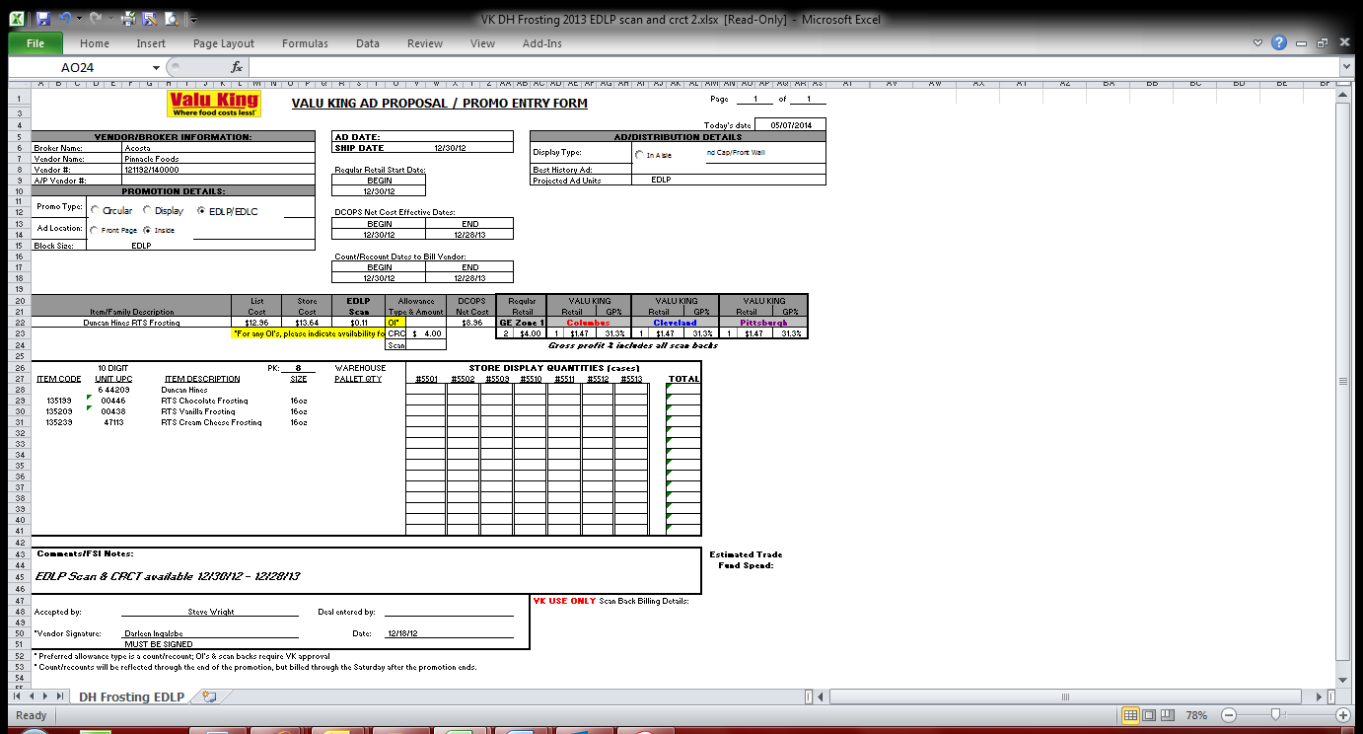
1
UPC Code –.This is the UPC case code. Match this to the customer invoice and the sales analysis or scan data report.
2
Count Recount - This indicates the cost per case for Count Recount allowance. Compare to the customer invoice.
Begin and End Dates – This is the date during which the customer can claim the Count Recount allowance. Compare to the sales analysis or scan data report.

7.3 Refer to the SOPs/Generic Help File for POP requirements.

8. Deduction Type: Food Show
An event sponsored by a wholesaler exhibiting various clients’ products to indirect customers. There are various fees associated with participating in a food show and can include booth fees, show books, printing/survey charges, show samples and per case allowances for what is sold at the show.

8.1 Customer Invoice for Food Show:

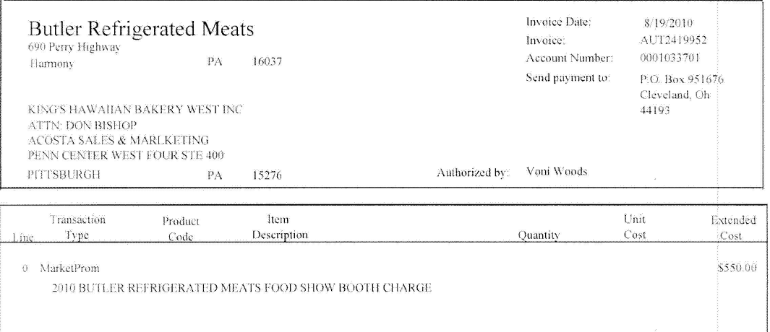
Invoice: This will match the beginning portion of the customer reference number on the claim. Remove the last 3 numbers in the customer reference field when searching for invoice. (Ex AUT2419952001 – search AUT2419952)

i
i
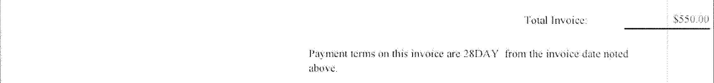
2
No UPCs are associated with this type of food show billing. This is for a food show both fee.

Allowance amount/Booth charges: This is the total amount for food show and it has to match with the participant agreement to validate the claim.

8.2 Customer Contract for Food Show: This type of contract could be found in backup documentation, document type 17 or via “Search For” Promotions.

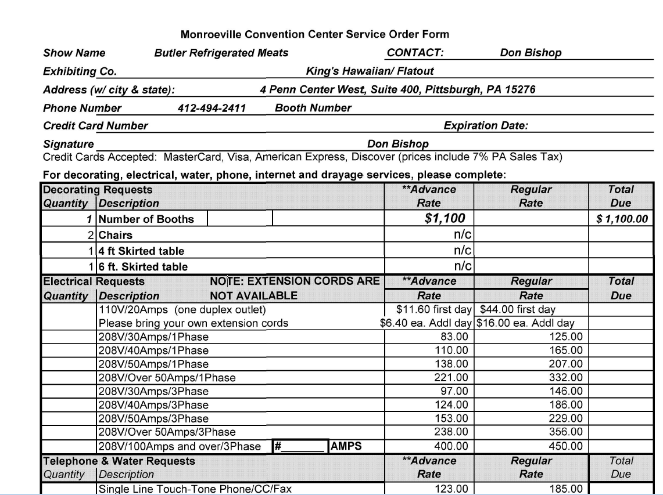
2
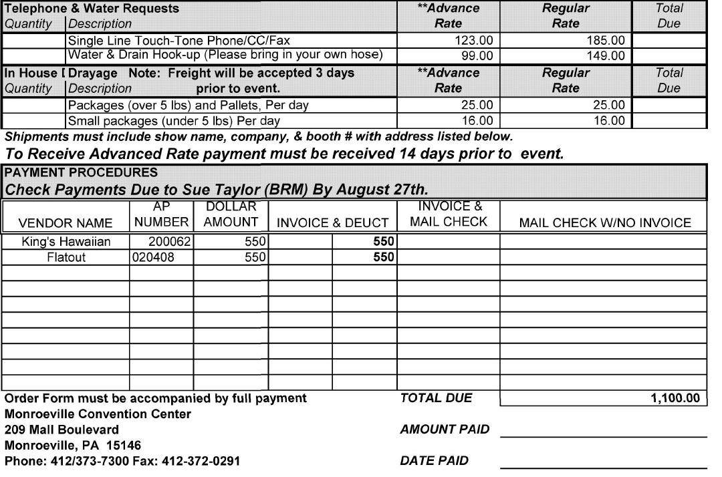
Allowance amount/Booth charges: This is the total amount for food show for the vendor King’s Hawaiian and it has to match with the customer invoice for a valid claim.

8.3 Refer to the SOPs/Generic Help File for POP requirements.

9. Deduction Type: Coupons (Non Trade Claim)
This is a manufacturer Coupon, typically cleared by client. *See in ad or in-store for these allowance types.
Customer Invoices beginning with “C”, “CI” and “CC” are coupon.

9.1 Customer Invoice for Coupon:
i

This is the customer reference number used to find the customer invoice in backup documentation, document type 2.

Invoices beginning with “C”, “CI” and “CC” are coupon claims.

Coupon Policy

10. Deduction Type: Fees (Trade Claim)
Fees charged for various reasons and can include late delivery, miss delivery appointment or lumper/driver
fees.

10.1 Customer Invoice for Fees, Example 1: Promotional Fee (Ad)These are fees associated with ad and scan and are cleared to trade.
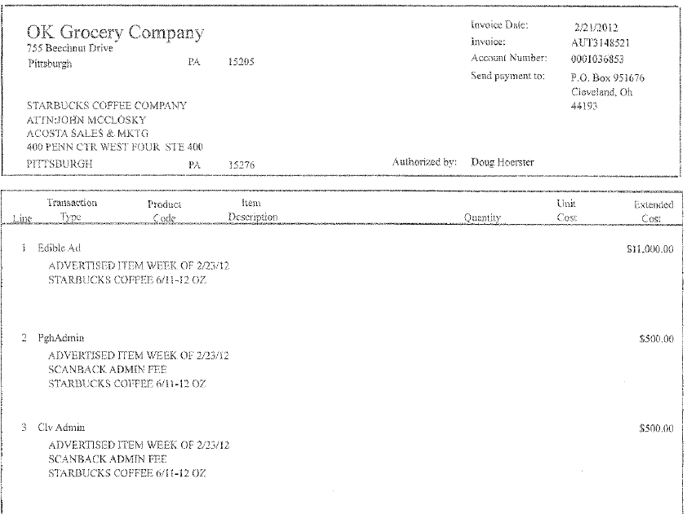
i
i
Invoice: This will match the beginning portion of the customer reference number on the claim. Remove the last 3 numbers in the customer reference field when searching for invoice. (Ex AUT3148521003 – search AUT3148521)

2
This is the amount of the fee being deducted.

i
This area will describe what is being deducted for – ADMIN FEE indicates that this is for a trade related fee.

Line: The last 3 numbers on the claim customer reference # will be the line on that invoice. (Ex AUT3148521003– is on invoice AUT3148521 line 3)

10.1 Customer Invoice for Fees, Example 2: Promotional Fee.

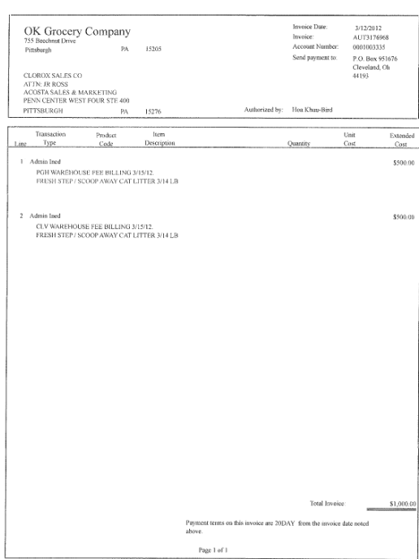
Invoice: This will match the beginning portion of the customer reference number on the claim. Remove the last 3 numbers in the customer reference field when searching for invoice. (Ex AUT3176968001 – search AUT3176968)

i
i
Line: The last 3 numbers on the claim customer reference # will be the line on that invoice. (Ex AUT3176968001– is on invoice AUT3176968 line 1)

i
2
This is the amount of the fee being deducted.

This area will describe what is being deducted for – ADMIN FEE indicates that this is for a trade related fee.

10.2 Contract for trade related Fee, Example 1: The contract can be found via “Search For” Promotions.

If the fee approval is not listed on the contract then should be in the plan notes within the virtual promotion folder (VPF).

i
Customer Name/Acosta Rep Name: If this contract was DTC’d, it is required for it to have the Customer Name, Acosta Rep’s name, and a presentation date. This is where those names will be located on OK Grocery contracts. If they do not include these names, the claim should be stepped as Escalate – Contract Issue.

10.2 Customer Contract for Fees, Example 2:

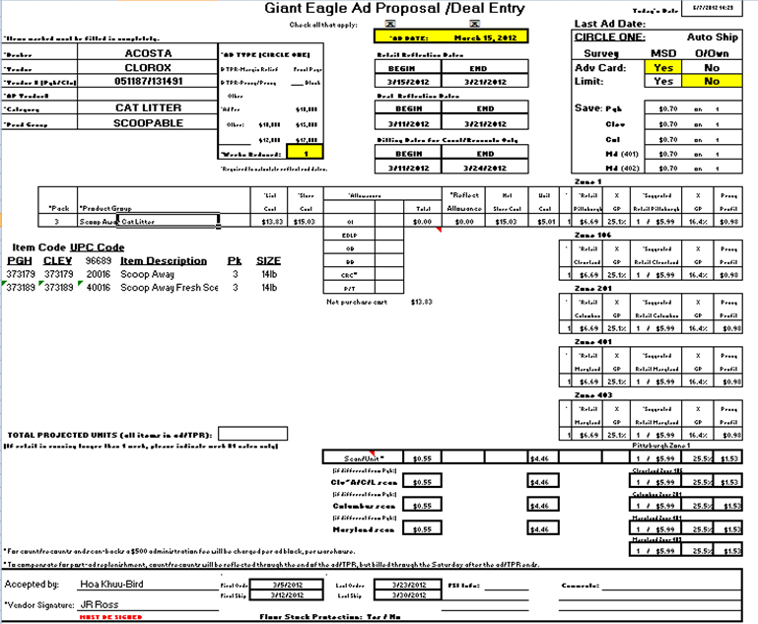
11. Deduction Type: Freight / Back Haul:
i
This date should match to the date on Ad copy.

This description should match to the Ad copy.

i
Customer Name/Acosta Rep Name: If this contract was DTC’d, it is required for it to have the Customer Name, Acosta Rep’s name, and a presentation date. This is where those names will be located on OK Grocery contracts. If they do not include these names, the claim should be stepped as Escalate – Contract Issue.
i
This is the Fees amount which should match to the Customer Invoice.

i
A Freight allowance is given to the customer for picking up the product via their own transportation services.

Documents required for validating a Freight claim:

Document Name | Source of the Document | Action by Accenture
Customer Invoice | Acosta Relay – search for the invoice under Backup Documentation, document type 2. | Step up the claim to Acosta for research
Client Order Invoice | Acosta Relay – search for this document within the Order/Invoice/PO search.

11.1 Customer Invoice for Freight /Back Haul:
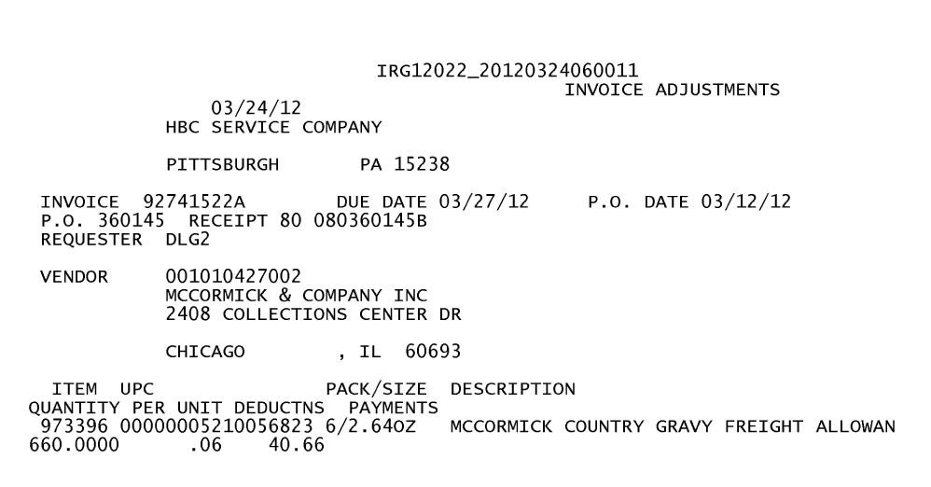
This is the customer reference number used to find the customer invoice in backup documentation, document type 2.

This is also the client order invoice number to be used to find the invoice via Order/Inv/PO.
Deduction type –
Here it states that the deduction is for Freight.
Once identified as Freight deduction the claim needs to be step-up to Acosta.

12. Deduction Type: Returns & Recall

Products returned by the customer to the client.

Documents required for validating a Shortages Deduction:

Document Name | Source of the Document | Action by Accenture
Customer Invoice | Acosta Relay – search for the invoice under Backup Documentation, document type 2. | Step up the claim to Acosta for research
Client Order Invoice | Acosta Relay – search for this document within the Order/Invoice/PO search.

12.1 Customer Invoice for Returns, Example 1:

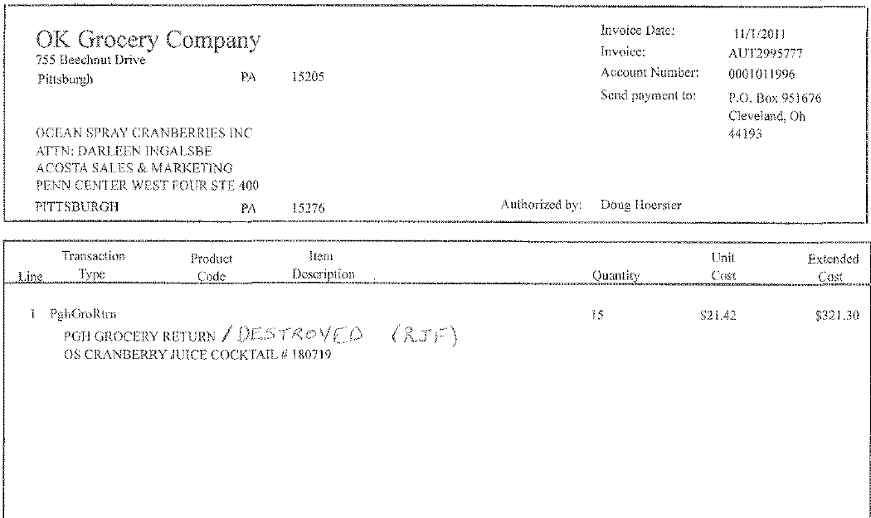
This is the customer reference number used to find the customer invoice in backup documentation, document type 2.
Transaction Type “PGH GROCERY RETURN”/ DESTROYED:
This Indicates that the claim is for Return deduction.

12.1 Customer Invoice for Recall, Example 2: Non-Trade Other

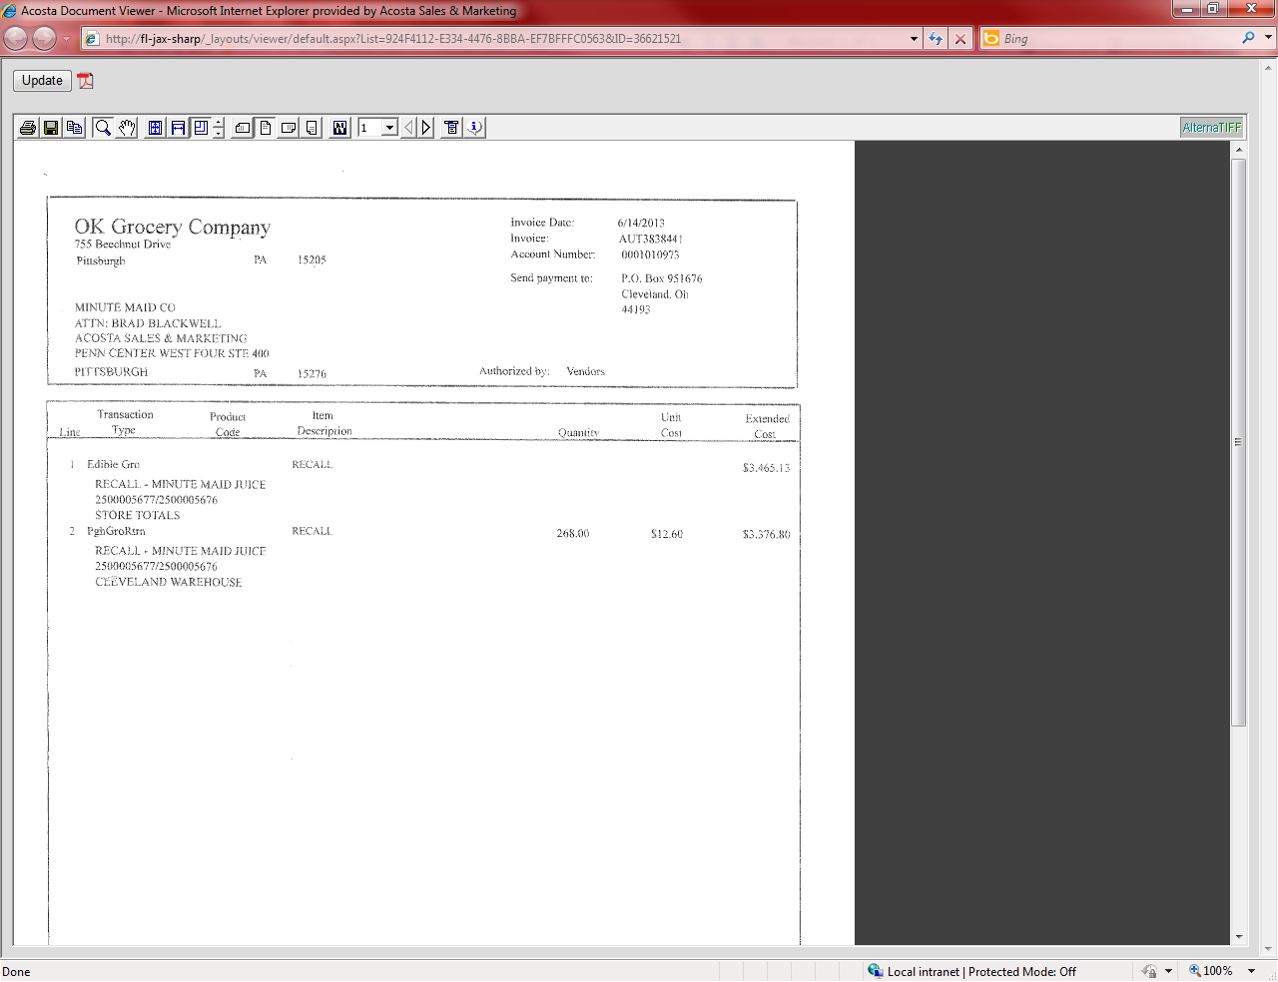
This is the customer reference number used to find the customer invoice in backup documentation, document type 2.
Transaction Type Recall:
This Indicates that the claim is for Recall deduction.

12.1 Customer Invoice for Recall, Example 3: Non-Trade Other
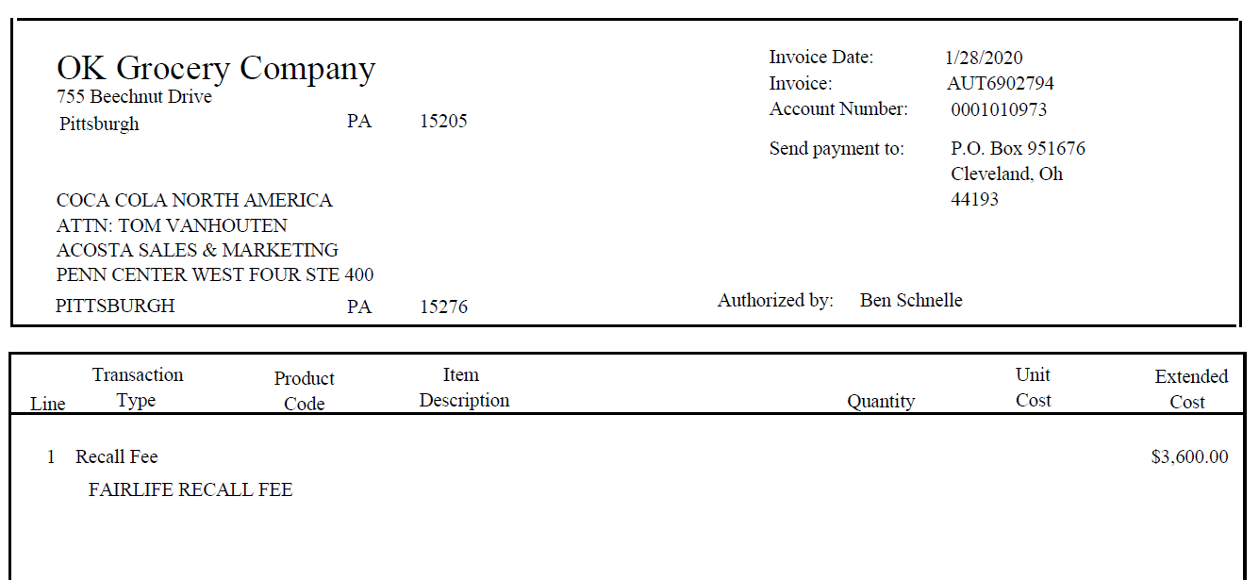
Transaction Type Recall:
This Indicates that the claim is for Recall deduction.
This is the customer reference number used to find the customer invoice in backup documentation, document type 2.

13. Deduction Type: Shortages
It is a deduction for shorted product on an order that the client billed the customer for.
Documents required for validating a Shortages Deduction:

Document Name | Source of the Document | Action by Accenture
Customer Invoice | Acosta Relay – search for the invoice under Backup Documentation, document type 2. | Step up the claim to Acosta for research
Client Order Invoice | Acosta Relay– search for this document within the Order/Invoice/PO search.

13.1 Customer Invoice for Shortages:

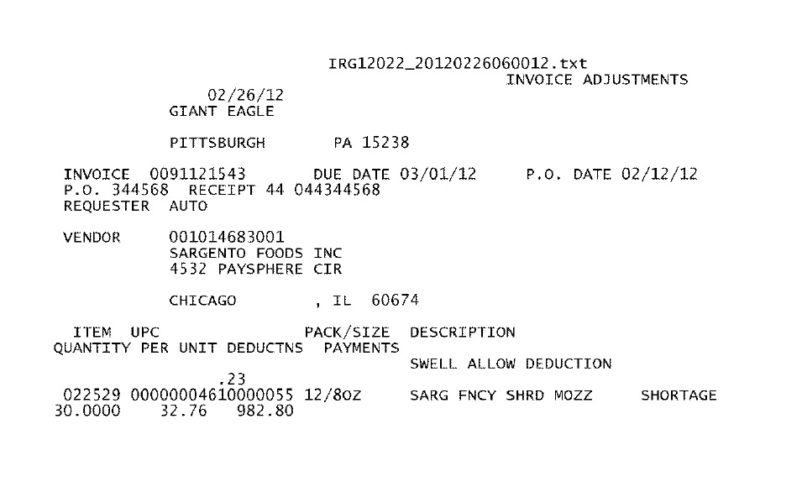
This is the customer reference number to be used to find the customer invoice in backup documentation, document type 2.

This is also the client order invoice number used to find the invoice via Orders/Inv/PO.
SHORTAGE - Allowance type –
This indicates the deduction type is for Shortages.
Once Identified as Shortages deduction the Client Order Invoice needs to be attached and the claim needs to be step-up to Acosta.

14. Deduction Type: Post Audit:
Internal/external auditors find claims that the customer is entitled to but did not take from previous years. Post Audits should be researched in the same manner as other claims by accessing previous year’s files.

14.1 Customer Invoice for Post Audit:
This is the customer reference number to be used to find the customer invoice in backup documentation, document type 2.

“AR” or “IA” indicates Post Audit.

i

15. Deduction Type: OI for Shorted Product:

15.1 Customer invoice for Off Invoice Claimed for Shorted Product: If not provided under View Document, the customer invoice can be found via Search For: Backup Documentation, Doc Type 2-Customer Invoice. Once the invoice is identified as a deduction for an off invoice allowance that was not given on product that was not shipped (shorted), refer to the appropriate client SOP to determine next step.

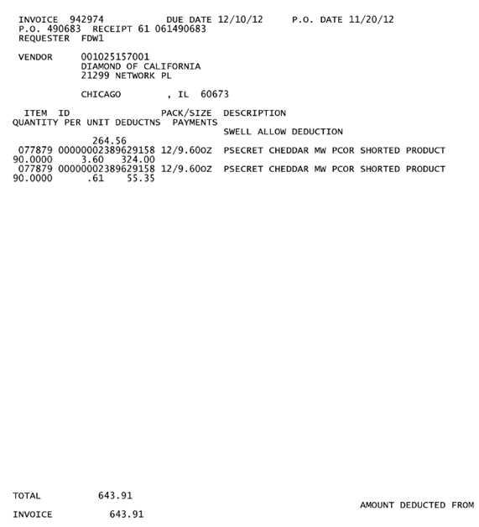
Line 1 - This is the customer code and UPC for the product on which the customer is claiming the OI allowance.
Line 2 – This is the quantity, OI amount and total deducted for the item.
Line 3 – If this references the same UPC as line 1 than this is the freight charge related to the UPC from line 1.
Line 4 – This the quantity, and rate for the freight charge.

The words “shorted product” with the OI amount shown to the left identify this invoice as being for an off invoice allowance not received on product that was shorted from the customer’s order.

i
i

16. Deduction Type: Loyalty Card
An allowance for a temporary price reduction on product when a customer uses a loyalty card.

16.1 Customer Invoice for Loyalty Card, Example 1: If not provided under View Document, this can be found via Search For: Backup Documentation, Doc Type 2-Customer Invoice.
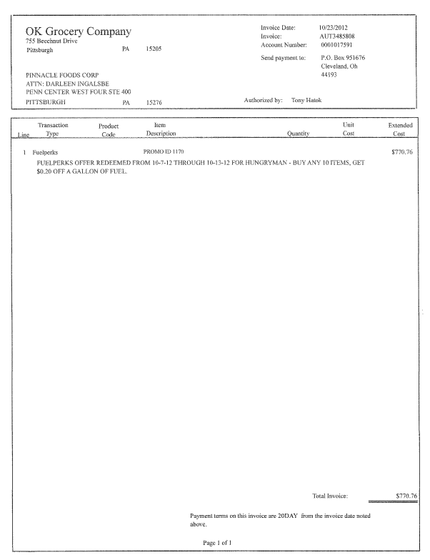
Line: The last 3 numbers on the claim customer reference # will be the line on that invoice. (Ex AUT3485808001– is on invoice AUT3485808 line 1)

i
i
i
2
i
1
Deal Amount: This is the “offer amount” that should match the contract.

Product Code / Item Description –This provides detailed comment as to what the claim is for, the time period and also the allowance amount offered.
In this example the claim is for Fuel Perks during the mentioned dates. This information needs to be validated with the customer contract.

TOTAL INVOICE: This is the amount they are deducting for the ad. This must match the contract.

Transaction Type: This indicates that the customer is deducting Fuel Perks. This needs to match the contract and proof of performance.

Invoice: This will match the beginning portion of the customer reference number on the claim. Remove the last 3 numbers in the customer reference field when searching for invoice. (Ex AUT3485808001 – search AUT3485808)

Page 2: If available with the invoice the store recap can also be used as the POP as it is a list of transactions by store for each product purchased where consumer used their Loyalty card. Note: This document is not necessary unless it is a Client Specific requirement.
3
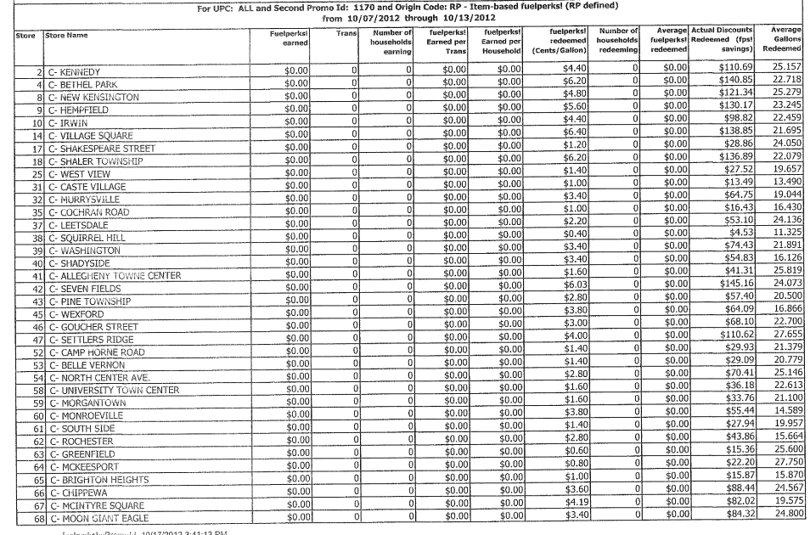
Deal Dates: These are the performance dates that should match the contract.

16.1 Customer Invoice for Loyalty Card, Example 2: If not provided under View Document, this can be found via Search For: Backup Documentation, Doc Type 2-Customer Invoice.

Page 1
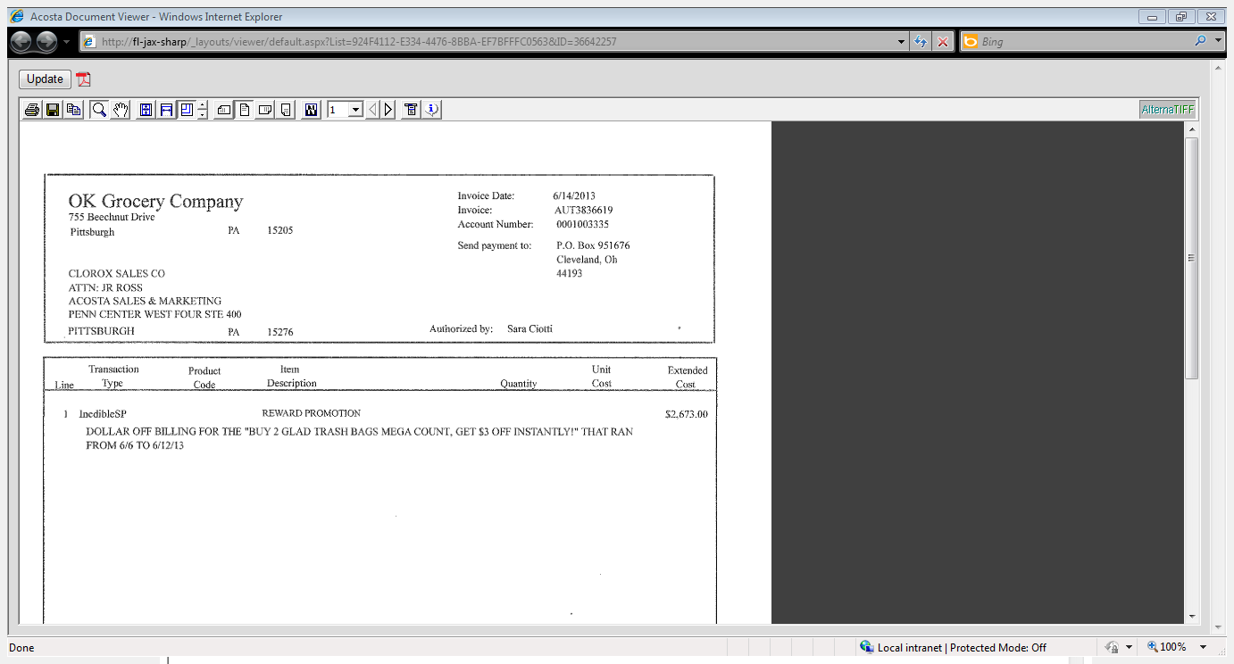
Product Code / Item Description –This provides detailed comment as to what the claim is for, the time period and also the allowance amount offered.

1
Deal Amount: This is the “offer amount” that should match the contract.

2
Transaction Type: This indicates that the customer is deducting Fuel Perks. This needs to match the contract and proof of performance.

i

Page 2: This document can also be used as the POP as it is a list of transactions by store for each product purchased where consumer used their Loyalty card. Note: This document is not necessary unless it is a Client requirement.

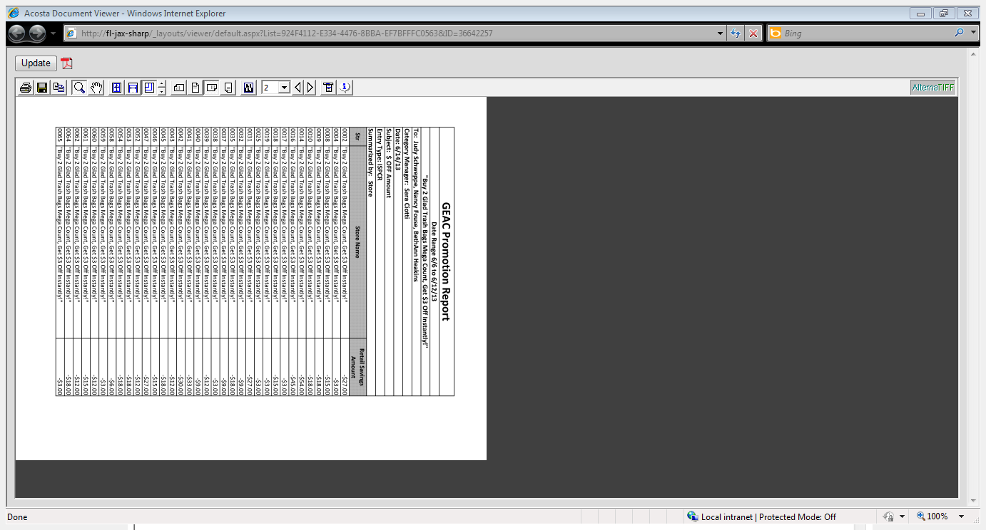

16.2 Customer Contract for Loyalty Card, Example 1: Found via Search For Promotions. Claim will be stepped as Trade Other
1
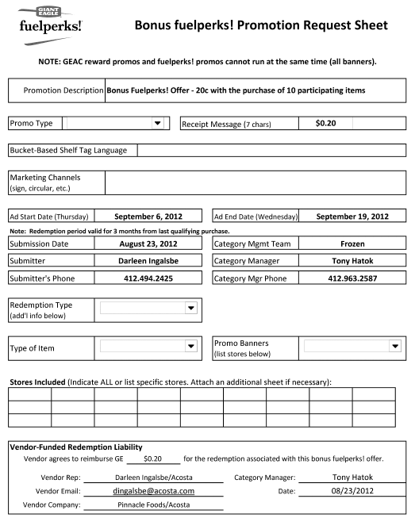
Performance Date : This indicates the dates on which the Ad ran for the promotion. The redemption period is valid for 3 months from the last qualifying purchase. In this example redemption dates would be 9/6/12 to 12/19/12.
3
Program Description: This indicates that the contract offer is for the customer’s Fuel Perks program.

16.2 Customer Contract for Loyalty Card, Example 2: Found via Search For Promotions. Claim will be stepped as Trade Other

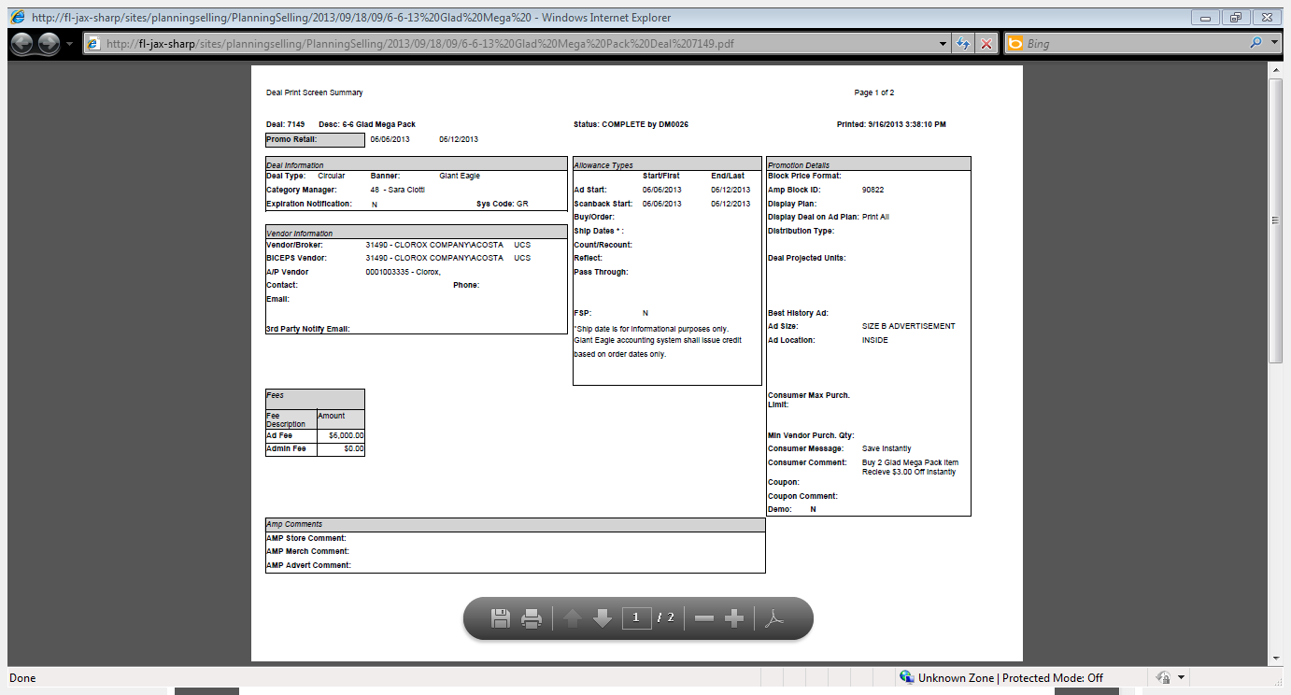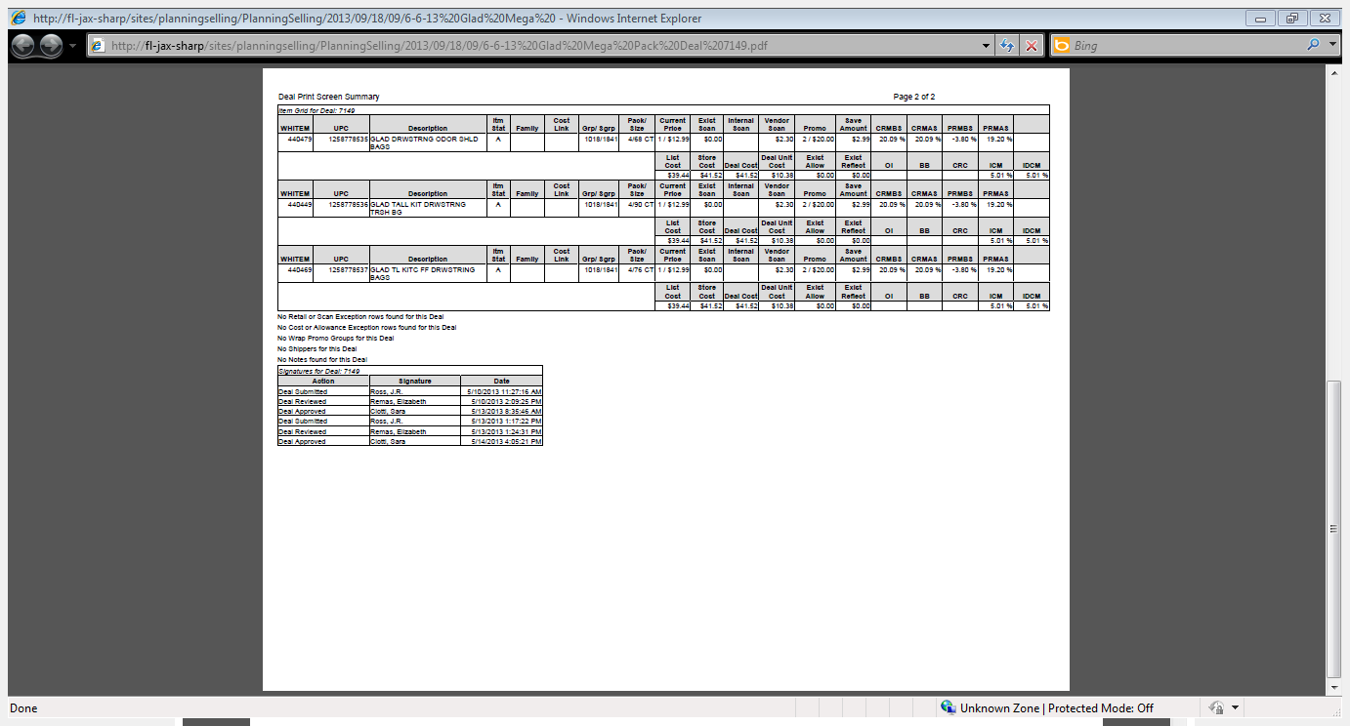
1
2
Product Code / Item Description –This provides detailed comment as to what the claim is for, the time period and also the allowance amount offered.

Program Description: This indicates that the contract offer is for the customer’s Loyalty Card program.
Performance Date : This indicates the dates on which the Ad ran for the promotion. The redemption period is valid for 3 months from the last qualifying purchase. In this example redemption dates would be 9/6/12 to 12/19/12.
3

16.3 Refer to the SOPs/Generic Help File for POP requirements.
17. Deduction Type: TPR
A TPR (Temporary Price Reduction) allowance is offered to the customer to reduce the retail price for shelf tags. It is offered to the customer as a lump sum.

17.1 Customer Invoice for TPR, Example 1:
i
Line: The last 3 numbers on the claim customer reference # will be the line on that invoice. (Ex DC583001– is on invoice DC583 line 1)

Amount: This is the claim amount under TPR this should match with the customer contract.
3
1
Highlighted Product description needs to match with the Contract.

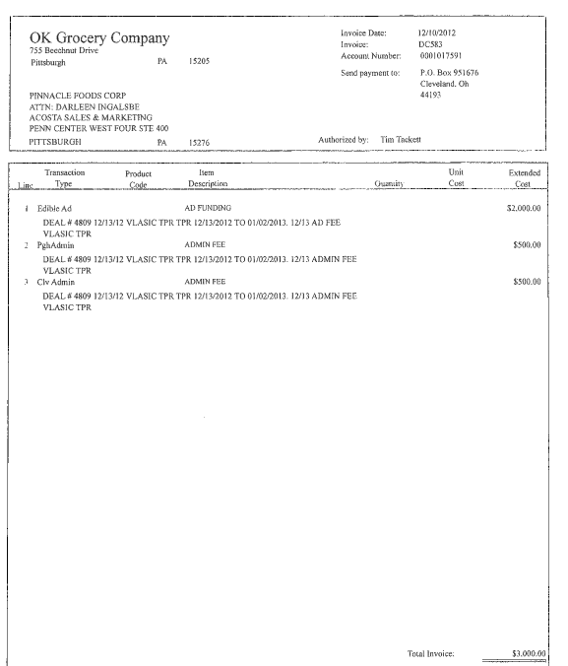
2
The date the TPR ran. This needs to be validated with the Contract.
i
Identification - This identifies the claim as TPR lump sum.
Identification - This identifies the claim as TPR lump sum.
Invoice: This will match the beginning portion of the customer reference number on the claim. Remove the last 3 numbers in the customer reference field when searching for invoice. (Ex DC583001 – search DC583)

i
i

Note: OK Grocery does not list UPC code on invoice, only description.

17.1 Customer Invoice for TPR, Example 2:

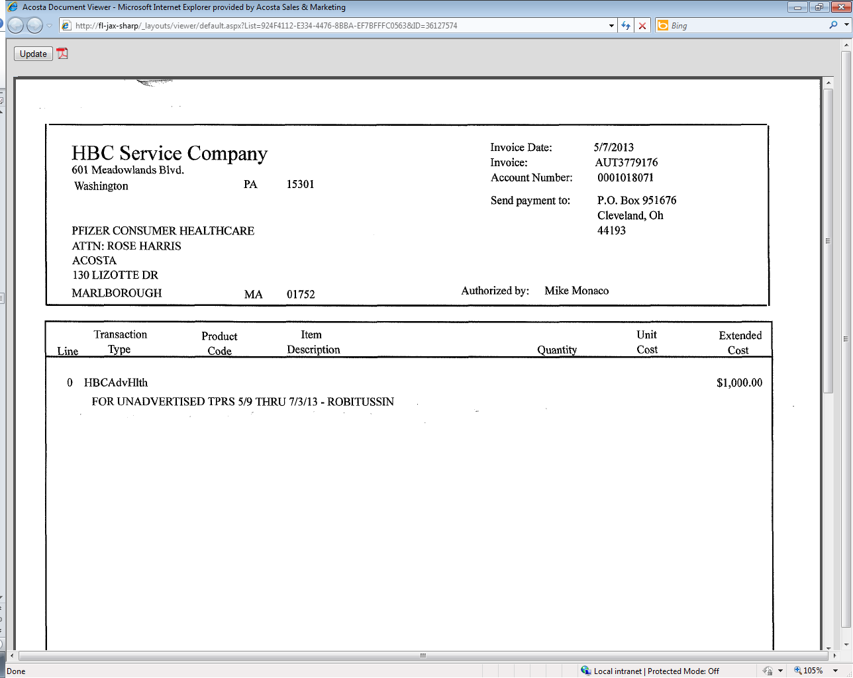
33
Amount: This is the claim amount under TPR this should match with the customer contract.
Invoice: This will match the beginning portion of the customer reference number on the claim. Remove the last 3 numbers in the customer reference field when searching for invoice. (Ex AUT3779176001 – search AUT3779176)

2
Transaction Type: This indicates that the customer is deducting for a TPR This needs to match the contract and proof of performance.

i

1
Product Code / Item Description – This is the product /product group in the customer ad. In this example it is Giant Eagle ad for Robitussin. This needs to match the contract and POP. Note: They do not provide a UPC number for reference.

17.1 Customer Invoice for TPR Fees, Example 3:
Identification - This identifies the claim as TPR fee.
i
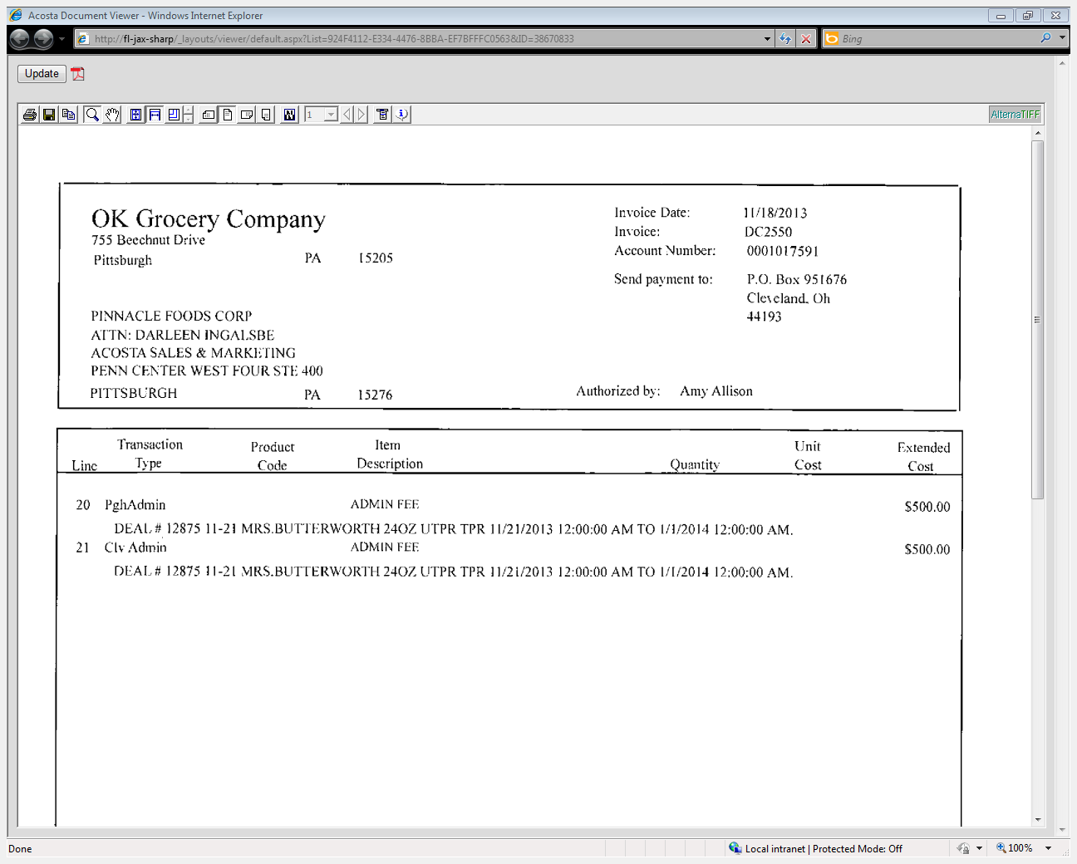
The date the TPR ran. This needs to be validated with the Contract.
2
Identification - This identifies the claim type as TPR. Along with the admin fee confirms this is for the TPR Fee.
Highlighted Product description needs to match with the Contract.
1
i
3
Amount: This is the claim amount under TPR fee this should match with the customer contract.

17.2 Customer Contract for TPR, Example 1: Found under Search For: Promotions.

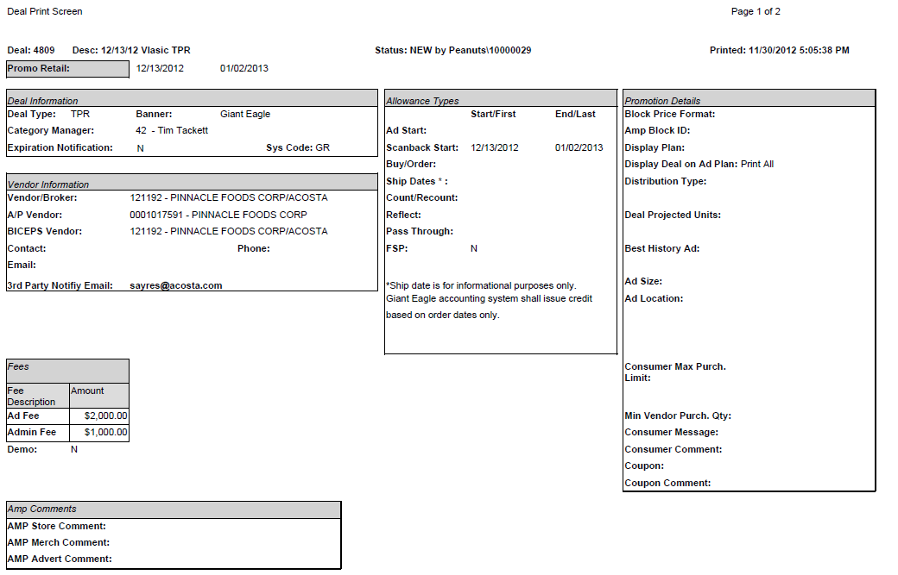
3
Amount: This is the claim amount under TPR lump sum this should match with the customer invoice.
i
Identification - This identifies the claim as TPR.
2
The date range reflects the time period the TPR rate was offered for. The date listed on the invoice must fall within these dates for a valid claim.
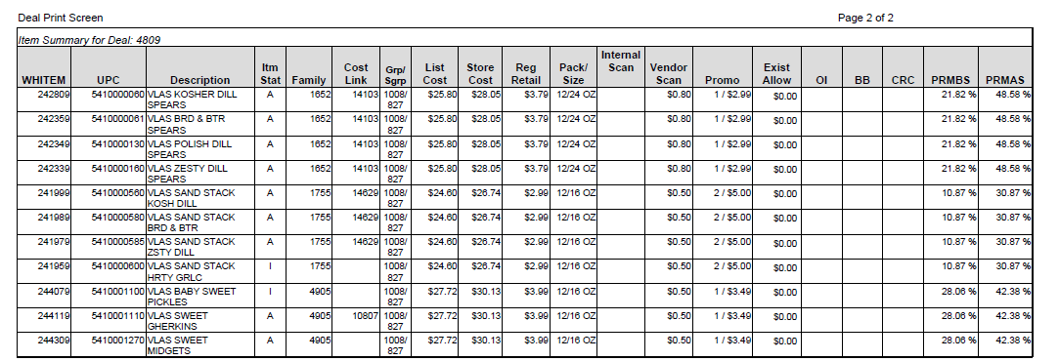
1
TPR Fees for the highlighted products have been approved on the Contract.

17.2 Customer Contract for TPR, Example 2: Found under Search For: Promotions.

TPR Fees for the highlighted products have been approved on the Contract.
2
3
Amount: This is the claim amount under TPR this should match with the customer invoice.
The date range reflects the time period the TPR rate was offered for. The date listed on the invoice must fall within these dates for a valid claim.
1

17.2 Customer Contract for TPR Fees, Example 3: Found under Search For: Promotions.

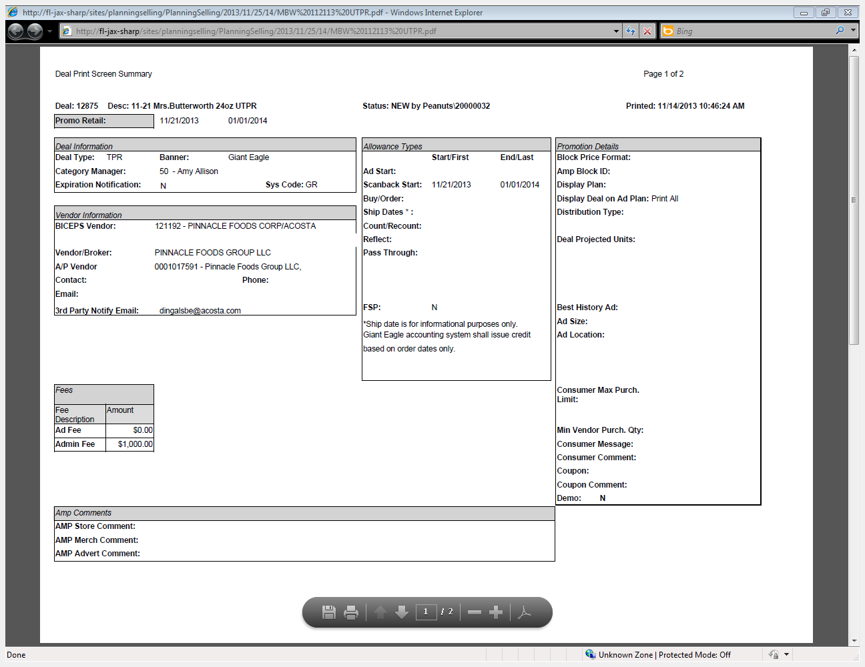
2
The date range reflects the time period the TPR rate was offered for. The date listed on the invoice must fall within these dates for a valid claim.
3
Amount: This is the claim amount under TPR fee this should match with the customer invoice.
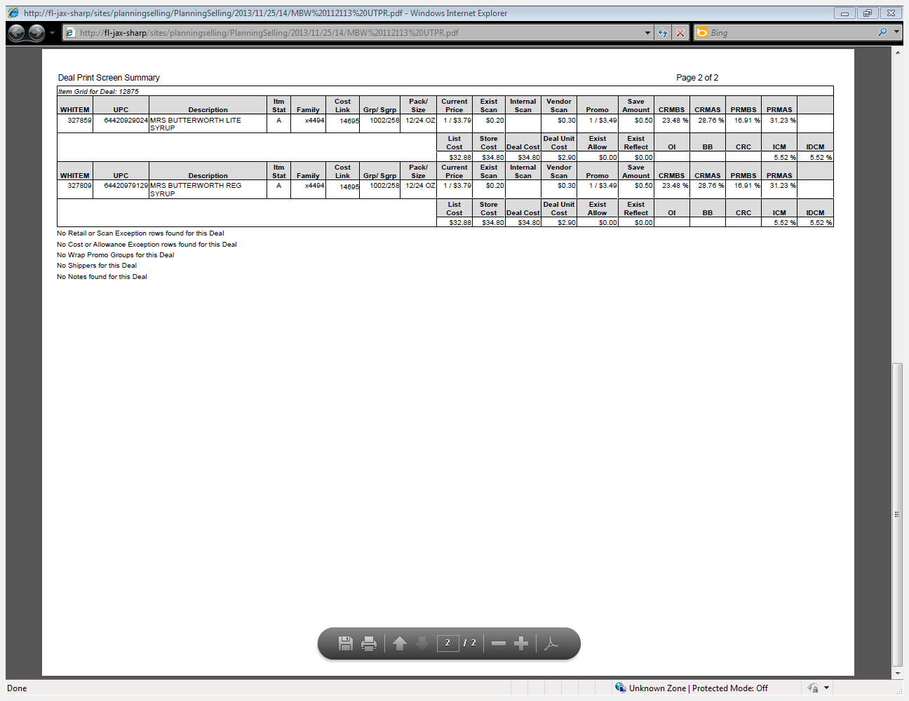
1
TPR Fees for the highlighted products have been approved on the Contract.
Identification - This identifies the claim as TPR.
i

17.3 Refer to the SOPs/Generic Help File for POP requirements.

18. Deduction Type: Demo
These are claims for in-store demonstration of the client's product to consumers. Time, resources and product charges are billed back to the client.

18.1 Customer Invoice for Demo:
Page 1
i
The description on the customer invoice states “One to One” which indicates the invoice is for a demo billed on invoice 24774 and the date of the demo is 9/21/12.
2

Total: This is the amount that the customer is claiming for the demo.
1

Product Group/Description- This is the product that was demonstrated.

**Split Image**
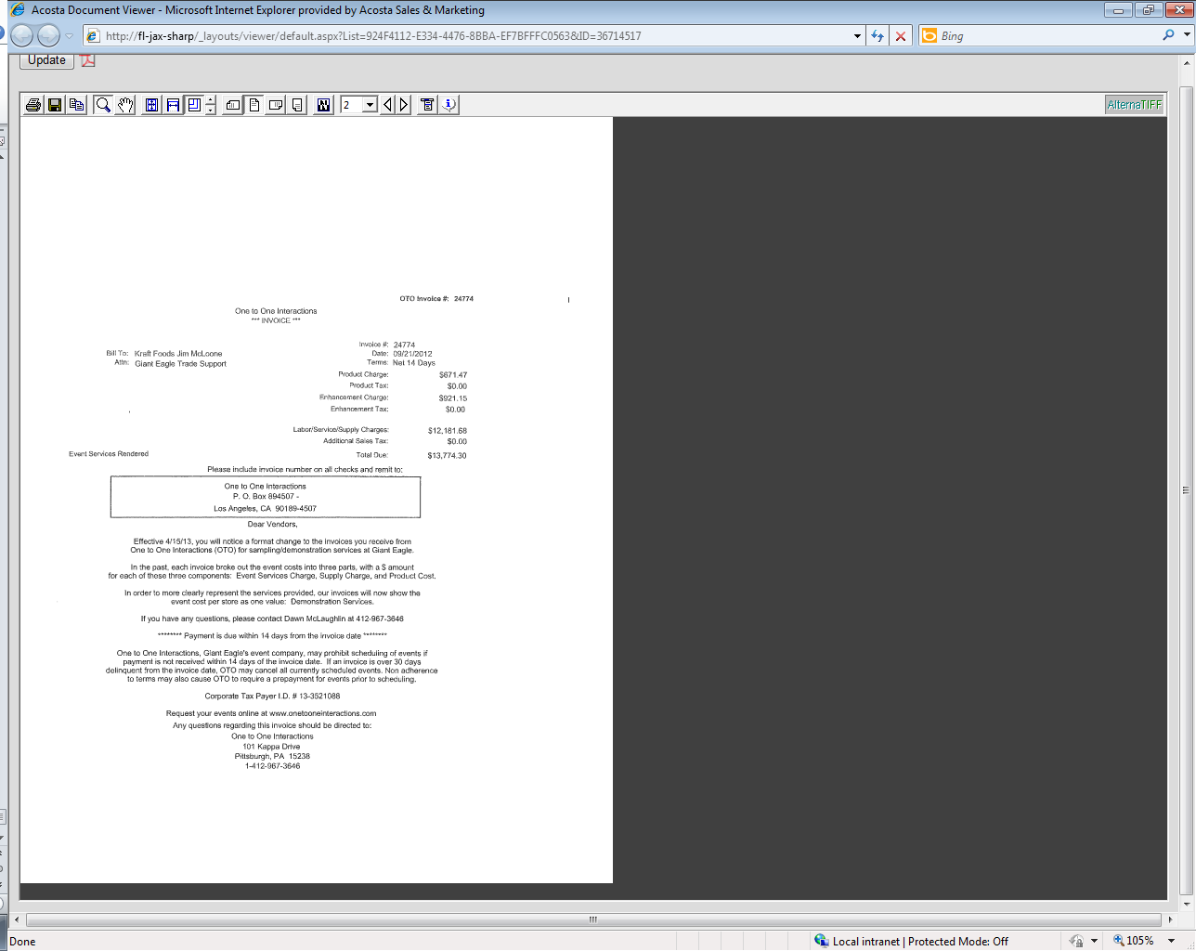
Page 2 This is the invoice copy from the demo company that will be provided behind the invoice.

**Split Image**
Page 3 This is a detail page of the demo, usually included with the demo company’s invoice copy. There are generally several pages of these.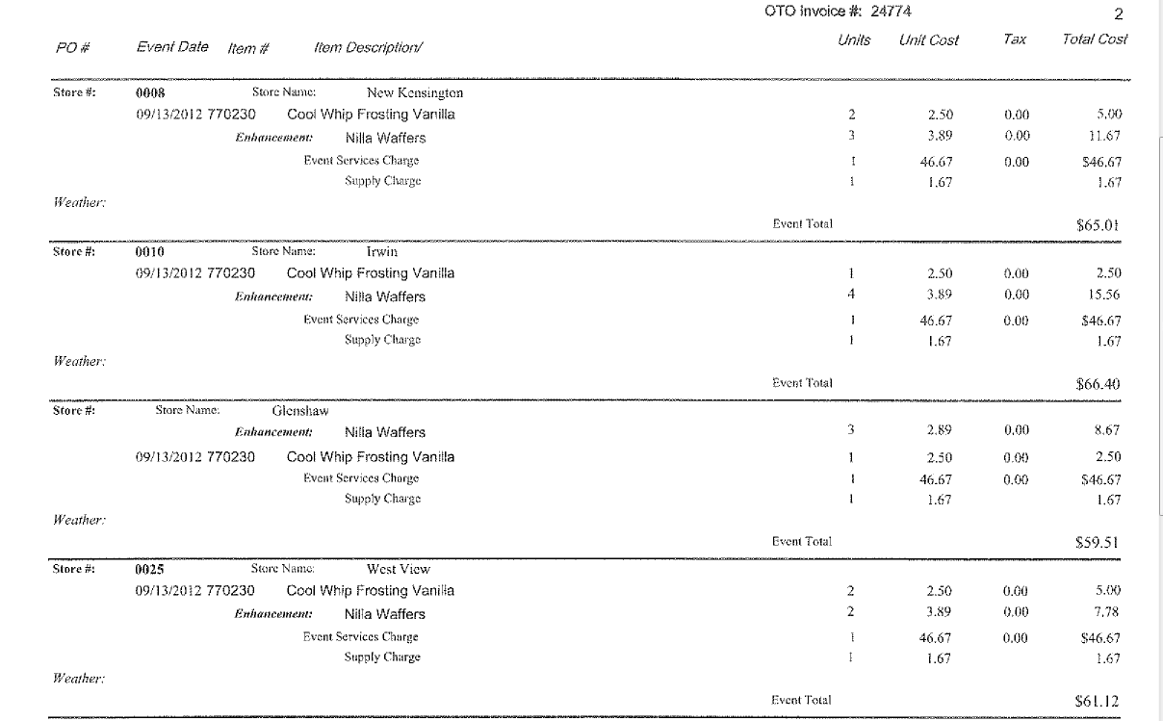

18.2 Customer Contract for Demo Fees: Found under Search For: Promotions. If not found under Promotions, this can be found via search for: Backup Documentation, Doc Tye 17 - Contract.
1

Product Group/Description- This is the product that was demonstrated.

19 Deduction Type: Floor stock
Floor stock deductions are taken when a customer is not notified in advance of a promotional offer according to their policy. The allowance amount is taken on product in stock at the customer's warehouse.
Documents required for validating a Floor stock claim

Document Name | Source of the Document | Action by Accenture
Customer Invoice | Acosta Relay – search for the invoice under Backup Documentation, document type 2. | Step up the claim to Acosta for research

19.1 Customer Invoice for Floor Stock:
This is the customer reference number.
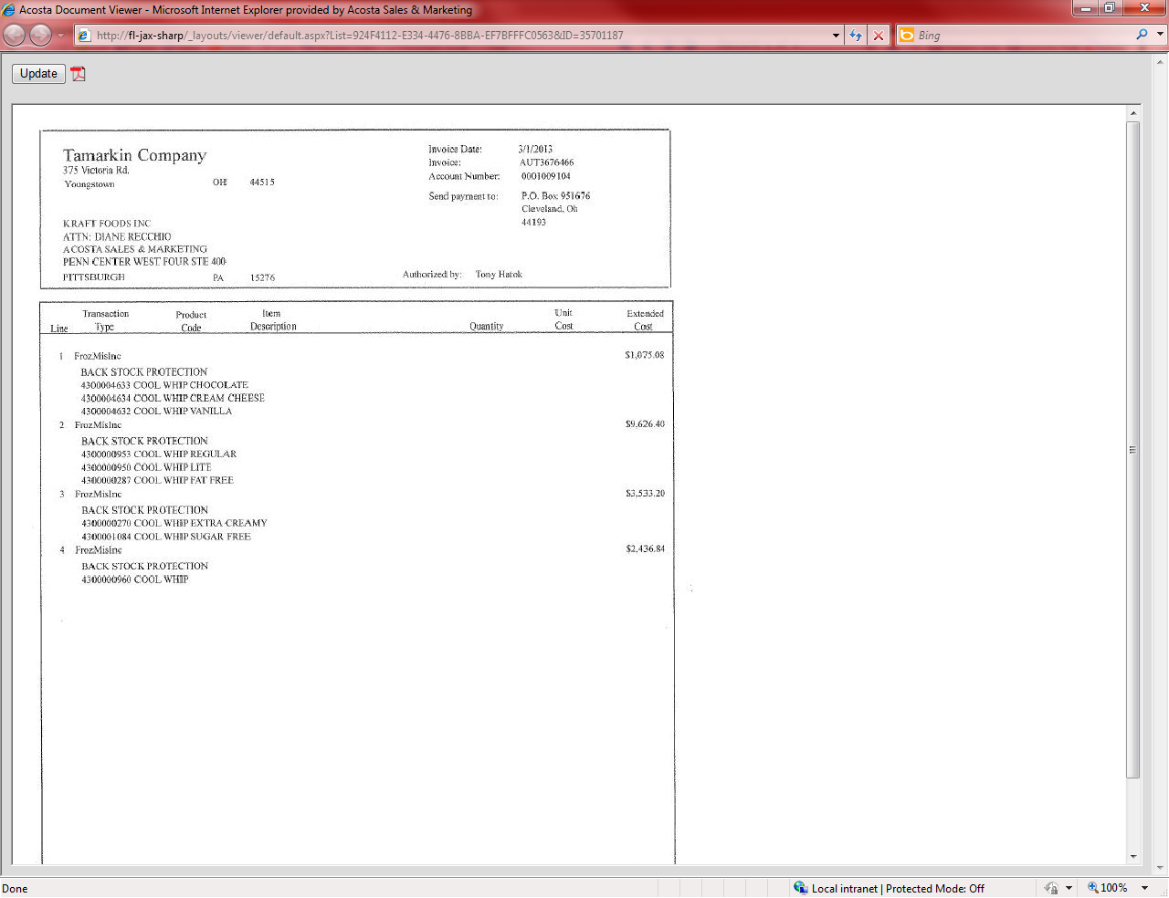
The verbiage back stock on the invoice indicates the invoice is for Floorstock. We need to know the client policy and the customer policy to validate the claim. Once we know that the invoice is for floor stock we need to step it up.
The description here says what the product for floor stock is.
This is the total amount of the customer invoice being deducted for.

19.2 Customer Contract for Floor Stock Fees: Found under Search For: Promotions. If not found under Promotions, this can be found via search for: Backup Documentation, Doc Tye 17 - Contract.

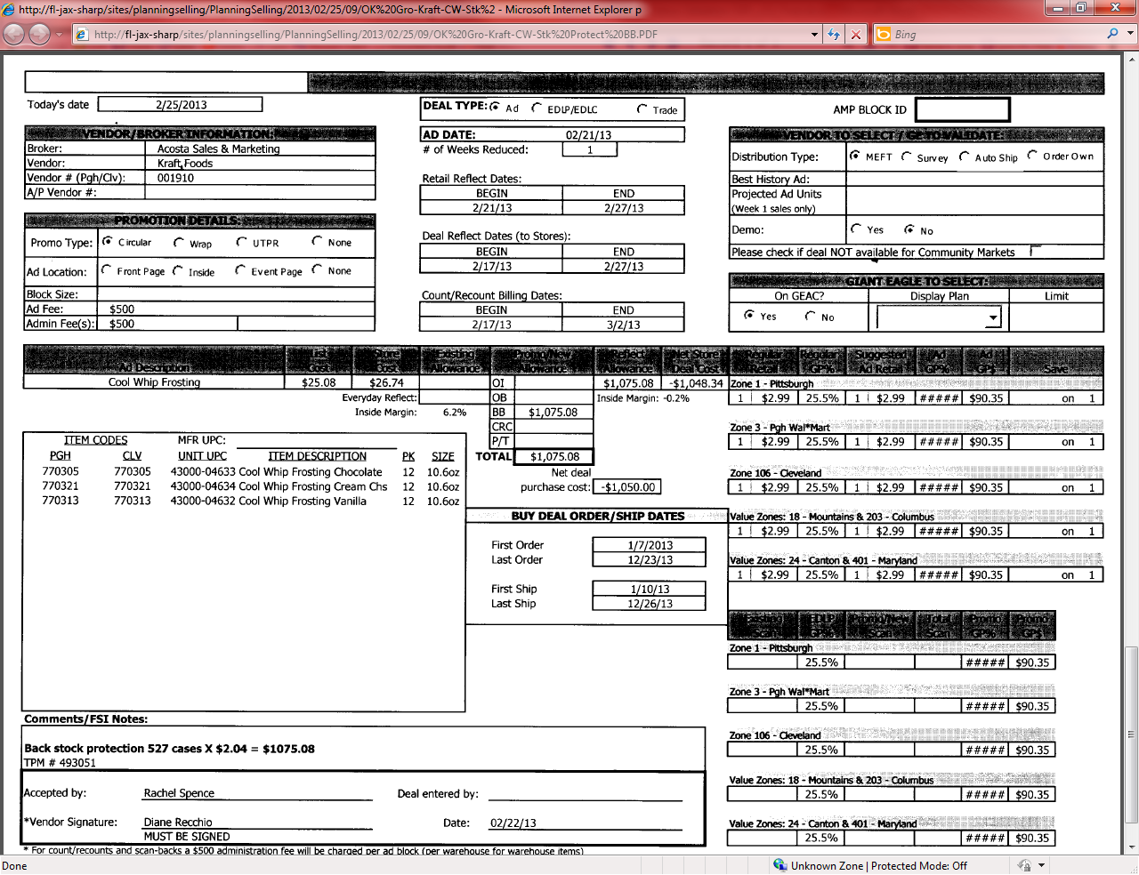
The verbiage Back stock on the contracct indicates the invoice is for Floorstock. We need to know the client policy and the customer policy to validate the claim.
The description here says what the product for floor stock is.
This is the total amount the customer is offered.

19.3 Refer to the SOPs/Generic Help File for POP requirements.

20 Deduction Type: Penalty - (Non-Trade)
It is a deduction for a penalty for unloading on an order that the client billed the customer for.
Documents required for validating a Unloading Deduction:

Document Name | Source of the Document | Action by Accenture
Customer Invoice | Acosta Relay – search for the invoice under Backup Documentation, document type 2. | Step up the claim to Acosta for research
Client Order Invoice | Acosta Relay – search for this document within the Order/Invoice/PO search.

20.1 Customer Invoice for Penalty: Example 1, Unloading Fee Non-Trade Other

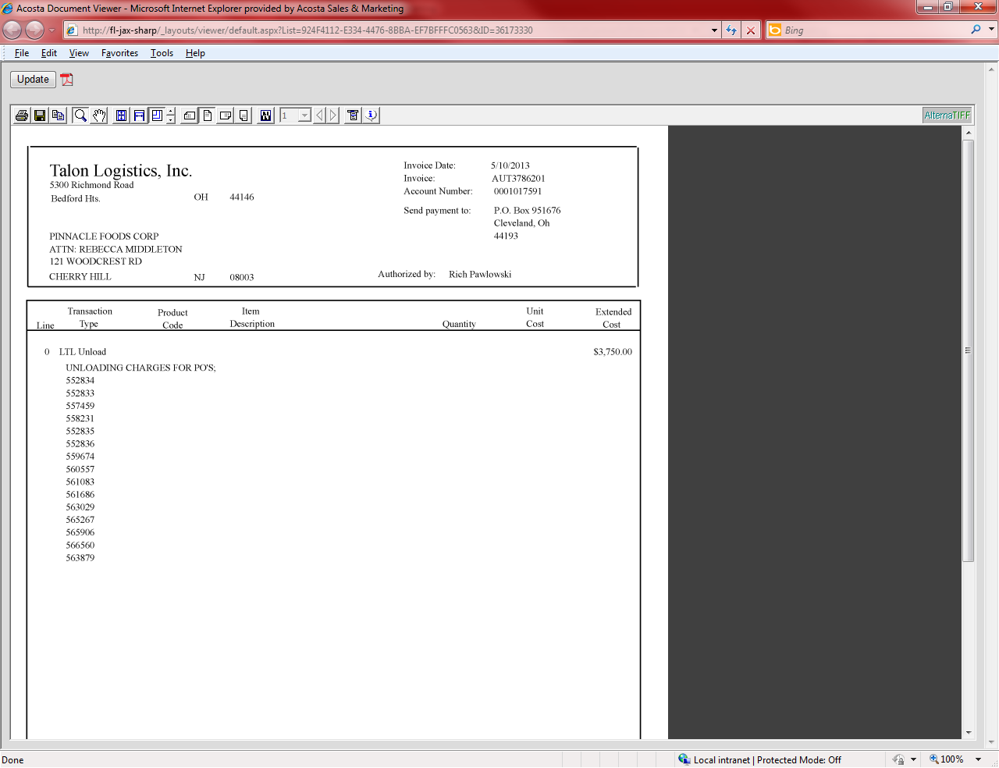
i
This is the customer reference number.
Amount – This is the total amount deducted towards unloading fee deduction.
i
Reference Number – The reference number is the PO# Central is claiming the fee on. Link the PO to the claim before escalating to the CRA.
i
i
Description: “Lumping” indicates the claim is for an unloading fee.

20.1 Customer Invoice for Penalty: Example 2, Fill Rate Non-Compliance

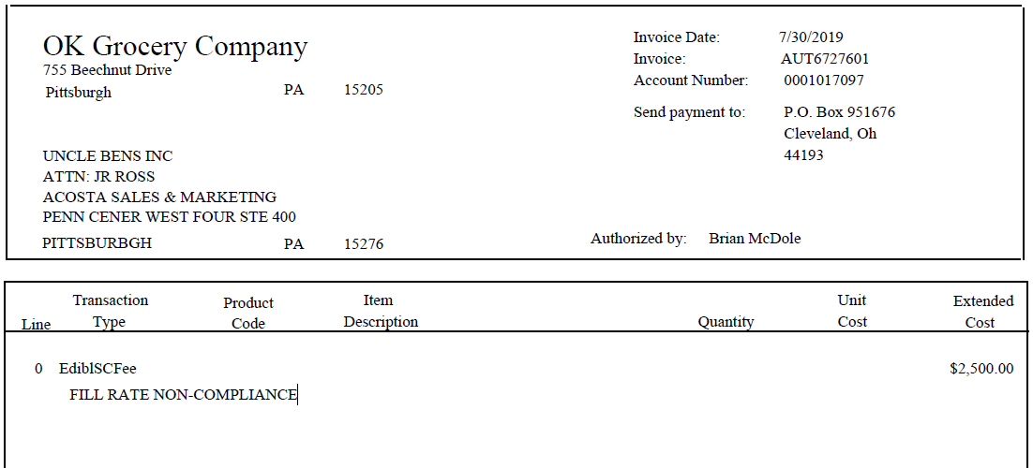
i
i
Amount – This is the total amount deducted.
i
This is the customer reference number.
Description: “Fill Rate Non-Compliance” indicates the claim is for an unloading fee.

20.1 Customer Invoice for Penalty: Example 3, Fill Rate Non-Compliance

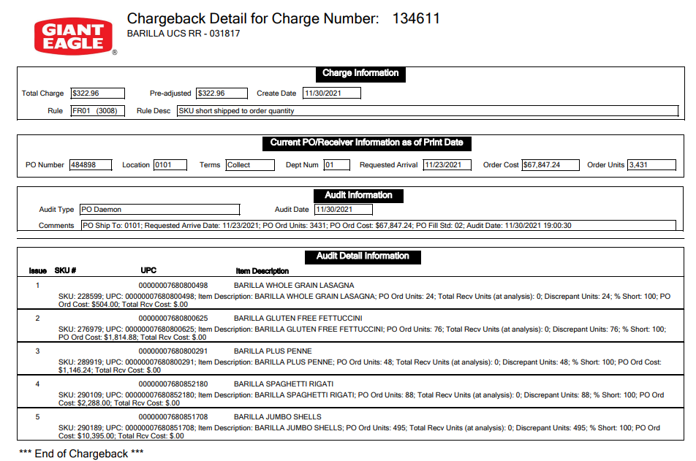
i
Amount – This is the total amount deducted.
i
Description: “Fill Std” indicates the claim is for an unloading fee.
21 Deduction Type: Markdowns
Offer to reduce the shelf price of the product. Usually offered to aid in selling slow moving or discontinued items.

21.1 Customer Invoice for Markdowns: If not provided under View Document, this can be found via Search For: Backup Documentation, Doc Type 2-Customer Invoice.

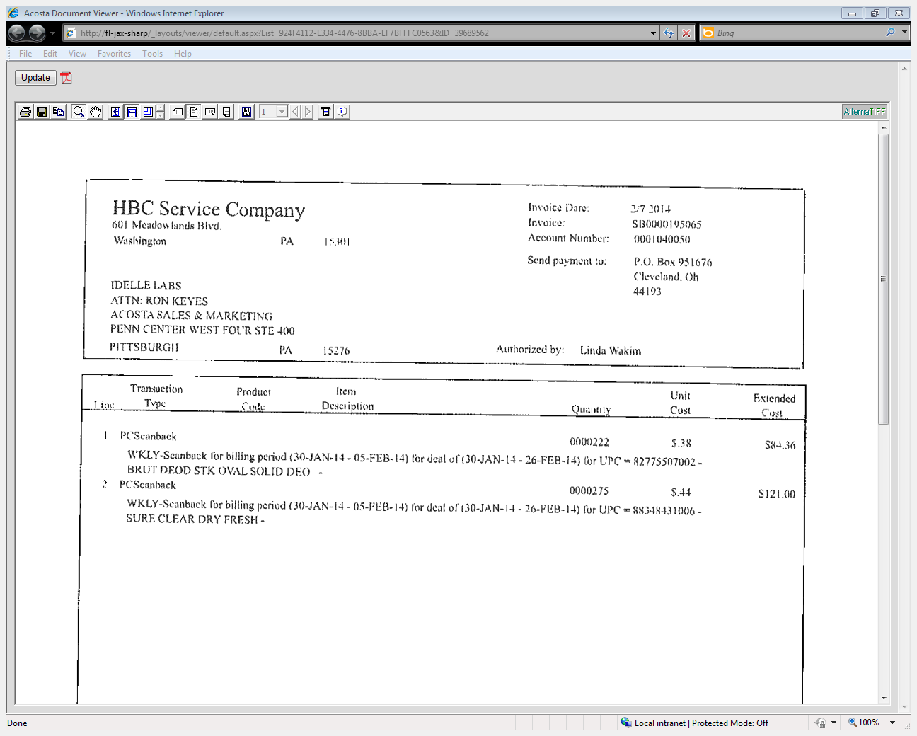
4

Performance Dates – The dates need to match the dates listed on the contract.
3

QTY: The number of units being claimed for the markdown scan.
Scan Value – The rate per unit of the markdown.
2

1

UPC and Desc: The Universal Product Code and description on the customer invoice needs to match with the contract.

21.1 Customer Contract for Markdowns: Found via Search For: Promotions
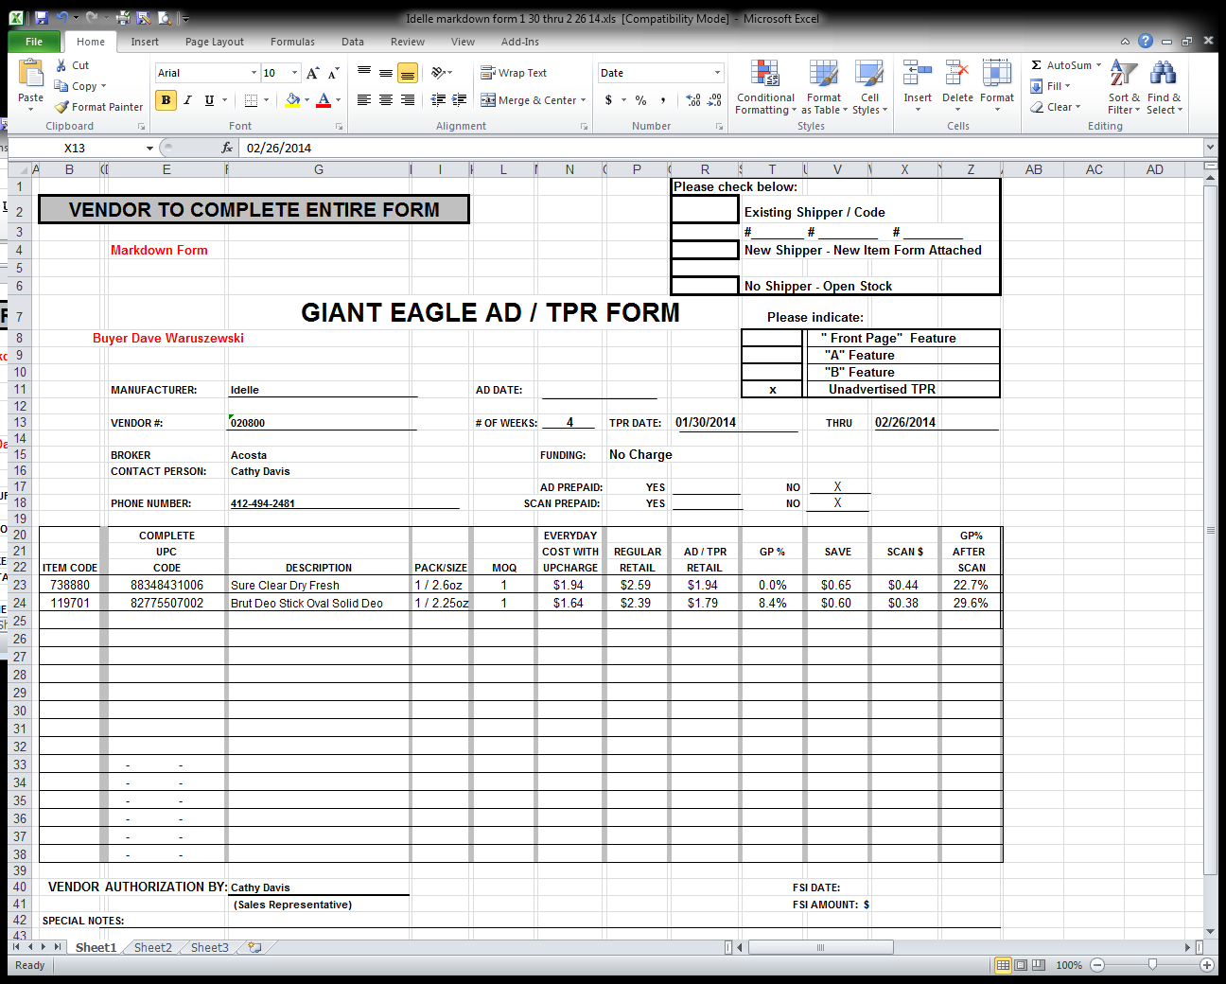
4

Performance Dates – The dates need to cover the dates listed on the customer invoice.
2

Unit Scan Down Amt: This is the rate per unit of the markdown. This must match the customer invoice.
1

UPC: The description and UPC on the contract need to match the products on the customer invoice to validate the claim.

Vendor Comments: The details in the vendor comments box indicates the contract is for a markdown.
i

21.3 Refer to the SOPs/Generic Help File for POP requirements.

22 Deduction Type: Other

22.1 Customer Invoice for Other: Vendor Up Charge (Non-Trade Other)
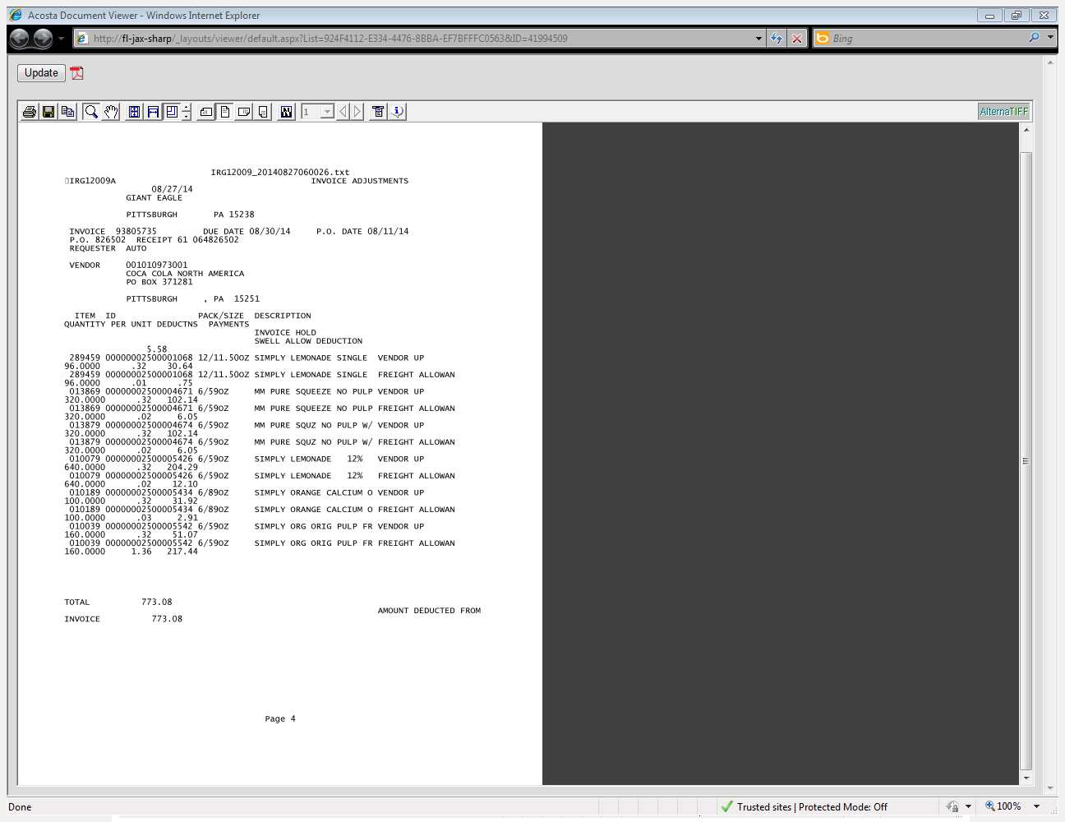
Invoice: This is the Client Invoice/PO #
i
i
Qty/Rate/Total: This is the quantity, rate, total for this UPC.
i
UPC: This is the UPC the customer is questioning the charge.
Vendor Up: This indicates the vendor is charging for something on the invoice the customer does not agree with. In this example when checking the PO the customer is disputing the Tax charges.
i

22.1 Client Order Invoice for Other: Vendor Up Charge

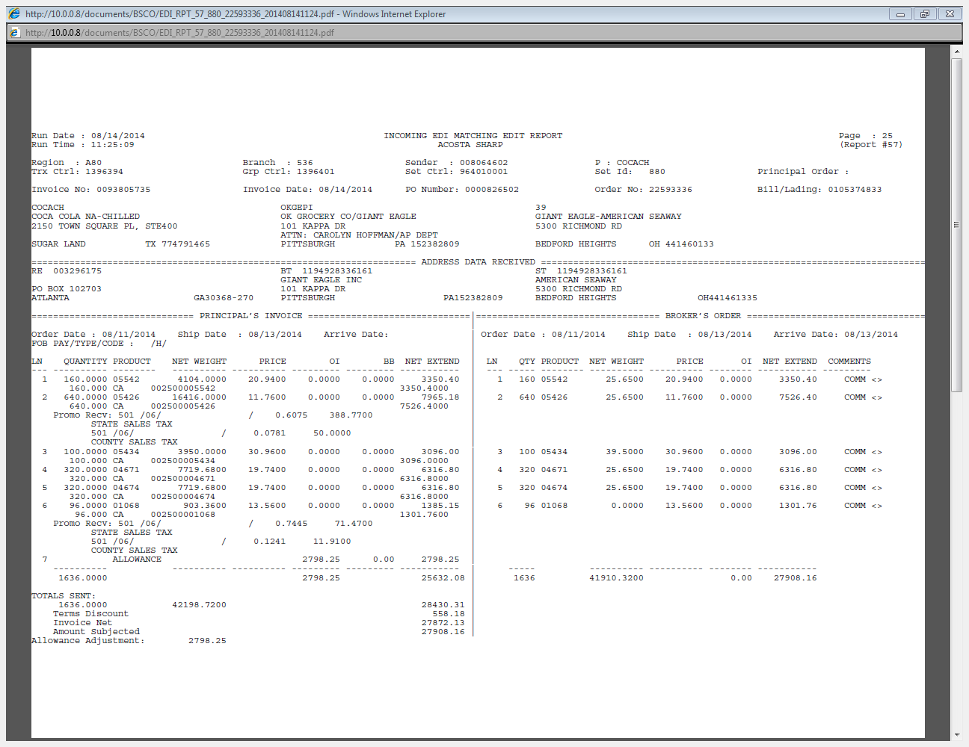
i
Tax: This shows where the item was charged tax in this example.

23 Deduction Type: Retail Merchandising Program

23.1 Customer Invoice for Retail Merchandising Program: Long Term Reset or Fair Share Billing
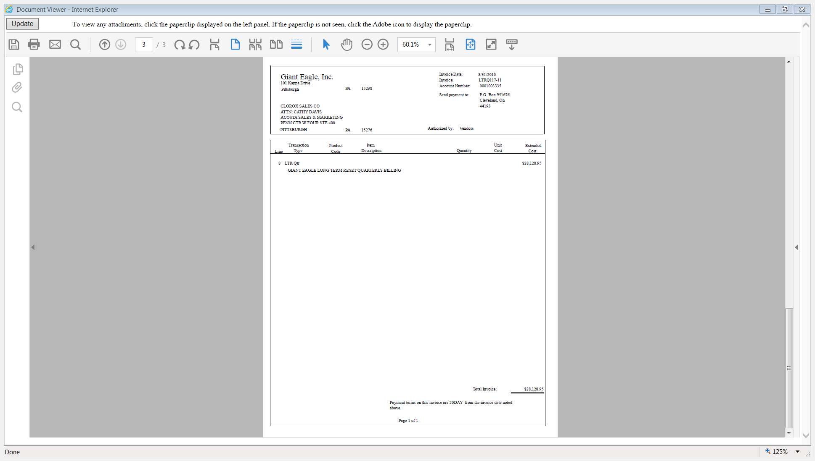
Description: “Long Term Reset Quarterly Billing” or Fair Share Billing” indicates the claim is for the Retail Merchandising Program.
Amount – This is the total amount deducted.
i
i
This is the customer reference number.
i

Fair Share Policy

BPS TEAM INFORMATION

CRA VALIDATION SPECIFIC

CRA Client Specific

CCA CLEARING INFORMATION SPECIFIC

CCA Client Specific

CAMPBELLS
- Claims are cleared to a lump sum/fixed tactic, no variable tactic events are created.

COMPLETE VERSION HISTORY
UPDATE DESCRIPTION | DATE | AUTHOR
First draft of the OK Grocery SOP | 04/11/12 | Narendra Gangaram
Second draft with Flow Charts | 04/22/12 | Narendra Gangaram
Updated by Pam Trimble | 05/02/12 | Pam Trimble
Revised Flow Charts and Definitions | 05/09/12 | Narendra Gangaram
After chairside observations | 06/07/12 | Giriraju TL
Added Count Recount Deduction type example | 07/06/12 | Giriraju TL
Final Review by Trainer | 07/18/12 | Heather Blackwell
Updated all contract examples with DTC requirements and callouts as to where they are located. | 08/08/12 | Geoffrey Van Syckle
Updated Section 2 with updates concerning Deal start and end dates | 09/05/12 | Geoffrey Van Syckle
Update for IRI/Nielsen Price Point Verification | 09/10/12 | Joey Van Zant
Updated hyperlinks to deduction types | 09/16/12 | Nagesh Kumar
Added Example screenshots to Section 7 Count/Recount | 10/08/12 | Geoffrey Van Syckle
Added information about Butler Refrigerated customer invoices, and instruction correction, pages 2 and 3. General edit and corrections to OI and scan sections. Added example of OI claimed on shorted product – section 15. Added client specific information – section 16. | 03/11/13 | Suzy Fields
Corrected examples of Fuel Perks ad. Added explanation box to scan customer invoice example. | 04/01/13 | Suzy Fields
General Edits | 04/08/13 | Tracy Lewis
Moved client section, updated Nielsen and removed client note for Welchs per ticket #2767 | 04/15/13 | Tracy Lewis
Added VK notes to CRC ticket #2798 | 04/22/13 | Tracy Lewis
Added “DC” Ad example ticket #2970, updated notes on locating customer invoices. Changed Diamond from IRI report to Nielsen tool ticket #2632. Added TPR example & Fuel Perks ticket #1723 | 04/29/13 | Tracy Lewis
Added new contract scan example ticket #4536 & ticket #4505, added Demo example ticket #4424. Added HBC TPR example ticket #4093 | 07/22/13 | Tracy Lewis
Added freight info to Section 19 ticket #4557 | 07/29/13 | Tracy Lewis
Added additional details to promo # in scan example #4969. Changed date match to contracts to Retail Reflect Dates #4032. Added HBC Services as another name for OK Grocery #3198. Added Family Foods Group, Dave’s, Golden Dawn & Sparkle of stores American Seaway will deduct on behalf of #4889, #3567/4867, #4862. Added American Seaway invoice example to scan #4726/4548/4834. Added client specific information for Diamond foods ticket #3904. Added Floorstock Example #3060. Added unloading charge #4710 | 8/19/13 | Tracy Lewis
Added customer Signon link (5675) | 10/7/13 | Tracy Lewis
Added client event linking & splitting instructions for Pinnacle (6883). | 2-03-14 | Kristin Jones
Added DBW instructions to Scan Ex 5 (6055) | 3-03-14 | Tracy Lewis
Updated Pinnacle verbage for selecting event # (7535) | 3-17-14 | Tracy Lewis
Added J&J bump chart requirement to Client section (5087) Added McCormick freight allowances are repay to Client section (5212) Added GOJO specific to Client specific section (7454) | 4-14-14 | Tracy Lewis
Added Reason Code to Fuel Perks example (5994) | 4-28-14 | Tracy Lewis
Added where to search for backup to Signon section (7453) Added Diamond specific for shorted OI to Client section (5190) Added note to CRC note dates may be listed in comment section (5802) Added new CRC example (5933) Added new loyalty card example (5964) Added check remittance is required to request missing backup from Customer (5977) | 5-12-14 | Tracy Lewis
Added Markdown example (8150) | 5-26-14 | Tracy Lewis
Added TPR Fee example (6829) | 6-9-14 | Tracy Lewis
Added McCormick small balance exception to Client section (9472) Added process for locating invoices for Coca-Cola to Client section (9399) Added coupon process to Kens in Client section (9288) Added 2nd slotting example (8371) Added Hostess allows shorted deal deductions to Client section (7497) Added McCormick locating invoice process to Client section (6340) | 12-8-14 | Tracy Lewis
Added Campbells customer ref # needs to be updatd to include complete # including line number (11817) Added Kraft redemeption billing requirements to Client section (10954) Added Hostess specific no event #’s until Jan 2015 to Client section (11091) Added invoice dollar amount difference process for Coke to Client section (11751) Added new contract version example to ad section (12073) Added vendor up example to Other section (10978) | 02-02-15 | Tracy Lewis
Added CC invoices are considered coupons cleared internally by client for Boulder Brands (GFA) in client specific section (12180) | 02-16-15 | Tracy Lewis
Updated note for second document in Loyalty Card examples to state the second pg is not necessary unless required by Client (12806) | 03-30-15 | Tracy Lewis
Added this customer is a wholesaler/distributor, direct or indirect customer to customer sign-on box. (13429) | 04-27-15 | Tracy Lewis
Added CCA clearing info for Pinnacle for dates to BPS Team Info section (13345) Added Cambell’s considers pricing incentives invoices as non-trade to Client section (13410) Added Alva-Amco does not allow checks for OK Grocery to Client section (13095)  Added is Req CI from CIT used for this customer to BPS Team Info section (13772) | 05-11-15  5-25-15 | Tracy Lewis
Added Coca Cola Buy X Get Y process to Client specific section (13201) Added out-dated product example to Unsaleable section (13871) | 08-17-15 | Tracy Lewis
Added to shorted deal process for freight for Diamond to Client Specific section (14747)  Updated line level detail in Customer Specific (15509) | 09-14-15  10-26-15 | Tracy Lewis
Clean up and reorganization of information to new format structure & removal of out of date material (14730). Added CLS invoices for damages can be requested from CIT to BPS Team Info section (15554) Added Campbell’s UT events to Client specific section (15741) Added swell allowance for McIlheney to Client specifics (15894) | 12-21-15 | Tracy Lewis
Added note to Ad section about changes to customer policy the invoice/contract may be for a display (15628) Added LCM process for Boulder to Client Specifics section (15634) | 01-18-16 | Tracy Lewis
Added Campbells clears a lump sum tactic in CCA Clearing Info in BPS Team Info section (16717) Updated events for UT for Campbells is F2016 not 2015 in Client Specific section (16801) | 02-15-16 | Tracy Lewis
Added how to search for SBNB customer invoice format to Customer General info section (16567) | 03-14-16 | Tracy Lewis
Added how to handle coupons invoices for Starbucks to Client Specific section (17546) Added MCM is handled like LCM for Boulder Brands in the Client Specific section (17785) | 06-06-16 | Tracy Lewis
Added Clorox CCA Specific for clearing Ad funds (18494) | 06-20-16 | Tracy Lewis
Added requests for backup are sent to Sales to the BPS section (17836) | 07-04-16 | Tracy Lewis
Added note to trade fees for displays in Fees section (18037)  Removed Boulder Brands client specifics (19016)  Updated Post Audit Example and updated process info in Post Audit Section (19056)  Removed Kraft & Heinz client specifics (19311) | 07-18-16  08-01-16  08-29-16 | Tracy Lewis
Updated invoice # reference in CRC section example 2 (19260) | 09-12-16 | Tracy Lewis
Updated event names for Campbells in Client Specific section (19667) | 10-24-16 | Tracy Lewis
Removed Boulder Brands client specifics (19016) Removed extra contract copies and POP examples (19418) | 11-07-16 | Tracy Lewis
Updated low dollar events for Campbells in Client Specific section (19853) | 12-05-16 | Tracy Lewis
Added Clorox exception for GCC to step to sales for this customer to Client Specific section (19689) Added client specific backup info for Frenchs to BPS Team Info section (19846) Added Campbells process for Retail Merchandising Program to Client Specific section (20050) Added Retail Merchandising Program example (19632/19696) | 12-19-16 | Tracy Lewis
Added Sales exception for Colgate to Client Specific section (21011) | 03/17/17 | Tracy Lewis
Added Sunny D Retail Merchandising process in Client Specific section (20168) Added swell info for Vogue International in Client Specific section (20147)  Added Starkist event date process in BPS Team Info section for CCA (20671) | 03/27/17 | Tracy Lewis
Add BIC to client specific section, Acosta does not handle deductions for lighters (21280) | 05/22/17 | Laurinda Ogburn
Added FY2018 events for Low Dollar claims from $300-$500 to Campbells specifc section (22550) | 09-25-2017 | Laurie Barber
Removed J&J specifc section as POP information has changed. See client SOP for simplified POP (22355) | 09-29-2017 | Laurie Barber
Added Starkist specific section to CRA Validation specific section (23197)  Updated hyperlinks for new Sharepoint Online site (23751) | 01-05-2018  02-06-2018 | Laurie Barber  Laurie Barber
Updated client event number info for Campbell in the Client Specific section (24487) | 5/07/18 | Maria Ovalles
Added Performance Fee info for Colgate in the Client Specific section (24717) Added check remit info for CCNA in the Client Specific section (24349) | 6/04/18 | Maria Ovalles
Added swell allowance & Spoils/unsaleables info for Bush to the Client Specific section (25237) Added FY2019 Events for Low Dollar claims from $300-$500 to Campbells specifc section (25281) | 7/30/18 | Maria Ovalles
Added Supplier Non-Compliance Fee info to the Customer General Info section (25211). Added Mailer example to the Ad section (25054). | 8/13/18 | Maria Ovalles
Added swell allowance info for Ainsworth to the Client Specific section (25647) Added swell allowance info for Noosa to the Client Specific section (25561) Added the In-Store Execution Reset Agreement for Harvest Hill to the Client Specific (25306) | 9/10/18 | Maria Ovalles
Added promo fees info for CCNA to the Client Specific section (25985) Added swell allowance info for Starkist to the Client Specific section (25913) | 10/8/18 | Maria Ovalles
Added swell allowance info for Method to the Client Specific section (26246) Added distributors info to the distributor table (25127) | 11/19/18 | Maria Ovalles
Updated DBW instructions for Colgate in the Client Specific section (26278). | 12/3/18 | Maria Ovalles
In Campbell’s/Pepperidge Farm section, added missed OI info for PEPPGR/PEPPBK claims (26694). | 01/04/19 | Kristin Jones
Added Ad approval info for Noosa to the Client Specific section (26480) Added Get Go Invoices process for CCNA to the Client Specific section (26646) | 01/28/19 | Maria Ovalles
Added Retail Merchandising / ISE Program info for Toms of Maine to the Client Specific section (27019) | 02/11/19 | Maria Ovalles
Removed McCormick/Frenchs information as Acosta no longer represents them from the Client Specific section (26829) | 02/13/19 | Maria Ovalles
Added Retail Merchandising program info for Mars Foods to the client Specific section (27231) Added FY2019 Event for V8 Fusion Low Dollar claims from $300-$500 to Campbells specifc section (27438) Renamed SOP doc to match AR. | 03/25/19  4/5/19 | Maria Ovalles
Removed Method information as Acosta no longer represents them from the Client Specific section (27787) Removed Ainsworth Pet Nutrition from the Client Specific section Acosta no longer their broker (27796)  Removed Clorox from the Client Specific section, Acosta no longer represents them (28157)  Removed Pinnacle from the Client Specific section, no longer handle claims effective 8/26/19 (28434) | 5/20/19  7/1/19  8/26/19 | Maria Ovalles
Removed Swell Allowance info for Noosa from the Client Specific section (28690) Removed Starkist from the Client Specific section, Acosta no longer represents them (28760) | 10/21/19 | Maria Ovalles
Transitioned customer backup requests to GCIT. Removed Customer System & Backup Retrieval section from BPS Team section and added Backup Retrieval Information section. | 11/8/19 | Maria Ovalles
Added Fill Rate Non-Compliance example to the Penalty section (28844). Removed view document verbiage and updated backup retrieval section format | 11/18/19 | Maria Ovalles
Removed Starbucks specific info (29269) Removed Diamond from the Client Specific section, Acosta no longer represents them (24573) | 1/27/20 | Maria Ovalles
Removed Hostess/Superior Cake specific info Acosta is no longer their broker (29293) Added Coupon Policy to the Process step section and updated backup retrieval info section (29264) | 2/10/20 | Maria Ovalles
Removed Colgate specific info, Acosta is no longer their broker (29496) Removed Bic specific info, Acosta is no longer their broker (29499) Removed Toms of Maine specific info, Acosta is no longer their broker (29497) | 2/24/20 | Maria Ovalles
Added SB invoices info for Merisant to the Client Specific section (29533) | 3/23/20 | Maria Ovalles
Added under tolerance info & DBW requirement for Merisant to the Client Specific section (29904) Removed all of the content regarding low dollar claims and events info for the Campbell's from the Client Specific section (29786) | 4/20/20 | Maria Ovalles
Added another recall example to the Process Steps section (29850) | 5/4/20 | Maria Ovalles
Updated Get Go Invoices info for CCNA in the Client Specific section, Added Get Go Info to the Customer General info & Backup Retrieval info sections. (30794) | 9/7/20 | Maria Ovalles
Removed outdated info for CCNA from the Client Specific section (31057) | 11/2/20 | Maria Ovalles
Removed outdated info for Sunny D from the Client Specific section (31123) | 11/16/20 | Maria Ovalles
Added division info for Newell to the Client Specific section (31085) | 11/30/20 | Maria Ovalles
Updated Coupon info in the Process step section, added info on coupon invoices to the General Info section and updated backup retrieval info section (31643) | 2/12/21 | Maria Ovalles
Removed Newell client specific info (31785) Added customer invoice info for non-compliance invoces to the Customer General Info section (31895) | 3/22/21 | Maria Ovalles
Added another fill rate non-compliance example to the Penalty section (33096). | 1/24/22 | Maria Ovalles
Updated portal info in the Backup Retrieval info section and added example of AR Settlement letter to the General info section (33242). | 3/7/22 | Maria Ovalles
Added customer contact to the General info section (33302). Added another example of AR Settlement letter to the General info section (33242). | 4/18/22 | Maria Ovalles
Removed outdated info from the whole SOP (33780). | 7/18/22 | Maria Ovalles
Added Harvest Hills/Sunny D AR Settlement letter info to the Backup Retrieval info section (33738). | 7/25/22 | Maria Ovalles
Added Campbell’s Cust # info to the Client Specific section (33892). | 8/29/22 | Maria Ovalles
Added Campbell’s settlement letter info to the Backup Retrieval Info section (34070). | 11/14/22 | Maria Ovalles
Updated Campbell’s Cust # info to the Client Specific section (34615). | 3/20/23 | Maria Ovalles
Updated Campbell’s Cust # info to the Client Specific section (34615). | 6/12/23 | Maria Ovalles
Added client contact for Edgewell to the Backup Retrieval Info section (35011). Updated the Backup Retrieval info (34864) | 6/19/23 | Maria Ovalles
Added Giant Eagle Settlement Letter reconciliation instructions to the General Info section (35277) | 7/24/23 | Maria Ovalles
Removed Starkist info from Client Specific section (35363) | 8/21/23 | Maria Ovalles
Removed Starkist info from Client Specific section (35363) | 9/11/23 | Maria Ovalles
Added digital media sales info for CCNA to Client Specific section (35399) | 9/18/23 | Maria Ovalles
Updated the Customer contacts in the Customer General Info section (35558) | 10/30/23 | Maria Ovalles
Updated the check remit info in the Backup Retrieval section (35775) | 12/04/23 | Maria Ovalles
Added check request info for Litehouse to the Client Specific section (385779) | 06/10/24 | Maria Ovalles
Updated information pertaining to AR Settlement Letters to the Customer General Information section (401837) | 10/07/24 | Dawn Regan
Added J.M. Smuckers to Client Specific Section (405398). | 11/4/24 | Dawn Regan
Added information for J.M. Smuckers in the Client Specific Section (406283). | 11/18/24 | Dawn Regan
Updated information for Campbells in the Client Specific Section (407720). | 12/9/2024 | Dawn Regan
Updated information for Campbells in the Client Specific Section (412574). | 1/26/2025 | Dawn Regan
Added Beiersdorf and swell information in the Client Specific Section (420608).  Added information regarding Traverse invoices in Backup Retrieval Information Section (420762). | 4/7/2025 | Dawn Regan
Updated information in Backup Retrieval Information Section regarding CCNA (423611). | 5/5/2025 | Dawn Regan
Updated information in Backup Retrieval Information Section regarding J.M. Smuckers (429655). Replaced listing of customer contacts with updated listing in Customer General Inforamtion Section (429062). | 6/30/2025 | Dawn Regan
Updated information for Beiersdorf Inc in Client Specific Section (433757). Added contact listing/directions for backup for J.M.Smuckers. (435566) | 8/04/2025 | Dawn Regan
Updated listing of backup contacts in Backup Retrieval Information Section (437773) | 8/25/2025 | Dawn Regan
Updated information for Campbells in Client Specific Section (448708). | 11/17/25 | Dawn Regan
Added client and information for Nestle USA in Client Specific Section (452356 and Sunsweet Growers in Client Specific Section (456208). | 2/2/2026 | Dawn Regan
Added information and contact listing in Backup Retrieval Information Section for Campbells. (456040). Updated information for Sunsweet in Client Specific Section (457280). | 2/16/2026 | Dawn Regan
Added repay information for Campbells in Client Specific Section. (462270). | 3/23/2026 | Dawn Regan

