WORK INSTRUCTIONS

Process | Order to Cash
DTP Name | Save Mart Yosemite Save Mart Food Maxx Claims Validation Documents

CURRENT VERSION HISTORY

 | UPDATE DESCRIPTION | DATE |  | AUTHOR
Added Seneca Foods to the Client Specific Validation Information section (470790) |  |  | 5/25/2026 |  | Lindsay McGinnis

Link to complete version history: COMPLETE VERSION HISTORY

DEDUCTION TYPES COVERED
Sl. No. | Deduction Type
 | Customer General Information
 | Backup Retrieval Information
 | Client Specific Validation Information
1 | Off Invoice
2 | Bill Back
3 | Scan
4 | Ad
5 | Slotting
6 | Coupons
7 | Displays
8 | Food Shows
9 | Unsaleables
10 | Pricing (Non-Trade)
11 | Post Audit
12 | Returns (Non-Trade)
13 | Shortage (Non-Trade)
14 | Freight (Non-Trade)
15 | Retail Merchandising Program (Fair Share, Replacement Fees)
16 | Penalty Fees
 | BPS Team Information

Is the customer a Wholesaler/Distributor, Direct or Indirect customer? Indirect, they purchase product through C&S.

Note: SMMONC(Save Mart), FOOMNC(Food Maxx), and LUCKYNC(Lucky’s) are the Sign-ons used to work on Acosta Relay.

Sign ons to use for contract, backup, and PO/COI searches (do not change claim signon unless indicated by client)

ZZEVSSNC
ZZMAS3NC
YOSENC
SMMONC
FOOMNC – When the customer invoice has “FMO” this indicates that it is for Food Maxx and contract should be searched using this sign on.
LUCKYNC
SMPLUSNC
SUPENC

Save Mart IBM Deal Management VPF/contracts are typically found using the YOSENC signon. IBM Deal Management contract searches for Lucky’s work best in Event Scheduler using the ZZMAS3NC signon and %Deal% number in the customer event field. The physical contract may be found under any of the signons listed in the signon box above. Food Maxx IBM Deal Management VPF/contracts are typically found using the FOOMNC signon. NOTE: The physical IBM Deal Management contract (including a revised contract) for any division of Save Mart may be found under the YOSENC signon. When searching in backup documentation for these contracts, use %Deal#% in the client reference field.

Link to customer signon job aid:
https://acostaonline.sharepoint.com/sites/AS_Reporting/Claims_Reports/Forms/AllItems.aspx?web=1

Does customer subscribe to IRI/Nielsen for price point verification? Yes

CUSTOMER GENERAL INFORMATION

Customer Invoice Info

Is line level detail indexed on the customer’s documentation (Customer Invoice, Customer Check Request, Unsaleable/Spoils, Post Audit, EDI 812/820 or Client Deduction Notice if one of these documents is included)? YES

It is imperative that the repository and portals are searched thoroughly under all necessary signons and divisions due to Savemart charging $50 for each duplicate copy of backup that is sent.

Note: SaveMart/Food Maxx does not always supply any support documentation (Customer Invoice explaining why they are deducting) for PO Related claims: including Off Invoice, Billback, Pricing and Cash Discount. You must pull the Client Order Invoice and back into the claim.

You will need to review and follow the directions provided in the job aids listed below. These are located on Acosta Relay main screen under Claims then SOP Documents.

- PO Related Claims
- Pricing Deduction Job Aid
- Cash Discount Job Aid

**Please review the order found under View Documents of the Review Order Screen to determine which customer the order shipped to.
If, for these invoices, you are able to validate the majority as a BB or OI, GCC should split off the part that cannot be validated and escalate for Customer Invoice. Likewise, if no part of the PO can be validated, GCC should escalate for Customer Invoice.

Food Maxx will use their original purchase order (PO) to reference bill backs. This may be used to identify the QTY and allowances the customer is deducting for and assist in locating the contract. Locate the PO in ACOSTA RELAY using the Orders/Invoices/PO search screen. Under View Documents, at the top of the PO screen, a copy of the original order may be located under the Active Documents section. The contract will be the same as the purchase order, but must be indexed as a contract in ACOSTA RELAY for use in validation.

Cross Dock items are products that Food Maxx ordered which is crossing the Save Mart dock and being loaded on a truck going to Food Maxx. The product being ordered/cross docked is NOT a stock item in the Save Mart warehouse. The contract will be a Food Maxx contract.

Invoices may be indexed under any of the customer sign ons. These should be searched for by replacing the prefix (DEAL, RDS) with the wildcard (%) on the Backup Documentation search screen.

Spoils/Unsaleables may begin with the prefix PRC or SUN. However, not all PRC invoices are for spoils. Those ending in DM or A are debit memos and copies must be requested via the backup procedures outlined in the BPS Team information section.

Save Mart will take deductions for allowances offered on products that were cut from orders. These deductions are called “shorted deals”. These allowances may be Off Invoice or Bill Back, or other types of allowances. There should be a contract for these products and allowances. SEE EXAMPLE NEXT PAGE
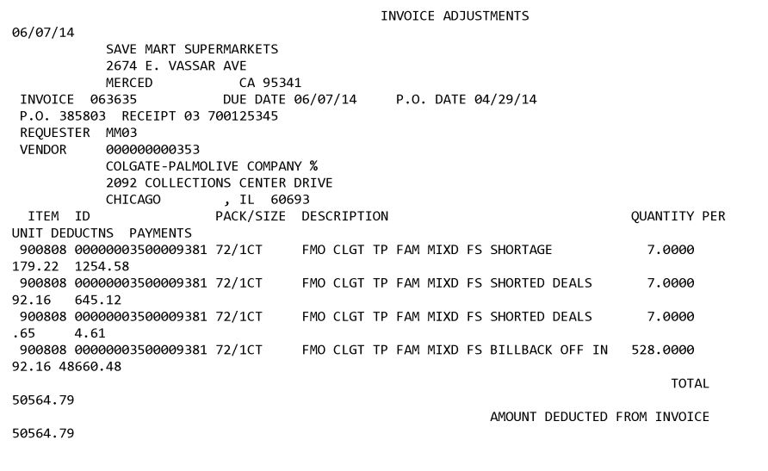

Save Mart will only use each DEAL # once. The “P” at the end of DEALxxxxxP stands for Partial Payment due to not enough funds. These will result in a split deduction (more than one claim tied to the customer invoice). The Customer Invoice will not have the P included on the invoice number.

Invoice numbers ending in F are for the fee C&S charges when deducting on behalf of an indirect. The check remittance will indicate "service fee". There will be no separate invoice for reference numbers ending in 'F' and these claims should not be escalated for missing invoice. See below for more information in Other General Info.

Contract Info:

Save Mart is an Acoustic DemandTec customer. an Acoustic DemandTec Contracts/Deal Sheets have a reference number that may be used to identify which store the deduction belongs to and assist in locating the contract. These numbers are listed on the customer invoice as the Deal #. The first 3 numbers indicate the division:

710 = Save Mart
810 = Food Maxx
910 = Lucky’s

NOTE: Some contracts are generated outside of Acoustic DemandTec. These may be located under any of the sign ons listed in the box above.

When searching for the Acoustic DemandTec contract use the Deal Sheet # listed on the invoice minus the letters at the end. These letters (SSI,VAC,STK etc) should not be included when completing the search in AR or entered in the Check # field when requesing contracts to be downloaded.
Even though the last letters will not be used when searching or requesting contracts to be downloaded, these letters should match on the invoice and the contract. If the VPF and the contract is not available in AR for the correct division (SSI, VAC, etc) step to sales for the contract. Effective 9/15/24 Save Mart, Lucky, and Food Maxx are owned by C&S the contract will include the STK abbreviation.

Speed Fee contracts will not have the $6.00 fee listed on their contracts.

POP Info:
For Sales Analysis Reporting - Since SaveMart/Yosemite or FoodMaxx can purchase product direct from the client or pull product from a direct customer, the report needs to be ran using all of the following customer signons: FOOMNC, SAVENC and SPRSNC. Note – Save Mart also owns FoodMaxx & Lucky’s.

Refer to the Proof of Performance Reporting Ads job aid for searching for ads.

Other General Info:
Refer to the C&S SOP for fee examples.

BACKUP RETRIEVAL INFORMATION

GENERAL BACKUP RETRIEVAL INFORMATION

Is GCIT responsible for obtaining backup from the customer? Yes
- If yes, is there a customer portal? No
- If yes, does GCIT request backup? Yes

Is check remittance information required to request backup? No

- PO related claims, after attempting to back into the PO/COI, if unable to validate the claim and additional backup is needed:
  - Note the claim with details on what was researched.
  - If a portion can be validated, include math notes on what could be validated.
  - Note if the claim is related to SM Roseville or Yosemite warehouse.

GCIT SPECIFIC BACKUP RETRIEVAL INFORMATION

Portal:

Customer Invoice or Note Identifier | Request From
PRC, SUN no DM or A at the end of the ref # | Pull from CLS portal
LRD | Pull from C&S Portal

Automated:

Customer Invoice Identifier | Request From
801, 802, 803 (begins with) | APDC@savemart.com
CRV | APDC@Savemart.com
OTH | Julie.Ton@savemart.com
CPN | maryann.king@savemart.com
DEAL, RDS | VendorDeals@savemart.com
PRC, SUN no DM or A at the end of the ref # (if not available in the portal)  CLA | reclamation@savemart.com
DD | Alex.salas@savemart.com
FLX or invoices with F at the end | savemart@flextecs.com
LL | sal.costanza@savemart.com
RE, YW, SRT | Diana.urban@savemart.com
PAG | savemart.audit@pinnacleaudit.com
PRGX  PRGAUDIT | Savemart.audit@PRGX.com
VRAAUDIT  JPD | claimsdept@jpdfinancial.com
APAUDIT | AP@savemart.com
SPD | speedprogram@savemart.com
Smart Charge TRD | smartcharge@samvemart.com
Repositrak – RT | miscreceivables@savemart.com
CCNA related invoices | Deborah.Hollins@savemart.com

Non-Automated:

Client name beginning with | Request From
Tillamook (PO related backup) | adelite.perez@savemart.com
A-C (PO related claim and IS NOT noted that the warehouse is SM Roseville or Yosemite:) | Jason.scott@savemart.com and APDC@savemart.com
D-J (PO related claim and IS NOT noted that the warehouse is SM Roseville or Yosemite:) | APDC@savemart.com
K-Q (PO related claim and IS NOT noted that the warehouse is SM Roseville or Yosemite:) | APDC@savemart.com
R-Z excluding Tillamook (PO related claim and IS NOT noted that the warehouse is SM Roseville or Yosemite:) | APDC@savemart.com
A-C PO related claim and IS noted that the warehouse is SM Roseville or Yosemite | APDC@savemart.com
D-J PO related claim and IS noted that the warehouse is SM Roseville or Yosemite | APDC@savemart.com
K-Q PO related claim and IS noted that the warehouse is SM Roseville or Yosemite | APDC@savemart.com
R-Z excluding Tillamook PO related claim and IS noted that the warehouse is SM Roseville or Yosemite | APDC@savemart.com
Save Mart Gift Cards | giftcards@savemart.com

CLIENT SPECIFIC VALIDATION INFORMATION

Client
Bush | Mars Food
Baldwin Foods | Nestle Coffee Partners
Barilla
Beiersdorf | Nestle Nutrition
Campbell’s | Noosa
CCNA | Seneca Foods
Farmland | Sunny D
Kens | Tillamook
Merisant Company

BARILLA
- Invalid post audits must be submitted through the Pinnacle Audit Group portal. The portal link for the audit can be found in the email attached to the Post Audit. If the email is not on the claim or if the link is expired, a new link is requested from claims admin@pinnacleaudit.com.

BALDWIN RICHARDSON FOODS

- Reclamation deductions / invoices always come in from Super Store Industries referencing RDS-PRC38346 (Baldwin’s vendor number is 38346). The actual invoice number will not match the claim. This is because the client sells to SSI, and SSI distribute to Save Mart.

BEIERSDORF
- Savemart deduction through C&S will not have the customer signon updated, the customer signon should reflect C&S West and will be cleared to C&S events.

BUSH
- Deductions for SAS Program will be handled in house. Backup must be attached to claim. Claim stepped Unknown/Not Acosta with notes that this is SAS program, handled internally. Backup is sent to Julie Jarnagin jjarnagin@bushbros.com.
- Invalid post audits must be submitted through the Pinnacle Audit Group portal. The portal link for the audit can be found in the email attached to the Post Audit. If the email is not on the claim or if the link is expired, a new link is requested from claims admin@pinnacleaudit.com

CAMPBELL’S
- SAS, Resets, Merchandising Fee, SRD Percent – are coded as Non Trade Retail Merchandising with a note to clear to the direct fund store resets.
- PEPPGR and PEPPBK – Update customer number in the header to CUST:0000017900.

CCNA
- Use the following for 2025 C&S 5% service fees.

BC | Brand | Event Amount | Claim Clearing % Split | TPM Event #
09 | SIMPLY ORANGE 6/52OZ PET | $9,000 | 10.00% | 1000315856
S9 | SIMPLY ORANGE 6/46OZ | $19,000 | 21.00% | 1000314390
B0 | SIMPLY ADES 6/52OZ PET | $7,500 | 8.00% | 1000315857
C0 | SIMPLY JUICE DRINKS 6/52OZ PET | $13,000 | 14.00% | 1000315859
V9 | SIMPLY GOLD PEAK TEA 6/52OZ | $8,000 | 8.00% | 1000315860
X3 | MM CHL PUN 8/59 OZ CRTN | $18,000 | 20.00% | 1000315858
SP | FAIRLIFE MILK 6/52 OZ PET | $18,000 | 19.00% | 1000315861
 |  | $92,500 | 100.00%

FARMLAND
- Invoices that say Vendor UP with an amount are for a leaker allowance. This portion of the invoice should be stepped as Unknown/Unknown with a note on the Client Event # field that says Leaker. Please see Client SOP for additional instructions.

HARVEST HILL
- CRV is a bottle tax deduction and will be handled internally
KENS
- Fees generated by C&S are cleared to event 25C-192-013A. These fees can be identified by the F at the end of the customer reference number (Ex. DEAL123456F)

MERISANT
- C&S does not handle the Swerve business for Save Mart/Lucky; instead, Kehe is responsible for managing it. Therefore, any Swerve deductions for Save Mart/Lucky should be cleared against a promotion under Kehe, which requires the claims team to update the promoted customer in client TPM.

MARS FOOD
- Save Mart is part of the Retail Merchandising Program.

NESTLE COFFEE PARTNERS
- The Nestle Account manager has given approval for the BMA to confirm funds in Osprey and authorize clearing. The GCC/CRA will note FUNDINGAPPROVED on the line note and close once sales confirm funds.

NESTLE NUTRITION
- SPD invoices or new replacement items are handled and stepped as Trade / Slotting.

NOOSA
- Acosta now handles deductions for this client as of 3/1/2019
SENECA FOODS
- SM350 $33,000 ACOSTA PACKAGE A LUMP SUM are valid rebates. No proof of performance.

SUNNY D
- Acosta does not represent Savemart deduction through C&S.
- For Food Maxx (FOOMNC) only: Deductions for missed Off Invoice on any PO that was ordered outside of the deal window (contract dates) should be cleared to the closest promotion (contract date). GCC/CRA/CCA should pick closest contract/event number and process the deduction to that event.
- CRV is a bottle tax deduction and will be handled internally

TILLAMOOK
- SPD (Fair Share) invoices must be broken out by product group. The claim will be stepped as Non Trade/Retail Merchandising with notes that the deduction is for reset fees. Cleared to an Event.

PROCESS STEPS
- Deduction Type: Off Invoice

A per case Off Invoice allowance is given to the customer as an automatic discount for product purchased from the client. If the customer does not receive the allowance off the face of the invoice they will deduct for it. If the customer requested an allowance that is not valid, the CSC will send a notification to the customer in writing. Customers view purchase orders as contracts. If they are not notified of allowance discrepancies, they will pay according to their purchase order total.

  - Customer Invoice for an Off Invoice allowance not given:
This is the Client Order Invoice number. This also serves as the Customer Reference number for searching for the document in Backup Documentation, Doc Type 2. This would be used to search and retrieve the Order/Invoice data from the Review Order/Linked Documents link screen within ACOSTA RELAY. Also, this needs to be matched with the Client Order Invoice. This data is needed to validate if the particular product was shipped and invoiced with the Off Invoice allowance
In this case the invoice number is 01567416.

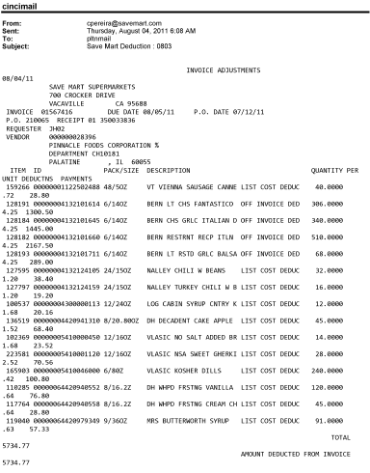
1
Mfr. Case UPC should match the Client Order Invoice and Contract.
This represents Off Invoice allowance discrepancy.
PO Number – This can be used to search for information regarding the order within ACOSTA RELAY. Eg: - In this case the PO # is 210065.

i
2
1
i
3
Final qty – The quantity listed is the quantity the customer has deducted as part of the Off Invoice not given.
4
This refers to the Off Invoice rate and it should match with the OI Rate on the Contract.

Item ID – This the Save Mart Item ID, which needs to be matched with the Contract and against this number, we can find the UPC Number on the contract in the corresponding column, which can be used to validate the UPC Code in Client Order Invoice.

  - Customer Contract for an Off Invoice allowance: This is required to compare the details which are referenced on the Customer Invoice and Client Order Invoice. Contracts are found via a “Search For” Promotions.
Savemart Contract # minus the letters at the end will assist in locating the VPF and Contract in ACOSTA RELAY.

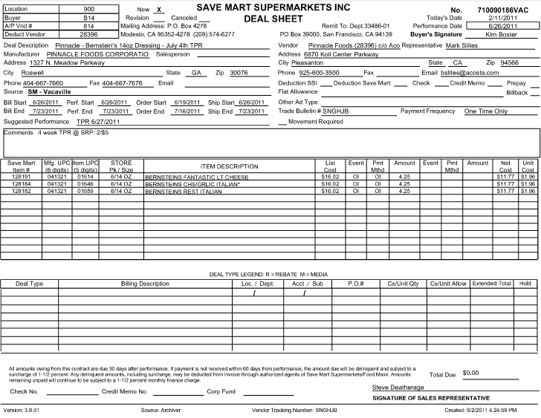
Rate - This is the per case Off Invoice allowance amount. This amount should match with the Customer Invoice and Client Order Invoice.

2
1
Ship Dates – This is the ship dates and the invoice date on the client order invoice should fall within these dates. In this case the ship date is from 06/26/2011 to 07/23/2011.
UPC Code – The Universal Product Code (UPC) is used to validate key data elements regarding the Customer Order and Client Order Invoice in the Review Order link of ACOSTA RELAY. This is the product the customer deducting for the off invoice not given.
Eg: - In this case the UPC is the highlighted in red 01614.
5
i
This indicates this is for an Off Invoice Allowance.

  - POP for an Off Invoice not given allowance: Refer to the Client SOPs/Generic Help File for POP requirements.

- Deduction Type: Bill Back

A Bill Back claim is a per case allowance offered for a specific performance requirement. A per case bill back allowance is claimed by the direct buying customer for product purchased from the client, or by the indirect customer for product purchased from the direct customer. This is an allowance the customer will bill the client for. This is not an automatic discount given off the face of the invoice.

NOTE: When the customer invoice has “FMO”, this indicates that it is for Food Maxx and the Contract should be searched for using the FOOMNC sign on.

2.1 Customer Invoice/ Food MAXX PO for Bill Back:

PO Number – This can be used to search for information regarding the order within ACOSTA RELAY. The Client Order Invoice data is needed to validate if the particular product was shipped and invoiced with the Bill Back allowance.
Eg: - In this case the PO # is 31128.

i
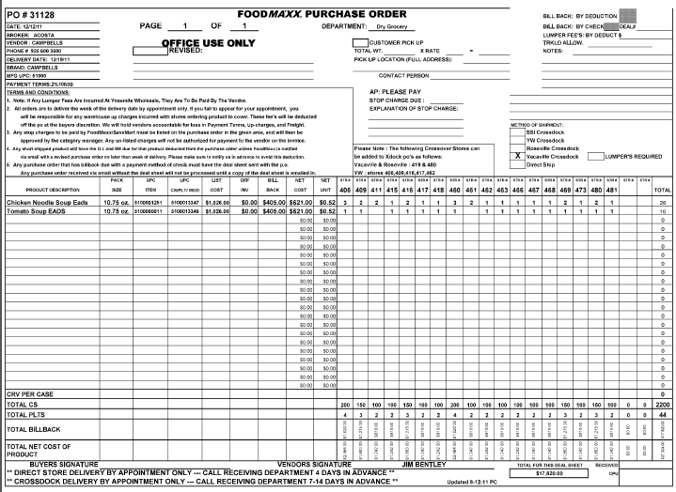
3
2
This refers to the Bill Back rate and it should match with the Bill Back Rate on the Customer Invoice.
Mfr Item UPC Code – This is the Mfr Item UPC that matches the customer contract. The Mfr UPC case code is used to validate key data elements regarding the Customer Invoice and Client Order Invoice in the Review Order link within ACOSTA RELAY.

Total # of cases for this order.
Qty- The number of cases per UPC the customer is requesting the Bill Back rate on.
i
i
Total Billback – The highlighted amount is the total amount the customer has deducted as part of the Bill Back allowance.
1
This indicates this is for an Bill Back Allowance.

2.2 Customer Contract for Bill Back: Contracts can be found via “Search For” Promotions.

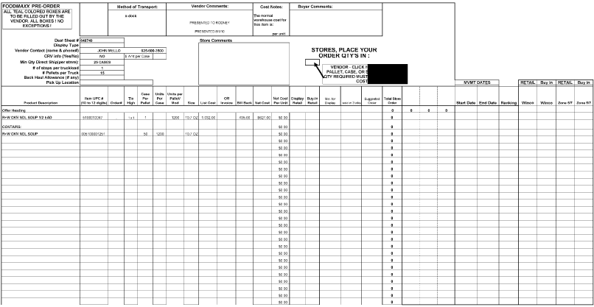
This refers to the Bill Back rate and it should match with the Bill Back Rate on the Customer Invoice.
2
Mfr Item UPC Code – This is the Mfr Item UPC that matches the customer Contract. The Mfr UPC case code listed on the Customer Invoice can be used to validate key data elements regarding the Customer Invoice and client order invoice in the Review Order link within ACOSTA RELAY.

1

2.3 POP for Bill Back: Refer to the Client SOPs/Generic Help File for POP requirements.

2.4 Customer Invoice for Billback
When the Customer Invoice states SaveMart at the top of the claim, the deduction could be for SaveMart or Lucky’s. Checking the Deal # will assist in determining which Contract matches the customer claim ( see 1st 4 numbers in the Deal column for reference 7100 = SaveMart, 8100= FoodMaxx, 9100=Lucky’s) Note – Save Mart also owns FoodMaxx & Lucky’s.
(e.g. This particular claim is for Save Mart).

Example #2
2
1
Product details, which needs to be matched with the Contract and POP.

These dates should fall within the Contract Ship Dates on the Contract.
This is the Bill Back Rate the customer has claimed for the Bill Back allowance.
Invoice # – This is the reference number used to search for the Customer Invoice within ACOSTA RELAY. This is also the Customer Reference number for Customer Invoice. It may show on the Claims Processing Screen with the prefix DEAL.
i
i
i
This refers to the Deal Number and it should match with the Deal ID # on the Customer Contract. Enter this number minus the letters at the end in the customer event number field when searching

Page 2 – Customer Invoice for Billback
3

2.5 Customer Contract for Billback
Savemart Contract # minus the letters at the end will assist in locating the VPF and Contract in ACOSTA RELAY.
Example #2

1
Customer Item/UPC/Description: This has UPC code details, which needs to be matched with the Customer Invoice and POP.

3
Performance Dates – The performance date on POP should be within these dates.
i
Indicates the deduction may be a direct claim from Savement to the client.
i
2
The customer name on the Invoice needs to match the Contract. Note – Save Mart also owns FoodMaxx & Lucky’s.
(e.g. this particular claim is for Save Mart).

This is the Bill Back Rate, and needs to be validated with the Customer Invoice.

2.6 SaveMart/FoodMaxx Customer Invoice for Billback (deducted through SSI): Example # 3

(Locate the SaveMart/FoodMaxx Customer Invoice using customer sign-on YOSENC or FOOMNC and link to the claim) – THIS EXAMPLE IS A FOODMAXX DEDUCTION.

Invoice Number – Customer Invoice Number will show on the Claims Processing Screen as DEAL310623. When searching for the invoice, use only the wild card % and 6 digits 310623 in the Customer Reference field on the ACOSTA RELAY search screen.
3
2
5
4
i
Contract must match the store name = FoodMaxx and the suffix on the deal sheet (VAC). (Please note, other deal sheet suffixes SSI, ROS, YW) to ensure the correct Contract is used in validating the claim and should match the Customer Invoice information. (Please note, Savemart banner stores include Foodmaxx and Lucky’s, This type of claim example could also be noted in this area as SaveMart
i
i
Case Qty and Case Allowance – Total cases and Bill Back allowance amount per case claimed by the customer

Performance Description - Provides the product description and this product should be listed on the Contract.

Date of Perform. = This date should fall within the Ship Start/End dates of the Contract.
No, - Represents the Contract number and is used to locate the VPF under Promotions and the Physical Contract under Backup Documentation under Doc Type 17 - Contract.

i
Amount Due – Represents the total amount claimed by the customer for the Bill Back allowance.

2.7 SaveMart/FoodMaxx Contract for Bill Back (deducted through SSI):

(Search for the Contract using customer sign-on YOSENC or FOOMNC or leave the customer sign-on blank)

1
2
5
Event BB = Billback; Method D = Deduction; Amount = $5.76 per case Bill Back allowance.

No - Represents the Contract number and is used to locate the VPF under Promotions and the Physical Contract under Backup Documentation under Doc Type 17 - Contract.

Source – Identifies FM (FoodMaxx) and the product movement from the Vacaville whse.

Suggested Performance: TPR (Temporary Price Reduction) Identifies the performance required in order for the customer to receive the bill back

i
Item UPC 00668 (Case UPC 00509) and Product Description should match the Customer Invoice.

i
Identifies the customer deduction source

i
i
Ship Start/End Dates – The dates on the Customer Invoice should fall within these.

Deal Sheet Store Name – FoodMaxx must match the Customer Invoice.

i
Note: SaveMart/FoodMaxx/Lucky’s Contracts are created in the Acoustic DemandTec system. Using the Contract number minus the last letters, locate the VPF found under Promotions and link it to the claim. You must ensure that you select the correct Contract based on the store name and suffix (VAC; SSI) at the end of the Contract number.

3.0 Deduction Type: Scan

An allowance for products scanned at the store through the register and are usually billed in eaches, not cases. The customer should not be referencing a purchase order on a scan allowance.

  - Customer Invoice for Scan:
4
Invoice # – This is the reference number used to search for the Customer Invoice within ACOSTA RELAY. This is also the Customer Reference number for Customer Invoice. It may show on the Claims Processing Screen with the prefix DEAL.

When the Customer Invoice states SaveMart at the top of the claim, the deduction could be for SaveMart or Lucky’s. Checking the Deal # will assist in determining which Contract matches the customer claim ( see 1st 4 numbers in the Deal column for reference 7100 = SaveMart, 8100= FoodMaxx, 9100=Lucky’s) Note – Save Mart also owns FoodMaxx & Lucky’s.
(e.g. this particular claim is for Save Mart).

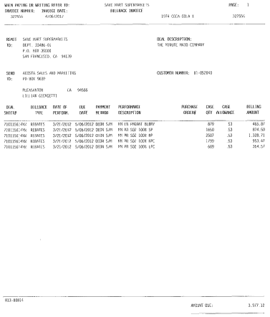
3
Case Qty = Reflects the units per item (may need to convert to cases using pack/size in order to validate.
(e.g. 879 / 8 = 109.875 cases)
2
This is the Scan Rate the customer has billed for the Scan allowance.
i
This refers to the Deal Number and it should match with the Deal ID # on the Customer Contract. Enter this number in the Customer Event Number field when searching

i
These dates should fall within the Contract performance dates on the Contract.
i

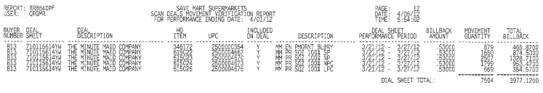
i

3.1 Customer Invoice for Scan example 2:
4
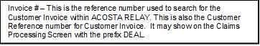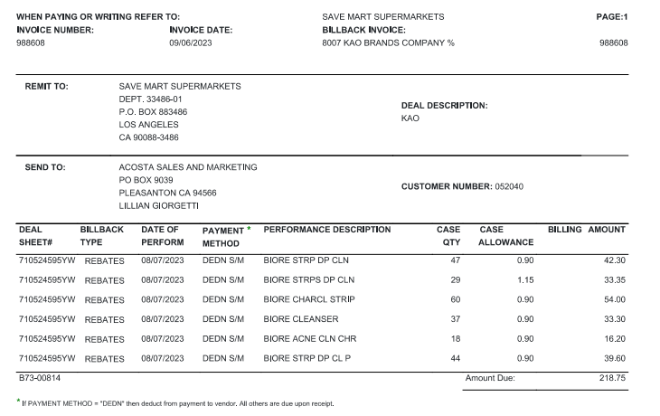
i
i
3
2
Case Qty = Reflects the units per item (may need to convert to cases using pack/size in order to validate.
(e.g. 879 / 8 = 109.875 cases)
This is the Scan Rate the customer has billed for the Scan allowance.
This refers to the Deal Number and it should match with the Deal ID # on the Customer Contract. Enter this number in the Customer Event Number field when searching

When the Customer Invoice states SaveMart at the top of the claim, the deduction could be for SaveMart or Lucky’s. Checking the Deal # will assist in determining which Contract matches the customer claim ( see 1st 4 numbers in the Deal column for reference 7100 = SaveMart, 8100= FoodMaxx, 9100=Lucky’s) Note – Save Mart also owns FoodMaxx & Lucky’s.
(e.g. this particular claim is for Save Mart).

This refers to the Deal Number and it should match with the Deal ID # on the Customer Contract.

3.2 Customer Contract for Scan:
Savemart Contract # will assist in locating the VPF and contract in ACOSTA RELAY.

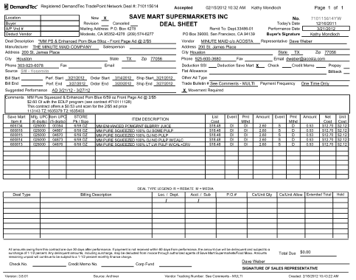
i
3
Performance Dates – The performance date on POP should be within this dates.
Indicates the deduction may be a direct claim from Savement to the client.
2
This is the Scan Rate, and needs to be validated with the Customer Invoice.
1
UPC: This has UPC code details, which needs to be matched with Customer Invoice and POP.

The customer name on the Invoice needs to match the Contract. Note – Save Mart also owns FoodMaxx & Lucky’s.
(e.g. this particular claim is for Save Mart).

i

3.3 Proof of Performance for Scan: Refer to the Client SOPs/Generic Help File for POP requirements.

- Deduction Type: Ad

A fee for featuring a client’s products in an advertisement.

Ad used for deduction must match Contract, e.g if Save Mart Contract, need Save Mart Ad.

  - Customer Invoice for Ad:
Invoice # – This is the reference number used to search for the Customer Invoice within ACOSTA RELAY. This is also the customer reference number for Customer Invoice. This may show on the Claims Processing Screen with the prefix DEAL.
1

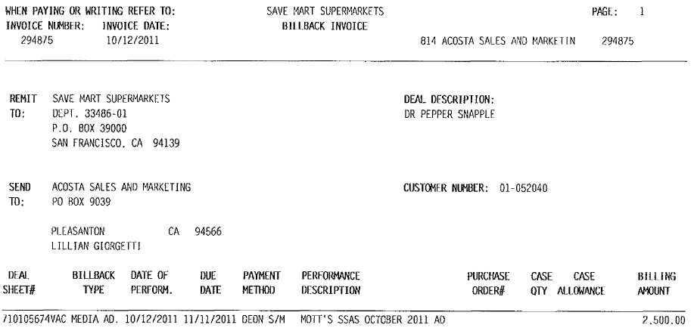
1
i
When the Customer Invoice states SaveMart at the top of the claim, the deduction could be for SaveMart or Lucky’s. Checking the Deal # will assist in determining which contract matches the customer claim ( see 1st 4 numbers in the Deal column for reference 7100 = SaveMart, 8100= FoodMaxx, 9100=Lucky’s) Note – Save Mart also owns FoodMaxx & Lucky’s.

Product Description and Performance information.

2
3
Performance Date–This date should fall with the performance dates on the Contract.
Lump sum Amount – Amount claimed by customer for the Ad deduction. This needs to be verified with the Contract.

Deal Number – Deal Number 710105674 is the reference number used to search for the contract within ACOSTA RELAY. Enter this number in the Customer Event number field when searching.

i

4.2 Customer Contract for Ad:

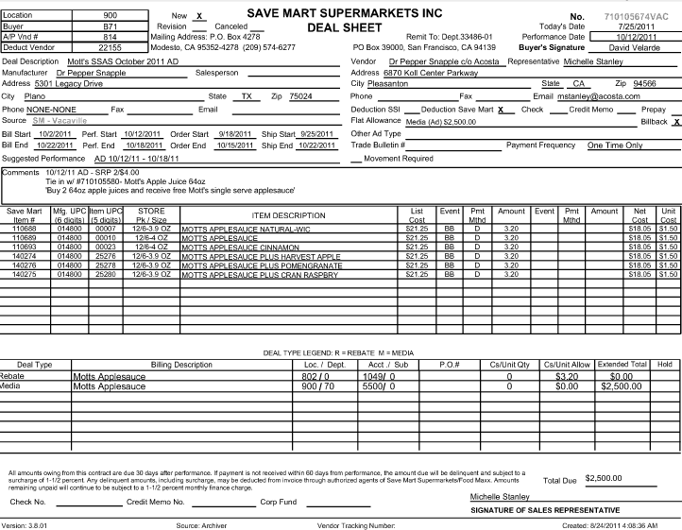
2
5
Deal Sheet # – This is the reference number used to search for the contract within ACOSTA RELAY. Enter this number in the Customer Event number field when searching.

Promotion Duration Period - The Ad date should fall within the performance dates.
Flat Allowance should match the Customer Invoice.
Vendor Comments – This area provides the details of the product that needs to be advertised.
1
Product Description – This would provide the description of the product that needs to be advertised.

4.3 Proof of Performance for Ad: Refer to the Client SOPs/Generic Help File for POP requirements.

5. Deduction Type: Slotting

A Slotting allowance is offered to the customer to purchase an item not currently stocked. A slotting lump sum allowance can be offered for each item and/or an off invoice can be offered as an introductory allowance for the first 30 days.

NOTE: Additional movement detail pages will not be available for Slotting deductions. These can be processed with the Invoice summary page.

5.1 Customer Invoice for Slotting:

Description Comments –This is the number used to search for the Customer Invoice via Backup Documentation, Doc Type 2. This number may begin with the prefix DEAL on the Claims Processing Screen. Pull the Contract first to determine allowance type.

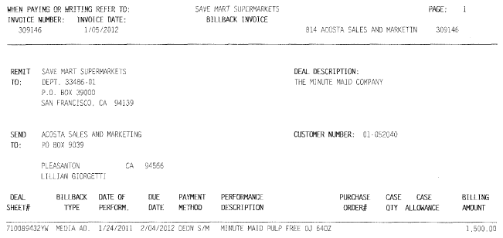
5
When the customer invoice states SaveMart at the top of the claim, the deduction could be for SaveMart or Lucky’s. Checking the Deal # will assist in determining which Contract matches the customer claim ( see 1st 4 numbers in the Deal column for reference 710 = SaveMart, 810= FoodMaxx, 910=Lucky’s) Note – Save Mart also owns FoodMaxx & Lucky’s.

This date should fall within the Contract performance dates.

2

Lump Sum Amount – Deduction amount that customer is claiming for Slotting.

Deal Number – This number can be used to search for the VPF and Contract copy within ACOSTA RELAY. Here it is 710089432. Enter the deal number in the customer event number field when searching for the Contract.
Note: If the Customer Invoice does not state that it is for Slotting then find the Contract for confirmation.

5.2 Customer Contract for Slotting: Contracts are found via “Search For” Promotions.

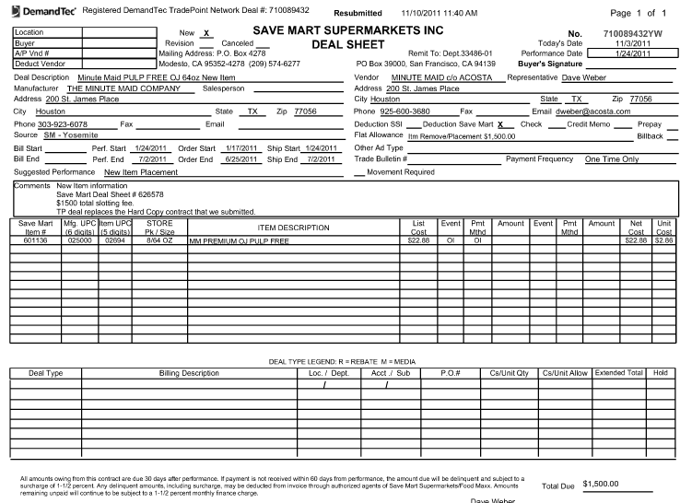
1
1
5
Description – This is the Product description for the item on the Contract. Here it is “MM Premium OJ Pulp Free”.
Deal Dates – This is the Performance Period of the Deal, 01/24/2011 to 07/02/2011. These dates can be used to find a Client Order Invoice or run a Sales Analysis Memo report to verify invoiced cases. The Invoice date should fall within the Ship dates of the Contract.
Deal Sheet # – This is the reference number used to search for the Contract within ACOSTA RELAY. Enter this number in the customer event number field when searching.

UPC Code – The Universal Product Code (UPC) is used to validate key data elements regarding the Customer Order and Client Order Invoice in the Review Order link of ACOSTA RELAY. This is the product the customer is deducting for the Slotting.

Deduction Type – The term New Item Placement confirms that the Contract is for Slotting.
2
Lump Sum Amount – Allowance amount offered per item for Slotting.

5.3 Proof of Performance for Slotting: Refer to the Client SOPs/Generic Help File for POP requirements.

5.4 Customer Invoice for Slotting
Description Comments –This is the number used to search for the Customer Invoice via Backup Documentation, Document Type 2. This number may begin with the prefix DEAL on the Claims Processing Screen. Pull the contract first to determine allowance type.
Example # 2

When the Customer Invoice states SaveMart at the top of the claim, the deduction could be for SaveMart or Lucky’s. Checking the Deal # will assist in determining which Contract matches the customer claim ( see 1st 4 numbers in the Deal column for reference 7100 = SaveMart, 8100= FoodMaxx, 9100=Lucky’s) Note – Save Mart also owns FoodMaxx & Lucky’s.

2
5
Deduction Type – The term SPEED Merchandising Fee confirms the claim is for Slotting and should match the Contract.
Date of Performance = Will assist in locating the Contract. Use the Contract performance/ship dates to verify and validate the claim.
Lump Sum Amount – Flat Allowance amount offered for Slotting.
Deal Sheet # – This is the reference number used to search for the Contract within ACOSTA RELAY. Enter this number in the Customer Event Number field when searching.

5.5 Customer Contract for Slotting
Deal Sheet # – This is the reference number used to search for the Contract within ACOSTA RELAY. Enter this number in the customer event number field when searching.

UPC Code – This is the Universal Product Code (UPC) . The UPC code needs to be compared to their code number on the Contract then validated on Customer Invoice. This is the product the customer is claiming the Slotting allowance on.
Lump Sum Amount – Flat Allowance amount offered for Slotting.
2
1
1
5
Description – This is the Product description for the item on the Contract.
Deal Dates – This is the Performance Period of the Deal, 03/16/2012. These dates can be used to find a Client Order Invoice or run a Sales Analysis Memo report to verify invoiced cases. The invoice date should fall within the Performance/Ship dates of the Contract.
Deduction Type – The term SPEED Merchandising Fee confirms that the Contract is for Slotting.

5.7 Customer Invoice for Slotting ---SPEED
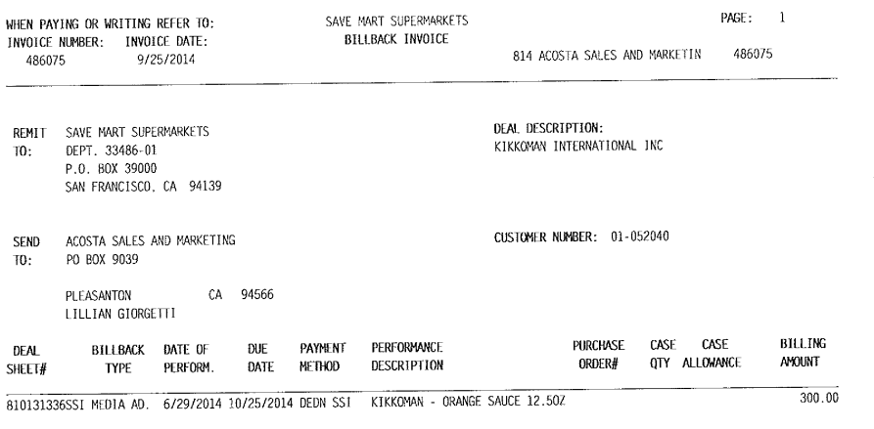
4
1
Product description - This should match the item(s) on the Contract.
Invoice # – This is the Customer Invoice number. This may be preceeded by “DEAL” in the Customer Reference Field in ACOSTA RELAY.

Deal Sheet # – This is the reference number used to search for the Contract within ACOSTA RELAY. Enter this number in the customer event number field when searching.

5
5
Allowance Amount— Lump Sum for Slotting. This should match the Contract.
Date of Performance - Will assist in locating the Contract. Use the Contract Performance/Ship dates to verify and validate the claim.
5.8 Contract for Slotting---SPEED
Deal Sheet # – This is the reference number used to search for the Contract within Acosta RELAY. This should match the Deal Sheet # on the Customer Invoice.

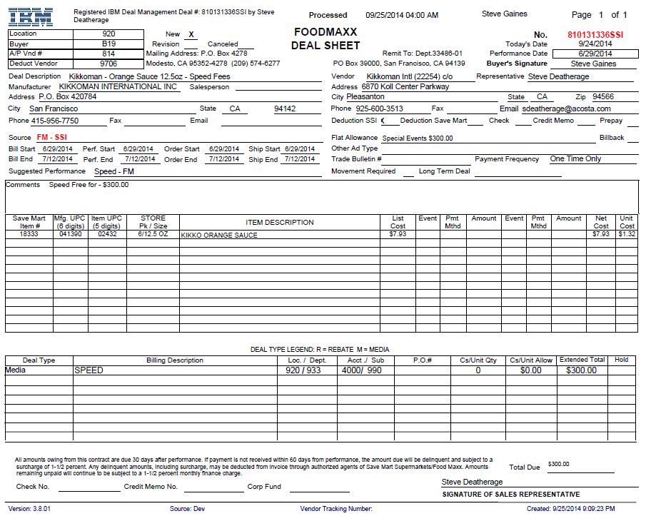
Deduction Type – The term SPEED Fee confirms the claim is for Slotting .
1
2
Product description, item code and UPC. At least one should match the Customer Invoice.
Allowance Amount - Lump Sum should match Customer Invoice.

6. Deduction Type: Mfr. Coupon and eCoupon

A Manufacturer Coupon, typically cleared by client.

Documents required for validating a Manufacturer Coupon

Document Name | Source of the Document | Action by Accenture
Customer Invoice | ACOSTA RELAY – search for the invoice under Backup Documentation, document type 2 | Step up the claim to Acosta for research

eCoupons will be validated by Acosta. These are shown in example 2.

6.1 Customer Invoice for Manufacturer Coupon:

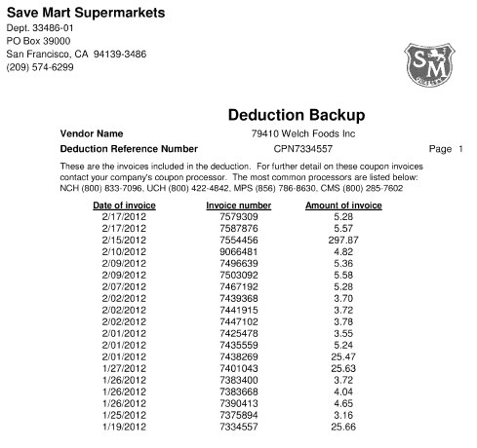
Deduction Reference Number beginning with CPN confirms that this is for Coupon Deduction.
Once identified as Manufacturer’s Coupon deduction, the claim needs to be stepped up to Acosta.

6.2 Customer Invoice for eCoupon

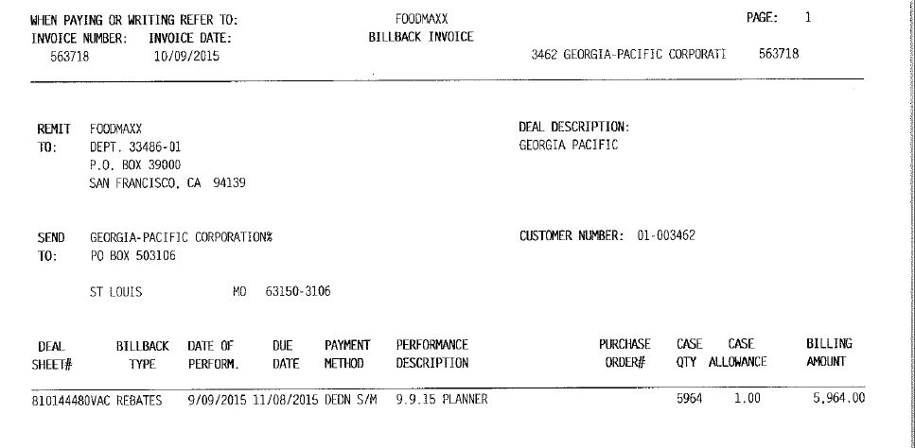
4
This refers to the Deal Number and it should match with the Deal ID # on the Customer Contract. Enter this number in the Customer Event Number field when searching.

Invoice # – This is the reference number used to search for the Customer Invoice within ACOSTA RELAY. This is also the Customer Reference number for Customer Invoice. It may show on the Claims Processing Screen with the prefix DEAL.
This is the rate the customer has claimed for the eCoupon.
2

6.3 Contract for eCoupon

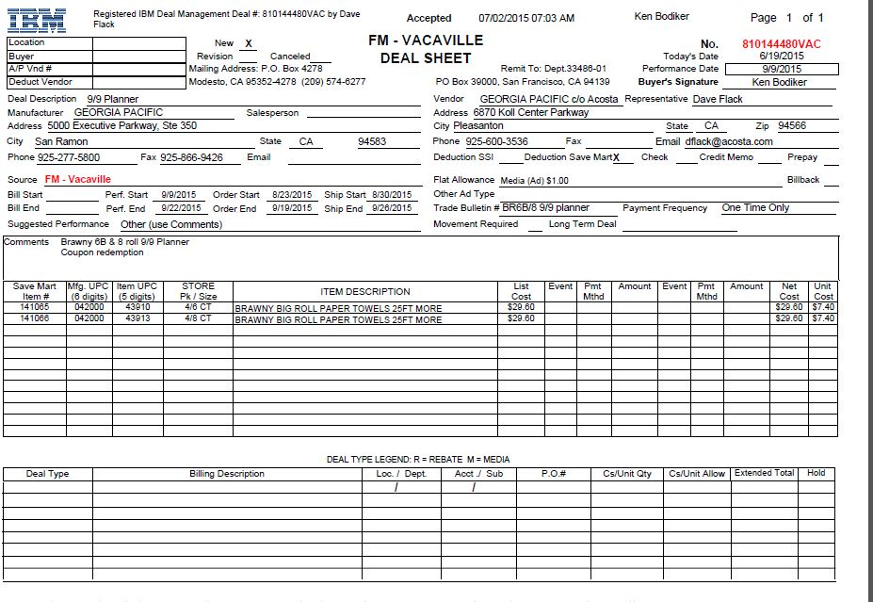
1
2
This refers to the Deal Number and it should match with the Deal ID # on the Customer Invoice.

Media (Ad) and Coupon redemption together indicate an eCoupon.
Customer Item/UPC/Description: This has UPC code details, which needs to be matched with POP.
This is the rate offered for the eCoupon and should match the Customer Invoice.

Refer to the Client SOPs/Generic Help File for POP requirements.
7. Deduction Type: Display

A Display deduction is an allowance given on an in-store product display (within a specific agreed section of the store) on an end cap or displayed per the client’s requirements.

4
7.1 Customer Invoice for Display:
Customer Invoice #–This is the number used to search for the Customer Invoice via Backup Documentation, Document Type 2. This number may begin with the prefix DEAL on the Claims Processing Screen. Pull the Contract first to determine allowance type.

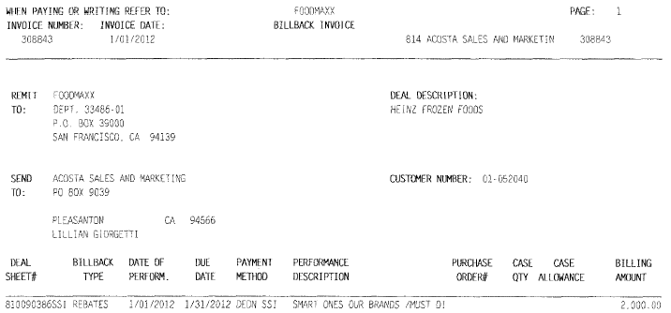
For FoodMaxx – The customer name on the Contract must match the name in this area. Checking the Deal # will assist in determining which Contract matches the customer claim ( see 1st 4 numbers in the Deal column for reference 7100 = SaveMart, 8100= FoodMaxx, 9100=Lucky’s) Note – Save Mart also owns FoodMaxx & Lucky’s.

Deal Sheet # – This Deal is made in “Acoustic DemandTec” and this is the reference number used to search for the VPF and Contract within ACOSTA RELAY. Enter this number in the customer event number field when searching.
DI = This confirms the invoice is for Display.
5
This date should fall within the Contract Performance Dates.
Lump Sum Amount – This is the amount the customer is claiming for the Display per the Contract.

2

7.2 Customer Contract for Display: Contracts are found via “Search For” Promotions.

Deal Sheet # and Contract # – The Contract # should match the Customer Invoice and will assist in locating the VPF and Contract copy within ACOSTA RELAY.

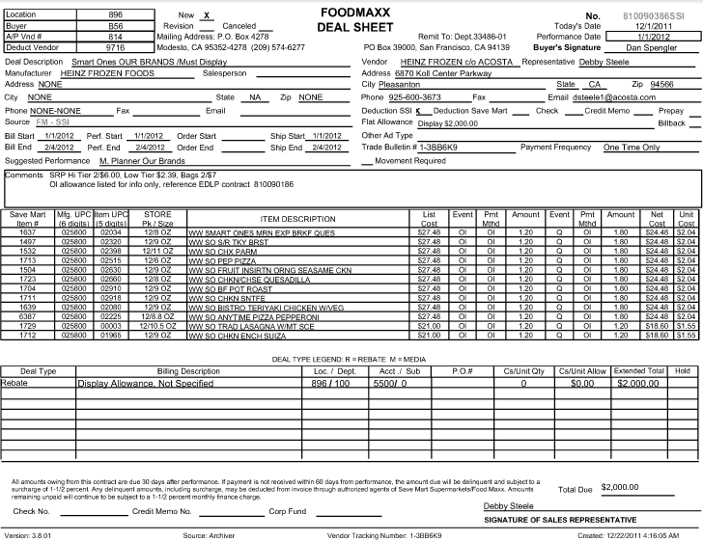
2
1
5
Promotion Dates –The Customer Invoice Performance Date should fall with these dates. In this example, the Performance Dates are June 1, 2011 to June 30, 2011.
Product Description – Product to be displayed in store.
Vendor Comments – Comments may provide additional information in support of the Contract and customer claim.
This is the lump sum amount allocated for the Display activity.
This indicates the customer will deduct through SSI

7.3 Proof of Performance for Display:
Refer to the Client SOPs/Generic Help File for POP requirements.

8. Deduction Type: Food Show:

An event sponsored by a wholesaler exhibiting various clients’ products to indirect customers. There are various fees associated with participating in a food show and can include booth fees, show books, printing/survey charges, show samples and per case allowances for what is sold at the show.

NOTE: Additional movement detail pages will not be available for Food Show Booth Fee deductions. These can be processed with the Invoice Summary page.

8.1 Customer Invoice for Food Show:
4

Invoice # –This is the Customer Reference Number used to search for the Customer Invoice in Backup Documentation, Doc Type 2. This Invoice # on the Claims Producessing Screen may begin with the prefix DEAL.

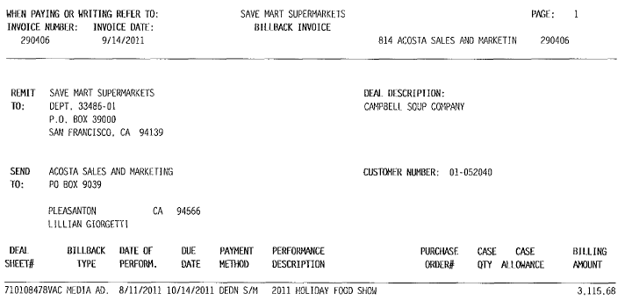
i
Customer name on Contract must match the name in this area.

Performance Date – This date should fall within the Performance Period listed on the Customer Contract.
3
Deduction Amt. – The amount listed is the amount the customer has deducted for the Food Show.

2

Deal Sheet # – This Deal is made in “Acoustic DemandTec” and this is the reference number used to search for the VPF and Contract within ACOSTA RELAY. Enter this number in the Customer Event Number field when searching.

Holiday Food Show # – This indicates the deduction involved is for Food Show.
i
i

i
8.2 Customer Contract for Food Show:
Deal Sheet # and Contract # – The Contract # should match the Customer Invoice and will assist in locating the VPF and Contract copy within ACOSTA RELAY.

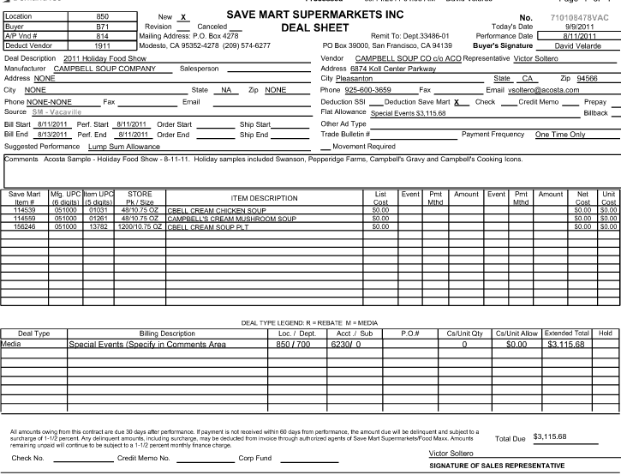
i
Vendor Comments - Comments may provide additional information in support of the Contract and Customer Claim.
Offer Amount –This amount should match with the Customer Invoice.
Performance Date –The Food Show date should fall within these dates.
i
3
This indicates the customer will deduct directly from the client.
2

9. Deduction Type: Unsaleable

An Unsaleable claim is taken for product that cannot be sold at the stores due to damages and short coded product .

Document Name | Source of the Document | Action by Accenture
Customer Invoice | ACOSTA RELAY – search for the invoice under Backup Documentation, document type 2 or document type 8 | Step up the claim to Acosta for research
Documents required for validating an Unsaleable claim

9.1 Customer Invoice for Unsaleable:

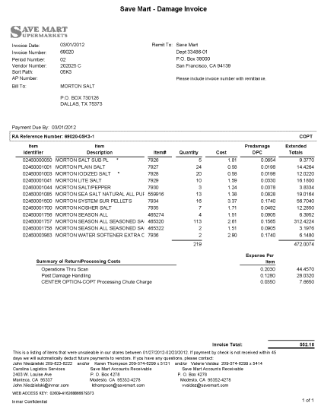
4
Customer Invoice #
Deduction Type – This indicates the deduction is for Unsaleables. Once identified as Unsaleables, the claim needs to be stepped up to Acosta for review.

Invoices with the prefix “PRC” are claims for damages/unsaleables. The Claims Processing Screen Customer Reference number may note PRCXXXXX. When searching for the Customer Invoice, drop the prefix and search using the 5 digit number.

9.2 Example #2 - Customer Invoice for Unsaleable

Total Unsaleable claim amount
4
i
Customer Invoice #

9.3 Example # 3 Invoice for PO related Unsalable

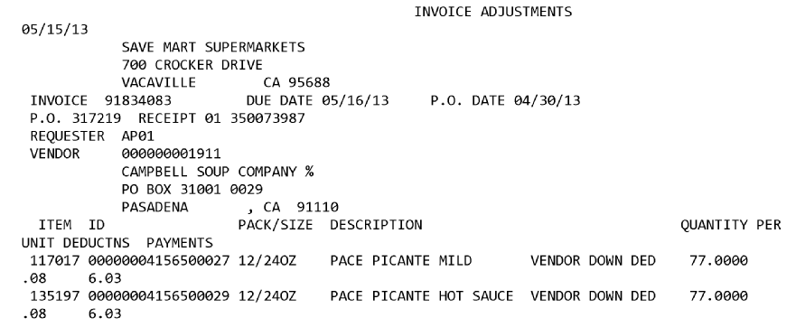
2
1
Unsalable Allowance amount requested.
Indicates Unsalable Allowance
Product UPC on which Unsalable Allowance is requested.
PO the Allowance is requested for.

9.3 Example # 4 Invoice for Vendor Up Unsalable

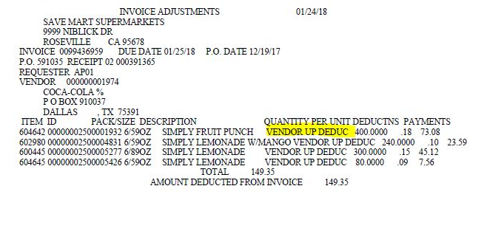
Indicates Unsalable Allowance
10. Deduction Type: Pricing-Non Trade related Claim

A pricing deduction occurs when the customer’s requested price on the original purchase order differs from the client’s invoice.

Documents required for validating a Pricing claim

Document Name | Source of the Document | Action by Accenture
Customer Invoice | ACOSTA RELAY – search for the invoice under Backup Documentation, document type 2. | Step up the claim to Acosta for research
Order Invoice or Client Order Invoice | ACOSTA RELAY – search for this document within the Order/Invoice/PO search.

10.1 Customer Invoice for a Pricing Allowance:
NOTE: List Cost Deductions could include a missing promotion, further research is needed to confirm if it is a missed promotion or a pricing issue.

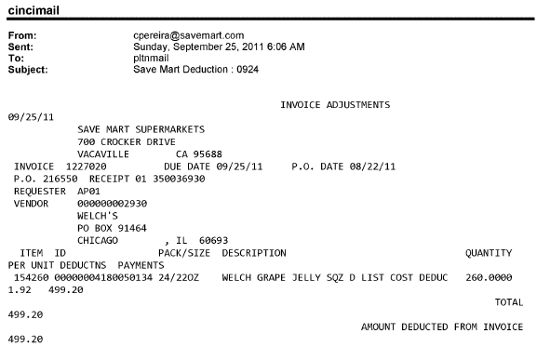
“List Cost Deduction” Indicates the possibility of a line item pricing issue, or a missed promotion. Research if the pricing issue is due to a missed allowance or a pricing issue..
1
4
Product UPC # should match the UPC code on the Client Order Invoice.
Invoice#- This is the Client Order Invoice number which needs to match with the Customer Invoice.
PO# - This is the PO number of the Customer Invoice which needs to be validated with the Client Order Invoice.

11. Deduction Type: Post Audit

Internal/external auditors find claims that the customer is entitled to but did not take from previous years. Post Audits should be researched in the same manner as other claims by accessing previous year’s files.

NOTE: The post audit claim must first be researched to ensure the customer has not already billed for the allowance before the normal validation process can begin.

Once the post audit claim has been researched to ensure the customer has not already billed for the allowance refer to the appropriate allowance section of the SOP to continue with validation. If the post audit is for an allowance not defined in an allowance section of the SOP refer to the post audit example for validation information.

The following document outlines the new Save Mart procedures for resolution of Post Audit deductions.

This customer sends pre-notification post audits.

11.1 Customer Invoice for Post Audit:
4
PRGAUD indicates the Invoice is for Post Audit.
Invoice Number – This is the Customer Invoice Number referenced on the Check Remittance/Customer Invoice.
Total amount claimed for the Post Audit.
Claim Reason – This is the reason the Post Audit was deducted by the customer.

Claim Reason – This is the reason the Post Audit was deducted by the customer.
i
Review “Previously Billed” Invoices located inside the VPF to ensure they have not already claimed the “Total Amount Due”.
3
Quantity – This is the total cases claimed for this promotion. The POP should reflect equal or greater cases.
Items – These are the items being deducted for. (Customer Codes, UPCs, and Product Descriptions.
1
5
Deal number will assist in locating the VPF and Contract in ACOSTA RELAY.
Allowance dates should fit within the Ship Dates on the Contract.

12. Deduction Type: Returns (Non Trade)

Products returned by the customer to the client.

Documents required for validating a Returned Goods

Document Name | Source of the Document | Action by Accenture
Customer Invoice | ACOSTA RELAY – search for the invoice under Backup Documentation, document type 2 | Step up the claim to Acosta for research

12.1 Customer Invoice for Returns:

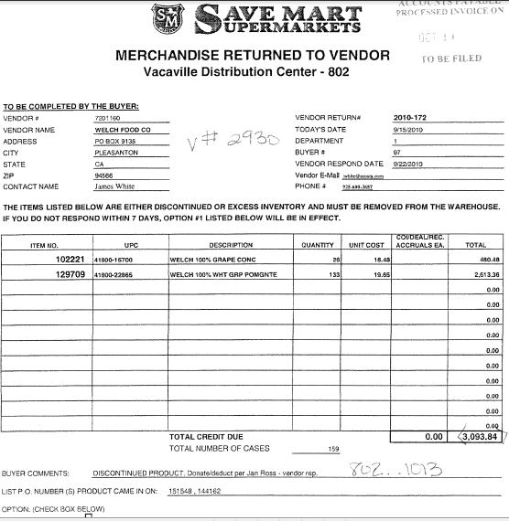
Deduction Type –This statement indicates that this Invoice is for Returns.
Once the Invoice is identified as for Returns, the claim needs to be stepped up to Acosta for further research.

List of Customer PO numbers involved in the Return.
i

12.2 Customer Contract for Returns:

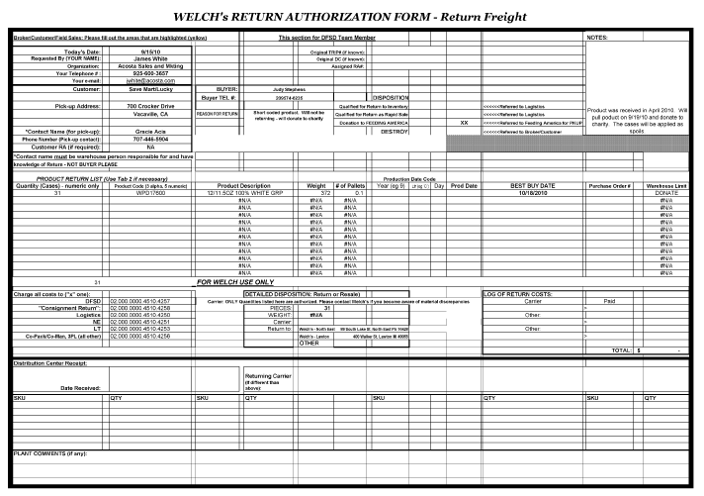

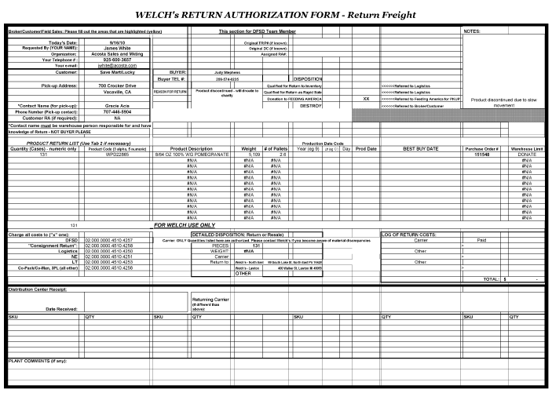

13. Deduction Type: Shortage

It is a deduction for shorted product on an order that the client billed the customer for.

Documents required for validating a Shortages Deduction:

Document Name | Source of the Document | Action by Accenture
Customer Invoice | ACOSTA RELAY – search for the invoice under Backup Documentation, document type 2. | Step up the claim to Acosta for research
Order Invoice or Client Order Invoice | ACOSTA RELAY – search for this document within the Order/Invoice/PO search.

NOTE: Shorted Deals are NOT the same thing as Shortages. Please see customer information section for more details.

13.1 Customer Invoice for Shortage:

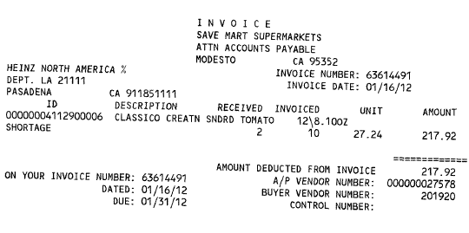
Deduction Type – Shortage indicates this invoice is for Shortages. Once the Invoice is identified as Shortage, the claim needs to be stepped up to Acosta for further research.
Invoice#- This is the Client Order Invoice number which should match the Client Order Invoice.

14. Freight Deduction Type: Freight/Backhaul

A Freight allowance is given to the customer for picking up the product via their own transportation services.

Documents required for validating a Freight claim:

Document Name | Source of the Document | Action by Accenture
Customer Invoice | ACOSTA RELAY – search for the invoice under Backup Documentation, document type 2. | Step up the claim to Acosta for research
Client Order Invoice | ACOSTA RELAY – search for this document within the Order/Invoice/PO search.

14.1 Customer Invoice for Freight (Non-Trade)

Invoice#- This is the Client Order Invoice number which can be used to locate the Client Order Invoice within the ACOSTA RELAY search screen.
i
Total amount claimed for Freight Allowance.
i
Indicates the claim is for Freight Allowance.
PO#- This is the PO number which may be used to locate the Client Order Invoice with the ACOSTA RELAY search screen.

If the PO/Client Order Invoice is available in ACOSTA RELAY under View Documents of the Review Order Screen, then link the order to the claim and step Escalate – Non Trade to Acosta for further review.

15. Deduction Type Retail Merchandising Program
Example 1: Fair Share

15.1 Customer Invoice for Fair Share
First page of Invoice:
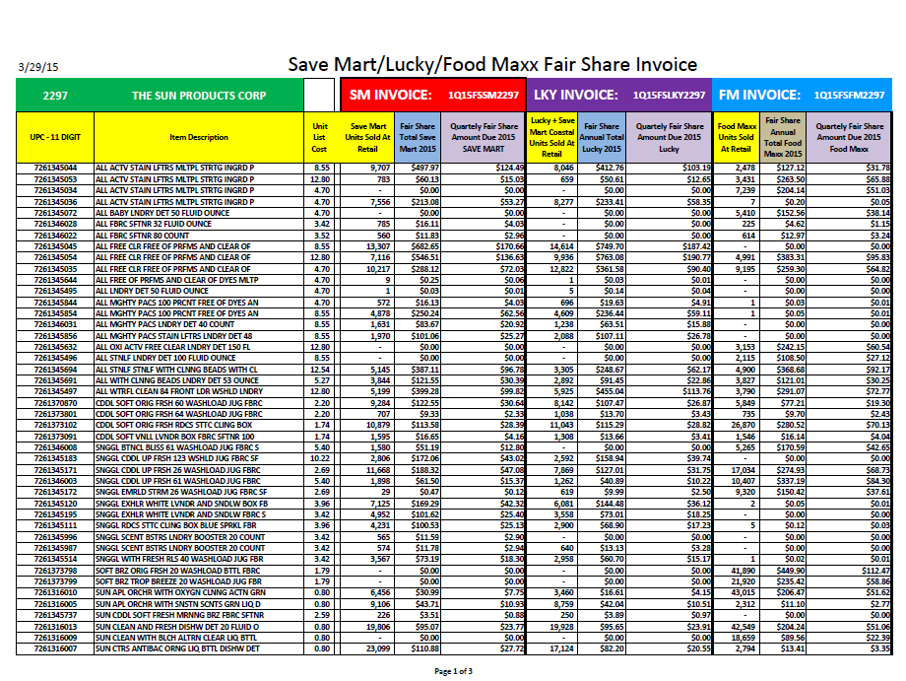
Customer Reference number for Food Maxx portion. This should match the Customer Reference Number on the claim with the prefix SPD on the claim.
Last page of Invoice:
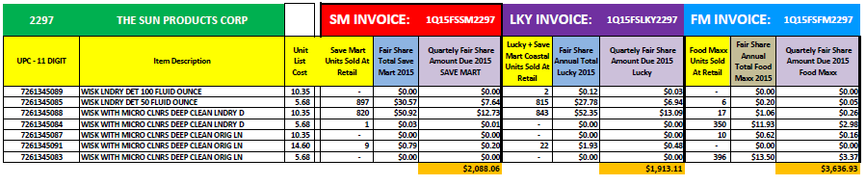
Claim amount for Food Maxx.

15.2 Customer Invoice for Retail Merchandising Program
Fair Share Example #2

Effective January 2016, invoices will be monthly and will have the following format:

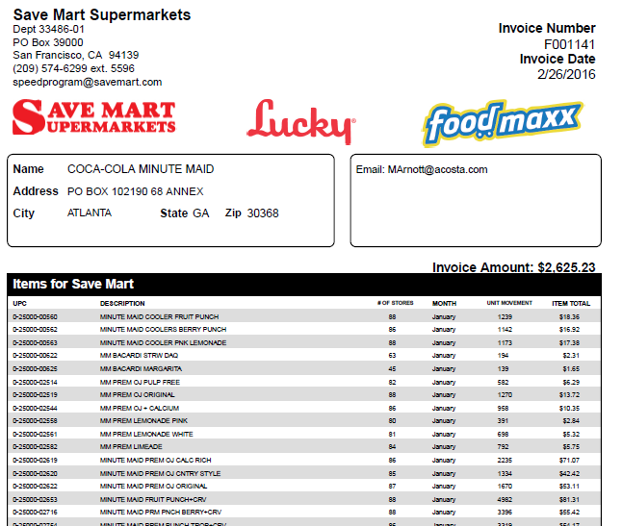
4
Claim amount
Invoice number should match the Customer Reference number on the claim (may include prefix SPD on the claim).

NOTE: Fair Share invoices will all begin with an “F” as the invoice number on the document.

15.3 Customer Invoice for Retail Merchandising Program
Replacement Fees (New/Replacement/Expanded distribution)

Invoice number should match the Customer Reference number on the claim (may have prefix SPD) on the claim.
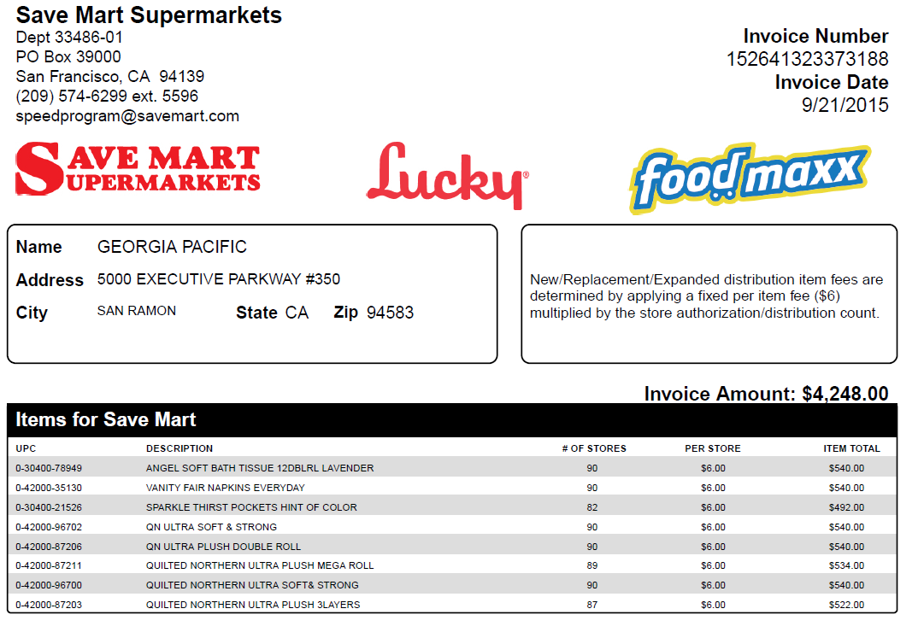
4
Claim amount for Food Maxx.
This notation indicates the deduction type.

NOTE: Effective January 2016, the notes referring to New/Replacement/Expanded distribution may not be present on the invoice. However, these invoices will all begin with a “N” as the invoice number.

15.4 Customer Agreementt for Speed Retail Merchandising Program

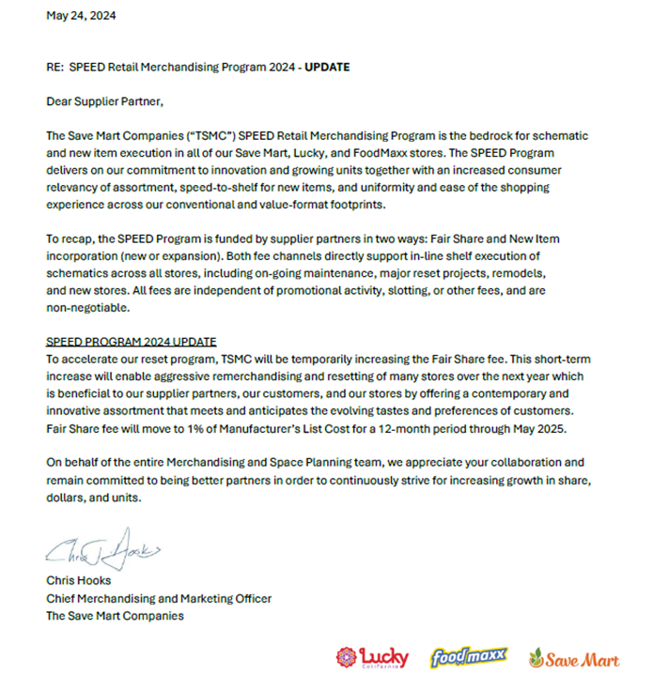
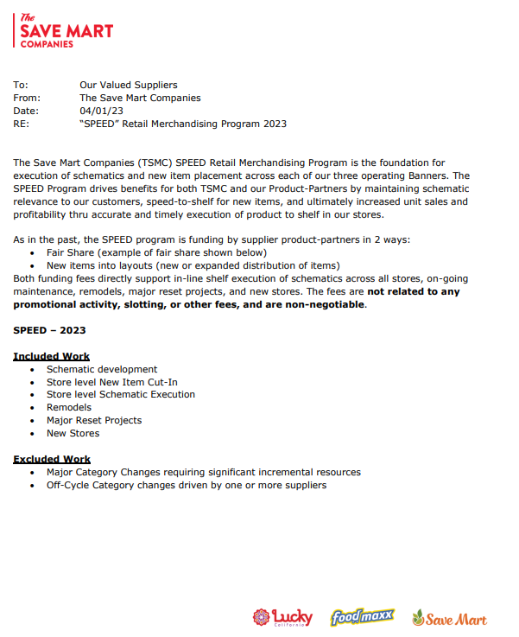

Agreement page 2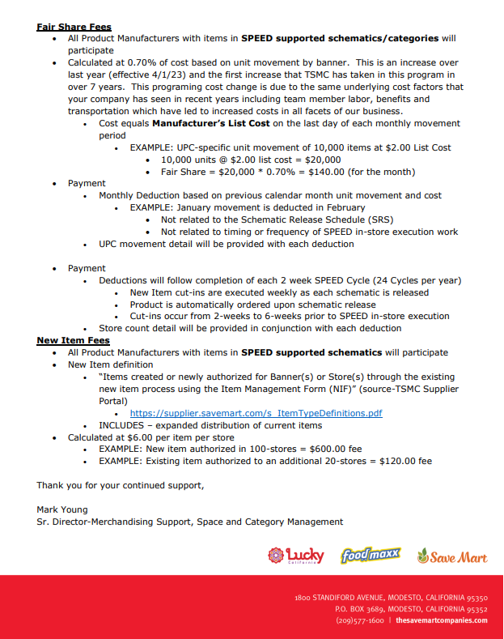

No POP required unless indicated in Client SOP/Client Specific section. Review for additional information.

16. Deduction type: Penalty Fees (Non Trade)

A cost assessed by the customer for various reasons, including: handling, administrative, service and scan fees.
Can also include late deliviery, miss delivery appointment or lumper/driver fees.

Documents required for validating a Fee claim:

Document Name | Source of the Document | Action by Accenture
Customer Invoice | ACOSTA RELAY – search for the invoice under Backup Documentation | Step up the claim to Acosta for research

16.1 Late Load Penalty

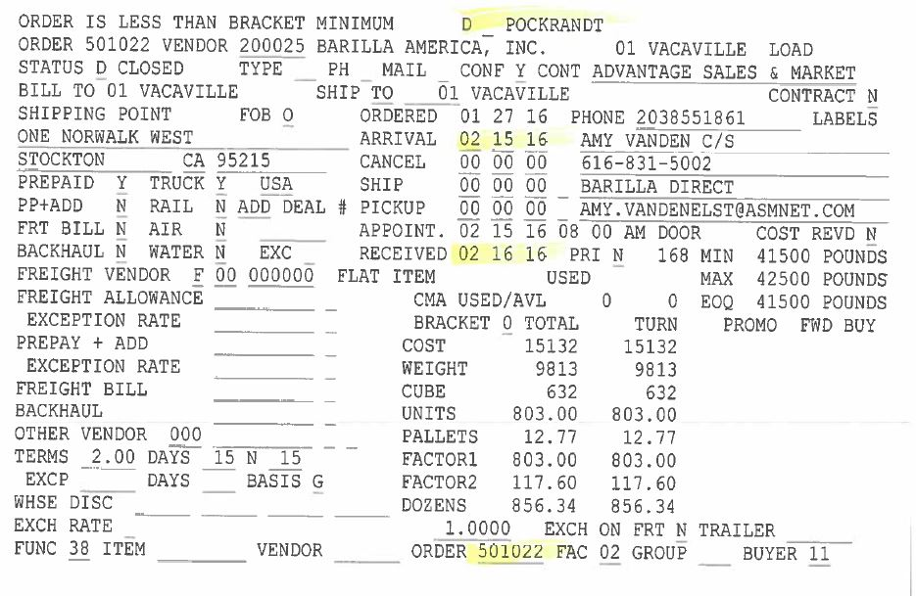
PO against which the fee is assessed. Should be attached to the claim.
Shows date discrepancy between scheduled appointment and actual arrival.
Client

16.1 ResposiTrak Fees
Savemart will charge an annual fee for access to the portal. These claims will not have additional customer invoices, and can be identified through the cuostmer reference number or check – Repositrak will be noted.

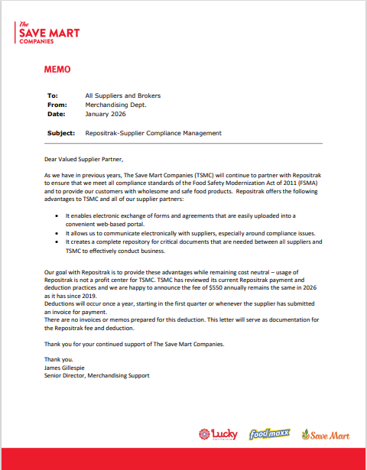
BPS TEAM INFORMATION

REPAY INFORMATION SECTION

Repays
- Invalid deuctions should be sent to both of the following addresses APDC@Savemart.com and AR@Savemart.com and CC the customer manager.
  - Additional contact information:
    - Additional contact is Maria Colondres :
      - Phone 209-574-6299 ext. 5287
      - Fax 209-530-1827
- Savemart SuperMarkets Audit Department (PRGX) send repay letters to Savemart.audit@prgx.com
  - One Bridgestone Parkway, Ste 100 Nashville, TN 37214
- Invalid post audits are initiated by emailing claims_admin@pinnacleaudit.com to request a link to the post audit invoice in the Pinnacle Portal. Once the link is received, the PRS can access the portal and submit the dispute and repay packet associated with the post audit. Follow-up actions should be completed using the same link. If the link has expired, a new link can be requested by emailing claims_admin@pinnacleaudit.com again.

CRA Client Specific

CCA CLEARING INFORMATION SPECIFIC

CCA Client Specific

BARILLA
  - Fair Share and Replacement fee claims are coded as a repay in Vistex with header notes that the claim is to clear to Acosta commission.

SUN PRODUCTS
  - Slotting claims for Save Mart, Food Maxx, and Lucky’s are set up in the client proprietary system under Super Store Industries and are cleared there without changing the customer in the client system.

TILLAMOOK
- Backup for SPD claims must be attached to the deduction. The claim will be processed as Non Trade, Reset fees in Demantra. Backup must be attached in Demantra if not already present.

COMPLETE VERSION HISTORY

UPDATE DESCRIPTION | DATE |  | AUTHOR
First draft of the Save Mart Yosemite SOP |  | 05/03/2012
Updated by Dellene Hubbard |  | 05/11/2012
Additional changes after chairside with the Trainer |  | 05/30/2012
Chair side observations |  | 06/27/2012 |  | Narendra Gangaram
Updated by Dellene Hubbard |  | 07/12/2012 |  | Dellene Hubbard
Updated by Dellene Hubbard |  | 08/09/2012 |  | Dellene Hubbard
Update IRI/Nielsen information for price point pg 2 |  | 9/10/2012 |  | Rick Smith
Updated Move Fact Sheet |  | 9/11/2012 |  | Holly Knight-Moreau
Updated hyperlinks to deduction types |  | 09/16/2012 |  | Nagesh Kumar
Added an Unsaleable claim example to Unsaleable section 9 pg. 37 |  | 09/24/2012 |  | Dellene Hubbard
Added Freight claim example (see section 14 pg. 50); updated Tradepoint Contract Information on SaveMart Customer Fact Sheet (see pg. 4); also added Billback example (see section 2 pgs. 15-17) |  | 01/11/2013 |  | Dellene Hubbard
Instruction to back into PO related claim and sign-ons for contract searches, pg 3 |  | 2/26/13 |  | Amy Bedor Salmey
Added Example # 2 to the Slotting section (SPEED Merchandising Fee) |  | 04/01/2013 |  | Dellene Hubbard
Added information on “FMO” invoices (tk 3767);  Changed invoice request contact to Theresa Lindner |  | 07/15/2013 |  | Karen Smith
Added “Vendor Down Deduction” example to Unsalable Section (tkt # 3732) |  | 07/22/2013 |  | Karen Smith
Updated the Job Aid for backing into a PO related claim |  | 7/29/2013 |  | Karen Smith
Added note on “FMO” invoices to BB section (tkt 5350); Added notes to Slotting and Food Show Booth Fee sections that detailed movement reports are not required for these deductions (tkt 5260) |  | 9/16/2013 |  | Karen Smith
Added link to National Toolbox and link to customer signon job aid (tkt 5675) |  | 10/4/2013 |  | Karen Smith
Updated POP requirements for Billback (tkt 5811) |  | 1/6/2014 |  | Karen Smith
Added Ken’s to Client Specific section with POP information (9620); Added Farmland to Client Specific Section with Vendor UP information (7594) |  | 9/15/2014 |  | Karen Smith
Added Diamond to Client Specific Section with instruction on locating PO (10539) |  | 10/27/14 |  | Karen Smith
Added note to Shortages regarding Shorted Deals with example in Customer Information section (9195); Updated backup request contact information in customer fact sheet (10817) |  | 11/10/14 |  | Karen Smith
Added Georgia Pacific to Client Specific Section with notes on POP (9273) |  | 11/24/14 |  | Karen Smith
Added BPS Team information section with details on requestiong backup (11300); Embedded new Post Audit policies in Post Audit section (11492) |  | 12/22/14 |  | Karen Smith
Add McCormick specific instructions for requesting backup (12552) |  | 3/2/15 |  | Karen Smith
Added additional Speed to Shelf example for slotting (12485) |  | 3/16/15 |  | Karen Smith
Updated Customer Fact Sheet (12827); Added type of customer question (13429) |  | 4/27/15 |  | Karen Smith
Added question on Req CI from CIT to backup retrieval information (13772) |  | 5/25/15 |  | Karen Smith
Updated Customer Fact Sheet for DemandTec/Tradepoint (13461); Updated Backup Retrieval instructions (14004); Moved Complete Version History |  | 6/8/15 |  | Karen Smith
Updated Customer Fact Sheet to remove Theresa Harvey as contact (14167); Added SAVENC to signon list (13999) |  | 6/22/15 |  | Karen Smith
Updated Backup Request Contact list (14430) |  | 7/20/15 |  | Karen Smith
Added McCormick to client specific section with Shorted deals event instructions (14414) |  | 8/17/15 |  | Karen Smith
Added any customer specific examples removed from the Super Store Industries SOP (15035) |  | 9/14/15 |  | Karen Smith
Added McCormick instructions for SPD claims (15142); Added Campbell’s to Client Specific with instructions on various reset, merchandising fee and other deductions (15416); Added Sunny D to client section with FOOMNC OI instructions (15490); Clean up and reorganization of information in Customer General Information section, consolidation of information in fact sheet to appropriate sections, fact sheet removal (14730) |  | 10/12/15 |  | Karen Smith
Added contact for SPD invoices (15218); Added info on line level detail to Customer general information (15509) |  | 10/26/15 |  | Karen Smith
Updated contact information for requesting DEAL invoices (15753); added contact for vendor returns (15766); updated contact sheet for SPD invoices (15888); removed all references to fact sheet (16092) |  | 12/7/15 |  | Karen Smith
Add SPD (speed fees) instructions to GAPAC section (16183); added additional signons for contract searches with additional contract information to customer general information section (16214) |  | 12/21/15 |  | Karen Smith
Added Starkist to client section with instructions on SPD invoices (16213) |  | ¼/16 |  | Karen Smith
Added eCoupon example to coupon section and added notes to distinguish Manufaturer coupons from eCoupons (15806) |  | 1/18/16 |  | Karen Smith
Added “Other” section with Fair Share and Replacement Fee invoice examples with instructions (16455); added Clorox to Client Section with instruction on SPD invoices (15878); Updated format of BPS Team information section with subsection headers (16491) |  | 2/1/16 |  | Karen Smith
Added Tyson to Client section with instruction on SPD Fair share invoices (16922); replaced backup request contact list (16980) |  | 2/29/16 |  | Karen Smith
Added that spoils backup from CLS portal may be requested from CIT (17277); added note on split deductions (17024); updated backup contact list (17322) |  | 3/14/16 |  | Karen Smith
Updated invoice format for Fairshare/New Item Replacement fees (17579); Added Barilla to CCA specific in BPS Team section with fair share and replacement fee instructions (17580) |  | 4/11/16 |  | Karen Smith
Added BUSH to client specific section with notes on SAS claims (17689); updated CAMBPL client section to add SPD invoices and change contact name (17861, 17035); updated backup request list for RDS invoices (17619) |  | 4/25/16 |  | Karen Smith
Added Late Load Penalty fee example (17602) |  | 5/9/16 |  | Karen Smith
Added COCACH to client section with instructions on replacement fees (17731); Added Tillamook to BPS Team CCA section with instructions on Speed deductions (17821); Added SUNPROD to BPS Team CCA section for slotting (18233); Added additional instruction for Campbells resets, SAS, etc. (18063); Added DSD validation dates for Clorox (18134) |  | 5/23/16 |  | Karen Smith
Added instructions for McCormick CRM report for POP in client section (18548); Added note in Ad section for Lucky vs SM ads (18423) |  | 6/20/16 |  | Karen Smith
Updated TP to IBM deal management, added new info on contract searches, moved contract info to sign-on box (18747) |  | 7/4/16 |  | Karen Smith
added approval requirement for clearing to Campbells direct fund (18863); updated Claim Dex contact (18803) |  | 8/1/16 |  | Karen Smith
Added Pinnacle to Client Specific and BPS Team CCA section with instruction for Fair Share, etc. claims (18796); updated Starkist Fair Share reason code (18865) |  | 8/15/16 |  | Karen Smith
Updated Post Audit examples and removed verbiage to escalate to Acosta, removed outdated auto escalate information (19506) |  | 8/29/16 |  | Karen Smith
Added instruction for SPDF claims to McCormick section & added Mccormick to the CCA section with additional instruction (19102); updated Pinnacle CCA specific instructions (19190) |  | 9/12/16 |  | Karen Smith
Added Tillamook to Client Section section with instruction on SPDF fees (19474) |  | 10/12/16 |  | Karen Smith
Updated Speed program information (retail merchandising program) and validation instructions (19823); added COCACH specific for retail merchandising to client section and BPS team section (19704); removed duplicate contracts and POP examples (19418) |  | 11/7/16 |  | Karen Smith
Updated contact information for additional backup (21492) |  | 5/22/17 |  | Danielle Martin
Updated Client Specific section for Tillamook SPD step code (22178). Added new backup list to BPS Team information section (21802). |  | 07/31/2017 |  | Michelle Mangus
Updated Client Specific section for McCormick to change CRM to DMS as client changed proprietary system ( 22295). |  | 08/14/2017 |  | Michelle Mangus
Updated POP requirements for slotting ded for Georgia Pacific section due to new POP requirements (22355) |  | 9/11/2017 |  | Katy Dolan
Updated backup contact information (22420), updated Tillamook PO related backup contact (22053) Added Nestle specific section and included direction on prior Acosta claims (22675) |  | 9/25/2017 |  | Katy Dolan
Updated Savemart backup spreadsheet (22618) added Nestle Nutrition specific section to include how to manage SPD invoices (22770) updated Nestele section to include how to manage SPD invoices (22775) |  | 10/23/2017 |  | Katy Dolan
Updated verbiage for Nestle USA for new item invoices (22726) added Colgate specific section regarding retail merchandising claims (22777) updated CAMPBL client specific regarding contact information (23189) |  | 12/8/2017 |  | Katy Dolan
Updated McCormick specific section to care for Fairshare and New Item deductions (23150) |  | 1/2/2018 |  | Katy Dolan
Updated BPS team information regarding contacts to obtain backup (23505, 23699) update Nestle specific information for Deal sheets (23038)  Updated hyperlinks to reflect new online location (23751) |  | 2/2/2018  2/13/2018 |  | Katy Dolan
Updated BPS team information section regarding contacts to request customer backup (23878) |  | 2/26/2018 |  | Katy Dolan
Updated client specific section for Colgate in regards to step code exceptions for the GCC (23803) added invoice information in the BPS Team information section for FLX post audits (24165) |  | 3/26/2018 |  | Katy Dolan
Updated backup contacts for invoices in the BPS team information section (24596) Removed Diamond from the client specific section (24753) |  | 6/4/2018 |  | Katy Dolan
Removed portal information for FLX invoices in the BPS team information customer system and backup retrieval information section backup contact is on the embedded ss (24390) |  | 6/18/2018 |  | Katy Dolan
Updated Hostess client specific section in regards to claims for deals on shorted product (24869) Updated Nestle USA SPD claim information regarding an event is required (24740) |  | 7/2/2018 |  | Katy Dolan
Updated Savemart backup request contacts for Deal sheets in the BPS team information section (25076) |  | 7/30/2018 |  | Katy Dolan
Added Vendor up ded example to unsaleables section (24324) update to customer backup request information/realignment of information, no process change |  | 8/13/18 |  | Katy Dolan
Added KAO Brand client specifc section in regards to Savemart and Foodmax claims are not required to be cleared by promoted product group (25672, 25674) |  | 9/10/2018 |  | Katy Dolan
Updated Colgate client specific information section in regards to SPDF and SPDN claims (25836) |  | 9/24/2018 |  | Katy Dolan
Updated the retail merch agreement in the Retail Merchandising Program section (25888) |  | 10/08/2018 |  | Katy Dolan
Updated Tyson client specific section in regards to Retail Merchandising claims (25936) |  | 11/05/2018 |  | Katy Dolan
Updated Colgate client specific information regarding Retail Merchandising Claims (SDPF) (26073) updated Colgate client specific information regarding DBW information for simplified customer (26290) updated Noosa client specific information for not Acosta (26158) |  | 11/19/2018 |  | Katy Dolan
Updated the email address for audits on the contract list (26479) |  | 12/31/2018 |  | Carlos Ocasio
Removed McCormick information as we no longer represent as of 2/13/19 (26829) |  | 02/13/19 |  | Carlos Ocasio
Added 2019 retail merchandising events to Colgate specific section (27064) |  | 02/25/19 |  | Carlos Ocasio
Added Speed Fee contracts to customer general information (27029) |  | 03/11/19 |  | Carlos Ocasio
Added floorstock protection is invalid for Hostess (26899) Added Mars Food to the client specific section (27233) |  | 03/25/19 |  | Carlos Ocasio
Added who can act as FCM for Nestle USA (27485) |  | 04/08/2019 |  | Carlos Ocasio
Acosta now handles Noosa (27475) Removed Event number 40121138 from Colgate (27480) Corrected contact name and email addresses for Prefix Deals (27186) |  | 04/22/2019 |  | Carlos Ocasio
Removed document location, version history and BPS Sharpoint links. Removed Tyson as Acosta no handles claims effective 04/27/19 (27728) |  | 04/30/2019 |  | Carlos Ocasio
Updated the email address for Deals F-U on the backup contact list (27401) |  | 06/03/2019 |  | Carlos Ocasio
Moved the 2019 event numbers for Colgate within their client specific section(27713) Updated the email address for Deals Prefix(27531) Added to the Colgate client specific section that Homecare and Hand/Body Soaps are cleared to SSI events (27885) Updated the contact information for Prefix PRC in the contact list (27794)  Removed Clorox specific information as Acosta no longer represent (28157)  Removed Pinnacle specific information, no longer handle claims effective 08/26/19 (28434) |  | 06/07/2019  07/01/2019  09/04/2019 |  | Carlos Ocasio
Updated SOP with the Backup Retrieval section  Remvoed Starkist specific, no longer rep (28760) |  | 10/7/2019  10/18/2019 |  | Katy Dolan
Updated the customer signon information in the customer general information section as SAVENC is merging to SMMONC (28920) removed Debby Melrose from the contacts in the backup retrieval section (28705)  Updated the backup retrieval section format and removed the view document verbiage |  | 11/8/2019  12/20/2019 |  | Katy Dolan
Removed GP client specific section (29281) |  | 1/27/2020 |  | Katy Dolan
Removed colgate client specific section (29456) removed standard process stepping instructions from the client specific section |  | 2/24/2020 |  | Katy Dolan
Updated reclamation contact information in the Backup retrieval information section (29622)  Removed Feature Vision/Numerator information (29654) |  | 2/28/2020  3/9/2020 |  | Katy Dolan
Updated the Nestle USA client specific section regarding information regarding FCM approval (29697) removed SMVCNC as this signon has been inactivated. |  | 4/6/2020 |  | Katy Dolan
Updated coca cola client specific information section regarding Odwalla DSD claims (29934) |  | 5/4/2020 |  | Katy Dolan
Removed Nestle USA client specific information (30502) |  | 7/13/2020 |  | Katy Dolan
Removed outdated campbells client specific information and added SAS, Resets, SRD and SPD claim information (30478) |  | 8/10/2020 |  | Katy Dolan
Updated the automated table in the backup retrieval section (30779) added a CCNA specific backup contact to the backup retrieval section (30616) |  | 9/7/2020 |  | Katy Dolan
Added an additional customer signon to the customer signon listing (30821) updated repay contact information in the BPS team information section (30831) |  | 10/5/2020 |  | Katy Dolan
Removed outdated information in the CCNA client specific section (30969) |  | 10/19/2020 |  | Katy Dolan
Updated automated contacts in the backup retrieval section (31336) updated BPS team information section regarding invalid claim contacts (31132) |  | 12/28/2020 |  | Katy Dolan
Added Repositrak fee process for Hostess client specific section, added Repositrak information to the penalty fee section (31752) |  | 3/22/2021 |  | Katy Dolan
Updated the Harvest Hill / Sunny D client specific section regarding CRV deductions (31969) |  | 4/19/2021 |  | Katy Dolan
Added verbiage in the Pricing section regarding confirming that the list cost deduction does not include allowances (32165) |  | 5/31/2021 |  | Katy Dolan
Added PRGX post audit repay information in the Repay information section (32520) |  | 8/23/2021 |  | Katy Dolan
Remved Odwalla from the CCNA client specific section (33620) |  | 6/27/2022 |  | Katy Dolan
Updated the contract information in the Customer General information section regarding searching for DemandTec contracts (33727) |  | 7/4/2022 |  | Katy Dolan
Removed Beverly Austin from CPN line on page 6 and added Mary Ann King – maryann.king@savemart.com (33952) |  | 9/12/2022 |  | Heather Phillips
Backup Retrieval Information: Removed Anna Delgado from Non Automated backup request contacts list (34311) |  | 1/5/23 |  | Heather Phillips
Remove Maria Colondres from Non-Automated section of SOP, Remove Lori McGuffey as the AR supervisor under the BPS Team Information Section. New contacts – GCIT SPECIFIC BACKUP RETRIEVAL INFORMATION Prefix CRV Audit contact request is now Sherice Martinez sherice.martinez@savemart.com LL prexis Sal Costanza sal.costanza@savemart.com (34689) |  | 4/17/23 |  | Pam Jaeger
Updated section 15.4 Customer Agreementt for Retail Merchandising Program with 2023 policy. |  | 5/22/23 |  | Pam Jaeger
Updated Process Steps with 3.1 Section for second example for Scans (35736). |  | 11/20/23 |  | Pam Jaeger
Updated Scan Section to include example of new invoices for scan spin reports (35785). |  | 12/4/23 |  | Pam Jaeger
Updated Automated back up for RDS and SPD. (35813) |  | 1/15/24 |  | Pam Jaeger
Updated Client Specific Validation Infor for Tillamook. (35953) |  | 1/22/24 |  | Pam Jaeger
Added Client Specific Validation Section for Baldwin Foods on Unsaleables (35852). |  | 2/12/24 |  | Pam Jaeger
Updated the Client Specific Section for Mars to read "Save Mart is part of the Retail Merchandising Program." (36172) |  | 3/25/24 |  | Pam Jaeger
Updated the Client Specific Section for Mars to read "Save Mart is part of the Retail Merchandising Program." (382215) |  | 4/8/24 |  | Pam Jaeger
Updated Deduction Types Covered for section Retail Merchandising Program with 2024 letter (388997). |  | 6/3/24 |  | Pam Jaeger
Removed Hostess (402814) and KAO (399177) from Client Specific Section. |  | 10/14/24 |  | Pam Jaeger
Client Specific Validation Information added Nestle Coffee Partners and information on BMA and funding . (402277) |  | 10/21/24 |  | Mary Kay Dressman
Updated the General Information Section with coding for STK contracts. (405544). |  | 11/18/24 |  | Pam Jaeger
Updated customer sign on information section - Save Mart to be an indirect of C&S. Updated Signons to use for claims and change IRI/Neilsen subscriber to No. (415797) |  | 2/17/2025 |  | Pam Jaeger
Updated Ken’s client specific section – fees generated by C & S (407438). Added client specific validation for Merisant – Swerve business (407831) |  | 2/24/2025 |  | Lindsay McGinnis
Added fee example to Customer General Information section. (412247) |  | 3/3/25 |  | Pam Jaeger
Updated customer sign ons for claims adding SMMONC and removing YOSENC. (420302) |  | 4/7/25 |  | Pam Jaeger
Updated client Specific Validation section for BUSH with new contact for back up. (424779). |  | 5/12/25 |  | Pam Jaeger
Removed Customer SSI from Kens in Client Specific Validation section (427005). |  | 06/02/2025 |  | Dawn Regan
Updated the Sunny D/Harvest client specific section regarding representation (421577) Added Beiersdorf client specific section (428610) updated the backup retrieval section (429026) Updated Tillamook client specific section (428722) |  | 6/16/25 |  | Katy Dolan
Added client specific section for Barilla. In same section updated BUSH (426948). |  | 6/23/25 |  | Pam Jaeger
Added instructions for submitting an invalid audit for repay to the Repay Information Section. (436840). Added CCNA to client specific section for fees (436060). |  | 8/25/2025 |  | Pam Jaeger
Pepperidge Farm client-specific: added customer number for PEPPGR and PEPPBK. (447400/443138)  LRD invoices are pulled from C&S portal. (447953) |  | 11/10/2025 |  | Michael Huml
Save Mart no longer a part of SSI – removed old customer sign-ons from Sales Analysis Report POP instructions. (443753) |  | 11/17/2025 |  | Michael Huml
Added information regarding invoice numbers ending in F to the Customer General Information section (436967) |  | 1/19/2026 |  | Lindsay McGinnis
Updated contact information for Repositrak – RT backup retrieval. (464954) |  | 4/6/2026 |  | Lindsay McGinnis
Updated RepositTrak Fees letter for 2026 (467745) |  | 5/4/2026 |  | Lindsay McGinnis
Updated Invalid Post Audit process in the Repay Information section. (470236) |  | 5/18/2026 |  | Lindsay McGinnis

