WORK INSTRUCTIONS

Process | Order to Cash
DTP Name | Schnucks Markets, Inc.

VERSION HISTORY
UPDATE DESCRIPTION | DATE |  | AUTHOR
Added Client Mars Foods US and information in Client Specific Information Section (471661). |  | 6/22/2026 |  | Dawn Regan

Link to complete version history: COMPLETE VERSION HISTORY

DEDUCTION TYPES COVERED
Sl. No. | Deduction Type
 | Customer General Information
 | Backup Retrieval Information
 | Client Specific Information
1 | Off Invoice
2 | Billback
3 | Scan
4 | Ad
5 | Pricing (Non-Trade)
6 | Slotting/New Store Opening
7 | Damages/Unsaleable (Non-Trade)
8 | Demo
9 | Display
10 | Food Shows
11 | Coupons (Non-Trade)
12 | Returns (Non-Trade)
13 | Shortages (Non-Trade)
14 | Post Audit
15 | REMOVED
16 | Retail Merchandising Program (SRD)
17 | REMOVED
18 | TPR FEES (TAG)
19 | Other (Non-Trade – Recall)
20 | Service Fee/Penalty
 | BPS Team Information

Is this customer a wholesaler/distributor, direct or indirect customer? Direct

Note: SCHNST is the sign-on used to work on Acosta Relay for Schnucks (for example to search a document and to refer the customer on Acosta Relay).

Link to customer sign-on job aid:

https://acostaonline.sharepoint.com/sites/AS_Reporting/Claims_Reports/Forms/AllItems.aspx?web=1

Does customer subscribe to IRI/Nielsen for price point verification? Yes

CUSTOMER GENERAL INFORMATION

Customer Invoice Info:

Is line level detail indexed on the customer’s documentation (customer invoice, customer check request, unsalable/spoils, post audit, EDI 812/820 or client deduction notice if one of these documents is included)? YES

The attached document is a listing of invoice examples and definitions to assist with identifying claims.

Schnucks Rockford, IL stores and UNFI- (Effective 8/1/24, Schnucks will stop purchasing through UNFI and start purchasing through AWG.

8 Schnucks stores are supplied by UNFI:

747 – Cherry Valley
748 – 11th Street
749 - DeKalb
750 – East State
753 – Loves Park
754 – Rockford Plaza
756 – Roscoe
758 – Janesville

There will be one Schnucks contract covering Schnucks-supplied (metro) stores and a separate Schnucks contract covering the stores for product supplied by UNFI.

Regardless of whether the product was pulled from Schnucks or UNFI, the claims will come in as Schnucks. Link the contract referenced on Schnucks invoice for validation, based on which stores are being billed for. All contracts will show as Schnucks. The UNFI-supplied contracts are identified by the Vendor # field stating 179591 – Supervalu and may also include UNFI or Supervalu listed in notes section.

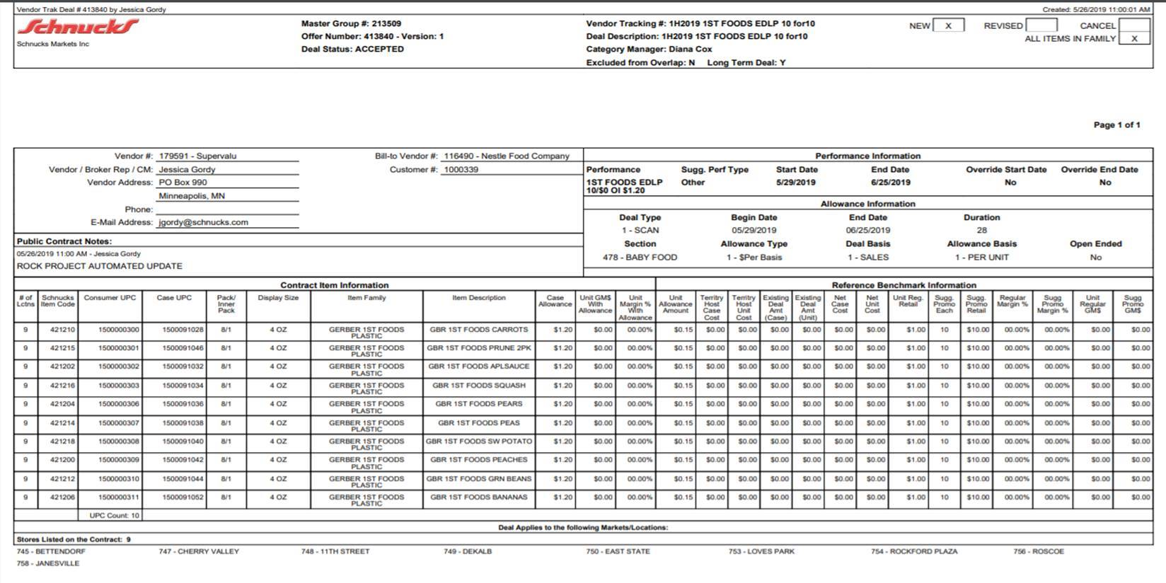

The customer invoice will list the Rockford, IL stores by number:

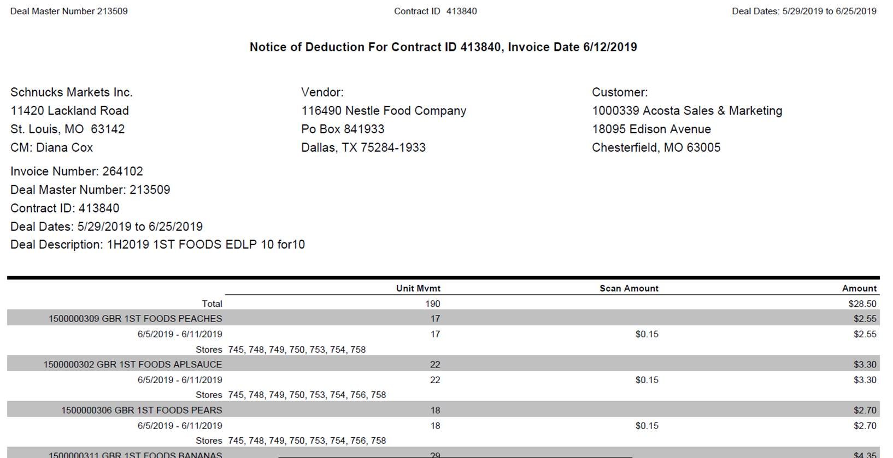

Cost Changes:

All cost changes must be submitted into the Schnucks Trade Partners portal 60 days prior to the new cost effective date. See attached policies.

Contract info:
When locating contracts for invoices that provide a contract id, please enter that id into the customer event # on the DBW detail grid.

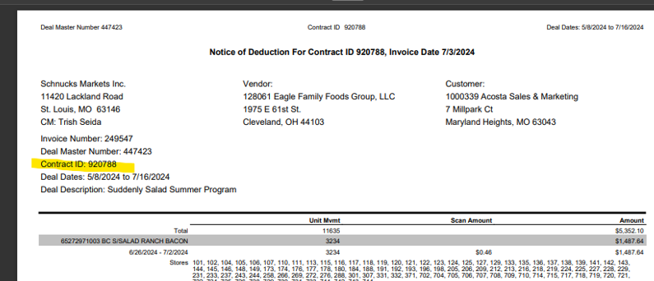

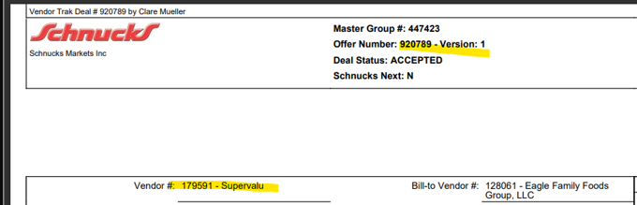
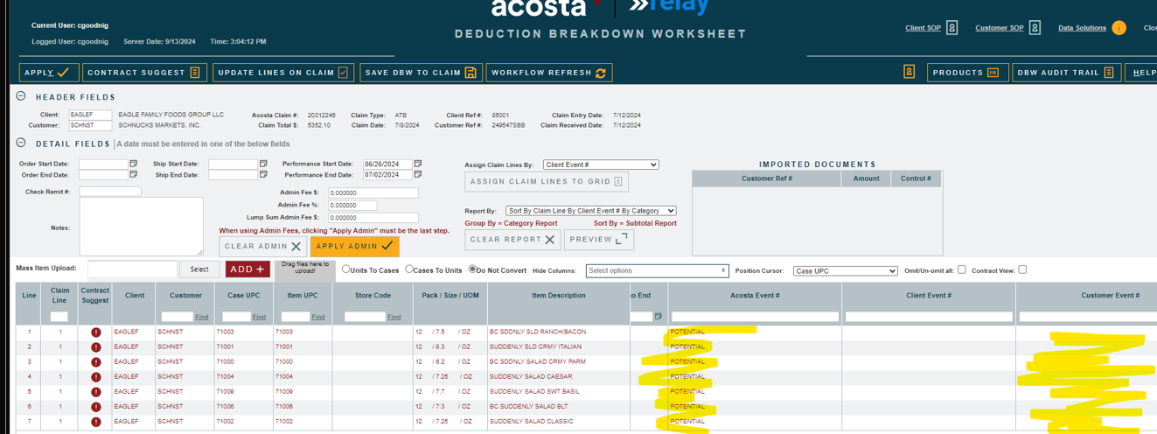

POP Info:

When a Schnucks contract shows a Suggested Performance Type that includes AD and no ad money is offered on the contract, it is at Schnucks’ discretion on whether an ad will be run. Search for an ad for the timeframe shown on the contract; if no ad is found, do not escalate for POP.

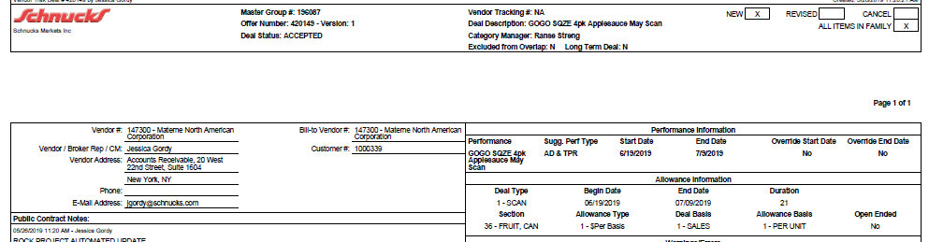

Performance dates run Wednesday-Tuesday.

BACKUP RETRIEVAL INFORMATION

GENERAL BACKUP RETRIEVAL INFORMATION

Is GCIT responsible for obtaining backup from the customer? Yes
- If yes, is there a customer portal? Yes
- If yes, does GCIT request backup? Yes

Is check remittance information required to request backup? No

GCIT SPECIFIC BACKUP RETRIEVAL INFORMATION

Portal:

Customer Invoice or Note Identifier | Request From
SBB  LSB  SRD  VGP (15 digit Invoice # Ex: 154 116490 220831)  PO # (7 numeric digits: Ex: 1926120) – can be used in Cust Ref # field | Schnucks portal – Trade Partners

Automated:

Customer Invoice or Note Identifier | Request From
ATG | schnucks@atgaudits.com
LL | schnucks@prgx.com
SRP (Schnucks Retail Partnership) | accountspayable@schnucks.com

Non - Automated:

Customer Invoice or Note Identifier | Request From
All formats or not in portal | Request from sales

CLIENT SPECIFIC VALIDATION INFORMATION

Client
Barilla
Campbell’s/Pepperidge Farms
Coca Cola North America (CCNA)
Eagle Family Foods
Horizon Organic Dairy LLC
Kens Foods
Mars Foods US LLC
Procter & Gamble
Simply Good Foods USA

BARILLA
- If SRP is referenced in the customer ref #, the invoice is for “Schnucks Retail Partnership”. Backup can be requested by contacting accountspayable@schnucks.com. Below is the contract example needed for these types of invoices.

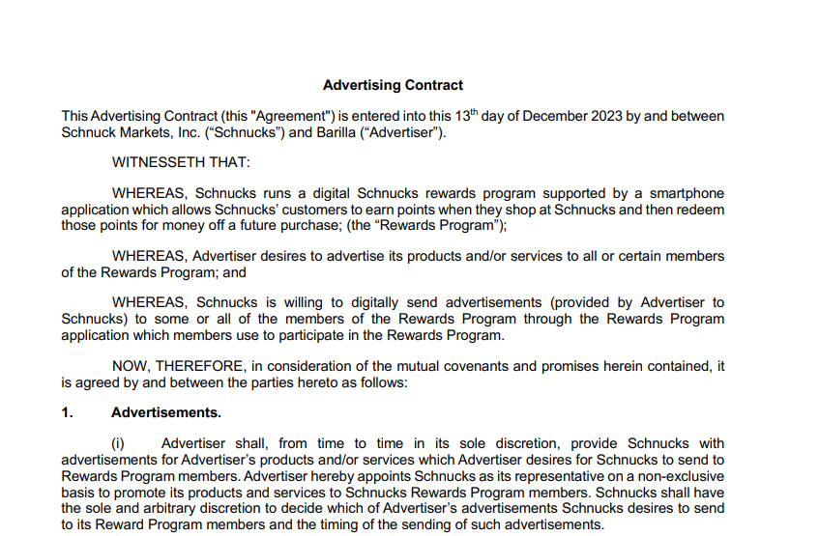

CAMPBELL’S / PEPPERIDGE FARM

- For PEPPGR and PEPPBK missed OI allowance claims: If no OI allowance can be identified, a scan contract may be used if the Late Deal report indicates a scan allowance and the allowance amount, product and dates match the SAP ticket details.
- For Pallet Fees there will be an invoice and additional detail page which can be pulled from Schnucks Portal. Once necessary documentation has been attached, code the claim as Non-Trade/Service Fee Penalty. Enter a clearing/math note: Pallet Fees, logistical allowance. See invoice examples below:
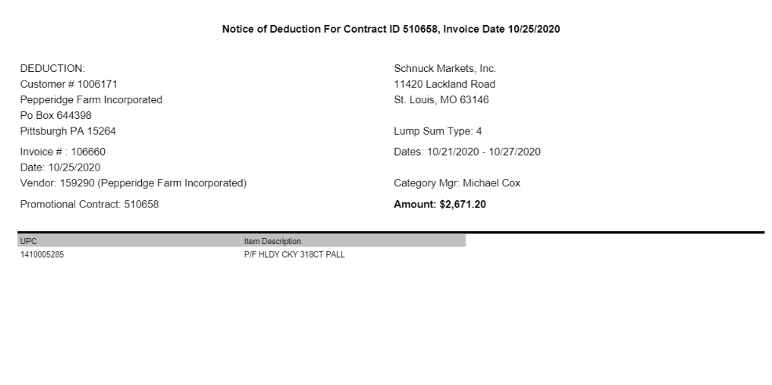

Below is the Invoice Detail pulled from Schnucks portal. This is necessary to validate. If detail cannot be located, step to Sales for assistance.
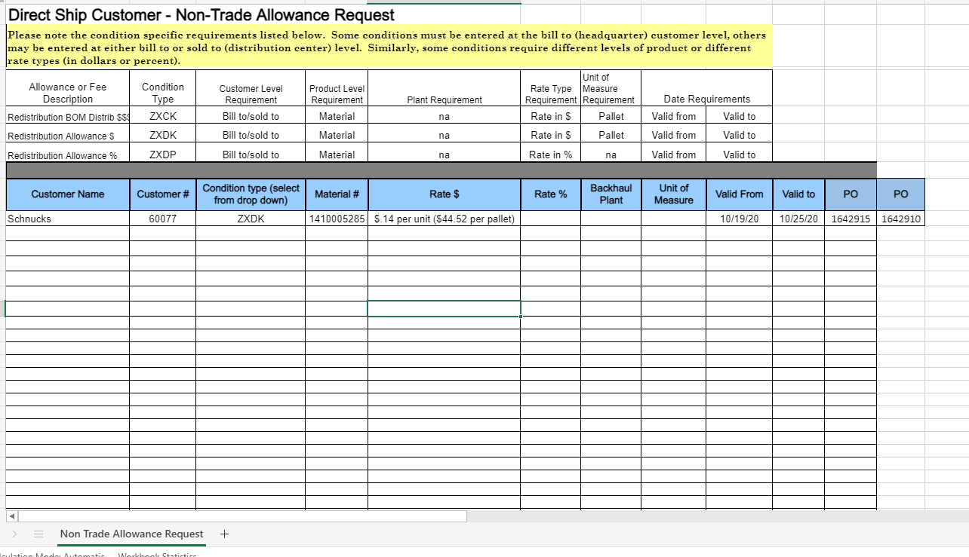

COCA COLA NORTH AMERICA (CCNA)
- Schnucks is allowed a seven (7) day shift.

EAGLE FAMILY FOODS:
- For Scan invoices: the dates on the invoice must align with the event dates before matching.

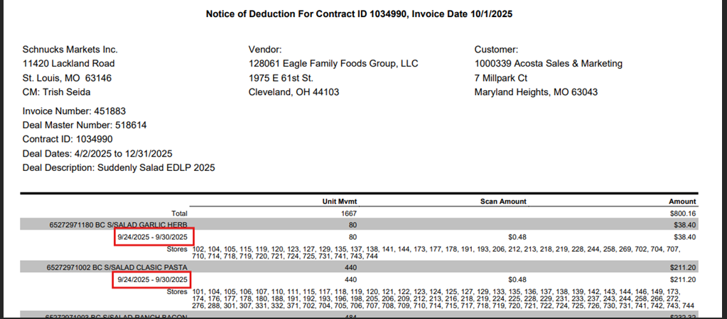

HORIZON ORGANIC DAIRY LLC
- Schnucks Check remits need to be attached to the Horizon claims, if, no other invoice is available. The EDI check remittance has some backup information listed on it.
- Scnucks claims that reference the PO # in the customer reference field are logistical fees - no show, missed appointment and deliveries. These fees we do not need the customer invoice. These need to be changed to non-trade/service fee/penalty in Relay and stepped to clear.

KENS FOODS
- Store Damages (a.k.a. VGP or Vendor Guaranteed Product) - Deductions will be in waves – Invoice Numbers will be in the following format: 724 140914 220522. The first 3 digits are the Store Number; the next 6 digits are the Ken’s Vendor Number at Schnucks, and the last 6 digits are the date Schnucks posted the charge (this date does not always exactly match the date deducted, but they are usually close). Ken’s requires back-up for each of these charges, follow attached instructions:

MARS FOODS US LLC
- Schnucks is part of the Retail Merchandising for Mars Foods.

PROCTER & GAMBLE (P&G)
- Schnucks submits monthly check requests for scans. The billing comes via e-mail and will be in this format:
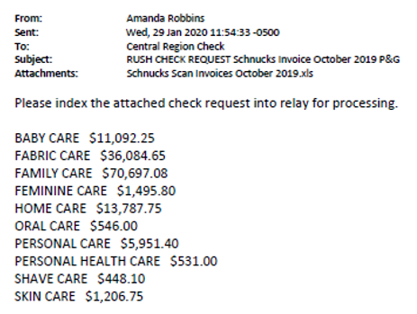

Each PPG will be indexed as a separate check request and will have scan data attached. When creating the DBW, use the performance dates for the full month that is in the subject line. (In this example, use 10/1/19 – 10/31/19.) A contract that covers the dates of the scan needs to be linked for any check request over $300.00.

SIMPLY GOOD FOODS USA
- Store Damages (a.k.a. VGP or Vendor Guaranteed Product) - Deductions will be in waves – Invoice Numbers will be in the following format: 206162621240908. Stepped as Non-Trade/Damages.

PROCESS STEPS

- Deduction Type: Off Invoice

A per case off invoice allowance (OI) is given to the customer as an automatic discount for product purchased from the client. If the customer does not receive the allowance off the face of the invoice they will deduct for it. If the customer requested an allowance that is not valid, the CSC will send a notification to the customer in writing. Customers view purchase orders as contracts. If they are not notified of allowance discrepancies, they will pay according to their purchase order total.

  - Customer Invoice for Off Invoice (OI):

The PO-related invoices are an Excel file. The below example is show only sections of the invoice, based on what is needed to validate a missed OI claim. The entire invoice must be reviewed for any possible PO-related issue.

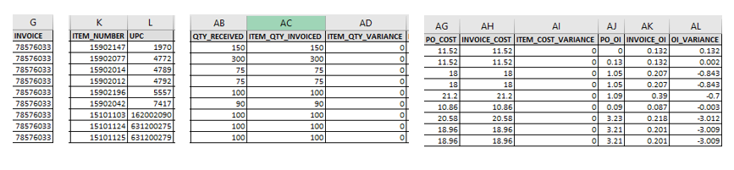
3
1

Quantity – QTY RECEIVED identifies how many cases the customer unloaded from the truck and ITEM QTY INVOICED identifies how many cases they were charged for. If there were any shortages/damages, the ITEM_QTY_VARIANCE wil identify the difference. The missed OI rate is calculated based on the ITEM QTY INVOICED total.

Item Number/UPC – This identifies the Shcnucks item (store) number and client UPC code the claim is for.

Rate – PO_OI identifies what OI (if any) Schnucks expected and INVOICE_OI identifies what OI (If any) they received. OI_VARIANCE identifies the difference that Schnucks is deducting for.

Invoice Number – This identifies the client order invoice # the claim is for.

4
2

  - Customer Contract for Off Invoice: Found via Search For: Event Scheduler.

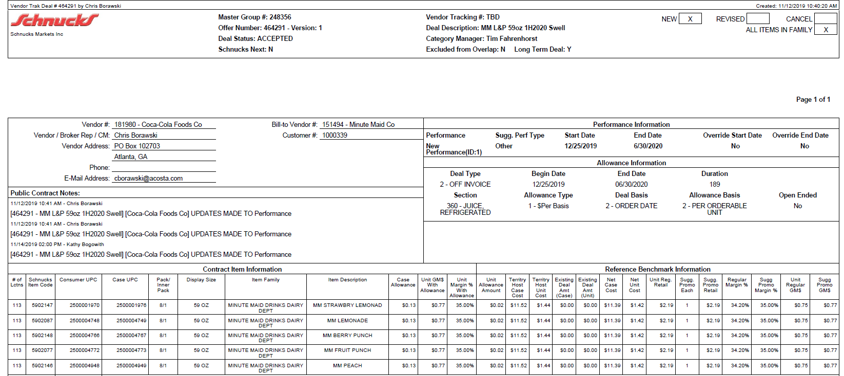
Deal Type – The deal type is identified as Off Invoice allowance.
i
Order start and end date –– The order date on the client order invoice needs to fall within these dates.

5
Rate – This is the per case off invoice allowance amount that was offered to the customer.

2
1

Item Code/Case UPC –This is the product for which the customer is being offered an off invoice.

Refer to the SOPs/Generic Help File for POP requirements.

- Deduction Type: Billback

A billback (BB) claim is a per case allowance offered for a specific performance requirement. A per case billback allowance is claimed by the direct buying customer for product purchased from the client, or by the indirect customer for product purchased from the direct customer. This is an allowance the customer will bill the client for. This is not an automatic discount given off the face of the invoice.

2.1 Customer Invoice for Billback, Example 1:

3
Rate – BILLBACK_VARIANCE is the per case BB allowance the customer is claiming.

QTY – INV_QTY is the number of cases the customer is claiming a BB allowance for.

2

1

Item Code/Case UPC – This is the store code/client UPC that the customer is claiming a BB allowance for.

4
PO Number – This identifies the cusomter purchase order # the claim is for.

2.2 Customer Contract for Billback, Example 1: Found via Search For: Event Scheduler.

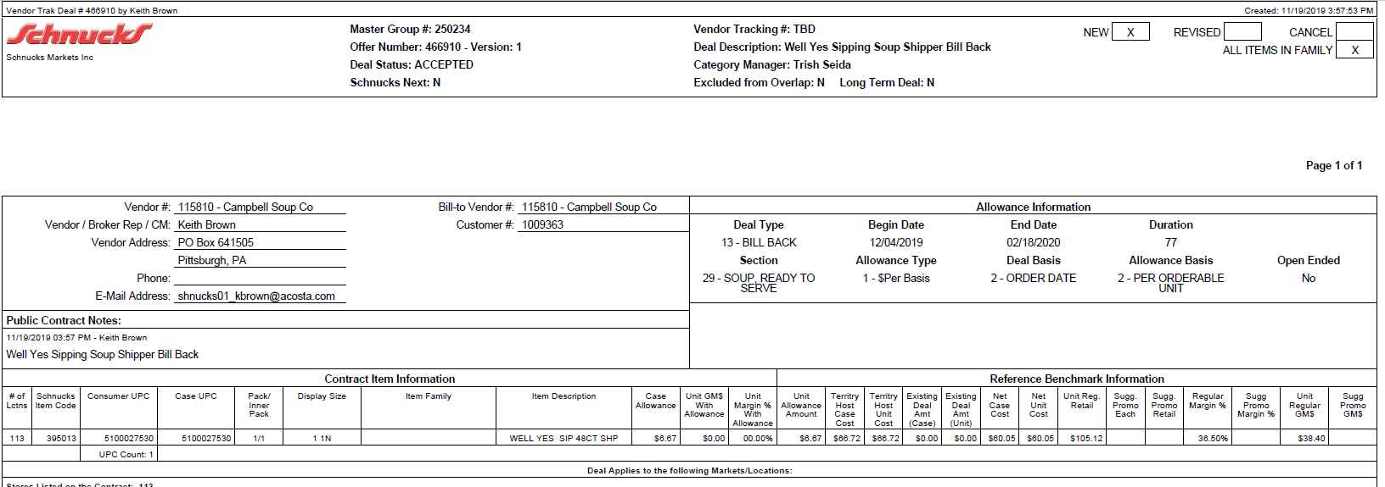
5
Order start and end date –– The order date on the client order invoice needs to fall within these dates.

i
Deal Type – The deal type is identified as Billback allowance.
2
Rate – This is the per case billback allowance amount that was offered to the customer.

Item Code/Case UPC – This is the product for which the customer is being offered a billback.

1

Refer to the SOPs/Generic Help File for POP requirements.

- Deduction Type: Scan

Scan allowances are for product scanned at the store register and are usually billed in eaches, not cases.

  - Customer Invoice for Scan:

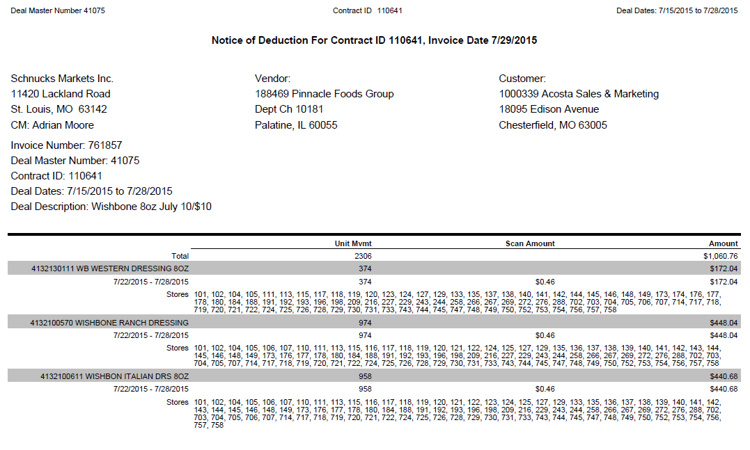
Total Scan $ amount. .
These dates are the performance dates the scan ran. .
i
Contract ID: The contract ID can be used in the customer event field to locate a contract.
Product Detail: This is the product on which the customer is stating there is a scan allowance due.
Deal Dates: These dates will match the contracts.
1
i
Scan Amount: This verbiage identifies the claim as scan.
4

Scan Rate: This is the rate per unit claimed for the scan on each item, which must match the contract.
2

3
Unit Mvmt: This is quantity scanned. While the individual store numbers are listed for each product, the quantity is not broken down for each store.
The customer invoice lists quantity in units and the sales summary is in cases. A conversion will need to be done to confirm sufficient cases were purchased.

  - Customer Contract for Scan, example 1: Found via Search For: Event Scheduler.

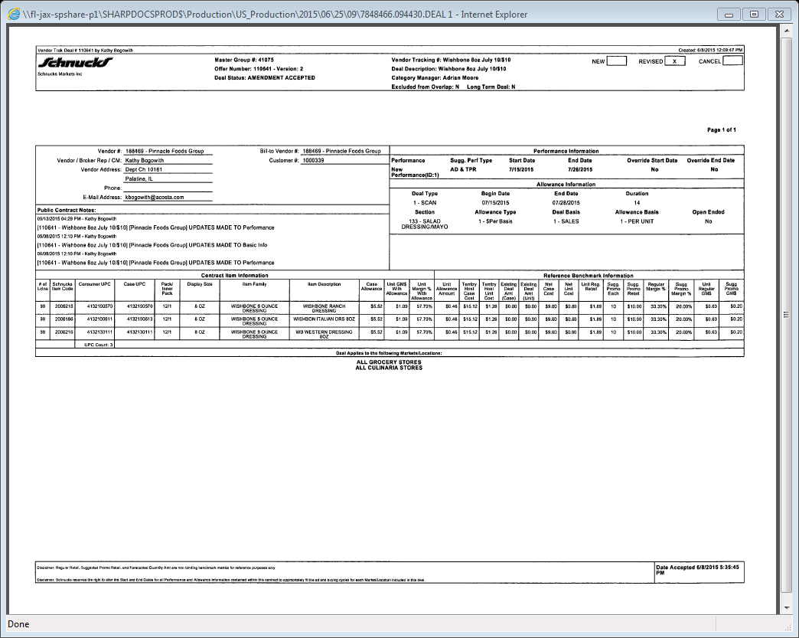
Offer Number: Match the Contract ID on the customer invoice to the offer # on the contract.
i
Unit Allowance Amount: This is the amount per unit being offered for the scan.
Store Code/Consumer UPC/Case UPC: The customer store code/item UPC/case UPC the scan allowance is offered on.
Deal Type: This identifies that the promotional allowance offered is a scan.
i
3
Begin Date & End Date: The performance dates on the scan allowance is offered for.
1
2

3.1 Customer Invoice for Scan, example 2, Global Promotion (in-store promotion):

Page 1: The invoice is on an Excel document w/ multiple tabs.
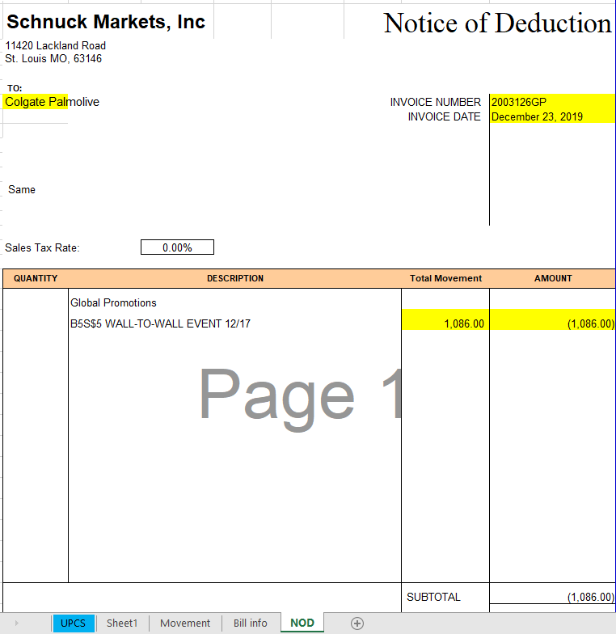
Identification: The primary invoice page may not provide production information. Refer to the UPCS tab breakdown detail.
i
Identification: GP identifies the invoice as being for Global Promotion.
i

Page 2: The UPCS tab identifies specific UPCs offered the scan allowance, the scan rate, and the scan performance dates.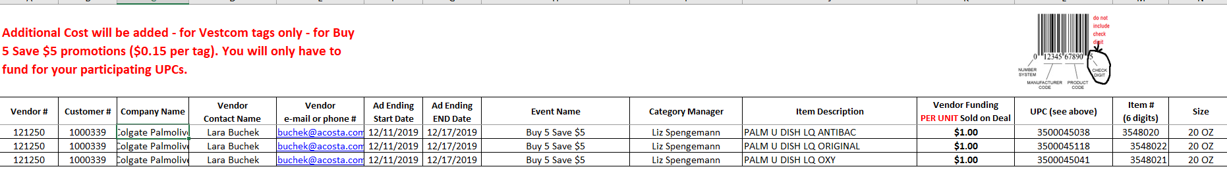
2
1
4

Deal Dates: The dates the customer is claiming for scan allowance.
Product Detail: This is the product on which the customer is stating there is a scan allowance due.
Scan Rate: This is the rate per unit claimed for the scan on each item, which must match the contract.

Page 3: If client requires clearing down to UPC level, the Movement tab can be used to identify quantity by UPC by expanding the detail. Divide the total movement by the scan amount to get total quantity by UPC.

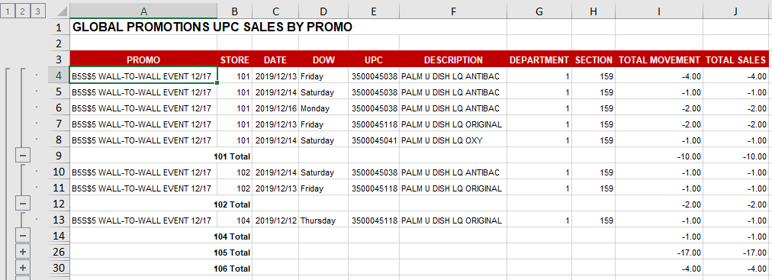

  - Contract for Scan, example 2, in-store promotion: Found via Search For: Event Scheduler

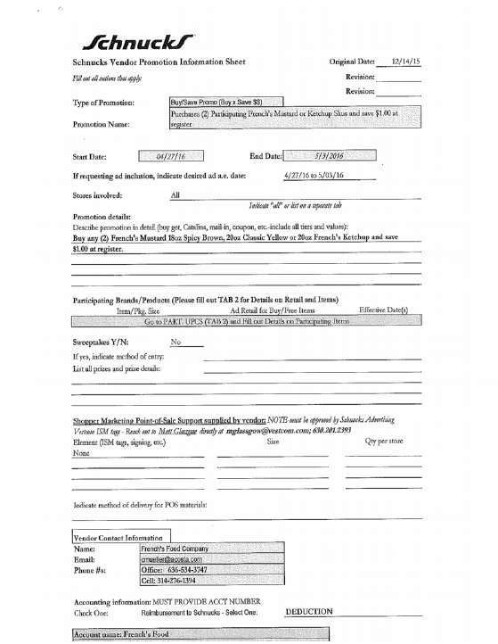
Performance Dates: The date range when the promotion is valid. This must match the performance dates on the customer invoice (if provided) and the POP-Ad.
4
Type of Promotion, Promotion Name, Promotion Description: This provides the detail for the in-store promotion/scan allowance being offered.
2

Refer to the SOPs/Generic Help File for POP requirements.
3.1 Customer Invoice for Scan, example 3, Digital Coupons/Points:

Schnucks Rewards – Vendor Report

Serves as the invoice.

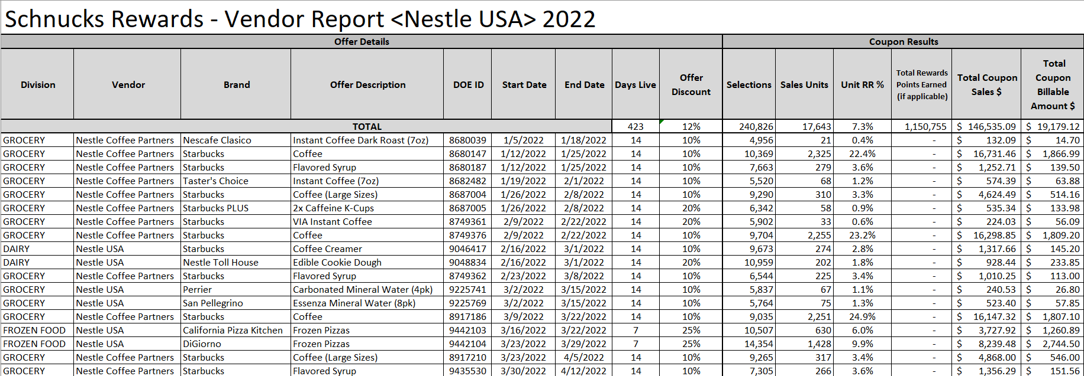

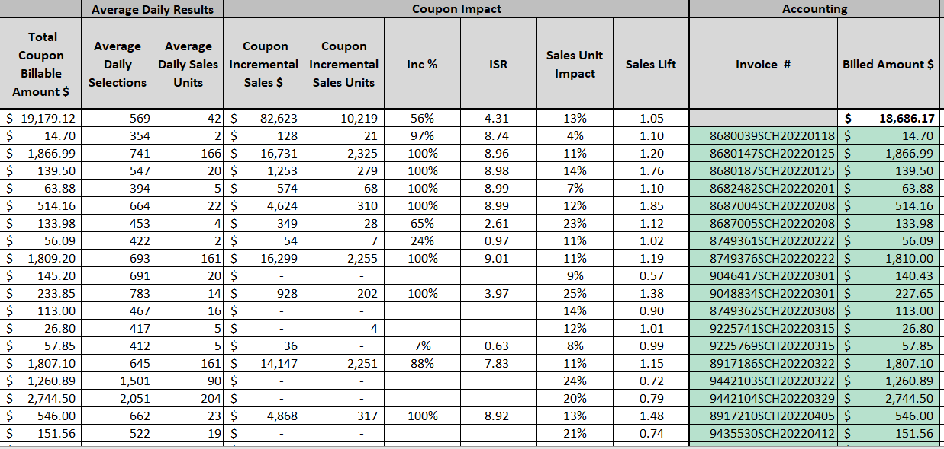
Invoice Number and Billed Amount listed on far right of spreadsheet:
3.2 Contract for Scan, example 3, Digital Coupons/Points: Rewards Submission form serves as contract. Found via search in Event Scheduler.
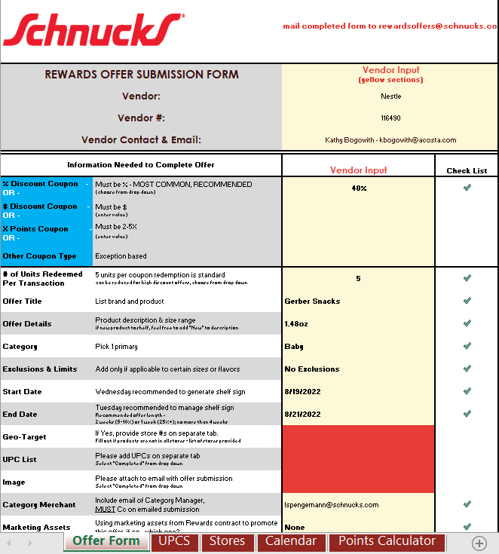
Identification: Indicates type of coupon redemption. .
Performance Dates: The dates the coupon is redeemable..
i

UPCs: The UPCs the coupon is for are listed on the 2nd tab of the contract.

UPC Tab
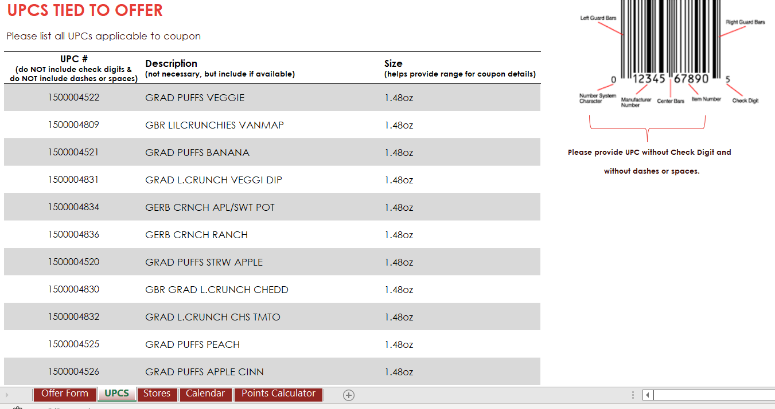

Points Calculator

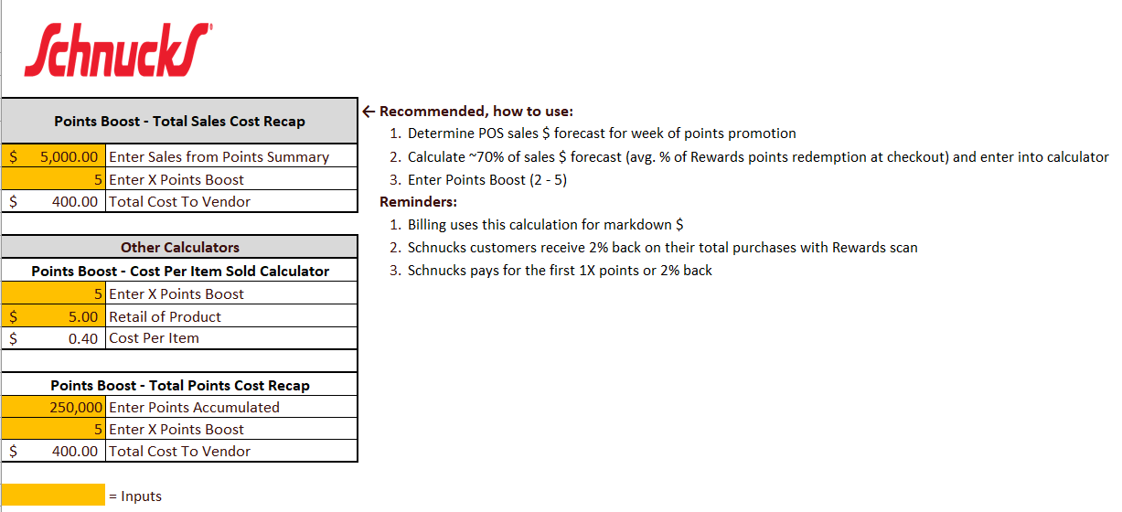
4 Deduction Type: Ad

A fee for featuring a client’s products in an advertisement.

4.1 Customer Invoice for Ad: If not provided under View Documents, this can be found via Search For: Backup Documentation, Doc Type 2-Customer Invoice.
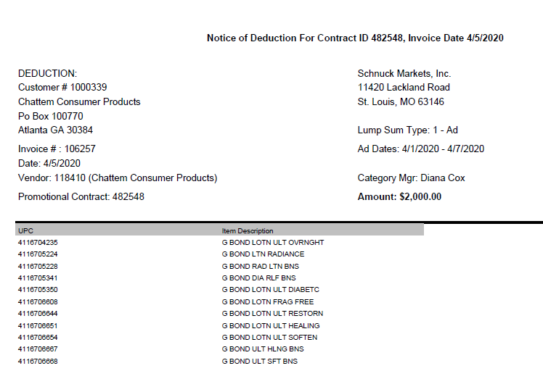
Identification: Lump Sume Type: 1-Ad identifies that the customer is billing for an ad lump sum.
i
Contract ID: The contract ID can be used in the customer event field to locate a contract.
i
2
Dates: The dates the customer is claiming the ad ran.
3
Amount: The ad lump sum the customer is claiming.
UPC/Item Description: The items the customer is claiming an ad allowance for.
1

4.2 Customer Contract for Ad: Found via Search For: Event Scheduler.
Offer Number: Match the Contract ID on the customer invoice to the offer # on the contract.
i
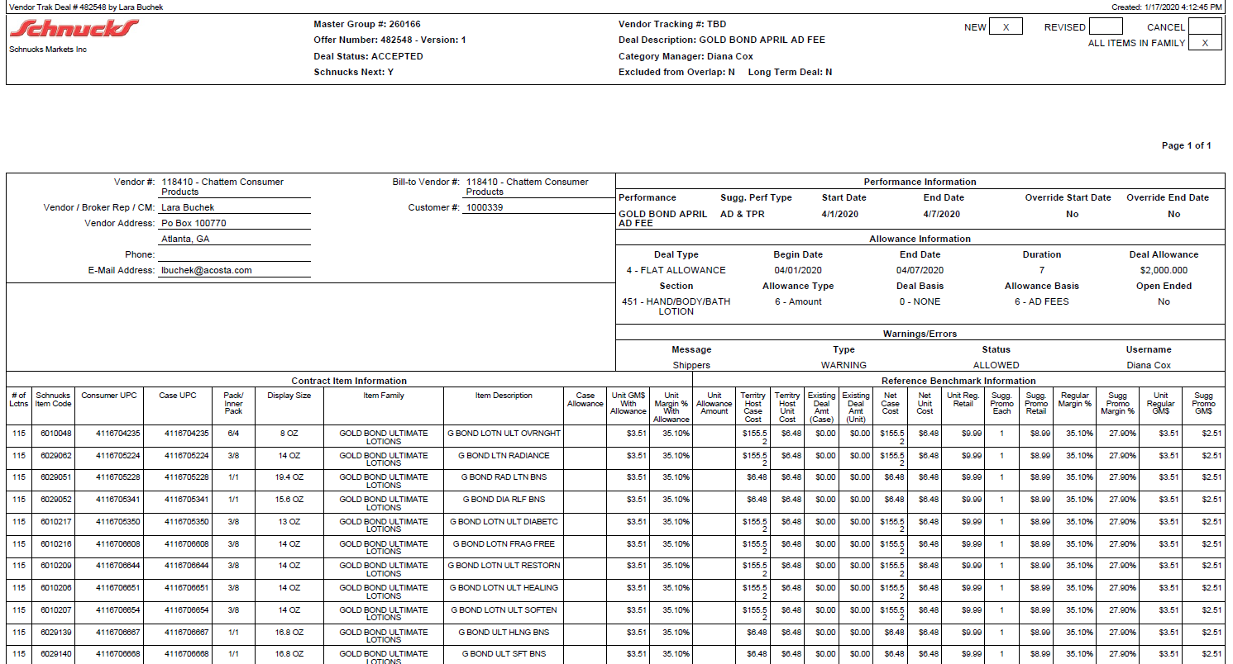
2
Dates: The dates the customer was offered the ad for.
Allowance Basis: This identifies that the lump sum is for an ad.
i
3
Deal Allowance: The amount the customer was offered for ad.
UPC/Item Description: The products the customer was offered an ad allowance on.
1

Refer to the SOPs/Generic Help File for POP requirements.

5. Deduction Type: Pricing

A pricing deduction occurs when the customer’s requested price on the original purchase order differs from the client’s invoice.

Documents required for validating a Pricing claim:

Document Name | Source of the Document | Action by Accenture
Customer Invoice | ACOSTA Relay – search for the invoice under Backup Documentation, document type 2. | Step the claim to Acosta for research.
Order Invoice or Client Order Invoice | ACOSTA Relay – search for this document within the Order/Invoice/PO search.

5.1 Customer Invoice for Pricing:

The PO-related invoices are an Excel file. The below example is show only sections of the invoice, based on what is needed to confirm/validate a pricing claim. The entire invoice must be reviewed for any possible PO-related issue.
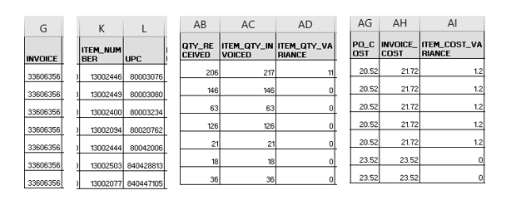
Identification: If there is an ITEM_QTY_VARIANCE identified, it’s possible a portion of the claim balance may be for shortage. Refer to the shortage example.
i
Identification: If the customer has an amount shown in the ITEM_COST_VARIANCE, they are deducting for pricing. Calculate the difference times the ITEM_QTY_INVOICED to determine how much of the claim is for pricing.
i

6. Deduction Type: Slotting

A slotting allowance is offered to the customer to purchase an item not currently stocked. It is a kind of promotional money offered to a customer as incentive to buy a new item and create a “slot” for that product on their warehouse storage shelves. It is a trade deduction. A slotting lump sum allowance can be offered for each item and/or an off invoice can be offered as an introductory allowance for the first 30 days.

6.1 Customer Invoice for Slotting, Example 1:

i
Voucher #: This is the customer’s invoice number.
NOTE: Search with the % wildcard, as additional letters may be included.
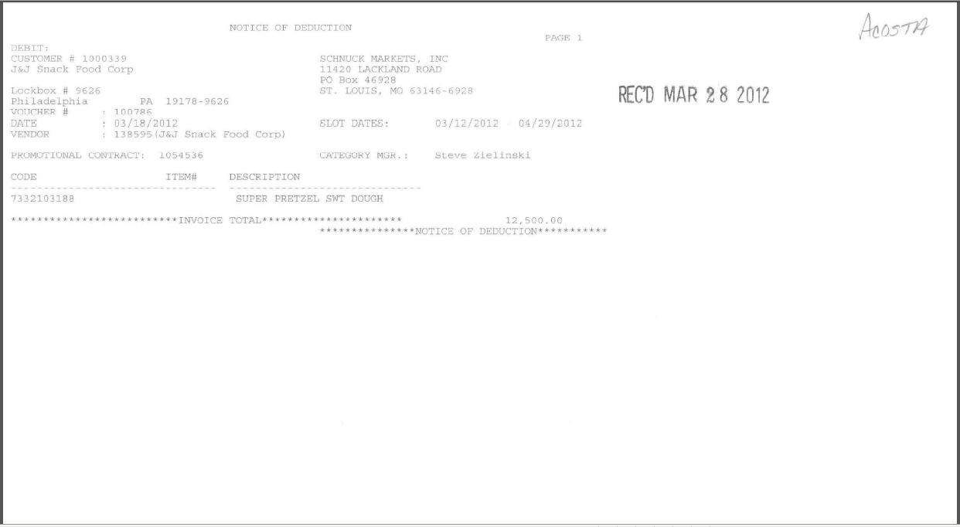
Code/Item #/Description – This area lists the product details, which needs to match with the contract.
Deduction Amount –This is the lump sum amount that the customer has claimed for slotting. This must match the contract.
i
Slot Dates: This indicates that the invoice is for slotting.
1
2

6.1 Customer Invoice for Slotting, Example 2:

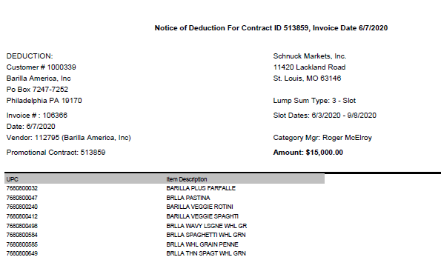
2
Amount: The slotting lump sum the customer is claiming.
i
Identification: Lump SumeType: 3-Slot identifies that the customer is billing for an ad lump sum.
i
Contract ID: The contract ID can be used in the customer event field to locate a contract.

1
UPC/Item Description: The items the customer is claiming a slotting for.
6.1 Customer Invoice for Slotting, Example 3 - New Store Free Fill: Schnucks policy for new store openings is outlined in paragraph 3 of the letter below. Clients are expected to provide free product to stock the new store. The customer reference number for these claims will contain some version of New Store Free Fill, New Store Fill, etc. There are no customer invoices or contracts for these fees. Unless specific approval for validation is received from the client, these claims must be stepped to sales for clearing direction. Note the claim that this is for a new store free fill, and ask the client manager to advise on how to clear.

6.1 Slotting – New Store Free Fill policy letter:

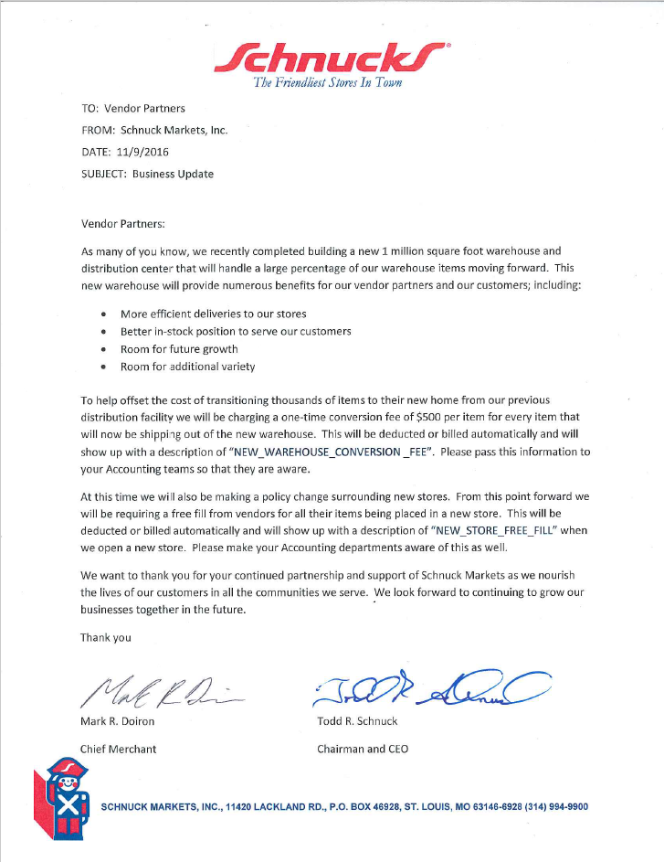

6.2 Customer Contract for Slotting: Found via Search For: Event Scheduler.

i
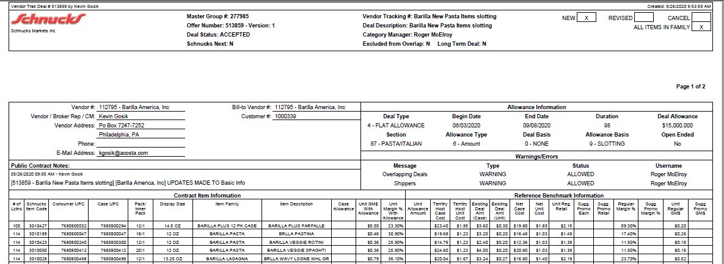
2
Deal Allowance: The amount the customer was offered for slotting.
i
Allowance Basis: This identifies that the lump sum is for slotting.
Offer Number: Match the Contract ID on the customer invoice to the offer # on the contract.
1

UPC/Item Description: The products the customer was offered a slotting allowance on.

Refer to the SOPs/Generic Help File for POP requirements.

7. Deduction Type: Unsaleable / Reclamation

An unsaleable claim is taken for product that cannot be sold at the stores due to damages, and for short coded product.

7.1 Customer Invoice for Warehouse Damages/Unsaleables, Example 1:

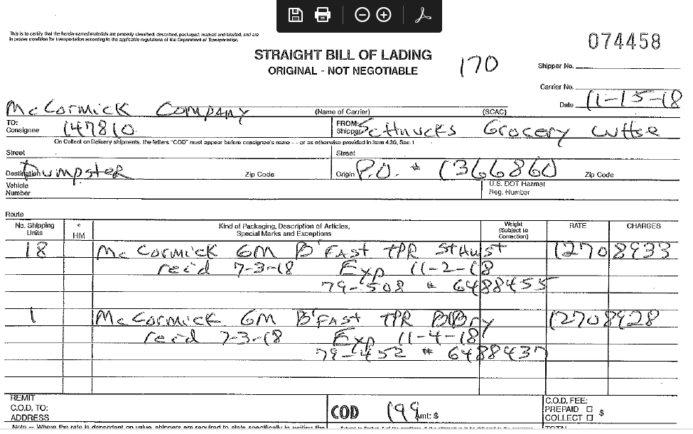
Identification: Dispostition is listed as dumpster – the customer has thrown away the product listed due to being outside code (insufficient shelf life).
i

8. Deduction Type: Demos

A demo is an in-store demonstration of the client’s product to consumers. Time, resources and product charges are billed back to the client.

Schnucks is currently not doing in-store demos.

9. Deduction Type: Display

A display deduction is an allowance given on an in-store product display (within a specific agreed section of the store) on an end cap or displayed per the client’s requirements.

9.1 Customer Invoice for Display:

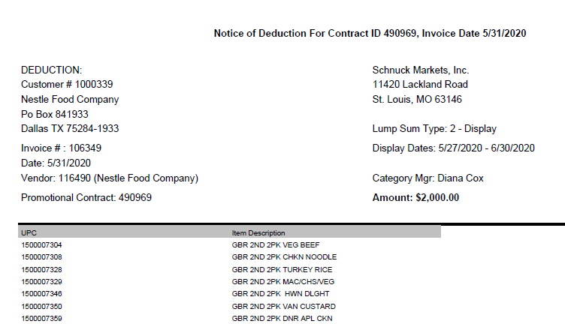
i
3
Amount: The slotting lump sum the customer is claiming.
Identification: Lump SumeType: 2- Display identifies that the customer is billing for a display lump sum.
i
Contract ID: The contract ID can be used in the customer event field to locate a contract.
Dates: The dates the customer is claiming the display allowance for.

2
UPC/Item Description: The items the customer is claiming a slotting for.
1

9.2 Customer Contract for Display: Found via Search For: Event Scheduler.

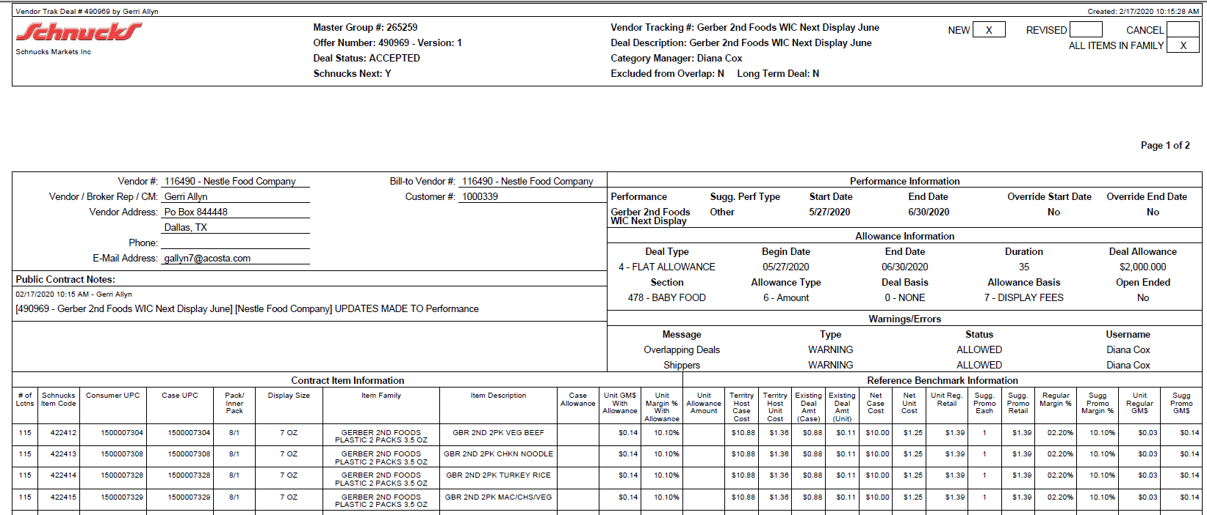
2
Dates: The dates the display is offered for.
Allowance Basis: This identifies that the lump sum is for display.
i
i
Offer Number: Match the Contract ID on the customer invoice to the offer # on the contract.
3
Deal Allowance: The amount the customer was offered for display.

1
UPC/Item Description: The products the customer was offered an display allowance on.

Refer to the SOPs/Generic Help File for POP requirements.

10. Deduction Type: Food Shows

An event sponsored by a wholesaler exhibiting various clients’ products to indirect customers.

10.1 Customer Invoice for Food Shows:

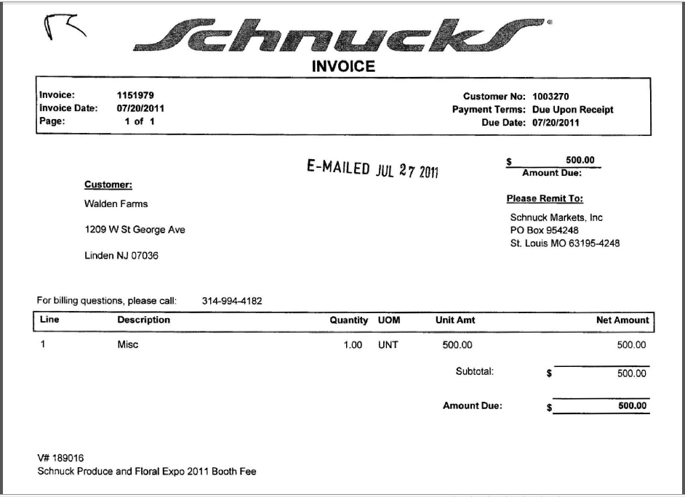
i
Amount Due: This is the lump sum the customer is claiming for a food show. This amount must match the food show participation agreement.

2
Schnucks customer invoices refer to the client as either the vendor or the customer. Regardless of their terminology, this is the client Schnucks is deducting from.
i
Description: This identifies the show that the claim is for. “Booth Fee” confirms that this is a food show deduction.

10.2 Participation Agreement: This can be found either via Search For: Event Scheduler or Search For: Backup documentation, Doc Type 17-Contract.

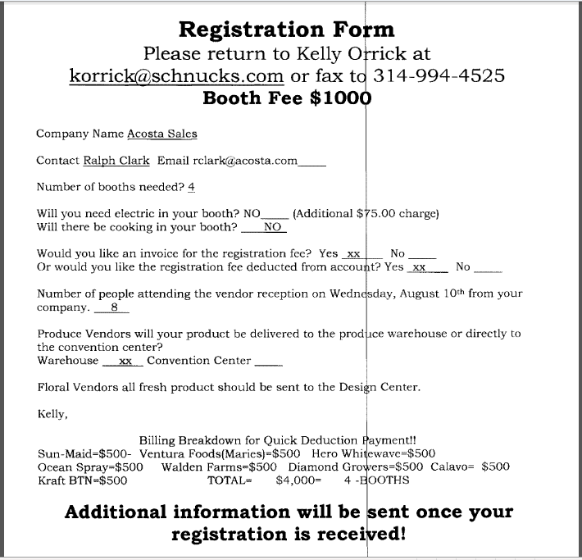
This is the amount the customer charges for participation in the food show.

In this example, they are billing multiple clients, for a total of $4000.00. The portion deducted from Walden Farms is $500.00. This amount must match the customer invoice.
2

Refer to the SOPs/Generic Help File for POP requirements.

11. Deduction Type: Coupons (Manufacturer’s)

This is a manufacturer Coupon, typically cleared by client.

Document Name | Source of the Document | Action by Accenture
Customer Invoice | ACOSTA Relay – search for the invoice under Backup Documentation, document type 2. | Step up the claim to Acosta for research

11.1 Customer Invoice for Coupons:

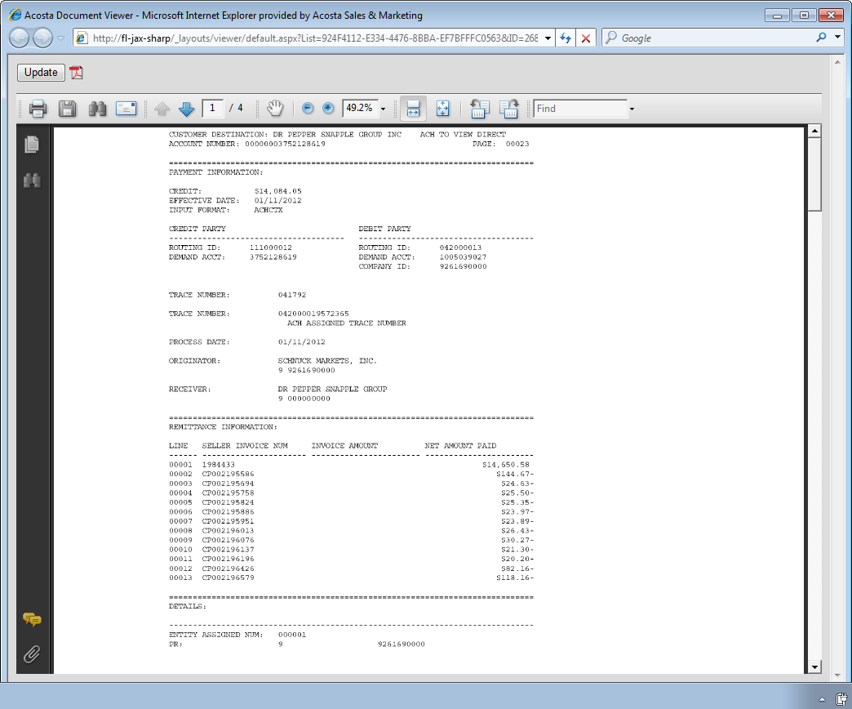
Customer Invoice Number: If the invoice number on the customer invoice or customer check remittance is prefixed by CP, it confirms that the invoice is for a Coupon Deduction.
Once identified as Coupons the claim needs to be stepped to Acosta for further research.

Refer to the SOPs/Generic Help File for POP requirements.

12. Deduction Type: Returns

Products returned by the customer to the client.

Documents required for validating a returns claim:

Document Name | Source of the Document | Action by Accenture
Customer Invoice | Acosta Relay – search for the invoice under Backup Documentation, document type 2. | Step the claim to Acosta for research
Client Order Invoice | Acosta Relay – search for this document within the Order/Invoice/PO search if one is present.

12.1 Customer Invoice for Returns, example 1:

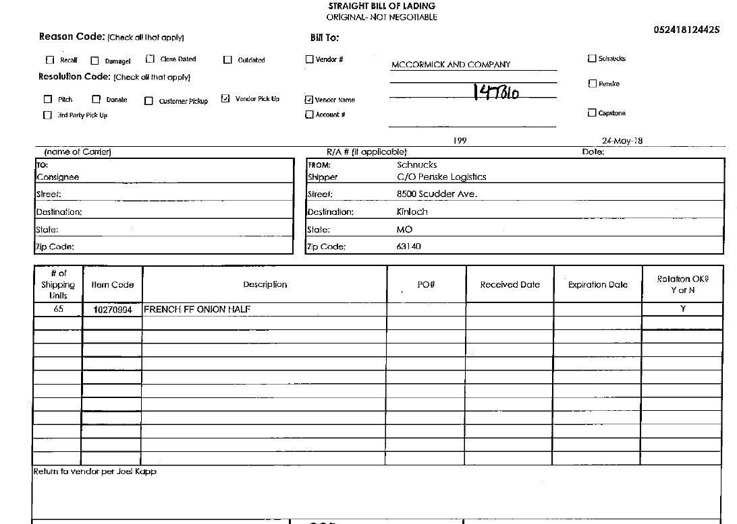
The comments indicate the product listed was returned to the vendor, making this claim for Returns.
i

13. Deduction Type: Shortage

It is a deduction for product that was not shipped on an order but that the client billed the customer for.

Documents required for validating a Shortage deduction:

Document Name | Source of the Document | Action by Accenture
Customer Invoice | Acosta Relay – search for the invoice under Backup Documentation, document type 2. | Step up the claim to Acosta for research
Order Invoice or Client Order Invoice | Acosta Relay – search for this document within the Order/Invoice/PO search.

13.1 Customer Invoice for Shortage:

The PO-related invoices are an Excel file. The below example is show only sections of the invoice, based on what is needed to validate a missed OI claim. The entire invoice must be reviewed for any possible PO-related issue.

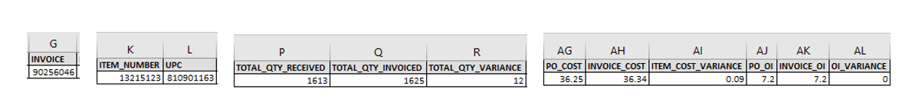

i

Identification: If there is a TOTAL QTY VARIANCE identified and the TOTAL QTY INVOICED is more than the TOTAL QTY RECEIVED, calculate the variance amount by the INVOICE COST. NOTE: If there is an ITEM COST VARIANCE and/or an OI VARIANCE, those differences may need to be taken into account when calculating the amount deducted for shortage.

14. Deduction Type: Post Audit

Internal/external auditors find claims that the customer is entitled to but did not take from previous years. Post Audits should be researched in the same manner as other claims by accessing previous year’s files.

NOTE: The post audit claim must first be researched to ensure the customer has not already billed for the allowance before the normal validation process can begin.

Once the post audit claim has been researched to ensure the customer has not already billed for the allowance, refer to the appropriate allowance section of this SOP to continue with validation. If the post audit is for an allowance not defined in an allowance section of the SOP, refer to the post audit example for validation information.

14.1 Customer Invoice for Post Audit, Example 1:

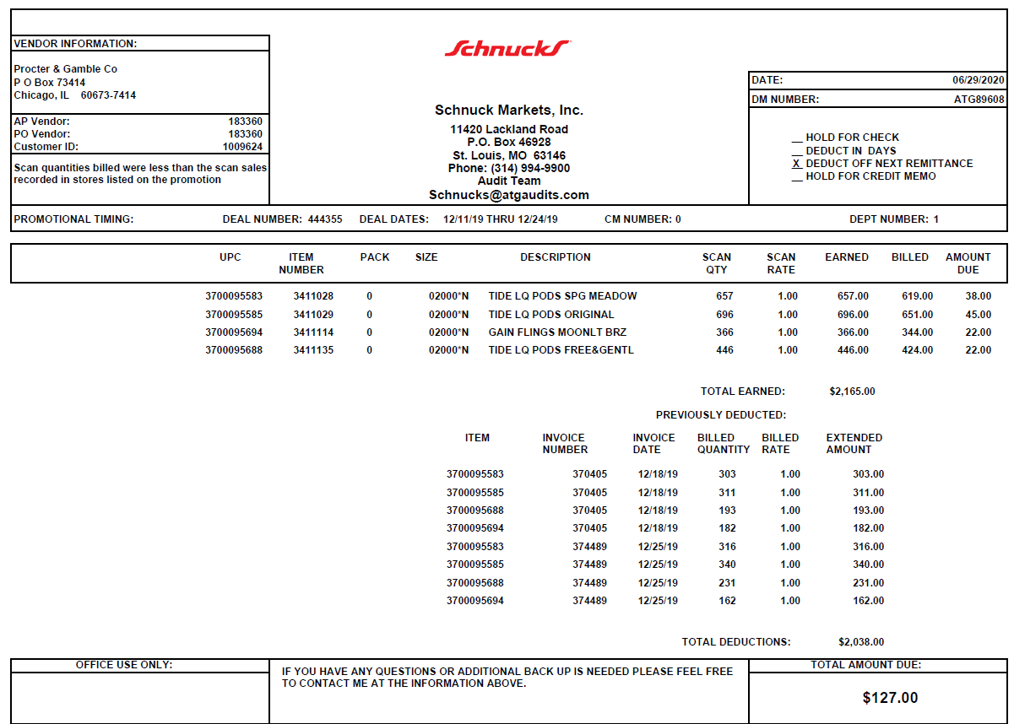
Quantity & Rate: The customer is listing the quantity and rate for the scan and subtracting the totals already deducted. The post audit is for the difference of total Earned minus what was already Billed.
Dates: The deal dates being claimed for post audit.
UPC/Item Number: The client upc & customer store code the post audit is for.
Previously Deducted:Schncuks provides claims that were previously deducted against the contract, these should be in the VPF.
i
i
i
Customer ref#:The customer ref# starting ATG identifies the invoice as being for post audit.
Deal Number:The contract the post audit is for – can be used to locate the contract.

14.1 Customer Invoice for Post Audit, LL invoice Example 2:

NOTE: The PRGX invoice is usually in Excel format, but can be scanned and indexed as a .pdf. Tab/page 1 is the cover sheet. Tab/page 2 has the claim detail. Tab/page 3 is the customer’s copy of the related contract. Tab/page 4 is for any additional supporting documentation.

Tab or Page 1:

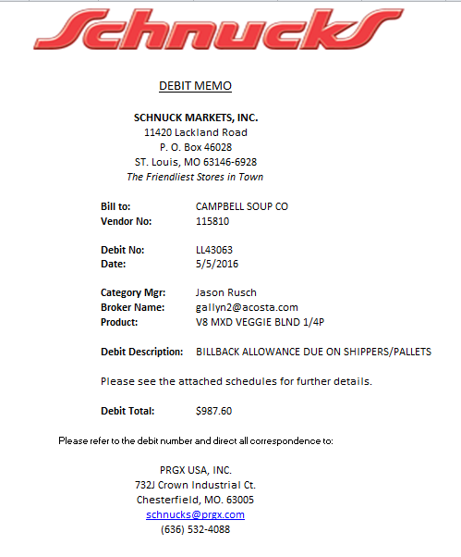
Identification:LL identifies the invoice as being for a post audit.
i
Post Audit Identifer:
PRGX is an audit company. By default, any CI from PRGX is for a post audit.
i
Debit Total: The amount Schnucks is claiming for the post audit deduction.
Vendor:Identifies the client Schnucks is deducting the post audit from.
i
i
Debit Description:
Identifies that the post audit is for a billback not taken.
i
i

Tab or page 2:

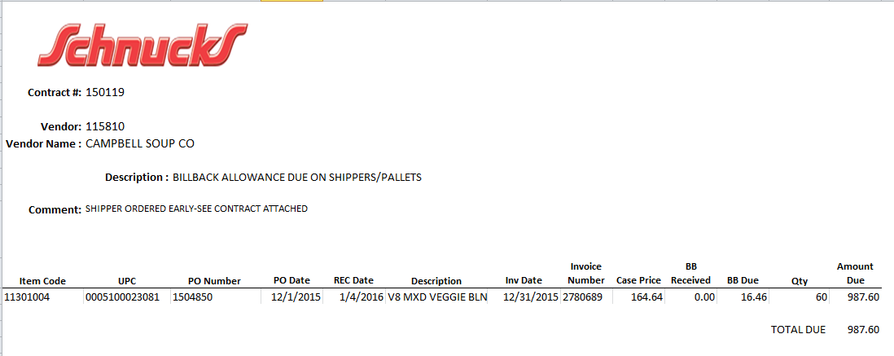
Rate: Schnucks is stating they were due an allowance that they didn’t receive. If both fields have a rate, then the claim is for the difference.
PO NUMBER:The post audit is for the PO # referenced.
ITEM CODE/UPC::The product Schnucks is claiming for the post audit deduction.
i
Quantity: The number of cases being claimed for the post audit.

14.1 Customer Invoice for Post Audit, Internal Audit Example3:

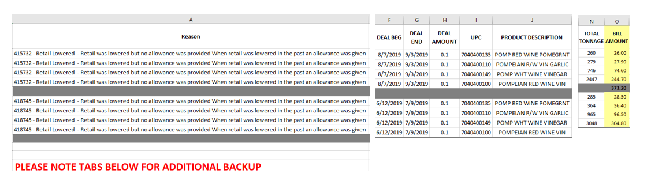
Total Tonnage: The quantity claimed for post audit.

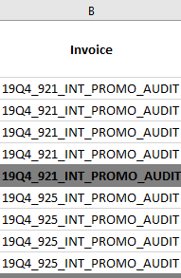
UPC/Prouct Desction: The client UPC and product description claimed for post audit.
Rate: The rate claimed for post audit.
Date: The deal dates the customer is claiming are used to match to the contract.
Identification: Explanation for why the post audit was taken. Additional backup may be on other tabs ofa the Excel file.
Identification: INT AUDIT identifies the claim as being for an internal post audit.
i
16 Retail Merchandising Program (SRD)

16.1 Customer Invoice – Retail Merchandsing Progra (SRD):

Schnucks invoice numbers that start with SRD are sent directly to the client and are available in the Schnuck’s portal. They usually send a copy to the Acosta St. Louis office manager.

The invoice is only required if the client specific section of this SOP says the client requires the invoice to be linked to the claim. If a client needs a copy of the SRD invoice, first search the repository. If the customer invoice is not found in the repository, step the claim to sales and ask them to check their files.

NOTE: Clients may request assistance with obtaining specific SRD invoices as an exception to their normal processes. These “one-off” requests should be handled as outlined above, whether the client is listed in the client specific section or not.

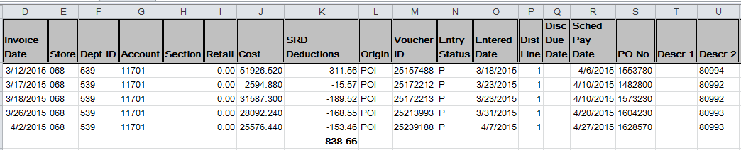
SRD Deductions: SRD identifies the claim as being for Retail Merchandising Program.

16.2 Vendor Agreement for Retail Merchandising (SRD) claims:

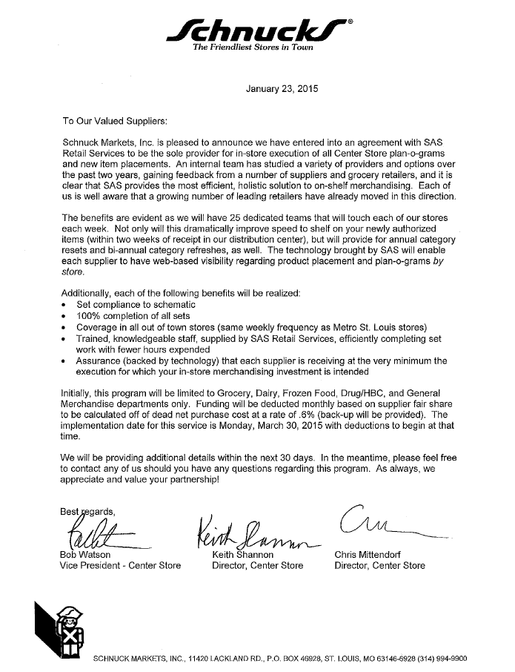

16.3 Vendor Agreement for In-Store Execution Program (ISE) claims:

Schnuck Markets charges the client a percentage of net purchase costs. This cost covers 3rd party resets and new item introduction at retail. See attached program description:

Schnuck Markets grants permission for UNFI to collect these funds for products shipped to the 8 Schnucks locations out of the UNFI Champaign DC on their behalf. See below example of UNFI invoice:
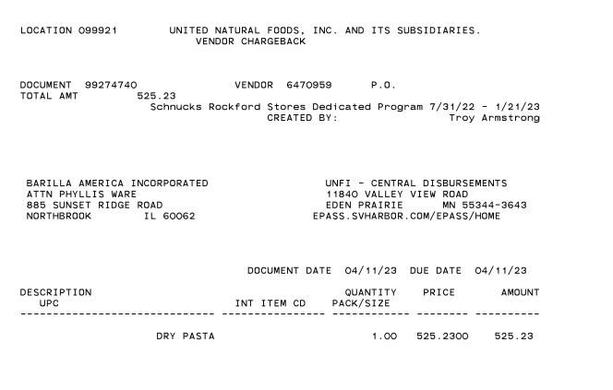

18 Deduction Type: TPR (TAG)

19 OTHER (Non-Trade – Recall):

19.1 Customer Invoice for Other/Recall:

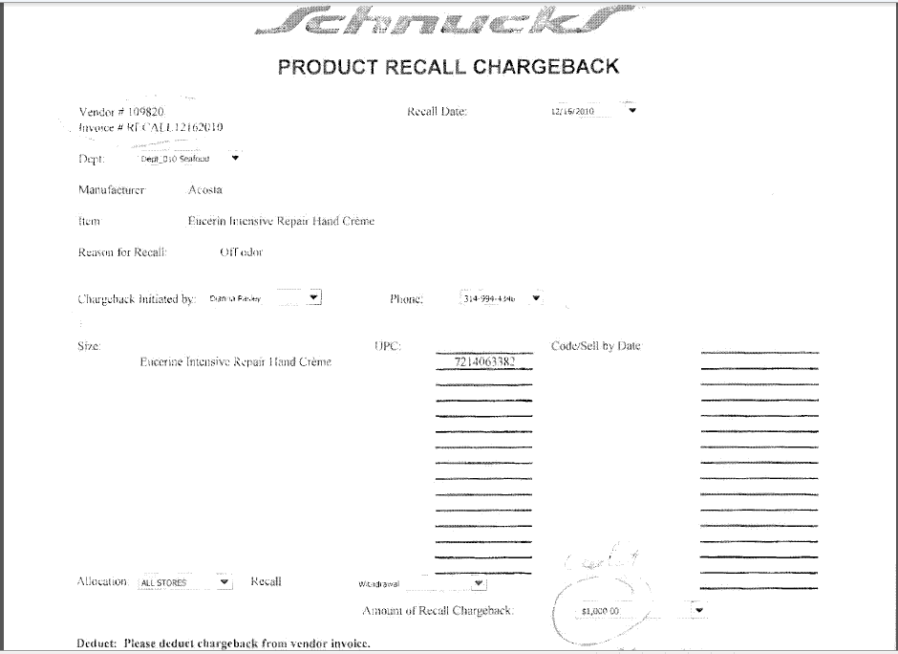
Product Recall: This confirms that the invoice is for Returns.
Once identified as a returns claim, it needs to be stepped to Acosta for further research.

12 SERVICE FEE/PENALTY:

19.1 Customer Invoice for Service Fee/Penalty:
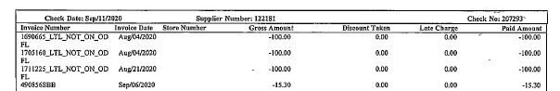

Identification: LTL Not ON ODFL is a service fee/penalty for the client shipping product as parcel and not on ODFL without contactin Shcnucks per the Schnucks Warehouse Vendor Compliance policy. This is a penalty for not using Schnucks’ preferred LTL carrier. No backup is provided for this. The number listed on the check remit identifieds the PO the fee is charged for.

Pa

BPS TEAM INFORMATION

CCA CLEARING INFORMATION SPECIFIC

CCA Client Specific

KEN’S

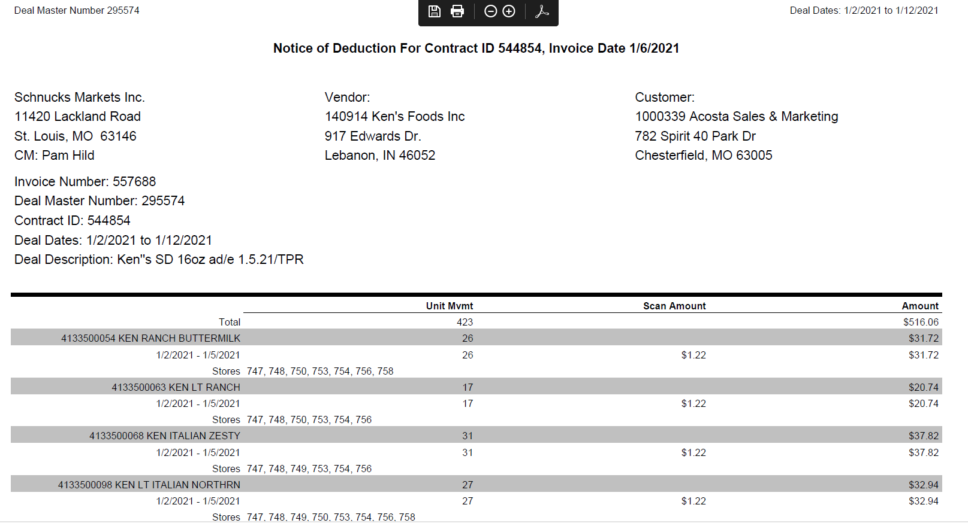

- Store Damages (VGP Vendor Guaranteed Product) will deduct at certain times throughout the year. A client event number will be provided by the Sales team to clear the damages. This CE # changes every 6 months. See attached portal instructions:

COMPLETE VERSION HISTORY

UPDATE DESCRIPTION | DATE |  |  | AUTHOR
First draft of the SchnucksSOP |  | 04/27/2012 | Amol Kumar
Changes by Kristin |  | 5/8/2012 | Kristin Jones
Revised Flow Charts and Definitions |  | 5/14/2012 | Narendra Gangaram
Updated by Michelle |  | 07/19/2012 | Michelle Roll
Adjustment to Ad Date language in Section 3 |  | 08/16/2012 | Geoffrey Van Syckle
Update IRI/Nielsen information for price point pg 2 |  | 9/10/2012 | Rick Smith
Updated hyperlinks to deduction types |  | 09/16/2012 | Nagesh Kumar
Added cash discount example |  | 10/26/12 | Kristin Jones
Changes by Suzy |  | 12/13/2012 | Suzy Fields
Added example of returns invoice; added client specific section |  | 03/11/2013 | Suzy Fields
Added explanation of flag on contract to specify all items in product group are included (3942); instruction for working 02 BB claims without detail (4267) |  | 08/12/2013 | Suzy Fields
Updated information on ad date changes (5131) |  | 08/19/2013 | Suzy Fields
Added National PA Toolbox Exception information |  | 09/27/2013 | Suzy Fields
Added link to customer sign-on job aid (5675) |  | 10/04/2013 | Suzy Fields
Updated direction for working demo claims (6020); moved client specific section in front of OI section |  | 11/25/2013 | Suzy Fields
Added note to Scan section regarding case UPCs (7813); added example of different customer invoice for billback (6828) |  | 6/23/2014 | Suzy Fields
Added note to OI section regarding swell allowances shown as OI2 on contracts (8987) |  | 8/4/2014 | Suzy Fields
General instructions – Schnucks is a deduct only customer for all clients (10099) |  | 9/2982014 | Suzy Fields
Client Specific section: Expanded directions for Kens coupon claims (10769) |  | 11/10/2014 | Suzy Fields
Client specific section: Added instruction for Kraft claims where the invoice amount and claim amount do not match (11700) |  | 1/5/5014 | Suzy Fields
Client specific section: Added Sun Products 2014 UT and ECF client event numbers (11891) |  | 3/2/2015 | Suzy Fields
Client specific section: Boulder Brands contracts with ad date (12724) |  | 3/30/2015 | Suzy Fields
Client specific section: McCormick accrual validation and clearing information (13134); updated validity code references to reflect 4.1 system change (13197) |  | 4/13/2015 | Suzy Fields
Added information on customer type (13429); revised verbiage from DemandTec to TradePoint (13461) and updated note that Schnucks stopped using TradePoint in 2014 |  | 4/27/2015 | Suzy Fields
Added BPS Team Information section; added CIT backup process (13772) |  | 5/25/2015 | Suzy Fields
Client specific section: added Clorox date shift information (14330) |  | 7/20/2015 | Suzy Fields
Client specific section: Clorox contract and POP requirements for SRD invoices (14354); Sunny D process for SRD invoices (14626). General info section: added example and explanation of new format customer invoice for PO related claims (14441); added direction regarding copies of SRD invoices (14699); Cleanup and reorganization of information (14730) |  | 8/17/2015 | Suzy Fields
Client Specific section: added Harvest Hill swell allowance detail (14790); added example of SRD invoice and additional processing detail in General Info section (14723); Unsaleable (Non-Trade) section: added example of new customer invoice for VGP claims (14912). |  | 8/31/2015 | Suzy Fields
Added example of new customer invoice to scan section (14991); removed comment box on post audit invoice example 2, as a T at the end of the invoice number does not necessarily mean it’s a post audit (15017); updated stepping instructions for Sunny D SRD invoices (14626) |  | 9/14/2015 | Suzy Fields
Customer Invoice section: Added process for SRD invoices; Client Specific section: Added instruction for Sun Products SRD invoices (15146) |  | 9/28/2015 | Suzy Fields
BPS/CCA section: Added Campbell’s process for SAS, resets, merchandising fee and SRD percent claims (15418) |  | 10/12/2015 | Suzy Fields
Added line level detail statement to Customer General Info section (15509) |  | 10/26/2015 | Suzy Fields
Client Specific section: Added instruction for Campbell’s missed OI claims (15360); added instruction for Bush SRD/SAS customer invoices (15619) |  | 11/9/2015 | Suzy Fields
Client Specific section: added Old Orchard processes for stepping validated and escalated claims (15986) and for SRD claim processing (16022). CIT and CRA section: added instruction for backup retrieval for French’s (15639) |  | 12/7/2015 | Suzy Fields
Client Specific section: updated Tyson POP for AD claims pre-11/1/15 (16049). Added clarification on contracts showing “suggested ad performance” (16376) |  | 1/4/2016 | Suzy Fields
Client Specific section: added Kikkoman process for SRD customer invoices (16436); Client specific section: Tyson - clarification for contracts on pre-11.1.15 claims (16614) |  | 2/1/2016 | Suzy Fields
Client Specific section: McCormick process for SRD/SAS claims (17162) |  | 3/14/2016 | Suzy Fields
Client specific section – added SRD processing instructions for Tillamook (17793); BPS Team Information/CCA/Client specific section – updated contact for Campbell’s (17774) |  | 4/11/2016 | Suzy Fields
Client specific section – added SRD processing instructions for Tillamook (17793); BPS Team Information/CCA/Client specific section – updated contact for Campbell’s (17774) |  | 4/25/2016 | Suzy Fields
Client specific section – added info on Tyson private label products (17808); JJSNAK SRD backup process (17885) |  | 5/9/2016 | Suzy Fields
Client specific section – added French’s SRD clearing process; BPS section – added French’s backup request process and SRD clearing information (17937 and 18167) |  | 5/23/2016 | Suzy Fields
Client specific section – added Produr/Duracell info (18405); added info from CIM to BPS section; BPS section – updated Req CI from CIT info (18033 |  | 6/20/2016 | Suzy Fields
Client specific section and BPS CCA client specific section – updated Kikkoman process for SRD invoices (18668) |  | 7/4/2016 | Suzy Fields
Client specific section: Updated stepping instruction for Old Orchard (18663) |  | 7/18/2016 | Suzy Fields
Added in-store promo example to scan section (18715); ); removed Boulder Brands from client specific section (19016) |  | 8/1/2016 | Suzy Fields
Post Audit section: updated header and customer invoice example (19056); client specific section: removed Kraft (19311) |  | 8/29/2016 | Suzy Fields
Client specific section: added McCormick date flexibility info (19319) |  | 9/12/2016 | Suzy Fields
Post audit section: Instructions and examples updated (19056); Client specific section: removed info on Harvest Hill swell allowances/claims for damages (19358) |  | 9/26/2016 | Suzy Fields
Removed extra contract examples and POP examples (19418) |  | 10/10/2016 | Suzy Fields
Client specific section: Added Barilla process for SRD invoices (19598); Clorox reset fee process (19719) |  | 10/24/2016 | Suzy Fields
Client specific section: added Coca Cola (CCNA) process for SRD (retail merchandising/Fair Share) billings (19525); added new section with SRD (retail merchandising/Fair Share) claim information; moved info from customer invoice section and imbedded SRD agreement letter in section (19809). |  | 11/7/2016 | Suzy Fields
BPS section – CRA Client specific: Removed French’s backup contact info (20480) |  | 1/30/2017 | Suzy Fields
Added new section/information regarding New Warehouse Conversion Fee customer invoices and validation process (20744); added new section/.information regarding New Store Free Refill customer invoices and validation process (20814); updated information on requesting customer invoices added to BPS section (20710) |  | 2/27/2017 | Suzy Fields
Updated Retail Merchandising Program (SRD) section with info on searching for invoices in the repository (21007) |  | 3/27/2017 | Suzy Fields
Added White Wave to client specific section (21179) ); updated backup retrieval process in BPS section (19980); added Clorox process for requesting Schnucks Discrepancy Reports (19462) |  | 5/8/2017 | Suzy Fields
Client specific section: Added Pinnacle POP info for product bought through DOT Foods (21430) |  | 5/8/2017 | Suzy Fields
Client specific section: Removed Sun Products (21793) |  | 6/19/2017 | Suzy Fields
Client specific section: Removed outdated McCormick event information – no longer valid due to proprietary system change (22295) |  | 8/14/2017 | Suzy Fields
Client specific section: Removed Bush direction for SRD invoices (22566) |  | 9/25/2017 | Suzy Fields
Client specific section: Updated verbiage on Tyson private label info due to move from client and customer SOPs to only customer SOP (22764) |  | 11/9/2017 | Suzy Fields
Customer invoice section: Added information about DOT invoices for Schnucks deductions (23351); 1/30/2018 – updated hyperlink to Customer Sign-on job aid (23751) |  | 1/15/2018 | Suzy Fields
Client specific section: Removed French’s information (23861); removed information on using Req Assist Client Manager (5/9/2018) |  | 3/12/2018 | Suzy Fields
Client specific section: Updated SRD invoice processing instructions (24620) |  | 5/14/2018 | Suzy Fields
Client specific section: Added Nestle & shipment report instructions (22020) |  | 7/2/2018 | Suzy Fields
Client Specific section: Removed White Wave information, as client took in house (25171); added Ainsworth process for Ready to Clear claims (25338). Added Colgate process for Reset Fee/Retail Merchandising claims to client specific and BPS sections (25249); |  | 8/13/2018 | Suzy Fields
Client Specific section: Added Noosa swell allowance info (25570) |  | 8/27/2018 | Suzy Fields
Removed reference to Doc Type 5 |  | 10/12/2018 | Suzy Fields
Client specific section: Coca Cola date flexibility (26125) |  | 11/5/2018 | Suzy Fields
Client specific section: Added Colgate DBW instructions (26291) |  | 11/19/2018 | Suzy Fields
New Store Free Refill section: Added detail related to Schnucks’ purchase of Stop and Save stores (26414) |  | 12/3/2018 | Suzy Fields
Client specific section: Removed Nestle Nutrition and spin requirement (26576) |  | 12/17/2018 | Suzy Fields
Client specific section: Added Pepperidge Farm and instructions for missed OI claims (26694) |  | 1/4/2019 | Suzy Fields
Client specific section: Added Pepperidge Farm and instructions for missed OI claims (26694) |  | 1/14/2019 | Suzy Fields
Client specific section: Removed Produr/Duracell (26833) |  | 2/1/2019 | Suzy Fields
Client specific section: Removed McCormick (26829) |  | 2/13/2019 | Suzy Fields
Retail Merchandising Program (SRD) section: Added CI example without PO number & instructions to use COI number to locate the order (26975) |  | 2/25/2019 | Suzy Fields
Client Specific section: Added Mars info for Retail Merchandising (27234) |  | 3/25/2019 | Suzy Fields
Slotting section: Moved new store free refill from its own section into slotting (27393)  Removed Produr/Duracell from client specific section |  | 4/8/2019  4/22/2019 | Suzy Fields
Client specific section: removed Tyson (27728) |  | 4/26/2019 | Suzy Fields
Customer General Information section: Added detail about buying relationship between Rockford, IL stores and SuperValu (28074)  Client specific section: removed Clorox as we no longer represent (28157) |  | 6/21/2019  7/1/2019 | Suzy Fields
Removed Pinnacle information as Acosta no longer handles effective 8/26/2019 |  | 8/26/2019 | Suzy Fields
Client specific section: Removed Noosa (28692) |  | 10/21/2019 | Suzy Fields
Created Backup Retrieval Section (28906) |  | 11/8/2019 | Suzy Fields
Removed Old Orchard information as Acosta no longer represents (28915) |  | 12/5/2019 | Suzy Fields
Client Specific section: Added Nestle USA POP instructions (28893) |  | 12/16/2019 | Suzy Fields
Customer General Information section: added store 749 to list of SuperValu stores as it was mistakenly left off in original posting (29555); (Client Specific section: Added P&G process for scan check requests (29467); removed Colgate information as Acosta no longer represents (29496) |  | 2/24/2020 | Suzy Fields
Backup Retrieval Information section: updated with customer portal and post audit ATG information (29879) |  | 3/27/2020 | Suzy Fields
Backup Retrieval Information section: updated with customer portal and post audit ATG information (29879) |  | 3/27/2020 | Suzy Fields
Added Hostess-specific section (29710). |  | 6/01/2020 | Kristin Jones
In Ken’s section, added not requirement when alerting sales for SV stores (30171). |  | 6/15/2020 | Kristin Jones
In Customer Invoice section, added info about contract ID (30387). |  | 6/29/2020 | Kristin Jones
Removed Nestle USA (30502). |  | 07-13-20 | Kristin Jones
In Ken’s section, removed ‘when alerting sales’ from note requirement for SV purchases. In BPS/CCA section, added Ken’s info (30527). Scrubbed entire SOP (30570). |  | 07-27-20 | Kristin Jones
In BPS section, updated Ken’s specific info (30623). Adjust rate callout box fo OI example (30653). |  | 08-10-20 | Kristin Jones
Added Service Fee/Penalty example (30908). |  | 10-05-20 | Kristin Jones
In Coke section, removed Retail Merch info (30970). |  | 10-19-20 | Kristin Jones
In Scan section, added Points Activity/Diigtal Coupon example (30793). |  | 11-02-20 | Kristin Jones
In CCA Client specific section updated Kens clearing instructions. Regional Mgr will provide events on stores buying through UNFI (31446) |  | 01/15/21 | Liz Vogel
Updated General Section verbiage about Schnucks stores buying through UNFI to remove confusion about contracts and Updated Client Specific Validation section for Kens that “claim will be stepped Awaiting Processing CCA without event” (31508) |  | 01/29/21 | Liz Vogel
Updated Client Specific section for Campbells with Pallet Fee claim information (31606). |  | 3/8/21 | Liz Vogel
Added Georgia Pacific to Client Specific section (32159). |  | 7/26/21 | Liz Vogel
Client specific section for Kens added that notes should include pack size, allowance rate and timeframe (32975). |  | 12/13/21 | Liz Vogel
Customer General Information section added updated cost change policies as of 7/1/22 (33797). |  | 7/25/22 | Liz Vogel
Revision and rewording of SOP per updates from Sales team. Removed several outdated forms (33964). |  | 9/12/22 | Liz Vogel
Process steps section added information for In Store Execution (ISE) program (35221). |  | 7/17/23 | Liz Vogel
In Client Specific Validation Information, removed Barilla specific section information as the SRD invoice instructions are outdated is now handled per the client SOP (35423). |  | 10-02-23 | Aimee Porritt
In the CCA Clearing Information Specific section under Ken’s, corrected claims buying thru SV UNFI information and added invoice example (35780). |  | 1/8/24 | Aimee Porritt
Removed Hostess from Client Specific section. (402814) |  | 10/14/24 | Aimee Porritt
Added additional information in Customer General information section (406992). Added contract id information in Customer General information section (400625). |  | 11/18/24 | Dawn Regan
Removed embedded file from Backup Retrieval Information Section (408507). Added embedded invoice example file in Customer General Information Section (408681). Added PO # format example in Backup Retrieval Information Section (408801). |  | 12/9/2024 | Dawn Regan
Added invoice identifier in Backup Retrieval Section (408682) |  | 12/16/2024 | Dawn Regan
Added Barilla and information in Client Specific Information Section (408682). |  | 12/16/2024 | Dawn Regan
Added Simply Good Foods and Information in Client Specific Information Section (413977). |  | 2/10/2025 | Dawn Regan
Added Horizon Organic Dairy LLC and Information in Client Specific Information Section (419076). |  | 03/24/2025 | Dawn Regan
Removed information regarding Kens from Client Specific Section and from BPS Team Information Section (424655). |  | 05/12/2025 | Dawn Regan
Added information for Logistical fees for Horizon Organic Dairy in Client Specific Section (427123) |  | 06/02/2025 | Dawn Regan
Added client Eagle Family Foods and information in Client Specific Information Section (453931). |  | 01/10/25 | Dawn Regan
Removed Client Mars Wrigley Confectionery and information from Client Specific Information Section (467544) |  | 5/4/2026 | Dawn Regan

