WORK INSTRUCTIONS

Process | Order to Cash
DTP Name | Smart and Final Claims Validation Documents

CURRENT VERSION HISTORY
 | DATE | AUTHOR
Added Client and Repay information for Coca Cola North America in BPS Team Information Section (468849). | 05/18/2026 | Dawn Regan

Link to complete version history: COMPLETE VERSION HISTORY

DEDUCTION TYPES COVERED
Sl. No. | Deduction Type
 | Customer General Information
 | Backup Retrieval Information
 | Client Specific Validation Information
1 | Off invoice
2 | Bill Back
3 | Scan
4 | TPR
5 | Display
6 | CRV Charges (Non-Trade/ Other)
7 | Unsaleables
8 | Pricing
9 | Floor Stock
10 | Post Audit
11 | Shortages
12 | Freight / Backhaul
13 | Slotting
14 | Retail Merchandising Program (Smart Retail Fairshare, New Store Allowance)
15 | Rebate
16 | Cash Discount
17 | Service / Penalty Fees
 | BPS Team Information

Is the customer a Wholesaler/Distributor, Direct or Indirect customer? Direct Customer

Note: SFLASM is the common Sign on used to work in ACOSTA RELAY for Smart & Final (for example to search for a document and to reference the customer in ACOSTA RELAY)

Apart from the above sign ons, the additional sign ons that may be used to locate back-up documents including Orders/Invoices/Pos and contracts – SFLASM (grocery), SFHHSM (chilled), CASISM (frozen).

Link to customer sign on job aid:
http://centralizedsupport.acosta.com/opdashreporting/Customer%20Signon%20Listing/Forms/AllItems.aspx

Does this Customer subscribe to IRI Neilson Data? Yes

CUSTOMER GENERAL INFORMATION
Customer Invoice Info:
Is line level detail indexed on the customer’s documentation (Customer Invoice, Customer Check Request, Unsaleable/Spoils, Post Audit, EDI 812/820 or Client Deduction Notice if one of these documents is included)? NO

If backup is not available in AR, search for the check remittance and review if backup is included.

PO related claims will not have backup. They take 2% off the gross invoice amount as cash discount.

Smart and Final is a deduction customer and should not receive checks.

Smart and Final Deduction Identifiers
STD - Billback (Short Term Deal)
DMO - monthly deals
DQT - quarterly deals
GRW - growth deals
NDL – No Deal Loaded (floor stock protection)

Example of Reclamations/unsaleables on a check remit. 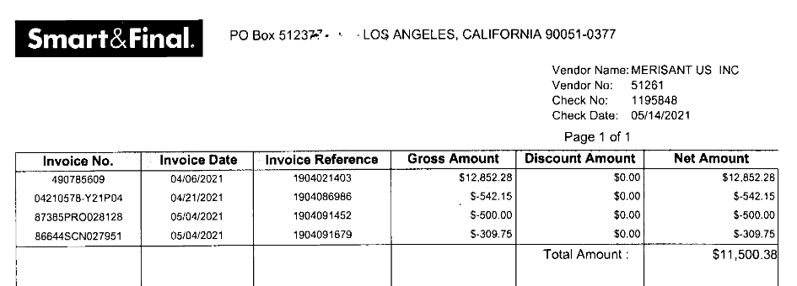

Contract Info:
For contracts with lump sum allowances, the dates that will be used are the “Promo Week” dates rather than the order dates. The Smart and Final calendar will need to be referenced to ensure that the dates are correct based on the invoice dates. See example below:
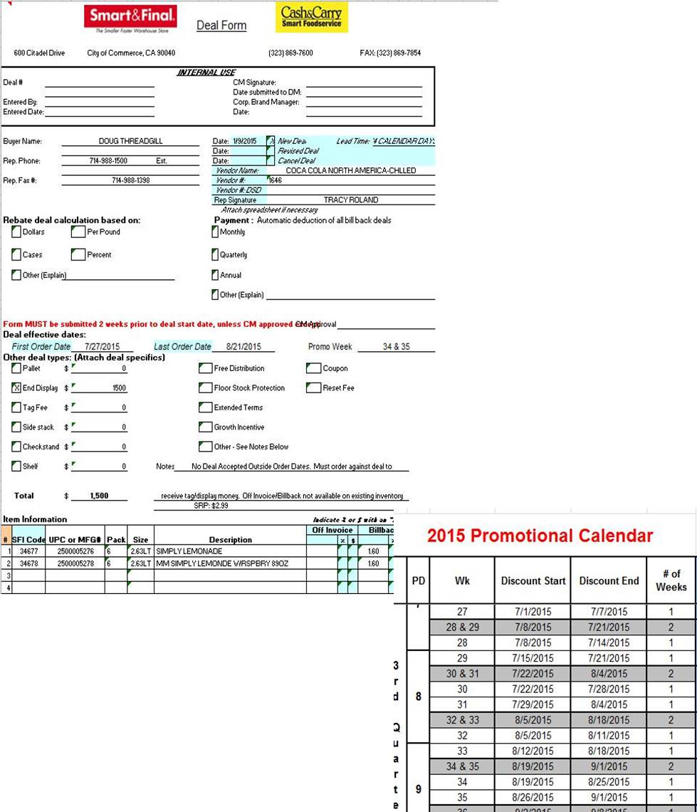
Performance Dates – The dates on the Customer Invoice for the Display Promotion should fall within the Contract dates.

Other General Info:
Smart and Final require 90 days notification for price changes.

Delivery fee policy

Smart & Final Deduction Identification:

Promotional calendars

BACKUP RETRIEVAL INFORMATION

GENERAL BACKUP RETRIEVAL INFORMATION

Is GCIT responsible for obtaining backup from the customer? Yes
- If yes, is there a customer portal? No
- If yes, does GCIT request backup? Yes

Is check remittance information required to request backup? No

- If backup is not available in AR, search for the check remittance and review if backup is included.
- If additional details are required for Rebate claims note the claim: “Please request additional item detail breakdown for Rebates invoice.”
- Backup is not provided for PO related deductions.

Beiersdorf
- For reclamation Smart and Final backup contact Alina.Skorzhenko@beiersdorf.com

Campbells Pepperidge Farms Frozen, Bakery and Ecce Panis
- Request warehouse backup from Patrick Trinh Patrick.Trinh@smartandfinal/cc: Bethany Cardenas-bethany.cardenas@acosta.com.

Michael Foods
- Backup is requested from Fletcher Schwartz at fletcher.schwartz@crystalfarms.com

Nestle Nutrition
- Backup is requested from Regina Lozinak at regina.lozinak@us.nestle.com.

Newell (all divisons)
- The check remit is required for all backup requests.

Nissin
- If check remit is not located request from GCIT to pull from Nissin portal
- Reclamation invoices are requested from pezaki@nissinfoods.com.

Pompeian
- Backup is requested from the client from Jeaunice Pulliam at jpulliam@pompeian.com, Ph: 443-573-8026 with the exception of New Store (NW STR), Smart Retail Fairshare (SMAR RT), and Post Audits (CL).

GCIT SPECIFIC BACKUP RETRIEVAL INFORMATION

Portal:
Customer Invoice Identifier | Pull From
Reclamation invoices - Reference numbers might include a Y followed by the month and year in front of the invoice number. Also, could include 7- or 8-digit numbers depending on it the zero is omitted the months Jan – Sept. Example 0725 could be used or just 725 (month and year). | www.RMS-Webscan.com

Automated:

Customer Invoice Identifier | Request From
“NW STR” (New Store Openings) or CR STR (Core Refresh Billing) and manual invoice submissions | AP.warehouse@smartandfinal.com
“CL” (Post Audits) | smartandfinal@arginc.net
All other formats for clients beginning #, A, B, C + Freight | veronica.jimenez@chedrauiUSA.com
All other formats for clients beginning E, F, G, H, I, J, | Antonio.Rodriguez@chedrauiUSA.com
All other formats for clients beginning D, K, L, M | Patrick.Trinh@chedrauiUSA.com
All other formats for clients beginning R, S, U, | Alicia.Osorio@chedrauiUSA.com
All other formats for clients beginning N, V, W, X, Y, Z | vanessa.villanueva@chedrauiUSA.com
All other formats for clients beginning O, P, Q, T | monica.ortega@chedrauiUSA.com
If second customer backup request is sent | Copy troland@acosta.com on second request
Georgia Pacifc | Copy GPSAPCASH@gapac.com on all backup requests

Non-Automated:

Client name beginning with | Request From
If noted for additional breakdown for Rebates  If second customer backup is sent  Georgia Pacific | rebate@smartandfinal.com  Copy troland@acosta.com on second request  Copy GPSAPCASH@gapac.com on all backup requests
Pepperidge Farms Bakery (PEPPGR and PEPPBK) for DSD backup | Angie.Madrigal@chedrauiUSA.com  add CC: Bethany Cardenas- Bethany.Cardenas@chedrauiUSA.com
Sovos (Michael Angelo’s, Noosa and Rao’s). | accountsreceivable@sovosbrands.com

CLIENT SPECIFIC VALIDATION INFORMATION

Client
Barilla
Campbells
Coca-Cola
Filippo Berio USA
Kikkoman
Mars Foods
Michael Angelo
Nestle Nutrition
Newell
Sunny Delight
Tillamook

Barilla
- On a PO related claim if there is an invoice discrepancy after all necessary research:
  - If the claim is less than $250 step as under tolerance
  - If the claims is greater than or equal to $250 escalate to the CRA.

CAMPBELLS
- The Vender number for Frozen is 475631 on the check remit. Reference this number when looking for backup.

COCA-COLA
- For New store allowance agreement - Coca Cola Chilled, this letter can be found in the ACOSTA RELAY repository under COCACH/SFHHSM – Doc Type 17 – Contract (for Grocery claims use COCAGR/SFLASM – Doc Type 17 – Contract)
- New Store Fees: The claim brand codes may not match the event brand codes due to the brand the money has been allocated to. Claim / line will be cleared to the event that is provided by sales.

FILLIPO BERIO USA
- Retail Merchandising – no contracts are needed.

KIKKOMAN
- Deductions for New Store Merchandising Support should be stepped as Trade/Other with Contract and POP attached.
- Before claim can be escalated as a customer invoice issue the check remit needs to be attached. The customer invoice will be included with the check remit.

MARS
- Smart and Final is part of the Retail Merchandising Program

MICHAEL ANGELO
- Reclamation Invoices need to be requested from deductions@sovosbrands.com. GCIT does not have access in the RMS portal to pull this back up.
- Back up for Smart and Final should be

NESTLE NUTRITION
- New store allowance invoices with AP vendor # 73663 will be cleared using only 7% of the total portion of the new store allowance on the invoice which will be coded as Trade/ Other. The remaining balance will be coded as Not Acosta.
  - No DBW, contract/agreement/ or POP is required.
- Fairshare deductions are coded Trade / Other, this will be cleared to an event and the Fairshare agreement is considered the contract.

NEWELL
- NEWFRSH claims will require a client event number

SUNNY DELIGHT
- CRV charges will be coded as Nontrade / Service fee.

TILLAMOOK
- No POP is required for Tag/Display fees.

PROCESS STEPS

- Deduction Type: Off Invoice

A per case Off Invoice allowance is given to the customer as an automatic discount for product purchased from the client. If the customer does not receive the allowance off the face of the invoice they will deduct for it. If the customer requested an allowance that is not valid, the CSC will send a notification to the customer in writing. Customers view Purchase Orders as Contracts. If they are not notified of allowance discrepancies, they will pay according to their Purchase Order total.

1.1 Customer Invoice for Off invoice:
Example:1

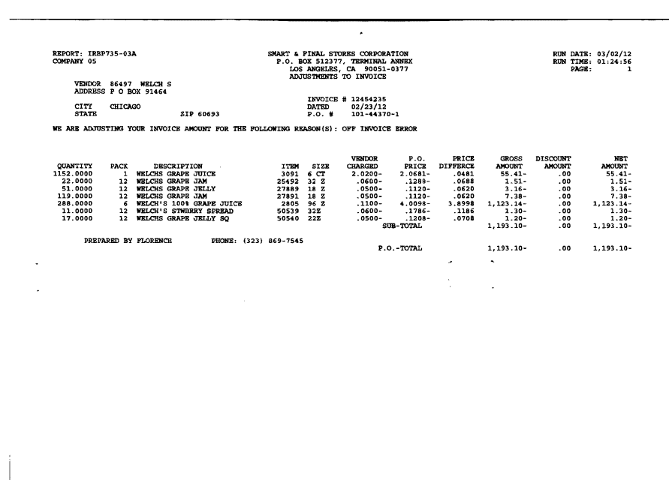
2
1
3
4
Price Difference: This indicates the difference the customer is claiming for Off Invoice allowance and may include Swell and/or Freight Allowance not received.

Invoice & PO Number – The Invoice & PO number will be used to search for the Client Order Invoice within ACOSTA RELAY. This data is needed to validate if the particular product was ordered and invoiced with the Off Invoice allowance.
E.g.: In this case the Invoice # is 124542235
Quantity – The highlighted section indicates the qty for the product for which the Off Invoice was not given. This need to be matched with the Client Order Invoice.
Item Code & Description – Item code is internal item code of S & F.
This code and description need to be matched with the Contract and using the UPC from the Contract (against the item code) can validate the Client Order Invoice.
i
Identification – This highlighted section indicates Off Invoice allowance.

The Smart & Final reason for an Off Invoice Error claim may include the Off Invoice allowance not received as well as a possible Swell and/or Freight Allowance the customer feels they did not receive. Refer to the Client Order Invoice to see what the customer did receive Off Invoice. Also note, the customer may be claiming an additional Swell and/or Freight Allowance they feel they were entitled to in addition to what they received Off Invoice.

  - Customer Invoice for Off invoice:
Example:2

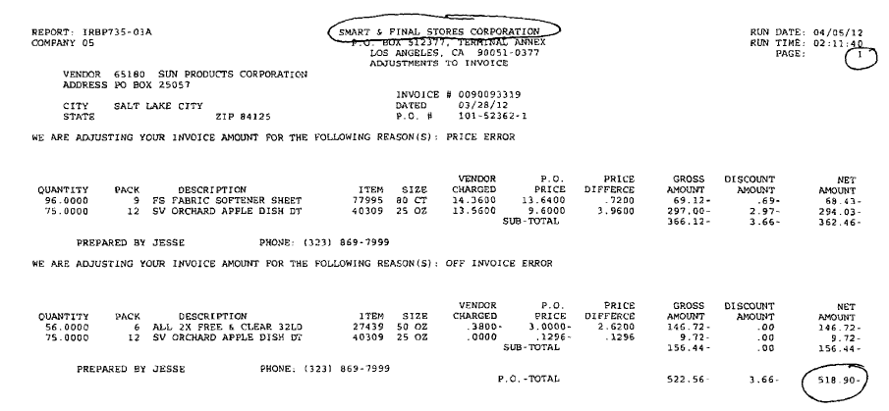
3
4
i
Identification – This highlighted section indicates Off Invoice allowance.
Invoice & PO Number – The Invoice & PO number will be used to search for the Client Order Invoice within ACOSTA RELAY. This data is needed to validate if the particular product was ordered and invoiced with the Off Invoice allowance.
E.g.: In this case the Invoice # is 90093329

Quantity – The highlighted section indicates the qty for the product for which the Off invoice was not given. This need to be matched with the Client Order Invoice.
1
Item Code & Description – Item code is internal item code of S & F.
This code and description need to be matched with the Contract and using the UPC from the Contract (against the item code) can validate the Client Order Invoice.
2
Price Difference: This indicates the difference the customer is claiming for Off Invoice allowance and may include Swell and/or Freight Allowance not received. Refer to the Customer Contract.

The Smart & Final reason for an Off Invoice Error claim may include the Off Invoice allowance not received as well as a possible Swell and/or Freight Allowance the customer feels they did not receive. Refer to the Client Order Invoice to see what the customer did receive Off Invoice. Also note, the customer may be claiming an additional Swell and/or Freight Allowance they feel they were entitled to in addition to what they received Off Invoice.

1.3 Customer Contract for Off invoice:
Example:1
Contracts can be found under Promotions & Back up documentation using the Client & Customer Sign on.

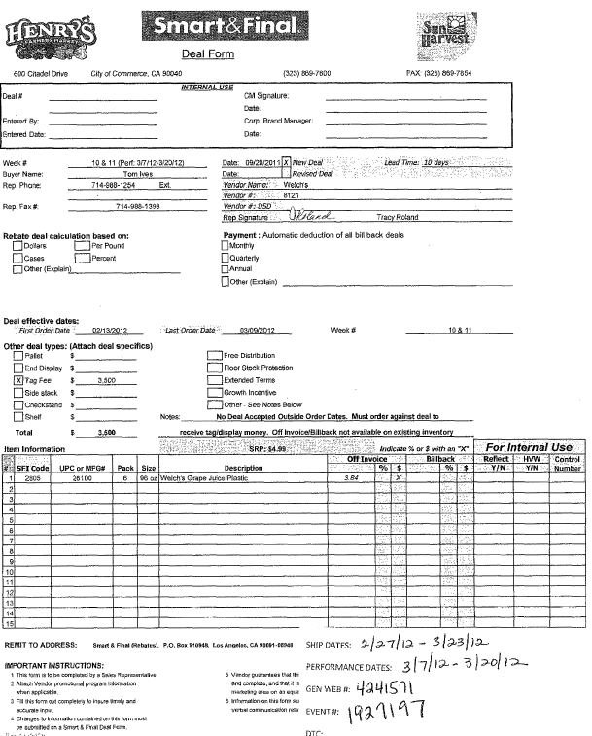
2
5
Mfr. UPC & SFI Code Item – Item code is internal item code of S & F & UPC is the mfr UPC case code. This code is used to validate key data elements regarding the Customer Invoice and Client Order Invoice on the Review Order/View Document link within ACOSTA RELAY. This is the product in which the customer is stating there is an Off Invoice allowance.
Off Invoice Amount: This indicates the Off Invoice allowance offered to the customer.

Performance Dates – These dates can be used to search for the Contract and run POP (Order Dates).

1

1.4 Customer Contract for Off invoice:
Example:2

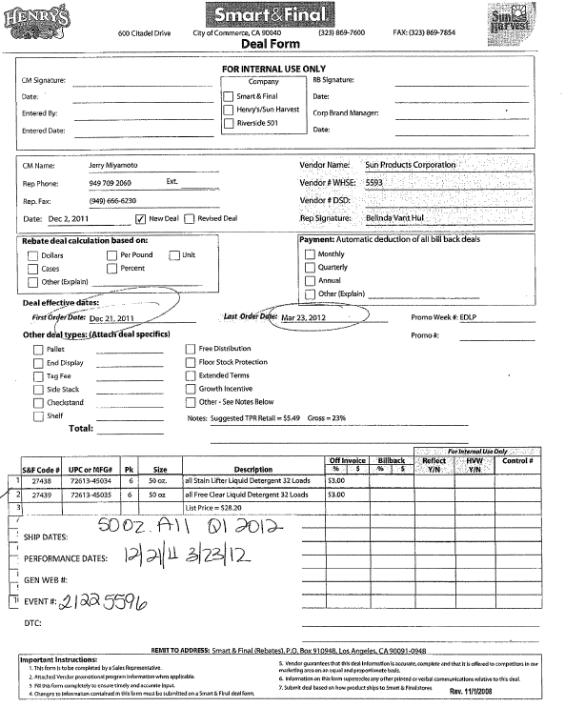
1
2
5
Mfr. UPC & SFI Code Item – Item code is internal item code of S & F & UPC is the mfr UPC case code. This code is used to validate key data elements regarding the Customer Invoice and Client Order Invoice on the Review Order/View Document link within ACOSTA RELAY. This is the product in which the customer is stating there is an Off Invoice allowance.

Off Invoice Amount: This indicates the Off Invoice allowance offered to the customer.

Performance Dates – These dates can be used to search for the Contract and run POP (Order Dates).

1.5 POP for Off Invoice: Refer to the Client SOPs/Generic Help File for POP requirements.

- Deduction Type: Bill Back

A Bill Back claim is a per case allowance offered for a specific performance requirement. A per case bill back allowance is claimed by the direct buying customer for product purchased from the client, or by the indirect customer for product purchased from the direct customer. This is an allowance the customer will bill the client for. This is not an automatic discount given off the face of the invoice.

2.1 Customer Invoice for Bill Back:

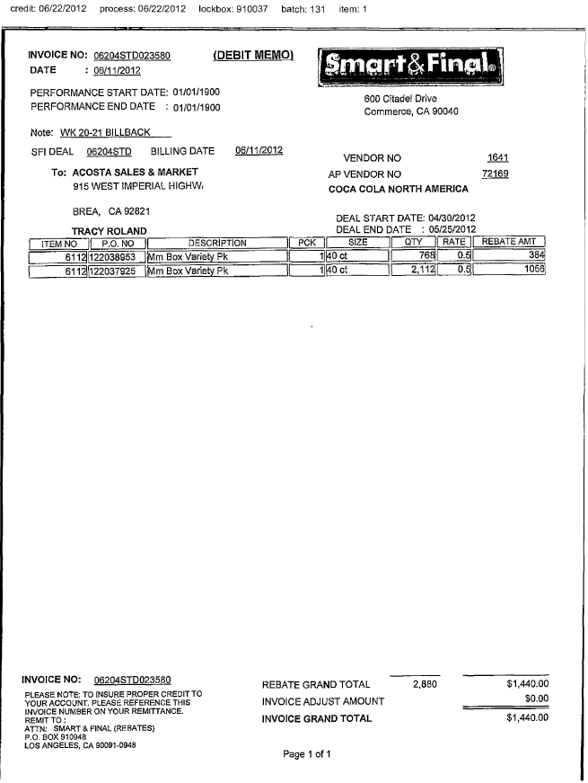
5
3
1
2
Bill Back Rate: The highlighted rate ($.50) customer is claiming for the Bill Back allowance.
Qty: For the highlighted quantity (768), customer is claiming the BB Allowance. This number needs to be validated with the Client Order Invoice details.
i
PO No. will assist in locating the Client Order Invoice in ACOSTA RELAY.
Item Code and Description: The item code and the product description should match with the Contract.

Performance Date: Dates need to fall within the Contract period.

2
BB Rate: At the highlighted rate customer is claiming the BB allowance. amount claimed by the customer for Billback.

Billback Allowance: This indicates the rate per case for Billback and also it should match with the contract.

2.2 Customer Contract for Bill Back:
Contracts can be found under Promotions & Back up documentation using the Client & Customer Sign on.

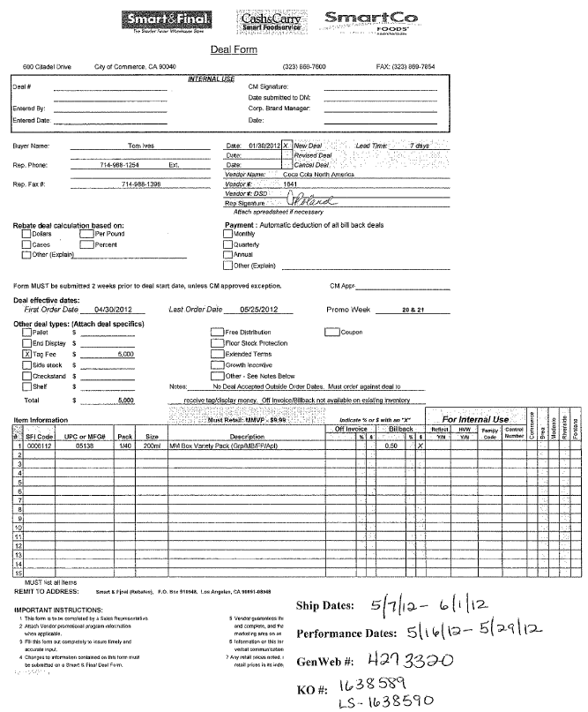
1
2
5
Mfr. UPC (05138) & SFI Item Code – This has UPC code details, which needs to be matched with the Customer Invoice.
Ex: - In this case, the Item code 6112 on the Invoice is available in the Contract.

Performance Dates – These dates can be used to search for the Contract and run POP (Order Dates).

Bill Back allowance – This is the rate ($.50) per case Bill Back allowance amount. This amount should match with the Customer Contract.

Email address of Sales Division Manager

i

2.3 POP for Bill Back: Refer to the Client SOPs/Generic Help File for POP requirements.

3. Deduction Type: Scan

Scan allowances are for product scanned at the store register and are usually billed in eaches, not cases.
The customer should not be referencing a purchase order on a scan allowance.

3.1 Customer Invoice for Scan:
If the rate listed on the Customer Invoice is the same as the Invoice Grand Total of the claim refer to the customer breakdown for item scan rates.
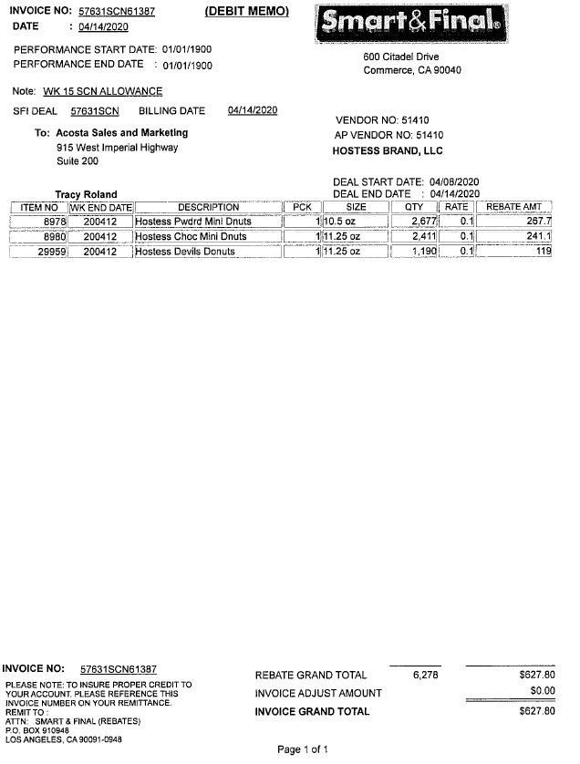
Preformance Dates – The Deal dates can be used to search for a Contract. The Note of WK 6-7 SCN allowance is the actual performance period the customer took. If the dates in the performance start date / end date differ from the Weeks noted in the Note field use the WK noted in the note field. The weeks are listed on the Smart and Final Calendars.

Code – The “Item number” on the Customer Invoice. This code is used to find the UPC code, which is corresponding to this number.
In this case, the Item number is 50540.
This column represents the key word SCN to identify the type as Scan deductions.

1
i
4

The item listed on the invoice may be one of many items being claimed for the scan deduction. The customer can provide additional detail breakdown page(s) for items, quantities, etc.
3.1 Customer Invoice for Scan example 2 (Buy 4 Save 4)
Pg 1
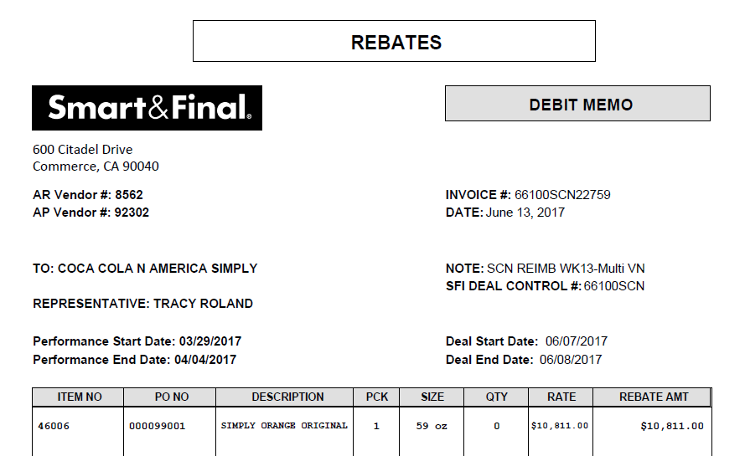
Additional detail page:

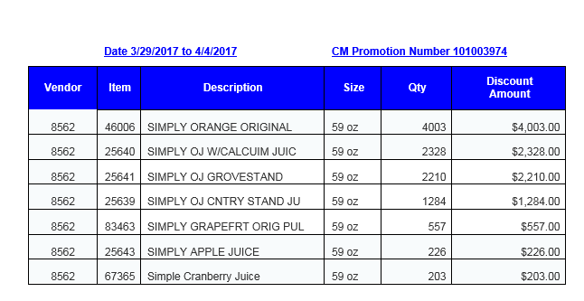
Scan rate: This column represents the scan rate per store.
To calculate the rate (Cost $ / Qty) = $3.12/12=$.26
Quantity: The number of units the store is claiming per UPC.
.

UPC/Product: The Mfr UPC code (00005) and item code (25494) the description for which product is being billed. It should match with the UPC/Product description mentioned on the Customer Invoice.
.

3.2 Customer Contract for Scan:

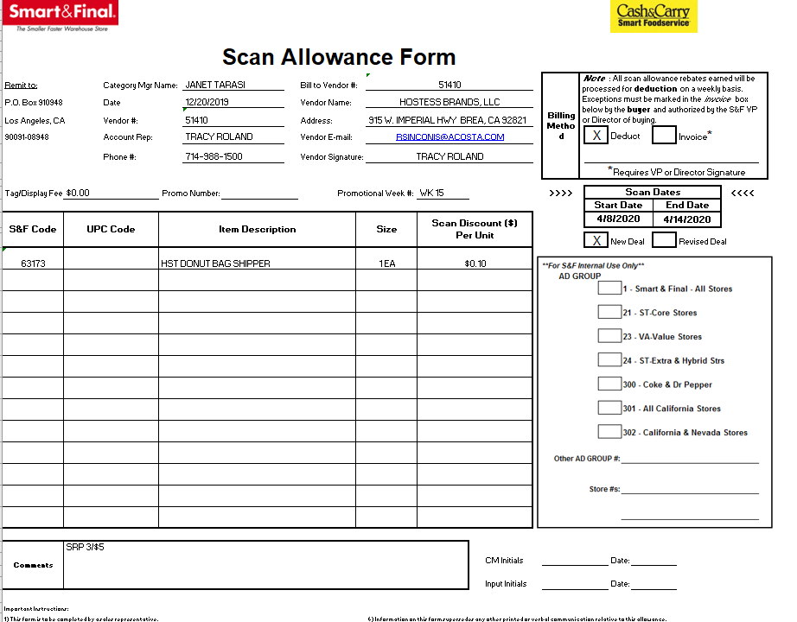
Deal Dates: Dates the deal is valid. The customers performance dates from the Customer Invoice should be within these dates.
Scan rate: This column represents the scan rate.

UPC/Product: The item code and the description for which product is being billed. It should match with the UPC/Product description mentioned on the Customer Invoice.
.

3.2 Customer Contract for Scan Example 2 (Buy 4 Save 4)

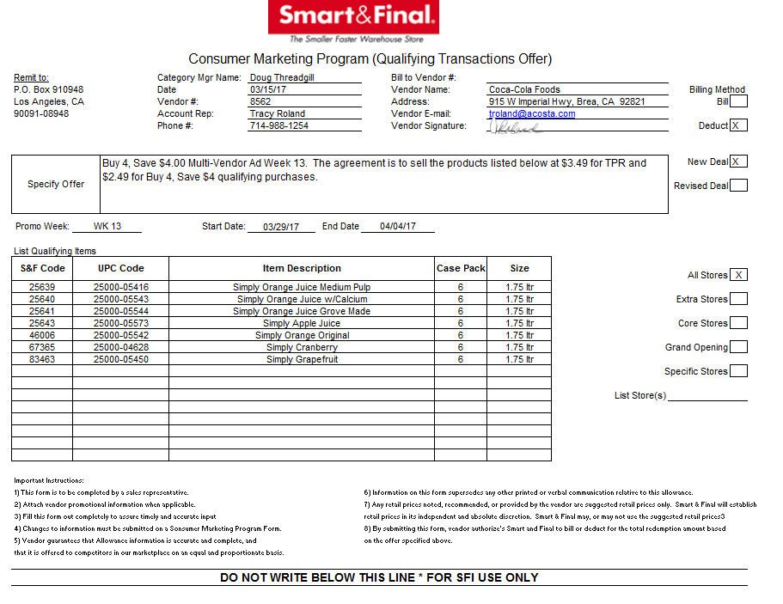
Performance Dates – The dates on the Customer Invoice should fall within these dates to validate the scan deductions.

Scan per unit – The highlighted portion offers a savings for buying multiple quantities. In this example the scan rate would be $1/unit.

UPC/Product: The Mfr UPC code (00005) and item code (25494) the description for which product is being billed. It should match with the UPC/Product description mentioned on the Customer Invoice.
.

3.3 Proof of performance for Scan: Shelf tags

The below shelf tag copies can be found in Backup Documentation.

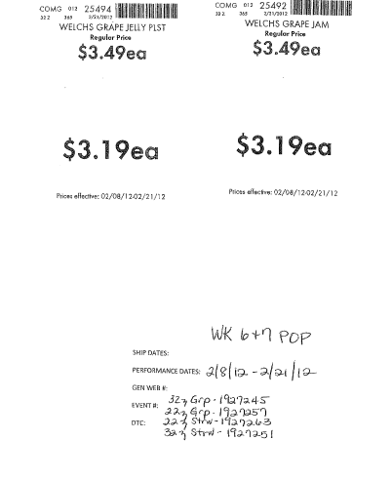
UPC/Product: The Mfr UPC code (50100) and item code (25494) the description for which product is being billed. It should match with the UPC/Product description mentioned on the Customer Invoice.
.
Performance Dates – The dates on the Customer Invoice should fall within these dates to validate the scan deductions.

**Please note, if this POP is not available see next page.**

3.3.1 Proof of Performance for Scan: Shelf Tags
You may see the following document with the Customer Invoice as the POP:

If this document is not attached to the Customer Invoice, Price Point Validation must be found through Nielsen data for subscribing customers, or an Ad copy, when required by the client (see Client Audit guidelines and/or Client SOP documentation for confirmation). Otherwise, Proof of Purchase will be found via GenWeb Sales Analysis reports (Sales Summary is preferred), Client Order Invoice or Client Proprietary system sales reports using dates 1 month prior to promo dates through the end of the promo period.

4. Deduction Type: TPR

4.1 Customer Invoice for TPR:

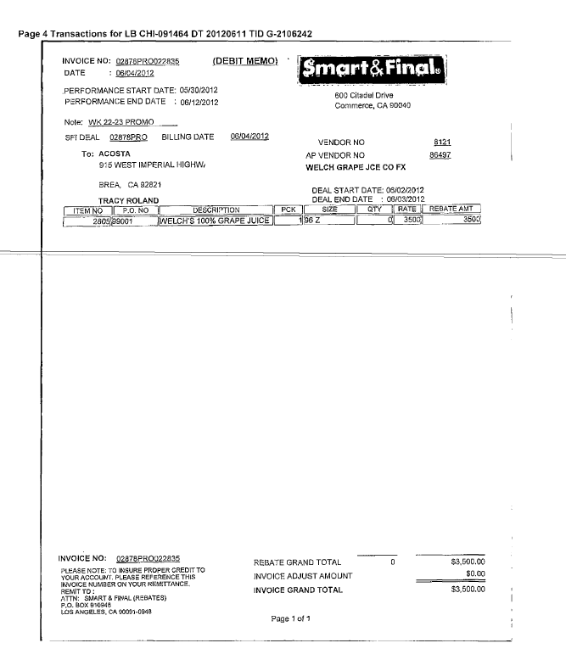
3
2
i
1
Performance Dates – The dates for the TPR promotion should fall within the Contract dates.
Item Code: Item code and description for which product is being billed. It should match with the Item code/Product description mentioned on the Contract.
Lumpsum – The highlighted section is the total lump sum offered for the TPR allowance.

This column represents the key word PRO to identify the claim is for TPR or Display deductions.

4.2 Customer Contract for TPR:
Contracts can be found under Promotions & Backup documentation using the Client & Customer Sign on.

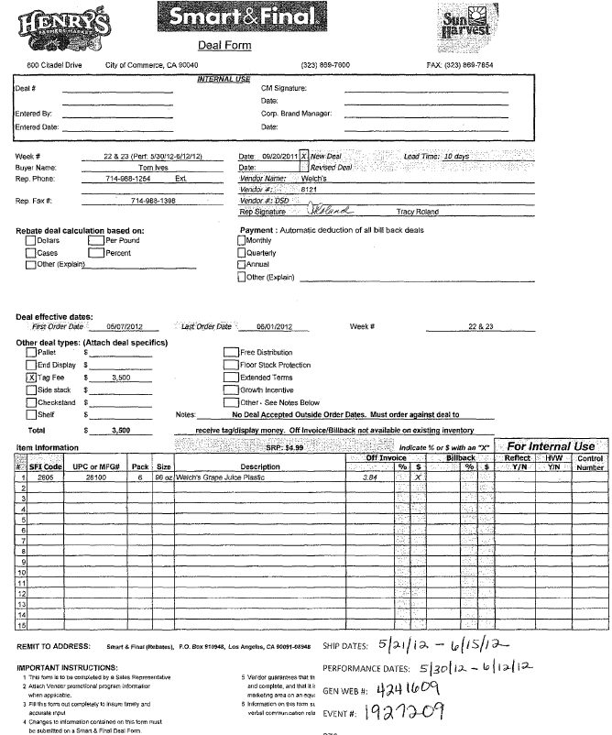
1
2
3
Tag Fee (TPR Lump sum) – This is the total lump sum for the TPR (Tag Fee) allowance and needs to be matched with the Customer Invoice.

UPC, Item Code & Description – For this highlighted product the price reduction allowance must match that the customer is claiming.

Performance Dates – The invoice should fall within these highlighted performance days. These are the dates and weeks to be used to locate the Ad.

Note: The description ‘tag fee’ should be treated as TPR.

Additional Contract Example for TPR Tag Fees:

Note: The description ‘tag fee’ should be treated as TPR.

5
2
1
UPC, Item Code & Description – For this highlighted product, the price reduction allowance must match what the customer is claiming.

Performance Dates – The invoice should fall within these highlighted performance days. These are the dates that can be used to locate the Ad.
Tag Fee (TPR Lump sum) – This is the total lump sum for the TPR (Tag Fee) allowance and needs to be matched with the Customer Invoice.

Additional Contract Example for TPR Tag Fees:
Note - The week # and performance dates on the invoice will match the week # on the contract but will need to use the Calendar on page 4 to match the performance dates on the invoice.

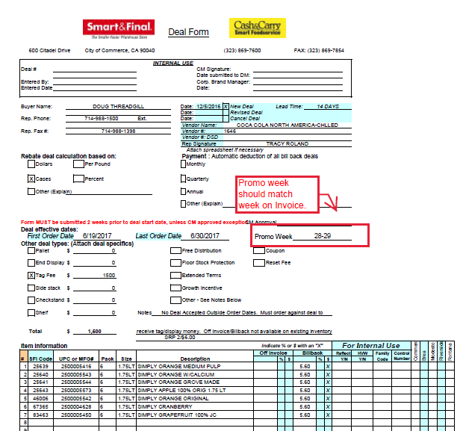

4.3 Proof of Performance for TPR Tag Fees:
NOTE: Price Point Validation is required only when the client SOP indicates that the client requires it. No POP is required for Lump Sum TPR fees per generic help (unless client SOP indicates otherwise.)

The BM receives a copy of the printed tag and uploads ACOSTA RELAY repository under Backup Documentation under Doc Type 7 - POP-TPR.

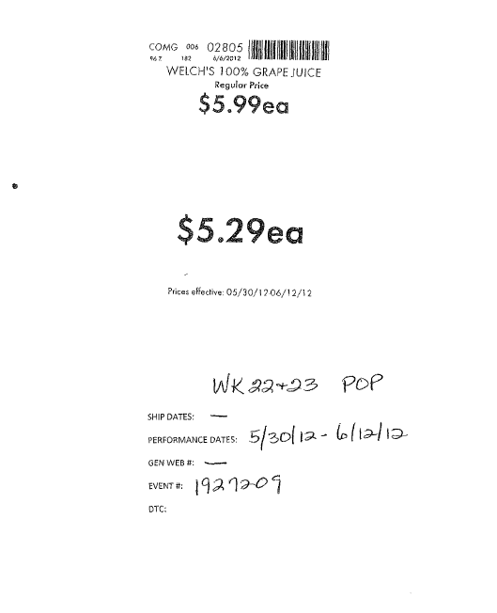
The Product description for which the price should be reduced needs to match with contract and the performance dates/week needs to be matched with the contract
i

**Please note, if this POP is not available see next page.**

4.3.1 Proof of Performance for TPR Tag Fees:
You may see the following document with the Customer Invoice as the POP:

If this document is not attached to the Customer Invoice, Price Point Validation must be found through Nielsen data for subscribing customers, or an Ad copy, when required by the client (see Client Audit guidelines and/or Client SOP documentation for confirmation). Otherwise, Proof of Purchase will be found via GenWeb Sales Analysis reports (Sales Summary is preferred), Client Order Invoice or Client Proprietary system sales reports using dates 1 month prior to promo dates through the end of the promo period.

4.3.2 Proof of Performance for TPR Tag Fees:
This is another type of POP that can be used for TPR tag Fees:
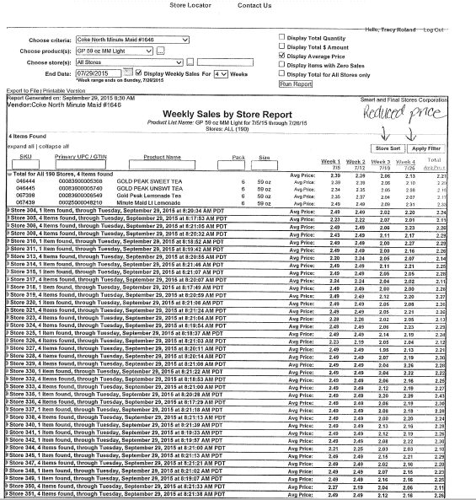

5. Deduction Type: Displays

A Display deduction is an allowance given on an in-store product display (within a specific agreed section of the store) on and end cap or displayed per the client’s requirement.

5.1 Customer Invoice for Display:
This column represents the key word PRO to identify the claim is for TPR or Display deductions.

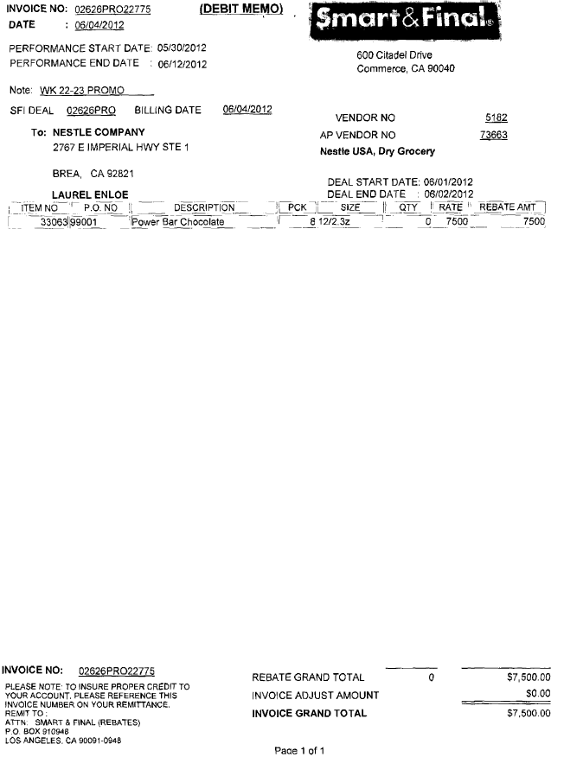
2
3
1
i
Lumpsum – The highlighted section is the total lump sum offered for the Display allowance.

Performance Dates – The dates the display promotion was conducted and should fall within the Contract dates.
Item Code: Item code and description for which product is being billed. It should match with the Item Code/Product description mentioned on the Contract.

5.2 Customer Contract for Display:

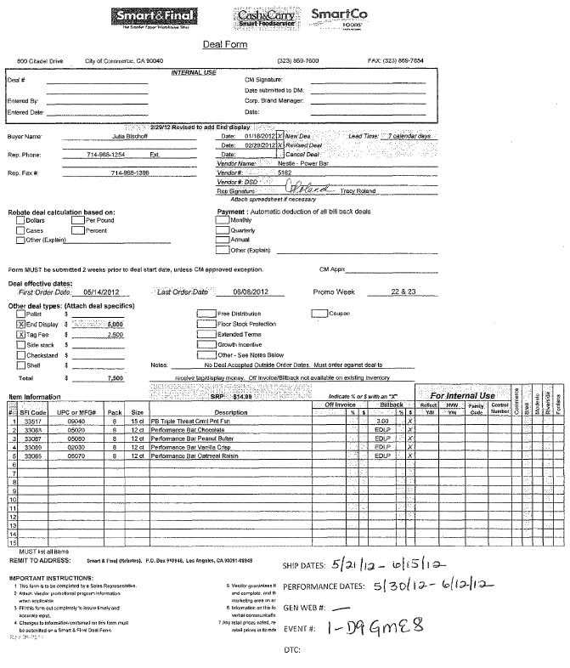
1
3
2
Performance Dates – The Invoice dates should fall within these highlighted performance days. These are the dates and weeks for the Display promotion conducted and can be used to locate the Ad.
Display + Tag Fee = Lump sum – This is the total lump sum for the total display allowance and needs to be matched with the Customer Invoice.

UPC, Item Code & Description – This highlighted product is the display product the customer is claiming for the allowance.

Note: The above contract has two split – $5000.00 is for End Display which should be treated as Display and $2500.00 for Tag fees which should be treated as TPR.

5.3 Proof of performance for Display:
Refer to the Proof of Performance Reporting Ads job aid for searching for ads.

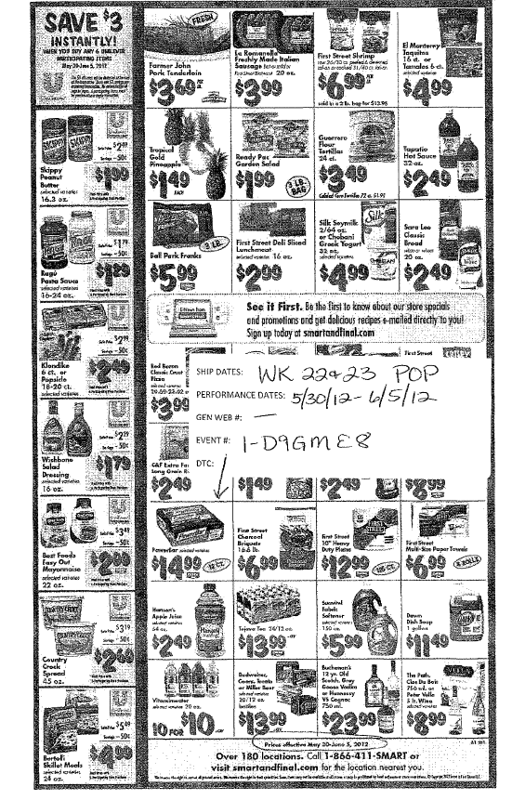
Performance date – Needs to be compared with the Contract and Customer Invoice.
i

Note: Refer to the Client SOP for the Proof of Performance required for the deduction type Display.

5.3 Proof of performance for Display:
Page# 2
The BM receives a copy of the printed tag and uploads ACOSTA RELAY repository under Back-up documentation under POP-TPR.

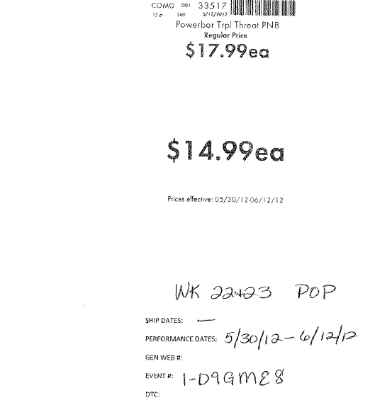
i
The Product description for which the price should be reduced needs to match with the Contract and the Performance dates/week needs to matched with the Contract.

**Please note, if this POP is not available see next page.**

5.3.1 Proof of Performance for Display:
You may see the following document with the customer invoice as the POP:

If this document is not attached to the Customer Invoice, Price Point Validation must be found through Nielsen data for subscribing customers, or an Ad copy, when required by the client (see Client Audit guidelines and/or Client SOP documentation for confirmation). Otherwise, Proof of Purchase will be found via GenWeb Sales Analysis reports (Sales Summary is preferred), Client Order Invoice or Client Proprietary system sales reports using dates 1 month prior to promo dates through the end of the promo period.

5.4 Customer Invoice for Display:
Example # 2
i
This column represents the key word PRO to identify the claim is for TPR or Display deductions.

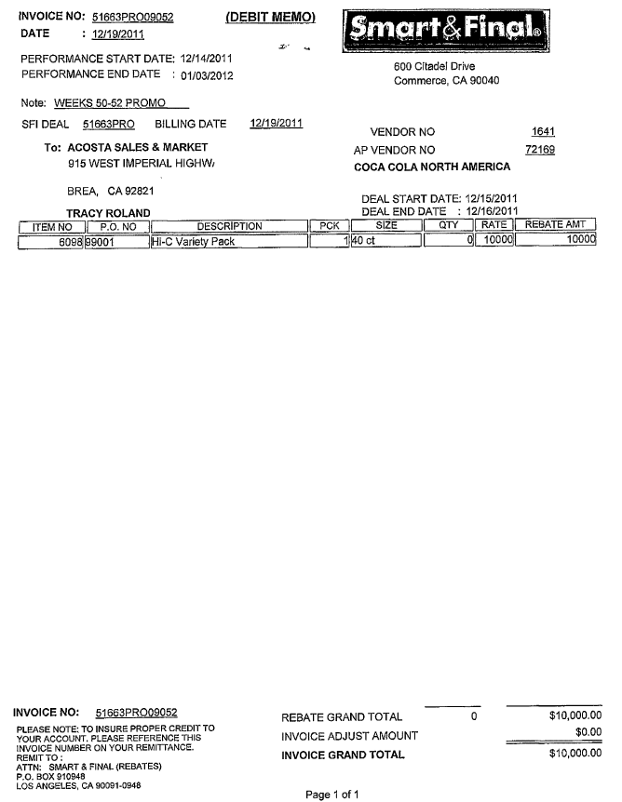
3
2
1
Performance Dates – These dates for the display promotion should fall within the Contract dates.
Lumpsum – The highlighted section is the total lump sum offered for the Display allowance.

Item Code: Item code and description for which product is being billed. It should match with the Item Code/Product description mentioned on the Contract.

5.6 Customer Invoice for Display #3
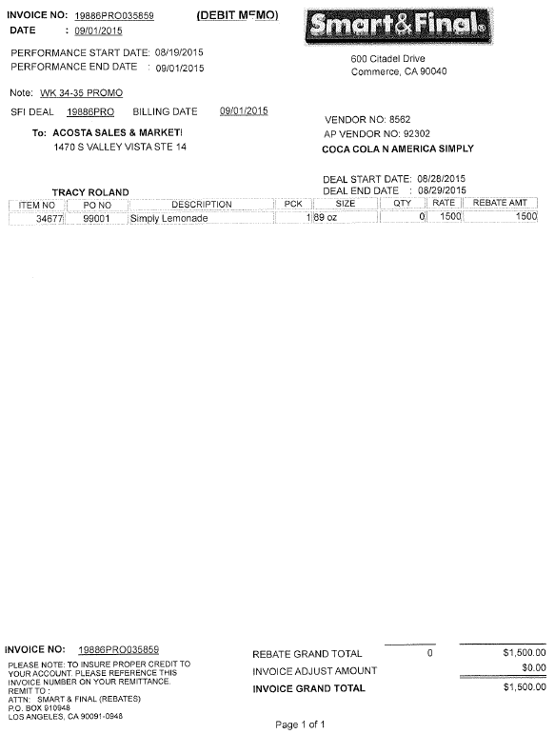
2
5
Display = Lump sum – This is the total lump sum for the total Display allowance and needs to be matched with the Customer Invoice.

Performance Dates – The dates on the Customer Invoice for the Display promotion should fall within the Contract dates.

5.7 Customer Contract for Display #3

2
5
Display = Lump sum – This is the total lump sum for the total Display allowance and needs to be matched with the Customer Invoice.

If the Contract only has the Promo Week, the appropriate Promotional calendar must be reviewed to determine the dates. The promotional calendar is found in the Customer General Information section.

Performance Dates – The dates on the Customer Invoice for the Display promotion should fall within the Contract dates.

5.8 Proof of Performance for Display:

Note: Refer Client SOP for the Proof of Performance required for the deduction type Displays.

6. Deduction Type: Non-Trade / Other

6.1 Customer invoice: CRV Charges
Page 1
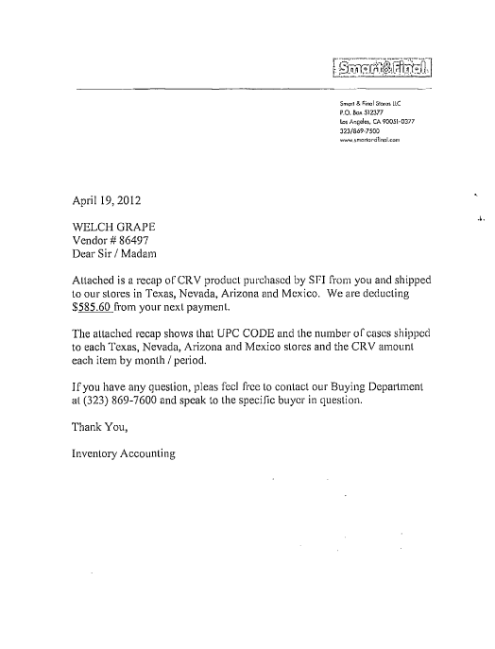
i
The highlighted section is for the CRV (Cash Redemption Value)

Note: Cash Redemption value is for Non-Trade. See Client SOP/Matrix for instructions for Non-Trade.

Customer invoice: CRV Page# 2
The below report is for the CRV promotion sales report.

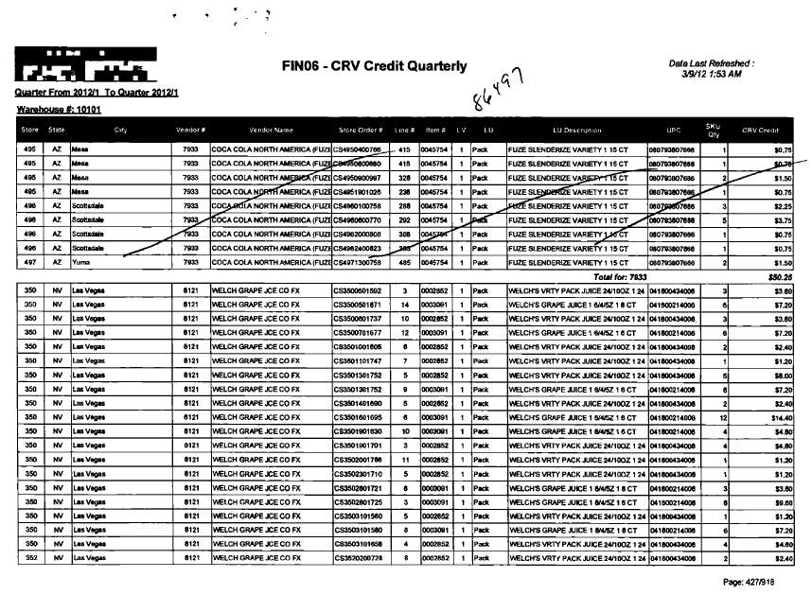

6.1 Additional CRV invoice example #2:

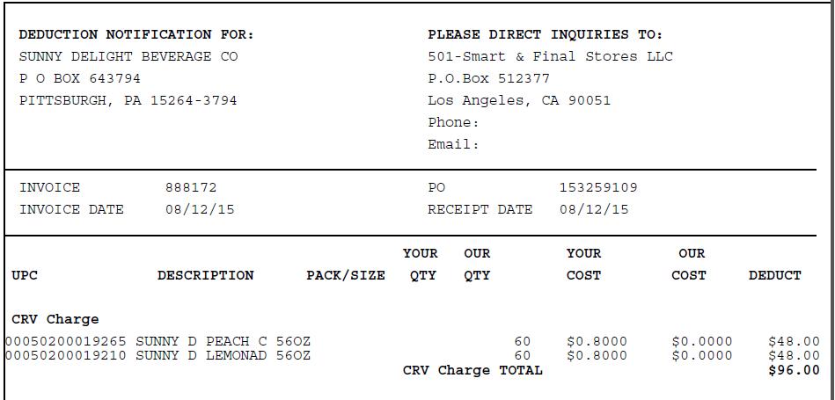

6.1 Customer invoice: CRV example #3

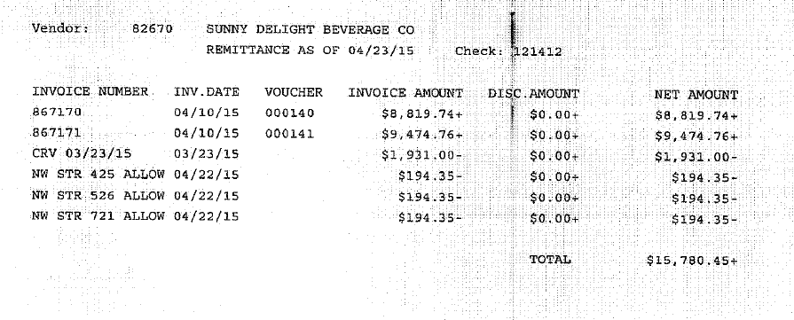
This is a Check Remittance. No additional details are required for submitting the claim as CRV (Non-Trade). See client SOP/matrix for Non-Trade instructions.

6.3 Refer to the SOPs/Generic Help File for POP requirements.
7. Deduction Type : Unsaleables / Reclamation / Spoils / Damages

7.1 Customer Invoice for Unsaleables:

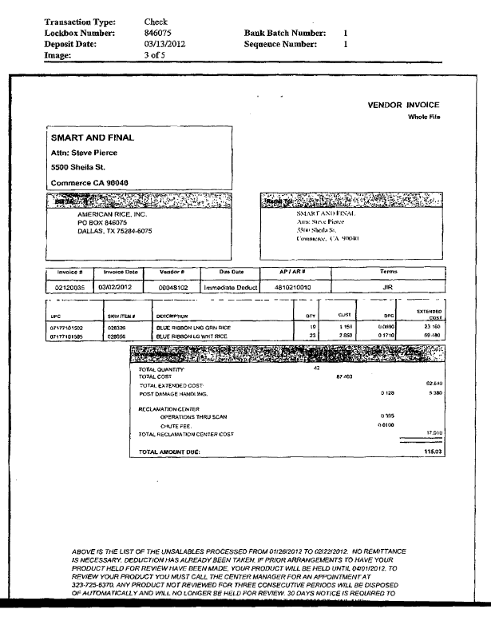
Reference # / Invoice #: The claims customer reference number may include the Y##P## (0212) followed by the Invoice #.

Deduction Type: The Claim is referenced as unsaleables. Once the Invoice is identified as for Unsaleable, the claim needs to be stepped up to Acosta for further research.

8. Deduction Type: Pricing

Document Name | Source of the Document | Action by Accenture
Customer Invoice | ACOSTA RELAY – search for the invoice under Backup Documentation, document type 2. | Step up the claim to Acosta for research
Client Order Invoice | ACOSTA RELAY – search for this document within the Order/Invoice/PO search.

8.1 Customer Invoice for Pricing
Example #1

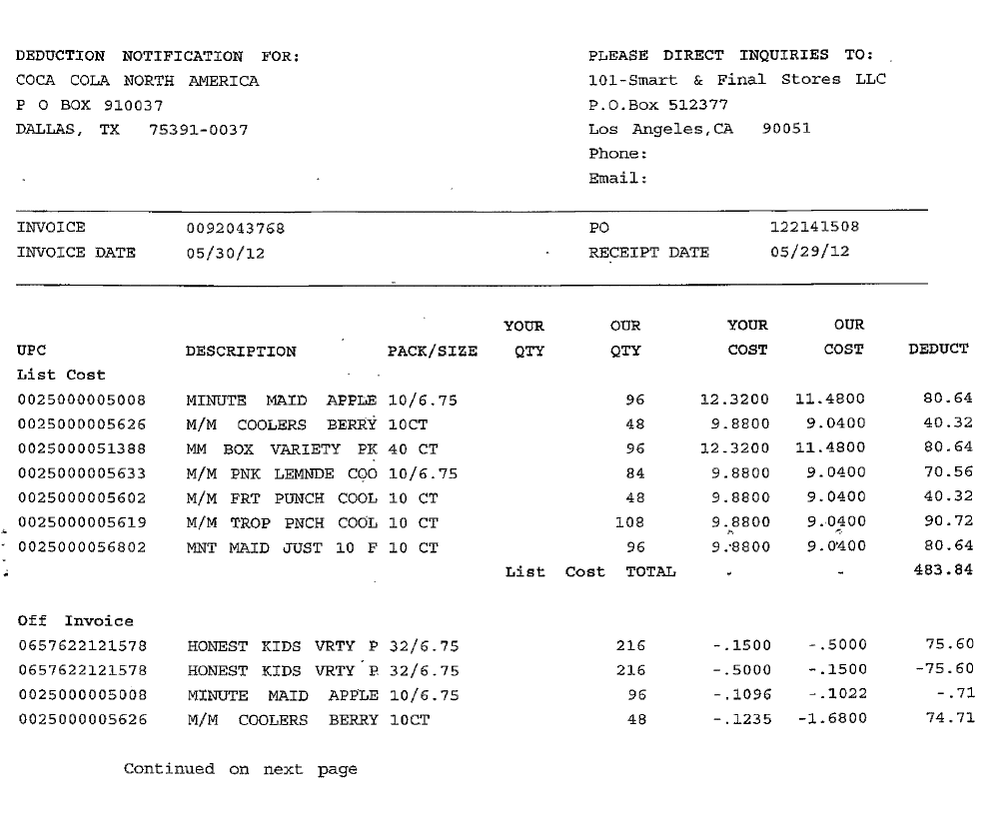
4
Pricing Difference: If the Your Cost (Vendor billed) is more than the Our Cost (customer billed), the difference should be treated as a Pricing error
Invoice Number –This is used to retrieve the Order/Invoice data out of the Order/Invoice/PO search screen of ACOSTA RELAY if it is not attached in the claim as a backup.
Eg. In this case the Client Invoice Number is 92043768.

8.2 Customer Invoice for Pricing
Example #2:

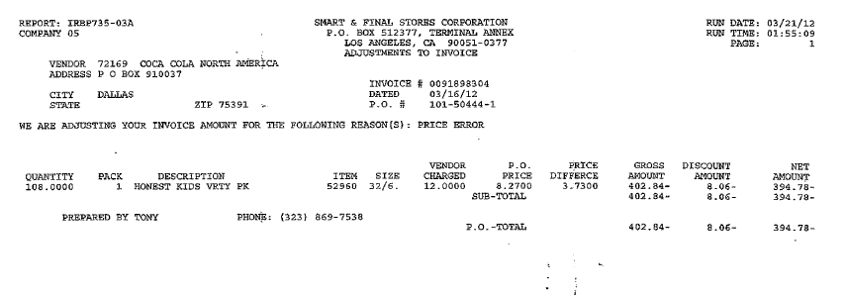
4
Pricing Error: This is the identification the customer is claiming for the Pricing error.
Invoice Number –This is used to retrieve the Order/Invoice data out of the Order/Invoice/PO search screen of ACOSTA RELAY if it is not attached in the claim as a back-up.
Eg. In this case the Client Invoice Number is 91898304.

9. Deduction Type: Floor Stock

Floor stock deductions are taken when a customer is not notified in advance of a promotional offer according to their policy. The allowance amount is taken on product in stock at the customer’s warehouse.

Document Name | Source of the Document | Action by Accenture
Customer Invoice | ACOSTA RELAY – search for the invoice under Backup Documentation, document type 2. | Step up the claim to Acosta for research

9.1 Customer invoice for Floor Stock:

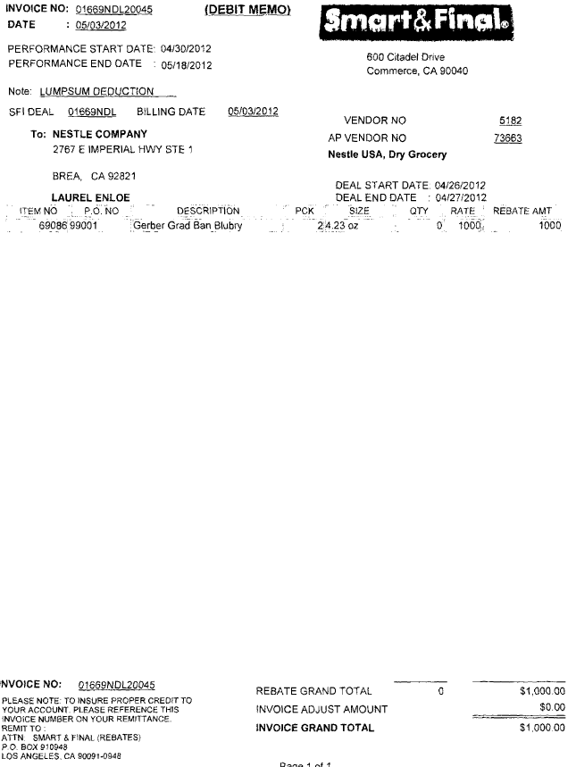
4
i
This is the Customer Reference number and can be used to pull the Customer Invoice from Backup Documentation within ACOSTA RELAY.

10. Deduction Type: Post Audit

Internal/external auditors find claims that the customer is entitled to but did not take from previous years. Post Audits should be researched in the same manner as other claims by accessing previous year’s files.

NOTE: The post audit claim must first be researched to ensure the customer has not already billed for the allowance before the normal validation process can begin.

Once the post audit claim has been researched to ensure the customer has not already billed for the allowance refer to the appropriate allowance section of the SOP to continue with validation. If the post audit is for an allowance not defined in an allowance section of the SOP refer to the post audit example for validation information.

The Customer Reference number for Post Audits typically includes “CL”.

10.1 Customer Invoice for Post Audit:
Page No -1.
4
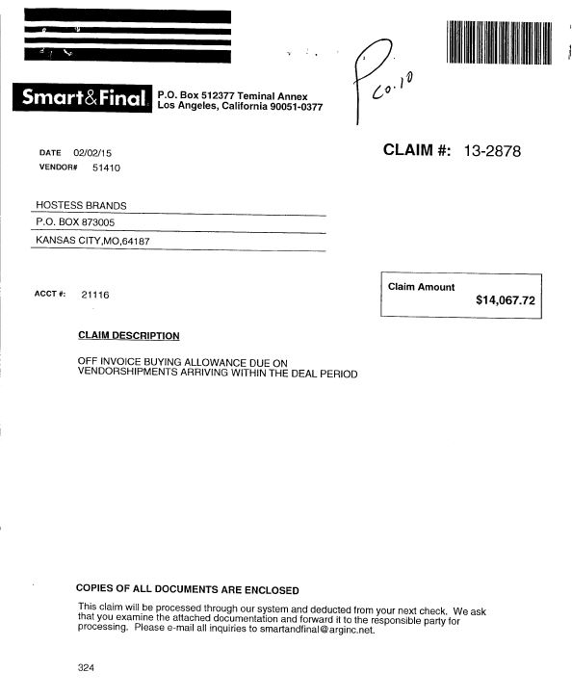
Claim # – This is the reference number for the Post Audit. The Customer Reference Number on the claim will not have the dash, e.g: CL 132878
Claim Amount – The amount of the Post Audit. Should match the claim amount.
Claim Description – Indicates that the deduction is for a Post Audit.

10.1 Customer Invoice for Post Audit:
Page No -2
1
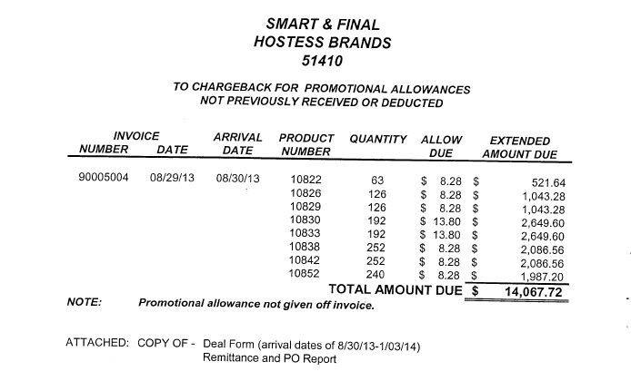
3
2
Allow Due – This is the amount that the customer is claiming per item. This must match the Contract.
Product number – This is the customer’s code for the products. Use the Contract to match UPC or run an APL. The products must be on the Contract.
Quantity – Must match the Client Order Invoice.
Invoice Number – This is the Client Order Invoice number. The dates must fall within the Contract dates

10.1 Customer Invoice for Post Audit: Example 2
Page No -1.
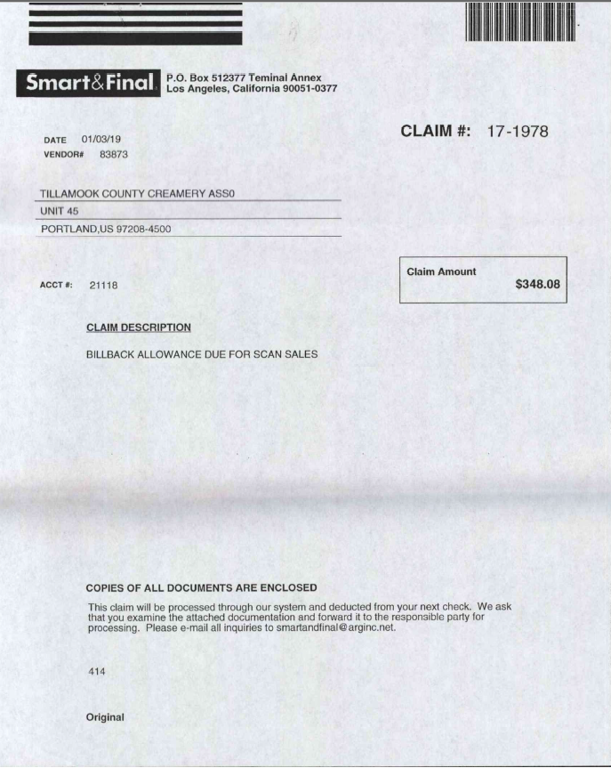
Claim Description – Indicates that the deduction is for a Post Audit.
Claim Amount – The amount of the Post Audit. Should match the claim amount.
Claim # – This is the reference number for the Post Audit. The Customer Reference Number on the claim will not have the dash, e.g: CL 171978

10.1 Customer Invoice for Post Audit:
Page No -2

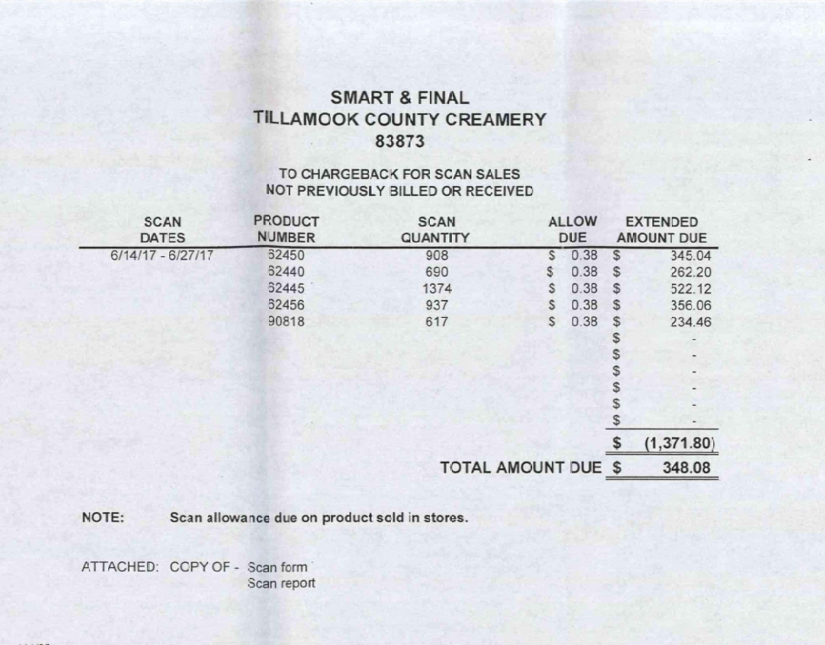
Previously Billed – This is the amount that the customer has already billed for on previous invoices.
Total Amount Due – This total is the amount due for the allowance that was not billed. Total of the extended amount due – the previously billed.
Product number – This is the customer’s code for the products. Use the Contract to match UPC or run an APL. The products must be on the Contract.
Scan Dates – These are the dates the performance dates. These should be within the contract dates.
Allow Due – This is the amount that the customer is claiming per item. This must match the Contract.
Quantity – Must match the Client Order Invoice.

11. Deduction Type: Shortages

Document Name | Source of the Document | Action by Accenture
Customer Invoice | ACOSTA RELAY – search for the invoice under Backup Documentation, document type 2. | Step up the claim to Acosta for research
Client Order Invoice | ACOSTA RELAY – search for this document within the Order/Invoice/PO search.

11.1 Customer Invoice for Shortages:

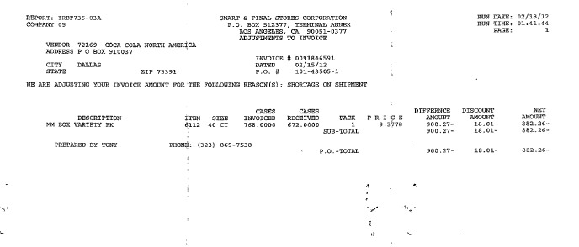
Deduction Type – This states that the Invoice is for Shortage Deduction.
Once identified as a Shortage Deduction, the Client Order Invoice needs to be linked and the claim needs to be stepped up to Acosta for further research. This is the Customer Reference Number used to search for the Customer Invoice in Backup Documentation, Doc Type 2.

Invoice – This is the Client Order Invoice number that can be used to search for the Client Order Invoice.

12. Deduction Type: Freight / Backhaul

Document Name | Source of the Document | Action by Accenture
Customer Invoice | ACOSTA RELAY – search for the invoice under Backup Documentation, document type 2. | Step up the claim to Acosta for research
Client Order Invoice | ACOSTA RELAY – search for this document within the Order/Invoice/PO search.

12.1 Customer Invoice for Freight / Backhaul :

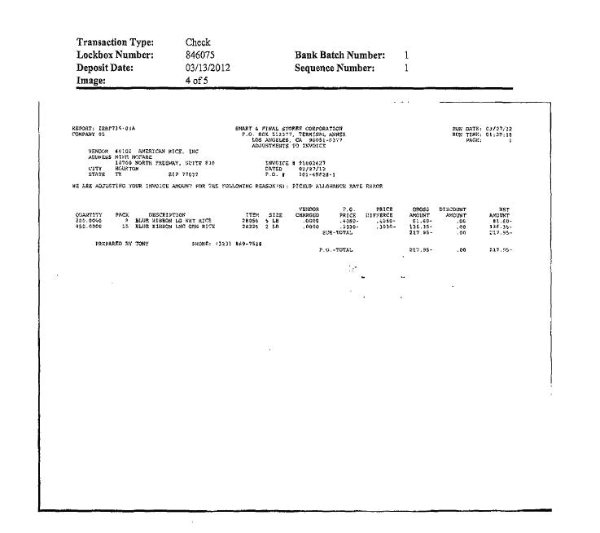
Deduction Type – This states that the Invoice is for Freight Allowance. Also, the Reason states as Pick up Allowance, this indicates it is a Freight Claim. This is also the Customer Reference Number used to search for the Customer Invoice in Backup Documentation, Doc Type 2.
Once identified as Freight Allowance, the Client Order Invoice needs to be attached and the claim needs to be stepped-up to Acosta for further research.

13. Deduction Type: Slotting

A Slotting allowance is offered to the customer to purchase an item not currently stocked. It is a kind of promotional money offered to a customer as incentive to buy a new item and create a “slot” for that product on their warehouse storage shelves. It is a Trade Deduction. A slotting lump sum allowance can be offered for each item and/or an off invoice can be offered as an introductory allowance for the first 30 days.

13.1 Customer invoice for Slotting

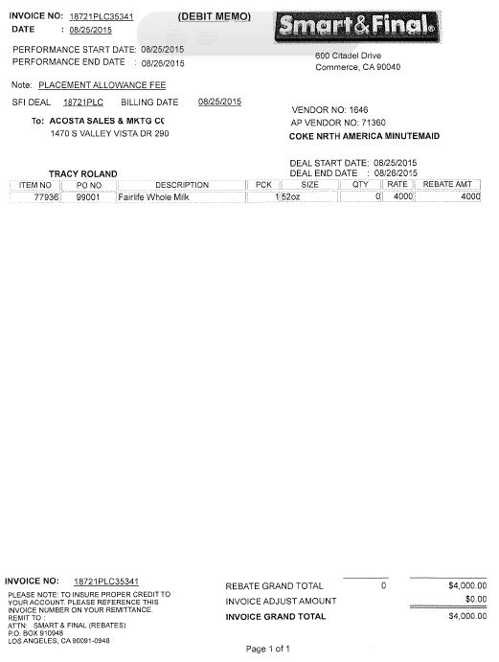
1
4
Amount being deducted per item. This should match the allowance amount on the Contract.
The description of the the product being deducted for. This should appear on the Contract.
Placement allowance fee indicates Slotting.
This is the Customer Reference number and can be used to pull the Customer Invoice from Backup Documentation within ACOSTA RELAY.

13.2 Customer Contract for Slotting

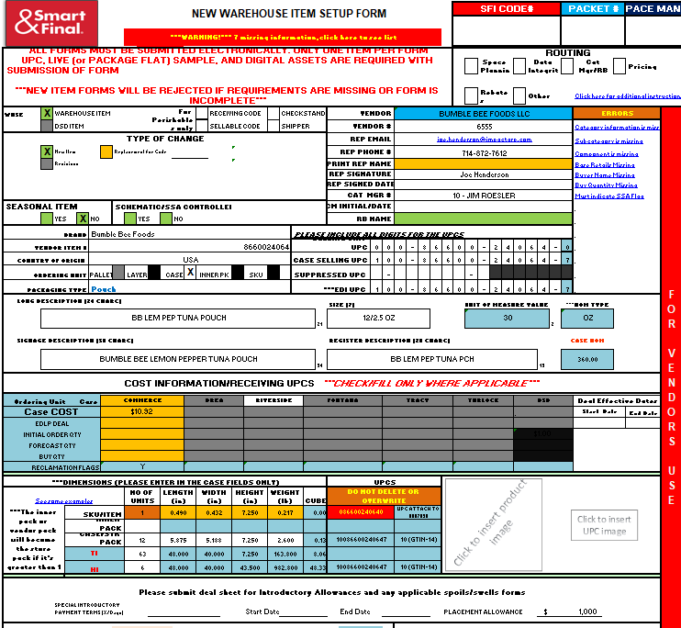
2
Amount being offered per item. This should match the allowance amount on the Customer Invoice.
1
The description of the the product being offered. This should match the Customer Invoice.

NOTE: The date next to the Client Manager name may be used as the first available date if no other dates are present on the New Item Form.

13.3 Refer to the SOPs/Generic Help File for POP requirements.

14. Deduction Type: Retail Merchandising Program

14.1 Customer invoice: Example# 1 Smart Retail Fairshare
The customer refers to this as “Retail Fair Share” These claims can be identified by the letters “SMRT, SMRTL or SMRTRTL” in the customer reference #. The complete reference number located on the check remittance will typically also include the time period and year that the invoice is related to. Example 2H25 is second half 25. See contract example below:
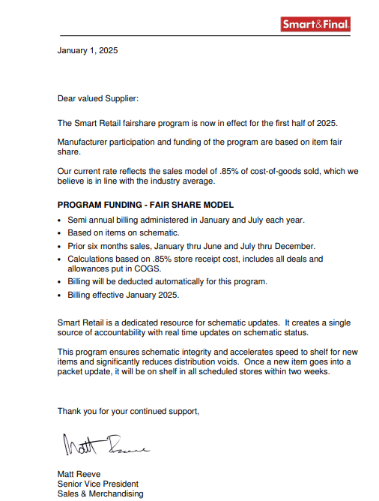

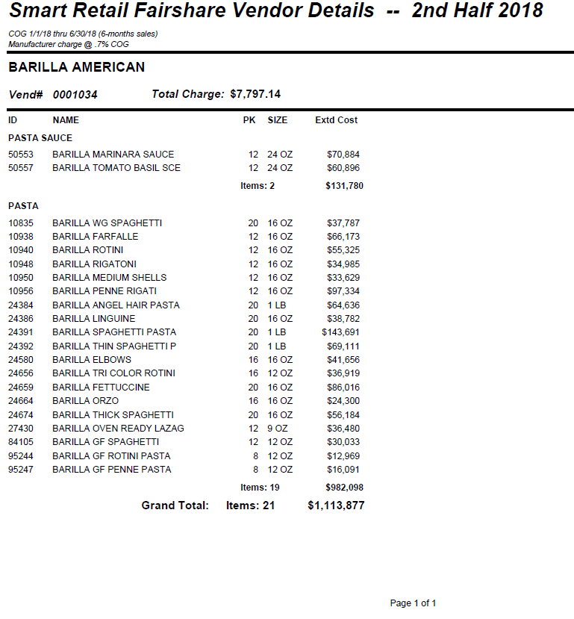
The highlighted section is the total amount to be deducted on the claim. This will be a percentage of the grand total of the invoice.

The highlighted section is the allowance rate on the gross total. To get the claim total take the grand total and multiple by .007.

2

NOTE: The invoice may be a copy of the agreement
14.1 Customer invoice: Example #2 New Store Allowance / Merchandising Support

- New store allowance deductions can be identified by the NW STR noted in the customer reference number. The customer reference number will not be located on the customer invoice. The digits located after NW STR will indicate the store number the allowance is for. The full customer reference number can be located on the check remittance. I.e. NW STR 390 Allow (Customer reference field could only reference A, Allow, or neither).
- New store allowances are deducted one store at a time. In the example below there will be two deductions one for store 390 in the amount of $119.96, and one for store 568 in the amount of $119.96.
  - This document will be indexed twice into the repository the customer reference # for one will be NW STR 390 Allow and the other will be NW STR 568 Allow.

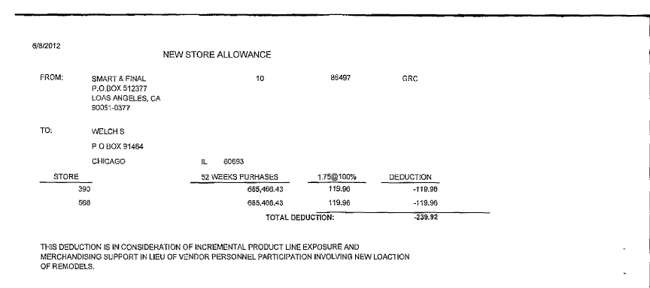
i
It is for New store Merchandising program.- Customer reference # NW STR.

The dollar amount that is being deducted for by store number.

The store number that participated in the program. This will be noted in the customer reference #.

2
The rate that the customer is claiming is 1.75% of total annual sales per store.

i
The highlighted section is for the Merchandise Support. Please see note below

14.1 Customer invoice: Eample #2 Core Refresh Billing

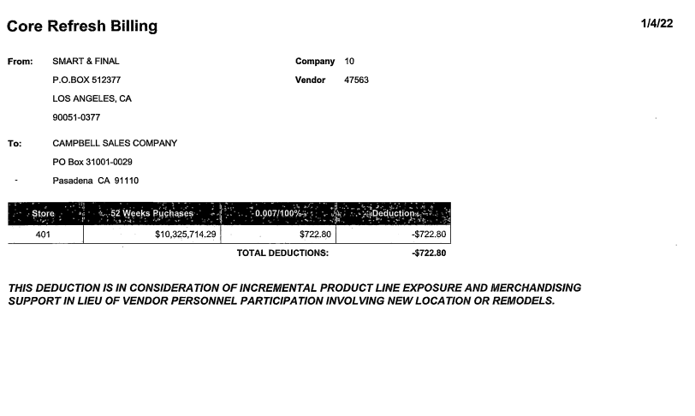
It is for Core Refresh Billing which is a Retail Merchandising Program.
The store number that participated in the program.

The dollar amount that is being deducted for by store number.

14.2 Customer Contract Retail Merchandising Program: Example #1 Smart Retail Fairshare
This is also known as the Agreement.

The highlighted section is calculated on the Program Funding associated with effective dates and percentages to be used.

i

14.2 Customer Contract Retail Merchandising Program: Example #2 New Store Allowance / Merchandising Allowance.

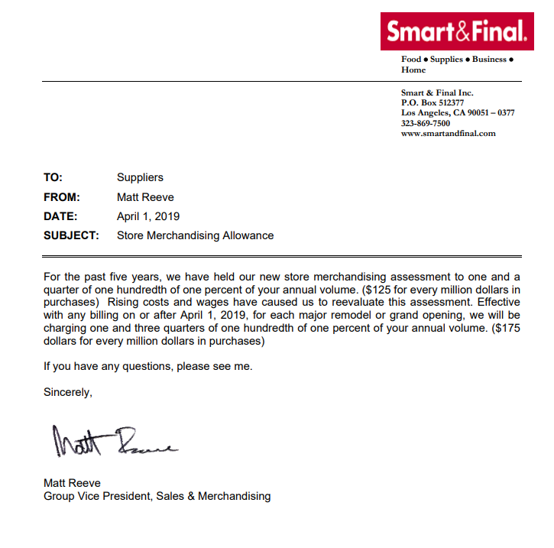

This agreement is considered the contract for the deduction and should be in ACOSTA RELAY.

14.3 Refer to the SOPs/Generic Help File for POP requirements.

15. Deduction Type: Rebates

15.1 Customer invoice: Example# 1 Rebate

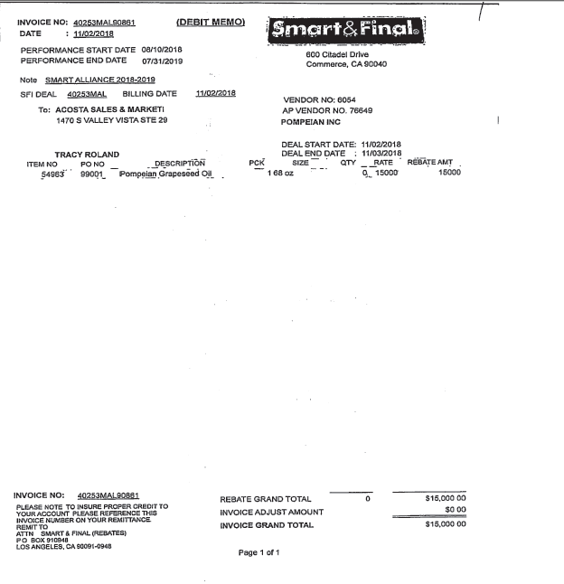
Note – Smart Alliance identifies this deduction as a Rebate allowance.
Performance Dates – The dates the display promotion was conducted and should fall within the Contract dates.
Amount being deducted for the rebate allowance. This should match the allowance amount on the Contract.
The description of the the product being deducted for. This should appear on the Contract.

15.2 Contract: Example# 1 Rebate

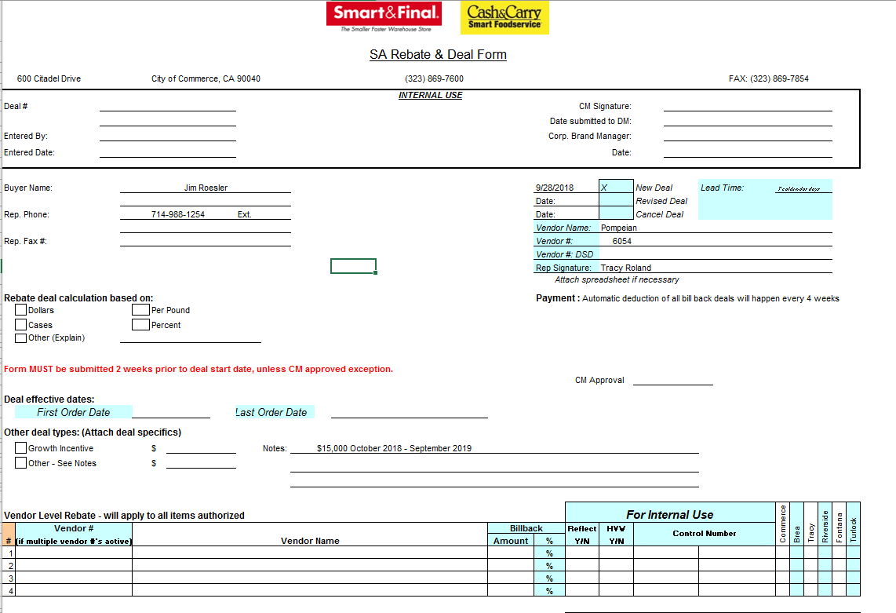
SA Rebate – This information identifies this contract is for the Smart Alliance Rebate.
Allowance amount / Performance Dates – The dates the display promotion was conducted and should fall within the Contract dates.

15.3 POP for Rebate: Refer to the Client SOPs/Generic Help File for POP requirements

16. Deduction Type: Cash Discount

Documents required for validating an Other Cash Discount claim:

Document Name | Source of the Document | Action by Accenture
Client Order Invoice | ACOSTA Relay – search for this document within the Order/Invoice/PO search. | Step up the claim to Acosta for research

16.1 Customer Invoice for Cash Discount:
The customer does not provide customer backup for cash discounts. The customer will deduct a 2% cash discount off the gross amount.

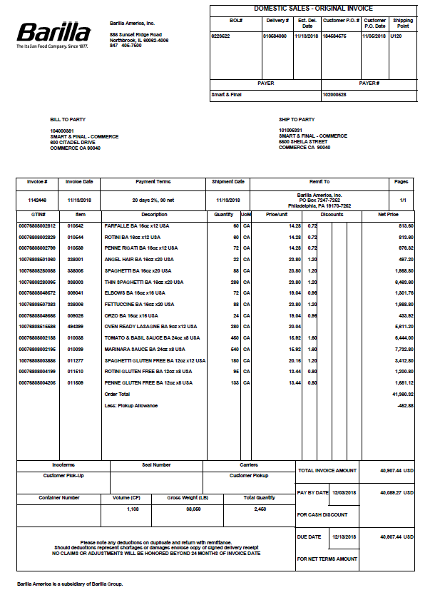
To calculate the cash discount from the client order invoice locate the order total before the deduction of any allowance, the gorss total and multiply this amount by 2%. In this case $41380.32 * 2% = $827.61

17. Deduction Type: Service / Penalty Fee

17.1 Customer Invoice for Unloading Fees:
See below policies – Smart and Final does not allow drivers to unload at any of the distribution centers. Due to this policy Smart and Final will charge a variety of unloading fees (see attached fee rates)

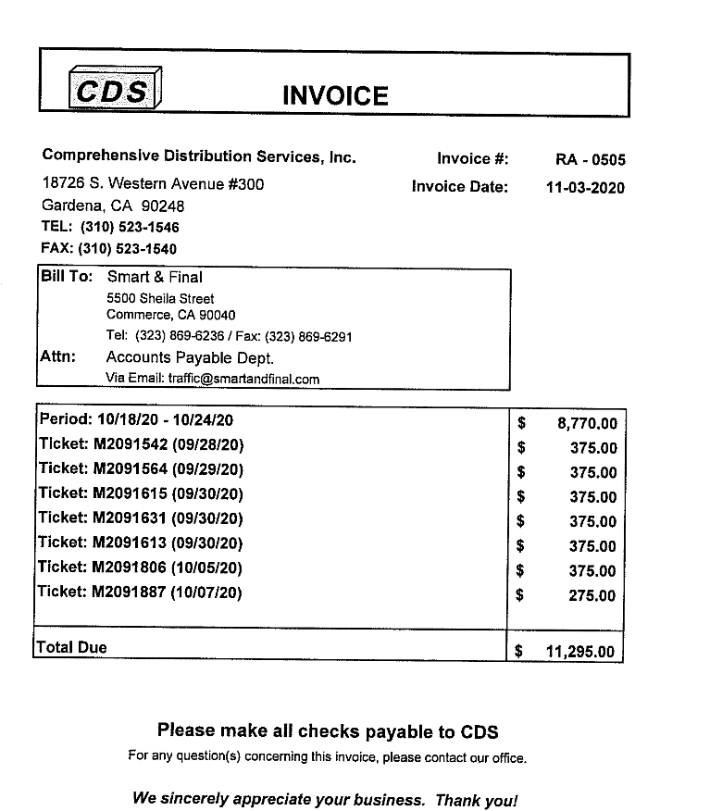

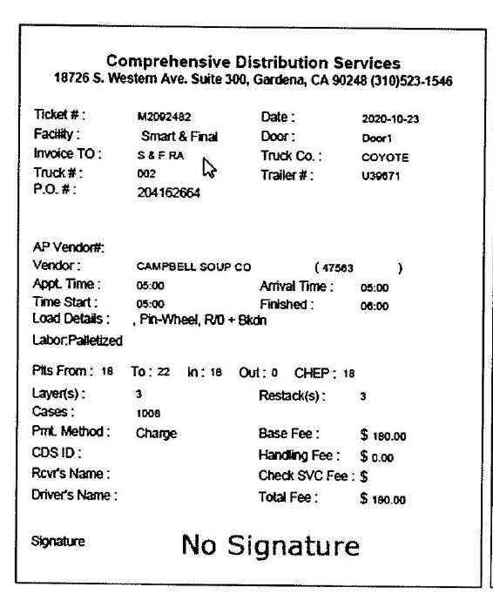

BPS Team Information

REPAY INFORMATION

- Claims for SMAR RT (Smart Retail Fairshare Deductions), NW STR (New Store Openings) and CR STR (Core Refresh Billing repay letters are sent to charles.weaver@smartandfinal.com.

Coca Cola North America
- Repays for no backup should be sent to veronica.jimenez@chedrauiUSA.com, copying the assigned Acosta Business Manager and Customer Manager Tracy Roland (TRoland@acosta.com).
- All other repays should be sent to Customer Manager Tracy Roland (TRoland@acosta.com), copying the Acosta Business Manager.

J.M. Smuckers Co.
- Repays are to be sent to Alicia Osorio – Alicia.Osorio@chedrauiusa.com

CCA CLEARING INFORMATION SPECIFIC

CCA Client Specific

Kikkoman:
- For New Store Allowances: Please provide Kikkoman with the totals page of spin report only as report is too large for the entire packet to be pulled from Kikkonet.

Sunny Delight:
- CRV claims will be recoded in TPPM as a bottle tax.

COMPLETE VERSION HISTORY
UPDATE DESCRIPTION | DATE | AUTHOR
Draft:
First draft of the Smart and Final SOP | 11/08/2012 | Pradeep/Bharath
Reviewed & updated | 11/15/2012 | Dellene Hubbard
Added an additional contract example for Tag Fee (TPR Lump Sum) – see pg. 25 | 12/21/2012 | Dellene Hubbard
Added an additional POP example for TPR Tag Fee (see 4.3.1), Scan Section (see 3.3.1) and Display Section (see 5.3.1) | 04/15/2013 | Dellene Hubbard
Added client specific section, Coca-cola event numbers on contracts (4566); added note that Post Audit invoices begin with CL (4730); Added EBRO to Client Specific section, we do not work these claims (5385) | 9/16/2013 | Karen Smith
Added link to National toolbox and customer signon job aid (5675) | 10/4/2013 | Karen Smith
Added notes for Coca-cola New Store invoices to client specific section (5469); corrected verbiage for contract on new store openings (6031); transferred National Toolbox information to Client Specific Section | 12/23/2013 | Karen Smith
Added Starbucks to client specific section for finding PO and backing into the claim (6863, 7888) | 4/14/2014 | Karen Smith
Added additional information on locating CocaCola New Store invoices in client specific section (8925, 9309); Updated EBRO in client specific section to show we now handle these deductions (9003); Added Hostess to client specific section regarding swell allowances (8988) | 7/21/2014 | Karen Smith
Added note to Example 6.5 New Store Merchandising Support for clients who do not use event numbers and added Kikkoman to Client specific section with instructions for these claims (11391) | 12/22/2014 | Karen Smith
Added Kraft to Client Specific Section with instructions for Fair Share Marketing (11531) | 3/16/2015 | Karen Smith
Updated Fair Share example in deduction type Miscellaneous (previously called Other) (12776); Updated Validity code descriptions per ACOSTA RELAY update (NT); Added type of customer (13429) | 4/27/2015 | Karen Smith
Created BPS Team Section and question on Req CI from CIT to backup retrieval information (13772); moved version history table | 6/8/15 | Karen Smith
Updated New Store deduction invoice instructions for Coca-Cola (14035) | 6/22/15 | Karen Smith
Updated SUNPROD events for new store opening (14593); Added Tyson to Client Section with instructions on Fair Share deductions (15067); Added instructions on new store allowance deductions to Tyson (15123); Added additional CRV example to Miscellaneous (15298); Clean up and reorganization of information in Customer General Information section (14730) | 9/28/15 | Karen Smith
Added Promotional calendar for 2015 (15290) | 10-12-15 | Karen Smith
Added line level detail information to Customer General Information (15509) | 10-26-15 | Karen Smith
Added additional example of display with contract/dates callout (15286); added note to General information section covering all invoice/contract types with only promo weeks and lump sums (15600); Clarified POP for TPR/Tag fees and added additional example for POP (15450); Added additional CRV example and grouped all CRV examples together under Miscellaneous (15390) | 11-23-15 | Karen Smith
Removed New World Pasta from Client Specific section as we no longer represent (15859) | 12-7-15 | Karen Smith
Added slotting example (15883) | 1-18-16 | Karen Smith
Added contact for Fair Share retail invoices (16410) | 2-1-16 | Karen Smith
Added Tillamook to Client section with notes on Tag/display fees (16633); added updated 2015 calendar and 2016 calendar (16827) | 2-15-16 | Karen Smith
Removed EBRO as we no longer represent (17640) | 4-11-16 | Karen Smith
Added BUSH to client specific section with notes on Retail Program claims (17691); added additional backup request contact (17326); added post audit invoice request contact (17680); added additional instruction for New Store Allowances to Tyson (17399) | 4-25-16 | Karen Smith
Updated backup request information (17923) | 8-1-16 | Karen Smith
Added Post Audit examples and removed verbiage to escalate to Acosta (19506); removed Kraft instructions as we no longer represent (19311) | 9-2-16 | Karen Smith
Moved Fair Share to own section and renamed with additional instructions (19788); updated backup request information (19726); removed duplicate contracts and POP examples (19418) | 11-7-16 | Karen Smith
Updated backup contact for Fairshare deductions (20125) | 12-19-16 | Dani Martin
Updated Instructions for New Store Allowances for Tyson (20099) | 1-30-17 | Dani Martin
Updated Customer Contact information (20557) | 2-13-17 | Dani Martin
Smart and Final is now handled internally by Pinnacle (20577) | 3/27/17 | Dani Martin
Updated instructions for Coke Fair Share deductions (20916) | 3/31/17 | Dani Martin
Updated contact information for backup requests (21056) | 4/24/17 | Dani Martin
Added CCA Client Specific information for Kikkoman (21147). | 07/31/17 | Michelle Mangus
Added CCA Client Specific information for Kikkoman (21147). Added in BPS Team Info section CRA Backup Client Specific for Ainsworth (22182). | 07/31/17 | Michelle Mangus
Updated Nestle specific New Item store allowance (22020) | 9/11/2017 | Katy Dolan
Added the 2017 promotional calendar (22569), updated BPS backup request information (22557, 22497) | 9/25/2017 | Katy Dolan
Added Lactalis Deri BPS specific section to care for repay (22757) added new contract example for the TPR section to include notes on how to handle contracts with promo periods (22805) | 10/23/2017 | Katy Dolan
Added additional scan example (22651) updated Nissin specific section for backup requests (22895)  Updated hyperlinks to reflect new online location (23751) | 12/18/2017  2/13/2018 | Katy Dolan
Updated client specific section for Kikkoman regarding backup being included with the check remit (23709) | 2/26/2018 | Katy Dolan
update to customer backup request information/realignment of information, no process change | 8/13/2018 | Katy Dolan
Updated Ainsworth client specific section in regard to GCC stepping process(25340) Updated the customer general information customer invoice section in regards to customer should not receive check requests (25385) | 8/27/2018 | Katy Dolan
Added Barilla CRA specific information to the BPS team information section regarding requesting backup (26135) | 11/05/2018 | Katy Dolan
Updated BPS team information section regarding contacts for backup requests and removed Nissin CRA specific information regarding backup requests, added the 2018 and 2019 calendars in the customer general information section, updated Nielson information in the customer general information section. Removed bullet regarding events written on contract in Coca Cola Specific section (26858) Added client contact information for Michael Foods in the Backup Retrieval Information section (26943) Added client contact information for Nissin in the Backup Retrieval Information section (26922) Added client contact information for Mars Food in the Backup Retrieval Information section (26944) Added client contact information for Camino Real Kitchens in the Backup Retrieval Information section (26945) Added an example of a rebate invoice/contract to the Rebates section (26840) Added client contact information for Tyson in the Backup Retrieval Information section (26918) Added client contact information for Nestle Nutrition in the Backup Retrieval Information section (26971) Added new backup retrieval information section to include new process for GCIT, updated new store allowance and Fairshare examples, Add Keurig client specific section regarding New store allowances (26757) Added Sunny D in the client specific validation and in the CCA client specific section regarding CRV charges (26792) Added client contact information for Starbucks in the Backup Retrieval Information section (26991) Added client contact information for Pepperidge Farms in the Backup Retrieval Information section (26990) updated contact information in the Backup Retrieval information section for Camino (27011) Added GP client contact to the Backup Retrieval section (27023) | 2/1/2019 | Katy Dolan
Removed the Barilla GCIT client specific information regarding CC’ing David Nelson and Tonia Ripoly in the Backup Retrieval Information section (27285) | 3/1/2019 | Katy Dolan
Added additional invoice examples to the Post Audit section (27488) updated backup retrieval information section regarding Michael Angelos and Rao’s (27504) | 3/25/2019 | Katy Dolan
Updated CCNA client specific information in the backup retrieval section as backup requests need to have the check remit number included (27721) | 4/22/2019 | Katy Dolan
Updated the backup retrieval section to include additional requirement for Campbells when requesting backup from the customer (27742) | 4/26/2019 | Katy Dolan
Removed Tyson client specific information section as Acosta no longer handles (27728) | 5/20/2019 | Katy Dolan
Removed Keurig client specific section as Acosta no longer represents (27921) | 6/3/2019 | Katy Dolan
Updated the Backup retrieval information section regarding check remits required for all divisions of Newell and updated the contact information for Pepperidge Farms (PEPPPGR and PEPPBK) for DSD claims (28150) removed Ainsworth client specific information as Acosta no longer represents (27796) | 7/1/2019 | Katy Dolan
Added the updated delivery fee policy in the customer general information section (28288)  Added Barilla client specific information regarding under tolerance level for PO related claims (28310)  Removed Pinnacle specific information, no longer handle claims eff 8/26/19 (28434). | 8/26/2019 | Katy Dolan  Pam Trimble
Updated the Backup Retrieval Section regarding Campbells client specific information and GCIT information for additional details (28443) | 8/30/2019 | Katy Dolan
Removed Sovos client specific information regarding requesting backup from the client from the backup retrieval section (28666) updated Nissin client specific section in the backup retrieval information section (28835) updated format of the backup retrieval section | 11/18/2019 | Katy Dolan
Updated the backup retrieval section regarding Coca Cola contact (29011) removed Camino Real Kitchens from the client exception listing in the backup retrieval section backup requests are made to the customer (29044) removed view document verbiage and updated the format of the backup retrieval section | 12/16/2019 | Katy Dolan
Removed Starbucks client specific information (29269)  Removed Feature Vision/Numerator information (29654) | 1/27/2020  3/9/2020 | Katy Dolan
Updated the contact information for Nissin in the backup retrieval section (29838) | 4/14/2020 | Katy Dolan
Removed the Campbells client specific section from the backup retrieval section (30012) | 5/18/2020 | Katy Dolan
Updated Scan example in the Scan section to include the use of Wk on the invoice and the Deal dates can be used to locate a contract (30070) | 6/29/2020 | Katy Dolan
Updated backup retrieval section (30482) | 7/3/2020 | Katy Dolan
Updated contacts in the backup retrieval section (30666) | 8/14/2020 | Katy Dolan
Added client event requirements in the Newell client specific section (30727) | 9/7/2020 | Katy Dolan
Removed outdated CCNA information in the client specific section (30971) | 10/19/2020 | Katy Dolan
Removed Mars client information from the backup retrieval section (30926) | 11/16/2020 | Katy Dolan
Removed Coca Cola client specific information in the backup retrieval section (30841) | 11/30/2020 | Katy Dolan
Updated the backup retrieval section regarding Chattem backup requests (31414) | 1/11/2021 | Katy Dolan
Updated the backup retrieval and repay information section regarding NW STR and SMAR RT deductions (31533) Updated the Nestle Nutrition regarding Fairshare deductions (31405) added 2020 and 2021 calendars in the customer general information section (31450) | 1/29/2021 | Katy Dolan
Added service fee policies to the Service Penalty fee section (31600) updated backup retrieval section for Campbells to include additional divisions (31714) | 3/22/2021 | Katy Dolan
Added in the Customer sign on section contracts should be searched under additional sign ons (31789) | 4/5/2021 | Katy Dolan
Updated the Mars client specific section regarding the Retail Merchandising Program (31996) | 4/19/2021 | Katy Dolan
Updated backup retrieval section with the backup contact for client beginning with #, A, B, or S (32168) updated the backup retrieval section for the contacts for SMAR RT, NW STR, CR STR, and clients beginning from C – Ferrero (32172) | 5/21/2021 | Katy Dolan
Updated the backup retrieval information section regarding reclamations being pulled out of a portal and the automated contact listing (32380) | 7/12/2021 | Katy Dolan
Updated the backup retrieval section regarding requesting Merisant backup (32333) | 8/9/2021 | Katy Dolan
Updated the automated contacts in the Backup retrieval section (32839) | 11/1/2021 | Katy Dolan
Updated the Backup Retrieval Information Section regarding Juanita’s RMS backup (32969) | 12/13/2021 | Katy Dolan
Updated the Backup Retrieval section regarding Reclamation claims also updated the Reference # in the unsaleable section (33092) | 1/24/2022 | Katy Dolan
Updated the Retail backup contact in the backup retrieval information section (33153) | 2/11/2022 | Katy Dolan
Updated the backup retrieval section regarding Nissin backup (33194) | 2/21/22 | Katy Dolan
Updated backup retrieval contact information (33378) | 3/28/2022 | Katy Dolan
Added the 2022 calendar, removed 2018 and 2019 calendars to the customer general information section (33805) added an example of Core Refresh Billing to the Retail Merchandising section (33597) | 7/25/2022 | Katy Dolan
Updated Customer general information regarding Price Change notification. (33825) | 8/1/2022 | Pamalla Jaeger
Updated Deduction Types Slotting to include more recent example of a Slotting Contract. (33826). Updated Backup retrieval section to include contacting Bumble Bee for backup. (33953) | 9/19/2022 | Pamalla Jaeger
Updated GCIT Specific Backup Retrieval Information by replacing Georgina Barrales and replacing Vanessa Villanueva. (34212) | 12/5/22 | Pam Jaeger
Added Client Specific Validation Information for Michael Angelo. Reclamation invoices need to be requested by emailing deductions@sovosbrands.com. 34333 | 1/4/23 | Pam Jaeger
Updated Section 14.2 - Customer Contract Retail Merchandising Program: Example #2 Store Merchandising Allowance (34344) | 1/23/23 | Pam Jaeger
Updated Deduction Type: Unsaleable / Reclamation / Spoils / Damages with update to text box regarding unsaleable invoice numbers. Also updated GCIT SPECIFIC BACKUP RETRIEVAL INFORMATION to include a better description of how invoice numbers look. (34527). | 2/27/23 | Pam Jaeger
Removed Merisant from BACKUP RETRIEVAL INFORMATION. GCIT should use normal process for requesting back up. (34490) | 2/27/23 | Pam Jaeger
Updated Customer SOP with Backup Retrieval automated contacts. (35044) | 5/29/23 | Pam Jaeger
Updated Back Up Retrieval Information section with new contact for Campbell’s (35108) | 7/17/23 | Pam Jaeger
Updated Back Up Retrieval Information section for Campbell’s to include “. If Campbell’s cannot provide the backup information, then it should be requested from the customer.” (35199) | 8/28/23 | Pam Jaeger
Added sub header under Back Up Retrieval Information for Campbell’s. Also added under GCIT SPECIFIC BACKUP RETRIEVAL INFORMATION non automated for Campbells CC information. (35449) and customer contact Automated under same header (35591). | 10/16/23 | Pam Jaeger
Updated BPS Team Information to remove Lactalis. (35696) | 11/6/23 | Pam Jaeger
Updated Back up Retrieval Information for Campbells (35757). | 12/11/23 | Pam Jaeger
Updated customer sign on section by removing SMARSM and adding customer sign on definitions for finding back up. (35918). | 1/8/24 | Pam Jaeger
Added Campbells in the Client Specific Validation Information for frozen vendor number (36190). Added Smart and Final 2023 and 2024 promotion calendars under Other General Info Section (36123). | 3/18/24 | Pam Jaeger
Updated Backup retrieval section with Salov North America (382125). Also updated Customer General Information section with instruction for PO related claims (383653). | 4/15/24 | Pam Jaeger
Updated Smart and Final email address to the new company email address chedrauiUSA.com. (384756) | 5/13/24 | Pam Jaeger
Updated non-automated rebate requests email address. (395316) | 8/12/24 | Pam Jaeger
Updated automated email address for Charles Weaver in Back Up Retrieval Information Section. (400417) | 9/23/24 | Pam Jaeger
Removed Sovos from automated backup and added Sovos (Michael Angelo’s, Noosa and Raos) to non-automated. (397749) | 9/30/24 | Pam Jaeger
Removed Hostess from the Client Specific Section. (402814) | 10/14/24 | Pam Jaeger
Removed Bumble Bee, Chattem, Juanita’s and Sun Products from Client Specific Section. Also added back up contacts for Salov North American Corp. (407386). | 12/9/24 | Pam Jaeger
Updated Client Specific Section for CCNA for new store fees (406583). | 1/20/25 | Pam Jaeger
Updated automated backup email address for AP Warehouse. (420040). | 3/31/25 | Pam Jaeger
Updated backup retrieval section regarding smart retail Fairshare (426900) | 6/16/25 | Katy Dolan
Added Beiersdorf to the Back Up Retrieval Information for reclamation invoices. (430097) Updated Automated Backup Retrieval information section (430662) | 6/30/25 | Pam Jaeger
Removed 2023 and 2022 Planning calendar and added 2025 and 2026 calendars. (448219) | 10/27/2025 | Pam Jaeger
Added client and information for JM Smucker in Client Specific Validation Information Section | 02/09/2026 | Dawn Regan
Updated information in Retail Merchandising Program (Smart Retail Fairshare, New Store Allowance) Section (452219). | 02/16/2026 | Dawn Regan
Removed J.M. Smuckers and repay information from Client Specific Validation Information Section and added to BPS Team Information / Repay Information Section (457797). | 02/16/2026 | Dawn Regan
Added Filippo Berio USA and information to Client Specific Validation Information Section (465098) | 04/13/2026 | Dawn Regan

