WORK INSTRUCTIONS

Process | Order to Cash
DTP Name | Stater Bros. Claims Validation Documents

CURRENT VERSION HISTORY

UPDATE DESCRIPTION | DATE | AUTHOR
Removed Mars Ice Cream and information from Client Specifics Section (472152) | 06/22/2026 | Dawn Regan

Link to complete version history: Complete Version History

DEDUCTION TYPES COVERED

Sl. No. | Deduction Type
 | Customer General Information
 | Backup Retrieval Information
 | Client Specifics
1 | Off Invoice
2 | Bill back
3 | Warehouse Withdrawal (Count/Recount/WHSE MOVEMENT)
4 | Scan
5 | Ad
6 | Slotting
7 | Manufacturer Coupon
8 | Displays
9 | Sponsorship
10 | Pricing (Non-Trade)
11 | Post Audit
12 | Returns (Non Trade)
13 | Shortages (Non Trade)
14 | Loyalty Program (E-Coupon)
15 | Unsaleables / Reclamation / Spoils / Damages (Swells)
16 | Service Fee/Penalty (Non-Trade)
 | BPS Team Information

Is the customer a wholesaler/distributor, direct or indirect customer? Direct customer.

Note: “STATDB”- This is the Sign-on used to work on ACOSTA Relay for STATER BROS (for example to search a document and to refer the customer on ACOSTA Relay).

Link to customer signon job aid:
https://acostaonline.sharepoint.com/sites/AS_Reporting/Claims_Reports/Forms/AllItems.aspx?web=1

Does customer subscribe to IRI/Nielson for price point verification? Yes

CUSTOMER GENERAL INFORMATION

Customer Invoice Info:

- Is line level detail indexed on the customers documentation (customer invoice, customer check request, unsalable/spoils, post audit, EDI 812/820 or client deduction notice if one of these documents is included)? Yes

- Customer Invoices starting with a “A are for Advertising (ads)
- Customer Invoices starting with a “B” are Billback (promotional)
- Customer invoices starting with a “C” and for $480 are ReposiTrak Fees (Service Fee/Penalty) and any other amount are for Manufacturer Coupons.
- Customer invoices that list PO numbers on the check remit (reference number can end in a B or C) and are for a flat lump sum are late/no show/missed appointment fees.

- Stater Bros claims cannot be validated using just the summary page. You MUST have the detail pages that represent each item listed on the summary page as part of the document in order to validate the claim. Stater Bros sends only the pages of the invoices that they are deducting for and does not include all pages. For example, if the invoice is 4 pages and they only send pages 1 thru 3 and not page 4 then page 4 does not have any deductions on it that they are requesting. If all you have is a detail page(s) continue the validation process.

- Adjustment Codes cheat sheet: These codes may be found on their customer invoices for PO related claims or their check remittance.

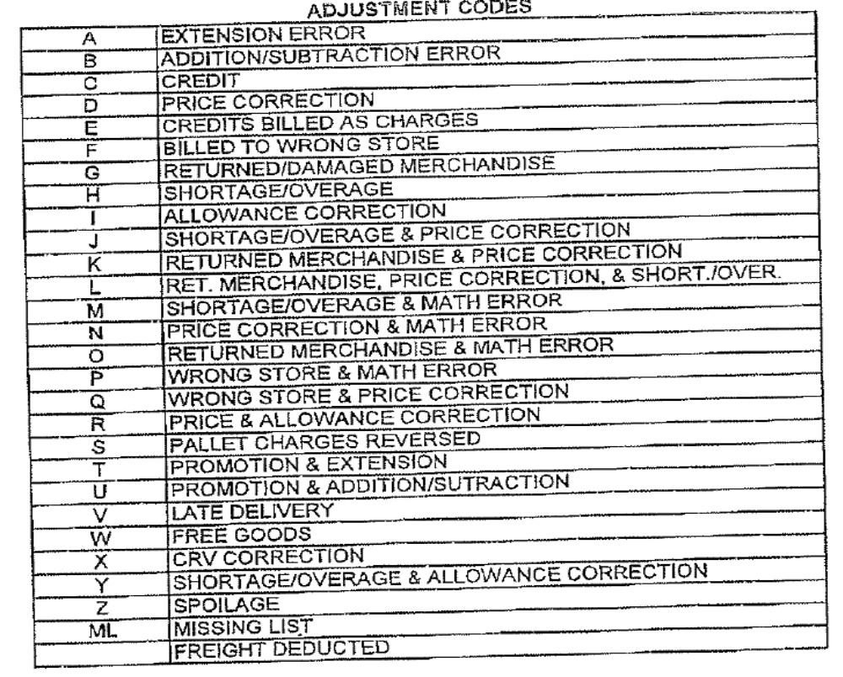

- If the customer reference number on the claim ends in a ‘K’ this is a PO-related claim. The PO/client order invoice record can be found in ACOSTA Relay searching under Orders/Invoices/PO and using the customer reference number without the K.

- If Customer Invoice is not found for PO Related claims, including Off Invoice, Billback, Pricing and Cash Discount, attempt to back in before requesting backup from the customer. See Backup Retrieval section for flat amounts between $125 & $800.

- Check remits that shows a code of “Z” indicates spoilage.

- AD or A/D notations on customer invoice callout:
Customer will raise the gross amount on their invoices to account for “in and out/freight charges” and is indicated with a code of AD or A/D on the invoices. This code indicates indicate that this is for their internal records and the net amount is never affected. These should be stepped as Non-Trade/Other.

- AMG Invoices:
AMG will send invoices for fees and these will need to be escalated to Acosta for research. These types of claims will be at the client’s discretion on how to handle the check request/deduction.

AMG Invoice showing Labor charges:
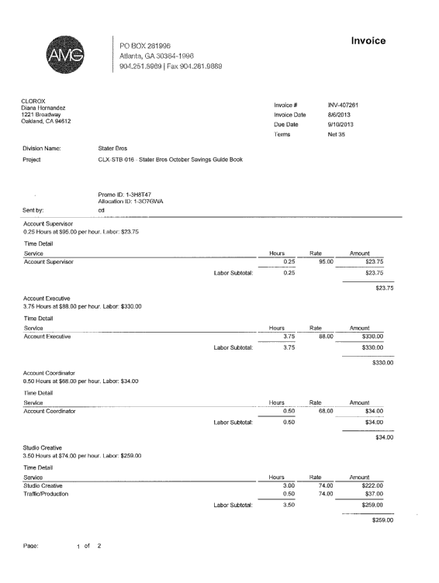
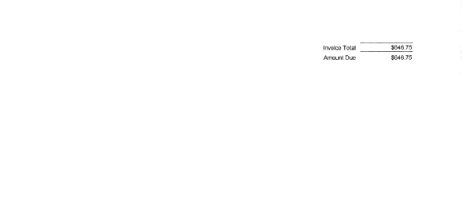

Copy of Ad that AMG submitted with this invoice example.
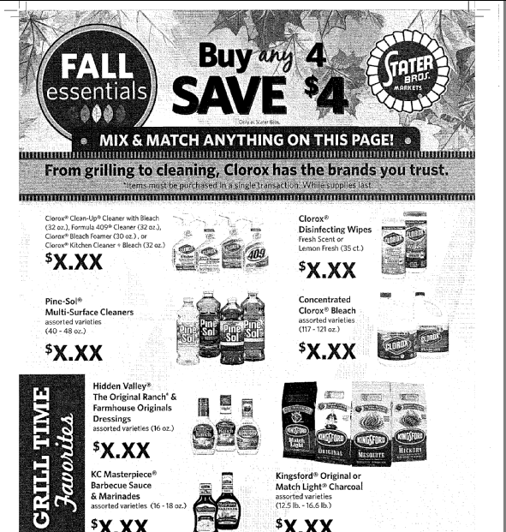

- If customer invoice says “Market Centre” deduction for Stater Bros or Stater Bros Scan, a Stater Bros contract can be used.

Contract Info:

When working some non-food accounts for Off Invoice, Billback and Warehouse Withdrawal allowances, the customer invoice allowance may not match the contract. The allowance per case may be broken down into inner packs per case.

For example: contract offer is for $12.00 per case. The claim comes in at $4.00 as the inner packs are 4/3 or 3/4 ($12 per case / 3 units per case = $4 x 3 inner packs = $12.00).

POP Info:

When a contract references an ad and no ad money is offered on the contract, it is at Stater Bros’ discretion on whether an ad will be run. Search for an ad for the timeframe shown on the contract; if no ad is found, do not escalate for POP.

BACKUP RETRIEVAL INFORMATION

GENERAL BACKUP RETRIEVAL INFORMATION

Is GCIT responsible for obtaining backup from the customer? Yes
- If yes, is there a customer portal? No
- If yes, does GCIT request backup? Yes

Is check remittance information required to request backup? Yes

- For PO related claims refer to Customer General Information section.
  - If stepping for backup request, note the claim “request PO related backup.”
- For PO related claims that are a flat lump sum between $125 & $800, the claim is for a late/no show/missed appointment and backup is sent to the client. If the client does not have the backup and requires it, note the claim “request from Sherry” when stepping to GCIT.

Hostess
- With the exception of B & C invoices, backup is requested from the client.

GCIT SPECIFIC BACKUP RETRIEVAL INFORMATION

Automated

Customer Invoice or Note Identifier | Request From
D | staterbros.audit@prgx.com
G | staterbros.audit@prgx.com

Non – Automated:

Customer Invoice or Note Identifier | Request From
C invoices that are $480 | michele.whitney@staterbros.com
B and C invoices for all other amounts (not PO-related) | couponclaim@staterbros.com, cc jdebellis@acosta.com and bbrockmeier@acosta.com
Claim is noted to request PO related backup | AccountsPayable@Staterbros.com.
Claim is noted to request from Sherry | Sherry.mohn@staterbros.com
All other formats | Request from sales

CLIENT SPECIFIC VALIDATION INFORMATION

Client
BarillaWasa
Bush
Campbell’s
Coca Cola
Dole
Edgewell
glmezzetta
Kens
MARS Food
Perfetti
Tata Tetley Eight O Clock Good Earth

Barilla Wasa

- Customer receives a swell allowance via Off Invoice. Spoils/Unsaleables are considered invald.

Bush

- Customer receives a swell allowance via Off Invoice. Spoils/Unsaleables are considered invald.

CAMPBELL’S

- Check requests for Campbell's Meals & Beverages should be processed under Customer #1000009205, SAP shows physical and mailing address.

Coca-Cola

- Client approval received to validate scan and count/recount deductions without POP if ad copy cannot be located when the specific performance name mentions Feature or Ad. If no ad found, note the claim and proceed with validation.

- If customer is deducting for a spoils allowance it will be noted on the invoice as indicated below. The spoils allowance must be listed on a separate claim line and stepped as Non-Trade – Damages/Unsaleables – Awaiting Processing by CCA with a line note that says “this claim line is for a swell allowance”.

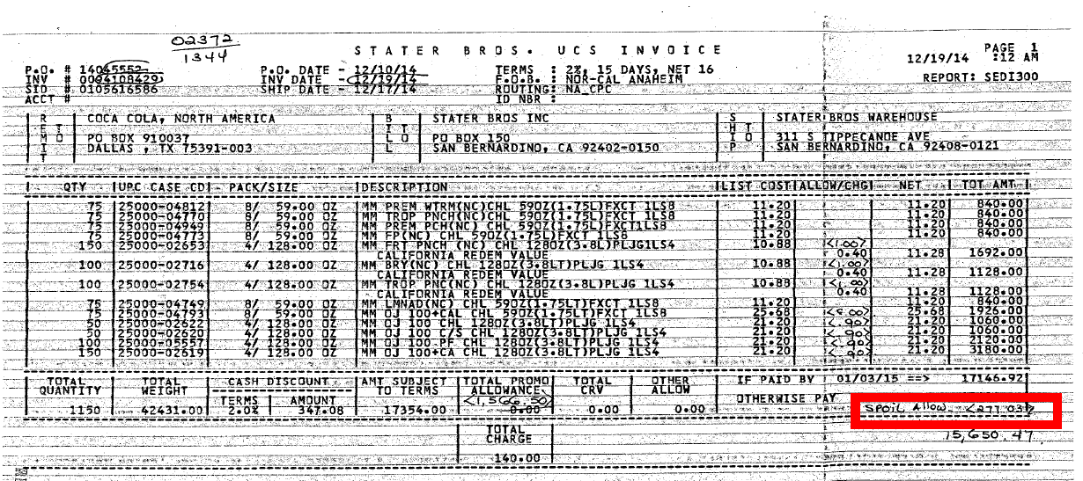

DOLE
- Repositrak fees are considered Trade and require a client event #.

EDGEWELL

- Repositrak fees are considered Trade and require a client event #.

GL MEZZETTA

- Spoilage/damage allowance for this client is 0.75% on net. Customer does not provide deduction backup for Swell Allowance to validate the claim. Deductions for spoils are cleared by client and claims are to be stepped as Non-Trade / Damages and Math notes must be shown (net * .75% = $ )

Horizon
- Stater Brothers charges a $500.00 fee for "no shows" and $300.00 fee for purchase orders received at 85% or less of the original quantity written and without notice of shortage in writing, the fine/fee will be $300.00. For both of these fee's we will clearing using client event numbers. For claims deducted in 2024 2nd quarter use event number, 24TTP03JI3, for claims with claim date of 3rd quarter use event number 24TTP03JI4. The fees are listed on the EDI check remittance.

Kens

- Spoilage/damage allowance for this client is 1% on net. Deductions for spoilage/damages are cleared by client and claims are to be stepped as Non-Trade / Damages and Math notes must be shown
(net * 1% = $ )

MARS FOODs

- Claims for Repositrak Fee need to be coded as Trade Other and stepped to Sales for Event Number

Perfetti

- Spoilage/damage allowance for this client is 0.744% on net. Customer does not provide a deduction invoice for Swell Allowance to validate the claim.

TATA TETLEY EIGHT O CLOCK GOOD EARTH

- Stater Bros is allowed a date extension of a total of 2 weeks before and/or after the contract dates.

PROCESS STEPS

1. Deduction Type: Off Invoice

A per case off invoice allowance is given to the customer as an automatic discount for product purchased from the client. If the customer does not receive the allowance off the face of the invoice they will deduct for it. If the customer requested an allowance that is not valid, the CSC will send a notification to the customer in writing. Customers view purchase orders as contracts. If they are not notified of allowance discrepancies, they will pay according to their purchase order total.

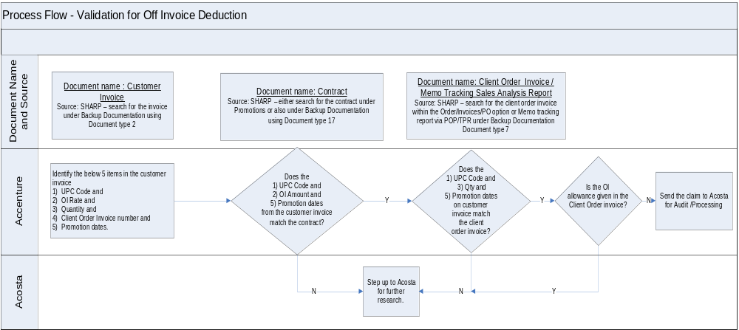

When working some non-food accounts for Off Invoice, Billback and Warehouse Withdrawal allowances, the customer invoice allowance may not match the contract. The allowance per case may be broken down into inner packs per case.

For example: contract offer is for $12.00 per case. The claim comes in at $4.00 as the inner packs are 4/3 or 3/4 ($12 per case / 3 units per case = $4 x 3 inner packs = $12.00).

  - Customer Invoice for Off Invoice:

i
i
PO Number – This will be used to search for information regarding the order within ACOSTA Relay. This data is needed to validate if the particular product was ordered and invoiced with the off invoice allowance.
Eg: In this case the PO # is 11028185.
This is the Client Order Invoice number. This would be used to retrieve the Client Order Invoice from the Review Order/view document link within ACOSTA Relay. Also, this needs to be matched with the Client order invoice.
In this case the invoice number is 91448857.
This must be pulled first to determine the rate per case OI allowance.

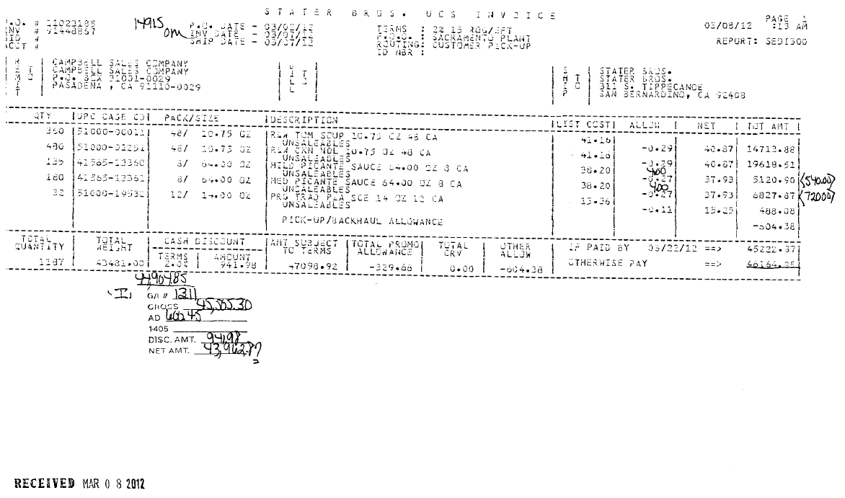
1
2
5
UPC Code – The Universal Product Code (UPC) is 5 digits from the last number.
This code is used to validate key data elements regarding the customer invoice and client order invoice on the Review Order/view document link within ACOSTA Relay. This is the product in which the customer is stating that there is an off invoice allowance.
Eg: In this case the UPC is the one highlighted in red 141565-13360.

OI Rate – This is the rate per case the customer is claiming for the Off Invoice allowance amount. This amount should match with the contract to validate a claim.

The Invoice/Ship date listed should fall within the contract arrival dates.

  - Customer Contract for Off-Invoice:
When reviewing Stater Bros. contracts under Promotions on the ACOSTA Relay Search Screen, open the contract file full screen to ensure you can see all tabs at the bottom of the screen. More than one tab represents multiple pages of the contract.
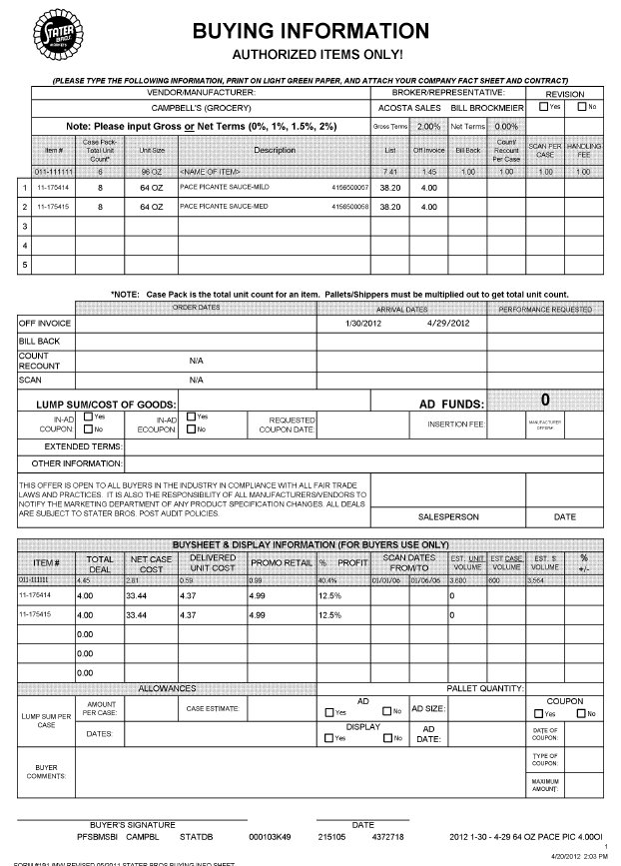
2
5
i
OI Rate – This is the rate per case for Off Invoice allowance amount. This amount should match with the Customer Invoice to validate a claim.

Arrival start and end dates –– The Invoice date on the Customer Invoice/ Client Order Invoice should fall within these dates for the claim to be valid.

Item description – This is the product description for which the customer is claiming the Off Invoice allowance. This description should match the Client Order Invoice.

1.3 Proof of Performance: Refer to the Client SOPs/Generic Help File for POP requirements
2. Deduction Type: Bill Back

A Bill Back claim is a per case allowance offered for a specific performance requirement. A per case billback allowance is claimed by the direct buying customer for product purchased from the client, or by the indirect customer for product purchased from the direct customer. This is an allowance the customer will bill the client for. This is not an automatic discount given off the face of the invoice.

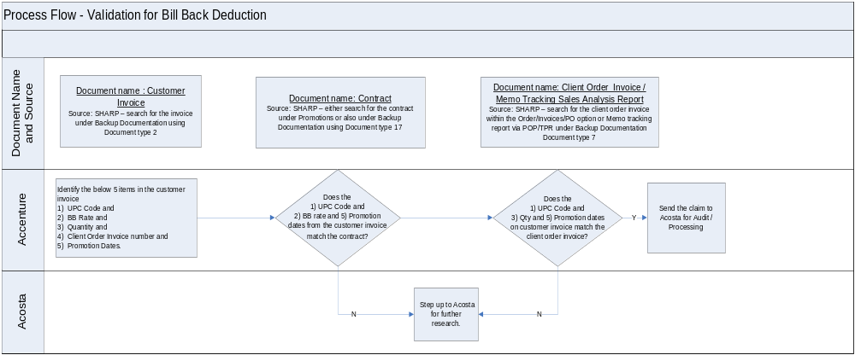

When working some non-food accounts for Off Invoice, Billback and Warehouse Withdrawal allowances, the customer invoice allowance may not match the contract. The allowance per case may be broken down into inner packs per case.

For example: contract offer is for $12.00 per case. The claim comes in at $4.00 as the inner packs are 4/3 or 3/4 ($12 per case / 3 units per case = $4 x 3 inner packs = $12.00).

i
CLaim Number –This is the customer invoice number can be used to retrieve the Customer Invoice from the backup documentation within ACOSTA Relay.
2.1 Customer Invoice for Bill Back:

.

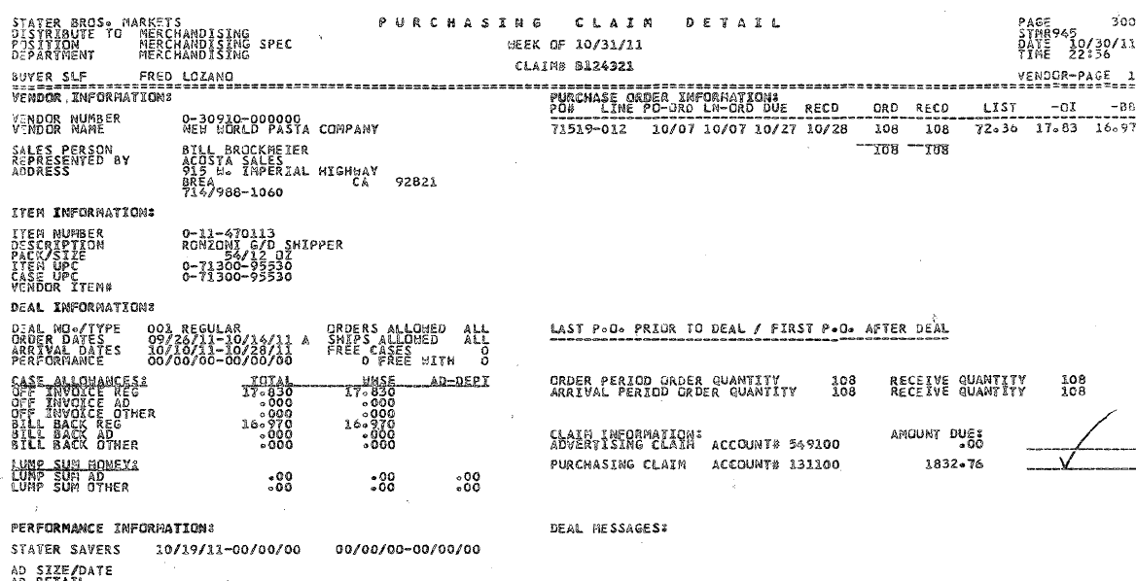
i
3
5
2
Customer Item Number: These are the item numbers for which BB is claimed.
Qty –This is the number of cases purchased by the Customer which are part of the Bill Back allowance.

Dates – The dates mentioned in on the customer invoice should fall within the arrival/ship dates in on the contract.
BB Rate– This is the rate per case BB allowance amount which the customer has deducted as part of Bill Back allowance.
Mfr Item/Case UPC– The Universal Product Code (UPC) is the last 5 digits.
e.g: - Here the UPC is the one highlighted in red 95530

i
Amount Due – represents the total amount claimed for this item only.
e.g. 108 cs x 16.97 = $1832.76
1

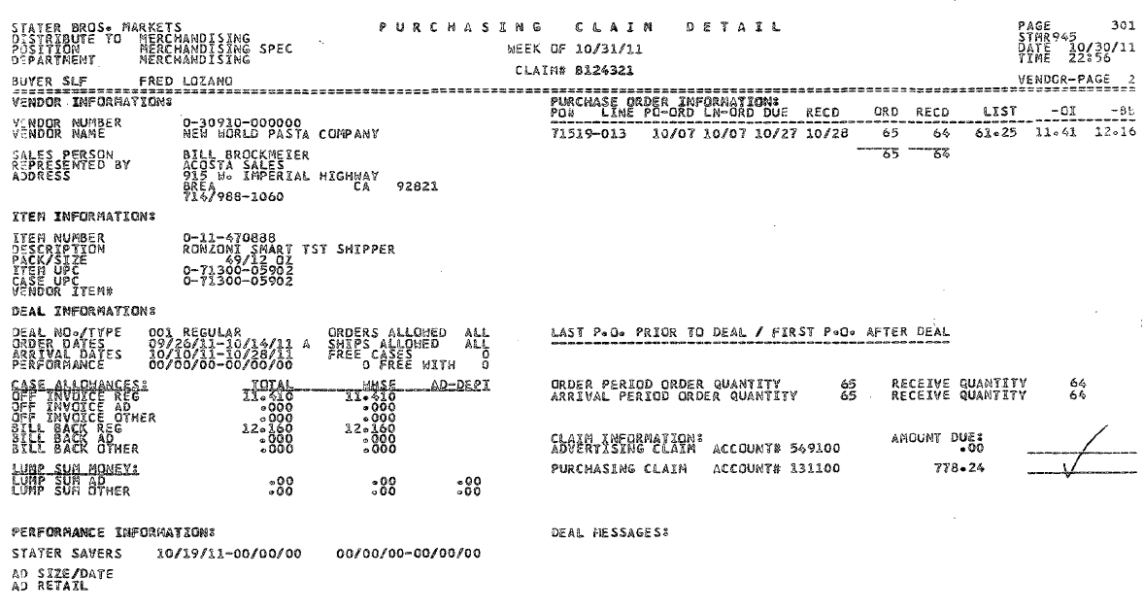
i
i
2
3
5
Customer Item Number: These are the item numbers for which BB is claimed.
CLaim Number –This is the customer invoice number that can be used to retrieve the Customer Invoice from backup documentation within ACOSTA Relay.
BB Rate– This is the rate per case BB allowance amount which the customer has deducted as part of Bill Back allowance.
Mfr Item/Case UPC– The Universal Product Code (UPC) is the last 5 digits.
E.g: - Here the UPC is the one highlighted in red 05902

Qty –This is the number of cases purchased by the Customer which are part of the Bill Back allowance.

Arrival Dates – The dates mentioned in on the customer invoice should fall within the arrival/ship dates in on the contract.

Amount Due – represents the total amount claimed for this item only.
e.g. 64 cs x $12.16 = $778.24
1

i
CLaim Number –This is the customer invoice number that can be used to retrieve the Customer Invoice from the backup documentation within ACOSTA Relay. The number should match the detail pages.

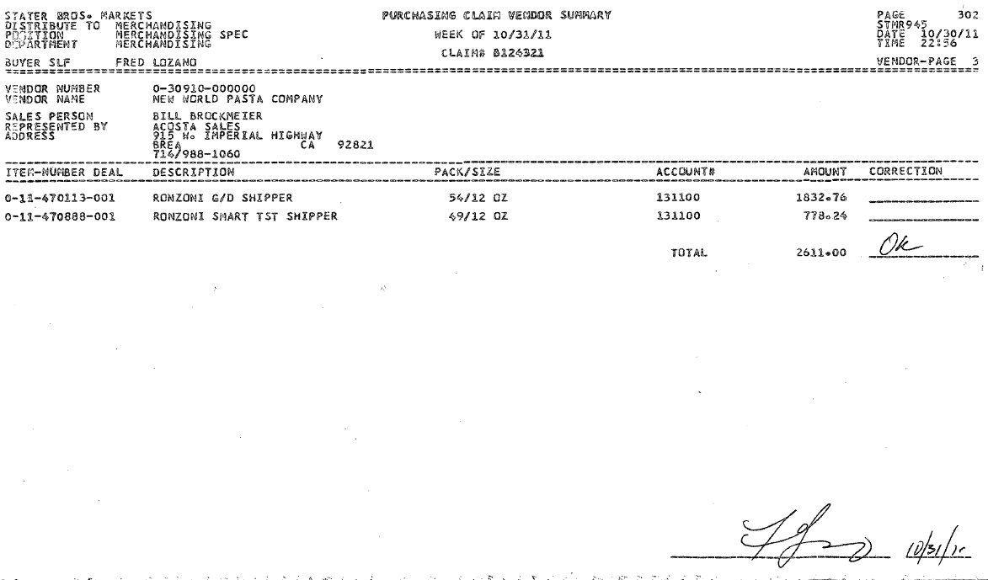
i
1
i
Customer Item Number: This is the Stater Bros. product item number for which BB is claimed.
Product Description– This is the product the customer is claiming the BB allowance. The product description mentioned on the customer invoice should be matched to the contract and memo tracking sales analysis report.
Total – this represents the total amount claimed by the customer for all items listed. There should be a detail page for each item listed on the summary page. The claim cannot be validated without the detail pages.

Stater Bros claims cannot be validated using just the summary page. You MUST have the detail pages that represent each item listed above as part of the document in order to validate the claim.

If all you have are the detail pages continue the validation process.

2.2 Customer Contract for Bill Back:

When reviewing Stater Bros. contracts under Promotions on the ACOSTA Relay Search Screen, open the contract file full screen to ensure you can see all tabs at the bottom of the screen. More than one tab represents multiple pages of the contract.
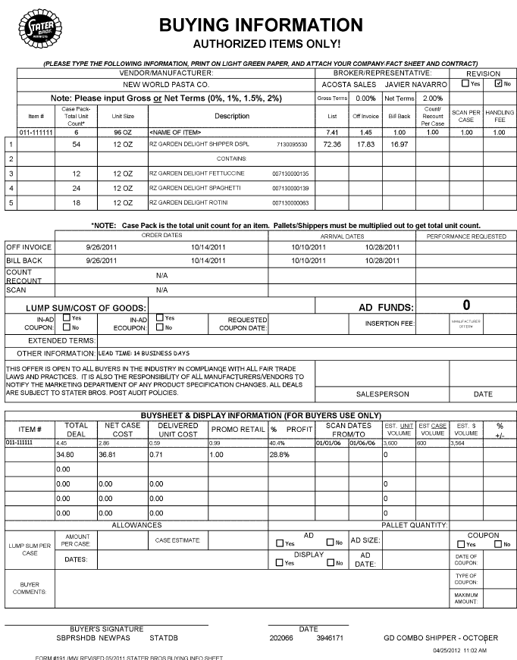
5
2
1
Order Arrival dates – This is the performance start and end dates. The period dates listed on the customer invoice should fall within the performance dates mentioned on in the contract.
Bill Back – This is the rate per case Bill Back allowance amount. This amount should match with the Customer Invoice.

UPC - The Universal Product Code (UPC) is the last 5 digits.
E.g. 95530
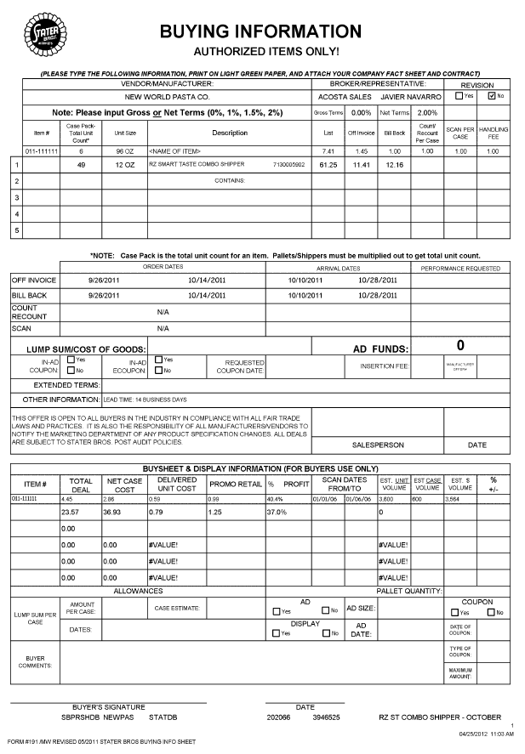
1
5
2
UPC - The Universal Product Code (UPC) is the last 5 digits
E.g. 05902
Arrival/Ship – This is the performance start and end dates. The period dates listed on the customer invoice should fall within the performance dates mentioned on in the contract.
Bill Back – This is the rate per case Bill Back allowance amount. This amount should match with the Customer Invoice.

2.3 Proof of Performance: Refer to the Client SOPs/Generic Help File for POP requirements

3. Deduction Type: Warehouse Withdrawal (Count/Recount/WHSE MOVE)

Warehouse Withdrawal/Count Recount is for cases shipped to stores from the main customer’s warehouse.

Scan allowances are for product scanned at the store register and are usually billed in eaches not cases.
The customer should not be referencing a purchase order number when deducting for a Scan allowance.

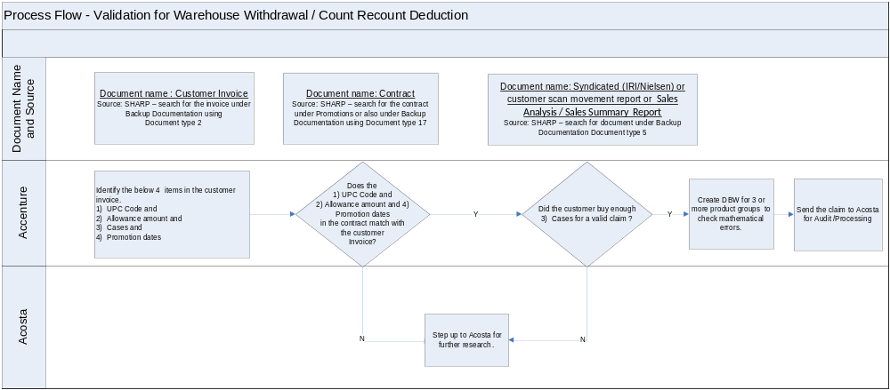

When working some non-food accounts for Off Invoice, Billback and Warehouse Withdrawal allowances, the customer invoice allowance may not match the contract. The allowance per case may be broken down into inner packs per case.

For example: contract offer is for $12.00 per case. The claim comes in at $4.00 as the inner packs are 4/3 or 3/4 ($12 per case / 3 units per case = $4 x 3 inner packs = $12.00).

3.1 Customer Invoice for Warehouse Withdrawal:

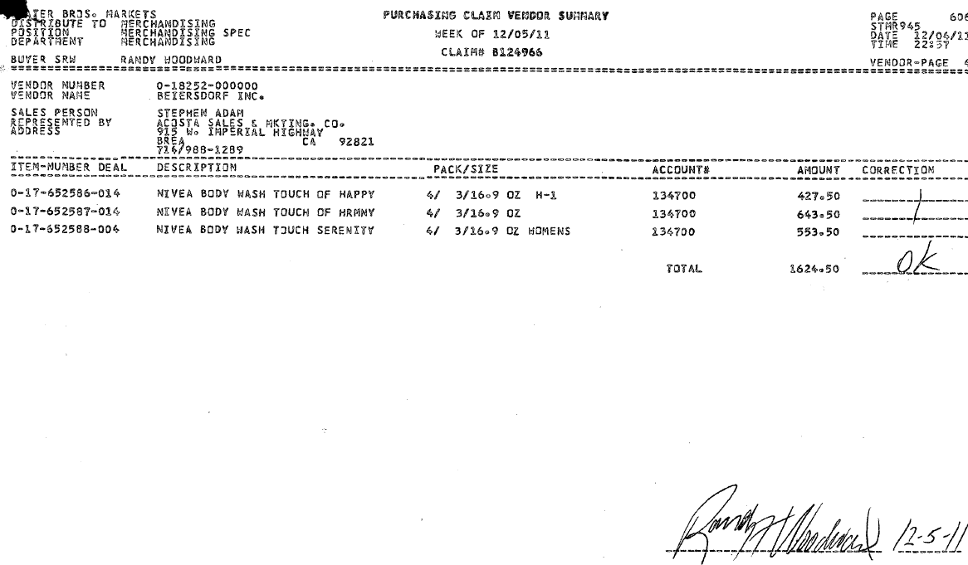
i
i
Claim Number –This number can be used to retrieve Customer Invoice from the backup documentation within ACOSTA Relay.

Total claim amount for all 3 items listed.

Stater Bros claims cannot be validated using just the summary page. You MUST have the detail pages that represent each item listed above as part of the document in order to validate the claim.

If all you have are the detail pages continue the validation process.

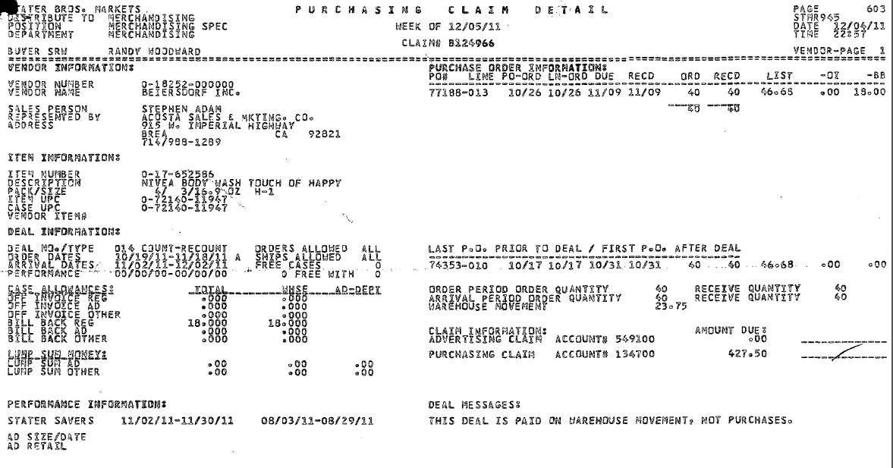
1
i
3
i
ITEM/Case UPC: This has UPC code details, which needs to be matched with the contract.
In this case the numbers highlighted in red is the UPC 11947.

Arrival Date – These invoice dates should fall within the dates on the contract.
.
Item Number: This is the product item number for which Warehouse Withdrawal Allowance is claimed.
Qty – This is the total quantity claimed by the customer for the Warehouse Withdrawal allowance.
Billback Regular – this represents the allowance rate taken by the customer for the per case Warehouse Withdrawal allowance. Note, the deal messages explain the type of allowance. E.g. This deal is paid on warehouse movement
Total amount claimed for this item only
e.g. 23.75 cs x $18.00 = $427.50

Claim Number –This number can be used to retrieve Customer Invoice from the backup documentation within ACOSTA Relay.

4

i
2

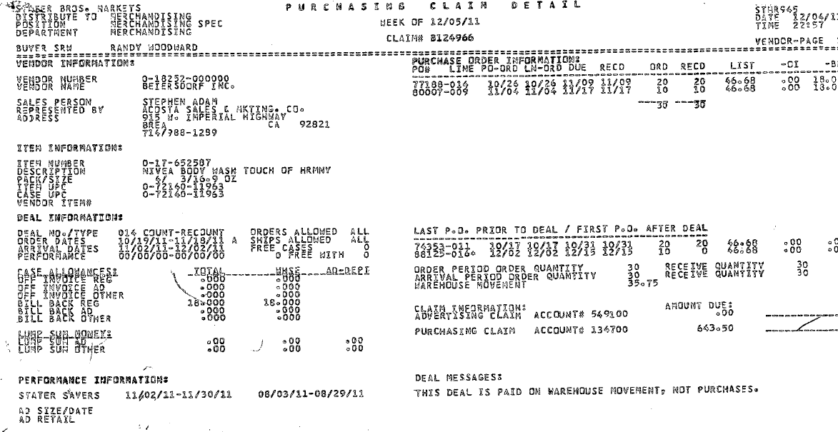
1
i
3
ITEM/Case UPC: This has UPC code details, which needs to be matched with the contract.
In this case the numbers highlighted in red is the UPC 11963.

Arrival Date – These invoice dates should fall within the dates on the contract.

Item Number: This is the product item number for which Warehouse Withdrawal Allowance is claimed.
Qty – This is the total quantity claimed by the customer for the Warehouse Withdrawal allowance.
Billback Regular – this represents the allowance rate taken by the customer for the per case Warehouse Withdrawal allowance. Note, the deal messages explain the type of allowance. E.g. This deal is paid on warehouse movement
Total amount claimed for this item only
e.g. 35.75 cs x $18.00 = $643.50

Claim Number –This number can be used to retrieve Customer Invoice from the backup documentation within ACOSTA Relay.

4
i

2

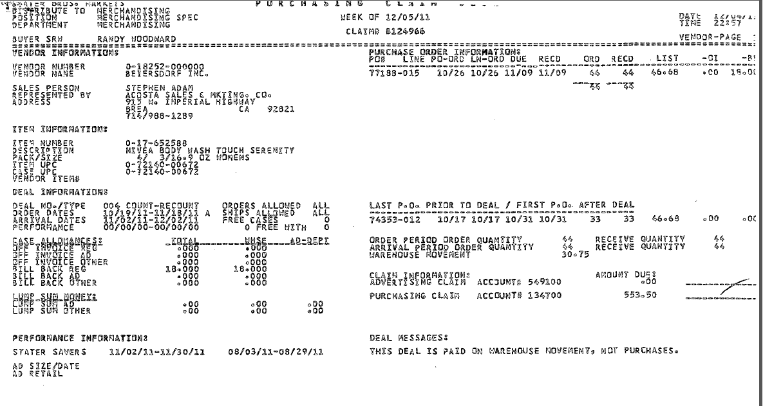
1
4
i
3
i
ITEM/Case UPC: This has UPC code details, which needs to be matched with the contract.
In this case the numbers highlighted in red is the UPC 00672.

Arrival Date – These invoice dates should fall within the dates on the contract.

Item Number: This is the product item number for which Warehouse Withdrawal Allowance is claimed.

Qty – This is the total quantity claimed by the customer for the Warehouse Withdrawal allowance.

Claim Number –This number can be used to retrieve Customer Invoice from the backup documentation within ACOSTA Relay.

Billback Regular – this represents the allowance rate taken by the customer for the per case Warehouse Withdrawal allowance. Note, the deal messages explain the type of allowance. E.g. This deal is paid on warehouse movement
Total amount claimed for this item only
e.g. 30.75 cs x$18.00 = $553.50

i
2

3.2 Customer Contract for Warehouse Withdrawal: When reviewing Stater Bros. contracts under Promotions on the ACOSTA Relay Search Screen, open the contract file full screen to ensure you can see all tabs at the bottom of the screen. More than one tab represents multiple pages of the contract.
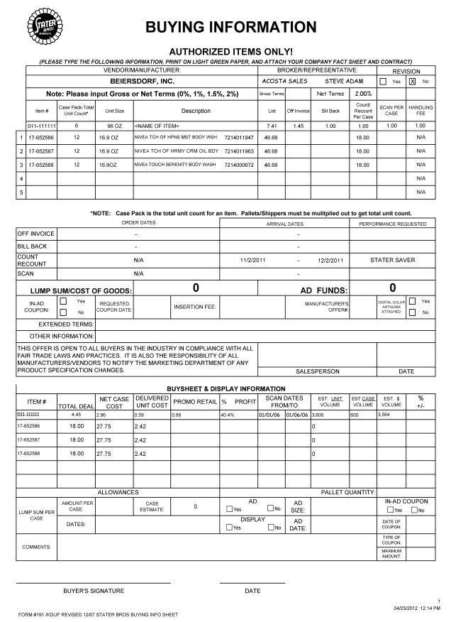
4
1
2
Arrival Date – The arrival dates on the customer invoice should fall between these dates.

UPC Case Code: This has UPC code details, which needs to be matched with customer invoice and Client Order Invoice.
Eg: In this case the UPC is 11947.

This area provides the rate per case for the Warehouse Withdrawal allowance.
3.3 Proof of Performance: Refer to the Client SOPs/Generic Help File for POP requirements

3.1 Customer Invoice for Warehouse Withdrawal

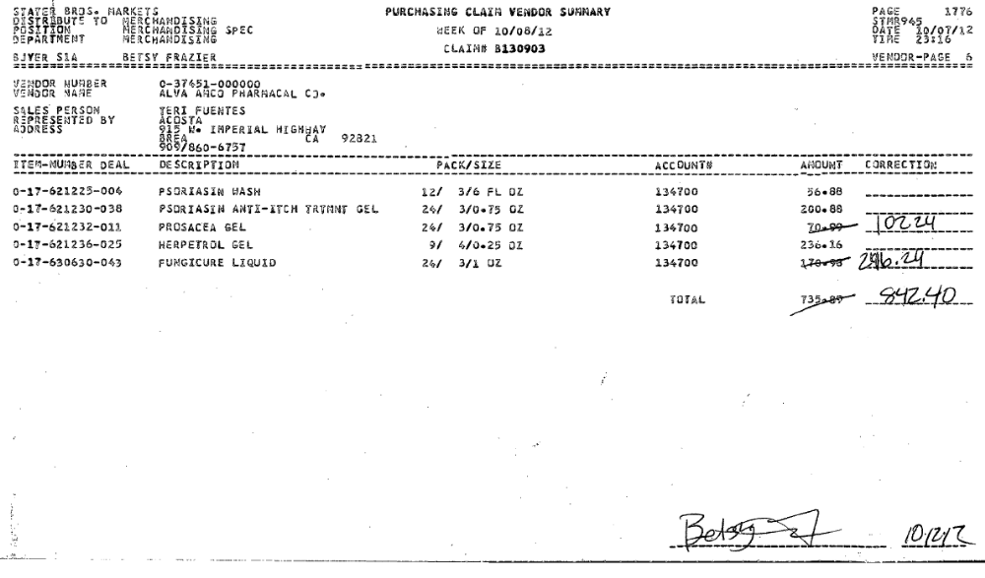
i
i
Claim Number –This number can be used to retrieve Customer Invoice from the backup documentation within ACOSTA Relay.

Total claim amount for all 5 items listed.

Stater Bros claims cannot be validated using just the summary page. You MUST have the detail pages that represent each item listed above as part of the document in order to validate the claim.

If all you have are the detail pages continue the validation process.

Page 2 Customer Invoice
i
Claim Number –This number can be used to retrieve Customer Invoice from the backup documentation within ACOSTA Relay.

Item Number & Description: This is the product item number and product description for which Warehouse Withdrawal Allowance is claimed.

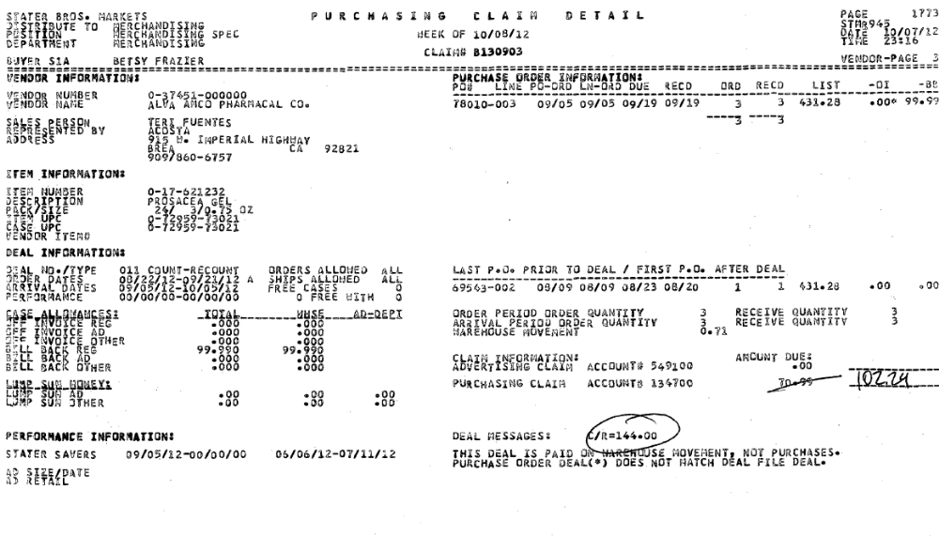
i
1
3
Case UPC: This has UPC code details, which needs to be matched with the contract.
In this case the numbers highlighted in red is the UPC 73021.

Qty – This is the total quantity claimed by the customer for the Warehouse Withdrawal allowance.

Arrival Date – These arrival dates should fall within the dates that are listed on the contract.

Total amount claimed for this item only
e.g.
.71 cs x $144.00 = $102.24

Billback Regular – this represents the allowance rate taken by the customer for the per case Warehouse Withdrawal allowance. Note, the deal messages explain the type of allowance. E.g. This deal is paid on warehouse movement
4

i
2

When the customer makes a handwritten correction you may find the allowance amount in the bottom right noted as C/R (i.e. C/R=$144.00). Use this allowance to match with the contract.

Just a quick note, the Stater Bros Customer System cannot accept offers greater than $99.99. With that said, any offer greater than $99.99 (allowance amount) will be found in the lower right corner next to the words “Deal Messages”.

3.1 Customer Invoice for Count/Recount – Lump Sum (Trade / Count/Recount/WHSE Movement)

Claim Number –This number can be used to retrieve Customer Invoice from the backup documentation within ACOSTA Relay.

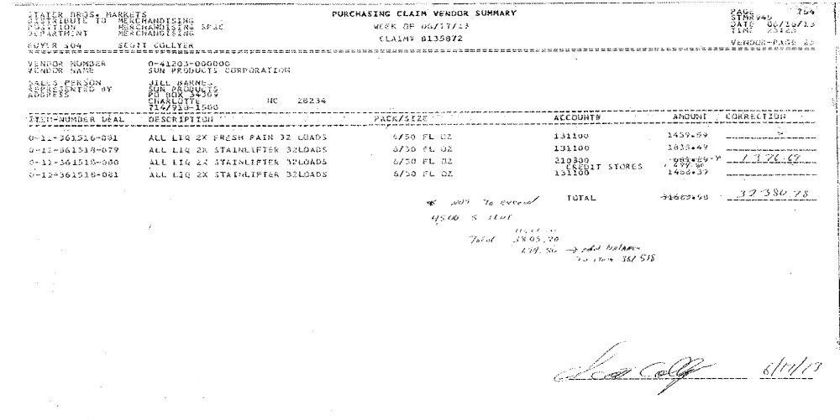
Hand written note indicating the Lump sum claim amount that is being deducted. This example indicates that the lump sum amount is for 5 sku’s.

Additonal page of customer invoice indicating what is covered in the lump sum amount
Claim Number –This number can be used to retrieve Customer Invoice from the backup documentation within ACOSTA Relay.

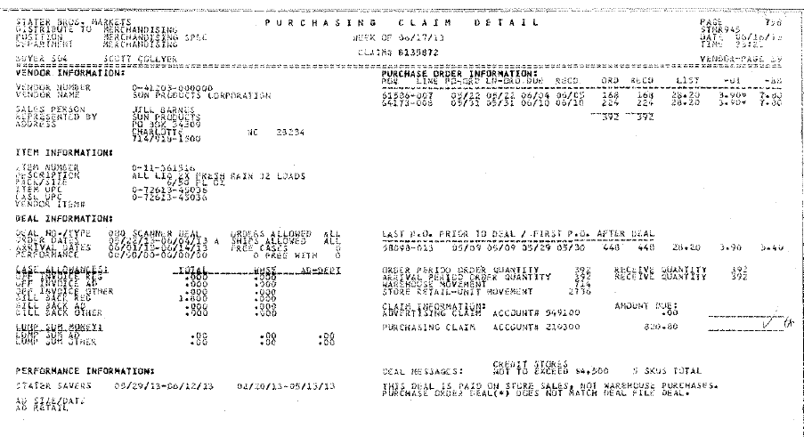
Item Number & Description: This is the product item number and product description for which Warehouse Withdrawal Allowance is claimed.

Case UPC: This has UPC code details, which needs to be matched with the contract.
In this case the numbers highlighted in red is the UPC 45036.

Arrival Date – These arrival dates should fall within the dates that are listed on the contract.

Indicates the lump sum being deducted and a total of 5 SKUs are covered by this lump sum deal.

3.2 Customer Contract for Count/Recount - Lump Sum

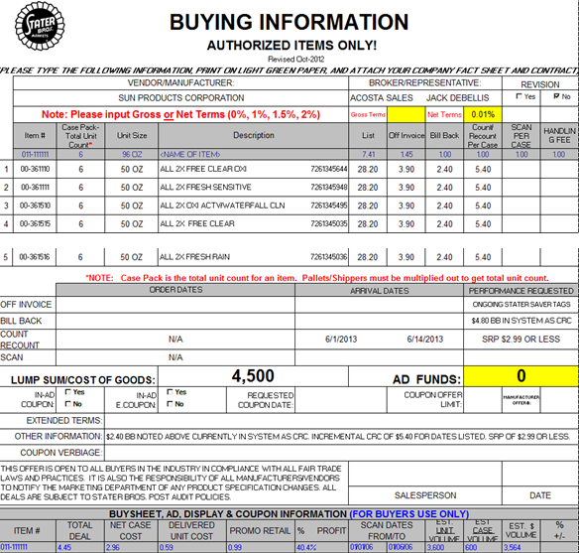
Arrival Dates – The arrival dates on the customer invoice should fall within these dates.

Lump Sum Amount – Amount being offered as a lump sum.
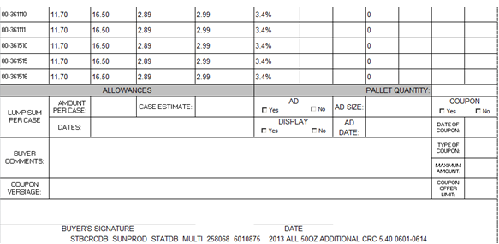

3.3 Proof of Performance: Refer to the Client SOPs/Generic Help File for POP requirements

4 DEDUCTION TYPE: Scan

An allowance for products scanned at the store through the register and is usually billed in eaches, not cases. The customer should not be referencing a purchase order on a scan allowance.
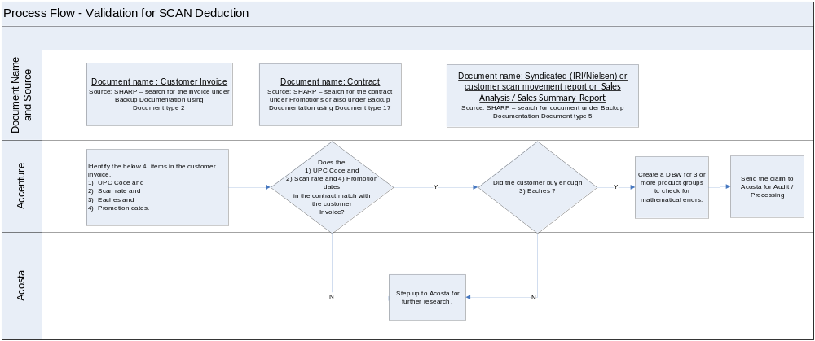

4.1 Customer Invoice for Scan, Example #1

(This page is known as the Summary page)
Claim Number –This number can be used to retrieve Customer Invoice from the backup documentation within ACOSTA Relay.

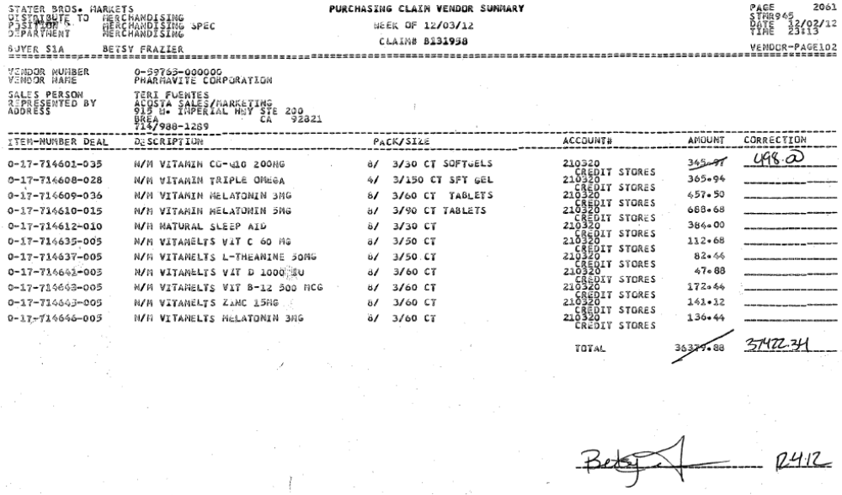
i
i
Total claim amount for all items listed.

Page 2 – Customer Invoice for Scan
(This page is known as an Item Detail page. This page is needed to validate the item within the claim)
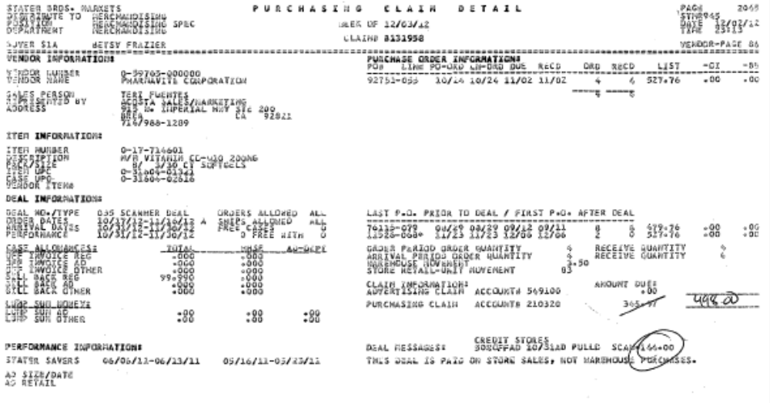
i
i
1
4
i
Claim Number –This number can be used to retrieve Customer Invoice from the backup documentation within ACOSTA Relay.

Item Number & Description: This is the product item number and product description for which the Scan Allowance is claimed.

Case UPC: This has UPC code details, which needs to be matched with the contract.
In this case the numbers highlighted in red is the UPC 02616.

Identification - This represents that the customer is billing for a scan allowance. E.g. This deal is paid on Store sales also known as Scan.
Qty – The store retail unit movement is the total quantity claimed by the customer for the scan allowance.

Arrival Dates – The arrival dates on the customer invoice should fall within the scan performance dates listed on the contract..

2
Rate – This is the cas rate equivalent of the scan offer. Divide the case rate by the cas pack size to get the unit rate for the scan used for validation.
In this example, the case rate is $144. Divided by the case pack size of 24, the unit rate for the scan is $6.00. $6.00 x the store retail unit movement quantity of 83 = $498.
3

Note: When working some non-food accounts for Off Invoice, Billback and Warehouse Withdrawal allowances, the customer invoice allowance may not match the contract. The allowance per case may be broken down into inner packs per case.

For example: contract offer is for $12.00 per case. The claim comes in at $4.00 as the inner packs are 4/3 or 3/4 ($12 per case / 3 units per case = $4 x 3 inner packs = $12.00).
4.2 Customer Contract for Scan

When reviewing Stater Bros. contracts under Promotions on the ACOSTA Relay Search Screen, open the contract file full screen to ensure you can see all tabs at the bottom of the screen. More than one tab represents multiple pages of the contract.
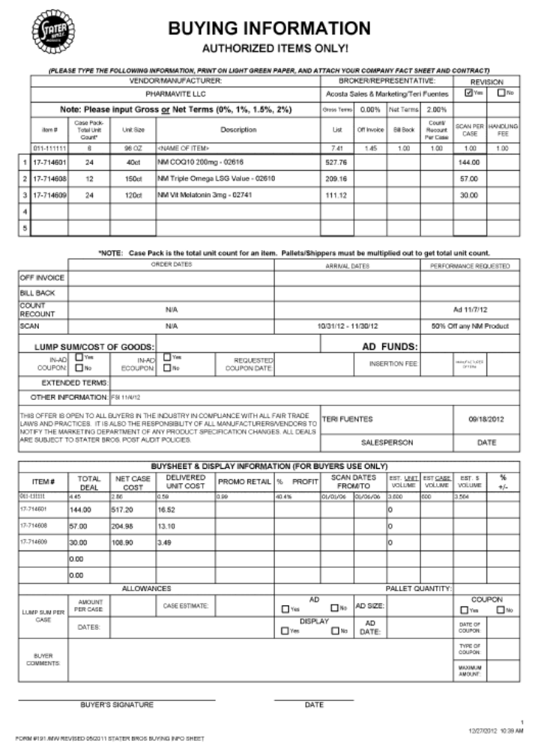
2
4
1
Rate - this represents the case allowance rate offered by the client to the customer for allowance. Divide this rate by the case pack size to get the unit rate offered.
Performance Dates – The performance dates on the customer invoice should fall within these dates.

Case UPC: This has UPC code details, which needs to be matched with the contract.
In this case the numbers highlighted in red is the UPC 02616.

4.3 Proof of Performance: Refer to the Client SOPs/Generic Help File for POP requirements

4.1 Customer Invoice for Scan – Example # 2
(This page is known as the Summary page)
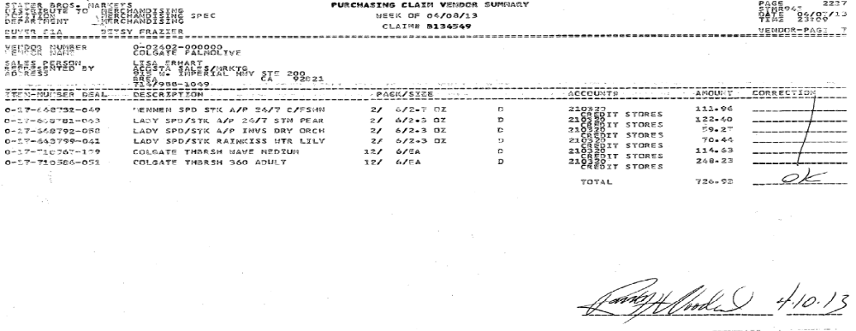
Page 2 – Customer Invoice
(This page is known as an Item Detail page. This page is needed to validate the item within the claim)

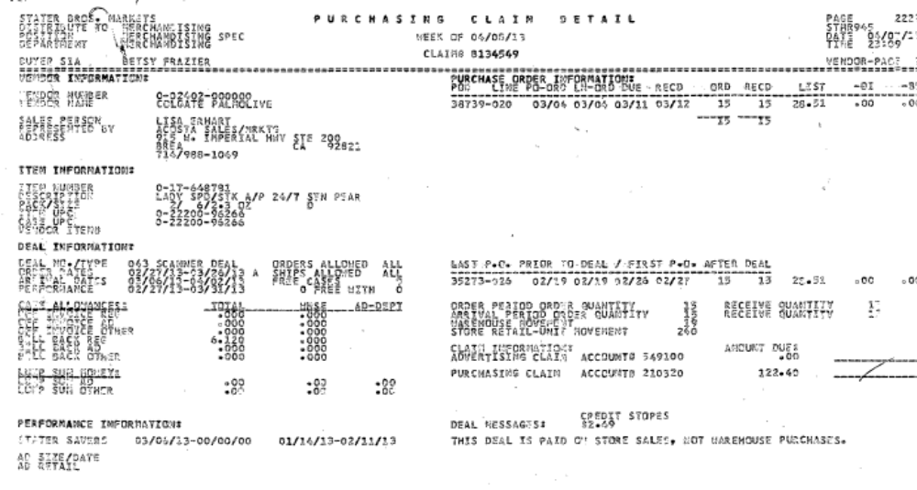
3
2
i
Qty – The store retail unit movement is the total quantity claimed by the customer for the scan allowance.

Rate – In this example, the case rate is listed in the Billback Total column. Divide the BB total ($6.12) by the pack size of 12 (2x6=12) to get the unit rate of $.51. Mulitply the unit rate by the quantity in Store Retail Unit Movement to total the invoice $.51 x 240 units = $122.40.

Total –The invoice total for the item.

The contract will show the scan allowance per case.

4.1 Customer Invoice for Scan (Digital Coupon Scan) Example #3
Claim Number – This can be used to pull the customer invoice from the back-up documentation.

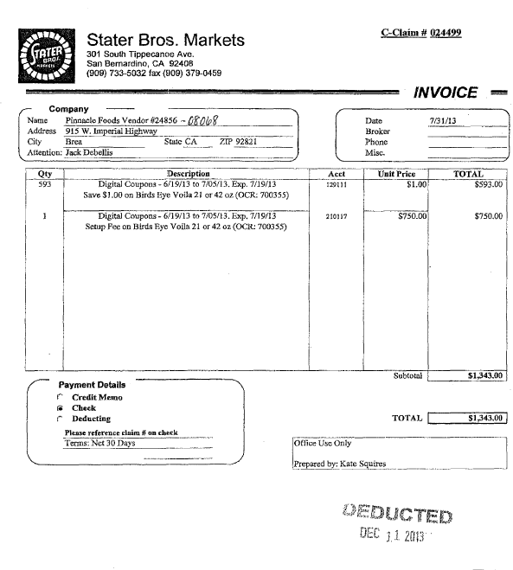
Claim amount –This is amount the customer is claiming.
Scan – this represents the allowance rate taken by customer for the per item scan allowance.
This box shows that customer is deducting for a set-up fee which should match what is on the contract.
Allowance type/Performance Dates/Description of item – Digital Coupon indicates that this is a Scan deduction. This box also lists the Performance Dates and item description with pack sizes that are being deducted .

Note: The words “Digital Coupons” refers to a type of scan and are stepped as Trade / Scans.

4.2 Customer Contract for Scan
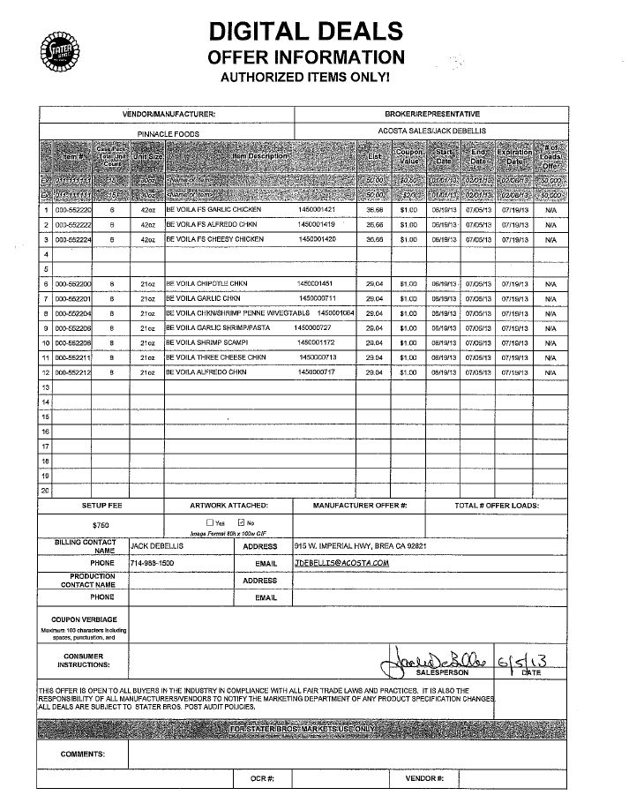
Allowance Rate / Performance Dates - This box indicates the allowance rate per item that was offered to customer. The performance dates on the customer invoice should fall within these dates.
UPC/Pack Size/Item description – this indicates the items and pack sizes available for this deduction.
Set up Fee – this indicates the dollar amount of the set up fee which needs to match what is on the invoice.

4.3 Proof of Performance: Refer to the Client SOPs/Generic Help File for POP requirements

5. Deduction Type: Ad
A fee for featuring a client's products in an advertisement.

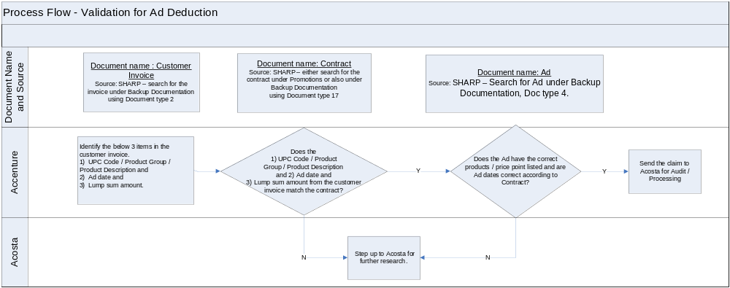

Note - Ad could be taken with other deductions such as Scan/Slotting/BB Etc.

5.1 Customer Invoice for Ad:

i
Claim Number –This number can be used to retrieve Customer Invoice from the backup documentation within ACOSTA Relay.

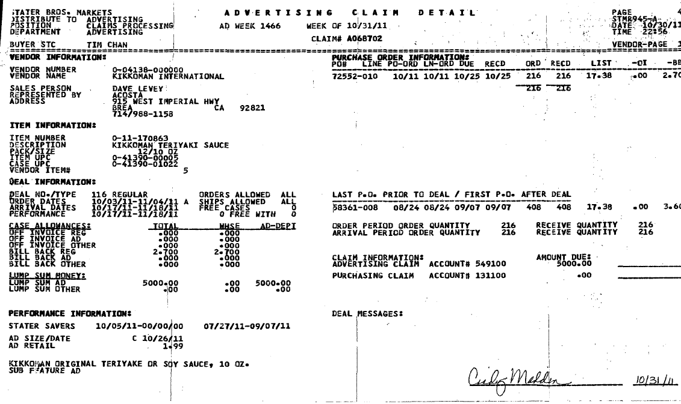
i
1
i
Lump Sum Amount – This area would indicate the Lump Sum Fund approved for the Advertisement of the product.
This amount needs to be matched with the Customer Contract.

Item Numbers: These are product item number for which Ad Allowance is claimed. It has to match with Customer Contract.
UPC Item/Case Code/Product Description: It shows the products which the customer has advertised and for which they are claiming the amount. This needs to be validated with the contract and POP for a valid claim.

Performance/Ad Dates/Product to be advertised.

3

5.2 Customer Contract for Ad:

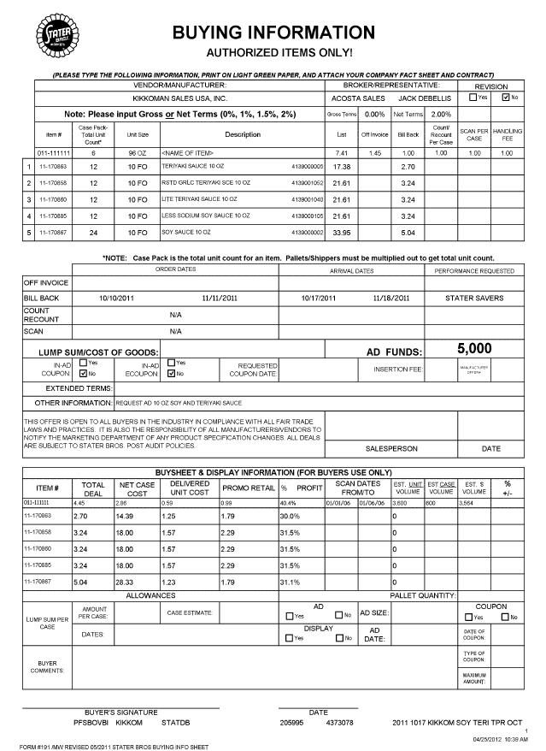
3
2
1
Lump Sum Amount – This area would indicate the Lump Sum Fund approved for the Advertisement of the product.
This amount needs to be matched with the Customer Invoice.

Promotion dates –– The Ad should be run within the dates mentioned on the contract for a valid claim.

UPC and Product Details: This box has UPC code and Product details, which needs to be matched with customer invoice to validate the claim.

5.3 Proof of Performance: Refer to the Client SOPs/Generic Help File for POP requirements. Refer tp the Proof of Performance Reporting Ads job aid for searching for ads.

5.1 Customer Invoice for Ad – ISM Special Bib Labels:
Fee for special labels for Mix & Match Ad coupon redemption and is submitted separately from the other items on the contract. This fee is stepped as Trade/Other

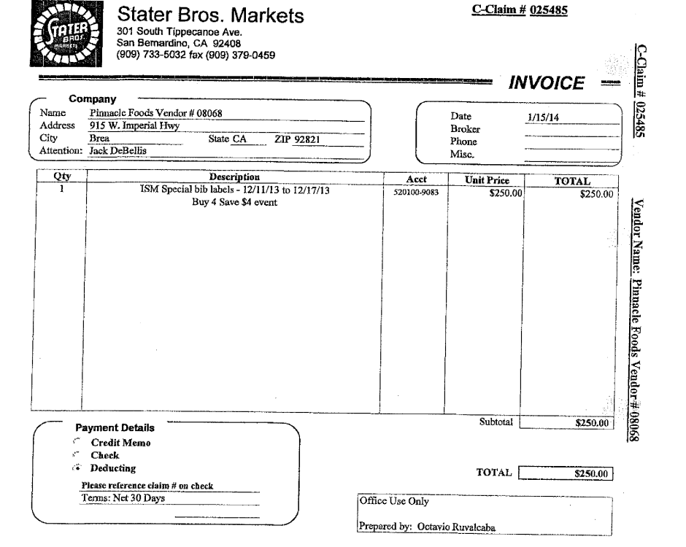
Performance Dates - Date must match the contract.
Lump Sum Amount – Lump Sum Amount approved for the ISM Special bib labels fee. This amount needs to be matched with the Customer Contract.

Note: The ISM invoices will only list a description of the type of deduction and may not include product information. If unable to locate contract, step this as Escalate – Contract Not Found.

5.2 Customer Contract for Ad – ISM Special Bib Labels:
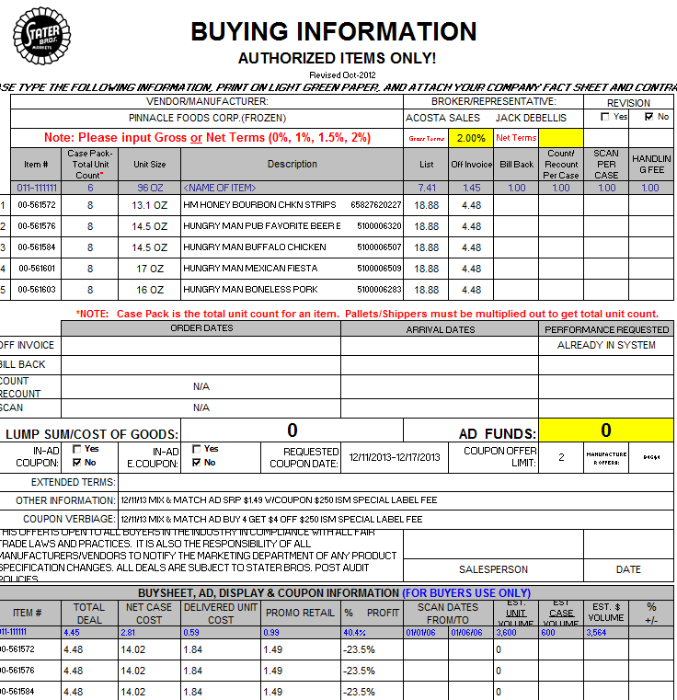
Lump Sum – this area indicates the amount approved for the ISM Special Label Fee and can be listed under Lump Sum/Cost of Goods section or in Other Information on the contract.
Promotion dates –– The Ad should be run within the dates mentioned on the contract for a valid claim.

5.3 Proof of Performance: Proof of Performance: Refer to the Client SOPs/Generic Help File for POP requirements. Refer tp the Proof of Performance Reporting Ads job aid for searching for ads.

6. Deduction Type: Slotting

A Slotting allowance is offered to the customer to purchase an item not currently stocked. It is a kind of promotional money offered to a customer as incentive to buy a new item and create a “slot” for that product on their warehouse storage shelves. It is a Trade Deduction. A slotting lump sum allowance can be offered for each item and/or an off invoice can be offered as an introductory allowance for the first 30 days.

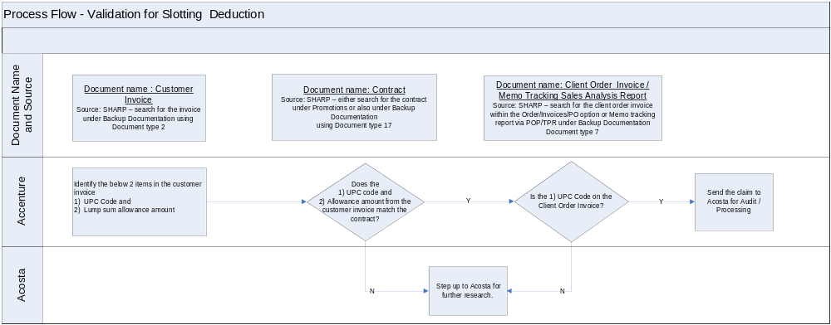

6.1 Customer Invoice for Slotting:

Page 1 – (known as the Summary Page)

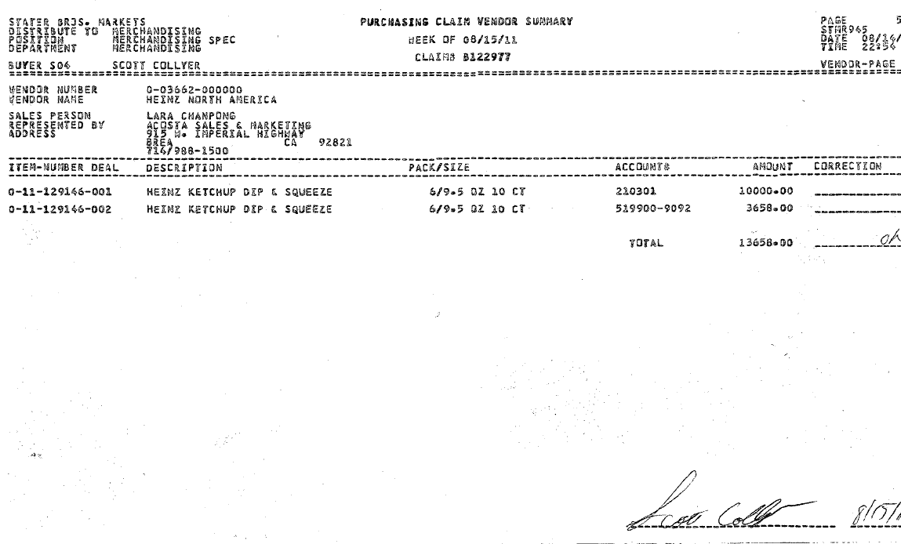
i
2
1
Claim Number – This can be used to pull the customer invoice from the back-up documentation.

Total Claim amount – Slotting deduction amount that customer has claimed for all items listed.

Item Number and Product Description: These are the item #s and should match with the customer contract to validate a claim. This box also shows the description for each product named s and it has to match with the customer contract for a valid claim.

(Known as the Claim Detail Page. These pages are needed in order to validate the claim).

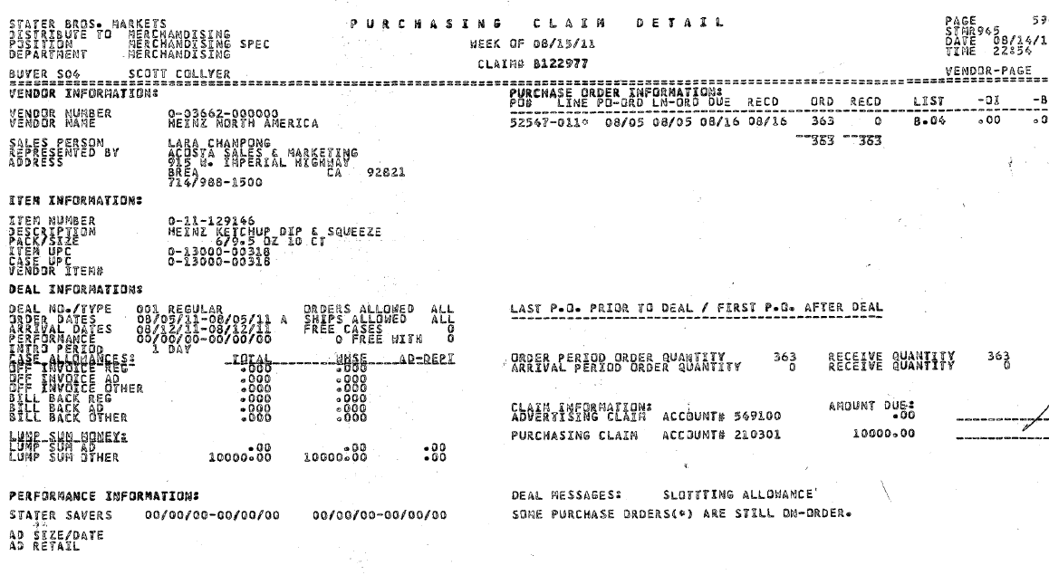
i
1
2
i
Arrival Dates – These dates on the customer invoice should fall within these dates listed on the customer contract.

Claim Number – This can be used to pull the customer invoice from the back-up documentation.

Claim amount – Slotting deduction amount claimed by the customer for this particular item. NOTE: Deal Message which reads “Partial New Item Funds” is considered a slotting allowance

Item Number and Product Description: This is the customer item code # and should match with the customer contract to validate a claim. This box also shows the description for the product and it should also match with the customer contract for a valid claim.
Item/Case UPC – identifies the mfr Item/UPC Case and should match the customer contract & POP.

Purchase information – this will assist in locating the PO# and the Client Order Invoice within ACOSTA Relay.
e.g. PO# 52547 (363 cs received)

i
i

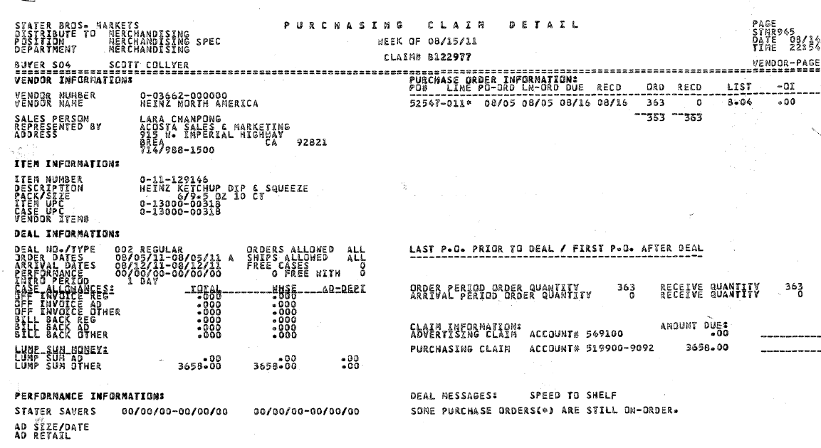
i
1
Arrival Order Dates – These dates on the customer invoice should fall within these dates listed on the customer contract.

Claim Number – This can be used to pull the customer invoice from the back-up documentation.

Item Number and Product Description: These are the item # has to match with the customer contract to validate a claim. This box also show description for the each product names and it has to match with the customer contract for a valid claim.
Claim amount – Slotting deduction amount claimed by the customer for this particular item. Speed To Shelf should be coded as Slotting.

Item/Case UPC – identifies the mfr Item/UPC Case and should match the customer contract & POP.

i
i
2

6.2 Customer Contract for Slotting: Found via: Search For: Promotions, use customer sign-on.
When reviewing Stater Bros. contracts under Promotions on the ACOSTA Relay Search Screen, open the contract file full screen to ensure you can see all tabs at the bottom of the screen. More than one tab represents multiple pages of the contract.

Page-1
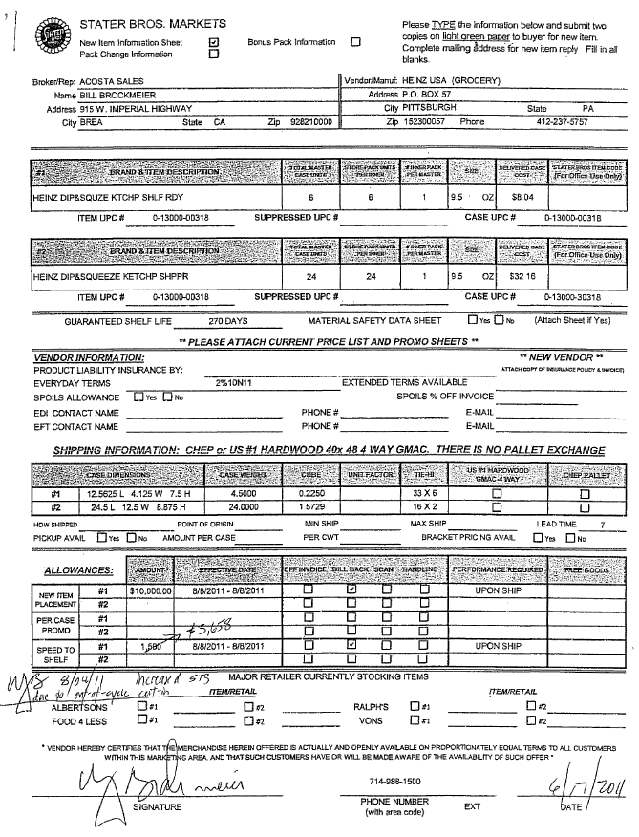
i
1
2
Identification: This helps in identifying the contract as New item Slotting.
Product Details and Item/CaseUPC: This box has Product details and UPC code, which needs to be matched with customer invoice to validate the claim.

New Item Placement/Speed to Shelf – This area would list out the lump sum amount agreed upon for the new item allowance per item.

Page-2
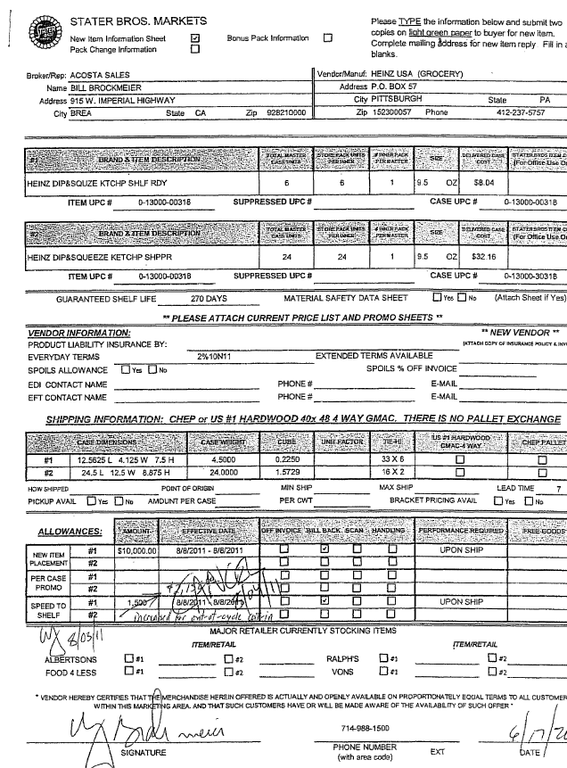
i
1
2
Identification: This helps in identifying the contract as New item Slotting.
Product Details and Item/CaseUPC: This box has Product details and UPC code, which needs to be matched with customer invoice to validate the claim.

New Item Placement/Speed to Shelf – This area would list out the lump sum amount agreed upon for the new item allowance per item.

6.3 Proof of Performance: Refer to the Client SOPs/Generic Help File for POP requirements

7. Deduction Type: Manufacturer Coupon

This is a manufacturer Coupon, typically cleared by client.

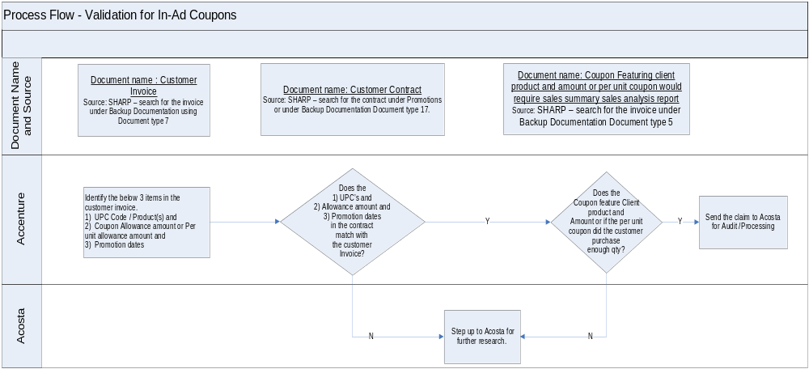

7.1 Customer Invoice of Manufacturer Coupon, Example 1:

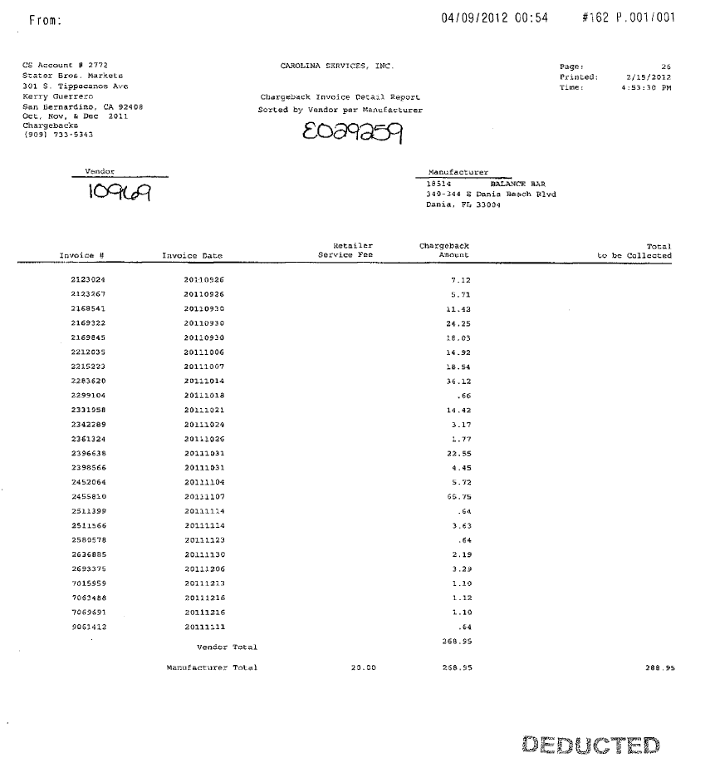
i
i
i
These invoice dates represent the timeframe in which the mfr coupon was charged back.

Manufacturer total – This is the amount the customer has deducted for coupon redemption.
This identifies the document as a claim for Manufacturer coupons.

7.1 Customer Invoice of Manufacturer Coupon, Example 2:

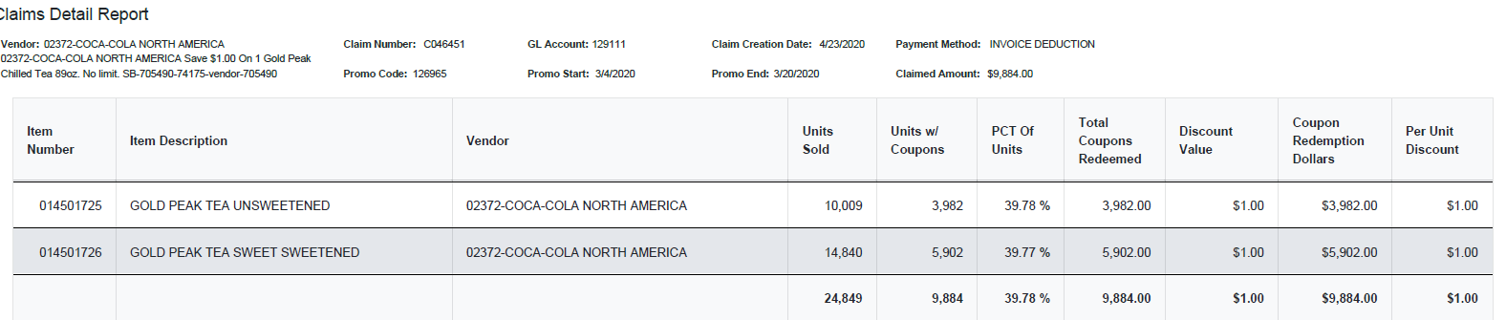
i
Identification: C invoices that are not for ReposiTrak Fees are for manufacturer coupon redemptions..

8. Deduction Type: Displays

A Display deduction is an allowance given on an in-store product display (within a specific agreed section of the store) on an end cap or displayed per the client's requirements.

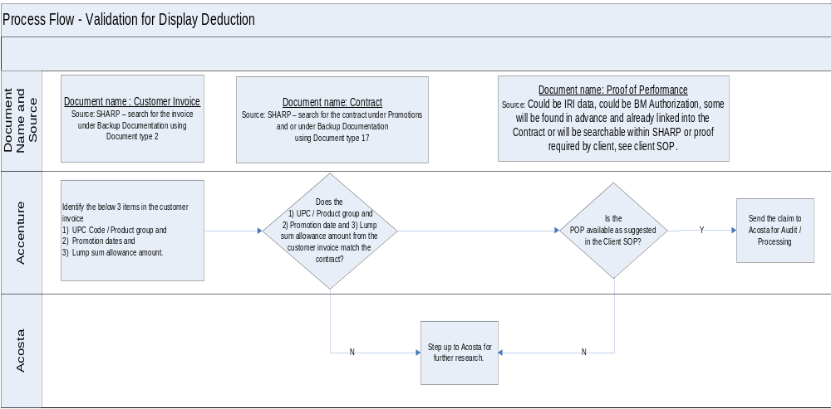

8.1 Customer Invoice for Display:

.
i
Claim Number – This can be used to pull the customer invoice from the back-up documentation.
In this case the invoice number is B124145.

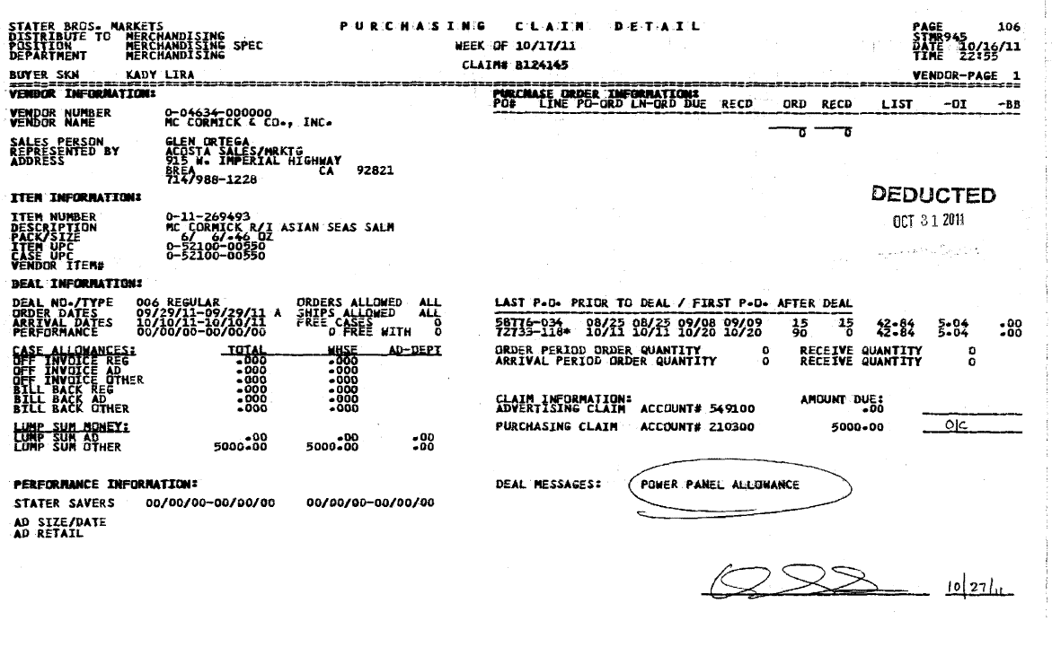
Arrival/Performance ORDER DATES – The dates on the customer invoice should fall within the contract arrival/ship dates. You must refer to the contract for the type of allowance offered. In this case, the contract indicates it’s for a display.
Customer Item Number/Product Description/Mfr Item/Case UPC: These are the item #s and should match with the customer contract to validate a claim. This box also shows the description for the product and it should also match with the customer contract for a valid claim.
Claim amount – total lump sum offered for the power panel allowance. This claim would be coded as a Display.

2

8.2 Customer Contract for Display:
The VPF shell will be found via Search for Promotions. Refer to the AWG_Job Aid AD Group Cheat Sheet for sign-ons.

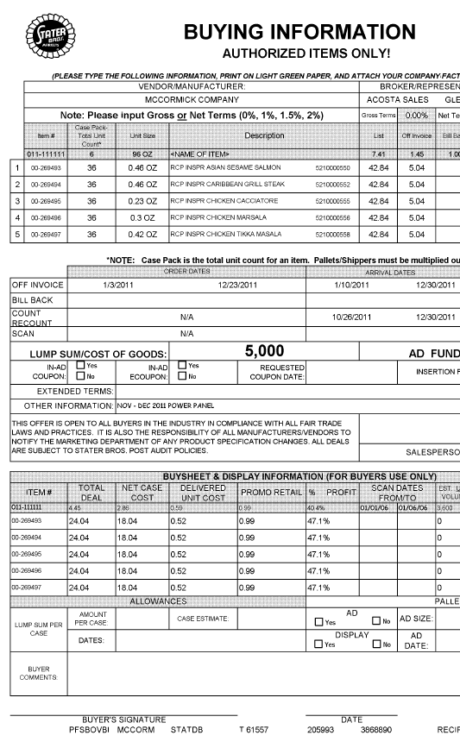
2
1
i
Promotion Dates – This is the duration during which the contracted activity needs to performed. This needs to be validated with the customer invoice. In this example, the Promotion dates are 1/10/11 to 12/30/11.
Customer Item #/Description/Case UPC –This identifies the product to be displayed in store. This needs to be validated with the customer invoice.
Vendor Comments other policies of Stater Bros.

This is lump sum amount allocated for the Display activity.

8.3 Proof of Performance: Refer to the Client SOPs/Generic Help File for POP requirements

8.1 Customer Invoice for Display – Checkstand Program:

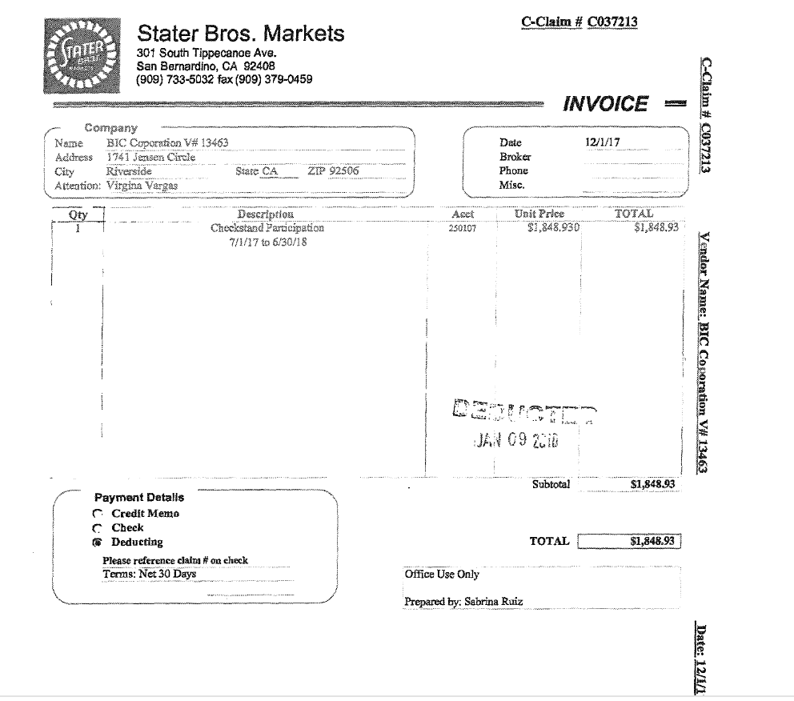
Claim Number – This can be used to pull the customer invoice from the back-up documentation
Checkstand Participation -this identifies the type of deduction and the dates this program covers.
Total Amount – this is the lump sum amount customer is deducting.

8.2 Customer Contract for Display – Checkstand Program:

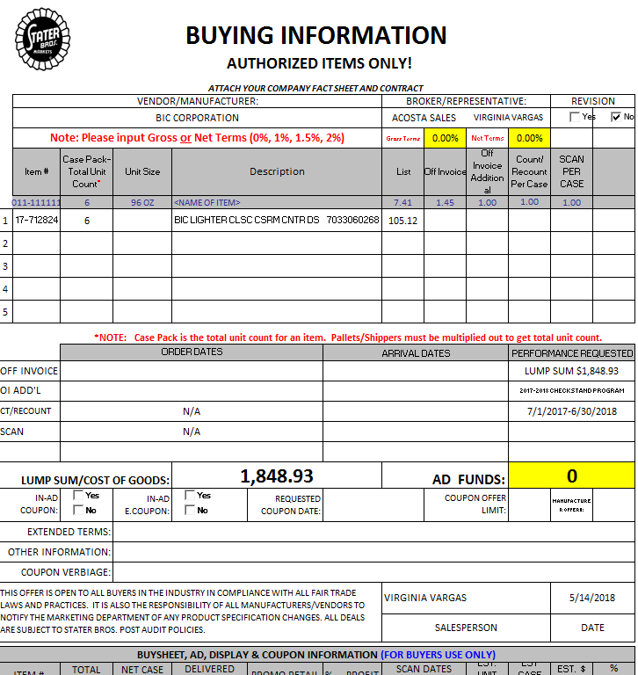
This is lump sum amount allocated for the Checkstand program activity.

Customer Item #/Description/Case UPC –This identifies the product to be displayed in store.

Program Name and Promotion Dates – Program is Checkstand Program and dates shown is the duration during which the contracted activity needs to performed. This needs to be validated with the customer invoice. .

8.3 Proof of Performance: Refer to the Client SOPs/Generic Help File for POP requirements

9. Deduction Type: Sponsorship

A fee for a sponsorship program. Programs could include golf tournaments, customer group dinner or lunch sponsorships.

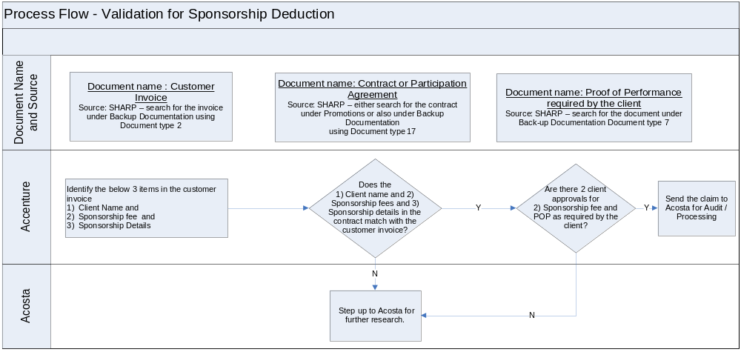

9.1 Customer invoice for Sponsorship
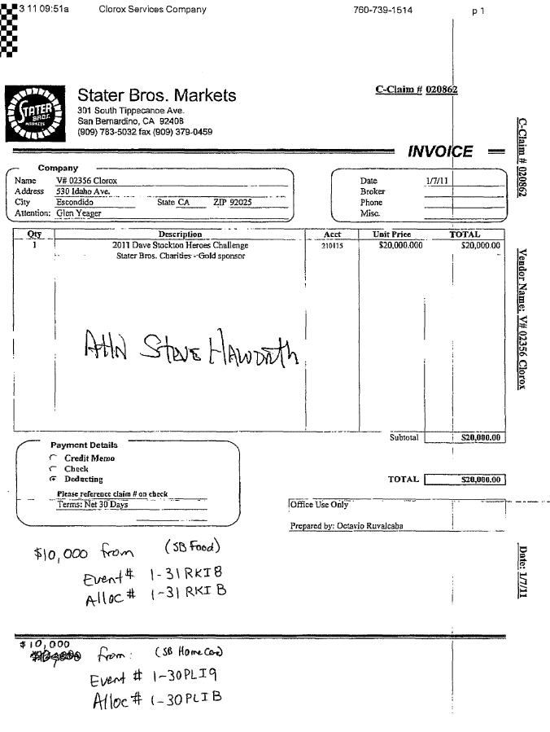
i
i
1
Deduction type - This Indicates that the deduction type is for Sponsorship
Claim amount –This is amount the customer has claimed for Sponsorship

Claim Number – This can be used to pull the customer invoice from the back-up documentation.

9.2 Customer Contract for Sponsorship:

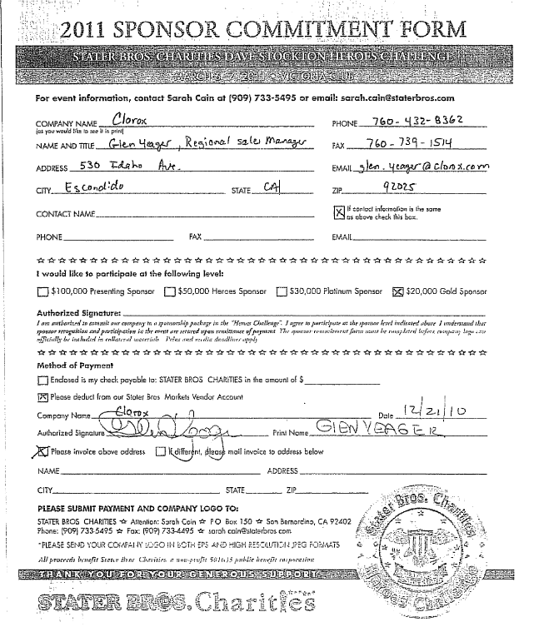
1
Claim amount –This is the contracted sponsorship amount for Gold sponsor

10. Deduction Type: Pricing

A pricing deduction occurs when the customer's requested price on the original purchase order differs from the client's invoice.

Document Name | Source of the Document | Action by Accenture
Customer Invoice | ACOSTA Relay – search for the invoice under Backup Documentation, document type 2. | Step up the claim to Acosta for research
Client Order Invoice | ACOSTA Relay – search for this document within the Order/Invoice/PO search. | Step up the claim to Acosta for research

10.1 Customer Invoice for Pricing
i
PO Number - This will be used to search for information regarding the order within ACOSTA Relay.
Invoice Number – This number is used to locate the customer Invoice within Backup Documentation and is also used to locate the client order invoice with ACOSTA Relay. It also represents the Customer Reference number on the claim.
i

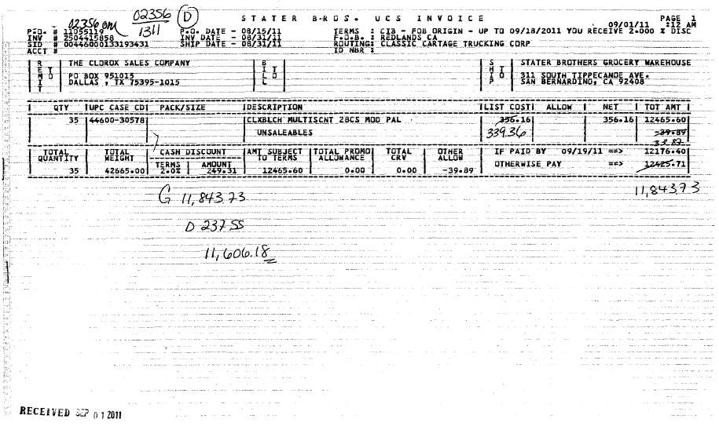
i
UPC Code:
This is the Universal product code.
e.g. 30578
Represents the difference in price billed vs. what the customer is claiming for this particular item.
e.g. $356.16 vs. $339.36

i
Invoice Number – This number is used to locate the Client Order Invoice within ACOSTA Relay and is also used as the Customer Reference number on the claim.
10.1 Customer invoice for Pricing

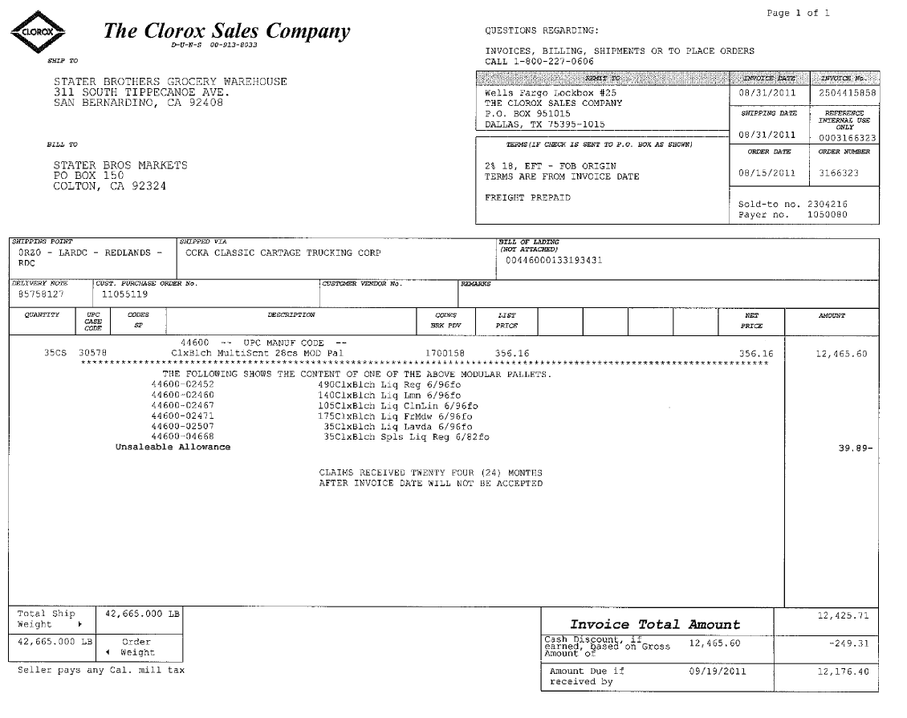
i
i
PO Number - This will be used to search for information regarding the order within ACOSTA Relay.
UPC Code – The Universal Product Code (UPC) is 5 digits. This code needs to be validated against the customer invoice. This is the product the customer is claiming the pricing deduction.

11. Deduction Type: Post Audit

Internal/external auditors find claims that the customer is entitled to but did not take from previous years. Post Audits should be researched in the same manner as other claims by accessing previous year’s files.

NOTE: The post audit claim must first be researched to ensure the customer has not already billed for the allowance before the normal validation process can begin.

Once the post audit claim has been researched to ensure the customer has not already billed for the allowance refer to the appropriate allowance section of the SOP to continue with validation. If the post audit is for an allowance not defined in an allowance section of the SOP refer to the post audit example for validation information.

11.1 Customer Invoice for Post Audit:

When the Claim # starts with a “D” or “G” the claim is considered a post audit.
Example # 1, Page 1:
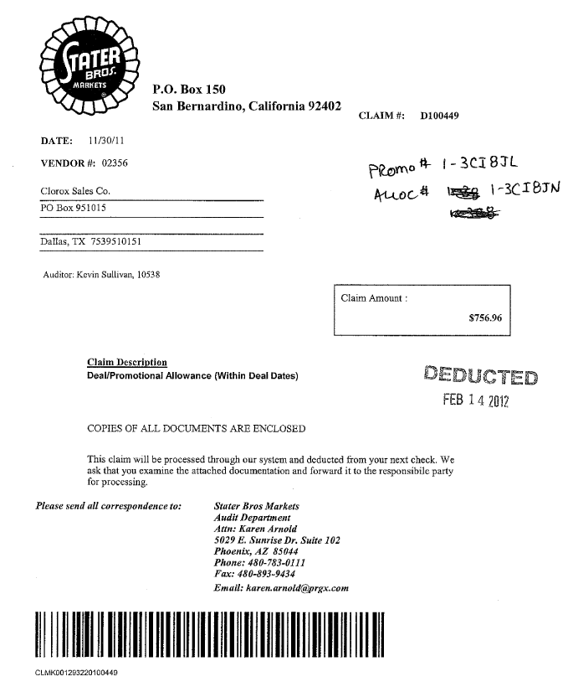
i
i
i
Audit Deparment: This indicates that the deduction is the Post Audit. Once identified as Post Audit deduction the claim needs to be step to Acosta.

Amount – This is the amount which is been claimed by the customer for Post Audit.
Claim Number – This can be used to pull the customer invoice from the back-up documentation.

Claim Description – describes the reason for the post audit.

i
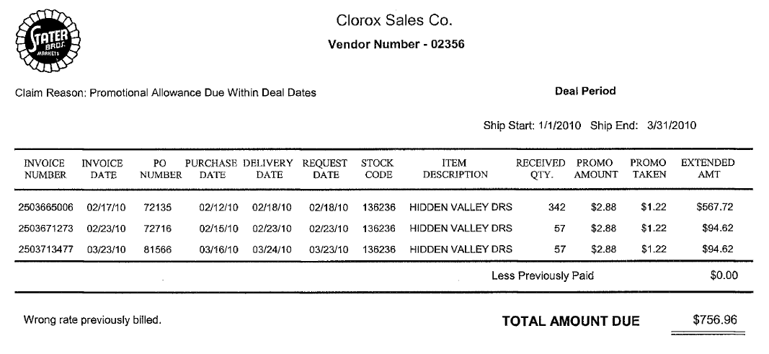
i
i
Wrong rate previously billed promo amt vs promo taken.
Ship Date – These are the dates claimed for Post Audit by the customer.
Claim Description – describes the reason for the post audit.

i
Amount – This is the total claim amount deducted by the customer for the post audit.
Invoice #/Invoice Date/PO# - represents the client order invoices/customer POs involved in this particular post audit. If not attached with the customer invoice should be pulled within ACOSTA Relay and linked to the claim.

i

12. Deduction Type: Returns

Products returned by the customer to the client.

Documents required for validating a Returns claim:

Document Name | Source of the Document | Action by Accenture
Customer Invoice | ACOSTA Relay – search for the invoice under Backup Documentation, document type 2. | Step up the claim to Acosta for research
Client Order Invoice | ACOSTA Relay – search for this document within the Order/Invoice/PO search if one is present. | Step up the claim to Acosta for research

12.1 Customer Invoice for Returns:

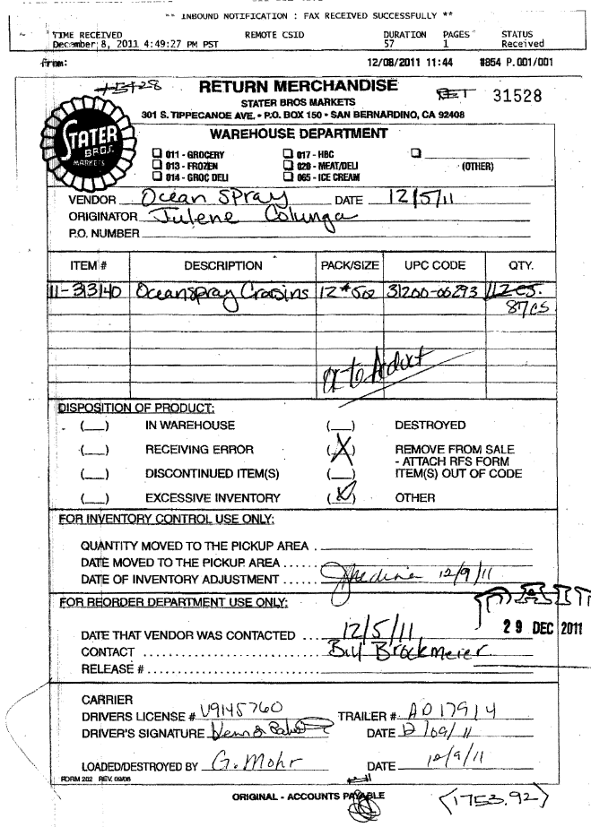
i
Identification- helps in identifying the claim as Returns. RA stands for Return Authorization.

13. Deduction Type: Shortage (Non Trade)

It is a deduction for shorted product on an order that the client billed the customer for.

Documents required for validating a Shortage deduction:

Document Name | Source of the Document | Action by Accenture
Customer Invoice | ACOSTA Relay – search for the invoice under Backup Documentation, document type 2. | Step up the claim to Acosta for research
Client Order Invoice | ACOSTA Relay – search for this document within the Order/Invoice/PO search. | Step up the claim to Acosta for research

13.1 Customer Invoice for Shortage:
i

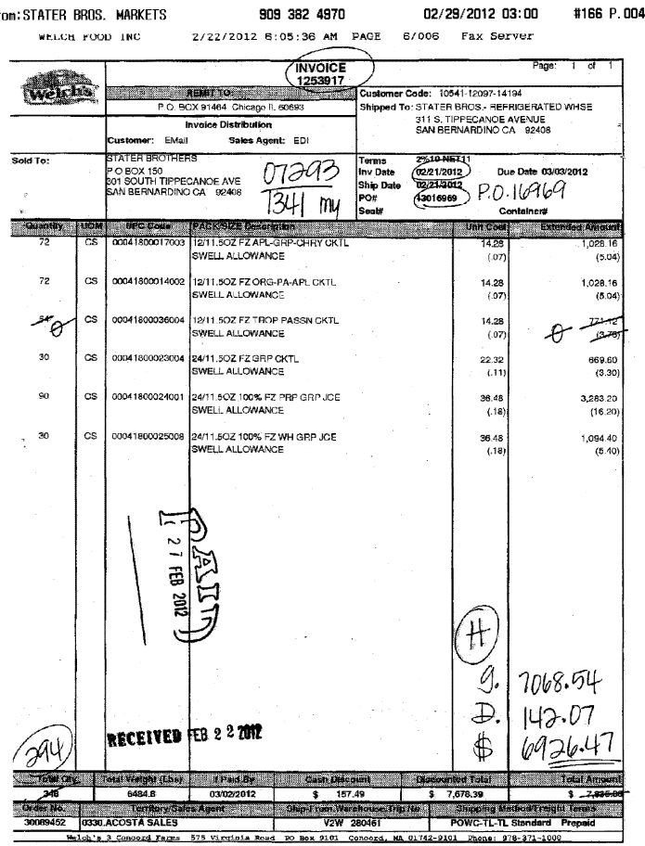
i
i
i
i
Invoice Number – This is the Customer Reference Invoice number as well as the Client Order Invoice number. This is used to retrieve the Order/Invoice data out of Review Order / view document link within ACOSTA Relay.

UPC Code – The Universal Product Code (UPC) is 5 digits from the last number, excluding the last digit. This code is used to validate key data elements regarding the customer invoice and client order invoice on the Review Order/view document link within SHARP.
Qty. and case cost – This is the quantity and case cost deducted by the customer for the shorted product.
Amount – This is the total claim amount deducted by the customer for the shorted product.
PO Number – This is the customer purchase order number and can be used to search for information regarding the order within ACOSTA Relay.

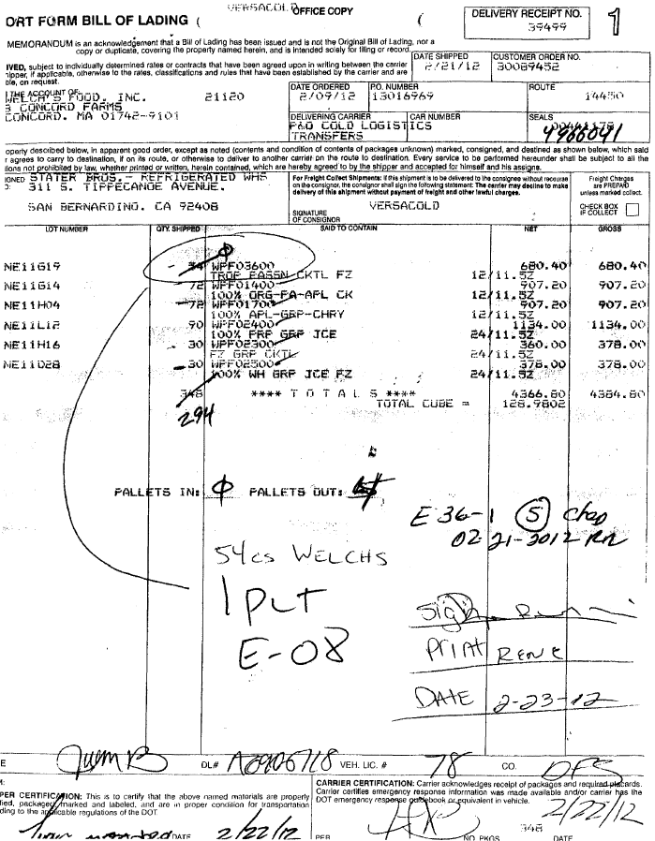

13.1 Customer Invoice details:
Found under view documents of the Order Review screen once you find the order via Search for Orders/Invoices/PO using the sign-on of the division listed on the invoice.

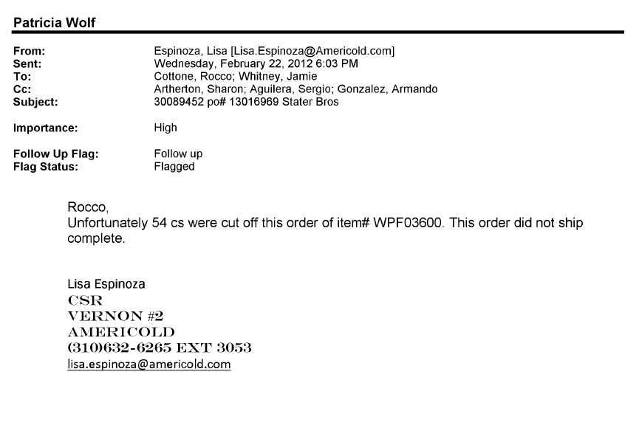
i
i
i
Deduction type – This indicates the deduction type and the deduction is for shortages
UPC Code – The Universal Product Code (UPC) is 5 digits from the last number, excluding the last digit. This code is used to validate key data elements regarding the customer invoice and client order invoice on the Review Order/view document link within ACOSTA Relay.

14. Deduction Type: Loyalty Program (E-Coupon coupon)

This is an Electronic Coupon offer, stepped as Trade Other w/notes.

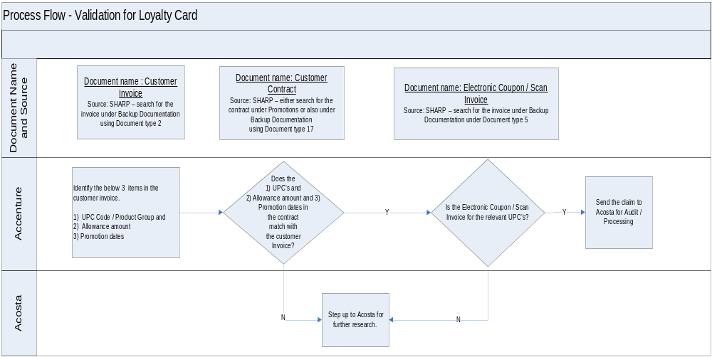

14.1 Customer Invoice for E-Coupon
i
This represents the Customer Invoice # and Invoice Date.

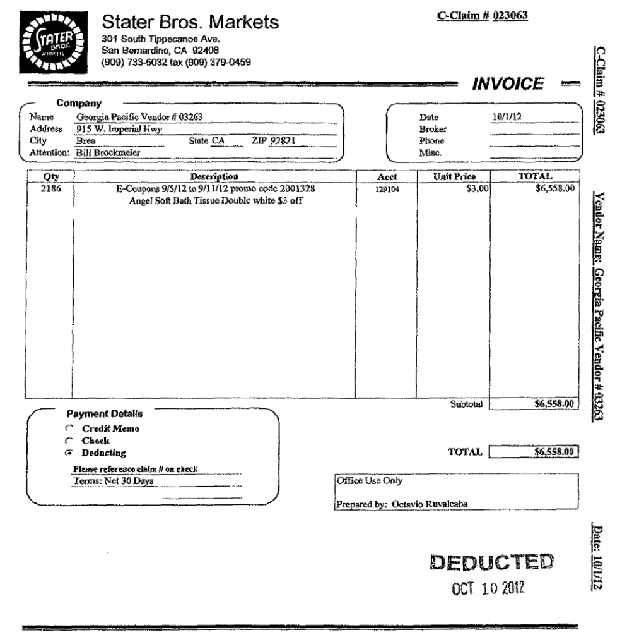
3
2
1
i
Total – This is the total amount of the customer deduction for coupon redemption.
Description –provides the coupon details/date.
e.g. $3.00 off 1 – 36 roll Angel Soft Bath Tissue during 9/5/2012-9/11/2012. E-Coupon stands for Electronic coupon. These dates should fall within the contract arrival dates.
Unit Price – represents the amount of the $3.00 coupon offer per coupon.
e.g. 2,186 cpns.x $3.00 = $6,558.00

14.2 Customer Contract for E-Coupon
i
Supplier Information – The name of the Client/Manufacturer is updated in this section.

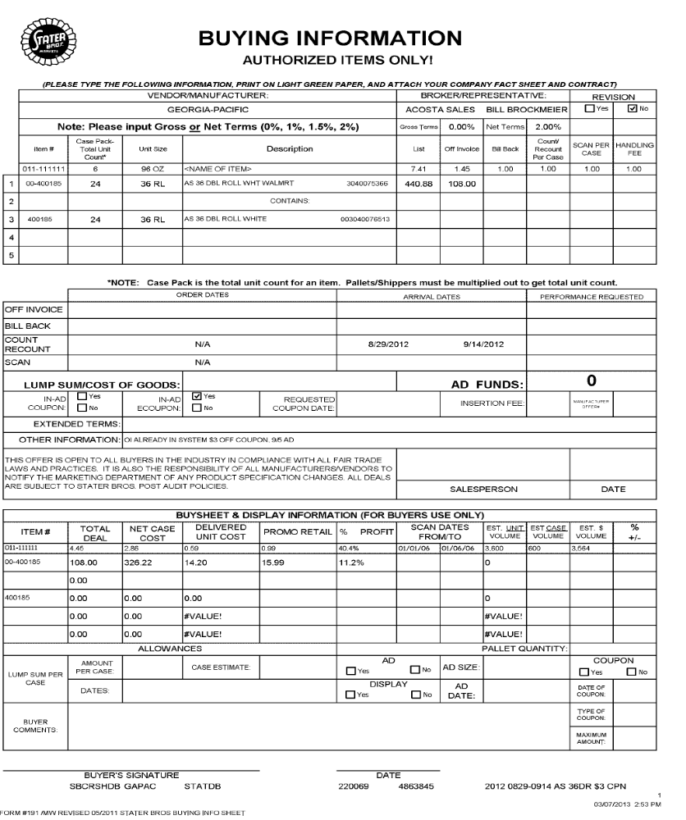
i
3
2
1
Deduction type – This indicates the type of deduction.
ARRIVAL DATES – The customer invoice date referenced on the customer invoice should fall within the contracted dates on the contract.
Customer Item Code –E.g.: In this case the Customer Item Code is the one highlighted in red 00-400185.
Item Description/Mfr Case UPC – This provides the product description that should match the information on the check remittance/customer invoice.
e.g. Mfr Case UPC 75366
Other Information: provides the contract offer $3.00 off 1 36 roll Angel Soft Bath Tissue

14.1 Customer Invoice for E-Coupon – Example #2
This represents the Customer Invoice # and Invoice Date.

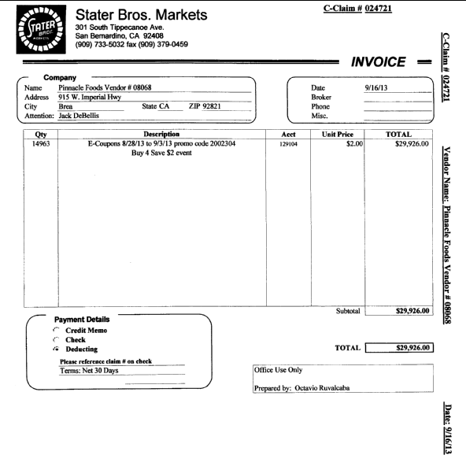
Total – This is the total amount of the customer deduction for coupon redemption.
Description –provides the coupon details/date.
e.g. Buy 4 Save $2.00 event during 8/28/2013 – 9/3/2013. E-Coupon stands for Electronic coupon. These dates should fall within the contract arrival dates.

14.2 Customer Contract for E-Coupon – Example # 2

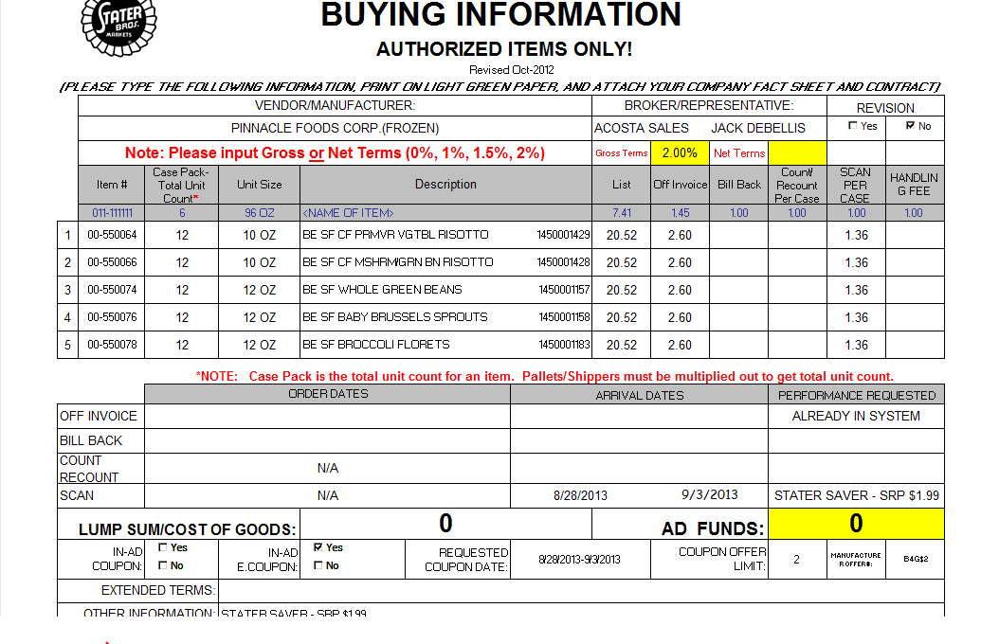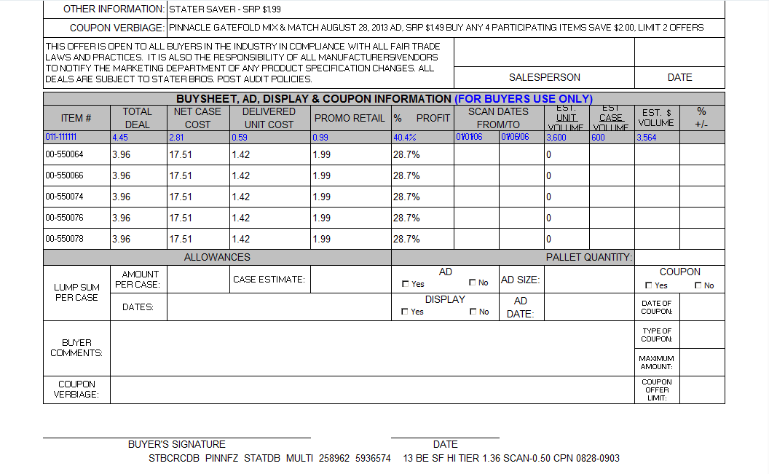
Supplier Information – The name of the Client/Manufacturer is updated in this section.
Item Description/Mfr Case UPC – This provides the product description that should match the information on the check remittance/customer invoice.
e.g. Mfr Case UPC 01157
Customer Item Code –E.g.: In this case the Customer Item Code is the one highlighted in red 00-550074.
ARRIVAL DATES – The customer invoice date referenced on the customer invoice should fall within the contracted dates on the contract.
Other Information: provides the contract offer Buy 4 Save $2.00
Deduction type – This indicates the type of deduction.

14.3 Proof of Performance for E-Coupon – Example # 2:

Copy of Electronic coupon, scan invoice or coupon detail report. The coupon detail report is needed to validate a claim. The coupon detail report generally needs to be requested from the customer . If either of these are not available run a GenWeb Sales Summaries Report. Also the Client may have specific requirements. Refer to Client SOP.

Example of Coupon Detail report from customer:
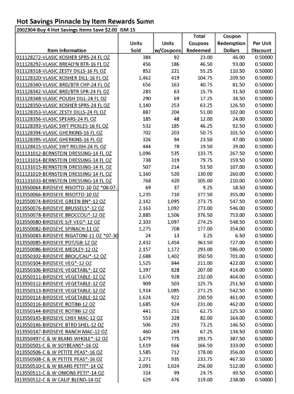
Customer Item Code/Description – This provides the product description that should match the information on the contract.

Page 2 of coupon detail report
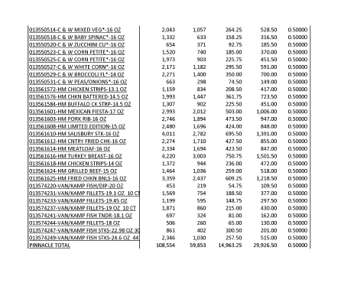
Total – This is the total amount of the customer deduction for coupon redemption.

15. Deduction Type: Unsaleables/Reclamation/Spoils/Damages

An Unsaleable claim is taken for product that cannot be sold at the stores due to damages (and short coded product).
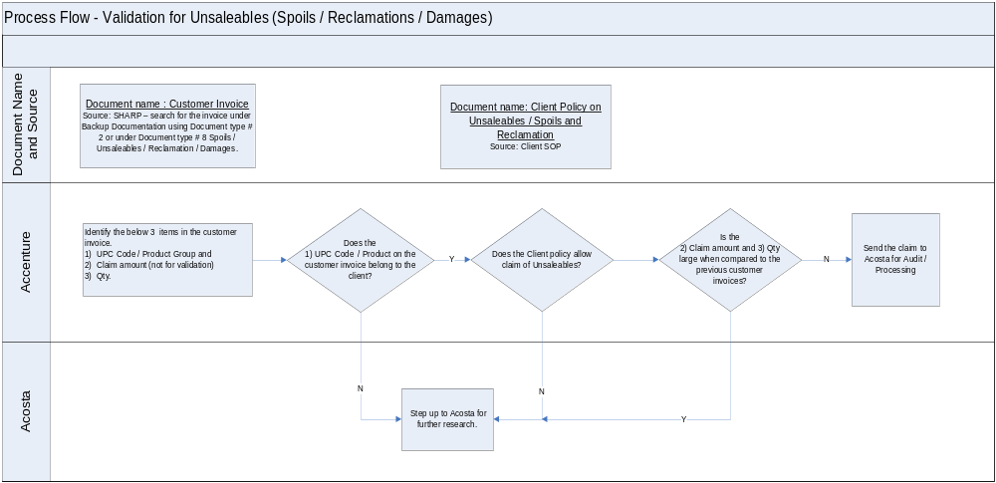

15.1 Customer Invoice for Swells

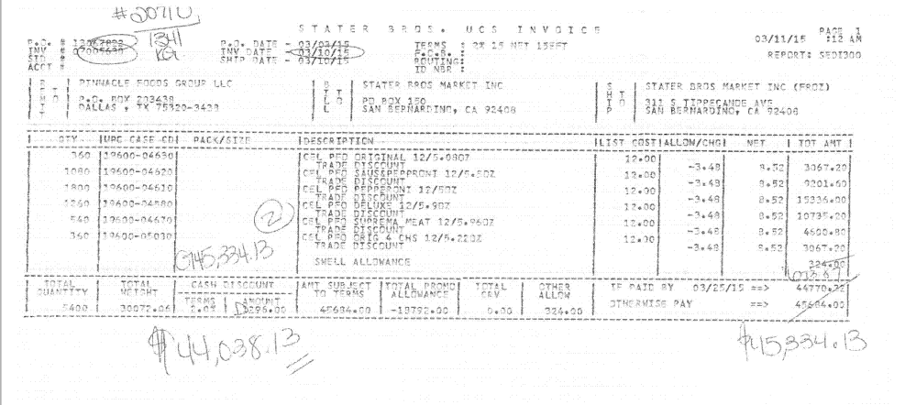
Amount - Swell amount of $324.00 crossed out and new amount of $673.87 handwritten in. The difference of $349.87 matches the amount of the claim and this indicates customer is deducting for additional swell allowance.
Description - Swell Allowance – this indicates that the amount on this line of customer invoice is for a Swell Allowance.

Note: Some clients do not allow swell allowances – refer to client SOP. Refer to Client SOP for POP requirements if we are required to validate swells deductions.

15. Deduction Type: Service Fee/Penalty
Fees charged for various reasons and can include late deliviery, miss delivery appointment or lumper/driver fees. Please see attached for fee policy.
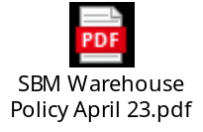
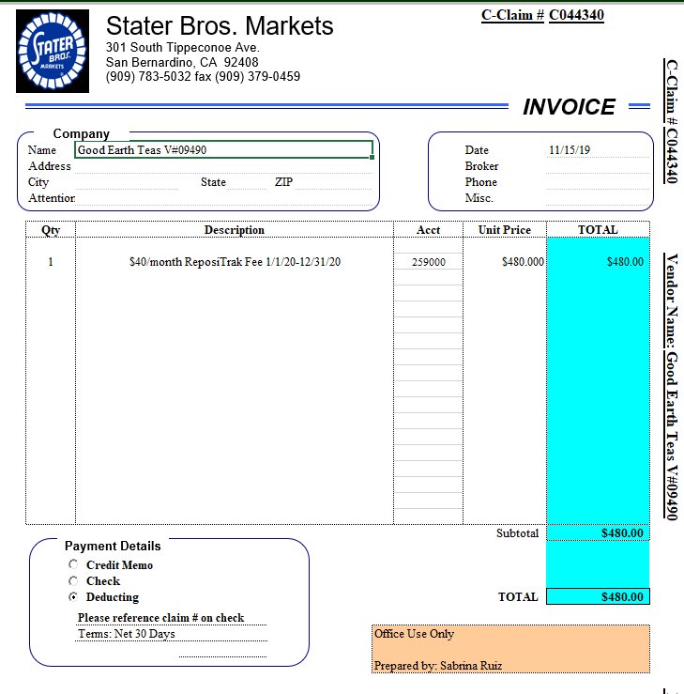
Description - ReposiTrak Fee – a service fee for use of the ReposiTrak software.
Identification – C ivoices for $480 are for ReposiTrak fees.

BPS Team Information

Repays/Invalid Claims:

For post audit repays, email repay packet to Staterbros.audit@prgx.com.

CCA Client Specific:

David Nelson (BM) or Dana Conklin (BMA) may approve clearing deductions to events that do not have the product reflected or to clear to event that may not pertain to the contract rather than creating a new event.

COMPLETE VERSION HISTORY

UPDATE DESCRIPTION | DATE | AUTHOR
First draft of the Stater Bros. SOP | 06/11/2012 | Nagaraj M
Changes by Dellene Hubbard | 07/06/2012 | Dellene Hubbard
Revised Flow Charts and Definitions
Update IRI/Nielsen information for price point pg 2 | 09/10/2012 | Rick Smith
Updated hyperlinks to deduction type | 09/17/2012 | Nagesh Kumar
Added WW/CRC example where customer made handwritten changes to the total line item amount (pages 23-26) | 12/06/2012 | Dellene Hubbard
Added Scan example claim to section 3 (see pages 27-29) | 12/27/2012 | Dellene Hubbard
removed In Ad coupon section and uploaded Loyalty Program (E Coupon) Section 13 | 03/11/2013 | Dellene Hubbard
Added Scan Example # 2 (see 3.10) (Tkt # 3268) | 05/13/2013 | Dellene Hubbard
Added verbiage to slotting example for Partial New Item Funds (tkt# 4394). Added verbiage on backing into claim if customer invoice not found (tkt# 4485) | 09/02/2013 | Michelle Mangus
Clarified verbiage on the Warehouse Withdrawal invoice arrival dates vs Performance dates | 09/30/2013 | Michelle Mangus
Added National Performance Analyst Toolbox Section, added customer signon job aid link. Added Client Specific Section | 10/06/2013 | Michelle Mangus
Added verbiage that customer sends in only invoice pages that contain items that they are deducting for (tkt# 5504) | 11/11/2013 | Michelle Mangus
Added example of Coupon Detail Report for E-Coupon, Section 13 (tkt# 5934) | 11/20/2013 | Michelle Mangus
Added to Client Specific section Pinnacle DPS allowance on full truck shipments of Celeste items (tkt# 4954) and Procter & Gamble Duracell monthly accrual claims information (tkt# 6322). | 02/17/2014 | Michelle Mangus
Added AMG invoice to customer section as needs to escalate to Acosta for research (tkt# 5971) | 03/03/2014 | Michelle Mangus
Added lump sum example for WW/CRC to Warehouse Withdrawal section (tkt# 5268), created Scan section 4 and renumbered remaining sections. | 05/26/2014 | Michelle Mangus
Added to Client Specific Section McCormick example of “A” and “B” invoice (6759). | 09/29/2014 | Michelle Mangus
Added Digital coupon scan example to Scan section (7295) | 11/10/2014 | Michelle Mangus
Added Clorox to Client Specific Section with notes on Lump Sum Cost of Goods allowance (9241). Added invoice ex for Special bib labels in Ad section (8225) | 11/24/14 | Michelle Mangus
Added to Post Audit section explanation on contract for allowance audits (9912) | 12/08/14 | Michelle Mangus
Added Starkist to Client Specific section and handling freight deductions (11579). | 01/05/15 | Michelle Mangus
Added AD or A/D callout to customer exclusive section and removed the Starkist client specific information as this callout covers the same information (12121). | 02/16/2015 | Michelle Mangus
Added BPS Team Information section with Backup Retrieval information for McCormick Post Audits (12103) | 03/30/2015 | Michelle Mangus
Added invoice example of DPS allowance to Pinnacle Client Specific section with verbiage that unload is same as DPS (12923). Added CRA specific information on Heinz Repay and pricing issues to BPS Team Information section (12680). Added Coca-Cola to Client Specific section with information on handling spoils allowance (13140). | 04/13/15 | Michelle Mangus
Added Kens to Client Specific with info on spoilage allowance and added verbiage on Z code to customer section (12738). Clearer explanation with verbiage regarding post audits for allowances (13439). Added question of direct/indirect customer to customer sign-on box (13429). | 4/27/15 | Michelle Mangus
Added Unsaleables section and added customer invoice example for swells (13480). Added question to Backup Retrieval section on backup retrieval by CIT (13722). | 5/25/15 | Michelle Mangus
Removed Beiersdorf references pgs 4/19/23/30/48 (14054). | 06/08/15 | Michelle Mangus
Added Sun Products to Client Specific Section with explanation on how to note Scan lump sums on DBW (13997). Added backup contact information to BPS Team Information section if not found in ACOSTA Relay (14754). Added CCA Clearing Instructions for McCormick to BPS Team Section to clear to event that do not reflect product or may not pertain to contract (14634). | 08/31/15 | Michelle Mangus
Added to BPS Team section contact for backup information for Frenchs (15435). Cleanup and reorganization of information (14730). Added to Customer General under Customer Invoice detail line level information (15509). | 10/26/15 | Michelle Mangus
Added Campbells to Client Specifics with information on customer invoices that says “Resets” (15304). Added to BPS Team Information section information on obtaining backup for A,B,C and D or G invoices (15666). | 11/23/15 | Michelle Mangus
Updated contact for A,B,C Invoices in the Customer System & Backup Retrieval Info section (16834) | 02/29/2016 | Michelle Mangus
Updated BPS Team Information section with post audit backup is from Claim Trax (16822). Removed Procter and Gamble/Duracell information on A & B invoices for monthly lump sum from Client Specifics (17475). | 03/18/2016 | Michelle Mangus
Updated BPS Team Information section on obtaining backup (17373). | 04/01/2016 | Michelle Mangus
Removed CRA Client Specific Validation for Heinz (19311). | 08/29/2016 | Michelle Mangus
Post Audit - Removed table from Post Audit section and replaced with instructions to research validatity and updated post audit examples (19056). | 10/10/2016 | Michelle Mangus
Updated contact for backup in BPS team information section (19739). Removed duplicate contract examples and POP examples and added statement (19418). | 11/07/2016 | Michelle Mangus
Added how to obtain backup for McCormick to BPS Team Information section for CRA System & Backup Retrieval Client Specific (20165). | 12/19/2016 | Michelle Mangus
Removed backup information for A,B,C invoices from BPS Team section as information is in ACOSTA Relay (20403). | 01/30/2017 | Michelle Mangus
Added Sales exception for Colgate to Client Specific section (21011) | 03/17/2017 | Michelle Mangus
Updated CIT to GCIT (21433). | 05/08/2017 | Michelle Mangus
Added note to Cust General Section if customer invoice states Market Centre deduction for Stater Bros use Stater Bros contract verbiage (21922). | 08/14/2017 | Michelle Mangus
Removed Sun Product from Client Specific (21793). Updated CRM to CSM and DTC to INDEX (22355) | 9/11/2017 | Michelle Mangus
Updated Scan customer invoice example to indicate Arrival Dates (22696). | 9/25/2017 | Michelle Mangus
Updated hyperlinks to new SPO site (23751). | 02/08/2017 | Michelle Mangus
Updated contact information for D & G invoices in the BPS Team Info section (24387). | 05/21/2018 | Michelle Mangus
Updated contact information for D invoices in the BPS Team Info section (24839). | 06/18/2018 | Michelle Mangus
Added Checkstand example to Display deduction section (25010). | 07/16/2018 | Michelle Mangus
Added Bush client specific information for swell allowance (25234). Added Barilla client specific information for swell allowance (25272). | 07/30/2018 | Michelle Mangus
Update to customer backup request information/realignment of information, no process change. Added to Coca Cola Client Specific section information on Hansens deductions (24943). | 08/13/2018 | Michelle Mangus
Added Noosa to client specific section with verbiage on swell allowance (25571). Added Tata to client specific with date flexibility (25517) | 08/27/2018 | Michelle Mangus
Added KAO Brands to client specific with verbiage on product groups (25680). | 09/10/2018 | Michelle Mangus
Added to Colgate client specific simplified DBW instructions (26301). | 11/19/2018 | Michelle Mangus
Reworded backup request instruction under the CRA System & Backup Retrieveal Specific section. (26958). | 02/01/2019 | Michelle Mangus
Removed McCormick client specific information and backup retrieval information from BPS Team Information section (26829). | 02/13/2019 | Michelle Mangus
Added to Coca Cola client specific information regarding POP for scan and count/recount deductions (27136).  Removed Clorox specific information, no longer represent (28157).  Removed Pinnacle specific information, no longer handle claims eff 8/26/19 (28434). | 03/11/2019  07/01/2019  8/26/19 | Michelle Mangus
Removed Noosa client specific information (28694). | 10/21/19 | Michelle Mangus
Removed backup retrieval information from BPS Team Info section. Created Backup Retrieval Information section, backup requests are the responsibility of GCIT (28981). | 11/22/19 | Michelle Mangus
Removed Colgate Client Specific information as no longer represent (29496). Added Edgewell Client Specific section with information on ReposiTrak fees (29137). | 02/24/20 | Michelle Mangus
Backup Retrieval section updated Check remit required question to yes (29936). Updated verbiage in Ad deduction section on searching for ads (29654). | 4/20/20 | Michelle Mangus
Removed KAO client specific information (30010). | 06/01/20 | Michelle Mangus
Added Service Fee/Penalty section for ReposiTrak fees. Added 2nd manufacturer coupon example. Added backup request info for both. (30489) | 07/13/20 | Kristin Jones
In Backup Retrieval section, added client specifics for Dole, Hostess, Noosa, and Sara Lee. Added PO-related info for CRAs and add PO-related to non-automated grid (30539). | 07/27/20 | Kristin Jones
In Customer General Info section, added POP info (30649). | 08/10/20 | Kristin Jones
In scan section for invoice examples 1 & 1, updated explanation on how to calculate the math of the invoice (30761). | 10/05/20 | Kristin Jones
In Backup Retrieval, removed Noosa-specific info (31305). In Backup Retrieval section, updated Dole for PO-related backup (31463). | 1/25/21 | Kristin Jones
In Backup Retrieval, revised Hostess specific info & added to non-automated grid (31740). | 3/22/21 | Kristin Jones
Removed Campbell’s specific section (31901). | 4/05/21 | Kristin Jones
In Edgewell section, updated Repositrak fee info (31980) | 5/03/21 | Kristin Jones
Hostess update for 31740 fell off – adding back in Backup Retrieval. | 5/21/21 | Kristin Jones
In Backup Retrieval, Hostess specific, added C invoices as an exception (32619). | 10/04/21 | Kristin Jones
In Customer General Info section, updated info about PO related backup, in Backup Retrieval, removed Dole-specific info, added note requirement for PO related claims & added non-atuomated contact for PO related backup requests (32921). | 12/13/21 | Kristin Jones
In Backup Retrieval/Non-Automated grid, updated contact for C invoices hat are $480 (33105). | 2/7/22 | Kristin Jones
Added Perfetti to the CLIENT SPECIFIC VALIDATION INFORMATION regarding Unsaleables. (34792) | 5/22/23 | Pam Jaeger
Removed Sara Lee from the BACKUP RETRIEVAL INFORMATION section (35113). | 6/19/23 | Pam Jaeger
Added Mars Ice Cream to the Client Specific Validation Information about digital coupons. (35252) | 8/7/23 | Pam Jaeger
Added GL Mezzetta section for Spoilage/Damage to CLIENT SPECIFIC VALIDATION INFORMATION (35385) | 9/11/23 | Pam Jaeger
Updated BPS Team Information to include email address for Invalid Post Audits. (35829) | 12/26/23 | Pam Jaeger
Updated GCIT SPECIFIC BACKUP RETRIEVAL INFORMATION for Audits that begin with G. (35949) | 1/15/24 | Pam Jaeger
Updated Section 15 Deduction Type: Service Fee/Penalty with Warehouse Policy file. (36221). | 3/18/24 | Pam Jaeger
Updated Backup Retrieval Section by removing back up portal Claim Trax. (400389) | 9/16/24 | Pam Jaeger
Updated Client Specific Section to include Campbell’s Meals and Beverages check requests. (401598) | 9/30/24 | Pam Jaeger
Added Horizon to the Client Specific Section for fees and Event numbers. (405752). Updated Back Up retrieval Section for B claims. (406160). | 12/9/24 | Pam Jaeger
Added Mars Foods to Client Specific Section for Repositrak Fees (416194). | 3/31/25 | Pam Jaeger
Updated the backup retrieval section regarding PO related backup (428797) | 6/16/25 | Katy Dolan
Removed from CCNA Client Specific Section for Hansen products. (430295) Updated back up retrieval section for customer portal to ‘N’ and updated G invoices email address. (434562) | 8/18/2025 | Pam Jaeger
Added information for identifying late/no show/missed appointment fees. (443609)  Added clarification verbiage for backup requests for B and C invoices (all other amounts). (447421) | 11/17/2025 | Michael Huml
Added Client Dole/information in Client Specific Section (461677) | 03/16/2026 | Dawn Regan
Removed Non-Trade from Post Audit in Deduction Types Covered Section (465273). | 04/13/2026 | Dawn Regan

