WORK INSTRUCTIONS

Process | Order to Cash
DTP Name | Winco Claims Validation Documents

CURRENT VERSION HISTORY

UPDATE DESCRIPTION | DATE | AUTHOR
Updated information for Kikkoman in Client Specific Validation Information Section (472991) | 06/22/2026 | Dawn Regan

Link to complete version history: Complete Version History

DEDUCTION TYPES COVERED

Sl. No. | Deduction Type
 | Customer General Information
 | Backup Retrieval Information
 | Client Specific Validation Information
1 | Off Invoice
2 | Bill Back
3 | Pricing (Non-Trade)
4 | Slotting/Regional Distribution Operating Allowance/New Store Grand Opening/ In & Out
5 | Unsaleables/Reclamation/Leaker Allowance (L/S) - (Non-Trade)
6 | Price Protection (Non-Trade)
7 | Floorstock Protection
8 | Display
9 | Coupons
10 | Sponsorship
11 | Fees
12 | Freight/Backhaul (Non-Trade)
13 | Returns (Non-Trade)
14 | Shortages (Non-Trade)
15 | Post Audit (Non-Trade)
16 | Product Recall
17 | Demos
18 | Warehouse Withdrawal/Count-Recount
19 | Retail Merchandising Program (HABA)
20 | Markdowns / (Discontinued)
 | BPS Team Information

Is the customer a wholesaler/distributor, direct or indirect customer? Direct customer.

Note: WINCPT is the sign-on used to work on ACOSTA Relay for Winco Foods (For example to search a document and to refer to the customer on ACOSTA Relay). For some NS Sales deductions contracts may be located under WINCPN.

Link to customer signon job aid:
https://acostaonline.sharepoint.com/sites/AS_Reporting/Claims_Reports/Forms/AllItems.aspx?web=1

Does customer subscribe to IRI/Nielsen for price point verification? No

CUSTOMER GENERAL INFORMATION

Customer Invoice Info

Is line level detail indexed on the customers documentation (customer invoice, customer check request, unsalable/spoils, post audit, EDI 812/820 or client deduction notice if one of these documents is included)? Yes

- Search using customer reference number, do not search using claim amount as totals may not match.
- If customer reference contains @, search using the numbers before the @A.

Cash Discount.
- Winco does NOT provide a Customer Invoice for Cash Discount claims. Back into the claim from the client order invoice.
  - Customer calculates the 2% cash discount on the gross amount of the invoice and not on the net

Price Increase Lead Time:
- Winco Requires 60 days’ notice for cost increases.

Grocery/Variety Warehouses Policies & Procedures

POP Info

Memo Tracking Report Callout:
If the original PO has product that does not ship in the first shipment, a backorder PO is created and the ending 0 (zero) of the original PO number is changed to a 1 (one). For example, original PO number is 107196200 and the backorder PO number would be 107196201. For memo tracker reports, look for both PO numbers to determine if there is enough cases to cover the deduction amounts.

BACKUP RETRIEVAL INFORMATION

GENERAL BACKUP RETRIEVAL INFORMATION

Is GCIT responsible for obtaining backup from the customer? Yes
- If yes, is there a customer portal? No
- If yes, does GCIT request backup? Yes

Is check remittance information required to request backup? No

- If the deduction is PO related the PO # must be noted in the claim notes, and the COI/PO needs to be attached to the claim before requesting for backup.
- When requesting backup, the client vendor number needs to be included in the request. See attached Winco Vendor List file for assigned vendor numbers.
- When requesting backup, Winco now requires submission of backup requests for each vendor individually.

ALEN

- Request backup from accounts.receivablena@alenusa.com if not in repository.

HOSTESS

- Request backup from accounts_receivable@hostessbrands.com.

NEWELL
- Request backup from Anant.Gupta@newellco.com.

GCIT SPECIFIC BACKUP RETRIEVAL INFORMATION

Portal:

Customer Invoice or Note Identifier | Request From
Ends in R | Pull from CLS/INMAR portal

Automated:

Customer Invoice or Note Identifier | Request From
Begins with AVS | winco@e-reconcile.com
Begins with 87A, 89A, 91A, 92A, 94A | wincofoods@atgaudits.com
Begins with 2 numbers and an X (example: 82X,86X, 87X, 89X, 91X, 92X, 94X), RCL, DUPX, or AUD) | If not found, request from  wincofoods.audit@prgx.com
All other formats (including RECLAMATIONS in the customer ref #)  (excluding invoices that begins with RCL, DUPX, AUD, or 2 numbers and X (example: 86X, 87X, 89X, 91X, 92X, 94X) or ending with an R). | backup@wincofoods.com  1st request sent every Tuesday  2nd request sent on the following Tuesday

Non - Automated:

Customer Invoice or Note Identifier | Request From

CLIENT SPECIFIC VALIDATION INFORMATION

Client
Alen USA | Kikkoman
Barilla | Nestle Nutrition
Beiersdorf Inc.
Campbell's/Pepperidge Farms | Newell
Coca Cola | Ralcorp
Dole | Sunny D
Kens Foods | Tata (Tetley/Good Earth Teas)

ALEN USA

- Claims with a performance date prior to 7/1/2020 are prior broker and will be coded as Not Acosta.

Barilla

- For PO related claims, if the invoice does not equal what the customer is billing for the difference will be the cash discount.

- Claims are created under customer sign-on of WINCPT but contracts for Wasa are indexed under WINCPN.

BEIERSDORF INC.

- Use the client event clearing number for 2026 that has the event description as "Winco FY Budget 2026" even though it is under non-promo. The client has created their event numbers as non-promo for their financial reasons. The 2026 clearing event number for Winco deductions is N26WIN009 that runs from 1/1/26-12/31/26.

CAMPBELL’S/PEPPERIDGE FARMS

- Per client approval, contract dates can extend to the Friday before a Monday deal start date or on Monday after a deal.
- Claims for New Store Grand Opening will not have a contract, step to sales for an event.
- Claims that mention sales deposit is a bottle fee, a line note is required stating the deduction is for a bottling fee.
- Claims that include Fuel Surcharge is coded as Freight.

Coca Cola

- Customer promotions are based off the Order Date. The order date needs to fall within the order dates of the contract.

- If allowance amount does not match the amount on the contract, step to sales and note that allowance amount does not match what is on the contract. Do not clear, even if the customer is claiming a lesser amount.

- Customer invoices that contain off invoice and wall buy off invoice deductions will need to be split into separate lines as they have different contracts and different event numbers.

- New Store Grand Opening deductions are cleared to product group and not down to the UPC level.

- PO related deductions for Price increase and bracket pricing. DBWs are required.
  - Bracket pricing (allocation) claims are valid as WINCO is to receive Full Truck Load Pricing
    - There is no contract
    - Will be cleared to an event (do not step as a Not Acosta)

Dole

- If backup is not obtained after two requests, the claim will need to be stepped to “Request BU Assist – Sales” for Sales to attempt obtaining it before a repay letter can be written.

KENS FOODS

- Customer calculates the 2% cash discount on the gross amount of the invoice and not on the net. This is Policy vs Policy as client calculates cash discount on the net amount. Deductions for cash discount must be stepped as Non-Trade/Cash Discount to the client to clear internally.

- Winco will deduct for missed wall buy OI’s and require an event number.

Kikkoman

- Cash Discount deduction – Per customer’s policy cash discount is based on gross. Client has given approval on customer’s policy as this is policy vs policy. Sales approval is not needed.

- Spoils/Damages deductions – Per customer’s policy spoils/damages are taken at current list cost. Client has given approval on customer’s policy as this is policy vs policy. Sales approval is not needed.

- Claims are created under the customer sign on of WINCPT but contracts may have been created under WINCPT for Grocery or WINCPN for NS Sales. GCC/CRA will need to look under both sign on’s for the contract.

- If invoice amount is greater than claim amount client has authorized clearing the negative claim amount up to $100.00 as Non-Trade/Other.

NESTLE NUTRITION

- Marketing Program – digital coupons check requests are handled internally by the client.
- Client approval to clear claims without POP.

NEWELL

- Client Event numbers are not required for all divisions
- Acosta does not represent this customer for the Writing division which is Newell Craft (NEWCRF) and Newell Office (NEWOFF). Step claims as Unknown/Not Acosta.
- Claims under $800.00 where the dates have extended not more than 10 days (7 days prior and 3 days after) can be cleared with valid contract. Claims under $1000.00 can be cleared without IRI Nielsen reports on POP.
- Acceptable to use order dates on the contracts as Winco only uses one set of dates.
- Damages/Shortages noted on invoice are processed as “Damages”.

Ralcorp

- No sales analysis - Client Finance approval must be linked to every claim.
- New stores will not have contract.

SUNNY D

- Invoices that reference Lobby Merchandising Fee are a lump event. No contract or POP required per client. Sales will provide breakdown and event # for these deductions and code as Trade/Other.

TATA (Tetley/Good Earth)

- Winco is allowed a date extension of a total of 2 weeks before and/or after the contract dates.

PROCESS STEPS

- Deduction Type: Off Invoice

A per case off invoice allowance is given to the customer as an automatic discount for product purchased from the client. If the customer does not receive the allowance off the face of the invoice they will deduct for it. If the customer requested an allowance that is not valid, the CSC will send a notification to the customer in writing. Customers view purchase orders as contracts. If they are not notified of allowance discrepancies, they will pay according to their purchase order total.

When working some non-food accounts for Off Invoice and Billback, the customer invoice allowance may not match the contract. The allowance per case may be broken down into inner packs per case.

For example: contract offer is for $12.00 per case. The claim comes in at $4.00 as the inner packs are 4/3 or 3/4 ($12 per case / 3 units per case = $4 x 3 inner packs = $12.00)

1.1 Customer Invoice for Off Invoice, Example 1:

4
i
UPC Code – The Universal Product Code (UPC) is the last 5 digits listed on the customer invoice.
This code is used to validate key data elements regarding the customer invoice and client order invoice on the Review Order/view document link within ACOSTA Relay. This is the product in which the customer is stating that there is an off invoice allowance.
Note : Customer invoice sometime lists Item UPC instead of case UPC, on this invoice case UPC is listed, which is last 5 digits (02241).

Product Description: This is the product for which the OI allowance is claimed and it should match with the customer contract.

This is the Client Order Invoice number. This would be used to retrieve the Client Order Invoice from the Review Order/view document link within ACOSTA Relay. Also, this needs to be matched with the Client order invoice.
In this case the invoice number is 3217784.
This must be pulled first to determine if the customer received the rate per case OI allowance off the bill.

This date will assist in locating the contract needed to validate the claim.
3
Qty –The Qty as per the customer invoice needs to match the qty shipped on the Client order invoice.
2
OI Rate – This amount reflectsthe extended amount per item deducted by the customer as part of OI allowance. Divide this amount by the total number of cases listed to arrive at the rate per case OI allowance. This amount should tie back to rate as per the contract. E.g. $288.00 / 240 = $1.20

i
PO Number – This can be used tosearch within ACOSTA Relay for the client order invoice information when a client order invoice number is not available. Eg: In this case the PO number is 51612300.
5
i
i
1
Total OI Allowance – This is the total OI allowance amount deducted by the customer.

Deduction Type - This indicates the deduction type is an allowance related claim, which could be an off invoice not given, billback or scan. Allowance type will be found on the contract.
1.2 Contract for Off Invoice, Example 1: Found via Search For: Event Scheduler.
Note: Use the DBW to confirm the rate per case.

Note: You may need to add both OI rates together when verifying if you have the correct contract. In this example, $2.88 OI + $1.20 WALL BUY OI = $4.08 TOTAL OI. If the customer is requesting a lower allowance that the 2 combined OI rates, check the client order invoice to determine what was offered. This amount should be subtracted from the combined OI rate and the result should be the requested allowance. EX: customer requesting $3.08, client order invoice shows $1.00 OI applied. $4.08 – $1.00 = $3.08 allowance requested.

5
2
OI Rate – This is the rate per case Off Invoice allowance amount. This amount should match with calculated OI rate on the customer Invoice.
Ship start and end date – The date on the customer invoice (found to the right of the Invoice number) should match the client order invoice date and fall within the ship dates listed on the contract.
Note: In some cases the order or ship date mentioned on client order invoice should fall between order dates \ship dates within the contract accordingly as per client specification.
i
Product Description: This is the product for which OI allowance is claimed and it should match with the customer invoice.

1
UPC Code – The Universal Product Code (UPC) is the last 5 digits. This code should match the UPC code listed on the customer invoice and is used to validate the OI deduction taken by the customer.
Eg: In this case the UPC is 02241.

1.3 Proof of Performance: Refer to the Client SOPs/Generic Help File for POP requirements

1.4 Customer Invoice for Off Invoice, Example 2: Found via Search For: Orders/Invoices/PO or if client order invoice is provided w/ customer invoice or deduction notice, it can be used.
4
This is the Client Order Invoice number. This would be used to retrieve the Client Order Invoice from the Review Order/view document link within ACOSTA Relay. Also, this needs to be matched with the Client order invoice.
In this case the invoice number is 343471.
This must be pulled first to determine if the customer received the rate per case OI allowance off the bill.

Qty –The Qty as per the customer invoice needs to match the qty shipped on the Client order invoice. (this qty is in units per pack (11 cs x 12 units =132)
OI Rate – This amount reflectsthe extended amount per item deducted by the customer as part of OI allowance. Divide this amount by the total number of cases listed to arrive at the rate per case OI allowance. This amount should tie back to rate as per the contract. E.g. $56.76/ 132 = $ $.43 inner pack unit ($.43 x 12 = $5.16 pack)

Product Description: This is the product for which the OI allowance is claimed and it should match with the customer contract.

UPC Code – The Universal Product Code (UPC) is the last 5 digits listed on the customer invoice.
This code is used to validate key data elements regarding the customer invoice and client order invoice on the Review Order/view document link within ACOSTA Relay. This is the product in which the customer is stating that there is an off-invoice allowance.
Note: Customer invoice sometime lists Item UPC instead of case UPC, on this invoice case UPC is listed, which is last 5 digits (00864).

2
3
5
This date will assist in locating the contract needed to validate the claim.
i
PO Number – This can be used tosearch within ACOSTA Relay for the client order invoice information when a client order invoice number is not available. Eg: In this case the PO number is 2832300.

Total OI Allowance – This is the total OI allowance amount deducted by the customer.

i
i
1

Deduction Type - This indicates the deduction type is an allowance related claim, which could be an off invoice not given, billback or scan. Allowance type will be found on the contract.

i

When working some non-food accounts (i.e. Willert) for Off Invoice and Billback, the customer invoice allowance may not match the contract. The allowance per case may be broken down into inner packs per case.
2

For example: contract offer is for $5.16 per case. The claim comes in at $.43 which would be $.43 x 12 (pack per contract) = $5.16/case.

1.5 Customer Contract for Off Invoice, Example 2: Found via Search For: Event Scheduler
Note: Use the DBW to confirm the rate per case.

Item UPC Code – The Universal Product Code (UPC) is the last 5 digits. This code should match the UPC code listed on the customer invoice and is used to validate the OI deduction taken by the customer.
Eg: In this case the item UPC listed on the contract is 31107 and matches the item UPC listed on the Client Order Invoice . Note the case UPC shown on the customer invoice (00864). In this instance verify the description and pack size match the contract and continue validation.
1
5
Ship start and end date – The date on the customer invoice (found to the right of the Invoice number) should match the client order invoice date and fall within the ship dates listed on the contract.
Note: In some cases the order or ship date mentioned on client order invoice should fall between order dates \ship dates within the contract accordingly as per client specification.
2
OI Rate – This is the rate per case Off Invoice allowance amount. This amount should match with calculated OI rate on the customer Invoice.
i
Product Description: This is the product for which OI allowance is claimed and it should match with the customer invoice.

1.6 Proof of Performance: Refer to the Client SOPs/Generic Help File for POP requirements

1.7 Contract for Off Invoice, Example 3: Found via Search For: Event Scheduler.

(not part of the Heinz or Willert example claims above, just an additional contract example)

WINCO IN-STORE DEMO’S –this is a general statement and is not used to determine the type of offer.
5
1
2
i
Product Description: This is the product for which OI allowance is claimed and it should match with the customer invoice.

UPC Code – The Universal Product Code (UPC) is the last 5 digits. This code should match the UPC code listed on the customer invoice and is used to validate the OI deduction taken by the customer.
Eg: In this case the UPC is 03508.
OI Rate – This is the rate per case Off Invoice allowance amount. This amount should match with calculated OI rate on the customer Invoice.
The Client Order Invoice must be pulled prior to locating the contract in order to identify the order/ship dates that need to fall within the dates listed on the contract. Reference the Client SOP to determine what dates are acceptable for claims validation.

- Deduction Type: Bill Back

A Bill Back claim is a per case allowance offered for a specific performance requirement. A per case billback allowance is claimed by the direct buying customer for product purchased from the client, or by the indirect customer for product purchased from the direct customer. This is an allowance the customer will bill the client for. This is not an automatic discount given off the face of the invoice.

Customer invoices ending in ‘RP’ with verbiage of “Retail Pricing Billbacks” are billback deductions.

When working some non-food accounts for Off Invoice and Billback, the customer invoice allowance may not match the contract. The allowance per case may be broken down into inner packs per case.

For example: contract offer is for $12.00 per case. The claim comes in at $4.00 as the inner packs are 4/3 or 3/4 ($12 per case / 3 units per case = $4 x 3 inner packs = $12.00)

2.1 Customer Invoice for Billback, Example 1:

Note: Use the DBW to confirm the rate per case.

2
1
5
UPC Code – The Universal Product Code (UPC) is the last 5 digits. This code needs to be validated on the Customer Invoice. This is the product in which the customer has deducted for the Billback allowance.
Eg: In this case the UPC is the one highlighted in red 01428
i
Total BB allowance – This is the total BB allowance amount deducted by the customer.

i
Product Description: This is the product for which the billback allowance is claimed and it should match with the customer contract.

BB Rate – The extended amount per item deducted by the customer as part of the Billback allowance. This amount needs to be divided by the Qty to obtain the rate per case & match with contract.
3
BB Quantity: This is the number of cases purchased as part of the Billback. The quantity listed on in the customer invoice needs to match the quantity listed on client order invoice.

The Client Order Invoice must be pulled prior to locating the contract in order to identify the order/ship dates that need to fall within the dates listed on the contract. Reference the Client SOP to determine what dates are acceptable for claims validation.
i
PO Number – This can be used to search for the client order invoice within ACOSTA Relay when the client order invoice number is not available. E.g.: In this case the PO # is 96203900

4
This is the Client Order Invoice number. This
can be used to retrieve the Client Order Invoice from the Review Order/view document link within ACOSTA Relay. . This data is needed to validate if the particular product was ordered and invoiced with the billback allowance.
Also, this needs to be matched with the Client order invoice.
In this case the invoice number is 3218654
This must be pulled first to determine the rate per case allowance.

2.2 Contract for Billback, Example 1: Found via Search For: Event Scheduler.

Note: Use the DBW to confirm the rate per case.

Product Description: This is the product for which the BB allowance is claimed and it should match with the customer invoice.

i

1
UPC Code – The Universal Product Code (UPC) is the last 5 digits. This code needs to be validated on the Customer Invoice. This is the product in which the customer has deducted for the Billback allowance.
Eg: In this case the UPC is the one highlighted in red 01428
2
5
The Client Order Invoice must be pulled prior to locating the contract in order to identify the order/ship dates that need to fall within the dates listed on the contract. Reference the Client SOP to determine what dates are acceptable for claims validation.
BB Rate: This is the rate per case Billback allowance amount. The billback rate listed on the customer invoice should match with the Customer contract. Note: BB also means Bill Back allowance.

2.3 Proof of Performance: Refer to the Client SOPs/Generic Help File for POP requirements

2.4 Customer Invoice for Billback, Example 2:

Quantity and Invoice Total: This is the total case qty (1680) and amount claimed by the customer for the Truckload allowance (see contract).

Product Description: This is the product for which the Truckload billback allowance is claimed and it should match with the customer contract.

This is the Client Order Invoice number. This
can be used to retrieve the Client Order Invoice from the Review Order/view document link within ACOSTA Relay. This data is needed to validate if the particular product was ordered and invoiced with the billback allowance.
Also, this needs to be matched with the Client order invoice.
In this case the invoice number is 91825943.
The Client Order Invoice must be pulled prior to locating the contract in order to identify the order/ship dates that need to fall within the dates listed on the contract. Reference the Client SOP to determine what dates are acceptable for claims validation.

UPC Code – The Universal Product Code (UPC) is the last 5 digits. This code needs to be validated on the Customer Invoice. This is the product in which the customer has deducted for the Billback allowance.
Eg: In this case the UPCs are the ones highlighted in red 12767 & 12855.
1
i
PO Number – This can be used to search for the client order invoice within ACOSTA Relay when the client order invoice number is not available. E.g.: In this case the PO # is 23132400

3
2
i

This particular claim is for a Truckload allowance taken as a Billback. The invoice lists the allowance as a price discrepancy, however if the number of cases equal a full truckload of product (see contract Truckload qty. requirement = 1680 cases), then this is NOT a price discrepancy. It is the Truckload billback allowance offered to the customer (see contract on next page).

2.5 Customer Contract for Billback, Example 2: Found via Search For: Event Scheduler.

1
UPC Code & Product Description – The Universal Product Code (UPC) is the last 5 digits. This code needs to be validated on the Customer Invoice. This is the product in which the customer has deducted for the Billback allowance.
Eg: In this case the UPCs are the ones highlighted in red 12767 & 12855.
3
First Ship/Last Ship - The Client Order Invoice must be pulled prior to locating the contract in order to identify the order/ship dates that need to fall within the dates listed on the contract. Reference the Client SOP to determine what dates are acceptable for claims validation.
Truckload Qty: This is the total case qty (1680) required in order for the customer to receive the Truckload allowance listed on the contract under comments ($436.80 Billback).

2

2.6 POP: Refer to the Client SOPs/Generic Help File for POP requirements

2.7 Customer Invoice for Billback, Example 3:

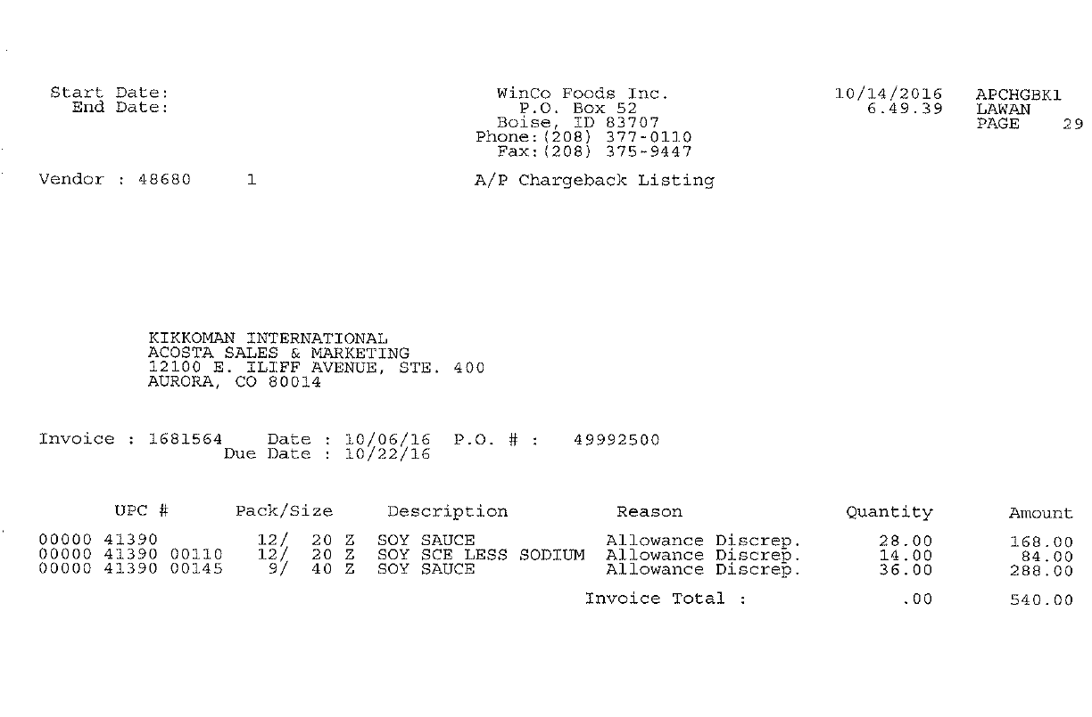
Product Description: This is the product for which the billback allowance is claimed and it should match with the customer contract.

The Client Order Invoice must be pulled prior to locating the contract in order to identify the order/ship dates that need to fall within the dates listed on the contract. Reference the Client SOP to determine what dates are acceptable for claims validation.
BB Quantity: This is the number of cases purchased as part of the Billback. The quantity listed on in the customer invoice needs to match the quantity listed on client order invoice
Total BB allowance – This is the total BB allowance amount deducted by the customer.

This is the Client Order Invoice number. This
can be used to retrieve the Client Order Invoice from the Review Order/view document link within ACOSTA Relay. This data is needed to validate if the particular product was ordered and invoiced with the billback allowance.
Also, this needs to be matched with the Client order invoice.
In this case the invoice number is 1681564
This must be pulled first to determine the rate per case allowance.

PO Number - This can be used to search for the client order invoice within ACOSTA Relay when the client order invoice number is not available. availableavailable.203900

UPC Code – The Universal Product Code (UPC) is the last 5 digits. This code needs to be validated on the Customer Invoice. This is the product in which the customer has deducted for the Billback allowance.

Note: This customer invoice example includes a deduction for a billback plus a deduction for a wall buy billback which may be on a separate contract. In this example 12/20 oz Soy Sauce items have a $6.00 billback amount ($168 / 28 = $$6.00 and $84 / 14 = $6.00) and the 9/40 oz Soy Sauce UPC 00145 indicates a $8.00 billback ( $288 / 36 = $8.00). If the billback contract does not include the wall buy allowance, then the wall buy contract must be located in ACOSTA Relay and attached to the claim.
2.8 Customer Contract for Billback, Example 3:

Contract #1

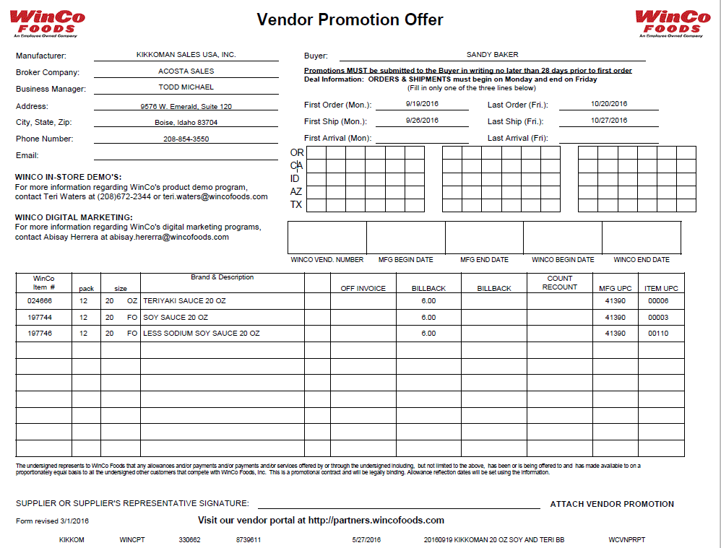
Product Description: This is the product for which the BB allowance is claimed and it should match with the customer invoice.

Billback Rate: This is the rate per case Billback allowance amount. The billback rate listed on the customer invoice should match with the Customer contract. Note: BB also means Bill Back allowance.

This contract is only listing the $6.00 billback for the 12/20 oz soy sauce.

Contract #2
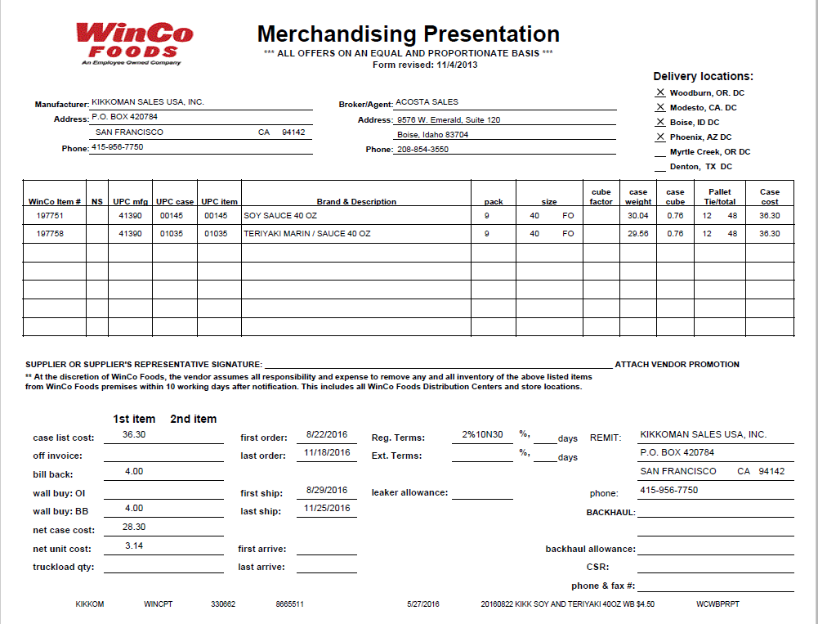
UPC Code/Description/Pack Size – This shows the UPC code, description of the item and pack size . The UPC code is the last 5 digits. This code needs to be validated on the Customer Invoice. This is the product in which the customer has deducted for the Billback allowance.
BB Rate: This is the rate per case Billback allowance amount.
The Client Order Invoice must be pulled prior to locating the contract in order to identify the order/ship dates that need to fall within the dates listed on the contract. Reference the Client SOP to determine what dates are acceptable for claims validation.

Note: You may need to add both BB rates together when verifying if you have the correct contract. In this example, $4.00 BB + $4.00 WALL BUY BB = $8.00 TOTAL BB. If the customer invoice is requesting an $8.00 BB, then a contract referencing both $4.00 BB and $4.00 Wall Buy: BB would cover this allowance. It is possible that the customer may submit separate deductions for the billback and the wall buy billback.

2.9 POP: Refer to the Client SOPs/Generic Help File for POP requirements

2.10 Contract for Billback Example 4: Found via Search For: Event Scheduler.

(not part of the above example claims, just an additional contract example)

Winco In-Store Demo’s – this is a general statement that may appear on contracts. This statement does not indicate the type of offer.
1
5
UPC Code – The Universal Product Code (UPC) is the last 5 digits. This code needs to be validated on the Customer Invoice. This is the product in which the customer has deducted for the Billback allowance.
Eg: In this case the UPC is the one highlighted in red 02018
i
Product Description: This is the product for which the BB allowance is claimed, and it should match with the customer invoice.

The Client Order Invoice must be pulled prior to locating the contract in order to identify the order/ship dates that need to fall within the dates listed on the contract. Reference the Client SOP to determine what dates are acceptable for claims validation.
Billback Rate: This is the rate per case Billback allowance amount. The billback rate listed on the customer invoice should match with the Customer contract. Note: BB also means Bill Back allowance.

2

- Deduction Type: Pricing

A pricing deduction occurs when the customer's requested price on the original purchase order differs from the client's invoice.

Documents required for validating a Pricing claim

Document Name | Source of the Document | Action by Accenture
Customer Invoice | ACOSTA Relay – search for the invoice under Backup Documentation, document type 2. | Step to Acosta for research
Client Order Invoice | ACOSTA Relay – search for this document within the Order/Invoice/PO search.

3.1 Customer Invoice for Pricing, Example 1:

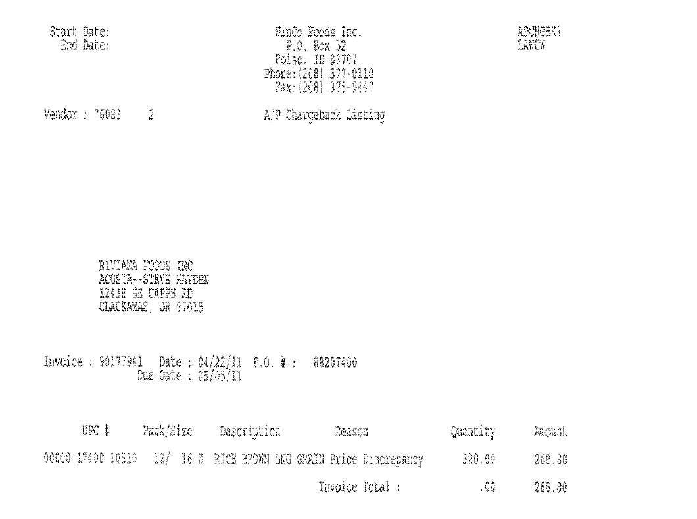
PO Number – This can be used to search in ACOSTA Relay for the client order invoice when the client order invoice number is not available. E.g.: In this case the PO # is 88207400

i
This is the Client Order Invoice number. This
can be used to retrieve the Client Order Invoice from the Review Order/view document link within ACOSTA Relay. . This data is needed to validate if the particular product was ordered and shipped. Also, this needs to be matched with the Client order invoice.
In this case the invoice number is 90177941
i
i
Deduction Type: This indicates that the deduction type is for Price Discrepancy

i
i
i
UPC Code – The Universal Product Code (UPC) is the last 5 digits. This code needs to be validated on Customer Invoice as well as Client order invoice. This is the product in which the customer has deducted for the Price Discrepancy.
E.g.: In this case the UPC is the one highlighted in red 00000 17400 10510
Pricing Allowance – This is the total difference amount claimed by the customer for pricing discrepancy.

Product Description: This is the product for which Price discrepancy is claimed and it should match with the client order invoice.

NOTE: Pepperidge Farms deductions which state price discrepancy are actually billbacks and should be worked per example in Billback deduction section.

3.2 Proof of Performance: Refer to the Client SOPs/Generic Help File for POP requirements

- Deduction Type: Slotting

A Slotting allowance is offered to the customer to purchase an item not currently stocked. A slotting lump sum allowance can be offered for each item and/or an off invoice can be offered as an introductory allowance for the first 30 days.

Winco will charge a $500 fee for in & out shippers and pallets

4.1 Customer Invoice for Slotting, Example 1:

i

Invoice No: This is the client order invoice number and is also the customer reference number that should match the Customer Reference number on the Claims Processing Screen.

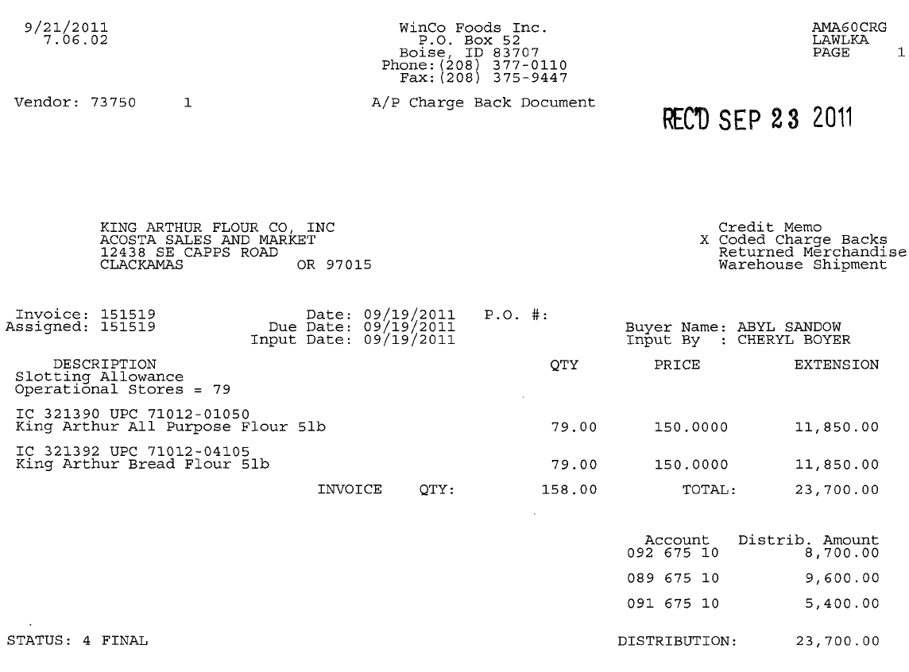
Invoice date - The invoice date can be used to determine the timeframe the customer was billed for the product and can assist in locating the contract. The date should fall between the ship dates on the contract for a valid claim.

1
UPC Code – The Universal Product Code (UPC) is the last 5 digits. This code needs to be validated on Customer Invoice as well as Client order invoice. This is the product the customer has deducted for the slotting allowance.
E.g.: In this case the UPC is the one highlighted in red 71012 01050
i
Number of Stores: This indicates the number of stores where the product has been slotted.
Extended Line-Item Amount: indicates the total slotting amount deducted for this line item.
i
i
Price per store – Slotting allowance per store claimed by the customer and it has to match with the contract per store.

2
Description Comments – This indicates the deduction is for slotting / New Item Placement
.

i
i
Product Description: This is the product for which slotting allowance is claimed and it should match with the customer contract.

4.2 Customer Contract for Slotting, Example 1: Found via Search For: Event Scheduler.

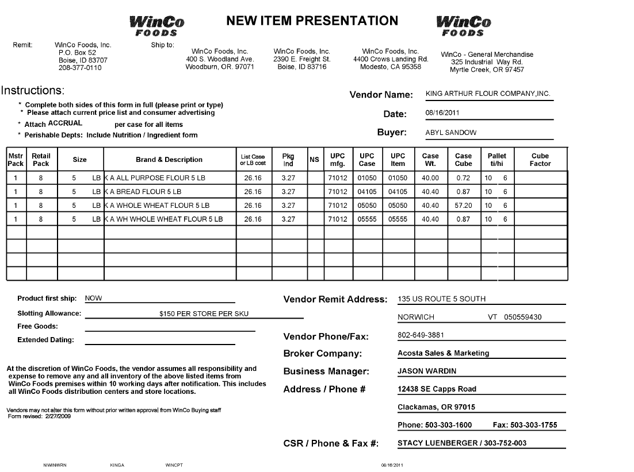
UPC Code – The Universal Product Code (UPC). This code needs to be validated on Customer Invoice as well as Client order invoice. This is the product the customer has deducted for the slotting allowance.
E.g.: In this case the UPC is the one highlighted in red 01050.

Order Dates: This is the date the contract was generated and can be considered if the product first ship date is not listed on the contract.

i
i
Ship Dates: This is the first date the product would be available for sale if the date is provided.

1
i
Product Description: This is the product for which the slotting allowance is claimed, and it should match with the customer invoice.

i
2
Order Dates: This is the date the contract was generated and can be considered if the product first ship date is not listed on the contract.

Slotting Allowance – This area will provide the slotting amount for each SKU and the lump sum amount can be arrived at by multiplying the number of stores by amount per SKU.
E.g.: 79 SKU *150-$ 11,850

4.3 Proof of Performance: Refer to the Client SOPs/Generic Help File for POP requirements

4.4 Customer Invoice for Slotting (Conversion Fee / Allowance), Example 2:

Description Comments – This indicates the deduction is for slotting / conversion fee. The invoice may also include verbiage of Conversion allowance.
.

i
UPC Code and Product Description – The Universal Product Code (UPC). This code needs to be validated on the Customer Invoice as well as the Client order invoice. This is the product the customer has deducted for the Slotting allowance. (e.g.: In this case the UPC is the one highlighted in red 00466

Date – The date on the customer invoice (found to the right of the Invoice number) should assist in locating the contract and fall within the ship dates listed on the contract.
Note: In some cases the order or ship date mentioned on client order invoice should fall between order dates \ship dates within the contract accordingly as per client specification.
3
1
i
Invoice No: This is the client order invoice number and is also the customer reference number that should match the Customer Reference number on the Claims Processing Screen.

Slotting Allowance – This area will provide the slotting amount claimed by the customer for each SKU and should match the contract per item allowance.
2

4.5 Customer Contract for Slotting (Conversion Fee), Example 2: Found via Search For: Event Scheduler.

Slotting Allowance – This area will provide the slotting amount offered to the customer for each SKU and should match the customer invoice per item allowance.

UPC Code and Product Description – The Universal Product Code (UPC). This code needs to be validated on the Customer Invoice as well as the Client order invoice. This is the product the customer has deducted for the Slotting allowance. (e.g.: In this case the UPC is the one highlighted in red 00466

1

2

Page 2 – Contract for Slotting (Conversion Fee), Example 2:

Ship start and end date – The date on the customer invoice (found to the right of the Invoice number) should assist in locating the contract and fall within the ship dates listed on the contract.
Note: In some cases the order or ship date mentioned on client order invoice should fall between order dates \ship dates within the contract accordingly as per client specification.
UPC Code and Product Description – The Universal Product Code (UPC). This code needs to be validated on the Customer Invoice as well as the Client order invoice. This is the product the customer has deducted for the Slotting allowance. (e.g.: In this case the UPC is the one highlighted in red 00466

1

3

4.6 Proof of Performance: Refer to the Client SOPs/Generic Help File for POP requirements

4.7 Customer Invoice for Slotting (Regional Distribution Operation Allowance Fee), Example 3:

Invoice date - The invoice date can be used to determine the timeframe the customer was billed for the product and can assist in locating the contract. The date should fall between the dates on the contract for a valid claim.

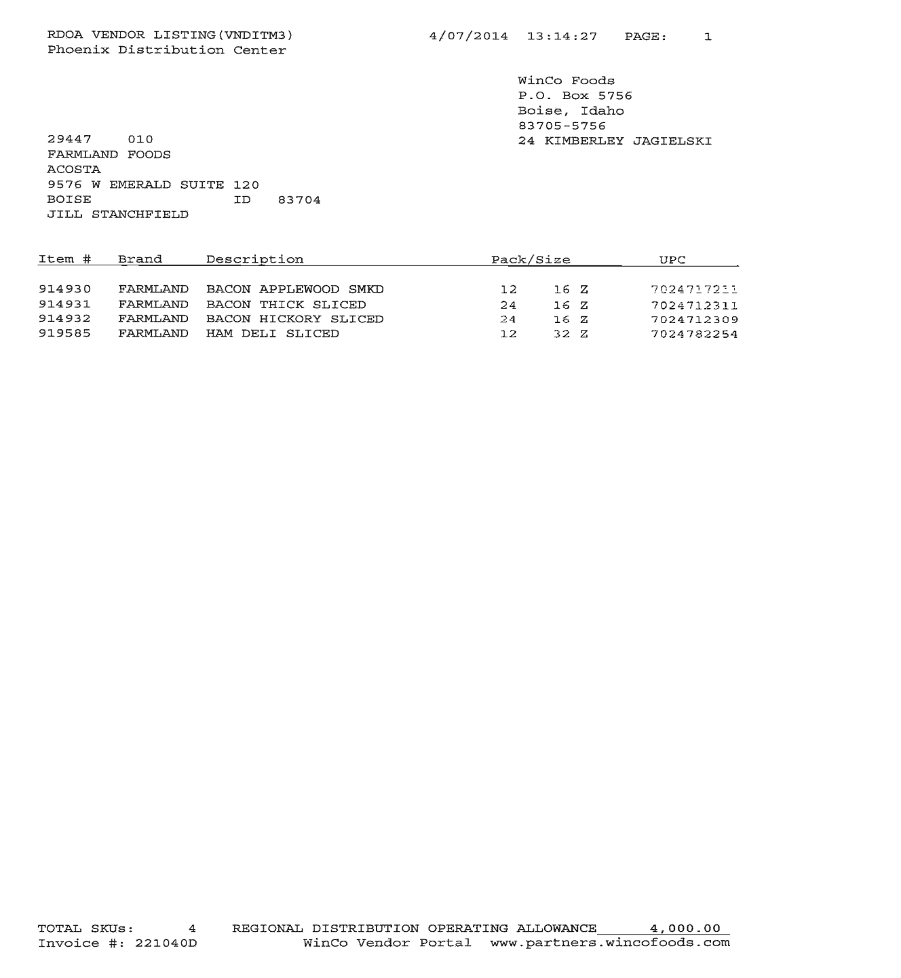
UPC Code and Product Description – This is the product the customer has deducted for the Slotting/Regional Distribution Operating allowance and it should match with the customer contract.
Allowance – This area will provide the slotting amount claimed by the customer. This example shows a lump sum total amount of $4,000.00 but the contract shows $1,000.00 per SKU. The invoice has 4 SKUs x $1,000.00 = $4,000.00.
Description Comments – This indicates the deduction is for slotting / regional operating allowance

4.8 Customer Contract for Slotting (Regional Distribution Operation Allowance Fee), Example 3: Found via Search For: Event Scheduler.

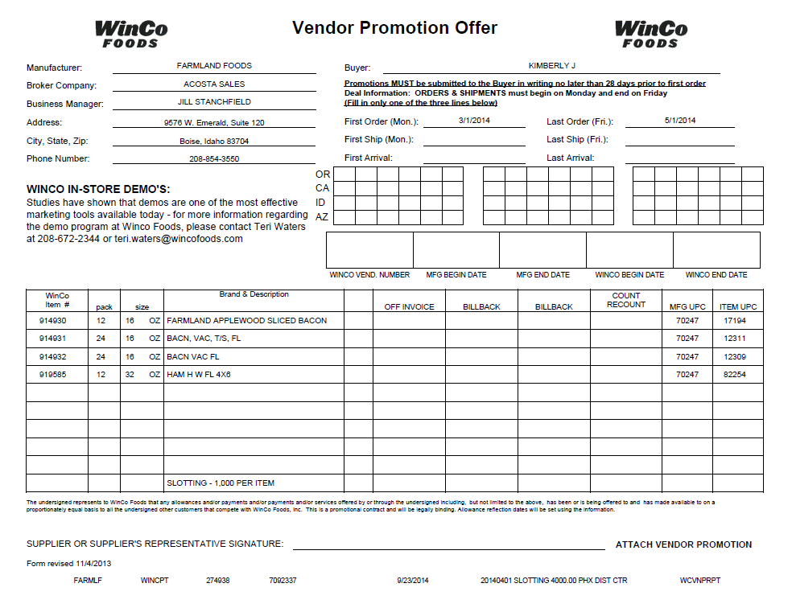
First order and last order date – The date on the customer invoice should fall within these dates.
Allowance – This area will provide the slotting amount claimed per each SKU and the lump sum amount can be arrived at by multiplying the number of SKUs by amount per SKU. Example: 4 SKUs x $1,000.00 = $4,000.00
UPC Code and Product Description – This is the product the customer has deducted for the Slotting/Regional Distribution Operating allowance and it should match with the customer contract.

4.9 Proof of Performance: Refer to the Client SOPs/Generic Help File for POP requirements

4.10 Customer Invoice for New Store Grand Opening, Example 4:

i
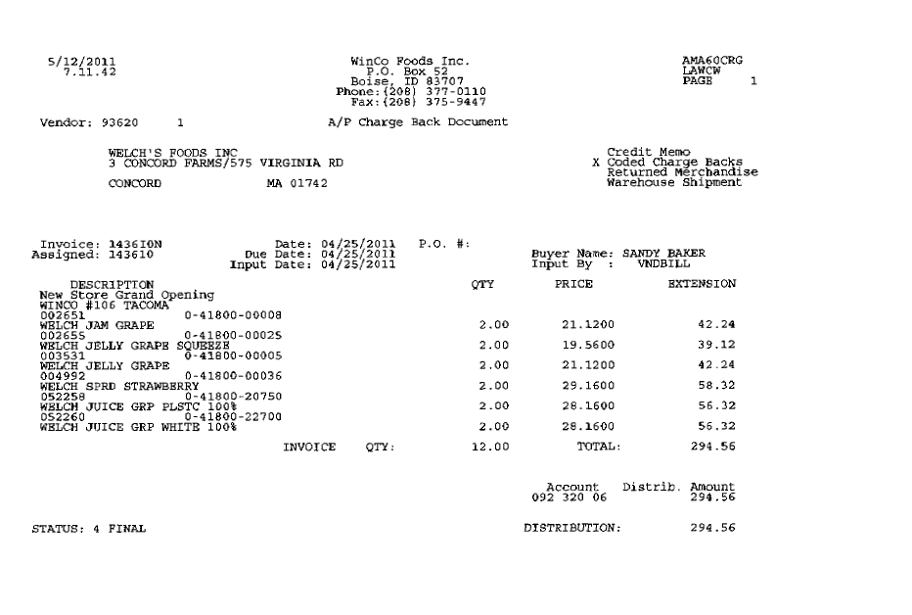
Qty – This shows the quantity the customer is claiming. This invoice is showing case quantity. Note: Quantity on the invoice could be either case or unit quantity.

Price – The cost that is being claimed. This example is showing case cost. Note: Cost may be shown as a case cost or unit cost.

Invoice No: This is the Client order Invoice number used to retrieve the Order/Invoice data out of Review Order / view document link within ACOSTA Relay

i
Customer Item Code: This can be matched to the APL – authorized Product Code List.
i
Invoice date: This is the invoice date which should fall within the customer contract ship dates to be a valid claim.

i
UPC Code – The Universal Product Code (UPC) is the last 5 digits. This code is used to validate key data elements regarding the customer invoice and client order invoice on the Review Order/view document link within ACOSTA Relay
E.g.: The UPC code is highlighted in red 0-41800 -00008

Description and store No: This indicates the deduction is for free goods to support a Winco New Store Grand Opening at this store location.
i
i
Total Amount: This is the total amount charged for the free goods.

Note: Customer is allowed 2 free cases with a max of 24 units for each New Store Grand Opening.

4.11 Contract or Sign Off Sheet for New Store Grand Opening, Example 4:

Winco New Store sign off sheet is no longer needed. Sales to continue creating events in Relay and attaching the Winco policy below in lieu of new store sign off sheet to clear new store opening claims.

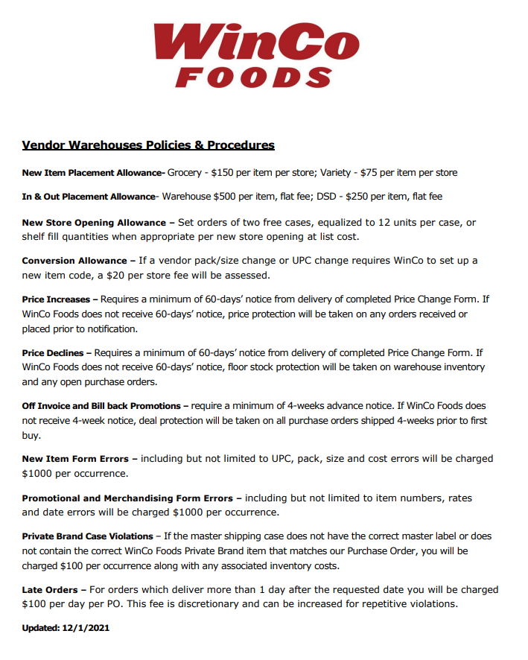

4.12 Proof of Performance: Refer to the Client SOPs/Generic Help File for POP requirements

4.13 Customer Invoice for New Store Grand Opening, Example 5:

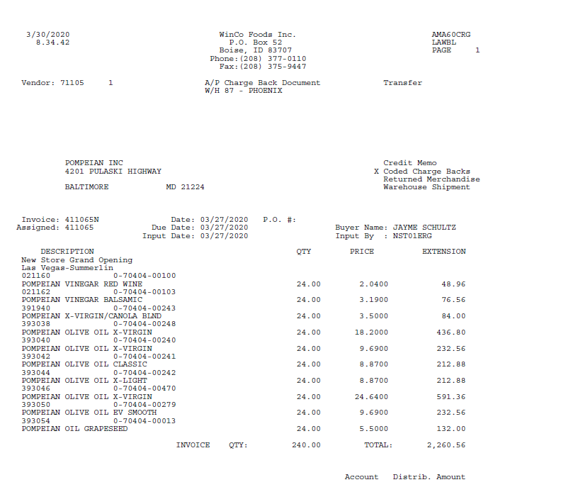
Price – The cost that is being claimed. This example is showing unit cost. Note: Cost may be shown as a case cost or unit cost.
Qty – This shows the quantity the customer is claiming. This invoice is showing unit quantity. Note: Quantity on the invoice could be either case or unit quantity. Customer is entitled to 2 free cases or a max of 24 units.
Description and store No: This indicates the deduction is for free goods to support a Winco New Store Grand Opening at this store location.
Customer Item Code: This can be matched to the APL – authorized Product Code List.
UPC Code – The Universal Product Code (UPC) is the last 5 digits. This code is used to validate key data elements regarding the customer invoice and client order invoice on the Review Order/view document link within ACOSTA Relay
E.g.: The UPC code is highlighted in red 0-41800 -00008

Total Amount: This is the total amount charged for the free goods.
Invoice date: This is the invoice date which should fall within the customer contract ship dates to be a valid claim.

Invoice No: This is the Client order Invoice number used to retrieve the Order/Invoice data out of Review Order / view document link within ACOSTA Relay

Note: Customer is allowed 2 free cases with a max of 24 units for each New Store Grand Opening.

4.14 Contract or Sign Off Sheet or Agreement for New Store Grand Opening, Example 4:

The Sign off sheet/Agreement form is the contract and is located in the Event Attachments tab of the VPF.

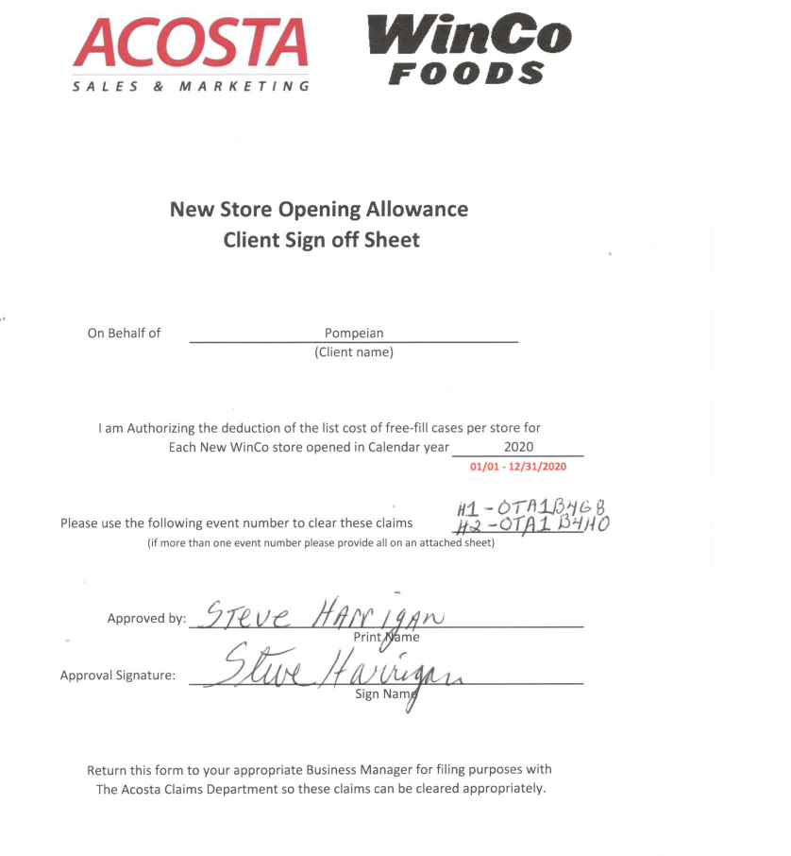

A Vendor Promotion Offer may also be in AR (see example below) and is not used as the contract. The Sign Off Sheet/Agreement Form is used as the contract.

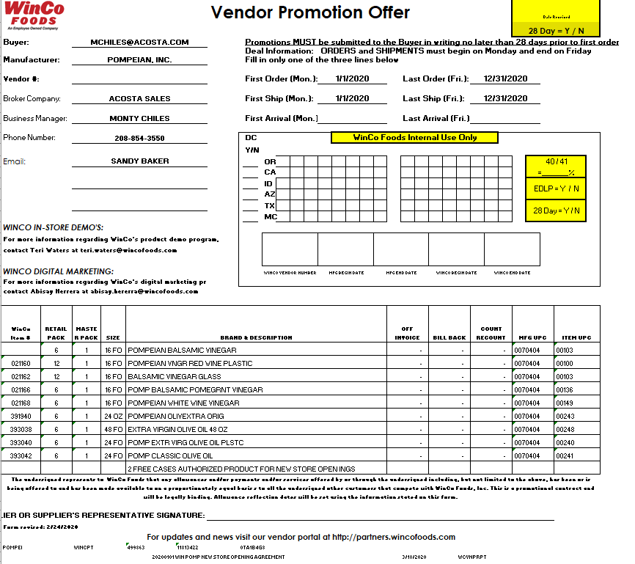

- Deduction Type: Unsaleables / Reclamation / Leaker Allowance (L/S)

An Unsaleable claim is taken for product that cannot be sold at the stores due to damages (and short coded Product)

Customer reclamation invoices may be called Reclamation or Damage Invoice and will have an “R” after invoice number which indicates these are reclamation claims.

There are multiple terms the customer may use on an invoice which indicate an Unsaleables deduction. These include (but are not limited to): Donate(d), Salvage(d), Out of Code, Short Dated, Short Coded, Expired Product, Swell, Mold(y)

5.1 Customer invoice for Unsaleables, Example 1:

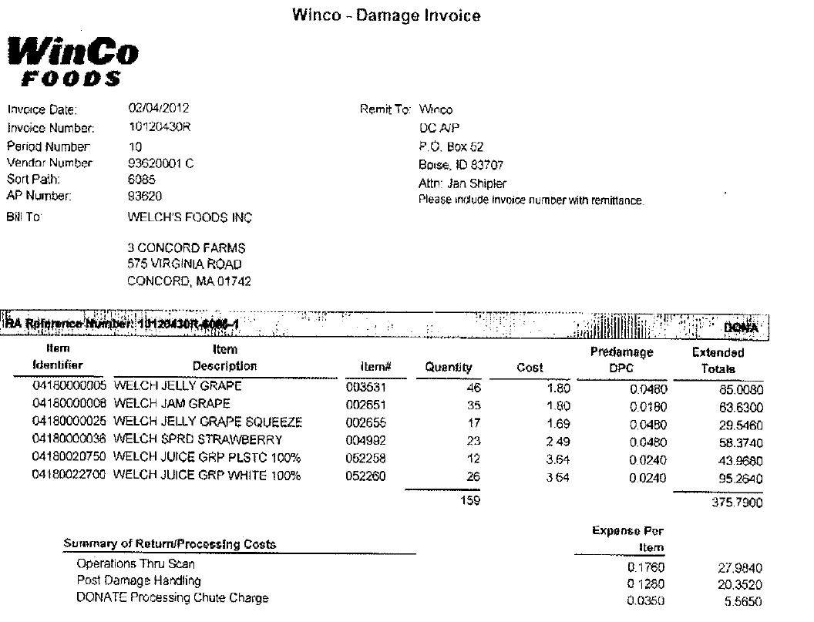
Invoice Number: This is the customer reference number. The customer reference number is suffixed with “R” indicating the invoice is for Reclamation/Unsaleables.
E.g.: 10120430R
Reclamation Quantity: This is the quantity claimed by the customer for unsaleables.
i
3
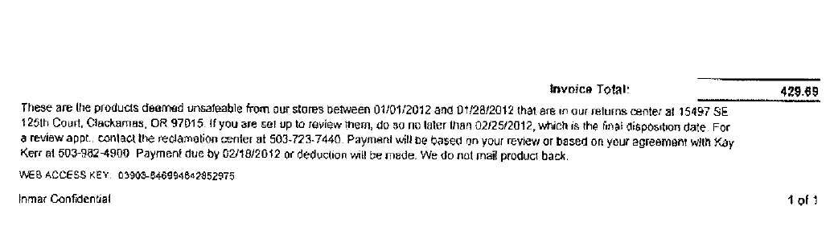
UPC Code – The Universal Product Code (UPC). This is the product the customer has deducted for the unsaleable claim. E.g.: In this case the UPC is the one highlighted in red 0418000005

Post Damage Handling – This would indicate the customer invoice is for Unsaleable product.
i
2
1
Reclamation Claim: This is the total amount claimed for unsaleables.

5.2 Client Deduction Notice – Leaker Allowance (L/S), Example 2:

Claim for Leaker Allowance would be stepped as Non-trade – Damaged/Unsaleables

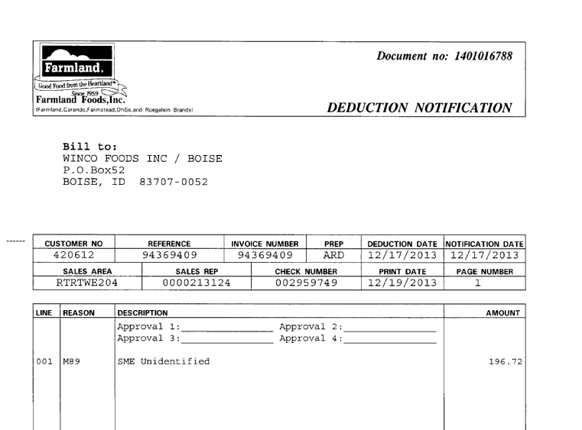
This amount is for additional Leaker Allowance customer is requesting.

The above Client Deduction notice indicates that customer is taking additional leaker allowance than what was invoiced.

5.3 Customer Invoice – Leaker Allowance (L/S), Example 3:

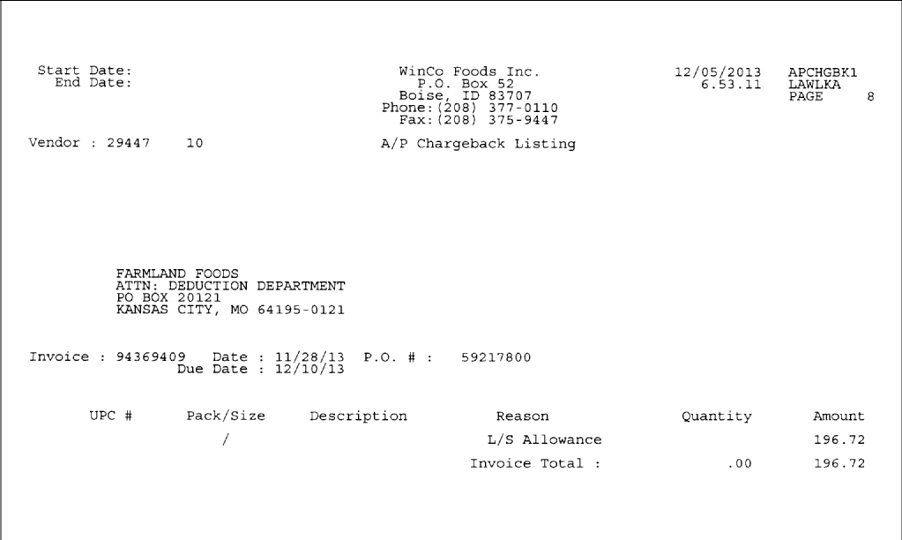
L/S = Leaker Allowance. This is an additional leaker allowance that customer is requesting.

The above Customer invoice indicates that customer is requsting an additional leaker allowance and this corresponds to the amount on the Client Deduction Notice.

5.4 Client Order Invoice – Leaker Allowance (L/S), Example 3:

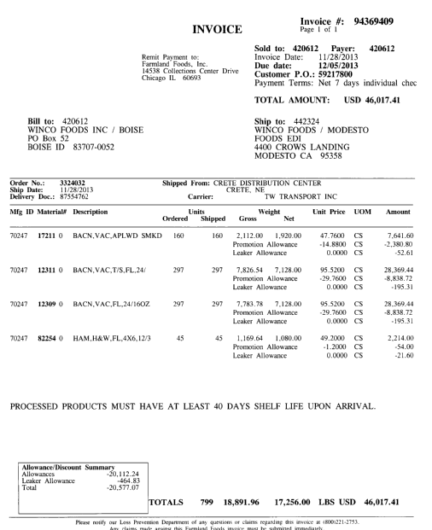
These amounts equal the leaker allowance amount that is listed in the Allowance/Discount Summary box

Above Client Order Invoice shows that client has already credited invoice with the leaker allowance that is offered to the customer. In example 5.2 and 5.3 customer is requesting additional amounts. Some clients do not allow extra leaker allowance – refer to client SOP.

Note: Additional promotional allowances may be included on invoice, see additional sections as necessary.

5.5 Customer Invoice – Short Coded Product / Expired Product, Example 4:

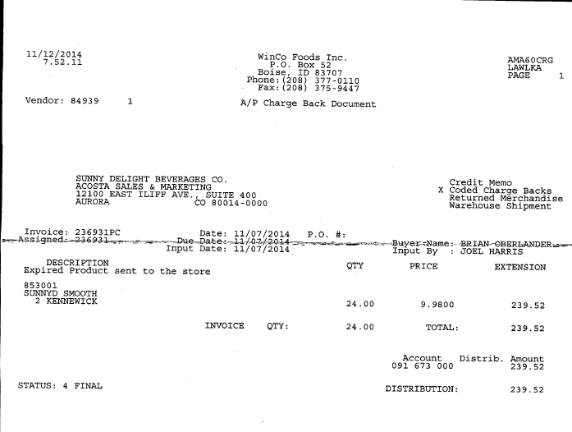
Qty – total quantity of expired product item.
Description – this is the description of product.
Total amount – this is total amount claimed for expired product.
Expired Product – refers to type of deduction. Expired Product is the same as short code(d) product.

- Deduction Type: Price Protection

A price protection deduction is taken by a customer when they are not notified in advance of a price change according to their policy. Customers will deduct the difference in price for the product in stock in their warehouse.

Documents required for validating a Pricing Protection claim

Document Name | Source of the Document | Action by Accenture
Customer Invoice | ACOSTA Relay – search for the invoice under Backup Documentation, document type 2. | Step to Acosta for research
Client Order Invoice | ACOSTA Relay – search for this document within the Order/Invoice/PO search.

6.1 Customer Invoice for Price Protection:

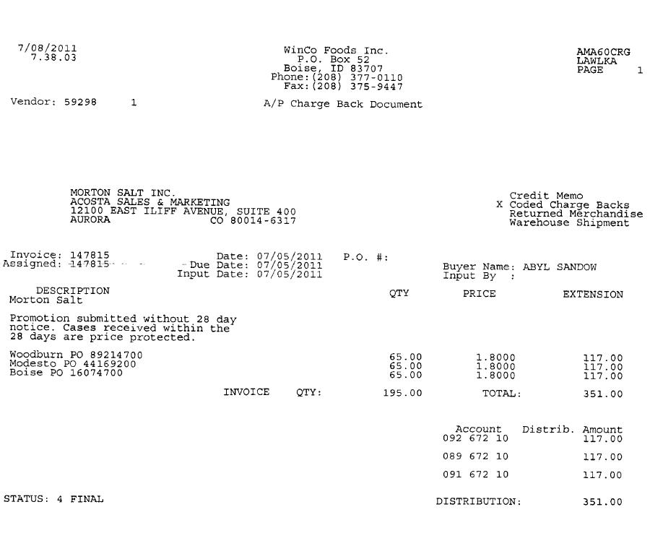
i
Total Claim: This is the total amount claimed by the customer towards price protection.
PO Numbers – customer PO numbers Price Protection was deducted against. These are used to retrieve the Order/Invoice data out of Review Order / view document link within ACOSTA Relay
i
Description Comments – This indicates that the deduction is for Price Protection.
Invoice date –– This is the date the customer billed for the price protection.

Invoice No: This is the customer reference number that should match the number in the Customer Reference field on the Claims Processing Screen.

i
i

- Deduction Type: Floor Stock Protection

Floorstock deductions are taken when a customer is not notified in advance of a promotional offer according to their policy. The allowance amount is taken on product in stock at the customer's warehouse.
Documents required for validating a Floor stock claim

Document Name | Source of the Document | Action by Accenture
Customer Invoice | ACOSTA Relay – search for the invoice under Backup Documentation | Step to Acosta for research

7.1 Customer Invoice for Floorstock Protection:

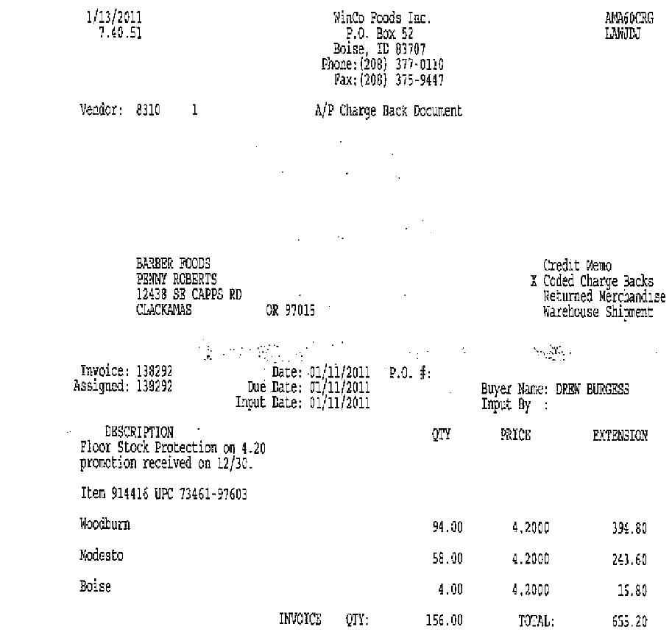
UPC Code – The Universal Product Code (UPC) is the last 5 digits. This code needs to be validated on Customer Invoice as well as Customer contract. Thishis is the product the customer has deducted for Floorstock Protection
E.g.: In this case the UPC is the one highlighted in red 73461-97603.
Invoice No: This is the customer reference number that should match the number in the Customer Reference field on the Claims Processing Screen.

i
Description Comments – This indicates the deduction is for Floor Stock Protection Could also be abrieviated FSP. It also states the allowance of $4.20 per case claimed by the customer.
i
Date – Customer claim date may assist in locating the customer contract and should fall with the ship dates on the contract.

i
i
i
Winco Location: These are the Winco warehouse locations where Floor stock protection is claimed.
i
Total Claim: This is the total amount claimed by the customer towards Floor stock Protection.
7.2 Customer Contract for Floorstock Protection: Found via Search For: Event Scheduler.
Ship start and end date –– The customer claim date should fall within the ship dates listed on the customer contract.

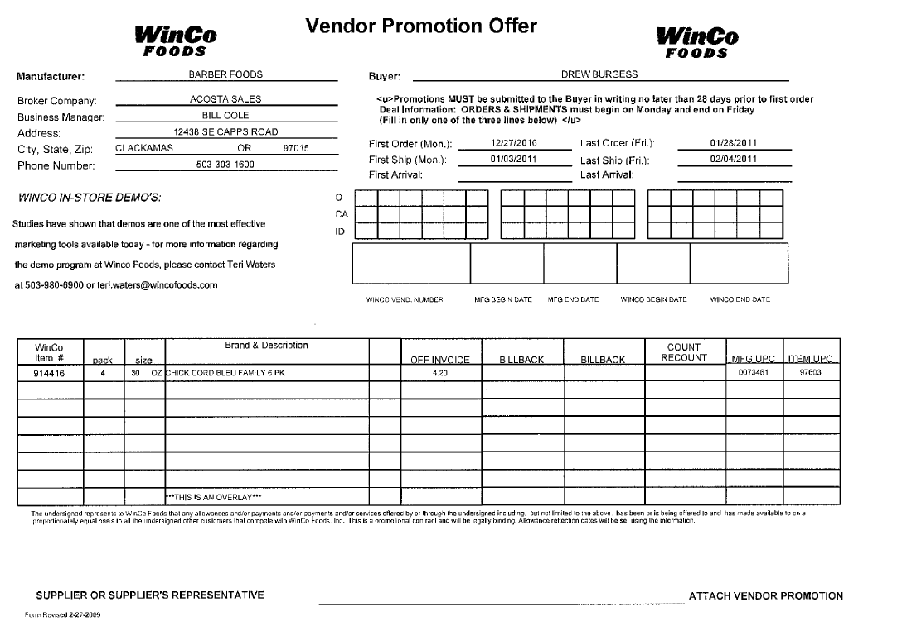
i
UPC Code – The Universal Product Code (UPC). This code needs to be validated on Customer Invoice as well as Client order invoice. This is the product the customer is claiming Floor stock protection. highlighted in red 73461-97603
i
Off Invoice – allowance the customer deducted for Floorstock should match the customer invoice.

Product Description: This is the product for which price protection allowance is claimed and it should match with the customer invoice.
i
i

- Deduction Type: Display

A Display deduction is an allowance given on an in-store product display (within a specific agreed section of the store) on an end cap or displayed per the client's requirements.

8.1 Customer Invoice for Display:

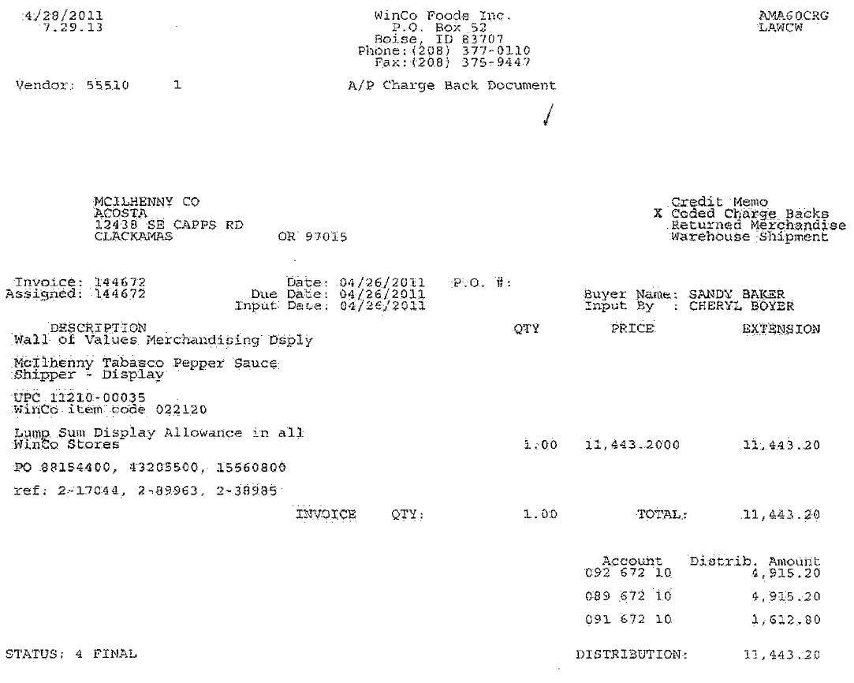
Date – Customer claim date.

Description Comments – This indicates the deduction is for Display.

Invoice No: This is the customer reference number that should match the number in the Customer Reference field on the Claims Processing Screen.

PO Numbers – This reflects the customer purchase of the product. This can be used to pull the client order invoice information.

UPC Code – The Universal Product Code (UPC) is the last 5 digits. This code needs to be validated on Customer Invoice as well as Client order invoice. This is the product in which the customer has deducted for the Display allowance.
E.g.: In this case the UPC is the one highlighted in red

i
i
Reason Comments – This indicates the reason “Wall of values Merchandising Display” is for a Display allowance.
2
i
i
3
1
Lump Sum: This is the total amount claimed by the customer towards display allowance.

8.2 Customer Contract for Display: Found via Search For: Event Scheduler.
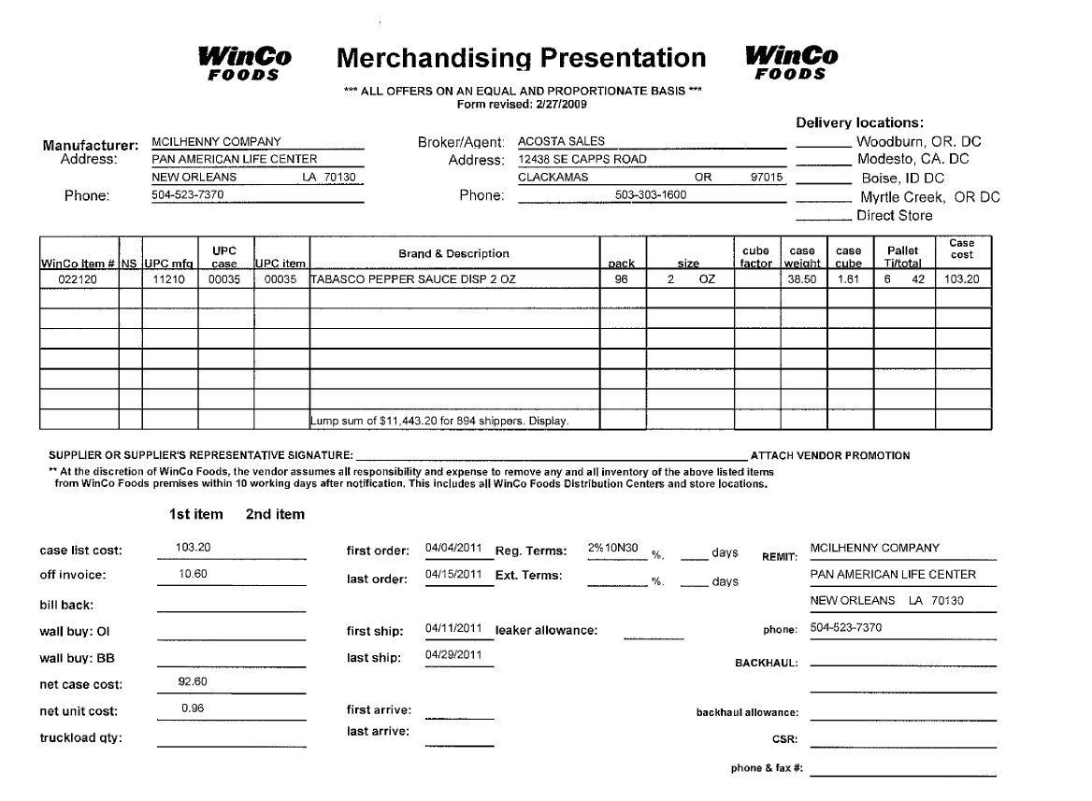
UPC Code – The Universal Product Code (UPC) is the last 5 digits. This code needs to be validated on Customer Invoice as well as Client order invoice. This is the product the customer has deducted for the Display allowance.
E.g.: In this case the UPC is the one highlighted in red 00035

1
i
Product Description: This is the product for which slotting allowance is claimed and it should match with the customer invoice and customer contract.

3
Lump Sum: This is the total amount claimed by the customer towards display allowance.

2
Ship start and end date –– The Client Order Invoice date/ship date should fall within the ship dates listed on the Contract.

Refer to Generic Help for POP requirements. Also note, refer to Client SOP for client specific requirements.

- Deduction Type: Mfr. Coupons

This is a manufacturer Coupon, typically cleared by client.

Documents required for validating a Coupon:

Document Name | Source of the Document | Action by Accenture
Customer Invoice | ACOSTA Relay – search for the invoice under Backup Documentation, document type 2. | Step to Acosta for research

  - Customer Invoice for Mfr. Coupons:

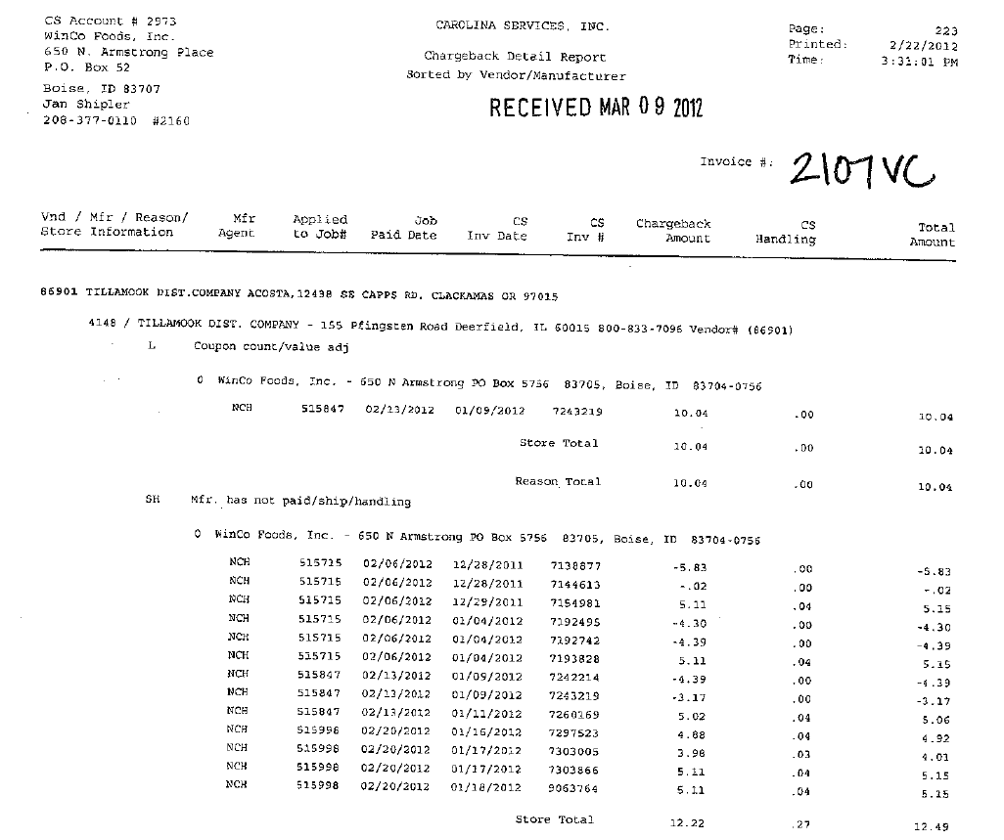
Invoice No: This is the Customer Invoice Reference Number. “VC” stands for vendor coupon also known as mfr coupon.
This identifies the claim is for Mfr Coupons and should be stepped up to Acosta for research.
i
This indicates the manufacturer name.
i

- Deduction Type: Sponsorship

A fee for a sponsorship program. Programs could include golf tournaments, customer group dinner or lunch sponsorships.

  - Check Request for Sponsorship:

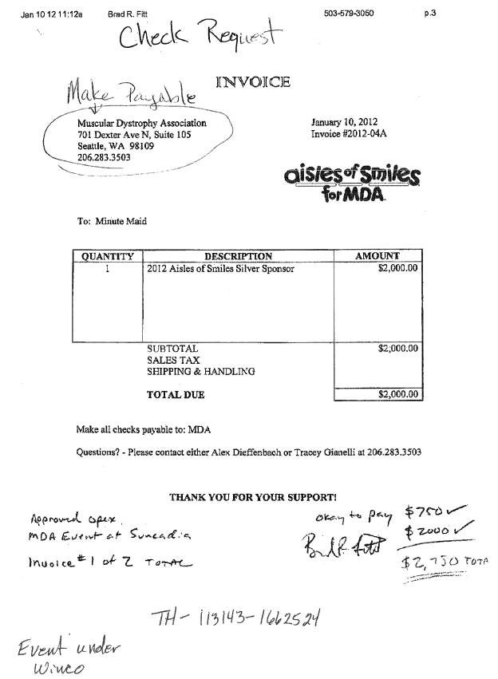
An additional amount of $750 towards the event was approved so the total amount of sponsorship matches the participant contract.
Sponsorship Fees: This is the amount for sponsor and it should match the participant agreement.
Details of Sponsorship: The program being sponsored by the client. This needs to match the participant agreement.
i
Invoice No: This is the Customer Check Request invoice number for the sponsorship
3
2
1
Client Name: This is the name of the client billed for the sponsorship.

  - Participation Agreement for Sponsorship:

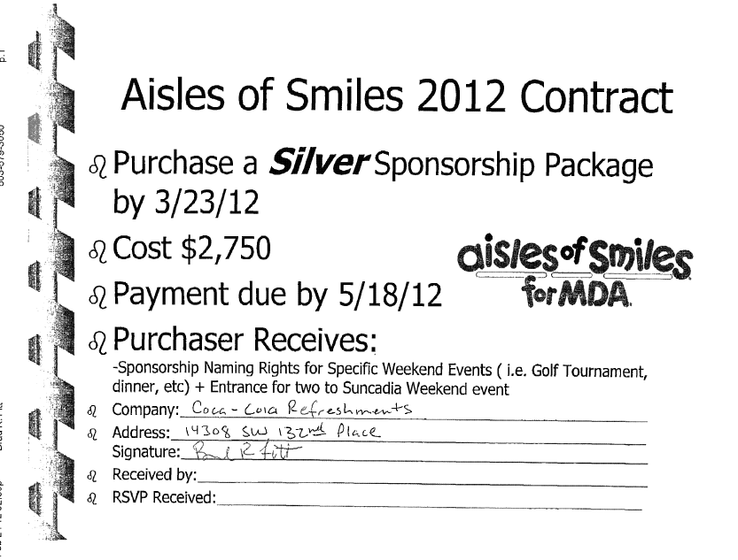
1
Company: Client sponsoring the event. (Coca Cola owns Minute Maid).

Details of Sponsorship: MDA also known as Muscular Dystrophy Association is the organization billing the mfr for the sponsorship fee and this needs to match the customer invoice. Aisles of Smiles is the name of the event/program.
2
Sponsorship Fees: This is the amount for the sponsorship fee and it should match the customer invoice.

3

- Deduction Type: Fees

Fees charged for various reasons and can include late delivery, miss delivery appointment or lumper/driver fees.
Documents required for validating a Fees/Penalties Deduction:

Document Name | Source of the Document | Action by Accenture
Customer Invoice | ACOSTA Relay – search for the invoice under Backup Documentation, document type 2. | Step up the claim to Acosta for research
Client Order Invoice | ACOSTA Relay – search for this document within the Order/Invoice/PO search.

  - Customer Invoice for Fees, Example 1:
i
Invoice No: This is the customer invoice reference number that should match the data in the Customer Reference field on the Claims Processing Screen.

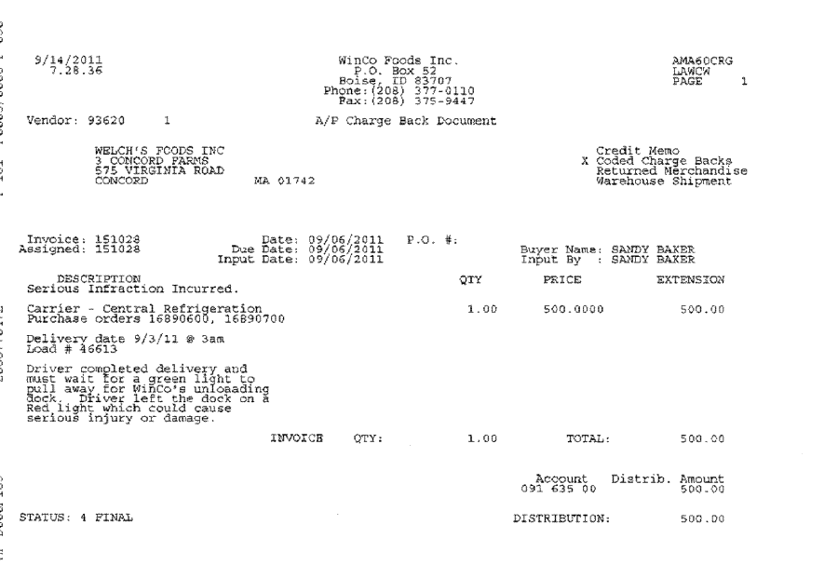
i
Total Amount: This is the total amount of the penalty fees charged.
i
Invoice date: This is the customer invoice date.

Explanation of why the client was charged the penalty fees.
Deduction Type: This indicates the penalty fees charged for the below mentioned P.O. numbers.

i

These are the P.O numbers for which the penalty Fees were charged. These will assist with pulling the Client Order Invoices in ACOSTA Relay.
i

11.2 Customer Invoice for Fees, Example 2:

This invoice shows Red Light Violation which is a Fee.

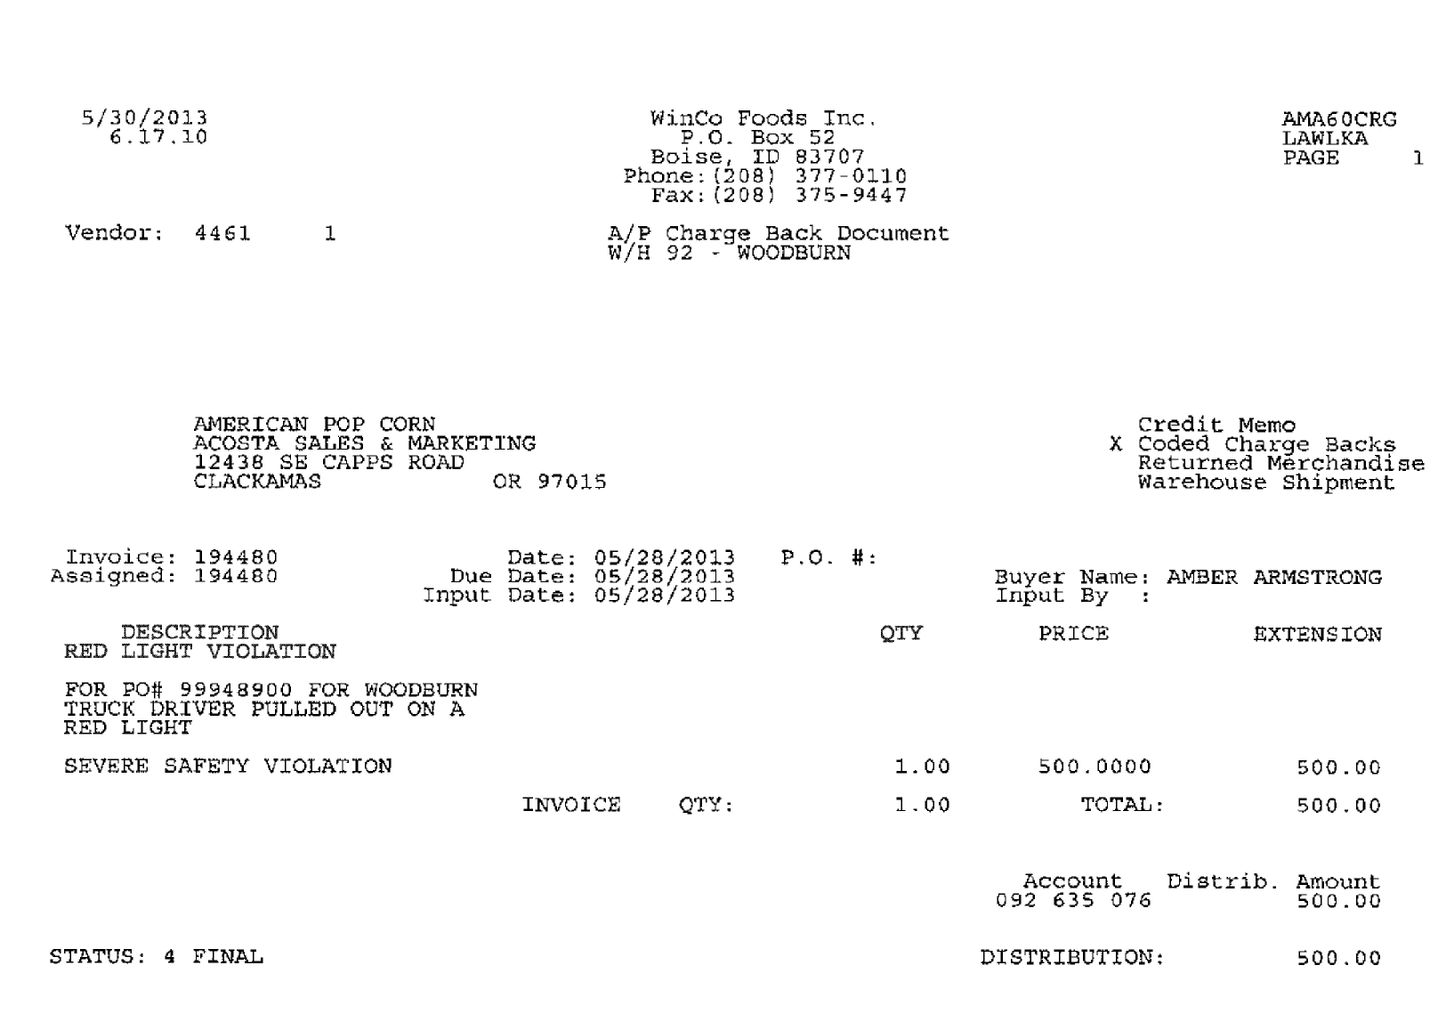
Invoice date: This is the customer invoice date.

Invoice No: This is the customer invoice reference number that should match the data in the Customer Reference field on the Claims Processing Screen.

This the the the P.O number for which the penalty Fees were charged. This will assist with pulling the Client Order Invoices in ACOSTA Relay.
Deduction Type: This indicates the penalty fees charged for the below mentioned P.O. numbers.

Explanation of why the client was charged the penalty fees.
Total Amount: This is the total amount of the penalty fees charged.

11.3 Client Order Invoice for Fees, Example 3:

Page 1
This is the Client Order Invoice number and needs to be matched with the customer invoice.
In this case the invoice number is 1226511

i
PO Number – The PO number referenced on the customer invoice
E.g.: In this case the PO # is 16890600
i

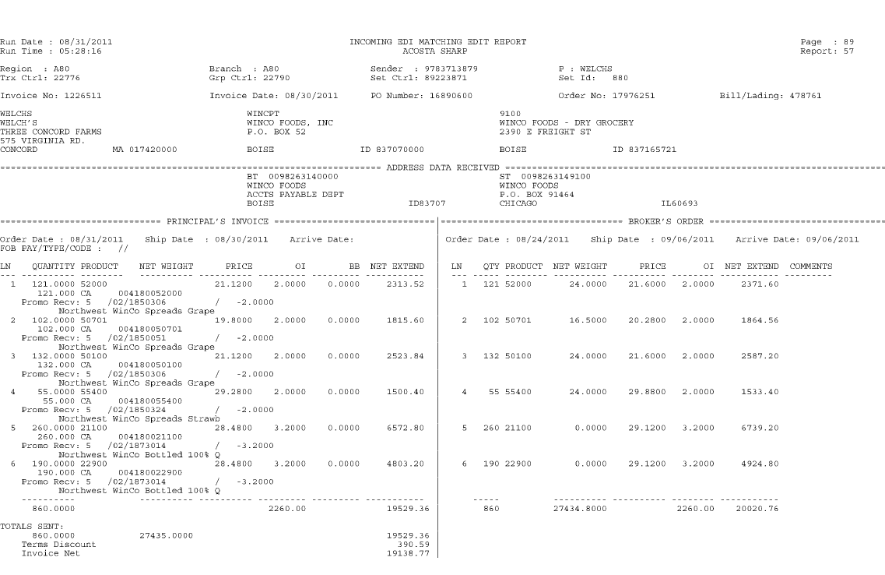

Page 2

i
i
This is the Client Order Invoice number and needs to be matched with the customer invoice.
In this case the invoice number is 1226512

PO Number – The PO number referenced on the customer invoice
E.g.: In this case the PO # is 16890700

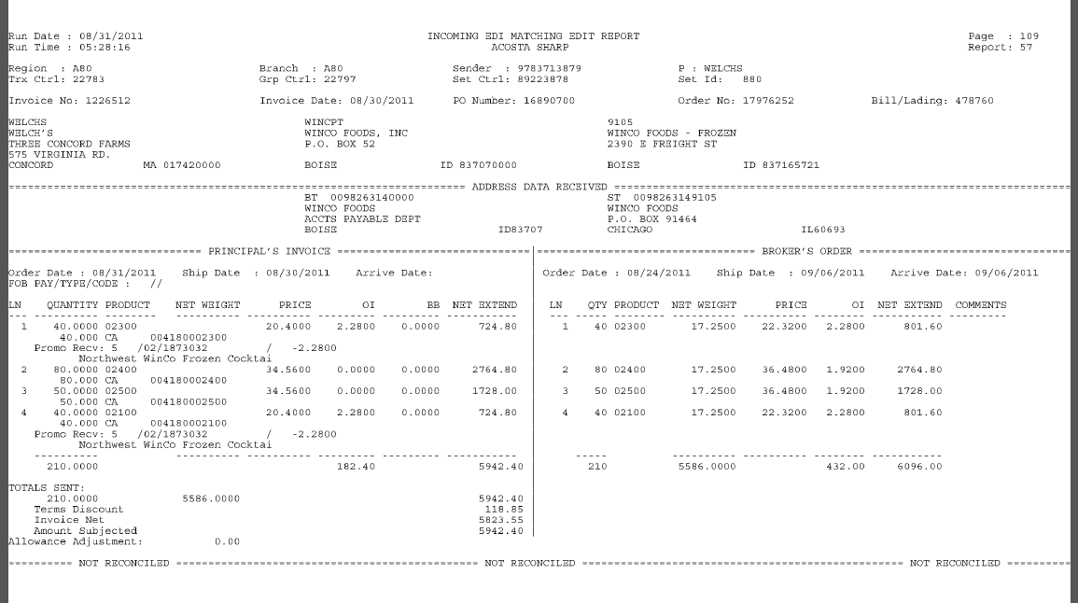

- Deduction Type: Freight/Backhaul

A Freight allowance is given to the customer for picking up the product via their own transportation services.

Documents required for validating a Freight/Backhaul claim:

Document Name | Source of the Document | Action by Accenture
Customer Invoice | ACOSTA Relay – search for the invoice under Backup Documentation, document type 2. | Step to Acosta for research
Client Order Invoice | ACOSTA Relay – search for this document within the Order/Invoice/PO search.

  - Customer Invoice for Freight, Example 1:

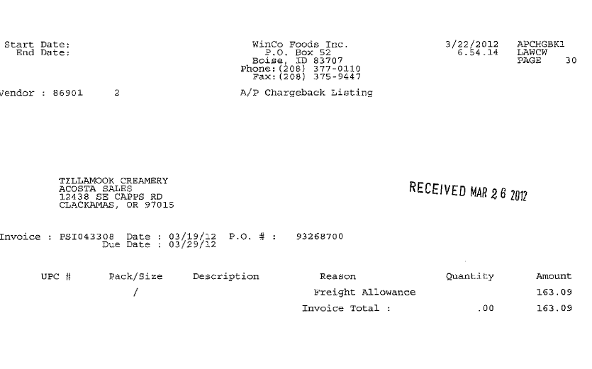
PO Number – This can be used to search for information regarding the order within ACOSTA Relay.
E.g.: In this case the PO # is 93268700
This is the Client Order Invoice number. This can be used to retrieve the Client Order Invoice from the Review Order/view document link within ACOSTA Relay. Also, this needs to be matched with the Client order invoice.
In this case the invoice number is PSI043308

Deduction Type: This indicates the type of deduction as Freight allowance.
i
i
i

Total Amount: This is the total amount claimed by the customer towards freight allowance.
i

If the PO/Client Order Invoice is available in ACOSTA Relay under View Documents of the Review Order Screen, then link the order to the claim and step Escalate – Non Trade to Acosta for further review.

12.2 Customer Invoice for Freight/Backhaul, Example 2:

i
i
i
Invoice/PO Number – This can be used to search for information regarding the order within ACOSTA Relay.
E.g.: In this case the PO # is 305844000(S)
Total Amount: This is the total amount claimed by the customer towards freight allowance.
Deduction Type: This indicates the type of deduction as Freight allowance.

A lumping allowance is charged when the customer hires someone to unload the truck and charges the client a lumper fee (this type of fee would be coded as Non-Trade / Freight/Backhaul). If available, link a copy of the Client Order Invoice (or 57/880) as the proof of performance and step up to Acosta for review.

- Deduction Type: Returns

Products returned by the customer to the client.

Documents required for validating a Return claim

Document Name | Source of the Document | Action by Accenture
Customer Invoice | ACOSTA Relay – search for the invoice under Backup Documentation, document type 2. | Step to Acosta for research
Client Order Invoice | ACOSTA Relay – search for this document within the Order/Invoice/PO search if one is present.

  - Customer invoice for Returns:
Page 1

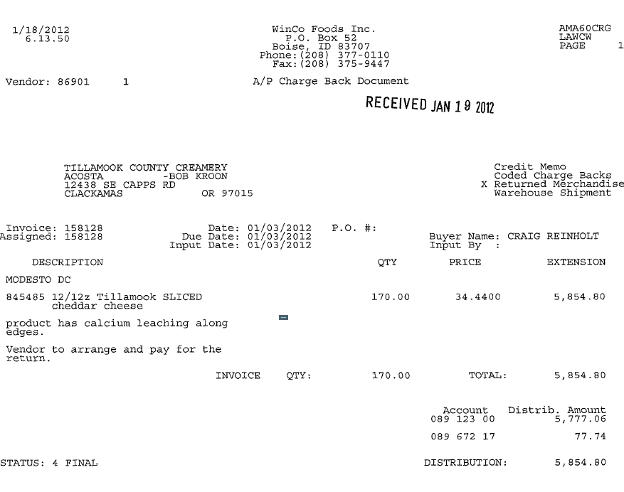
i
Deduction Type: This data specifies the deduction is for Returned goods.
i
Total Amount: This is the total amount claimed for the return goods by the customer.
Invoice date: This is the date reflected on the Client Order Invoice.

i
Reason for Shortage: This is the reason for the goods being returned. The product was leaking around the edges of the packaging.
i
Invoice No: This is the Client Order Invoice Number used to retrieve the Order/Invoice data out of Review Order / view document link within ACOSTA Relay
Product Description: This is the product for which the return deduction is claimed.
i
i

Page 2

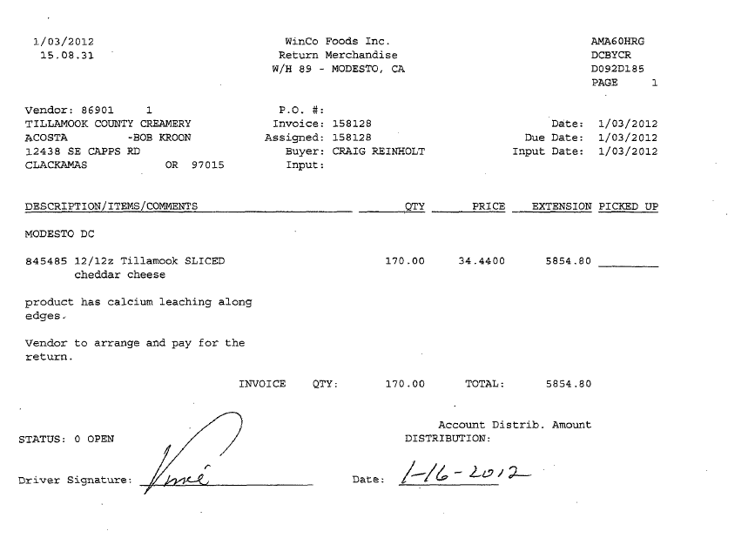

14. Deduction Type: Shortages

It is a deduction for shorted product on an order that the client billed the customer for.
Documents required for validating a Shortages Deduction:

Document Name | Source of the Document | Action by Accenture
Customer Invoice | ACOSTA Relay – search for the invoice under Backup Documentation, document type 2. | Step to Acosta for research
Client Order Invoice | ACOSTA Relay – search for this document within the Order/Invoice/PO search.

14.1 Customer Invoice for Shortages:

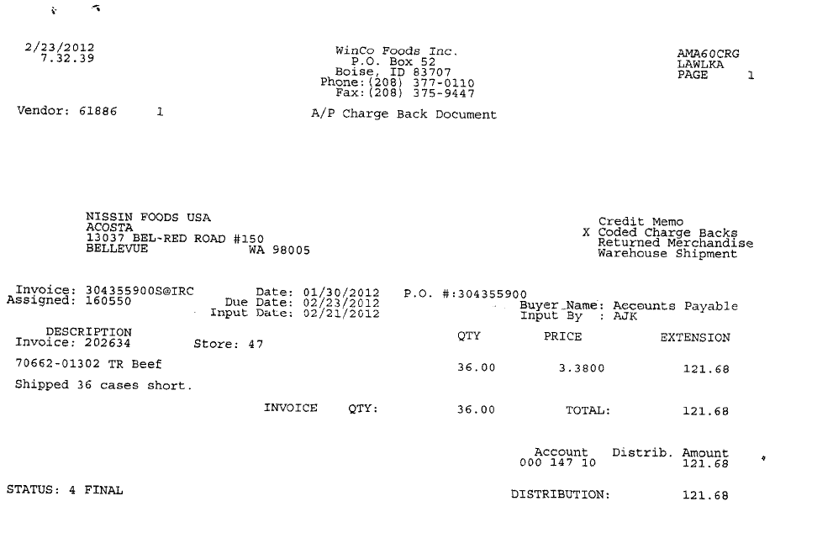
UPC Code – The Universal Product Code (UPC) is the last 5 digits. This code is used to validate key data elements regarding the customer invoice and client order invoice on the Review Order/view document link within ACOSTA Relay.
E.g. The UPC Code is highlighted in red 01302

Invoice date: This is the date matching the Client Order Invoice date.
i
i
i
This is the Client Order Invoice number which can be used to locate the client order invoice within ACOSTA Relay.
This is used to retrieve the Order/Invoice data out of Review Order / view document link within ACOSTA Relay.
In this case the invoice number is 304355900
i
i
Allowance type –This reflects the deduction is for Shortages.
Once Identified as Shortages the claim needs to be stepped to Acosta. Note: If invoice states CT Billed – Not Received this also indicates deduction is for shortages.

P.O No: This is the purchase order number which should match the information listed on the client order invoice.
In this case the invoice number is 304355900

i
Total Shortage – This is the total Shortage amount deducted by the customer.

14.2 Client Order Invoice for Shortages:

i
i
This is the Client Order Invoice number and needs to be matched with the customer invoice.
In this case the invoice number is PSI-202634.

PO Number – The PO number referenced on the customer invoice
E.g.: In this case the PO # is 304355900

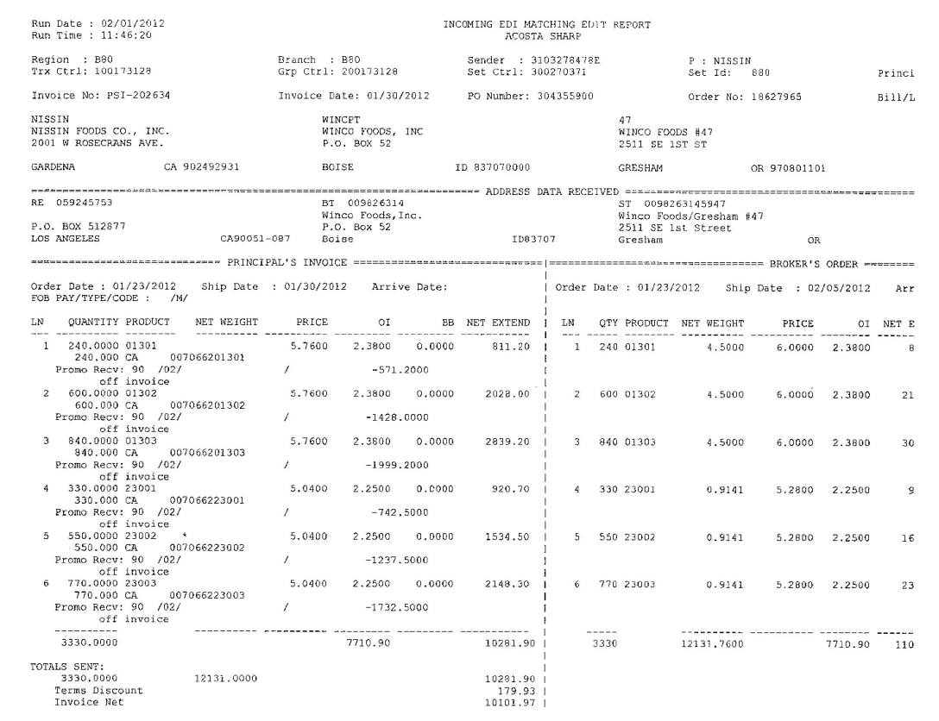
UPC Code – The Universal Product Code (UPC) is the last 5 digits. This code is used to validate key data elements regarding the customer invoice and client order invoice on the Review Order/view document link within ACOSTA Relay
E.g. The UPC Code is highlighted in red 01302

i

15. Deduction Type: Post Audit

Internal/external auditors find claims that the customer is entitled to but did not take from previous years. Post Audits should be researched in the same manner as other claims by accessing previous year’s files.

NOTE: The post audit claim must first be researched to ensure the customer has not already billed for the allowance before the normal validation process can begin.

Once the post audit claim has been researched to ensure the customer has not already billed for the allowance refer to the appropriate allowance section of the SOP to continue with validation. If the post audit is for an allowance not defined in an allowance section of the SOP refer to the post audit example for validation information.

15.1 Customer Invoice for Post Audit:

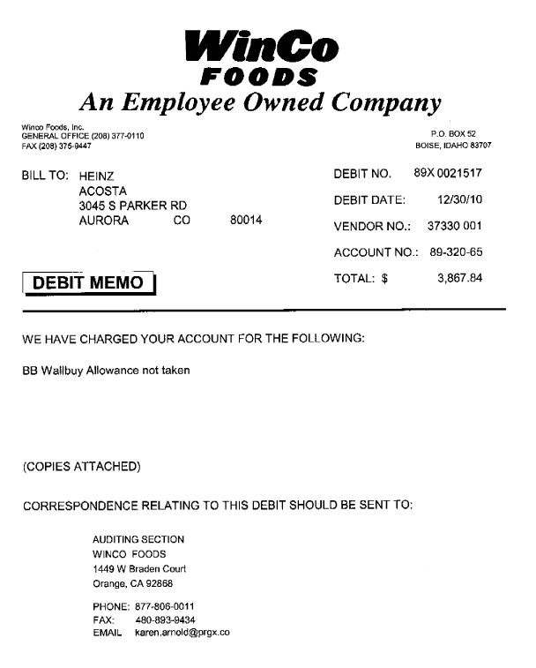
Invoice No: This is the customer invoice # for the Post Audit claim. Invoice #’s that begin with 89X, 91X, 92X or 94X indicates Post Audits.
Deduction Reason: The customer is charging for a Billback.
i
i
i
i
Invoice date: This is the customer invoice date for the Post Audit.
Total Amount: This is the total claim amount towards Post Audit

Customer Invoice Post Audit Summary Page:

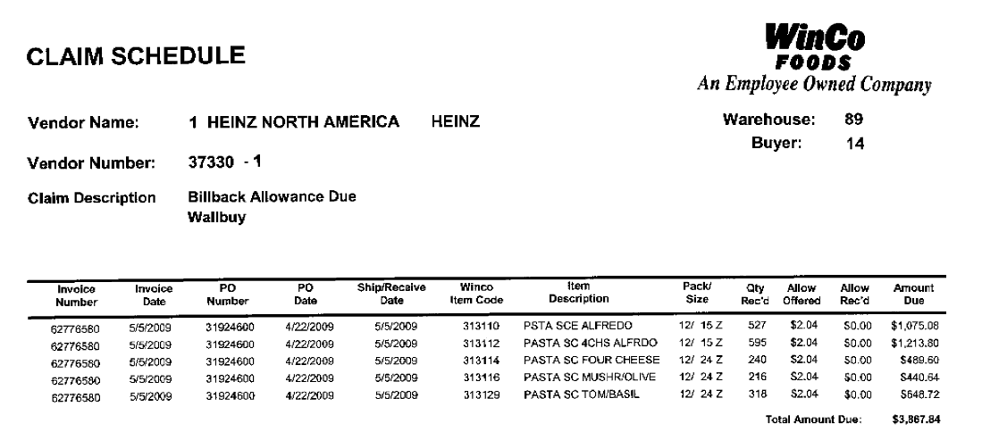
Ship/Receive Date: identifies the year for the post audit. E.g. 2009

i
i
BB Wall Buy Allowance and Qty Rec’d: reflects the allowance and item quantities received and deducted for in the post audit.

i
i
Item Description: These are the item descriptions for which the customer is claiming the Post Audit Billback allowance.
Invoice No: These are the client order invoice numbers used to locate the orders/invoices/POs in the Search Screen using the Review Order Screen under the View Documents tab in ACOSTA Relay.

16. Deduction Type: Product Recall

Note: Recall deductions may reflect the following fees on the customer invoice:

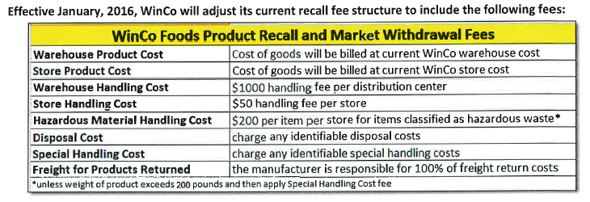

16.1 Customer Invoice for Product Recall:
Product Recall claims should be stepped as Non-Trade / Other w/notes

Page 2
Product Description and UPC
Total claim Amount

17. Deduction Type: Demos

In-store demonstration of client's product to consumers. Time, resources and product charges are billed back to the client.

17.1 Customer Invoice for Demos, Example 1:

If client clears to Trade a contract is needed. Otherwise, if Client clears as Non-Trade a contract is not required.

Page 1 of invoice

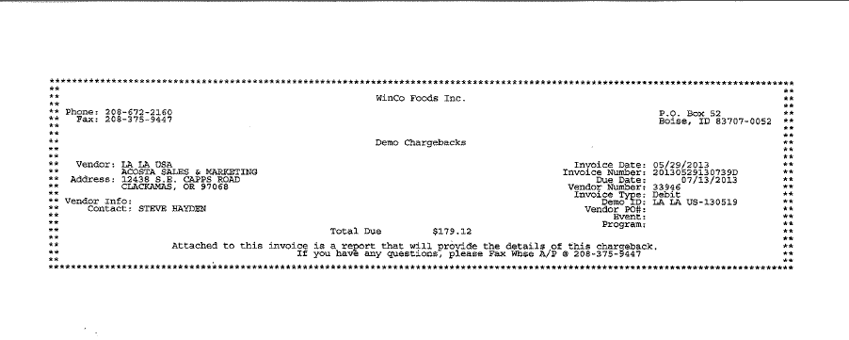
Total being deducted for this claim.
This indicates deduction type is for Demo.

Page 2 of invoice
Date of Demo
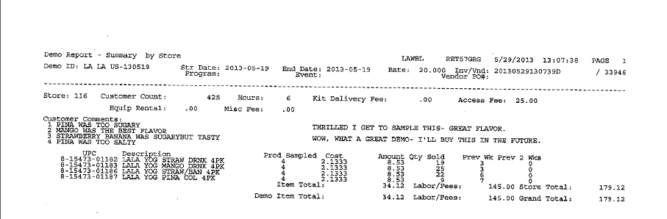
Indicates quantity of samples and cost for each along with total amount. Total amount is calculated by multiplying the # of samples used x the cost and in this example it is 4 x 2.1333 = 8.53.
This indicates the Labor/Fees associated with Demo which is include in the total that is being deducted.
Indicates item UPC and description of item along with pack size.
Total being deducted for this claim.
18. Deduction Type: Warehouse Withdrawal/Count-Recount

For cases shipped to stores from the main customer’s warehouse during a specified period of time per the contract. The customer should not be referencing a purchase order number when deducting for a warehouse withdrawal/count recount allowance.

When working some non-food accounts for Off Invoice, Billback and Warehouse Withdrawal allowances, the customer invoice allowance may not match the contract. The allowance per case may be broken down into inner packs per case.

For example: contract offer is for $12.00 per case. The claim comes in at $4.00 as the inner packs are 4/3 or 3/4 ($12 per case / 3 units per case = $4 x 3 inner packs = $12.00).

18.1 Customer Invoice for Warehouse Withdrawal/Count-Recount:

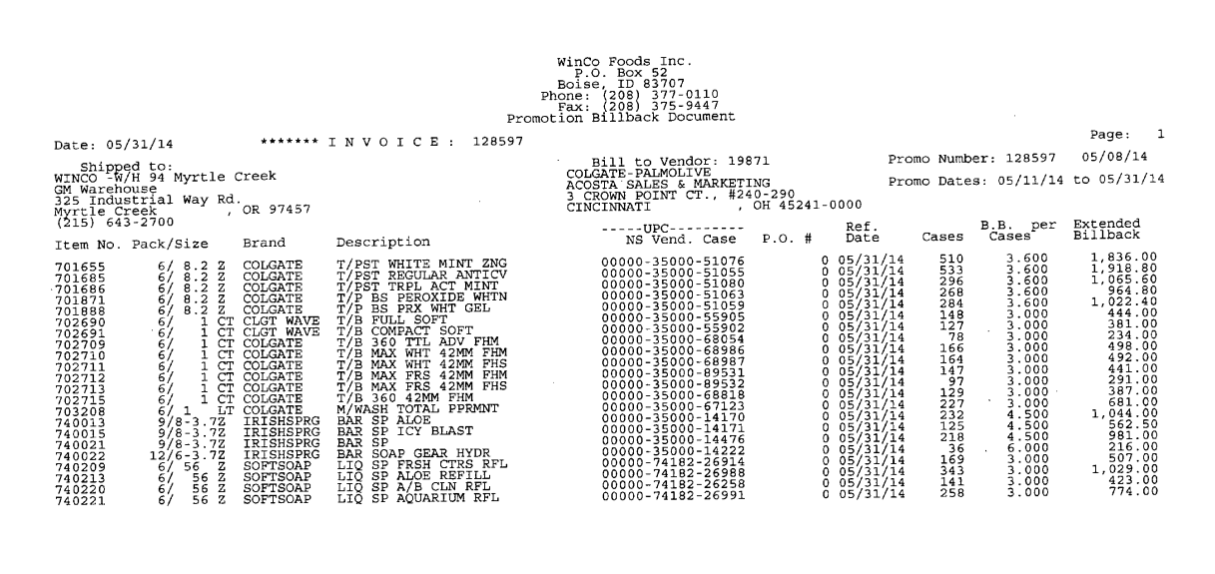
Allowance Rate – this is the rate customer is deducting for this item. The contract indicates a per case rate for this example. The contract offer is $14.40. The claim shows $3.60 as the inner packs are 4/6 ($14.40 / 4 units per case = $3.60 per inner pack = $14.40.
Quantity – this is the total quantity for item claimed for the Count/Recount
Performance dates - dates need to match contract dates
UPC Code – The Universal Product Code (UPC) is the last 5 digits. This is the product in which the customer has deducted for the Count/Recount allowance.
Eg: In this case the UPC is the one highlighted in red 51076
Pack/Product Description: This is the product for which the count/recount is claimed and it should match with the customer contract.
indicates
Customer Item Code: This can be matched to the APL – authorized Product Code List. It is also listed on the customer contract for this example.

Note: Customer Invoice may show deduction type as billback instead of Count/Recount. Review contract to determine correct deduction type.

18.2 Customer Contract for Warehouse Withdrawal/Count-Recount: Found via Search For: Event Scheduler.

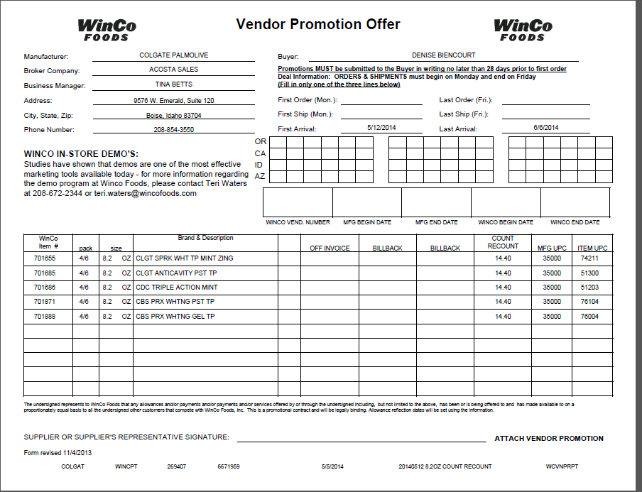
Performance dates – this is the date that the deduction should fall between.
Rate – per case rate for Count/Recount allowance
Customer Item Code/Pack/Description – This is the product details of item that is being offered for the Count/Recount . This can be matched to the APL.

18.3 Proof of Performance for Warehouse Withdrawal/Count-Recount:

If POP is required by client it would be a Sales Summary or Nielsen report. In this example, client does not require POP per client SOP. Check client SOP for requirements on POP.

19. Deduction Type: Retal Merchandising Program (HABA)

19.1 Customer Invoice for Retail Merchandising Program / HABA:

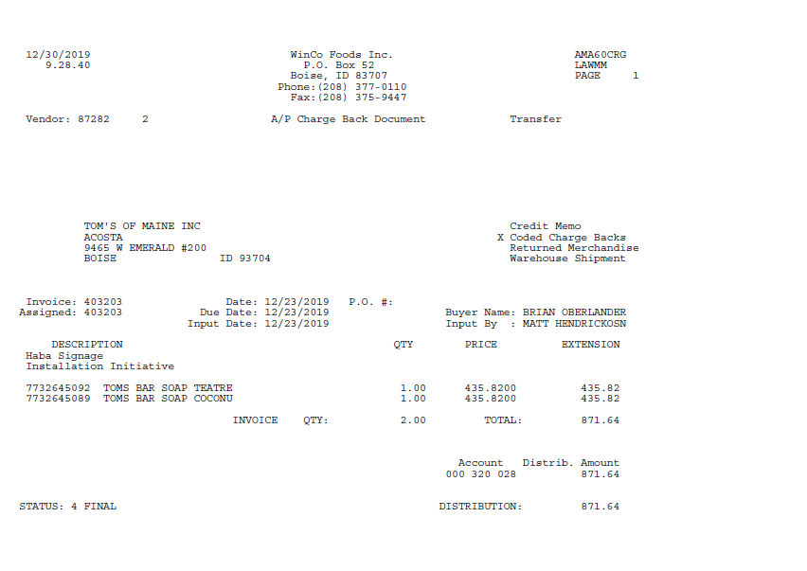
Description – Haba Signage Installation Initiative indicates what the deduction is for. This is considered Fair Share/Retail Merchandising.
Performance dates - date that the initiative was performed on. greement dates.
Deduction amount – this is the total amount of the deduction.

19.2 Customer Agreement for Retail Merchandising Program (HABA)
This may be used as the Contract.

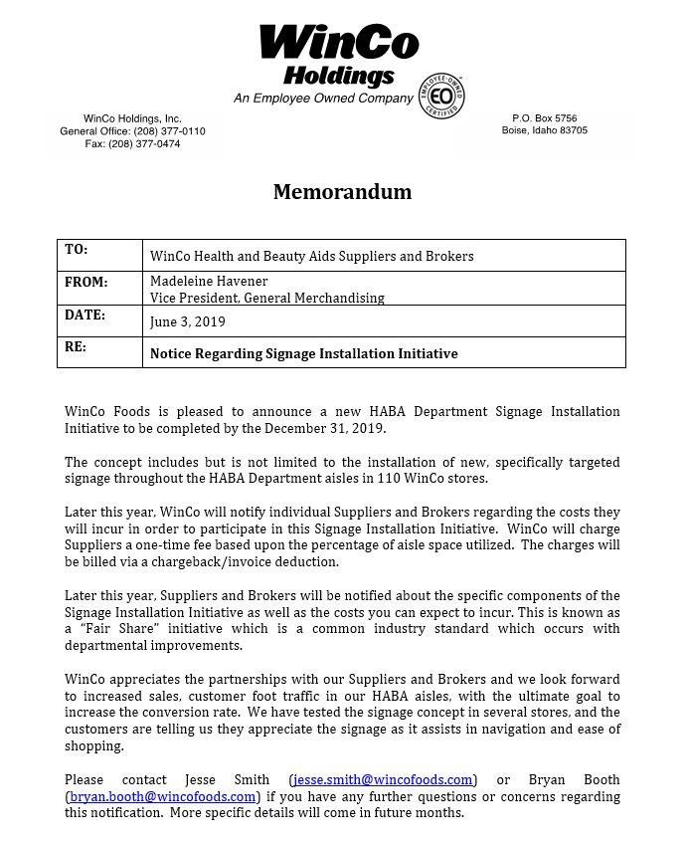
20. Deduction Type: Markdowns / (Discontinued)
Offer to reduce the shelf price of the product. Usually offered to aid in selling slow moving or discontinued items. Could be considered as Trade or Non-Trade.

20.1 Customer Invoice for Markdowns (Discontinued):

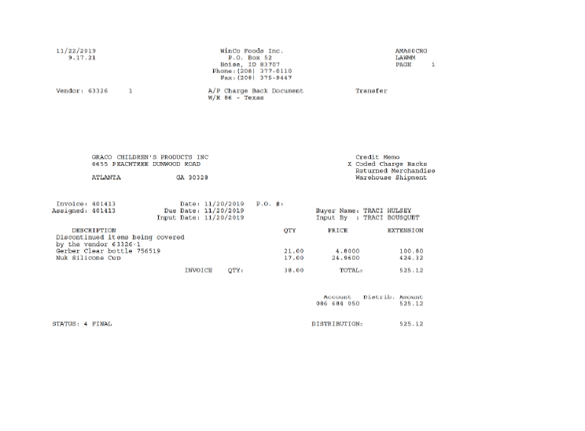
Product Description: This is the product for customer is deducting for.
Invoice date –– This is the date the customer billed for this deduction.

Description Comments – This indicates that the deduction is for Discontinued items.
Total Claim: This is the total amount claimed by the customer towards discontinued items.
Invoice No: This is the customer reference number that should match the number in the Customer Reference field on the Claims Processing Screen.

Note: Refer to Client SOP for client specific requirements.

BPS Team Information

REPAY INFORMATION SECTION

PRS/CRA SPECIFIC

Repay Letters: Repay letters for Winco Foods are to be submitted to payback@wincofoods.com. Do not mail repay letters to the customer.

Repay Letters for invoices beginning with 87X, 89X, 91X, 92X, 94X, RCL, DUPX or AUD are to be uploaded in the PRGX website - claimtrax.prgx.com. If access is needed it must be requested from PRGX.

Post Audit Repay Letters: Post audit repay letters should be mailed to wincofoods.audit@prgx.com Do not mail repay letters to the customer.

Repay letters that have been auto-approved or for No Backup Provided – Customer: are sent to customer manager. Do not send the repay letter directly to Winco or the auditor.

Client Specific

DOLE

Repay request for a non-trade issue are sent to the customer manager. Do not send these repays directly to Winco.

CCA CLEARING INFORMATION SPECIFIC

CCA Client Specific

KENS

Client system lists the wallbuy OI’s as a billback in their system.

Kikkoman

If the claim is not found in Kikkonet backup needs to be emailed to Luz Marquez at lmarquez@kikkoman.com

COMPLETE VERSION HISTORY

UPDATE DESCRIPTION | DATE | AUTHOR
First draft of the Winco SOP | 04/30/2012 | Prathima Sriram
Updated by Dellene Hubbard | 05/03/2012 | Dellene Hubbard
Updated with Flow Charts and Definitions | 05/11/2012 | Baburaj N
Updates as per Chairside training/observation | 05/19/2012 | Amol
Updated by Dellene Hubbard | 6/29/2012 | Dellene Hubbard
Updated by Dellene Hubbard | 08/09/2012 | Dellene Hubbard
Updated IRI/Nielsen information for price point pg 2 | 9/10/2012 | Rick Smith
Updated hyperlinks to deductin types | 09/17/2012 | Nagesh Kumar
Uploaded new Billback Example pages 9-11 | 10/12/2012 | Dellene Hubbard
Uploaded new Off Invoice Example pages 5-7 | 10/16/2012 | Dellene Hubbard
Uploaded new Off Invoice Example pages 8-10; also added verbiage outlining the rate calculation for OI & BB claims regarding a non-food account (see pages 4 & 11) | 11/06/2012 | Dellene Hubbard
Added ZZ signon to page 2 | 11/26/2012 | Pam Trimble
Added 2nd contract example for OI (section 1 pg. 7) and BB (section 2 pg 15) | 12/20/2012 | Dellene Hubbard
Added verbiage on mis-matched claim amounts (page 4) | 12/21/2012 | Dellene Hubbard
Added 2nd claim example for Slotting (showing conversion fee for slotting – see pages 28-31); added a 2nd customer invoice example for Billback (see pg. 8) and an customer invoice example of lumper fees (see pages 57-58) | 12/26/2012 | Dellene Hubbard
Added Winco Policy Fee Schedule to Free Goods/New Store Opening Section 12 and page 4 | 04/18/2013 | Dellene Hubbard
Added Truckload Allowance example to Billback section 2.4 (Tkt # 3552); added Recall section w/example (Tkt # 3950); added example and verbiage regarding Cash Discount (Tkt # 4235); added ACC Specific Section and customer back up search information for GCC (Tkt # 3760) | 06/24/2013 | Dellene Hubbard
Added example of Red Light Violation to Fees section (tkt # 4758). Added verbiage to page 26 indicating price discrepancy for Pepperidge Farms deductions are to be worked as billbacks (tkt# 5222). | 09/03/2013 | Michelle Mangus
Added National Performance Analyst Toolbox Section. Added customer signon job aid link | 10/06/2013 | Michelle Mangus
Added toolbox # 31 Ralcorp – to Client Specific Section and removed the toolbox link from SOP | 12/8/2013 | Michelle Mangus
Added Demo section to SOP (tkt# 6142). Added example of Leaker Allowance to Unsaleable section (tkt# 6518 & 6400) | 02/17/2014 | Michelle Mangus
Added verbiage to Off Invoice section on calculating allowance rate by adding OI and Wall buy OI together to verify correct contract is linked (tkt# 7132). Added Reason Code of Slotting to Free Goods section and clarified that there may not be a second page to slotting contract (tkt 7242). Added Backing into Claim instructions (tkt# 7216) | 03/03/2014 | Michelle Mangus
Added contact information to obtain Unsaleable/Reclamation invoices to CRA section (tkt# 8332) | 5/12/2014 | Michelle Mangus
Added Starbucks to Client section for PO related claims (8134). Added verbiage to Unsaleables section on Reclamation invoices and added Reclamation to deduction type listing (8212 & 7775). Added Hainn to Client Specific Section with information on how to handle deductions for Natural Nut butters and Coconut Oil products (8028). Clarified Client Specific Information for Pinnacle and handling New Store Opening deductions (8850). | 06/23/2014 | Michelle Mangus
Added to Client Specific Section instruction on how to clear claims for Georgia Pacific as Winco is an indirect of AWG and no contracts available (9037). Added verbiage that customer invoices may list multiple invoice types (7988). Added Coca Cola to Client Specific Section with instructions on splitting deductions for off invoice and wallbuy off invoice amounts to separate lines (9091) | 07/21/2014 | Michelle Mangus
Changed CRA Specific Section to BPS Team Information and updated Backup request information (10685) | 10/27/14 | Karen Smith
Added to Client Specific section for Coca-Cola new store openings are cleared to product group (9461). Added Count/Recount section and example (8897). | 11/24/14 | Michelle Mangus
Added Regional distribution operation allowance example to slotting (10101 ). Updated BPS Team Info with CRA section and direction on how to send repay letters (10534). Added to Client Specific Section for Coca Cola that Winco is an indirect of AWG for Dallas market (10761) | 12/08/14 | Michelle Mangus
Added Winco Store listing (11678). Added to Client Specific Section American Popcorn and GFA information for Winco Texas stores (10973). Updated client name of GFA Brands to Boulder Brands in client specific section(11502) | 1/1/15 | Michelle Mangus
Added example 5.5 of expired product to Unsaleables section (11304). | 1/19/15 | Michelle Mangus
Added Memo Tracking Callout to Customer Exclusive section (12045) | 02/16/15 | Michelle Mangus
Added invoice example of Texas store invoices to customer exclusive section and explanation of invoices ending in RP in billback section(12162). | 03/30/15 | Michelle Mangus
Added Heinz to Client Specific Section with information on handling customer po’s ending in ‘01’ and CRA/CCA instructions in BPS Team section (13100). Added repay and pricing issues to CRA section in BPS Team section (12680) | 04/13/15 | Michelle Mangus
Added verbiage that Winco is an AWG indirect in Customer Section (12808). Added question of direct or indirect customer to customer sign-on box (13429) | 04/27/15 | Michelle Mangus
Added to BPS Team Information for Backup Retrieval question on how backup is requested and if CIT requests the backup(13772) | 5/25/15 | Michelle Mangus
Added Lactalis to Client Specific section information on clearing spoils/leakers deductions (12270). Added EBRO/NEWPAS to Client Specific section with info on Private Label items (14059). Removed Beiersdorf reference from SOP from pages 13,22,87(14054) | 6/8/15 | Michelle Mangus
Added instructions on pulling backup for client French’s in BPS Team Information section in the CIT area (14356). Corrected where it said to step non-trade claims as trade if cleared to event to be stepped as non-trade (14994). | 08/31/15 | Michelle Mangus
Removed reference to search backdoor for backup documentation from the Backup Retrieval section (15118) | 09/14/15 | Michelle Mangus
Added explanation that WINCO IN-STORE DEMO’s statement on contract does not indicate the type of offer (15301). Cleanup and reorganization of information (14730). | 09/28/15 | Michelle Mangus
Updated Winco Texas store numbers and added list of all Winco store numbers to customer section (15414) | 10/12/15 | Michelle Mangus
Added to Customer General under Customer Invoice detail line level information (15509). | 10/26/15 | Michelle Mangus
Added to Client Specifics under Coca Cola instructions for attaching 1st half and 2nd half contract to new store opening deductions (15791). | 11/23/15 | Michelle Mangus
Removed NEWPAS reference in Client Specifics section and changed to read EBRO/RIVIAN (15859) | 12/7/2015 | Michelle Mangus
Added to Client Specifics approval for Texas stores to deduct past contract dates for Lacatalis (16197). | 01/04/2016 | Michelle Mangus
Added Starkist to Client Specific with instruction on clearing billback invoice to an OI contract (16347). | 01/18/2016 | Michelle Mangus
Added to BPS Team section that Post Audit backup is in Claim Trax (16821). Added Tillamook to Client Specifics with information on Reclamation claims (17159). | 03/14/2016 | Michelle Mangus
Updated Client Specifics for Lactalis approval to 2 weeks past contract dates (17236). Added Barilla to Client Specifics with note on cash discount (17242). Added Kikkoman to Client Specifics with blanket approval for no contracts (17398). Added to Recall deduction section recall fees that may be on recall deductions (17391). | 03/28/2016 | Michelle Mangus
Removed Ebro/Riviana from Client Specific section (17640). | 4/11/2016 | Michelle Mangus
Client Specific section for Coca-Cola added statement on flex dates (17876). In Client Specific Section for Kikkoman added statement to search using specific sign ons to locate contract (18018). | 5/23/2016 | Michelle Mangus
Added to BPS Team Info section R invoices are from CLS/INMAR (18126) | 06/05/2016 | Michelle Mangus
Updated Claim Trax website information in the BPS Team section. Moved information on obtaining reclamation/coupon invoices to CIT as an exception in the BPS Team Info section (18568). | 06/20/2016 | Michelle Mangus
Added exception for Post Audit backup to CIT information section (18787). | 07/18/2016 | Michelle Mangus
Clarified instructions on handling Winco Texas stores deductions in the Customer General section under Customer invoice header (18955). Added to Client Specific section under Tillamook Winco Texas deductions are to be closed (18180). Removed Boulder Brands from Client Specific (19016). | 08/01/2016 | Michelle Mangus
Removed Post Audit table and replaced with instructions to research validatity (19056). Added to Client Specific section that Duracell is deduct only (19204). Removed Heinz from Client Specific and from BPS CRA and CCA Specific (19311). | 08/29/2016 | Michelle Mangus
Added to CRV to Coca-Cola Client Specific section (19625). Added store # 140 to list of Texas stores and to Texas store deduction in Customer invoice section (19546). | 10/10/2016 | Michelle Mangus
Added McCormick to Client Specifics with note on internal accrual account (19958). Added additional post audit reference numbers of 87X, RCL, DUPX, AUD (20034). Removed duplicate contracts examples and pop (19418). Added new example to billback section to show wallbuy deduction with invoice and contract (19960). | 12/19/2016 | Michelle Mangus
Updated post audit backup in BPS Team section with additional reference numbers and requesting backup (20098). | 01/16/2017 | Michelle Mangus
Added to BPS Team Info section under Customer System & Backup Retrieval process to obtain backup for invoices ending in ‘RP’ (20627). | 03/13/2017 | Michelle Mangus
Added Sales exception for Colgate to Client Specific section (21011) | 03/17/17 | Michelle Mangus
Updated process for Winco Texas stores deducitons for Tillamook in the Client Specific section (21210). | 04/10/17 | Michelle Mangus
BPS Team Inforamtion section updated information on requesting backup (21378). Updated email address for deductions starting with 87A, 89A, 91A, 94A (21434). Added additional Winco Store numbers and 2017 Winco Store list in Customer Invoice section (21357). Added deductions starting with 92A to CRA Backup Retrieval section (21389). Updated CIT to GCIT and moved specific callouts for obtaining backup to CRA Backup Spec Retrieval section (21433). | 05/08/17 | Michelle Mangus
Added to client specific for Kikkoman negative claim line instructions (21519). | 07/17/2017 | Michelle Mangus
Removed notation in BPS Team Info section to go to Inmar for VC invoices (21628). | 07/31/2017 | Michelle Mangus
removed POP information from client specific for clients going with new Generic Help requirements (22355) | 09/11/2017 | Michelle Mangus
Added to CRA Specific in BPS Team Info section instructions on Post Audit repay letters (22311). Added to McCormick client specific new store opening (22530). | 10/09/2017 | Michelle Mangus
Added to CRA Specific in BPS Team section instructions on repay letters to PRGX (22508). Updated the question for Does customer subscribe to Nielsen to Yes (23247) | 12/05/2017 | Michelle Mangus
Removed Pinnacle from client specific section and info on repay (23370). | 12/18/2017 | Michelle Mangus
Added Tetley to client specifics with event number for new store slotting deductions (23507). | 01/15/2018 | Michelle Mangus
Added event number for Good Earth Teas in client specifics for new store slotting and updated client name from Tetley to Tata (23672 | 02/02/2018 | Michelle Mangus
Updated hyperlinks to new SPO site (23751). | 02/09/2018 | Michelle Mangus
Added Kikkoman to CCA Client specific section with instructions on when claim not found in Kikkonet (23791). | 02/26/2018 | Michelle Mangus
Removed Frenchs backup request information from CRA System & Backup Retrieval Client Specific section as client SOP retired (23861). | 03/12/18 | Michelle Mangus
Updated contact information for post audit invoices D & G in BPS Team Info section (24447). | 05/21/18 | Michelle Mangus
Added Campbells to client specific section with information on contract deal dates (24551). Added 86X to the Excepton for Post Audit backup in BPS Team Information section (24571). | 06/18/18 | Michelle Mangus
Added POP Info section to Customer General Info area and moved memo tracking callout to POP Info section, removed the example for cash discount that was in Customer Invoice section and explanation on mis-match claim total and client cash app verbiage and example. Updated verbiage on backing into a claim, and statement that customer does not provide CI for cash discount claims and removed ppt on backing into claim. Update to customer backup request information/realignment of information, no process change. | 08/13/18 | Michelle Mangus
Added Noosa to client specific with swell allowance amount (25574). Updated Tata client specific with date flex information (25519). | 08/27/18 | Michelle Mangus
Updated IRI Nielsen question (26218). | 10/26/18 | Michelle Mangus
Removed Duracell client specific information (26833) | 02/01/2019 | Michelle Mangus
Added Hostess to client specific section with information on Superior Cake (26890). | 02/11/2019 | Michelle Mangus
Removed McCormick client specific information (26829). | 02/13/2019 | Michelle Mangus
Added CT- Billed – Not Received verbiage to Shortages deduction example within the Allowance Type box (27005). Added backup request contact for post audit if not found in claim trax to BPS Team Info section under CRA System & Backup Retrieval Section (27075). | 03/11/2019 | Michelle Mangus
Moved New Store Opening examples to Slotting deduction section and renumbered SOP from section 12 to end (27393). | 04/08/2019 | Michelle Mangus
Added Nestle Nutrition to Client Specific section regarding Marketing Program – digital coupons (27678). | 04/22/2019 | Michelle Mangus
Added Newell Office to client specific section (27691). Added Sunny D to client specifics with Lobby Merchandising Fee information (27873). | 06/03/2019 | Michelle Mangus
Removed Hain client specific information (28113). | 07/01/2019 | Michelle Mangus
Added Kens to Client Specific section with instruction on cash discount claims (28383). | 08/26/2019 | Michelle Mangus
Removed Noosa client specific information (28699). Removed Starkist client specific information, no longer represent (28760). | 10/21/2019 | Michelle Mangus
Created backup retrieval section, removed backup retrieval information from BPS Team Section (28817). Added Coca Cola backup retrieval information to Backup Retrieval section (28608). | 10/25/2019 | Michelle Mangus
Added Newell Fresh to Client Specific Section with information on client event numbers (28985). Added to Kikkoman Client Specific section direction on cash discount and spoils/damages deductions (29172). Added to Backup Retrieval Info section client contact for Newell backup (29174). | 12/30/2019 | Michelle Mangus
Removed Starbucks client specific information (29269). Removed Georgia Pacific client specific information (29281). | 01/27/2020 | Michelle Mangus
Added to Kens client specific section that wallbuy OI’s require an event and added to BPS Team Info under CCA Clearing client specific section note on how wallbuy OI’s are loaded in client system (29170). Added to Nestle Nutrition client specific section approval to clear without POP (29164). Added to Coca Cola Client Specific off invoice based on order date and direction when allowance amount deducting does not match contract (29254). Removed Superior Cake information from Hostess Client Specific section (29293). | 02/10/2020 | Michelle Mangus
Removed Colgate Client Specific information as no longer represent (29496). Added Retail Merchandising deduction type for HABA Initiative Program example (29534). | 02/24/2020 | Michelle Mangus
Scrubbed SOP to remove references to Texas stores being indirect of AWG as no longer indirect from Customer General section and client specific section. Removed American Popcorn and Tillamook from client specific information. Updated verbiage for New Store Opening deduction example by adding Grand to title (29982). | 04/20/2020 | Michelle Mangus
Added new deduction example for New Store Grand Opening and added note to example 4.10 and qty and cost boxes (30092). | 05/04/2020 | Michelle Mangus
Added new deduction example for Markdowns/Discontinued (29829). | 06/01/2020 | Michelle Mangus
Added Hostess to Client Specific section along with instruction on Liquidate/Unsaleable/Damage claims (29711). | 06/15/2020 | Michelle Mangus
Added Hostess Client Specific information on swell allowances for Voortman and Hostess product (30440). | 06/29/2020 | Michelle Mangus
Added Hostess Client Specific information on swell allowances for Voortman and Hostess product (30440). | 06/29/2020 | Michelle Mangus
Added verbiage to the cash discount in the customer general information section (30669) | 8/24/2020 | Katy Dolan
Added Chattem client specific section in regards to New Store Grand opening deductions (30596) | 9/21/2020 | Katy Dolan
Removed the signon ZZWINFPT from the signon box (30897) | 9/25/2020 | Katy Dolan
Updated Newell Fresh client specific section regarding performance dates that would require an event (30907) removed outdated information in the CCNA client specific section (30979) | 10/19/2020 | Katy Dolan
Added Alen USA client specific section regarding not Acosta claims (31158) | 11/2/2020 | Katy Dolan
Added In/Out information to the Slotting section (31389) updated Kens client specific section regarding grocery procurement policy (31476) | 2/8/21 | Katy Dolan
Added verbiage to the Slotting section for invoices stating conversion allowance (31034) | 2/22/2021 | Katy Dolan
Added Newell all divisions no client event number required for trade claims(31677) | 3/22/2021 | Katy Dolan
Removed Chattem client specific information regarding New store opening (32069) | 5/31/2021 | Katy Dolan
Updated Campbells client specific section regarding New store grand opening deductions (32452) | 8/9/2021 | Katy Dolan
Updated the campbells client specific section regarding bottling fees (32517) | 9/7/2021 | Katy Dolan
Updated the BPS team information section regarding invalid post audits (32826) | 11/1/2021 | Katy Dolan
Updated the backup retrieval information section regarding the PO# requirement before requesting backup (32875) | 11/5/2021 | Katy Dolan
Updated the CCNA client specific section regarding PO related claims for price increase (32878) | 12/13/2021 | Katy Dolan
Updated Campbells client specific section regarding Fuel Surcharge (33055) | 1/24/2022 | Katy Dolan
Updated backup retrieval section regarding RECLAMATIONS (33777) | 7/18/2022 | Katy Dolan
Added Dole to Client Specifics with information on attempting to obtain backup prior to writing a repay letter (33836) | 8/2/2022 | Heather Phillips
Backup Retrieval Info: Updated with new requirements for manual backup requests and Newell specific instructions to include check remit requirement for backup requests (33859). | 9/6/2022 | Heather Phillips
Client Specific Validation Information: B&G Foods – No contract required for New Store Openings (34035). | 10/21/2022 | Heather Phillips
Backup Retrieval Information: Email address for backup requests has been updated to backup@wincofoods.com (34340) | 1/10/2023 | Heather Phillips
Client Specific Repay Section - Repay request for a non-trade issue are sent to the customer manager. Do not send these repays directly to Winco. (34361)  PRS/CRA SPECIFIC section – Updated section regarding auto approved and no backup provided – customer repay letters. (34360). | 1/30/23 | Pam Jaeger
Added Price increase policy to the CUSTOMER GENERAL INFORMATION Section (34903) Added KAO Post Audit instructions to the CLIENT SPECIFIC VALIDATION INFORMATION section (34849) | 5/15/23 | Pam Jaeger
Updated Client Specific Validation Information to remove Lactalis. (35696) | 11/6/23 | Pam Jaeger
Updated Client Specific Validation Information for Newell on IRI Nielsen and date extention. (35835). | 12/18/23 | Pam Jaeger
Updated Client Specific Validation Sections for KOA New Store Grand Opening. (35891) | 1/15/24 | Pam Jaeger
UPDATE DESCRIPTION  Added Hostess section to BackUp Retrieval Information. (35970) | 2/5/24 | Pam Jaeger
Added ALAN section to BackUp Retrieval Information. (36047) Also updated Process Steps for Floorstock protection to include invoice could have abrieviation FSP. (35940). | 2/12/24 | Pam Jaeger
Removed B&G Section of the Client Specific Validation Information. (36258) | 4/1/24 | Pam Jaeger
Updated Client Specific Section for Newell regarding check remits. (400657). | 9/23/24 | Pam Jaeger
Removed Hostess (402814) and KAO (399177) from Client Specific Section. | 10/14/24 | Pam Jaeger
Updated Client Specific Section for Newel on using Order dates on contracts. (410613). | 2/24/25 | Pam Jaeger
Updated email for back up for Newell. (420490). In Backup Retrieval information Section – Removed claim trax option. Moved Non-automated to automated section. | 04/07/25 | Pam Jaeger
Added the Grocery/Variety Warehouses Policies & Procedures in the customer general information section (427700) | 6/16/25 | Katy Dolan
Updated client specific section for CCNA (430410). Updated Customer General information for invoices with @. (436452). | 8/25/2025 | Katy Dolan
Updated Backup Retrieval Information Section (452449). | 02/16/2026 | Dawn Regan
Added non-trade information for Newell Brands in Client Specific Validation Information Section (465419). | 04/13/2026 | Dawn Regan
Added Client Beiersdorf and information to Client Specific Validation Information Section (467715). | 05/04/2026 | Dawn Regan

