QBS103 Project - Elodie Richard

2024-07-25

project1.data <- list.files(path = "/Users/elodierichard/Documents/QBS103/Project Submission 1 Data", pattern = ".csv")  
print(project1.data) #I first moved both data files into one folder on my laptop to retrieve it

## [1] "QBS103_GSE157103_genes.csv" "QBS103_GSE157103_series_matrix.csv"

setwd("/Users/elodierichard/Documents/QBS103/Project Submission 1 Data") #this is to set the working directory to the data files in this folder  
  
genes <- read.csv("QBS103_GSE157103_genes.csv") #this is to rename and retrieve the first gene data file  
the_matrix <- read.csv("QBS103_GSE157103_series_matrix.csv") #this is to rename and retrieve the second series matrix data file  
  
#head(genes) #this is used to visualize the data and only for 6 rows  
#head(the_matrix)

#creating a genes data frame for the genes file  
test_genes <- as.data.frame(t(genes))   
names(test_genes) <- test_genes[1,] #this allows the genes table to be organized according to names by adding an extra row with the names  
test_genes <- test_genes[-1,] #this removes the first row containing "x" in the genes file so that it can be combined in the next step with the matrix file

test_genes$participant_id <- row.names(test_genes) #this will move the participant id into it's own column in the table  
combined <- merge(test_genes, the_matrix, by = 'participant_id') #this combines the genes file and matrix file together to create one table that I names "combined"

#citation(package = 'tidyverse')

#Histogram using the gene AAAS   
library(ggplot2)  
setwd("/Users/elodierichard/Documents/QBS103/Project Submission 1 Data")  
  
combined$ABCA13 <- as.numeric(combined$ABCA13) #needed to make them all as.numeric for submission 2  
combined$AACS <- as.numeric(combined$AACS)  
combined$AAAS <- as.numeric(combined$AAAS) #this is so that the plot can pull just the gene AAAS from the combined data in order to plot it  
  
histogram <- ggplot(combined, aes(x=combined$AAAS)) + #this called on ggplot to use the file "combined" then aes was used to plot the x-axis with the gene chosen AAAS  
 geom_histogram(bins = 20, color = 'navy', fill = 'lightblue') + #this generated the histogram with the number of bars (20), the color and fill of each bar  
 labs(title = 'Gene Expression of AAAS', #this labeled the title and the axis  
 x= 'Gene: AAAS' ,   
 y= 'Frequency of AAAS' )  
#plot(histogram)

#Scatterplot of the gene expression of AAAS compared to ferritin levels  
library(ggplot2)  
combined$ferritin.ng.ml. <- as.numeric(combined$ferritin.ng.ml.) #used to pull out ferritin to plot

## Warning: NAs introduced by coercion

#comments mostly the same as for histogram except for a few changes  
scatterplot <- ggplot(combined, aes(x= combined$ferritin.ng.ml., y = combined$AAAS)) + #need to specifiy what is on the y-axis  
 geom_point(bins = 10, color = 'violet') + #use geom_point for a scatter plot to be generated  
 labs(title = 'Gene Expression of AAAS vs. Ferritin Levels' ,   
 x= 'Ferritin Levels (ng/mL)',   
 y= 'Gene Expression of AAAS')

## Warning in geom_point(bins = 10, color = "violet"): Ignoring unknown  
## parameters: `bins`

#for trendline it's geom_smooth  
#plot(scatterplot)

#Scatterplot for Gene Expression vs Age (this was run to compare different data to see differences) not using for presentation  
library(ggplot2)  
  
scatterplot_practice<- ggplot(combined, aes(x= combined$age, y = combined$AAAS)) +   
 geom_point(bins = 10, color = 'green') +   
 labs(title = 'Gene Expression of AAAS vs. Age' , x= 'Age of Participant (yrs)', y= 'Gene AAAS')

## Warning in geom_point(bins = 10, color = "green"): Ignoring unknown parameters:  
## `bins`

#plot(scatterplot_practice)

#Boxplot comparing gene expression of AAAS related to ICU status depending on Age  
library(ggplot2)  
#similar process to histogram and scatterplot with a few adjustments  
boxplot <- ggplot(combined, aes(x=icu_status, y = AAAS, fill = age)) + #need to add a fill to demonstrate the age range depending on gene expression and if ICU status  
 geom_boxplot(bins = 10, fill = 'maroon') + #to generate a box plot use geom_boxplot  
 labs(title = 'Gene Expression of AAAS vs ICU Status and Participant Age', #to label each attribute of the boxplot  
 x= 'ICU Status of Participant' ,   
 y= 'Gene Expression of AAAS',   
 fill= 'Age of Participant (yrs)')

## Warning in geom_boxplot(bins = 10, fill = "maroon"): Ignoring unknown  
## parameters: `bins`

#plot(boxplot)

### this is the fixed boxplot from the previous submission so that it includes a categorical variable (mechanical ventilation) instead of another continuous variable (age)  
#Boxplot comparing gene expression of AAAS related to ICU status depending on Age  
library(ggplot2)  
#similar process to histogram and scatterplot with a few adjustments  
boxplot <- ggplot(combined, aes(x=icu_status, y = AAAS, fill = mechanical_ventilation)) + #need to add a fill to demonstrate the age range depending on gene expression and if ICU status  
 geom_boxplot() + #to generate a box plot use geom_boxplot  
 scale_fill_manual(values = c('pink','salmon')) +  
 labs(title = 'Gene Expression of AAAS vs ICU Status and Mechanical Ventilation', #to label each attribute of the boxplot  
 x= 'ICU Status of Participant' ,   
 y= 'Gene Expression of AAAS',   
 fill= 'Mechanical Ventilation')  
#plot(boxplot)

Submission 2 Build a function to create the plots you made for Presentation 1, incorporating any feedback you received on your submission. Your functions should take the following input: (1) the name of the data frame, (2) a list of 1 or more gene names, (3) 1 continuous covariate, and (4) two categorical covariates (10 pts) Select 2 additional genes (for a total of 3 genes) to look at and implement a loop to generate your figures using the function you created (10 pts) Present one of your boxplots in class. Be prepared to explain the gene and covariates you chose and comment on the distribution as if you were presenting your research findings. No slides are required, just bring your plot. In class, be prepared to provide constructive feedback for your classmates (5 pts) Make sure you push your code to your git repository prior to class. As a reminder, we do not need you to share your GitHub repository until the final submission. Pushing this submission to GitHub will be worth 5 pts on the final submission and you can earn 1 additional point on your final project grade if you push 1 extra time along the way (changes between pushes must be significant to earn the extra point).

## comment out things you don't need anymore  
  
#sub_2_plots <- function(data, genes, cat1 , cat2, cont ) { #created a new function with each element defined  
   
 # histogram2 <- ggplot(data, aes_string(x= genes)) + geom_histogram(bins = 20, color = 'navy', fill = 'lightblue') + labs(title = 'Gene Expression', x= 'Gene' , y= 'Frequency of the Gene' )  
 # scatterplot2 <- ggplot(data, aes_string(x= cont, y = genes)) + geom_point(bins = 10, color = 'violet') + labs(title = 'Gene Expression vs. Ferritin Levels' , x= 'Ferritin Levels (ng/mL)', y= 'Gene Expression')  
 # boxplot2 <- ggplot(data, aes_string(x= cat1, y = genes, fill = cat2)) + geom_boxplot() + scale_fill_manual(values = c('pink','salmon')) + labs(title = 'Gene Expression vs ICU Status and Mechanical Ventilation', x= 'ICU Status of Participant' , y= 'Gene Expression', fill= 'Mechanical Ventilation')  
  
 # plot(histogram2)  
 # plot(scatterplot2)  
 # plot(boxplot2)  
#}  
  
#specific_genes = subset(combined, select = c("AAAS", "AACS", "ABCA13")) #this is to subset the data table so that it only runs through the chosen genes and not every gene in the table  
### had to be sure to make these chosen genes as.numeric so that it would run through  
#for (gene in colnames(specific_genes)) { #created a for loop to run through every gene chosen in the newly created subset of the data  
 # print(gene)  
 # print(combined[,gene]) # this will grab each row and the gene columns specifically  
 # sub_2_plots(combined, gene , cat1 = "icu_status", cat2 = "mechanical_ventilation", cont = "ferritin.ng.ml.")} #defined each of the variables from the function above so that it would plot  
  
 # sub_2_plots(combined, "AAAS", cat1 = "icu_status", cat2 = "mechanical_ventilation", cont = "ferritin.ng.ml.")

FINAL SUBMISSION Generate a table formatted in LaTeX of summary statistics for all the covariates you looked at and 2 additional continuous (3 total) and 1 additional categorical variable (3 total). (5 pts) Stratifying by one of your categorical variables Tables should report n (%) for categorical variables Tables should report mean (sd) or median [IQR] for continuous variables

#install.packages("tableone") #install the tableone packages  
library(tableone)  
  
#citation(package = 'tableone') #to get the citation

#making these columns/variables numeric  
combined$procalcitonin.ng.ml.. <- as.numeric(combined$procalcitonin.ng.ml..)

## Warning: NAs introduced by coercion

combined$lactate.mmol.l. <- as.numeric(combined$lactate.mmol.l.)

## Warning: NAs introduced by coercion

#creating a table with the data from 'combined' dataset and then pulling out the variables wanted for the table and what it should be stratified by  
project_table <- CreateTableOne(data = combined, vars = c('ferritin.ng.ml.', 'procalcitonin.ng.ml..', 'lactate.mmol.l.', 'icu_status', 'sex'), strata = 'mechanical_ventilation' )  
#print(project_table)  
#the nonnormal is meant for the variables that don't have a normal distribution  
project_table1 <- print(project_table, showAllLevels = T, nonnormal = c('ferritin.ng.ml.','procalcitonin.ng.ml..', 'lactate.mmol.l.'))

## Stratified by mechanical_ventilation  
## level no   
## n 74   
## ferritin.ng.ml. (median [IQR]) 411.00 [131.00, 968.00]  
## procalcitonin.ng.ml.. (median [IQR]) 0.37 [0.14, 0.73]   
## lactate.mmol.l. (median [IQR]) 1.17 [0.87, 1.49]   
## icu_status (%) no 54 (73.0)   
## yes 20 (27.0)   
## sex (%) female 35 (47.3)   
## male 38 (51.4)   
## unknown 1 ( 1.4)   
## Stratified by mechanical_ventilation  
## yes p test   
## n 51   
## ferritin.ng.ml. (median [IQR]) 697.00 [337.75, 1111.25] 0.057 nonnorm  
## procalcitonin.ng.ml.. (median [IQR]) 1.27 [0.34, 2.78] <0.001 nonnorm  
## lactate.mmol.l. (median [IQR]) 1.30 [0.92, 1.65] 0.412 nonnorm  
## icu_status (%) 5 ( 9.8) <0.001   
## 46 (90.2)   
## sex (%) 16 (31.4) 0.128   
## 35 (68.6)   
## 0 ( 0.0)

#making the file csv so it can be uploaded into overleaf  
#write.csv(project_table1, '/Users/elodierichard/Documents/QBS103/Project_Table1.csv')  
#table1(~ferritin.ng.ml. + procalcitonin.ng.ml.. + lactate.mmol.l. + icu_status + mechanical_ventilation)

#Generate final a publication quality histogram, scatter plot, and boxplot from submission 1 (i.e. only for your first gene of interest) (5 pts)

#citation(package = 'ggplot2') #inorder to cite ggplot

#library(ggplot2)  
#setwd("/Users/elodierichard/Documents/QBS103/Project Submission 1 Data")  
  
#used the function for loop from submission 2 but only used it for gene AAAS instead of 3 total genes  
sub_2_plots <- function(data, genes, cat1 , cat2, cont ) { #created a new function with each element defined  
   
 histogram2 <- ggplot(data, aes_string(x= genes)) + geom_histogram(bins = 20, color = 'salmon', fill = 'pink') + labs(title = 'Gene Expression of AAAS', x= 'Gene AAAS' , y= 'Frequency of the AAAS' )  
 scatterplot2 <- ggplot(data, aes_string(x= cont, y = genes)) + geom_point(bins = 10, color = 'salmon') + labs(title = 'Gene Expression of AAAS vs. Ferritin Levels' , x= 'Ferritin Levels (ng/mL)', y= 'Gene Expression of AAAS')  
 boxplot2 <- ggplot(data, aes_string(x= cat1, y = genes, fill = cat2)) + geom_boxplot() + scale_fill_manual(values = c('pink','salmon')) + labs(title = 'Gene Expression of AAAS vs ICU Status and Mechanical Ventilation', x= 'ICU Status of Participant' , y= 'Gene Expression of AAAS', fill= 'Mechanical Ventilation')  
  
 plot(histogram2)  
 plot(scatterplot2)  
 plot(boxplot2)  
}  
  
#this is just choosing one gene  
specific_genes = subset(combined, select = c("AAAS")) #this is to subset the data table so that it only runs through the chosen genes and not every gene in the table  
### had to be sure to make these chosen genes as.numeric so that it would run through  
for (gene in colnames(specific_genes)) { #created a for loop to run through every gene chosen in the newly created subset of the data  
 print(gene)  
 print(combined[,gene]) # this will grab each row and the gene columns specifically  
 sub_2_plots(combined, gene , cat1 = "icu_status", cat2 = "mechanical_ventilation", cont = "ferritin.ng.ml.")} #defined each of the variables from the function above so that it would plot

## [1] "AAAS"  
## [1] 18.92 18.68 13.85 22.11 8.45 28.59 10.50 22.78 15.47 18.40 26.98 9.10  
## [13] 8.42 29.27 16.00 22.10 10.30 9.37 23.99 19.46 18.82 18.73 12.61 7.10  
## [25] 5.17 8.87 11.16 24.38 15.47 14.32 11.91 9.74 15.31 10.40 8.96 21.24  
## [37] 10.45 14.82 14.16 14.76 12.17 10.22 14.60 6.63 15.10 5.78 10.80 5.36  
## [49] 19.77 12.44 10.85 23.14 6.16 20.18 11.07 16.28 13.81 15.18 25.29 19.47  
## [61] 18.66 21.99 19.80 16.31 15.76 9.99 19.42 28.19 25.11 16.03 23.40 22.49  
## [73] 12.27 29.46 28.55 13.91 14.43 7.88 11.87 18.02 18.88 11.38 17.10 20.27  
## [85] 15.62 11.78 24.21 21.21 14.80 17.65 19.02 13.08 21.87 29.28 18.11 16.89  
## [97] 14.46 18.15 9.76 18.74 12.29 10.45 12.54 15.03 26.54 17.95 13.92 22.16  
## [109] 12.57 18.04 11.35 15.53 7.77 24.64 16.26 16.31 10.98 11.28 13.57 24.83  
## [121] 17.06 20.31 27.25 21.64 5.54

## Warning: `aes_string()` was deprecated in ggplot2 3.0.0.  
## ℹ Please use tidy evaluation idioms with `aes()`.  
## ℹ See also `vignette("ggplot2-in-packages")` for more information.  
## This warning is displayed once every 8 hours.  
## Call `lifecycle::last_lifecycle_warnings()` to see where this warning was  
## generated.

## Warning in geom_point(bins = 10, color = "salmon"): Ignoring unknown  
## parameters: `bins`

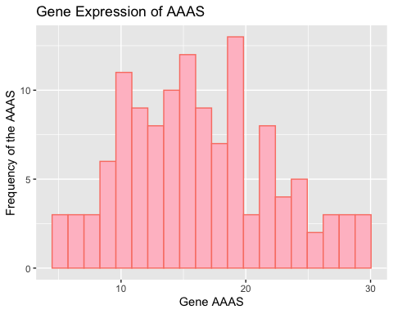

## Warning: Removed 16 rows containing missing values or values outside the scale range  
## (`geom_point()`).

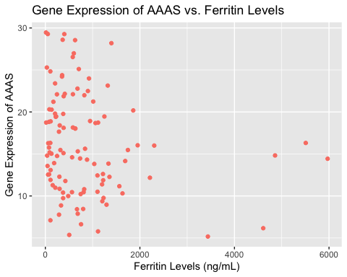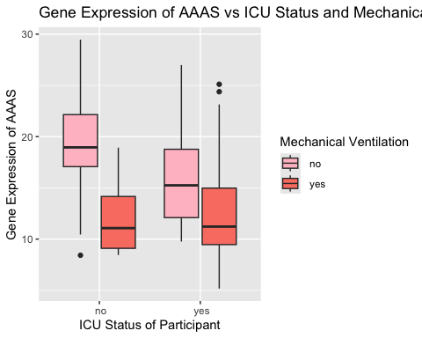

#sub_2_plots(combined, "AAAS", cat1 = "icu_status", cat2 = "mechanical_ventilation", cont = "ferritin.ng.ml.")

Generate a heatmap (5 pts) Heatmap should include at least 10 genes Include tracking bars for the 2 categorical covariates in your boxplot Heatmaps should include clustered rows and columns

#install.packages('pheatmap')  
library(pheatmap)  
  
#citation(package = 'pheatmap')

#head(select(participant_id, AAAS, AACS, AAGAB, AAK1, AAMDC, AAMP, AANAT, AAR2, AARS1, AARS2))  
#making all the selected genes numeric  
combined$AAGAB <- as.numeric(combined$AAGAB)   
combined$AAK1 <- as.numeric(combined$AAK1)   
combined$AAMDC <- as.numeric(combined$AAMDC)   
combined$AAMP <- as.numeric(combined$AAMP)   
combined$AANAT <- as.numeric(combined$AANAT)   
combined$AAR2 <- as.numeric(combined$AAR2)   
combined$AARS1 <- as.numeric(combined$AARS1)   
combined$AAAS <- as.numeric(combined$AAAS)   
combined$AACS <- as.numeric(combined$AACS)  
combined$AARS2 <- as.numeric(combined$AARS2)   
  
#head(combined)  
  
#new_combined(combined) <- c('AAAS', 'AACS', 'AAGAB', 'AAK1', 'AAMDC', 'AAMP', 'AANAT', 'AAR2', 'AARS1', 'AARS2')

combined_df <- data.frame(combined[,c('AAAS', 'AACS', 'AAGAB', 'AAK1', 'AAMDC', 'AAMP', 'AANAT', 'AAR2', 'AARS1', 'AARS2')]) #creating a data frame with the new information  
   
#new data frame with labeled ICU Status from the column same for mechanical ventilation  
annotationData <- data.frame(ICU_Status =combined$icu_status ,   
 Mechanical_Ventilation= combined$mechanical_ventilation,   
 row.names = row.names(combined_df)  
 )  
  
row.names(combined_df) <- row.names(combined) #making the row names from this data  
row.names(annotationData) <- row.names(combined)  
  
#coloring the icu and mechanical ventilation with the colors, be sure to put space between yes and no because it wasn't working because that's how the data was appearing  
annotationColors <- list(ICU_Status= c(' yes' = 'orange',  
 ' no' = 'salmon'),  
 Mechanical_Ventilation= c(' yes' = 'pink',  
 ' no' = 'hotpink')  
 )  
  
#combined$icu_status   
  
pheatmap(combined_df,  
 show_rownames = F,  
 cluster_rows = T,  
 cluster_cols = T,  
 annotation_row = annotationData, #be sure this is not annotation_col  
 annotation_colors = annotationColors  
 )

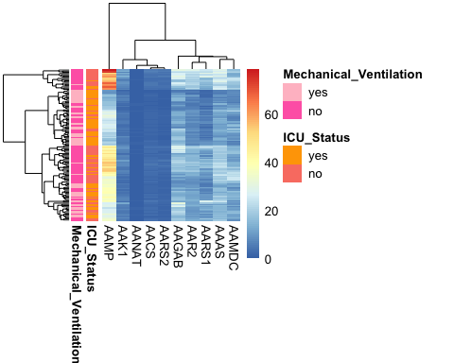

Going through the documentation for ggplot2, generate a plot type that we did not previously discuss in class that describes your data in a new and unique way (5 pts)

#citation(package = 'hexbin') #citation for the new plot

#look through ggplot to find cool new ways  
#install.packages('hexbin')  
library(ggplot2)  
  
#similar process to histogram and scatterplot with a few adjustments  
new_plot <- ggplot(combined, aes(x=icu_status, y = AAAS, fill = disease_status)) + #need to add a fill to demonstrate the disease status range depending on gene expression and if ICU status  
 geom_hex() + #to generate a hexbin use geom_hex  
 scale_fill_manual(values = c('pink','salmon')) +  
 labs(title = 'Gene Expression of AAAS vs ICU Status and Disease Status', #to label each attribute of the plot  
 x= 'ICU Status of Participant' ,   
 y= 'Gene Expression of AAAS',   
 fill= 'Disease Status')  
plot(new_plot)

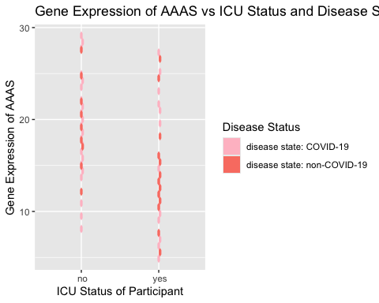

Submit a LaTeX file and knitted PDF file summarizing your results (20 pts total). This file should include the following sections: Table of summary statistics Histogram of gene Scatter plot of gene + continuous covariate Boxplot of gene stratified by 2 categorical covariates Heatmap Your selected new plot type Introduction: Brief description of the data set and your gene of choice for your main plots. Additional gene descriptions aren’t required for genes included in your heatmap. Methods: Brief summary of methods including data source, R version and packages, and clustering algorithm used, as discussed in class. Results: Description of the findings of each table/figure (outlined below). While you do not need to provide an extensive analysis of each item, you must provide a brief statement referencing them and then cite the relevant table or figure, as discussed in class. Example: “Gene x did not appear to be associated with covariate y (Figure 2).” Additionally, you must typeset and provide captions/figure legends for each item as discussed in class. Required elements include: References: At a minimum, your references must include the paper that the dataset came from, an original source for your gene description, and R packages used. All references should be cited within the text as shown in class. Submit a link to your github repository for review (15 pts total; 5 per presentation) Push all the clearly commented code for your final submission. You must have a commit from before each presentation including all of the code used for each presentation. Repository must be public facing after final submission. Provide a brief presentation of your new plot type providing a description of what it shows and why you think it’s useful. (5 pts) Reminder: All figures and tables should be “publication ready” (i.e. clean variable names, etc. as discussed in class). While we have not deducted points for this so far in prior iterations of this project, you will lose points on your final submission for sloppy figures and tables.