Staging Release ANPR

**Environment specific port changes:**

proxy-conf.json: the target ip and port needs to be changes for the respective environment as shown below

* "target": "http://10.36.121.59:8092"

environment.prod.ts:

* imageApi:'http://10.36.121.59:8083',
* blendApi:'http://10.36.121.59:8091',
* deviceApi: 'http://10.36.121.59:9066',
* apiUrl:'http://10.36.121.59:8092',

database.properties:

* url=jdbc:oracle:thin:@10.36.121.59:1521:CSCDEV
* dbuser=CSCTS_BLEND

application.yml

* port: 8092
* append 1111 to the value of "plant.sms.gateway.apikey" for the sms to get triggered in DEV.
* change the value of "environment" to DEV (anything other than "PROD").

**DB changes :**

* none

**files changed:**

anpr-v0.1/src/main/java/com/cscts/anpr/dao/impl/CsctsAnprDaoImpl.java

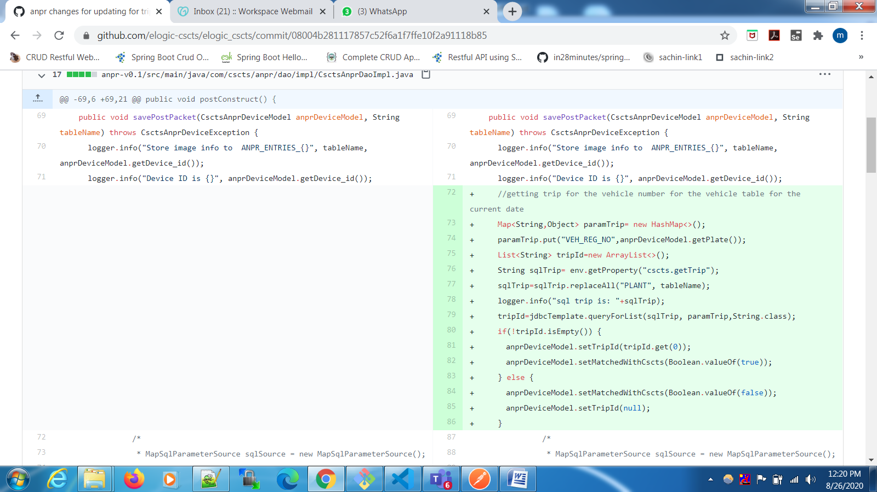

entry-gate-service/src/main/java/com/cscts/entrygate/minedispatch/dao/impl/CsctsMineDispatchDaoImpl.java

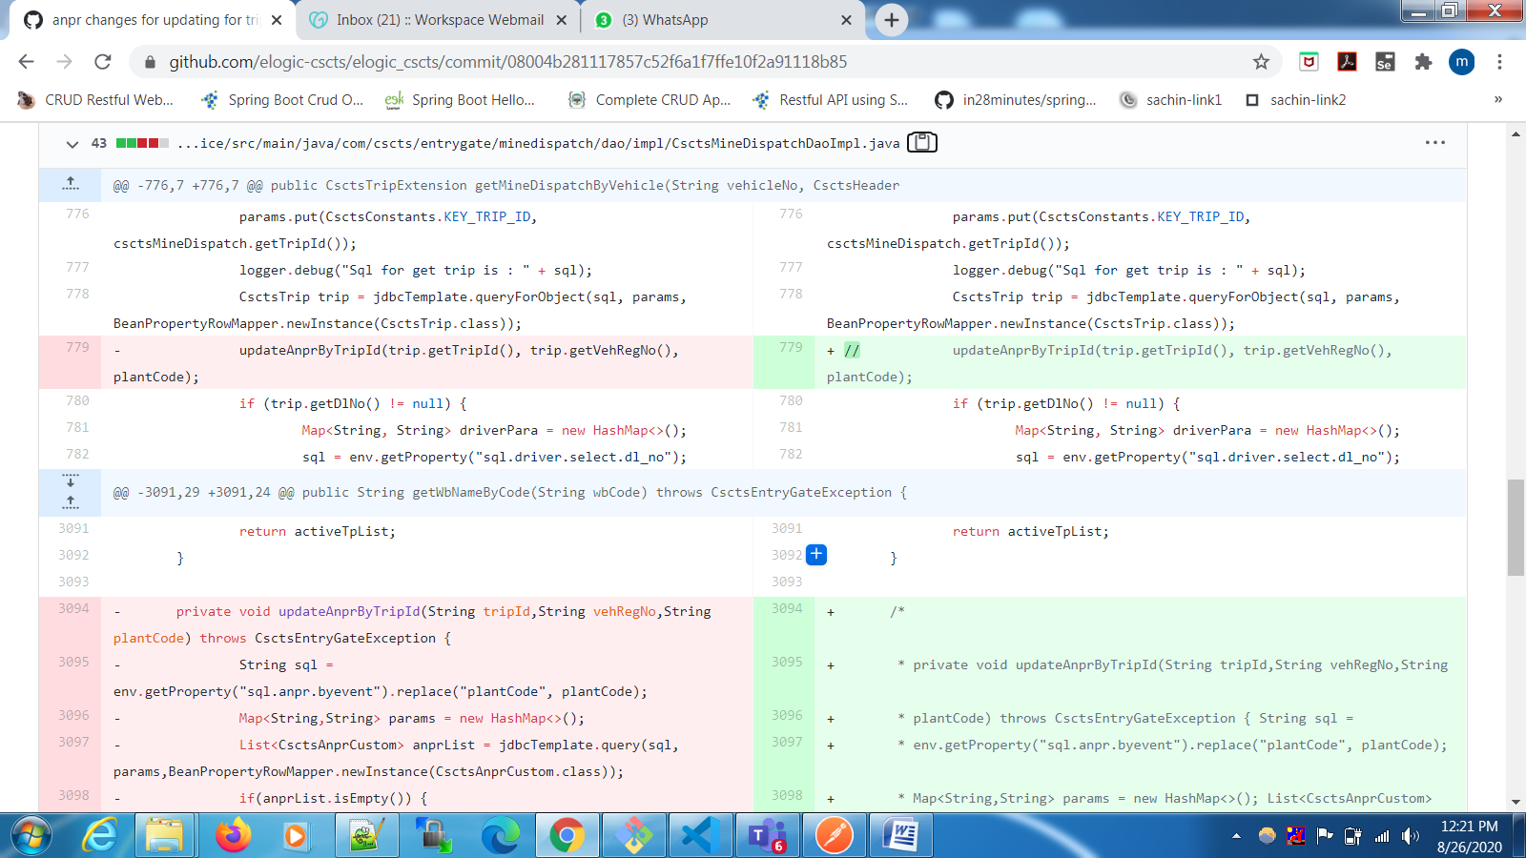

anpr-v0.1/src/main/resources/application.properties

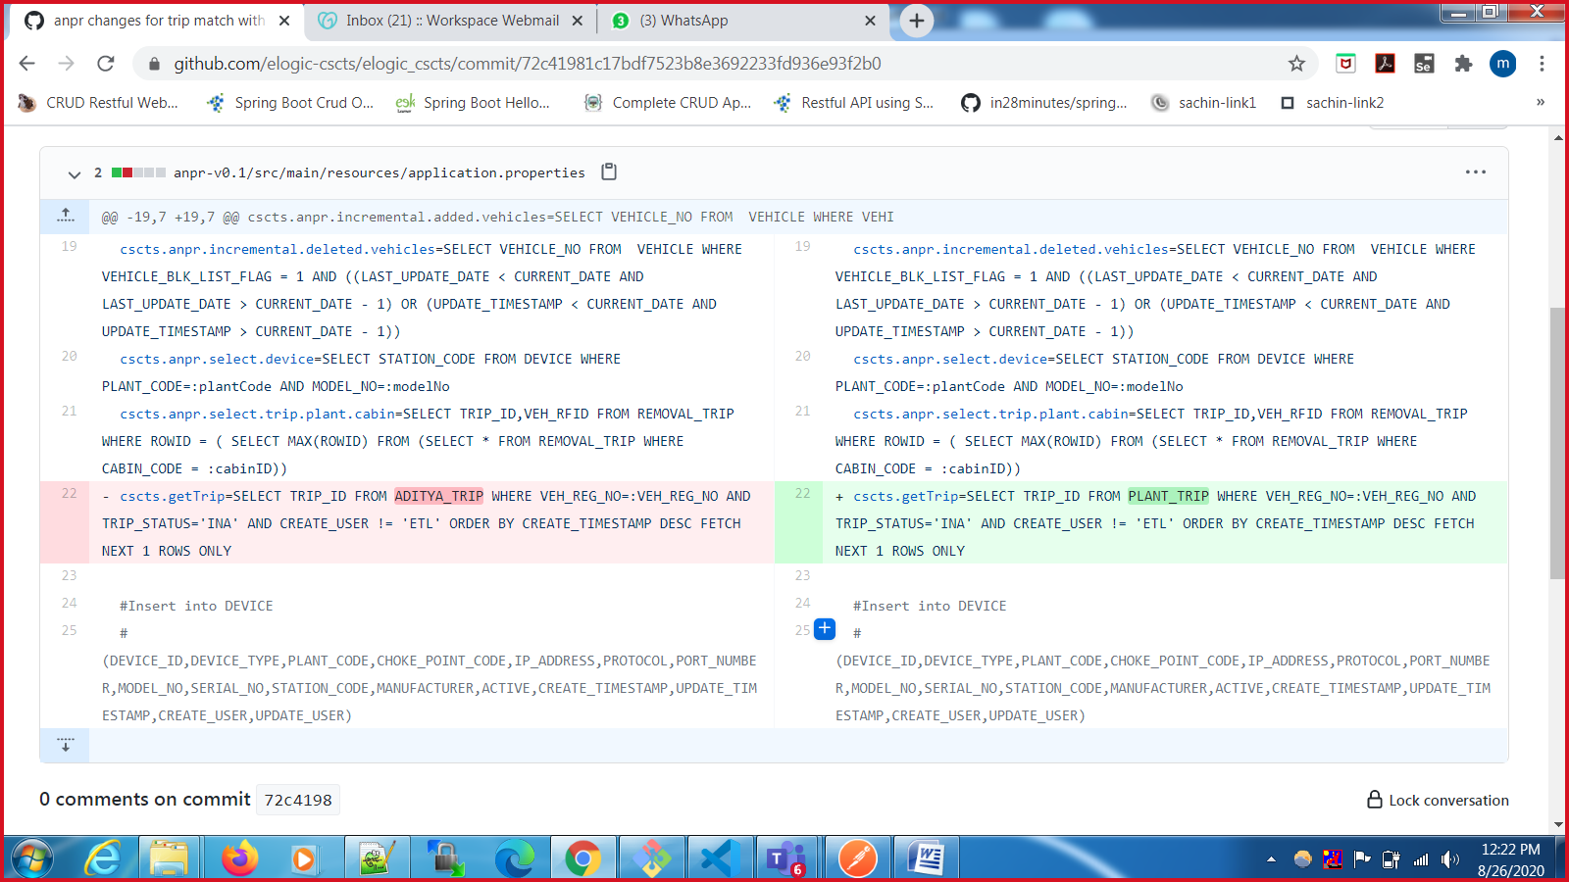

**Folder comparison snapshots :**

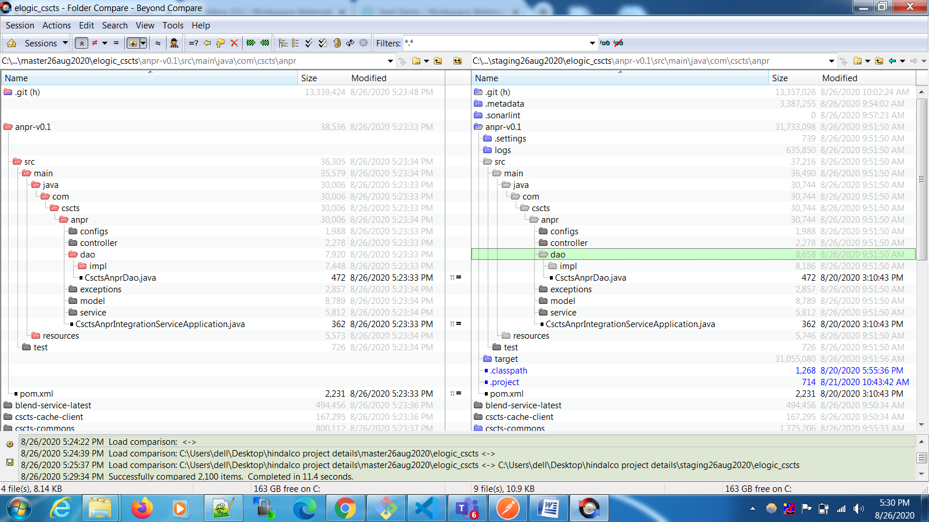

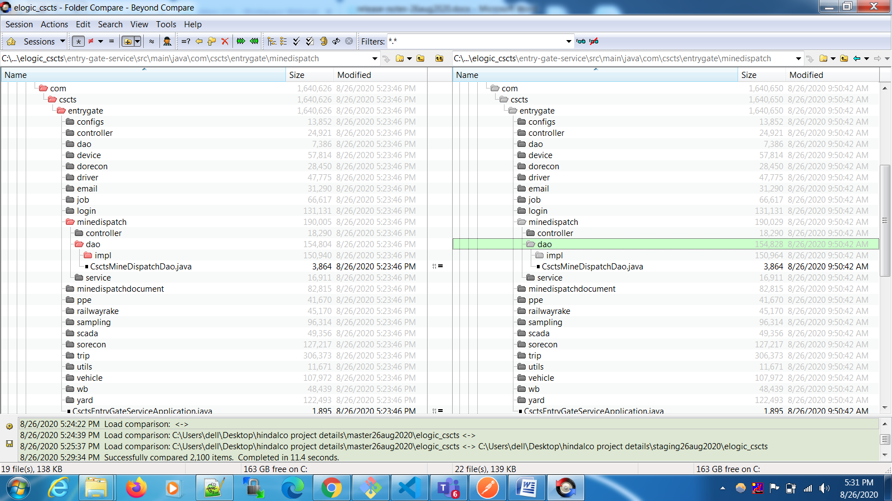

**Rollback steps:**

* Before the deployment, the current version of the running jar’s backup is taken. In case of failure the previous running jar is restored and deployed.
* The release (ANPR) does not have any DB changes. Hence from a db point of view no rollback is required.