User View

* When the mine dispatch takes place, and if ANPR has already captured the vehicle number, then a match will be shown in the mine dispatch page itself.

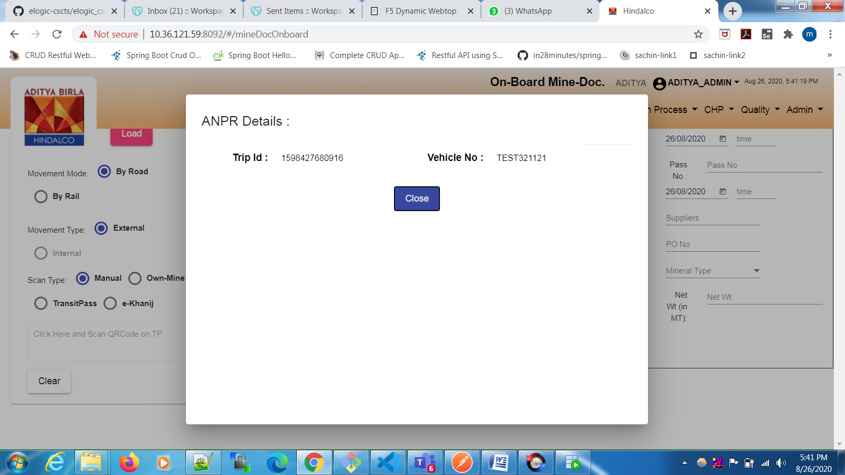

* If the anpr has not occured, then the screen will show a message as shown below:

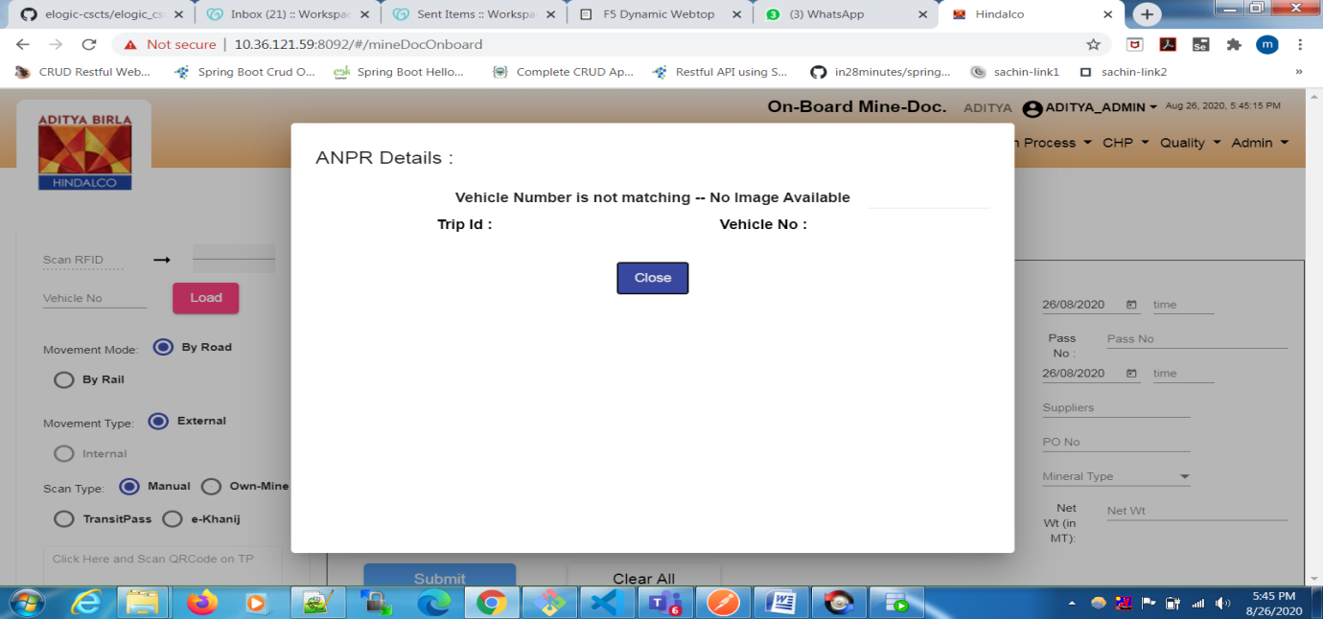

* Once the ANPR is done we can check for the match in the Trip UI against that particular trip

