Dev Release – Scada and Exception Master Configuration Features

# Functional Changes:

* Scada:

Scada modification shall have the functionality to start and end the job automatically based on path tag integration. Bunker fill % shall be visible on UI for taking the informed decision. The option to confirm the job by selecting the source and destination pair for running and ended job shall process and close the Scada transaction.

* Exception Flow:

The module should provide an UI for configuration of the Exception Configuration like active/inactive an exception, SMS, Email configuration and other parameters. Also the UI shall provide the workflow configurations. The configuration is used during the exception creation, updating when a check list submitted.

**Environment specific port changes:**

proxy-conf.json: the target IP and port needs to be changes for the respective environment as shown below

* "target": "http://10.36.121.59:9060"

environment.prod.ts:

* imageApi:'http://10.36.121.59:8083',
* blendApi:'http://10.36.121.59:8091',
* deviceApi: 'http://10.36.121.59:9066',
* apiUrl:'http://10.36.121.59:9060',

database.properties:

* url=jdbc:oracle:thin:@10.36.121.59:1521:orcl
* dbuser=CSCTS_BLEND

application.yml

* port: 9060

**DB changes:**

* database-scripts/exception_flow.sql

**Path of the Repo for changes:**

<https://dev.azure.com/HINDALCO/CSCTS/_git/CSCTS_EL/commit/574c04b85000add69fe387c239bef0ce21a7e408?refName=refs%2Fheads%2Fdev>

**Files Modified:**

/cscts-commons/src/main/java/com/cscts/common/alert/model/CsctsException.java

/cscts-commons/src/main/java/com/cscts/common/alert/model/CsctsExceptionApprov.java

/cscts-commons/src/main/java/com/cscts/common/alert/model/CsctsExceptionClearance.java

/cscts-commons/src/main/java/com/cscts/common/alert/model/CsctsExceptionFlow.java

/cscts-commons/src/main/java/com/cscts/common/alert/model/CsctsExceptionHistory.java

/cscts-commons/src/main/java/com/cscts/common/alert/model/CsctsHistory.java

/cscts-commons/src/main/java/com/cscts/common/checklist/model/CsctsCheckList.java

/cscts-commons/src/main/java/com/cscts/common/checklist/model/CsctsCheckListHistory.java

/cscts-commons/src/main/java/com/cscts/common/checklist/model/CsctsCheckResult.java

/cscts-commons/src/main/java/com/cscts/common/exceptionflow/model/CsctsCheckTypeOptions.java

/cscts-commons/src/main/java/com/cscts/common/exceptionflow/model/CsctsExcepRoleLevel.java

/cscts-commons/src/main/java/com/cscts/common/exceptionflow/model/CsctsExceptionFlowList.java

/cscts-commons/src/main/java/com/cscts/common/exceptionflow/model/CsctsExceptionFlowRequest.java

/cscts-commons/src/main/java/com/cscts/common/exceptionflow/model/CsctsExceptionFlowResponse.java

/cscts-commons/src/main/java/com/cscts/common/exceptionflow/model/CsctsExceptionSopThreshold.java

/cscts-commons/src/main/java/com/cscts/common/exceptionflow/model/CsctsExcepWorkflowResp.java

/cscts-commons/src/main/java/com/cscts/common/exceptionflow/model/CsctsRoleIdCode.java

/cscts-commons/src/main/java/com/cscts/common/scada/model/CsctsScada.java

/cscts-commons/src/main/java/com/cscts/common/scada/model/CsctsScadaBlend.java

/cscts-commons/src/main/java/com/cscts/common/scada/model/CsctsScadaBunker.java

/cscts-commons/src/main/java/com/cscts/common/scada/model/CsctsScadaBunkerAdityaRaw.java

/cscts-commons/src/main/java/com/cscts/common/scada/model/CsctsScadaBunkerChild.java

/cscts-commons/src/main/java/com/cscts/common/scada/model/CsctsScadaBunkerCustom.java

/cscts-commons/src/main/java/com/cscts/common/scada/model/CsctsScadaBunkerMahanRaw.java

/cscts-commons/src/main/java/com/cscts/common/scada/model/CsctsScadaMaster.java

/cscts-commons/src/main/java/com/cscts/common/scada/model/CsctsScadaTrxBwTotCustomHistory.java

/cscts-commons/src/main/java/com/cscts/common/scada/model/CsctsScadaTrxBwTotHistorical.java

/database-scripts/exception_flow.sql

/entry-gate-service/src/main/hindalco-ui/src/app/component/exception-cr/exception-cr.component.css

/entry-gate-service/src/main/hindalco-ui/src/app/component/exception-cr/exception-cr.component.html

/entry-gate-service/src/main/hindalco-ui/src/app/component/exception-cr/exception-cr.component.spec.ts

/entry-gate-service/src/main/hindalco-ui/src/app/component/exception-cr/exception-cr.component.ts

/entry-gate-service/src/main/hindalco-ui/src/app/component/header/header.component.html

/entry-gate-service/src/main/hindalco-ui/src/app/component/header/header.component.ts

/entry-gate-service/src/main/hindalco-ui/src/app/component/login/login.component.ts

/entry-gate-service/src/main/hindalco-ui/src/app/component/scada-jobs/scada-jobs.component.css

/entry-gate-service/src/main/hindalco-ui/src/app/component/scada-jobs/scada-jobs.component.html

/entry-gate-service/src/main/hindalco-ui/src/app/component/scada-jobs/scada-jobs.component.ts

/entry-gate-service/src/main/hindalco-ui/src/app/dialogModal/designworkflow/designworkflow.component.css

/entry-gate-service/src/main/hindalco-ui/src/app/dialogModal/designworkflow/designworkflow.component.html

/entry-gate-service/src/main/hindalco-ui/src/app/dialogModal/designworkflow/designworkflow.component.spec.ts

/entry-gate-service/src/main/hindalco-ui/src/app/dialogModal/designworkflow/designworkflow.component.ts

/entry-gate-service/src/main/hindalco-ui/src/app/dialogModal/editexceptioncr/editexceptioncr.component.css

/entry-gate-service/src/main/hindalco-ui/src/app/dialogModal/editexceptioncr/editexceptioncr.component.html

/entry-gate-service/src/main/hindalco-ui/src/app/dialogModal/editexceptioncr/editexceptioncr.component.spec.ts

/entry-gate-service/src/main/hindalco-ui/src/app/dialogModal/editexceptioncr/editexceptioncr.component.ts

/entry-gate-service/src/main/hindalco-ui/src/app/model/exceptionCr.ts

/entry-gate-service/src/main/hindalco-ui/src/app/services/auth-service.service.ts

/entry-gate-service/src/main/hindalco-ui/src/app/services/exception-cr.service.spec.ts

/entry-gate-service/src/main/hindalco-ui/src/app/services/exception-cr.service.ts

/entry-gate-service/src/main/hindalco-ui/src/app/services/login.service.ts

/entry-gate-service/src/main/hindalco-ui/src/app/services/scadajobs.service.ts

/entry-gate-service/src/main/hindalco-ui/src/app/app-routing.module.ts

/entry-gate-service/src/main/hindalco-ui/src/app/app.module.ts

/entry-gate-service/src/main/hindalco-ui/src/styles.css

/entry-gate-service/src/main/hindalco-ui/angular.json

/entry-gate-service/src/main/java/com/cscts/entrygate/email/dao/impl/CsctsNotificationDaoImpl.java

/entry-gate-service/src/main/java/com/cscts/entrygate/email/dao/CsctsNotificationDao.java

/entry-gate-service/src/main/java/com/cscts/entrygate/email/service/CsctsEmailNotifierService.java

/entry-gate-service/src/main/java/com/cscts/entrygate/exceptionFlow/controller/CsctsExceptionFlowController.java

/entry-gate-service/src/main/java/com/cscts/entrygate/exceptionFlow/dao/impl/CsctsExceptionFloeDaoImpl.java

/entry-gate-service/src/main/java/com/cscts/entrygate/exceptionFlow/dao/CsctsExceptionFlowDao.java

/entry-gate-service/src/main/java/com/cscts/entrygate/exceptionFlow/service/impl/CsctsExceptionFlowServiceImpl.java

/entry-gate-service/src/main/java/com/cscts/entrygate/exceptionFlow/service/CsctsExceptionFlowService.java

/entry-gate-service/src/main/java/com/cscts/entrygate/login/dao/impl/CsctsLoginDaoImpl.java

/entry-gate-service/src/main/java/com/cscts/entrygate/minedispatch/dao/impl/CsctsMineDispatchDaoImpl.java

/entry-gate-service/src/main/java/com/cscts/entrygate/minedispatchdocument/dao/imp/CsctsMineDispatchDocumentDaoImp.java

/entry-gate-service/src/main/java/com/cscts/entrygate/sampling/controller/CsctsSamplingController.java

/entry-gate-service/src/main/java/com/cscts/entrygate/scada/controller/CsctsScadaController.java

/entry-gate-service/src/main/java/com/cscts/entrygate/scada/dao/impl/CsctsScadaDaoImpl.java

/entry-gate-service/src/main/java/com/cscts/entrygate/scada/dao/CsctsScadaDao.java

/entry-gate-service/src/main/java/com/cscts/entrygate/scada/service/impl/CsctsScadaServiceImpl.java

/entry-gate-service/src/main/java/com/cscts/entrygate/scada/service/CsctsScadaService.java

/entry-gate-service/src/main/java/com/cscts/entrygate/trip/controller/CsctsTripController.java

/entry-gate-service/src/main/java/com/cscts/entrygate/trip/dao/impl/CsctsTripDaoImpl.java

/entry-gate-service/src/main/resources/application-db-queries.yml

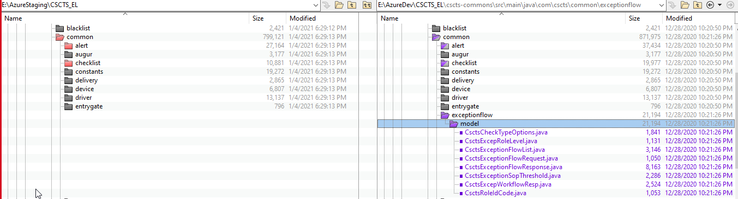

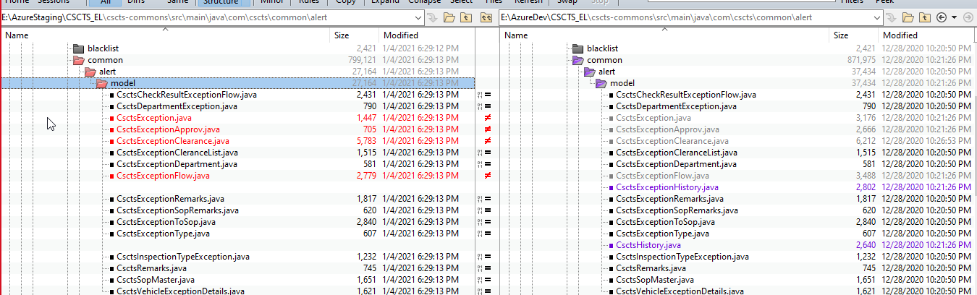

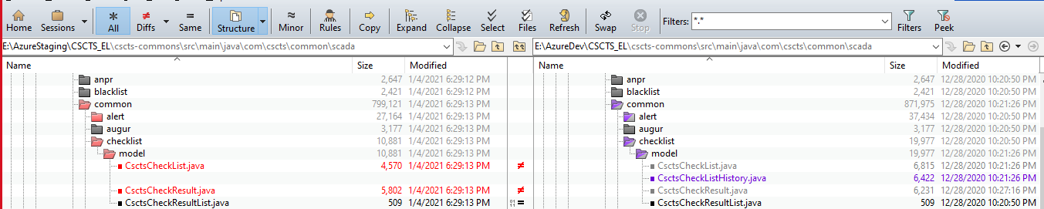

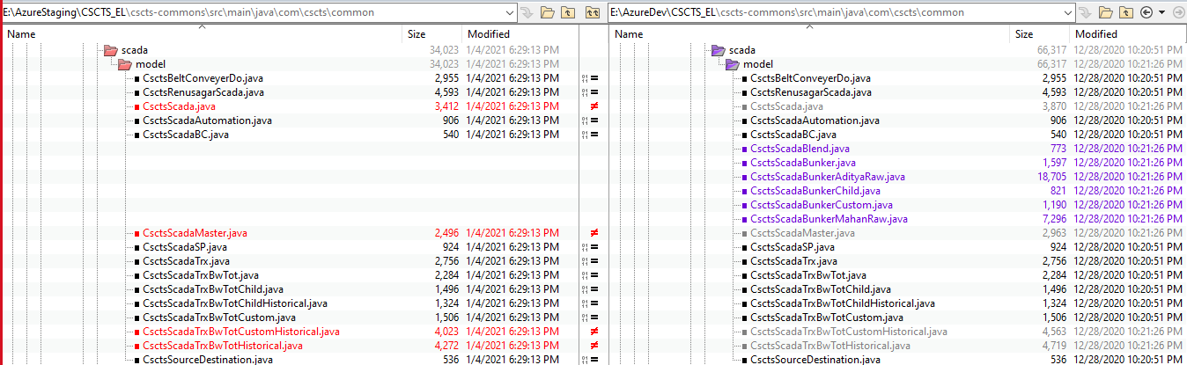

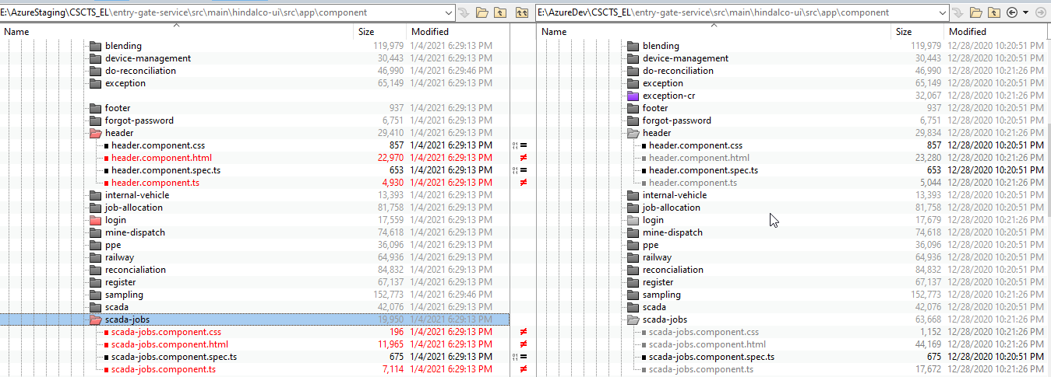

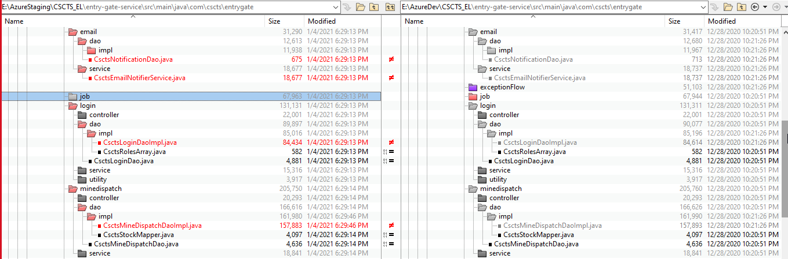

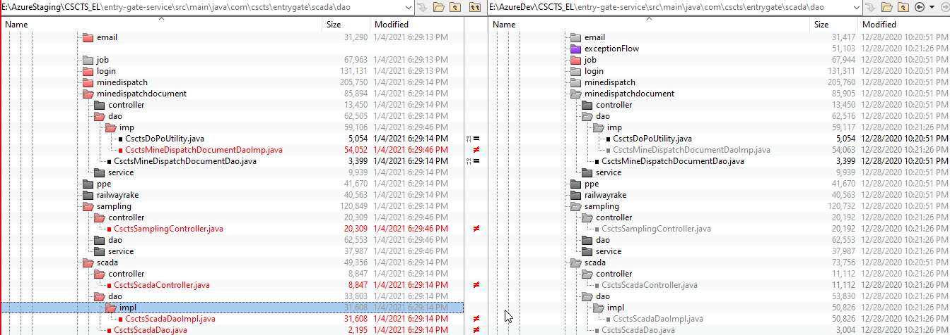

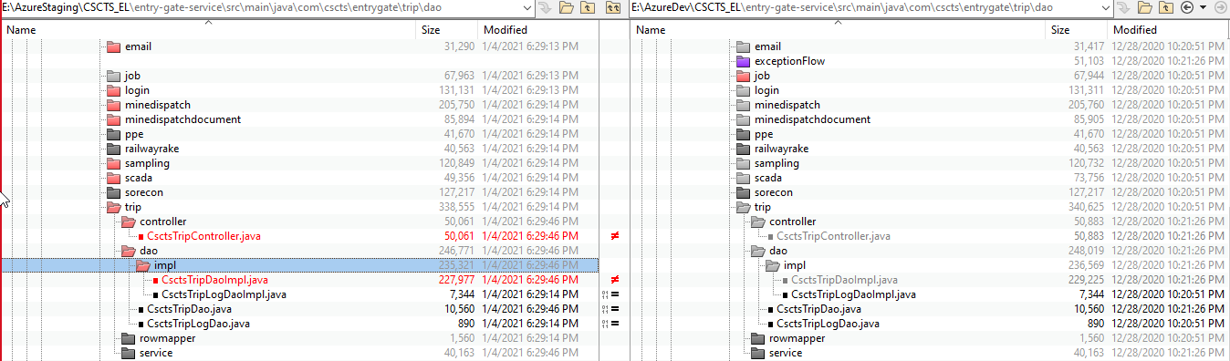

**Rollback steps:**

* New columns added are not mandatory columns and mostly with default values. So during rollback these will not cause any issue.
* Version will be updated during the actual release for reverting.