Functional Flow

**Blend:**

In the blend UI screen, user should be able to select the SR available.

User should be able to see the data from the last approved blend plan, populated in the UI on create blend plan tab master parameters.

User should have the option to choose the hybrid method, by filling the age and cost percentage during the Create Blend Tab.

Also once the Hyva execution is completed, the average speed and average capacity of each vehicle type is to be calculated.

**Blend UI:**

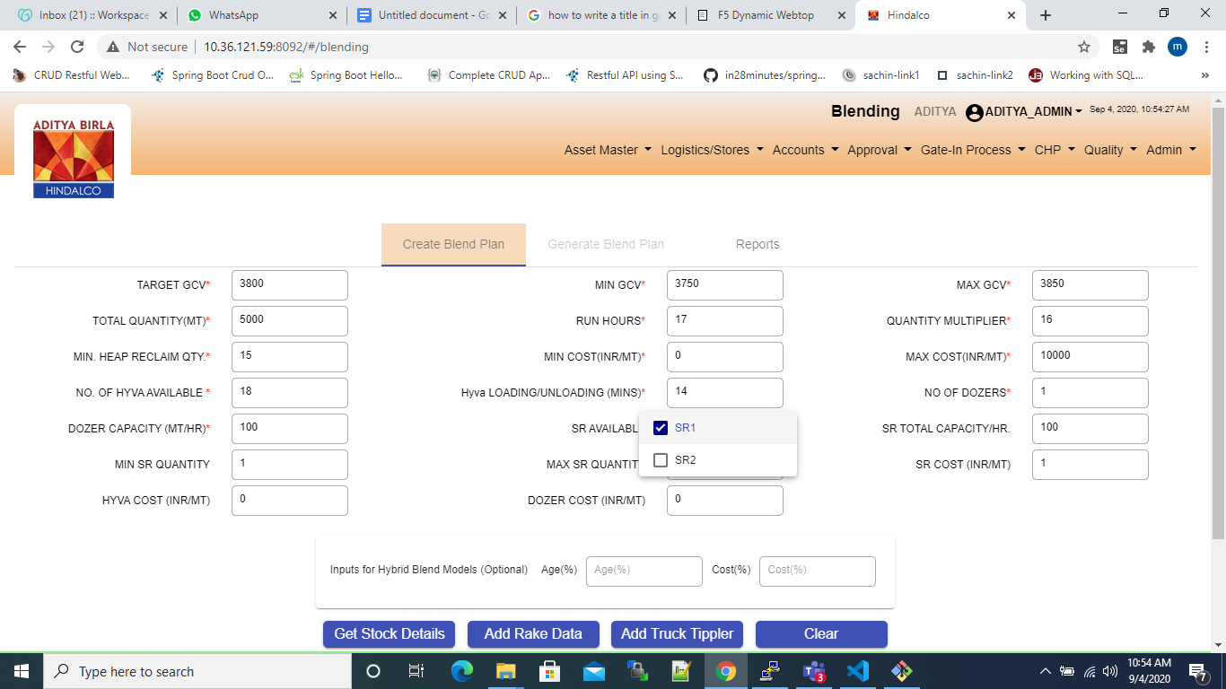

* User will be allowed to pick SR (if it available in the plant) and then get the stocks (by clicking on get stock details) according to their SR choice.

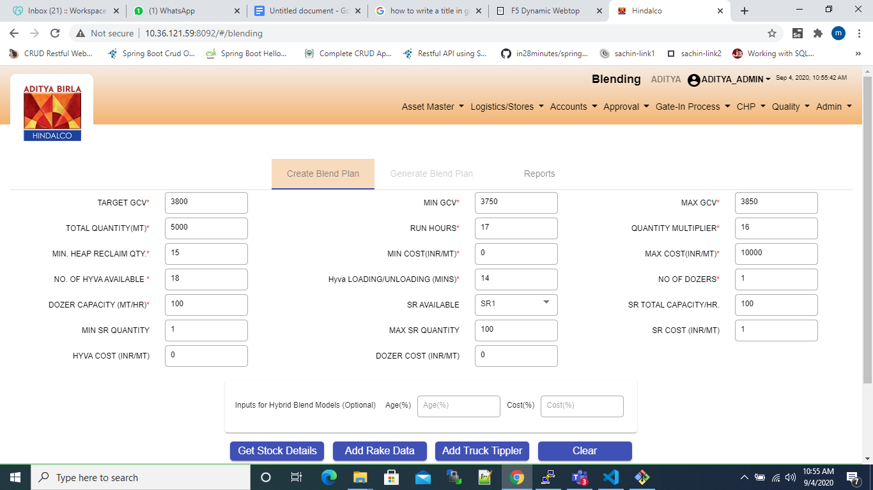

* User will get the last approved blend plan values for certain fields; other fields from the config table.
* The min and max gcv will be differing from the target gcv by a number that is configurable from the database. Say the diff is 50, and the target gcv is 3200, then min gcv is 3150 and max gcv is 3250. This diff values is configurable from the Db.
* ALl these values will be auto populated and then they can be changed by the user

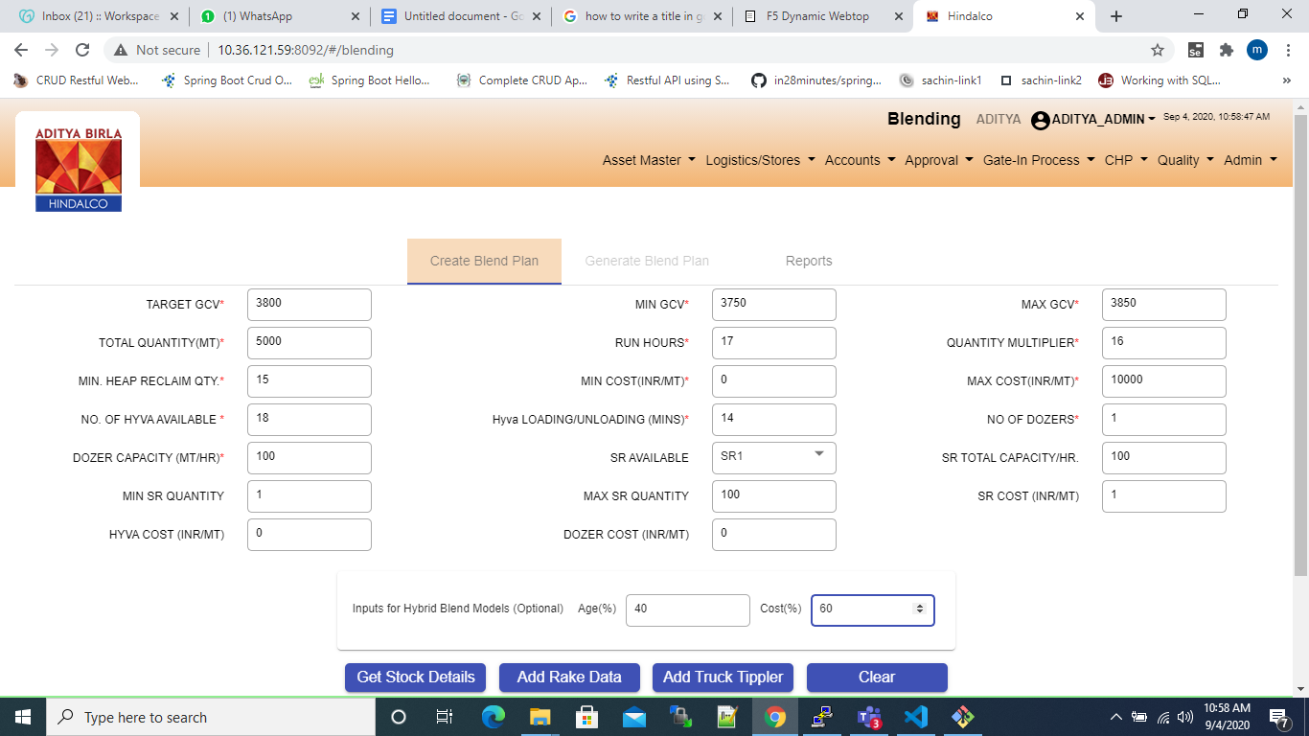

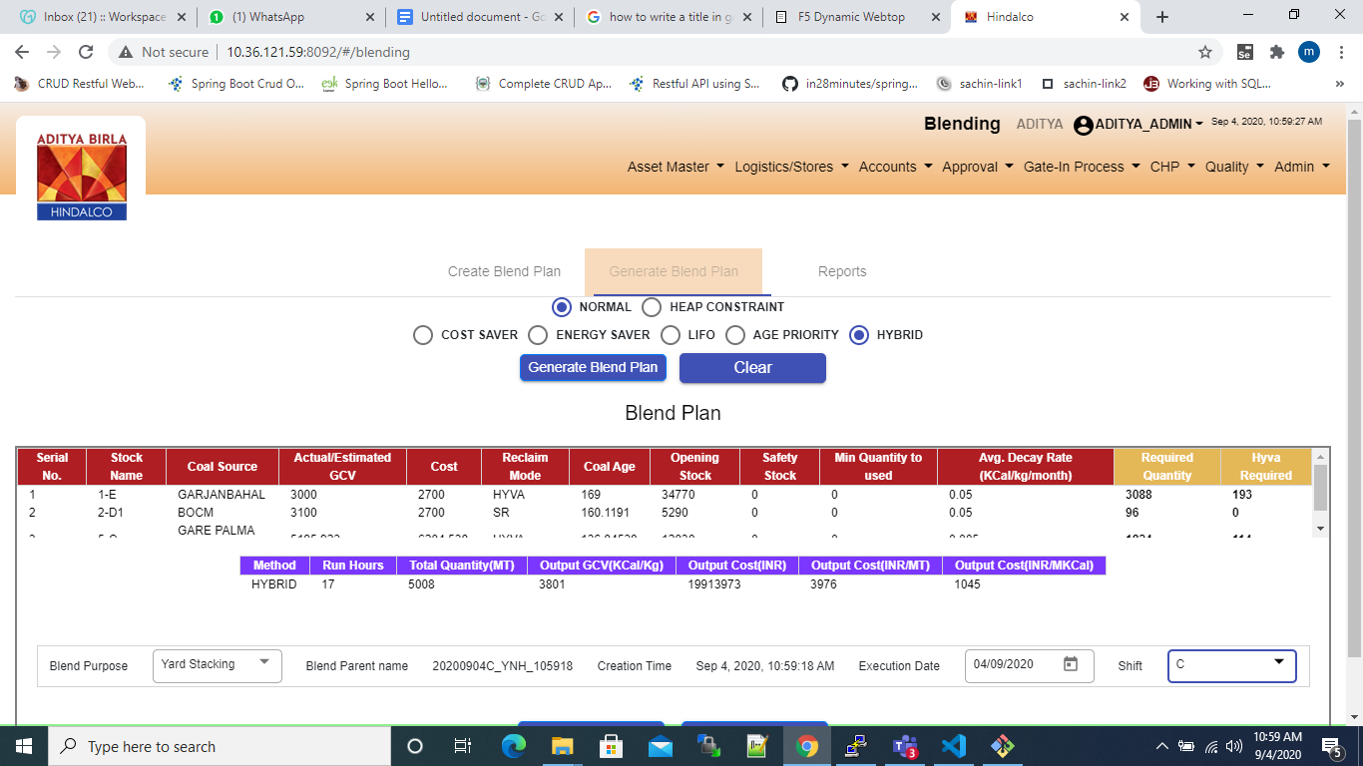

* The age and cost parameters entered in the first field will be used to generate the hybrid blend plan.

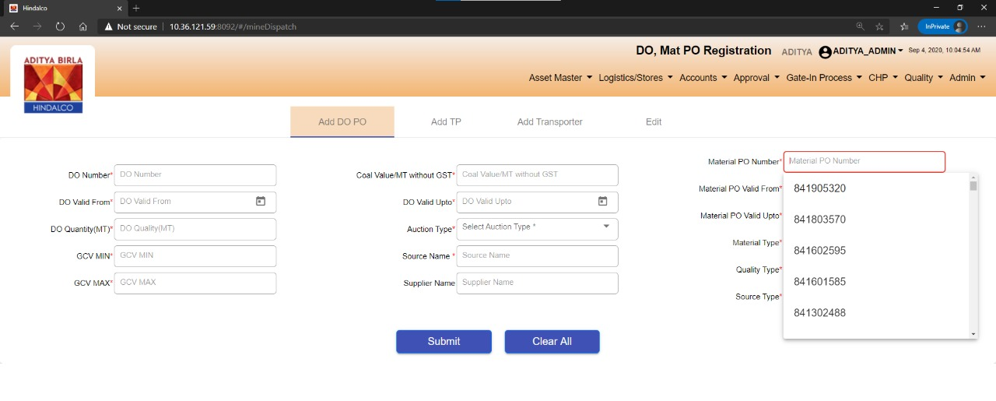

**ERP of Material PO and Transporter PO:**

The material PO and transporter PO details should be populated in the UI as a drop down based on the plant. This data should be available from the ERP table shared.

If the material PO or the transporter PO details are not available, the user should be able to type in the details manually.

**UI flow:**

Add/Edit DO Screen:

* User clicks on the Add/Edit the DO.
* User clicks on the Material PO field. The materail PO number should be displayed as a drop down

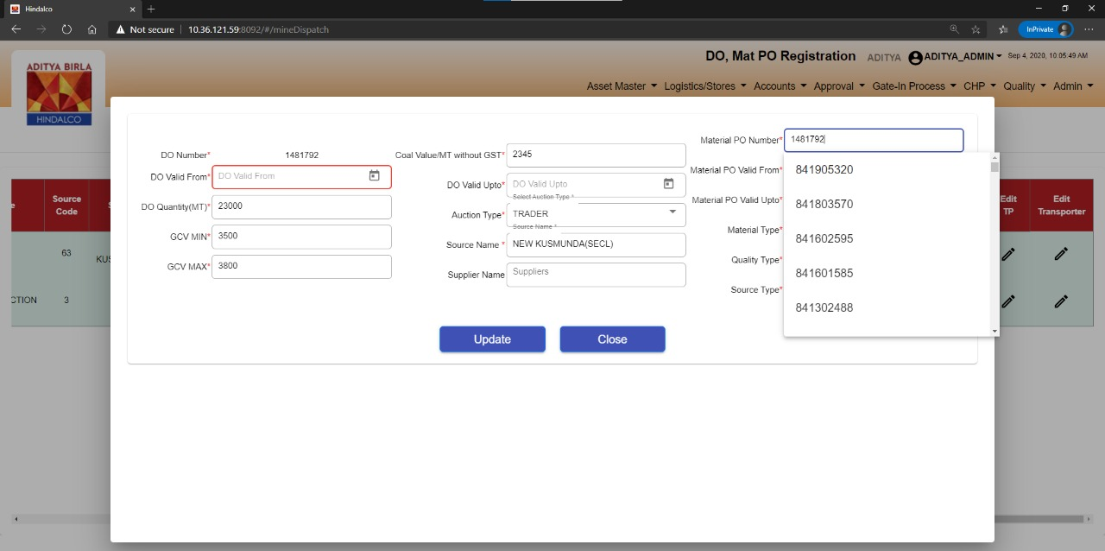

Add/Edit Transporter:

* User clicks on the Add/Edit the Transporter.
* User clicks on the Transporter PO No field. The materail PO number should be displayed as a drop down

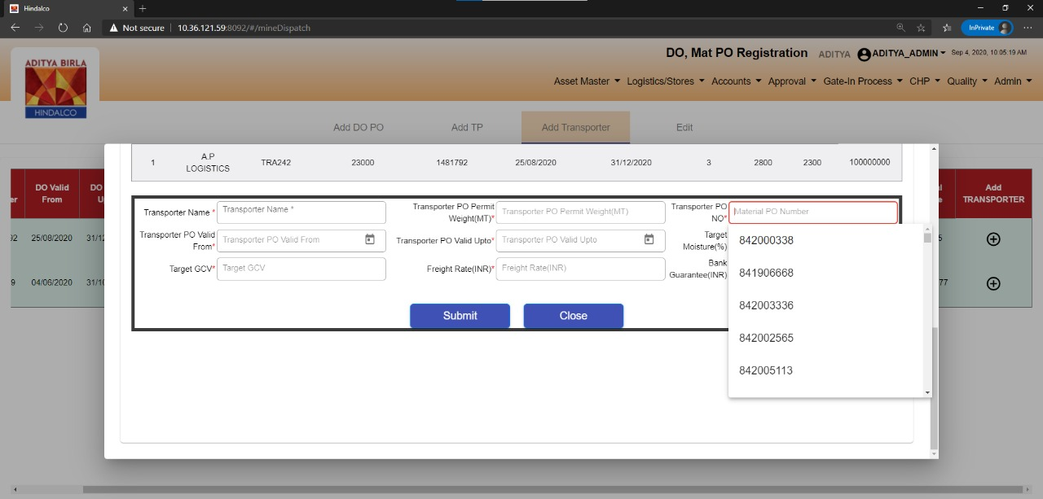

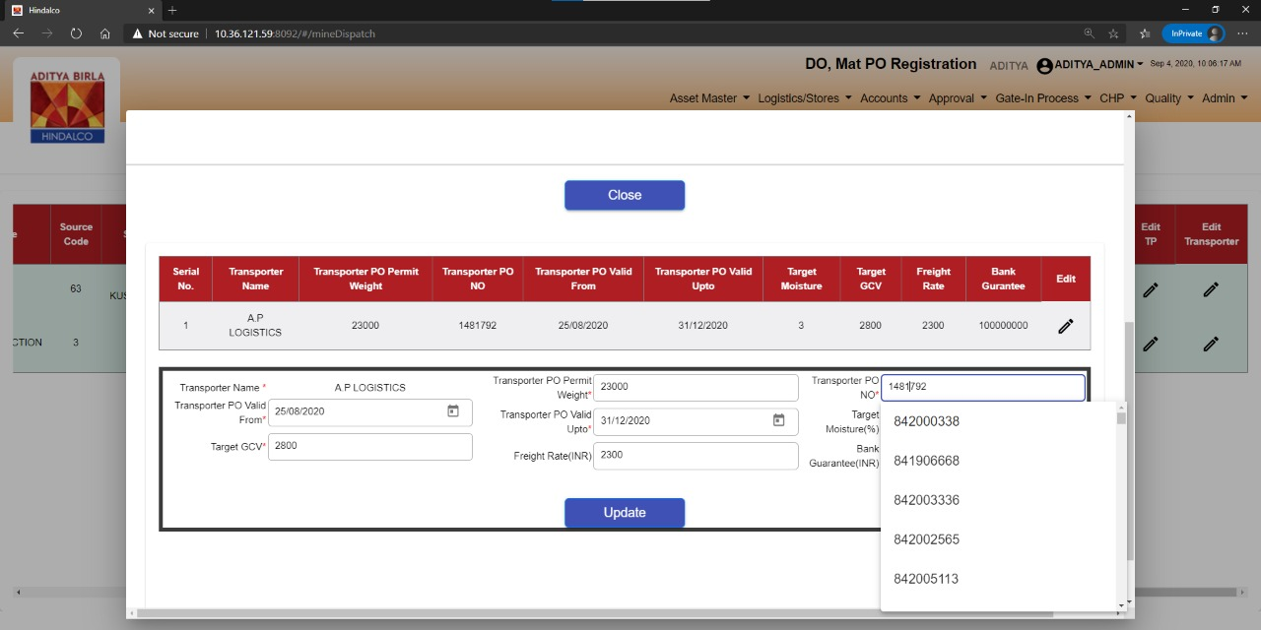

**Mine Doc Bug Fixes:**

The data format correction for the fields – Challan Date, Source Dep Date.

Disable the scan area once the scan is done to avoid any manual alterations to the scanned data.

