Production Release

**Environment specific port changes:**

proxy-conf.json: the target ip and port needs to be changes for the respective environment as shown below

* "target": "http://10.36.24.112:9060"

environment.prod.ts:

* imageApi:'http://10.36.24.112:8083',
* blendApi:'http://10.36.24.112:9061',
* deviceApi: 'http://10.36.24.112:9066',
* apiUrl:'http://10.36.24.112:9060',

database.properties:

* url=jdbc:oracle:thin:@10.36.24.112:1521:orcl
* dbuser=CSCTS_PROD

application.yml

* port: 9060

**DB changes:**

* yes
* database-scripts/sampling-do-look-up.sql
* /database-scripts/AugerSampling.sql

**Files Modified:**

* /cscts-commons/src/main/java/com/cscts/common/sampling/model/CsctsSampling.java
* /cscts-commons/src/main/java/com/cscts/common/trip/models/CsctsMineDispatch.java
* /cscts-commons/src/main/java/com/cscts/common/trip/models/CsctsTrip.java
* /cscts-commons/src/main/java/com/cscts/common/trip/models/CsctsTripExtension.java
* /database-scripts/AugerSampling.sql
* /database-scripts/rollback-sampling-do-look-up-entries.sql
* /database-scripts/sampling-do-look-up.sql
* /entry-gate-service/src/main/hindalco-ui/src/app/component/do-reconciliation/do-reconciliation.component.html
* /entry-gate-service/src/main/hindalco-ui/src/app/component/do-reconciliation/do-reconciliation.component.ts
* /entry-gate-service/src/main/hindalco-ui/src/app/ld-files/add-device-popup/add-device-popup.component.css
* /entry-gate-service/src/main/hindalco-ui/src/app/ld-files/add-device-popup/add-device-popup.component.html
* /entry-gate-service/src/main/hindalco-ui/src/app/ld-files/add-device-popup/add-device-popup.component.ts
* /entry-gate-service/src/main/hindalco-ui/src/app/ld-files/devices/devices.component.css
* /entry-gate-service/src/main/hindalco-ui/src/app/ld-files/devices/devices.component.html
* /entry-gate-service/src/main/hindalco-ui/src/app/ld-files/devices/devices.component.ts
* /entry-gate-service/src/main/hindalco-ui/src/app/ld-files/mine-docs-finalpopup/mine-docs-finalpopup.component.html
* /entry-gate-service/src/main/hindalco-ui/src/app/ld-files/mine-docs-finalpopup/mine-docs-finalpopup.component.ts
* /entry-gate-service/src/main/hindalco-ui/src/app/ld-files/mine-docs-upload/mine-docs-upload.component.html
* /entry-gate-service/src/main/hindalco-ui/src/app/ld-files/mine-docs-upload/mine-docs-upload.component.ts
* /entry-gate-service/src/main/hindalco-ui/src/app/ld-files/model/device-group.model.ts
* /entry-gate-service/src/main/hindalco-ui/src/app/ld-files/model/device.model.ts
* /entry-gate-service/src/main/hindalco-ui/src/app/ld-files/model/minedoc.model.ts
* /entry-gate-service/src/main/hindalco-ui/src/app/ld-files/pop-up-modals/add-device-additional-conf/add-device-additional-conf.component.css
* /entry-gate-service/src/main/hindalco-ui/src/app/ld-files/pop-up-modals/add-device-additional-conf/add-device-additional-conf.component.html
* /entry-gate-service/src/main/hindalco-ui/src/app/ld-files/pop-up-modals/add-device-additional-conf/add-device-additional-conf.component.spec.ts
* /entry-gate-service/src/main/hindalco-ui/src/app/ld-files/pop-up-modals/add-device-additional-conf/add-device-additional-conf.component.ts
* /entry-gate-service/src/main/hindalco-ui/src/app/ld-files/pop-up-modals/add-device-group/add-device-group.component.css
* /entry-gate-service/src/main/hindalco-ui/src/app/ld-files/pop-up-modals/add-device-group/add-device-group.component.html
* /entry-gate-service/src/main/hindalco-ui/src/app/ld-files/pop-up-modals/add-device-group/add-device-group.component.spec.ts
* /entry-gate-service/src/main/hindalco-ui/src/app/ld-files/pop-up-modals/add-device-group/add-device-group.component.ts
* /entry-gate-service/src/main/hindalco-ui/src/app/ld-files/pop-up-modals/trip-details-popup/trip-details-popup.component.css
* /entry-gate-service/src/main/hindalco-ui/src/app/ld-files/pop-up-modals/trip-details-popup/trip-details-popup.component.html
* /entry-gate-service/src/main/hindalco-ui/src/app/ld-files/pop-up-modals/trip-details-popup/trip-details-popup.component.ts
* /entry-gate-service/src/main/hindalco-ui/src/app/ld-files/pop-up-modals/trip-excep-popup/trip-excep-popup.component.css
* /entry-gate-service/src/main/hindalco-ui/src/app/ld-files/pop-up-modals/trip-excep-popup/trip-excep-popup.component.html
* /entry-gate-service/src/main/hindalco-ui/src/app/ld-files/pop-up-modals/trip-excep-popup/trip-excep-popup.component.spec.ts
* /entry-gate-service/src/main/hindalco-ui/src/app/ld-files/pop-up-modals/trip-excep-popup/trip-excep-popup.component.ts
* /entry-gate-service/src/main/hindalco-ui/src/app/ld-files/services/device-group.service.spec.ts
* /entry-gate-service/src/main/hindalco-ui/src/app/ld-files/services/device-group.service.ts
* /entry-gate-service/src/main/hindalco-ui/src/app/ld-files/services/trip-details.service.ts
* /entry-gate-service/src/main/hindalco-ui/src/app/services/sampling.service.ts
* /entry-gate-service/src/main/hindalco-ui/src/app/app.module.ts
* /entry-gate-service/src/main/java/com/cscts/entrygate/minedispatch/dao/impl/CsctsMineDispatchDaoImpl.java
* /entry-gate-service/src/main/java/com/cscts/entrygate/minedispatchdocument/dao/imp/CsctsMineDispatchDocumentDaoImp.java
* /entry-gate-service/src/main/java/com/cscts/entrygate/sampling/controller/CsctsSamplingController.java
* /entry-gate-service/src/main/java/com/cscts/entrygate/sampling/dao/impl/CsctsSamplingDaoImpl.java
* /entry-gate-service/src/main/java/com/cscts/entrygate/sampling/dao/CsctsSamplingDao.java
* /entry-gate-service/src/main/java/com/cscts/entrygate/sampling/service/impl/CsctsSamplingServiceImpl.java
* /entry-gate-service/src/main/java/com/cscts/entrygate/sampling/service/CsctsSamplingService.java
* /entry-gate-service/src/main/java/com/cscts/entrygate/trip/controller/CsctsTripController.java
* /entry-gate-service/src/main/java/com/cscts/entrygate/trip/dao/impl/CsctsTripDaoImpl.java
* /entry-gate-service/src/main/java/com/cscts/entrygate/trip/dao/impl/CsctsTripDaoImpl.java
* /entry-gate-service/src/main/java/com/cscts/entrygate/trip/service/impl/CsctsTripServiceImpl.java
* /entry-gate-service/src/main/java/com/cscts/entrygate/trip/service/CsctsTripService.java
* /entry-gate-service/src/main/java/com/cscts/entrygate/utils/CsctsEntryGateUtility.java
* /entry-gate-service/src/main/resources/application-db-queries.yml
* /entry-gate-service/src/main/hindalco-ui/src/app/component/sampling/sampling.component.html

**Folder compare snapshot:**

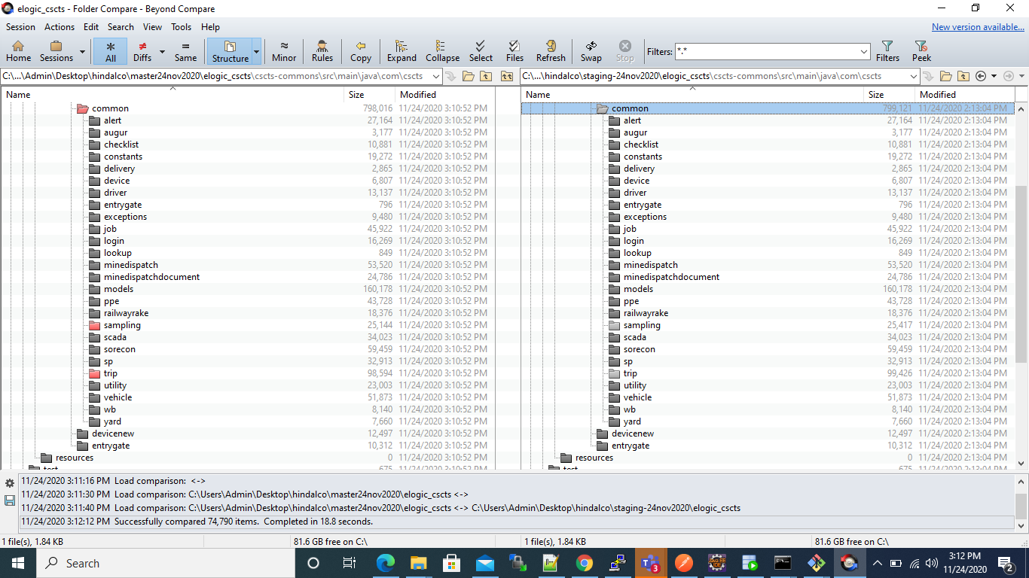

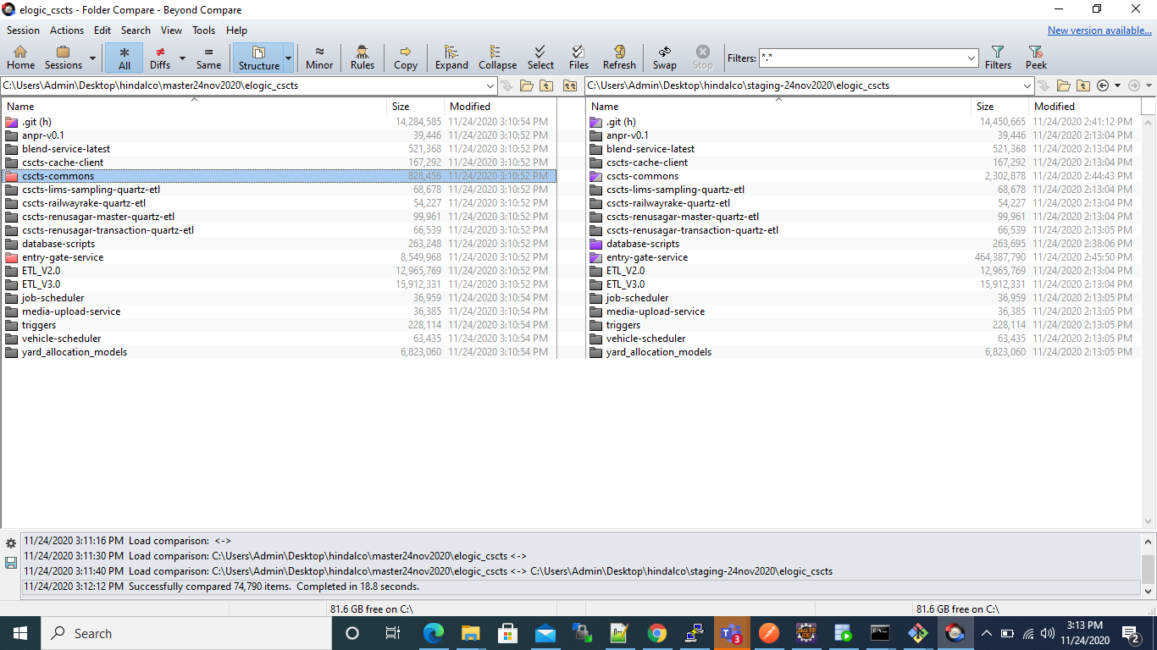

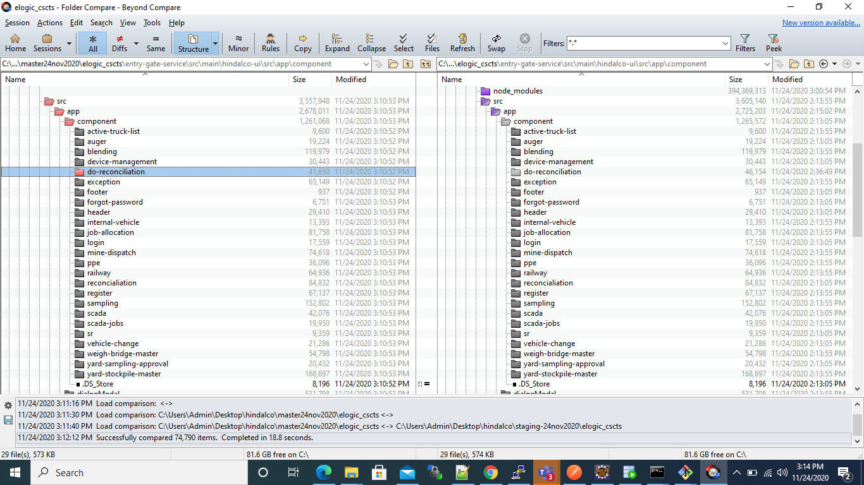

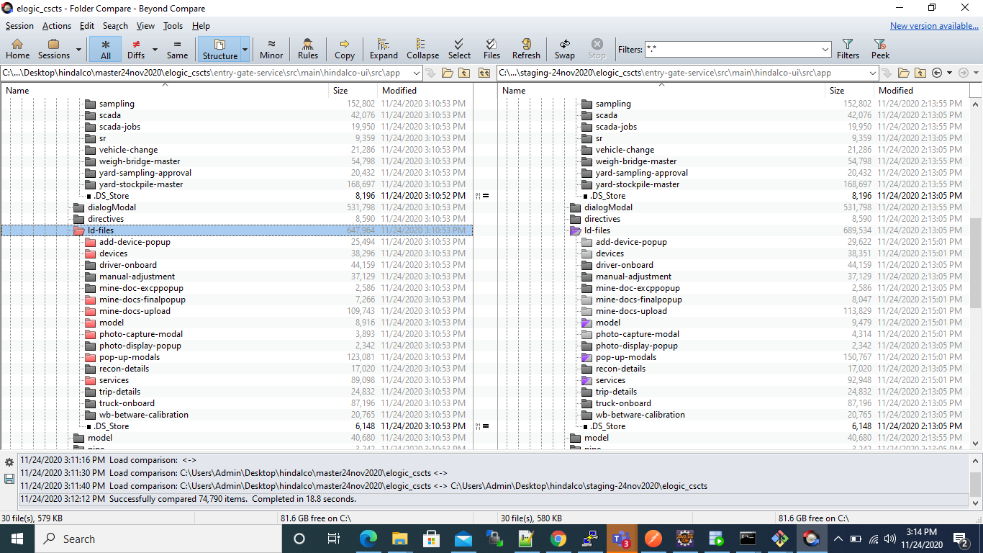

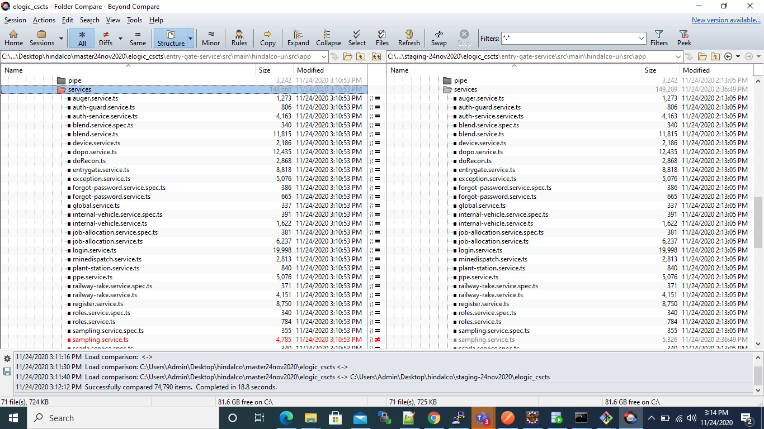

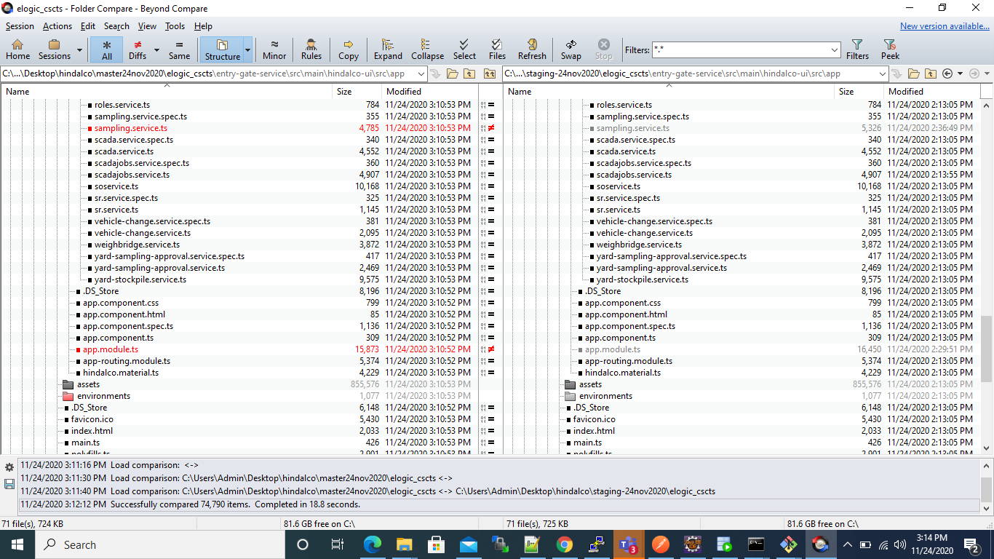

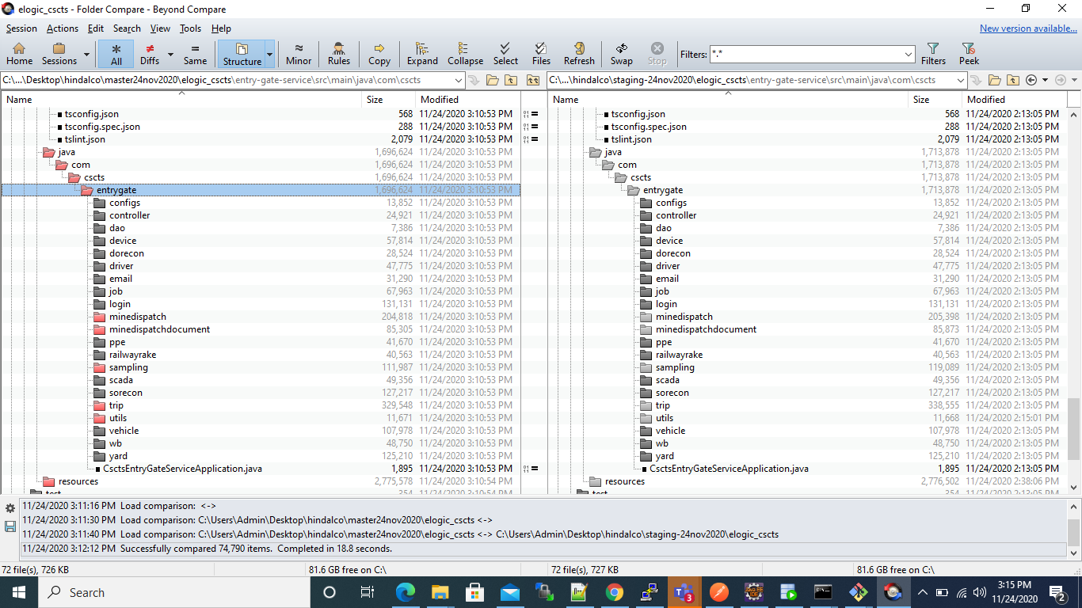

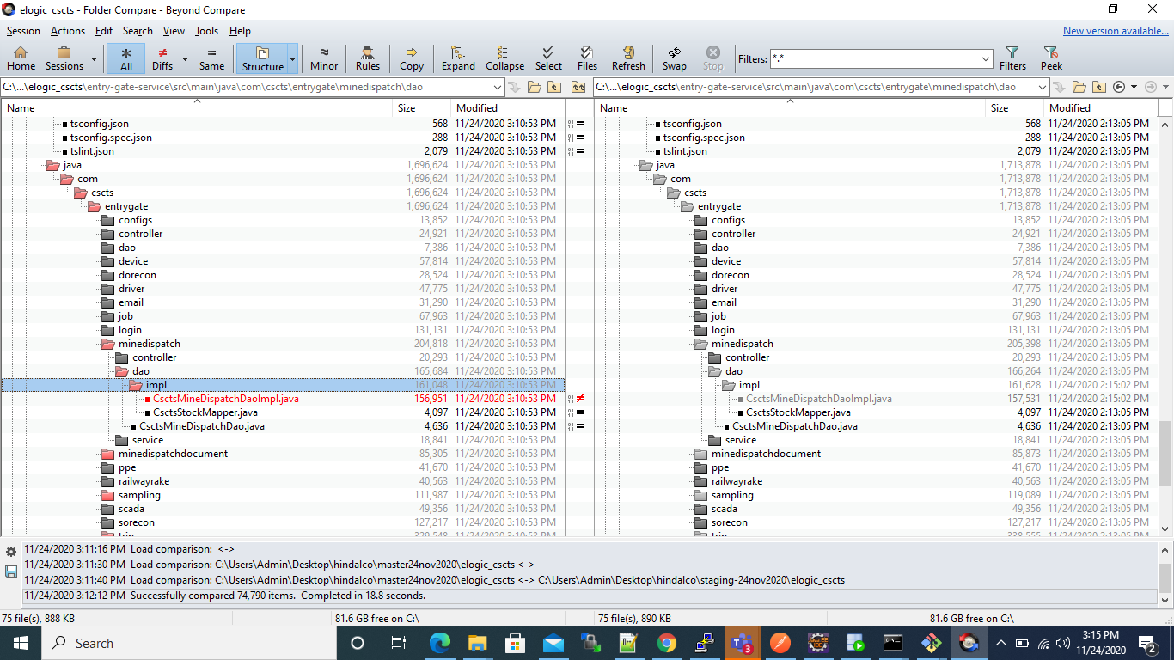

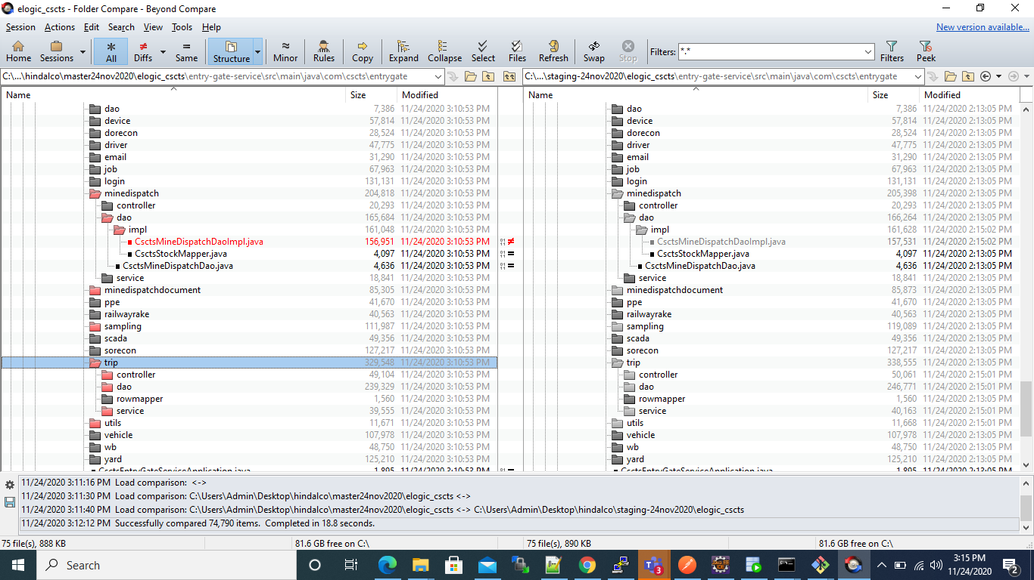

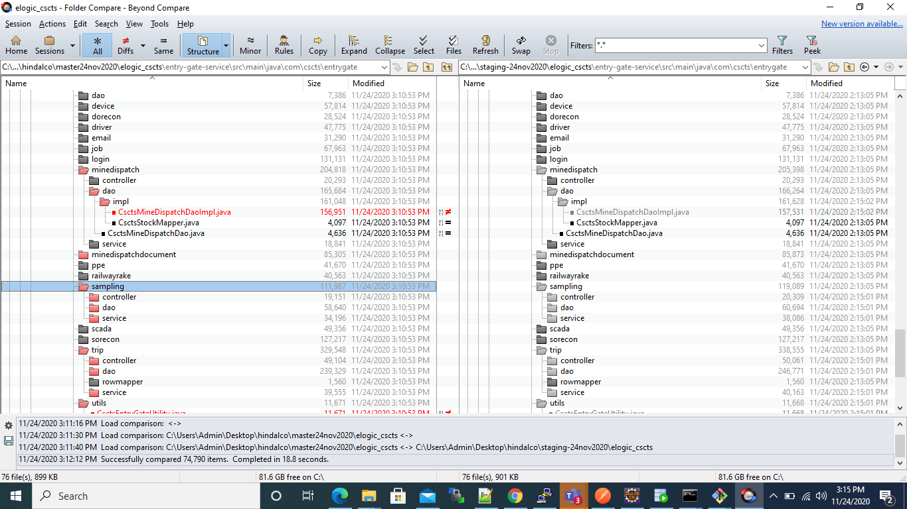

**Rollback steps:**

* The entry gate application current version is 0.96
* The preceding version is 0.95. In case of any issues, it will be rolled back to this version.
* database-scripts/rollback-sampling-do-look-up-entries.sql