Production Release

**Environment specific port changes:**

proxy-conf.json: the target ip and port needs to be changes for the respective environment as shown below

* "target": "http://10.36.24.112:9060"

environment.prod.ts:

* imageApi:'http://10.36.24.112:8083',
* blendApi:'http://10.36.24.112:9061',
* deviceApi: 'http://10.36.24.112:9066',
* apiUrl:'http://10.36.24.112:9060',

database.properties:

* url=jdbc:oracle:thin:@10.36.24.112:1521:ORCL
* dbuser=CSCTS_PROD

application.yml

* port: 9060
* change the value of "environment" to "PROD".

**DB changes:**

* database-scripts/railway - start_timestamp and rr_rake_no - addition.sql

**Files Modified:**

**cscts-commons/src/main/java/com/cscts/common/alert/model/CsctsExceptionClearance.java**

**cscts-commons/src/main/java/com/cscts/common/checklist/model/CsctsCheckResult.java**

**cscts-commons/src/main/java/com/cscts/common/railwayrake/model/CsctsRailwayRake.java**

**cscts-commons/src/main/java/com/cscts/common/railwayrake/model/CsctsRakeLevel.java**

**cscts-commons/src/main/java/com/cscts/common/railwayrake/model/CsctsWagonLevel.java**

**cscts-commons/src/main/java/com/cscts/common/railwayrake/model/CsctsWagonLevelCustom.java**

**entry-gate-service/src/main/hindalco-ui/angular.json**

**entry-gate-service/src/main/hindalco-ui/src/app/app.module.ts**

**entry-gate-service/src/main/hindalco-ui/src/app/component/active-truck-list/active-truck-list.component.css**

**entry-gate-service/src/main/hindalco-ui/src/app/component/blending/blending.component.html**

**entry-gate-service/src/main/hindalco-ui/src/app/component/blending/blending.component.ts**

**Folder compare snapshot:**

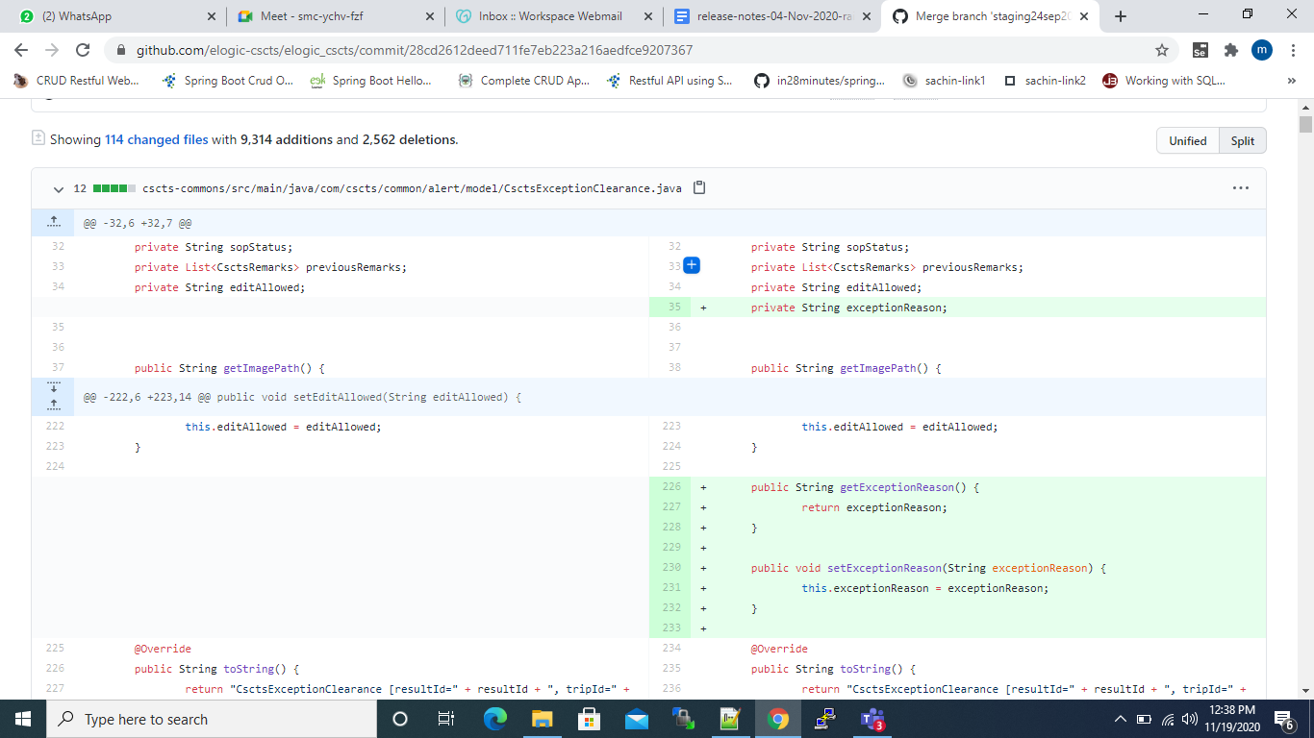

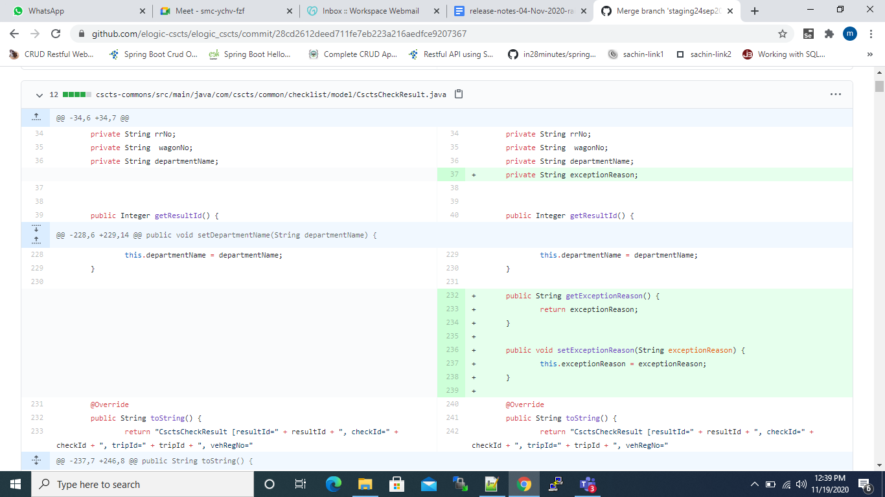

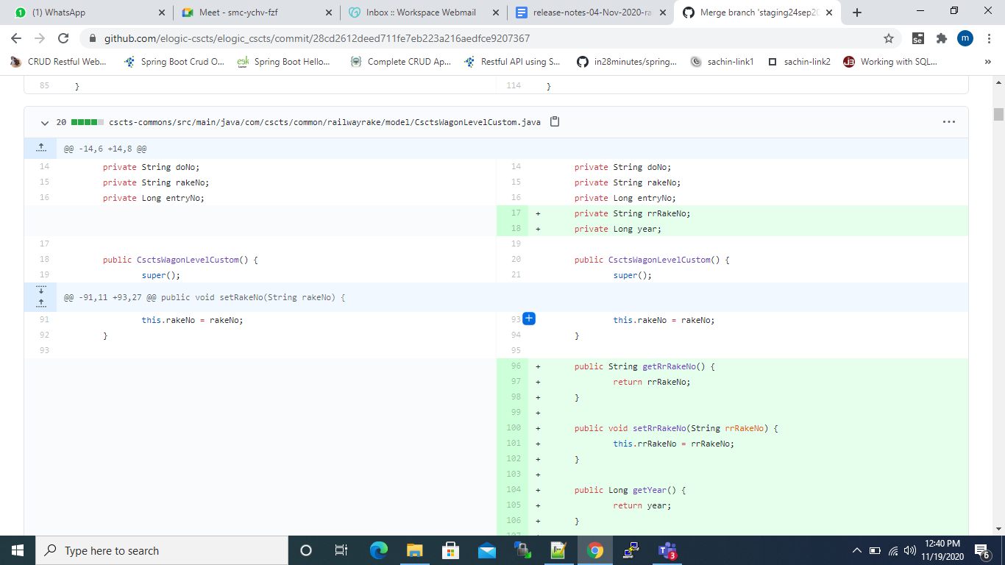

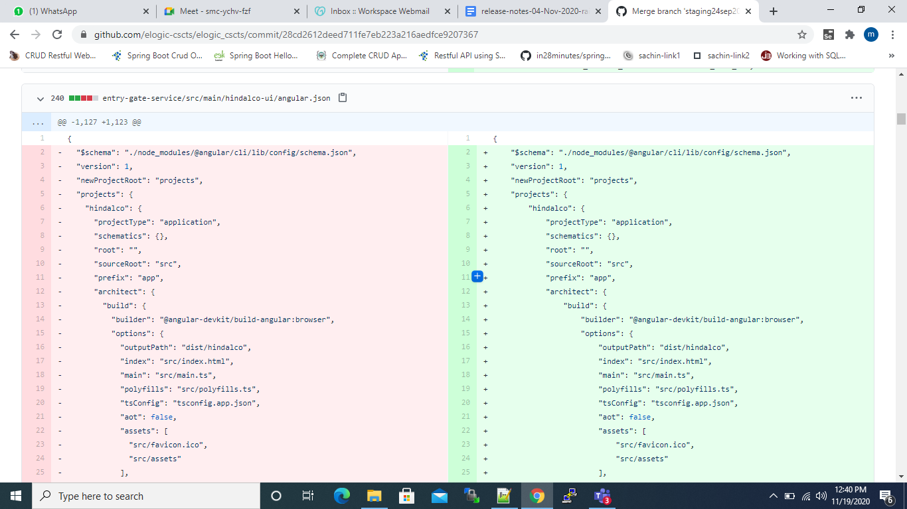

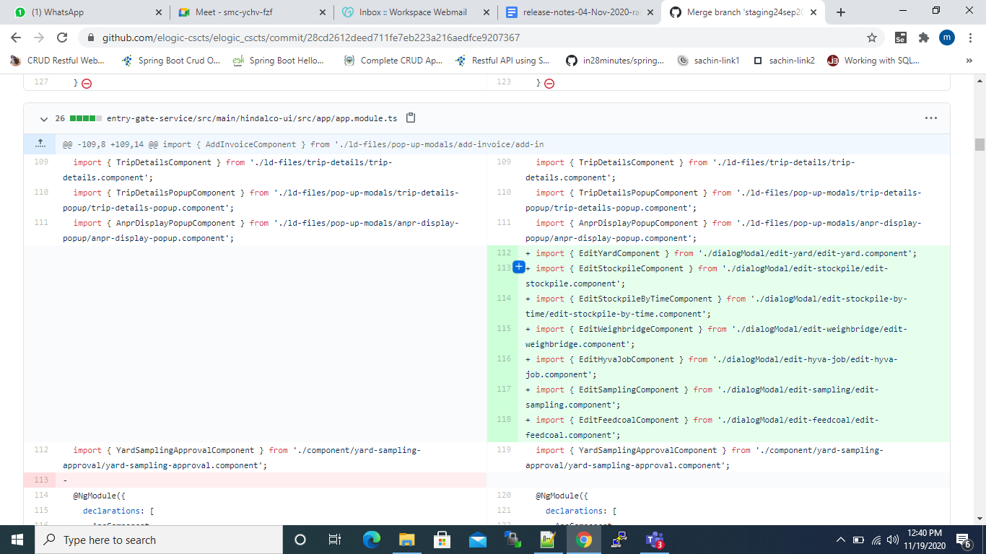

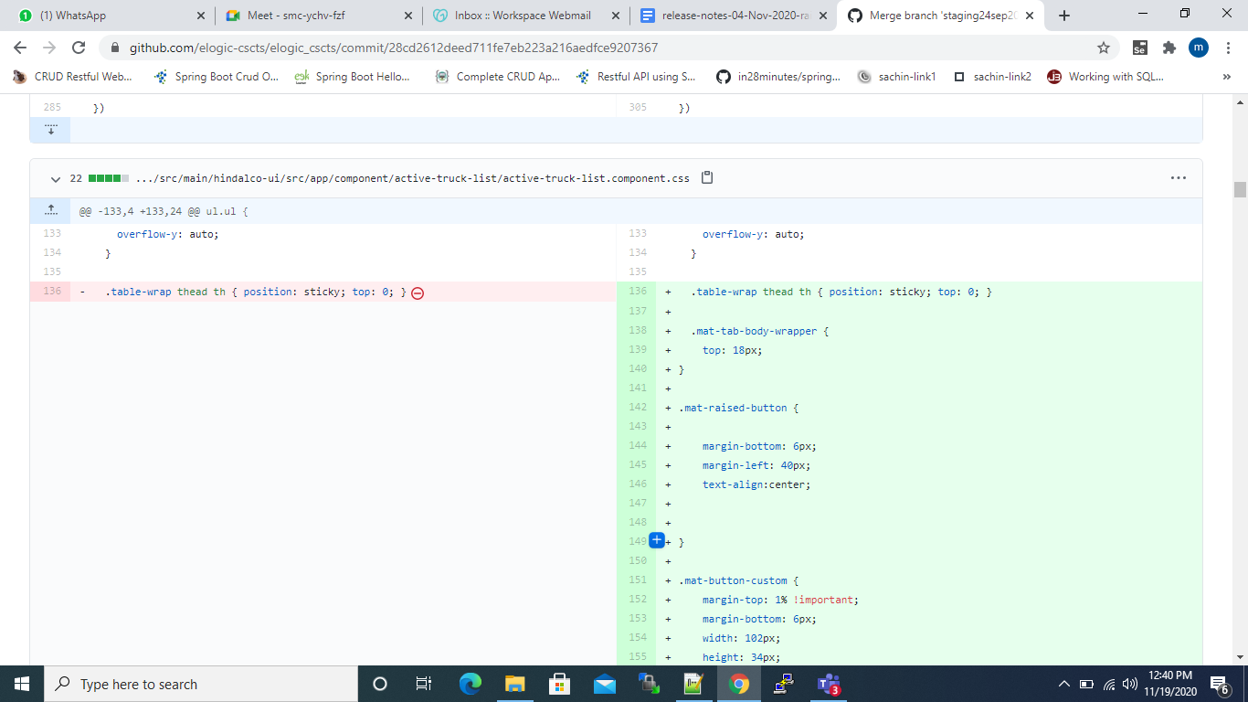

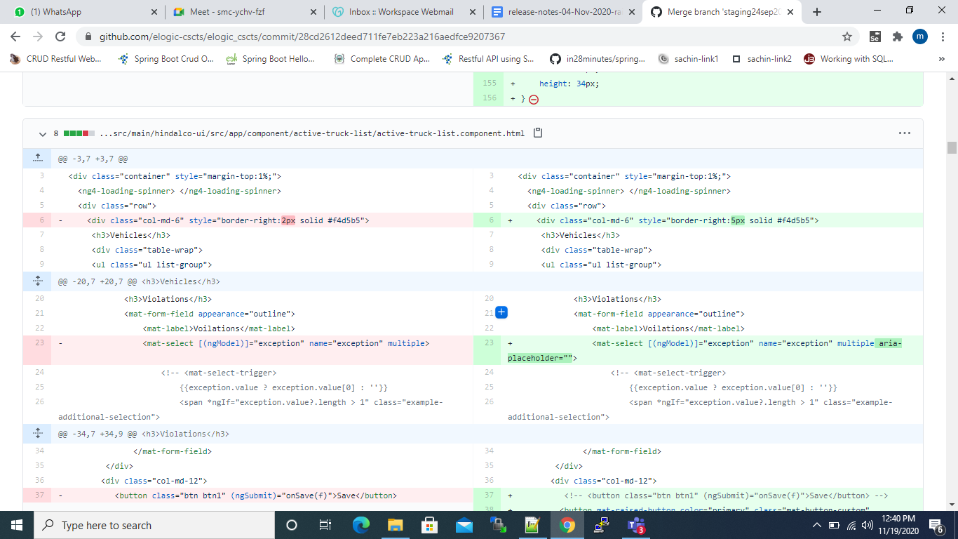

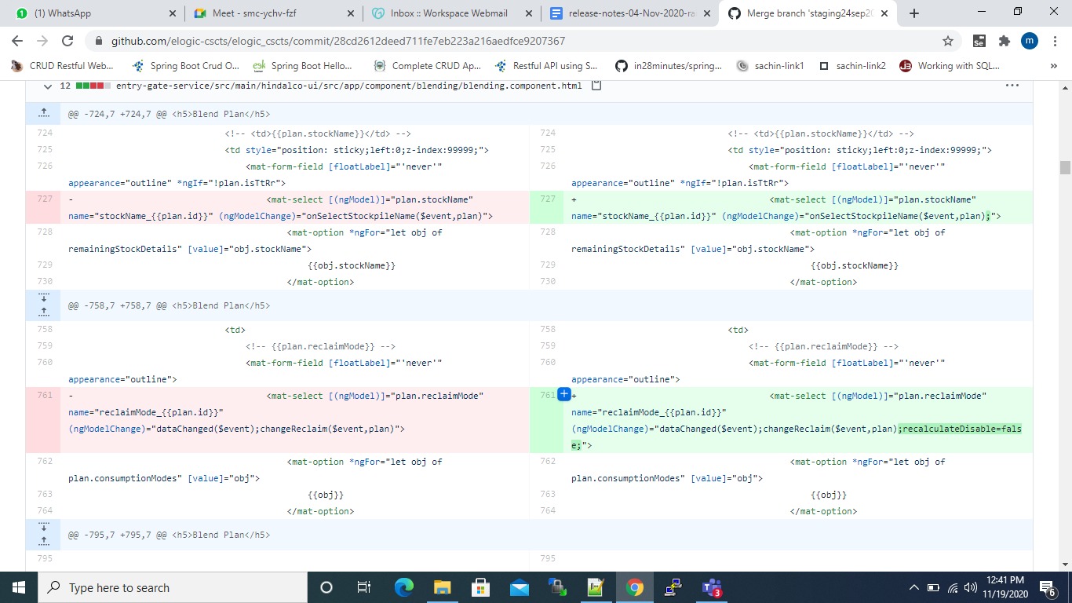

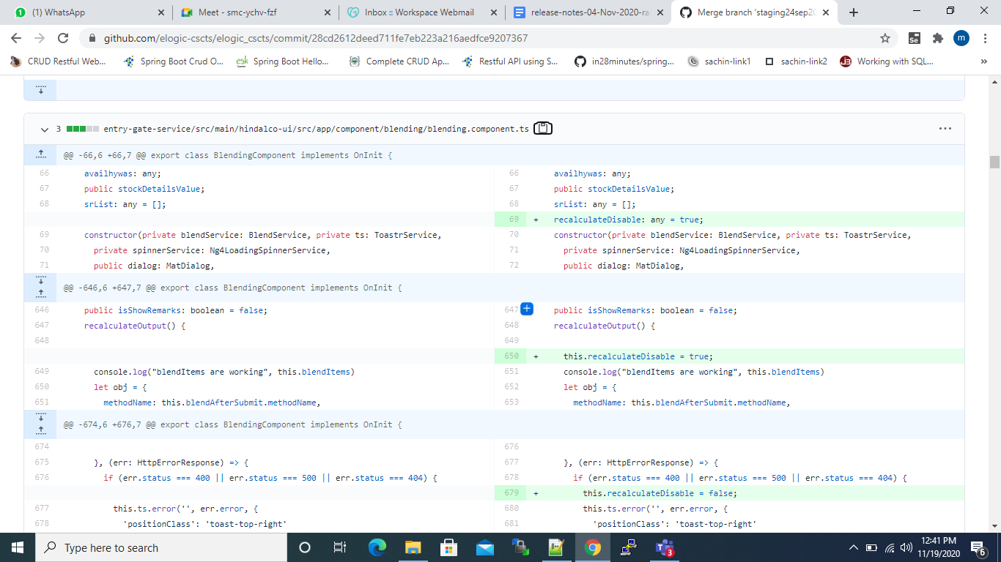

**Rollback steps:**

* The entry gate application current version is 0.95
* The preceding version is 0.94. In case of any issues, it will be rolled back to this version.
* database-scripts/rollback_railway_year+rr_rake_no.txt