Staging Release-UI guidelines set 1 and 2

**Environment specific port changes:**

proxy-conf.json: the target ip and port needs to be changes for the respective environment as shown below

* "target": "http://10.36.121.59:8092"

environment.prod.ts:

* imageApi:'http://10.36.121.59:8083',
* blendApi:'http://10.36.121.59:8091',
* deviceApi: 'http://10.36.121.59:9066',
* apiUrl:'http://10.36.121.59:8092',

database.properties:

* url=jdbc:oracle:thin:@10.36.121.59:1521:CSCDEV
* dbuser=CSCTS_BLEND

application.yml

* port: 8092
* append 1111 to the value of "plant.sms.gateway.apikey" for the sms to get triggered in DEV.
* change the value of "environment" to DEV (anything other than "PROD").

**DB changes:**

* No

**Files:**

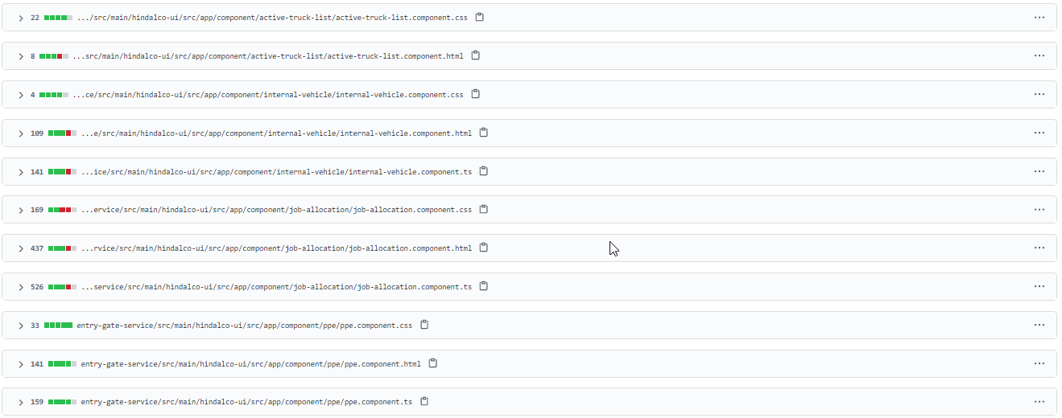

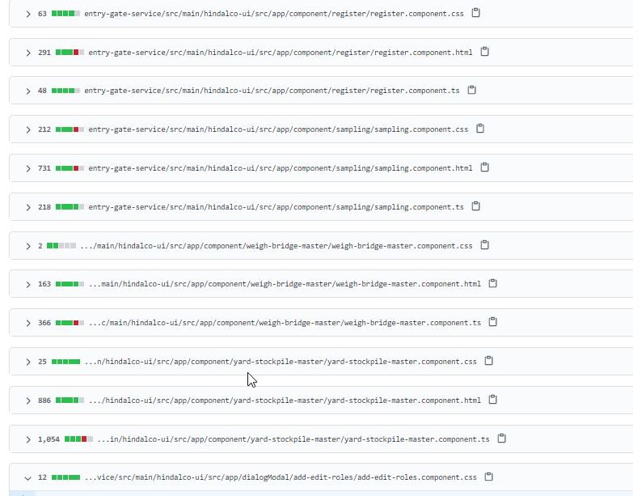 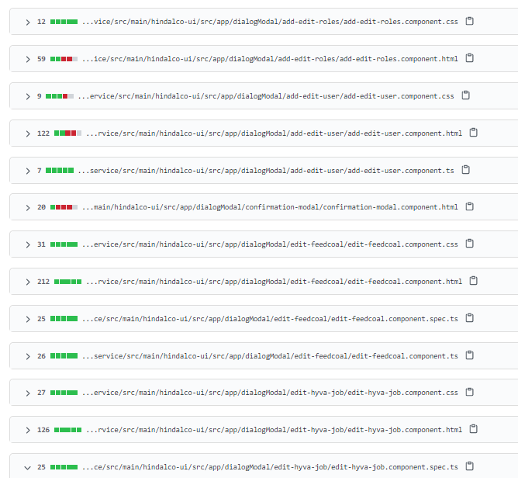 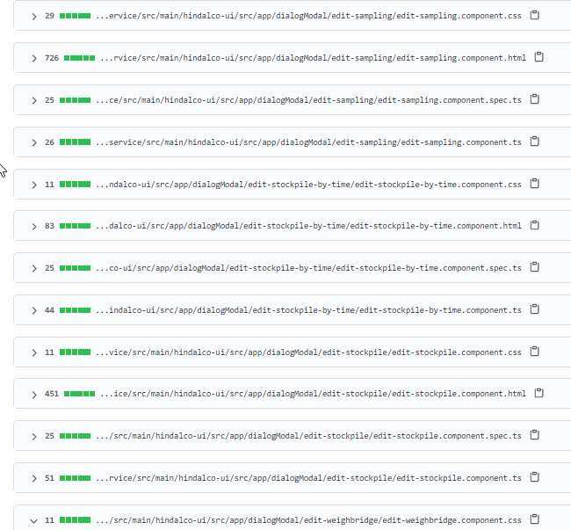 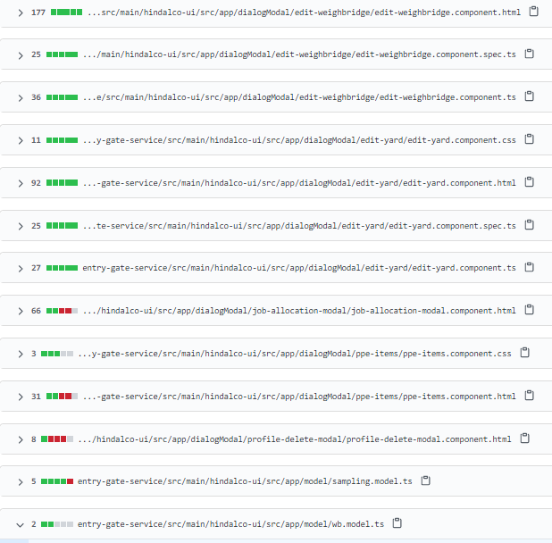

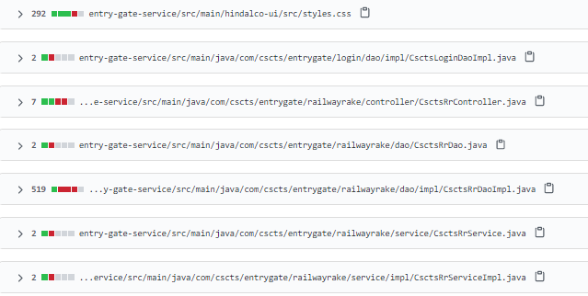

**Folder compare snapshot:**

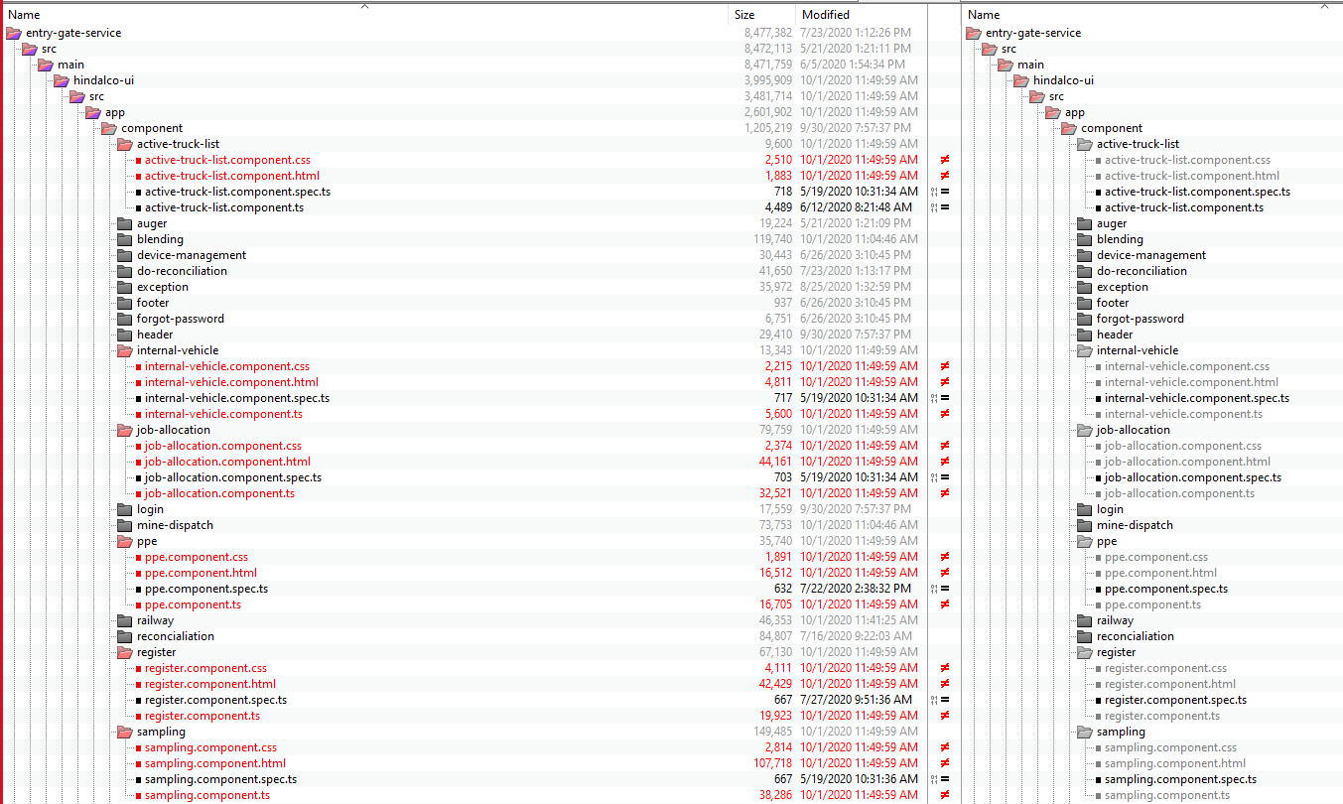

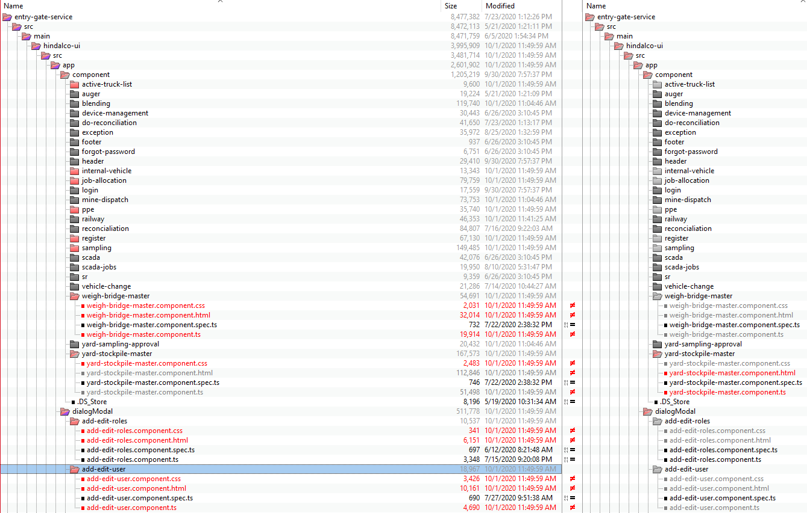

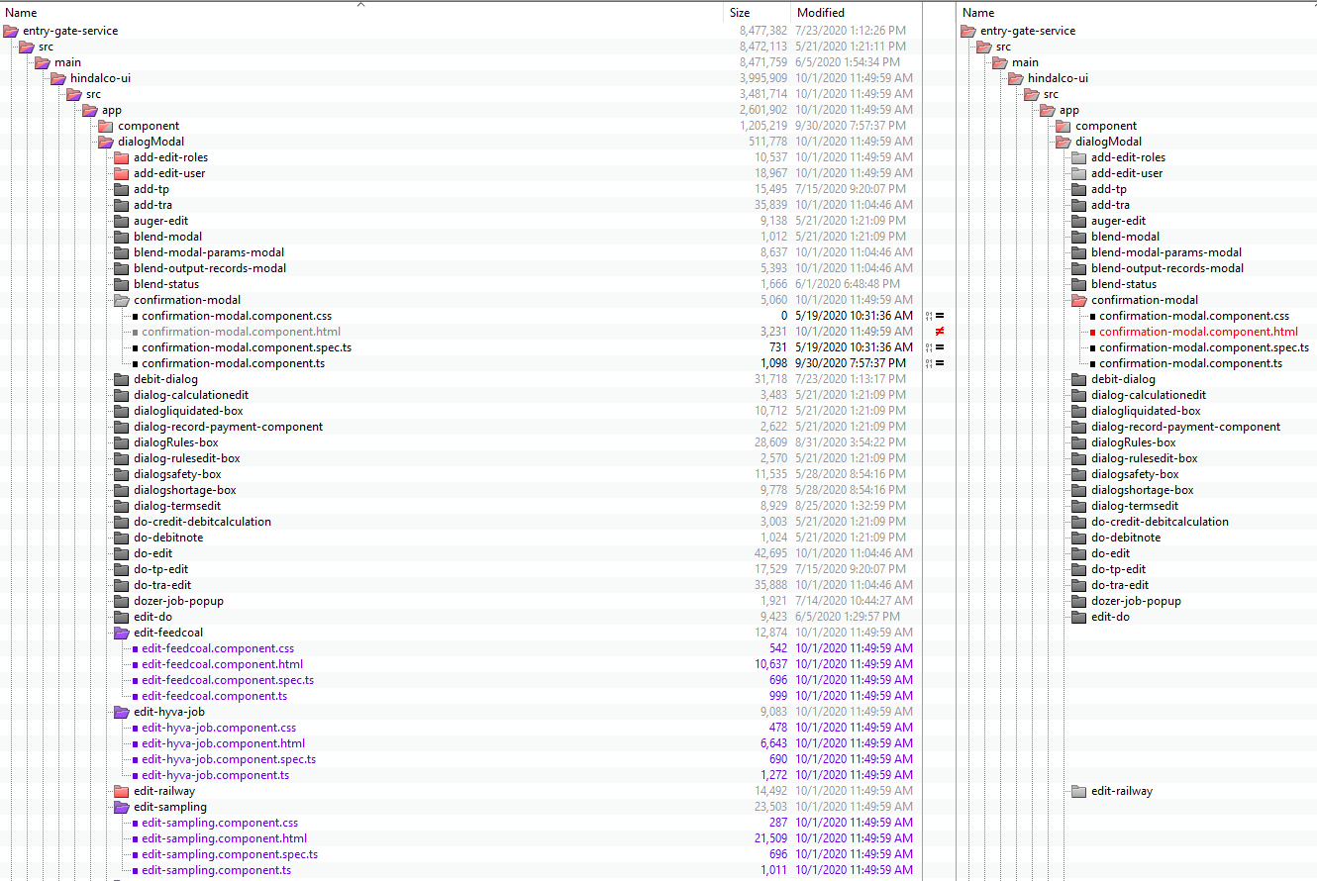

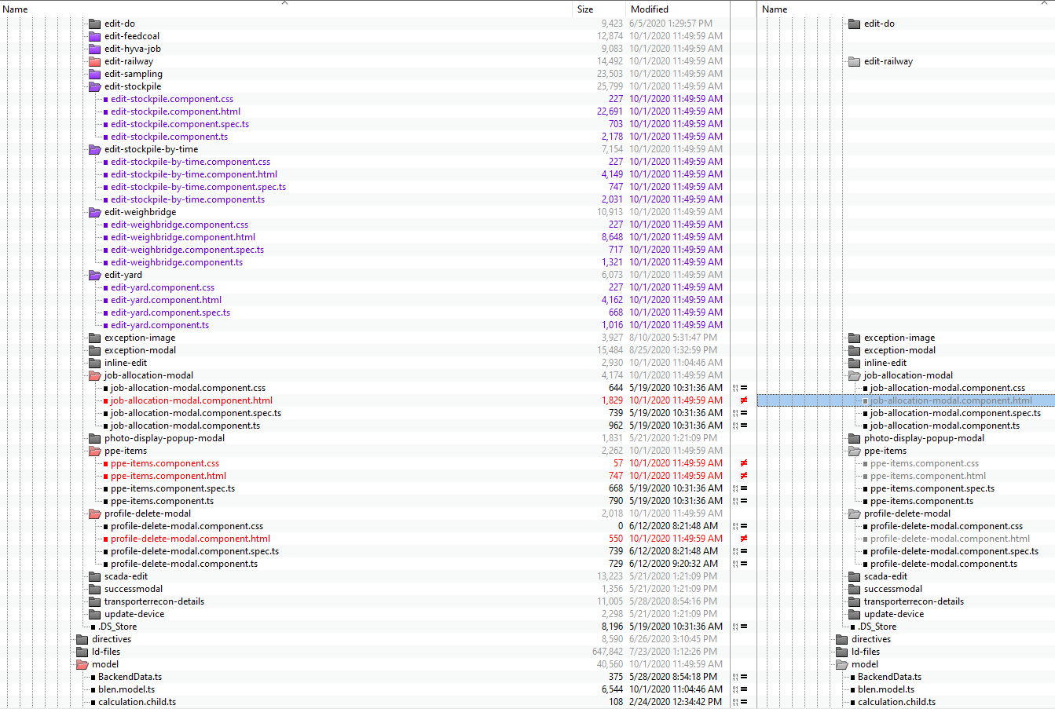

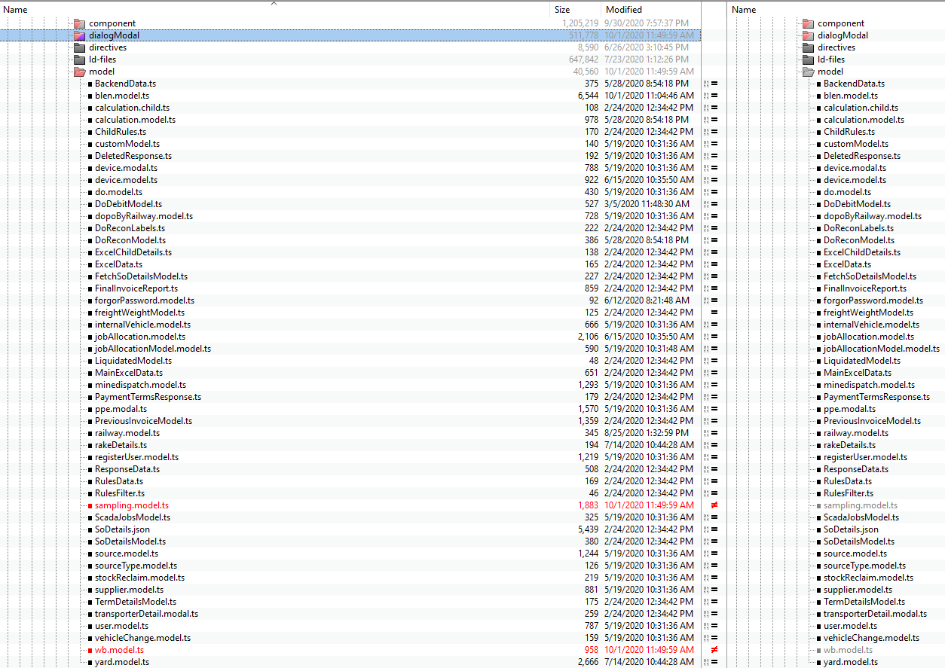

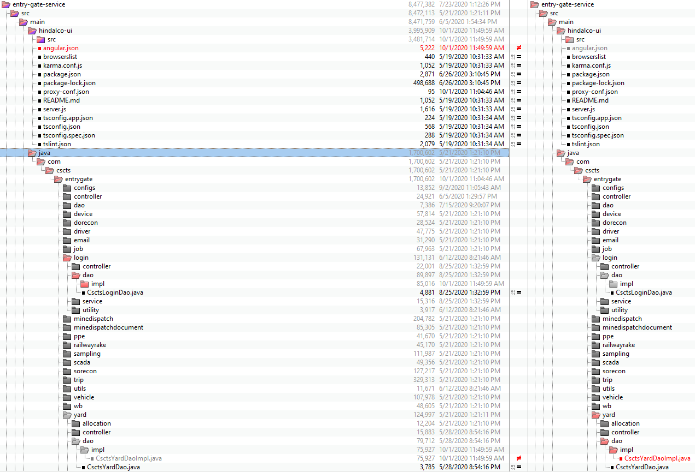

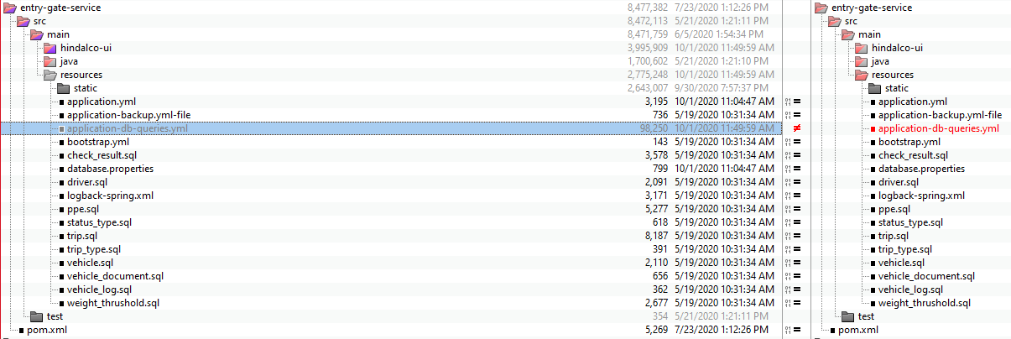

**Rollback steps:**

* The entry gate application current version is 0.22
* The preceding stable version is 0.17. In case of any issues, it will be rolled back to this version.