Staging Release

**Environment specific port changes:**

proxy-conf.json: the target ip and port needs to be changes for the respective environment as shown below

* "target": "http://10.36.121.59:8092"

environment.prod.ts:

* imageApi:'http://10.36.121.59:8083',
* blendApi:'http://10.36.121.59:8091',
* deviceApi: 'http://10.36.121.59:9066',
* apiUrl:'http://10.36.121.59:8092',

database.properties:

* url=jdbc:oracle:thin:@10.36.121.59:1521:CSCDEV
* dbuser=CSCTS_BLEND

application.yml

* port: 8092
* append 1111 to the value of "plant.sms.gateway.apikey" for the sms to get triggered in DEV.
* change the value of "environment" to DEV (anything other than "PROD").

**DB changes:**

* No

**Files Modified:**

**Search yard special sampling API:**

entry-gate-service/src/main/java/com/cscts/entrygate/sampling/dao/impl/CsctsSamplingDaoImpl.java

**Search yard special sampling UI:**

entry-gate-service/src/main/hindalco-ui/src/app/component/yard-sampling-approval/yard-sampling-approval.component.html

entry-gate-service/src/main/hindalco-ui/src/app/component/yard-sampling-approval/yard-sampling-approval.component.ts

entry-gate-service/src/main/hindalco-ui/src/app/dialogModal/inline-edit/inline-edit.component.html

**Blend Inactive vehicles API fix:**

entry-gate-service/src/main/java/com/cscts/entrygate/job/dao/impl/CsctsJobDaoImpl.java

entry-gate-service/src/main/resources/application-db-queries.yml

**Source Mapping Change Files Fix:**

entry-gate-service/src/main/java/com/cscts/entrygate/dorecon/dao/impl/CsctsDoReconDaoImpl.java

entry-gate-service/src/main/java/com/cscts/entrygate/minedispatch/dao/impl/CsctsMineDispatchDaoImpl.java

**Folder compare snapshot:**

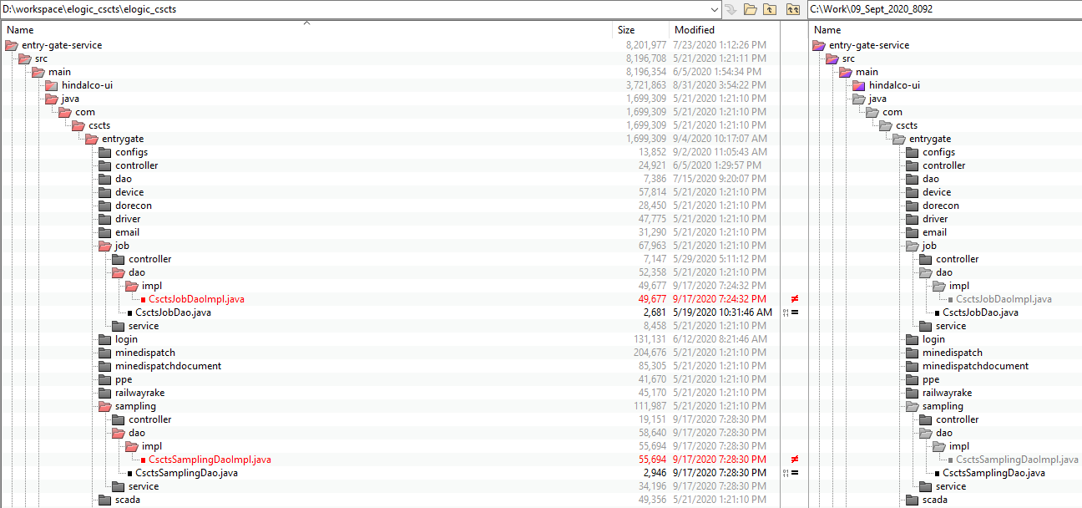

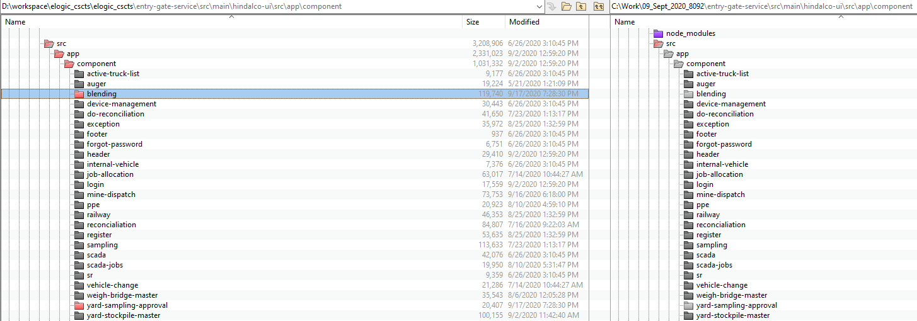

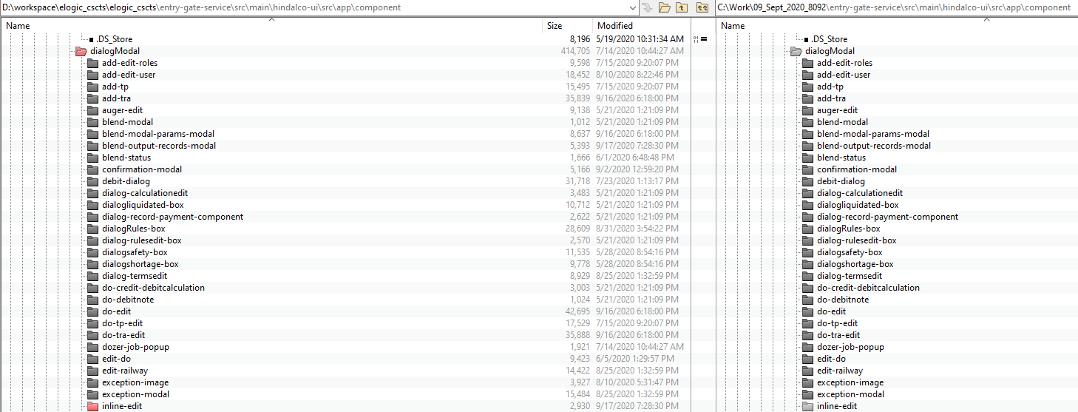

**Rollback steps:**

* The entry gate application current version is 0.17
* The preceding version is 0.18. In case of any issues, it will be rolled back to this version.