Production Release – Yard Special Sample and Blend UI fixes and Source Fix Features

**Environment specific port changes:**

proxy-conf.json: the target ip and port needs to be changes for the respective environment as shown below

* "target": "http://10.36.24.112:9060"

environment.prod.ts:

* imageApi:'http://10.36.24.112:8083',
* blendApi:'http://10.36.24.112:8091',
* deviceApi: 'http://10.36.24.112:9066',
* apiUrl:'http://10.36.24.112:9060',

database.properties:

* url=jdbc:oracle:thin:@10.36.24.112:1521:orcl
* dbuser=CSCTS_PROD

application.yml

* port: 9060
* remove 1111 to the value of "plant.sms.gateway.apikey" for the sms to get triggered in PROD.
* change the value of "environment" to PROD.

blend (application.properties)

* port:9061
* url=jdbc:oracle:thin:@10.36.24.112:1521:orcl
* dbuser=CSCTS_PROD

blend (python script)

* replace coal_blend_model.py in script folder.

**DB changes:**

* No

**Files Modified:**

blend-service-latest/blend-plan-service-latest/src/main/java/com/cscts/blendplan/dao/impl/CsctsBlendPlanDaoImpl.java

blend-service-latest/blend-plan-service-latest/src/main/java/com/cscts/blendplan/service/impl/CsctsBlendPlanServiceImpl.java

blend-service-latest/blend-plan-service-latest/src/main/java/com/cscts/blendplan/utility/CsctsBlendUtility.java

blend-service-latest/blend-plan-service-latest/src/main/resources/application.properties

blend-service-latest/blend-plan-service-latest/src/main/resources/application.properties

blend-service-latest/scripts/coal_blend_model.py

cscts-commons/src/main/java/com/cscts/common/sampling/model/CsctsSearchYardSampling.java

entry-gate-service/src/main/hindalco-ui/proxy-conf.json

entry-gate-service/src/main/hindalco-ui/src/app/component/blending/blending.component.html

entry-gate-service/src/main/hindalco-ui/src/app/component/blending/blending.component.html

entry-gate-service/src/main/hindalco-ui/src/app/component/yard-sampling-approval/yard-sampling-approval.component.css

entry-gate-service/src/main/hindalco-ui/src/app/component/yard-sampling-approval/yard-sampling-approval.component.html

entry-gate-service/src/main/hindalco-ui/src/app/component/yard-sampling-approval/yard-sampling-approval.component.ts

entry-gate-service/src/main/hindalco-ui/src/app/dialogModal/blend-output-records-modal/blend-output-records-modal.component.html

entry-gate-service/src/main/hindalco-ui/src/app/dialogModal/inline-edit/inline-edit.component.html

entry-gate-service/src/main/hindalco-ui/src/app/services/yard-sampling-approval.service.ts

entry-gate-service/src/main/hindalco-ui/src/environments/environment.prod.ts

entry-gate-service/src/main/java/com/cscts/entrygate/dorecon/dao/impl/CsctsDoReconDaoImpl.java

entry-gate-service/src/main/java/com/cscts/entrygate/job/dao/impl/CsctsJobDaoImpl.java

entry-gate-service/src/main/java/com/cscts/entrygate/minedispatch/dao/impl/CsctsMineDispatchDaoImpl.java

entry-gate-service/src/main/java/com/cscts/entrygate/sampling/controller/CsctsSamplingController.java

entry-gate-service/src/main/java/com/cscts/entrygate/sampling/dao/CsctsSamplingDao.java

entry-gate-service/src/main/java/com/cscts/entrygate/sampling/dao/impl/CsctsSamplingDaoImpl.java

entry-gate-service/src/main/java/com/cscts/entrygate/sampling/service/CsctsSamplingService.java

entry-gate-service/src/main/java/com/cscts/entrygate/sampling/service/impl/CsctsSamplingServiceImpl.java

entry-gate-service/src/main/java/com/cscts/entrygate/trip/dao/impl/CsctsTripDaoImpl.java

entry-gate-service/src/main/java/com/cscts/entrygate/vehicle/dao/impl/CsctsVehicleDaoImpl.java

entry-gate-service/src/main/java/com/cscts/entrygate/wb/dao/impl/CsctsWeighBridgeDaoImpl.java

entry-gate-service/src/main/resources/application-db-queries.yml

entry-gate-service/src/main/resources/application.yml

entry-gate-service/src/main/resources/database.properties

**Folder compare snapshot:**

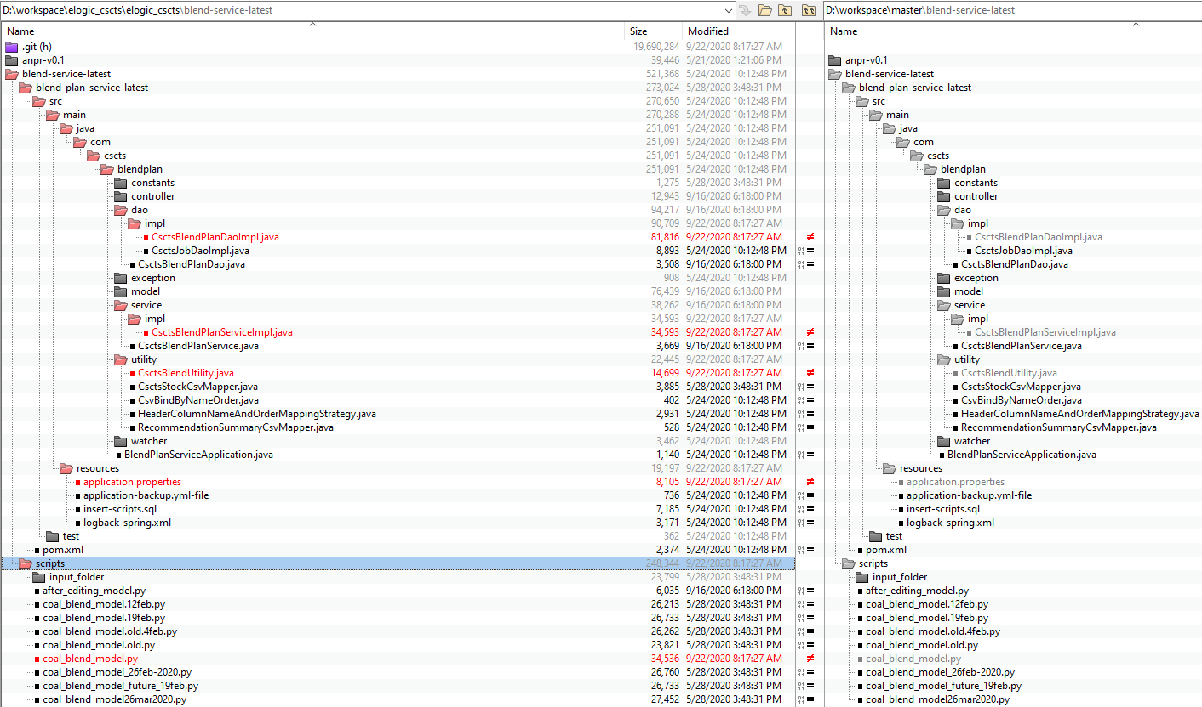

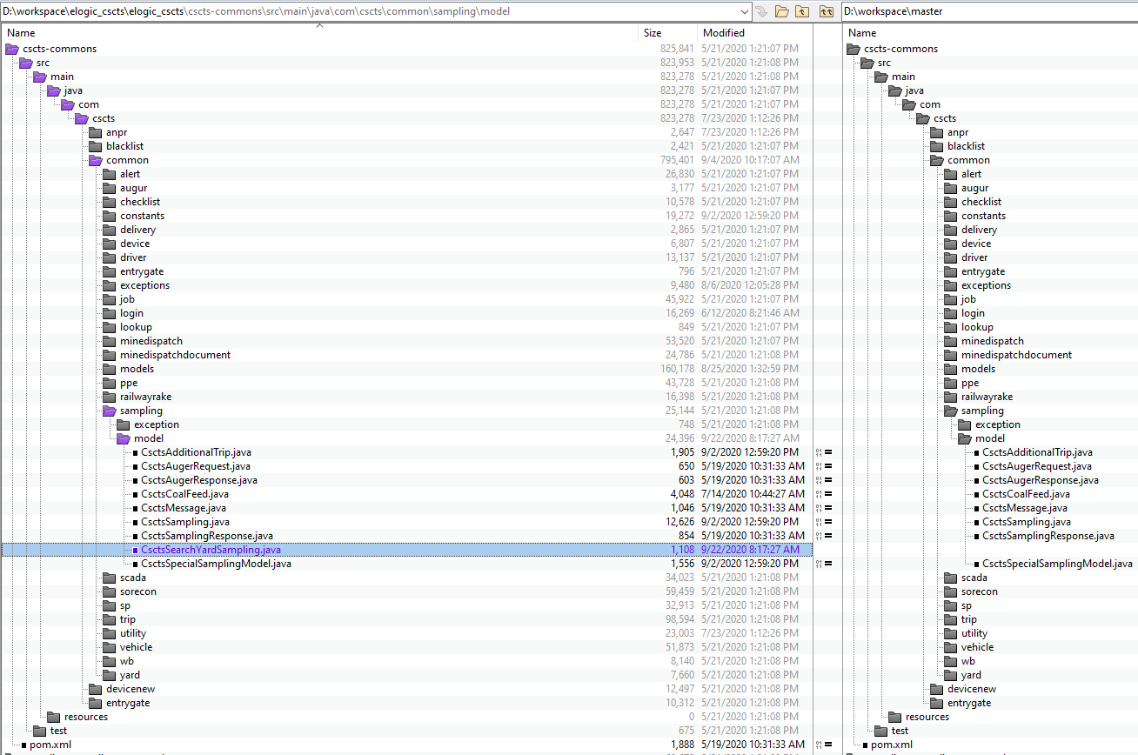

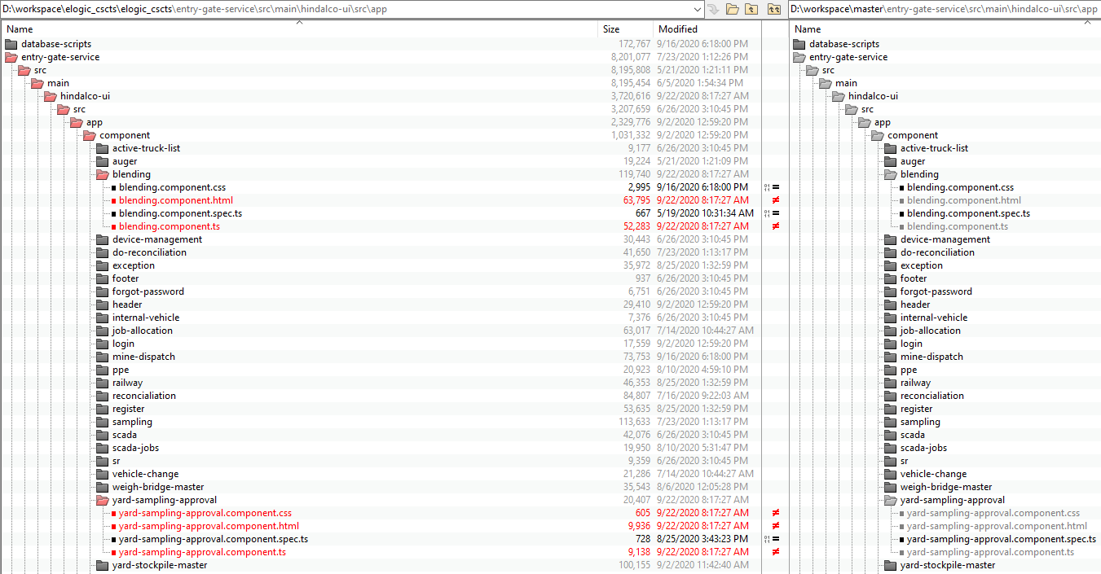

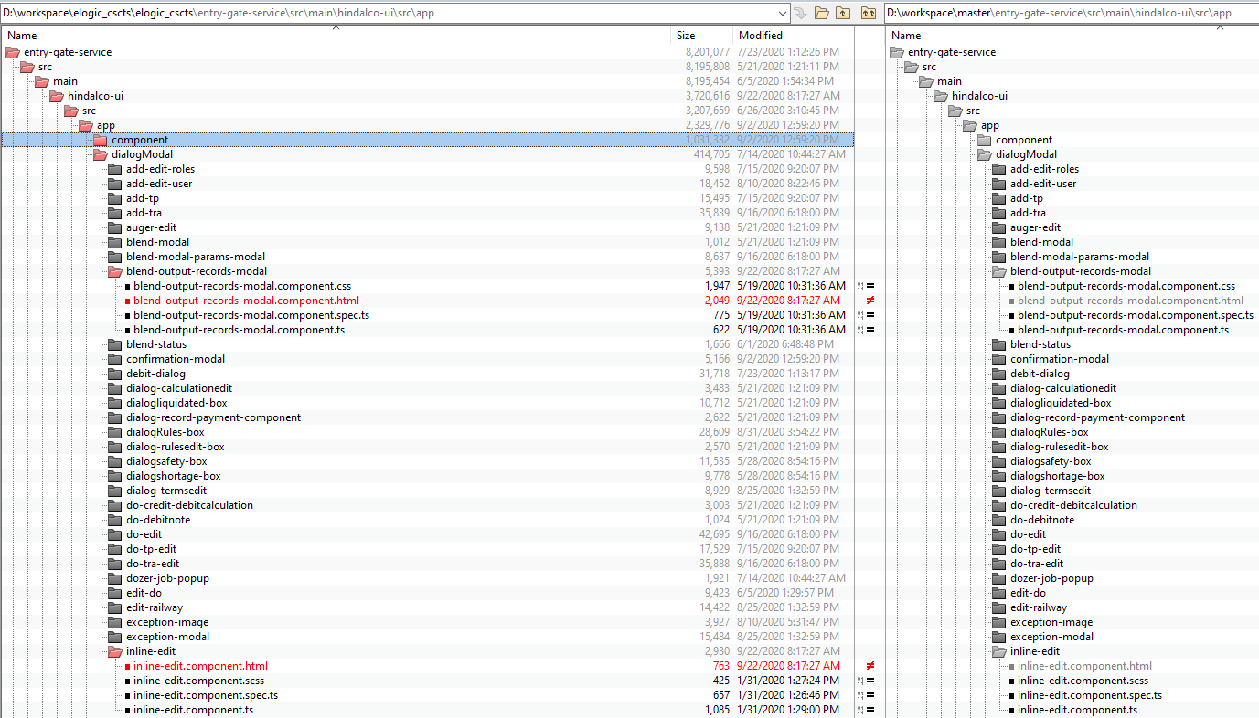

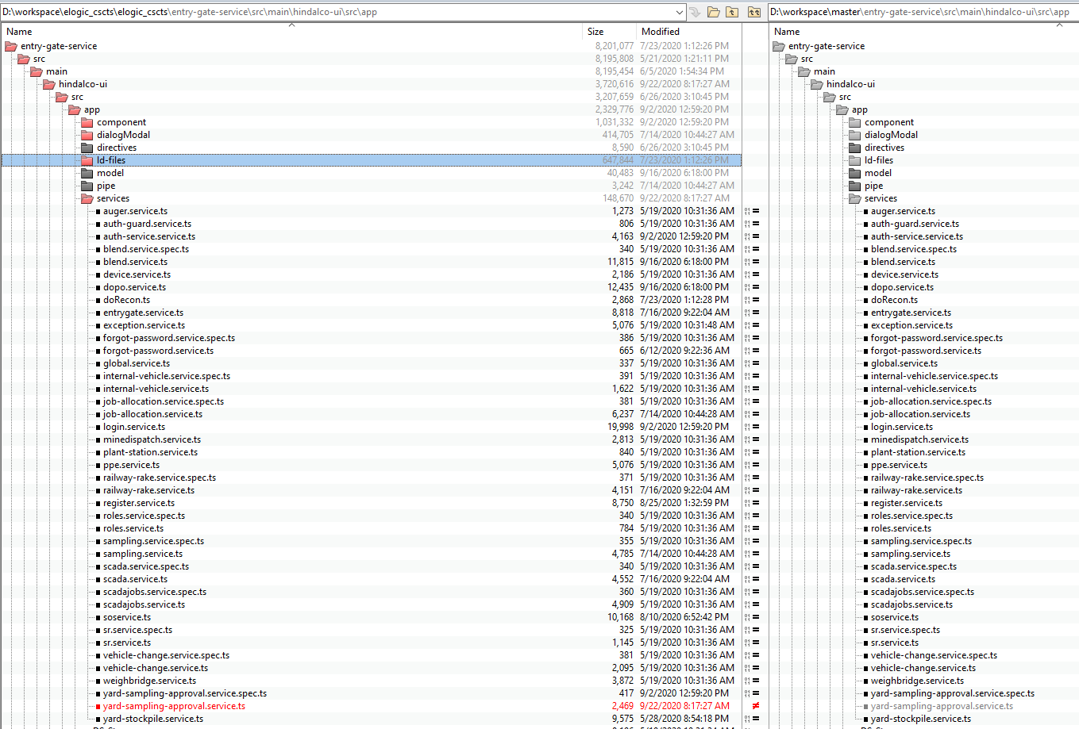

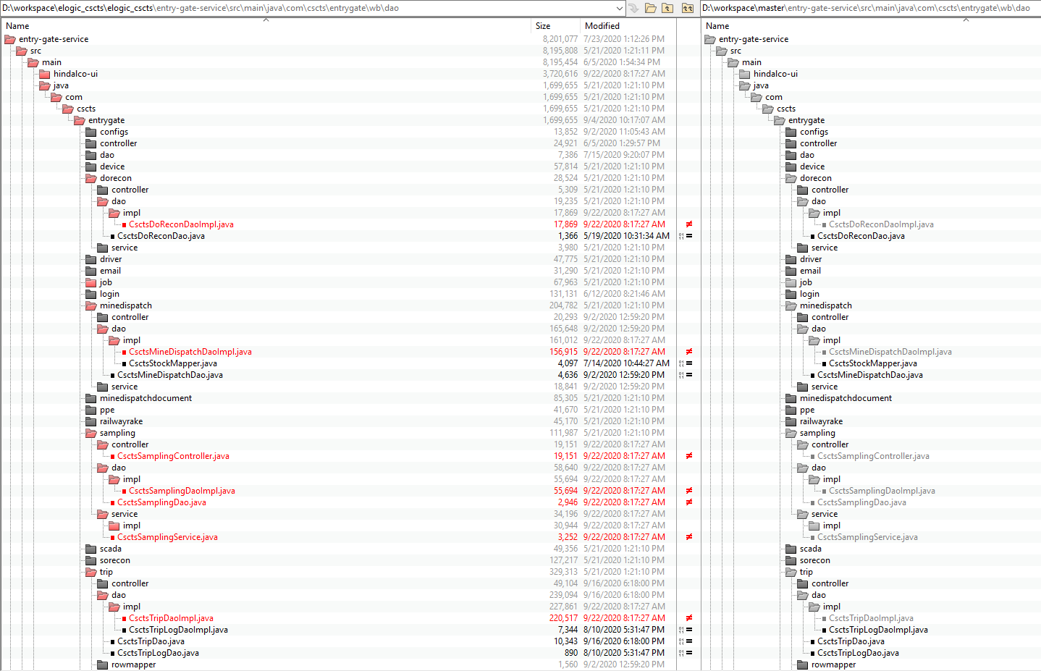

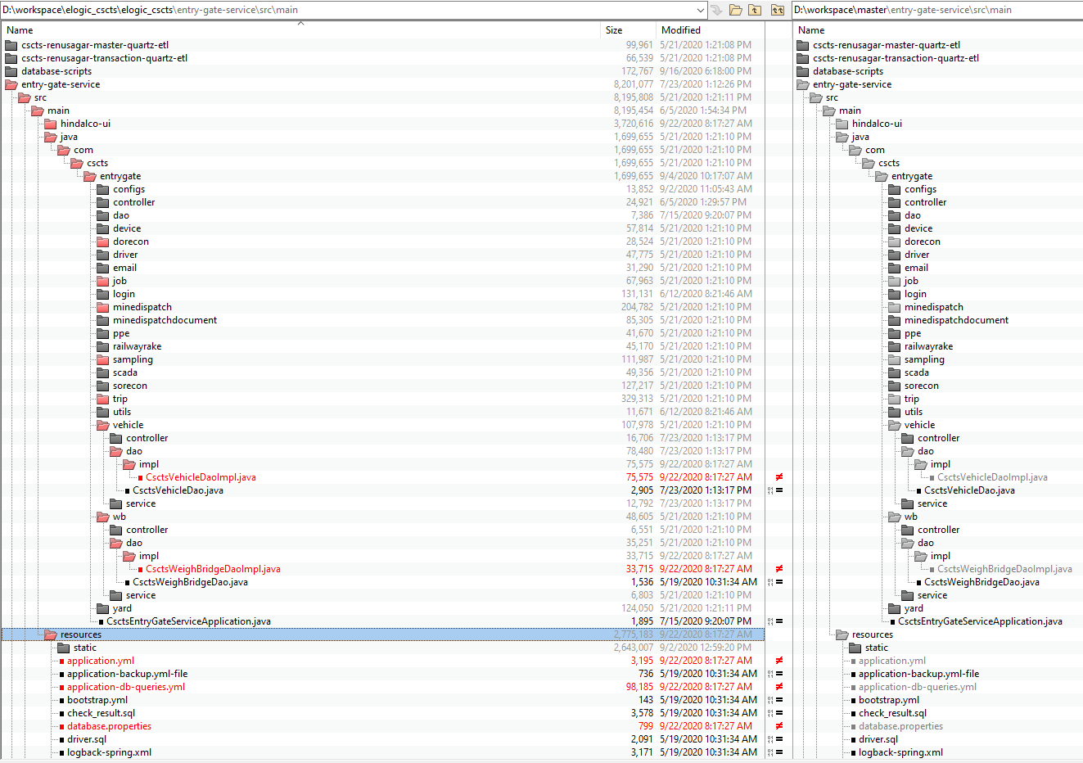

**Rollback steps:**

* The entry gate application current version is 0.92
* The preceding version is 0.93. In case of any issues, it will be rolled back to this version.
* The preceding version is blend-v23. In case of any issues, it will be rolled back to this version.