Functional Flow

# Yard Sampling

* In the yard sampling, user should have the option to search the details by dates
* User should be able to search the details by dates and status of the sampling
* User should be able to filter the data by vehicle number
* User should be able to do the search with all of the above fields or any of the field combinations
* User should be able to download the data in an excel format

## User Flow

* Yard sampling approval page is having the search features like based on vehicle, between any dates or status.

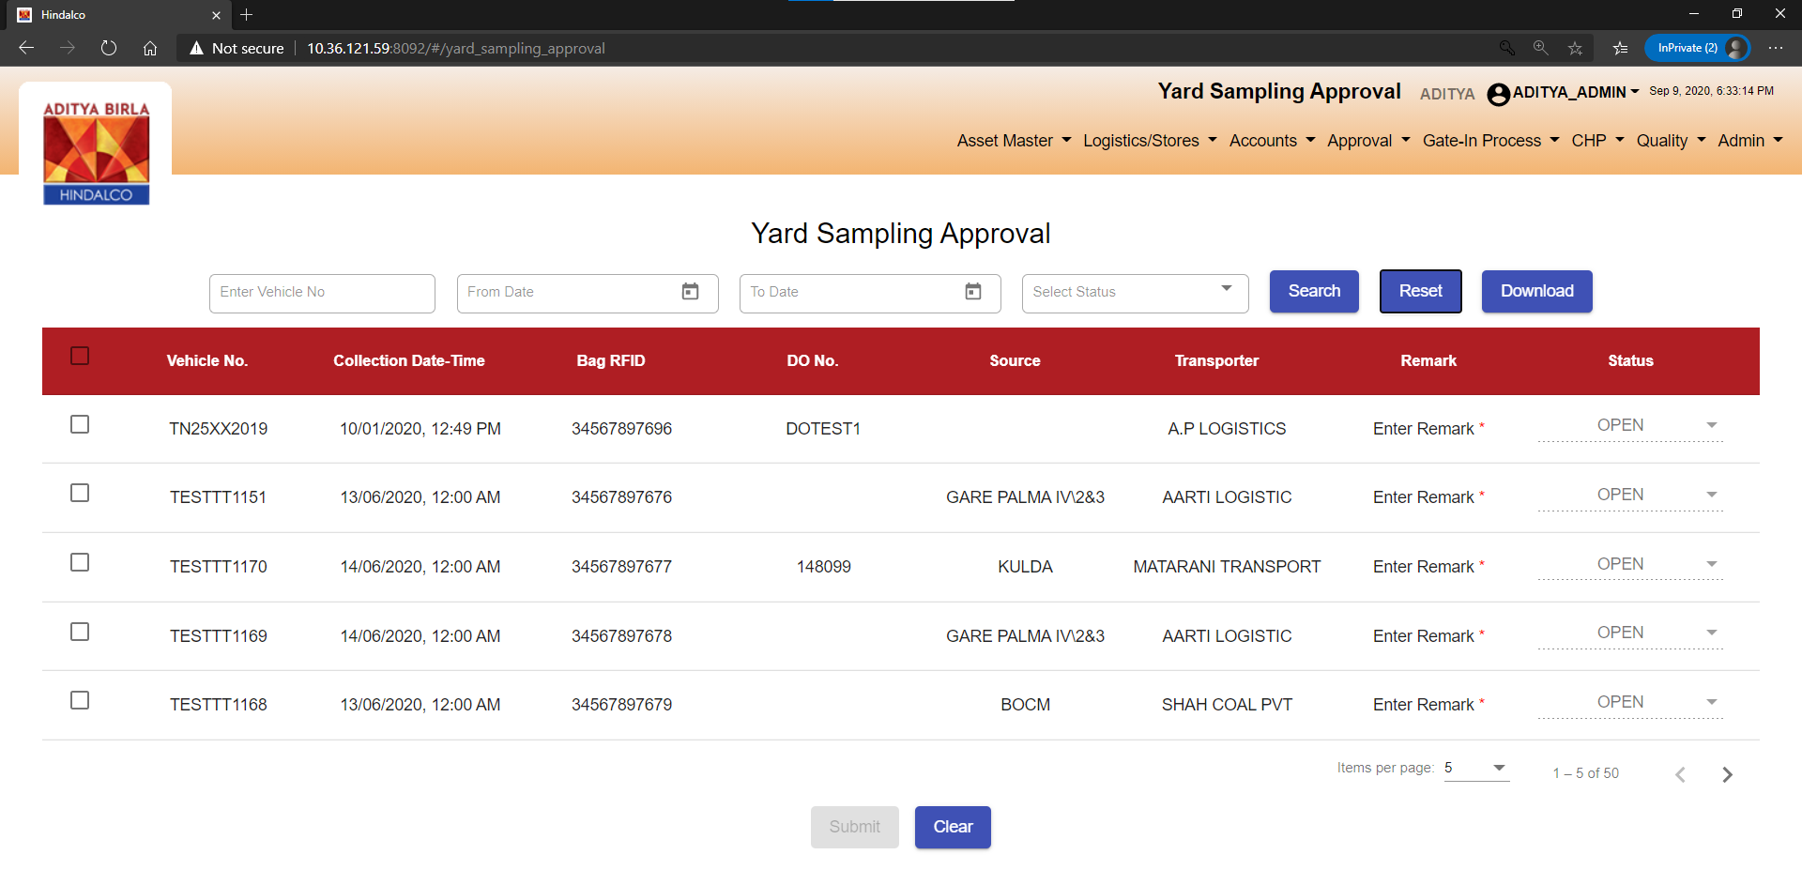

* User can search any entry based on vehicle.

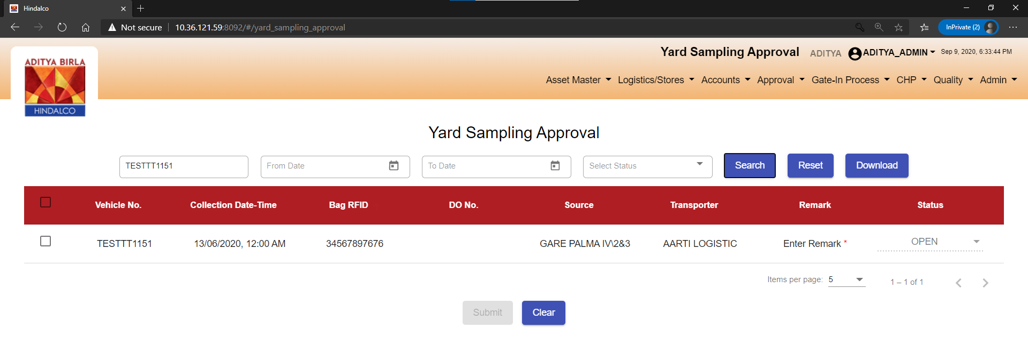

* User can search based on any dated.

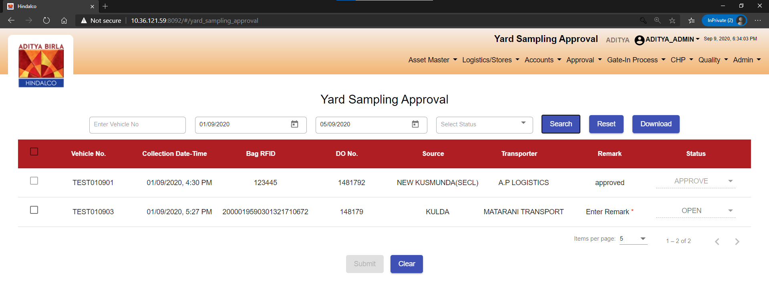

* User can search based on status. (Approve/Reject)

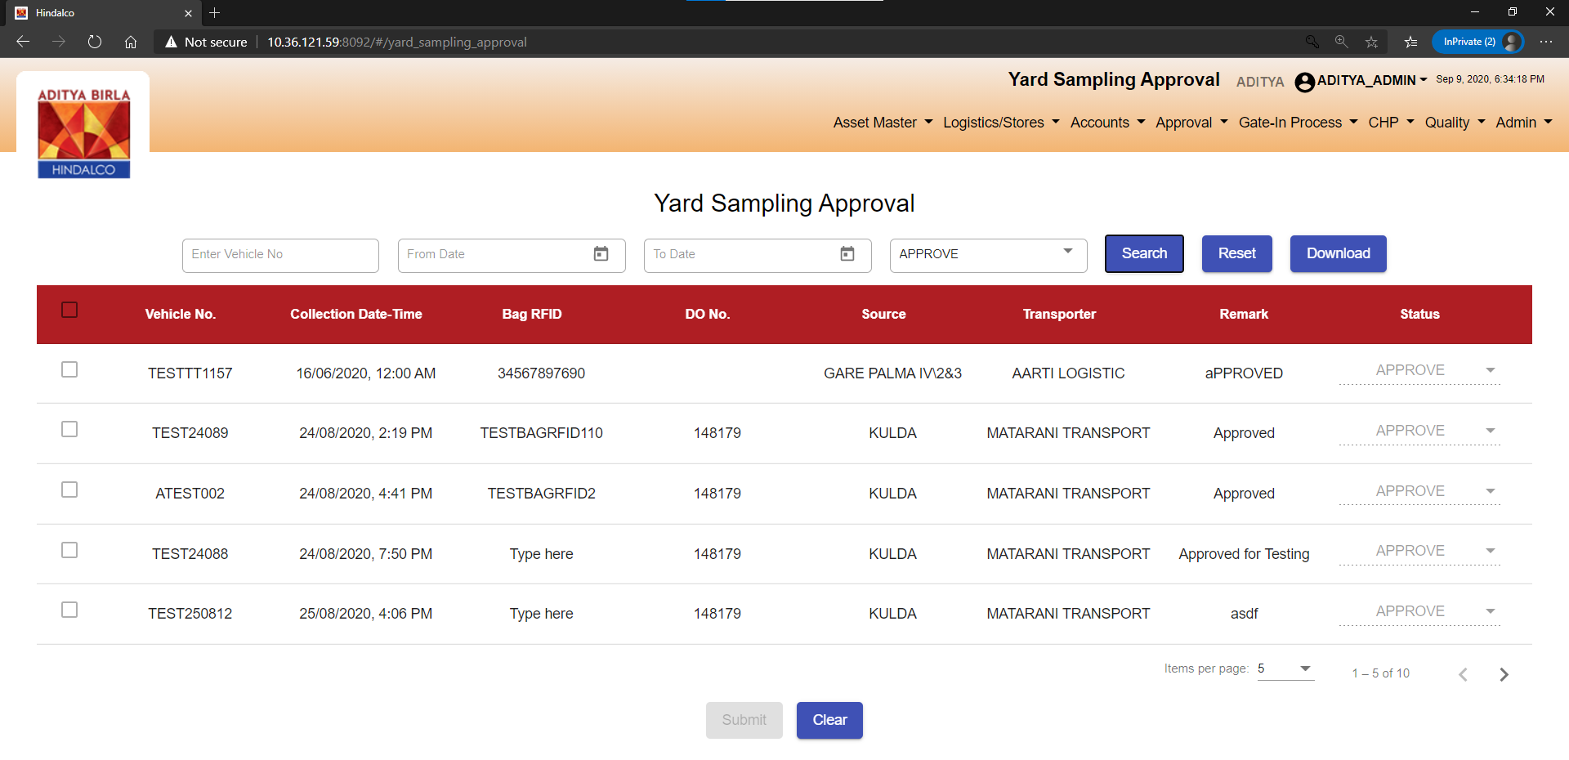

* User can search using all the fields at the same time.

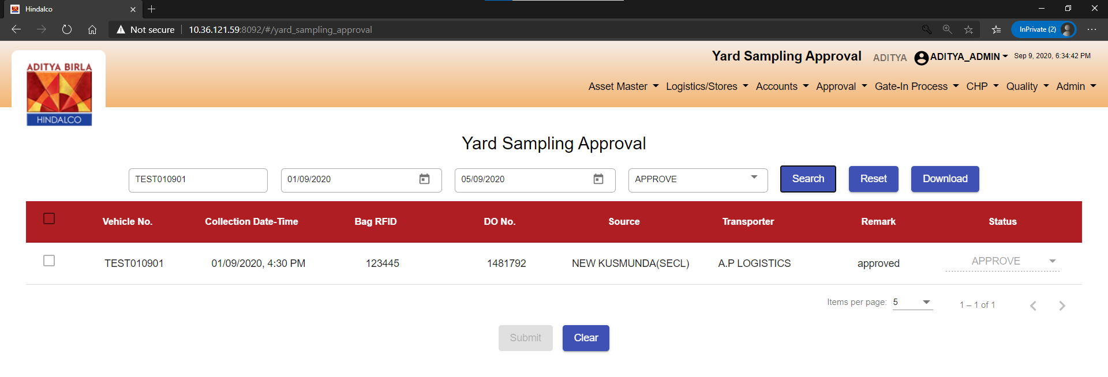

# Source Mismatch fix:

As per the bug identified, the source for the particular DO number is not coming as is showing a different source name from another plant.

Screenshot after the fix:

