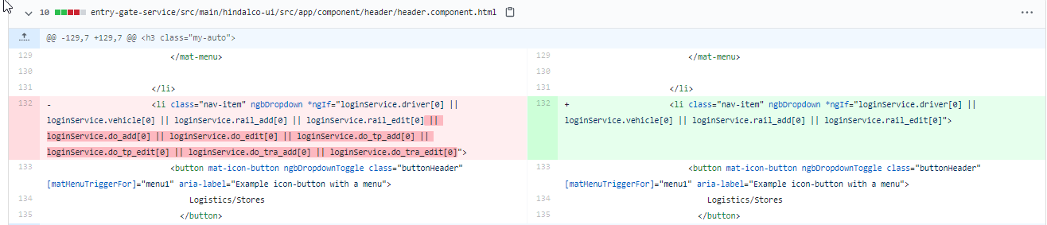

Why some attributes are removed? Apart from this one more change is there

2. [...service/src/main/hindalco-ui/src/app/dialogModal/dialogRules-box/dialog-body.component.ts](https://github.com/elogic-cscts/elogic_cscts/compare/staging26aug2020" \l "diff-ce53746631843f713bbeca33342acc7a" \o "entry-gate-service/src/main/hindalco-ui/src/app/dialogModal/dialogRules-box/dialog-body.component.ts)

Something related to invoice is added here

3. [entry-gate-service/src/main/hindalco-ui/src/app/ld-files/model/reconcilation.model.ts](https://github.com/elogic-cscts/elogic_cscts/compare/staging26aug2020#diff-70e38b73f40b7937b65e1245c058298f)

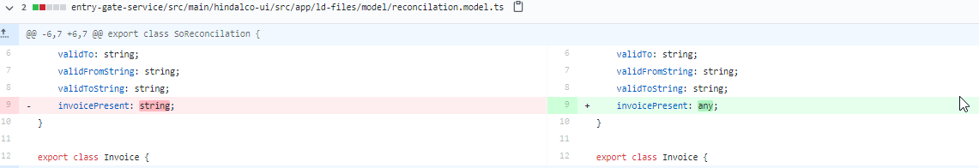

4. [...te-service/src/main/hindalco-ui/src/app/ld-files/recon-details/recon-details.component.ts](https://github.com/elogic-cscts/elogic_cscts/compare/staging26aug2020" \l "diff-21a0b551ffc964fc4765f80dcc810d25" \o "entry-gate-service/src/main/hindalco-ui/src/app/ld-files/recon-details/recon-details.component.ts)

5.  [entry-gate-service/src/main/hindalco-ui/src/app/ld-files/services/general.service.ts](https://github.com/elogic-cscts/elogic_cscts/compare/staging26aug2020#diff-ec90d488ea3141a3e503cfa81efb4c09)

6. [entry-gate-service/src/main/hindalco-ui/src/app/ld-files/services/reconcilation.service.ts](https://github.com/elogic-cscts/elogic_cscts/compare/staging26aug2020#diff-b820067f98896853ebf857659111db8d)

7. [entry-gate-service/src/main/hindalco-ui/src/app/ld-files/services/reconcilation.service.ts](https://github.com/elogic-cscts/elogic_cscts/compare/staging26aug2020#diff-b820067f98896853ebf857659111db8d)  - Code Review to be done

8. 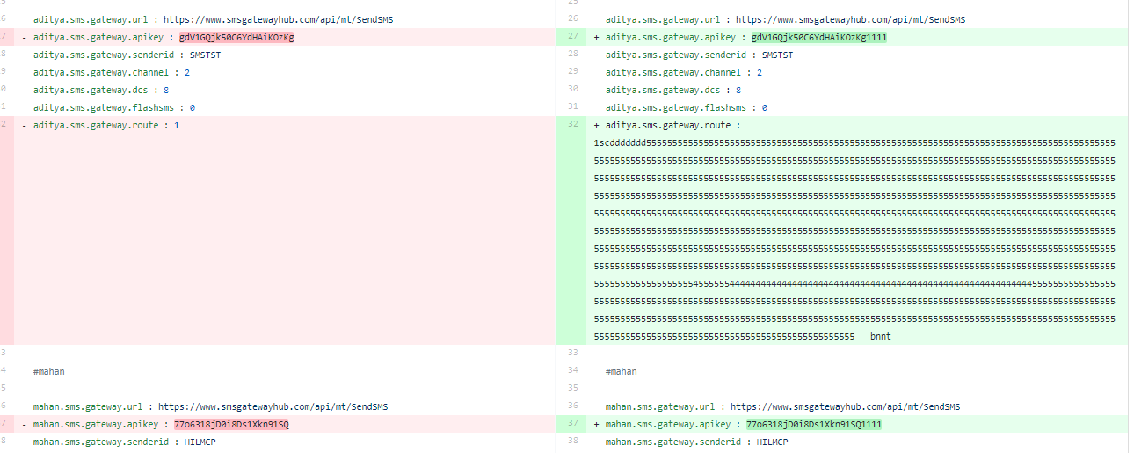

Revert these changes to 1 please