Staging Release – Yard Special Sample and Mine Double Entry Features

**Environment specific port changes:**

proxy-conf.json: the target ip and port needs to be changes for the respective environment as shown below

* "target": "http://10.36.121.59:8092"

environment.prod.ts:

* imageApi:'http://10.36.121.59:8083',
* blendApi:'http://10.36.121.59:8091',
* deviceApi: 'http://10.36.121.59:9066',
* apiUrl:'http://10.36.121.59:8092',

database.properties:

* url=jdbc:oracle:thin:@10.36.121.59:1521:CSCDEV
* dbuser=CSCTS_BLEND

application.yml

* port: 8092
* append 1111 to the value of "plant.sms.gateway.apikey" for the sms to get triggered in DEV.
* change the value of "environment" to DEV (anything other than "PROD").

**DB changes:**

* database-scripts/minedispatch_double_date_entry_scripts.sql
* database-scripts/YardSample.sql

**Files Modified:**

**Yard special sampling API:**

cscts-commons/src/main/java/com/cscts/common/checklist/model/CsctsCheckList.java

cscts-commons/src/main/java/com/cscts/common/constants/CsctsConstants.java

cscts-commons/src/main/java/com/cscts/common/sampling/model/CsctsAdditionalTrip.java

cscts-commons/src/main/java/com/cscts/common/trip/models/CsctsAdditionalTrip.java

cscts-commons/src/main/java/com/cscts/common/sampling/model/CsctsSampling.java

cscts-commons/src/main/java/com/cscts/common/sampling/model/CsctsSpecialSamplingModel.java

cscts-commons/src/main/java/com/cscts/common/trip/models/CsctsSpecialSampleYard.java

cscts-commons/src/main/java/com/cscts/common/trip/models/CsctsSpecialSamplingDetails.java

entry-gate-service/src/main/java/com/cscts/entrygate/sampling/controller/CsctsSamplingController.java

entry-gate-service/src/main/java/com/cscts/entrygate/sampling/dao/CsctsSamplingDao.java

entry-gate-service/src/main/java/com/cscts/entrygate/sampling/dao/impl/CsctsSamplingDaoImpl.java

entry-gate-service/src/main/java/com/cscts/entrygate/sampling/service/CsctsSamplingService.java

entry-gate-service/src/main/java/com/cscts/entrygate/sampling/service/impl/CsctsSamplingServiceImpl.java

entry-gate-service/src/main/java/com/cscts/entrygate/trip/controller/CsctsTripController.java

entry-gate-service/src/main/java/com/cscts/entrygate/trip/dao/CsctsTripDao.java

entry-gate-service/src/main/java/com/cscts/entrygate/trip/dao/impl/CsctsTripDaoImpl.java

entry-gate-service/src/main/java/com/cscts/entrygate/trip/rowmapper/CsctsCheckListRowMapper.java

entry-gate-service/src/main/java/com/cscts/entrygate/trip/service/CsctsTripService.java

entry-gate-service/src/main/java/com/cscts/entrygate/trip/service/impl/CsctsTripServiceImpl.java\

entry-gate-service/src/main/resources/application-db-queries.yml

**Yard special sampling UI:**

entry-gate-service/src/main/hindalco-ui/src/app/app-routing.module.ts

entry-gate-service/src/main/hindalco-ui/src/app/app.module.ts

entry-gate-service/src/main/hindalco-ui/src/app/component/header/header.component.html

entry-gate-service/src/main/hindalco-ui/src/app/component/header/header.component.ts

entry-gate-service/src/main/hindalco-ui/src/app/component/login/login.component.ts

entry-gate-service/src/main/hindalco-ui/src/app/component/yard-sampling-approval/yard-sampling-approval.component.css

entry-gate-service/src/main/hindalco-ui/src/app/component/yard-sampling-approval/yard-sampling-approval.component.html

entry-gate-service/src/main/hindalco-ui/src/app/component/yard-sampling-approval/yard-sampling-approval.component.spec.ts

entry-gate-service/src/main/hindalco-ui/src/app/component/yard-sampling-approval/yard-sampling-approval.component.ts

entry-gate-service/src/main/hindalco-ui/src/app/dialogModal/confirmation-modal/confirmation-modal.component.ts

entry-gate-service/src/main/hindalco-ui/src/app/services/auth-service.service.ts

entry-gate-service/src/main/hindalco-ui/src/app/services/login.service.ts

entry-gate-service/src/main/hindalco-ui/src/app/services/yard-sampling-approval.service.spec.ts

entry-gate-service/src/main/hindalco-ui/src/app/services/yard-sampling-approval.service.ts

entry-gate-service/src/main/hindalco-ui/src/app/app.module.ts

**Mine-dispatch API:**

cscts-commons/src/main/java/com/cscts/common/minedispatch/model/CsctsMineDispatchTokenResponse.java

cscts-commons/src/main/java/com/cscts/common/minedispatch/model/CsctsOpneMineDispatchResponse.java

cscts-commons/src/main/java/com/cscts/common/trip/models/CsctsTripIntermediate.java

entry-gate-service/src/main/java/com/cscts/entrygate/minedispatch/controller/MineDispatchController.java

entry-gate-service/src/main/java/com/cscts/entrygate/minedispatch/service/MineDispatchService.java

entry-gate-service/src/main/java/com/cscts/entrygate/minedispatch/service/impl/MineDispatchServiceImpl.java

entry-gate-service/src/main/java/com/cscts/entrygate/minedispatch/dao/CsctsMineDispatchDao.java

entry-gate-service/src/main/java/com/cscts/entrygate/minedispatch/dao/impl/CsctsMineDispatchDaoImpl.java

**Mine-dispatch UI:**

entry-gate-service/src/main/hindalco-ui/src/app/ld-files/mine-doc-excppopup/mine-doc-excppopup.component.html

entry-gate-service/src/main/hindalco-ui/src/app/ld-files/mine-doc-excppopup/mine-doc-excppopup.component.ts

entry-gate-service/src/main/hindalco-ui/src/app/ld-files/mine-docs-finalpopup/mine-docs-finalpopup.component.css

entry-gate-service/src/main/hindalco-ui/src/app/ld-files/mine-docs-finalpopup/mine-docs-finalpopup.component.html

entry-gate-service/src/main/hindalco-ui/src/app/ld-files/mine-docs-finalpopup/mine-docs-finalpopup.component.ts

entry-gate-service/src/main/hindalco-ui/src/app/ld-files/mine-docs-upload/mine-docs-upload.component.html

entry-gate-service/src/main/hindalco-ui/src/app/ld-files/mine-docs-upload/mine-docs-upload.component.ts

entry-gate-service/src/main/hindalco-ui/src/app/ld-files/services/minedoc.service.ts

entry-gate-service/src/main/hindalco-ui/src/app/app.module.ts

**Folder compare snapshot:**

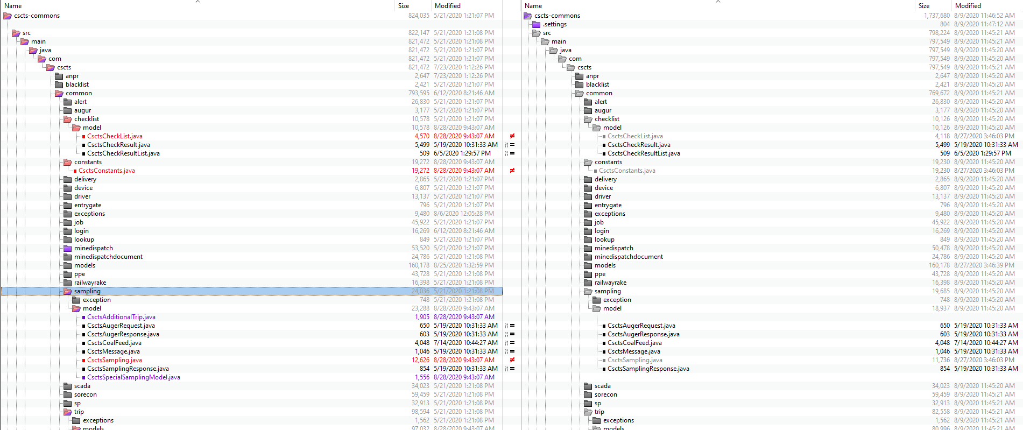 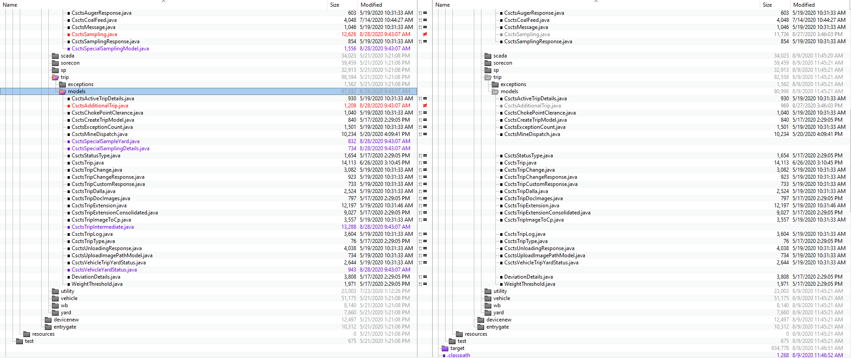

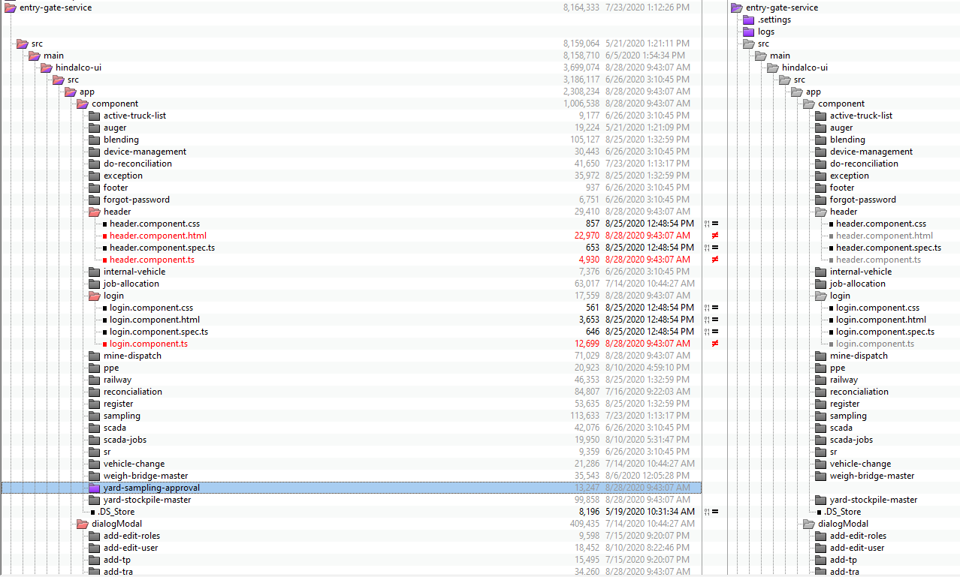

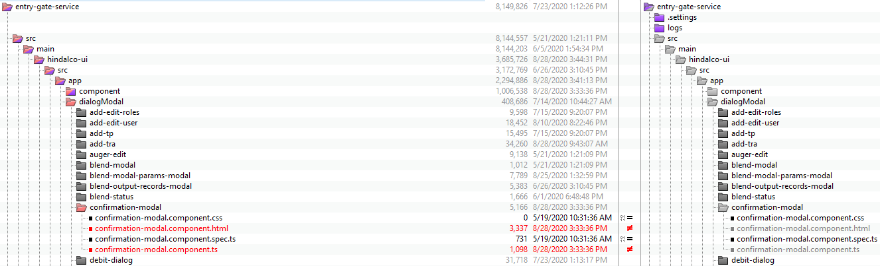

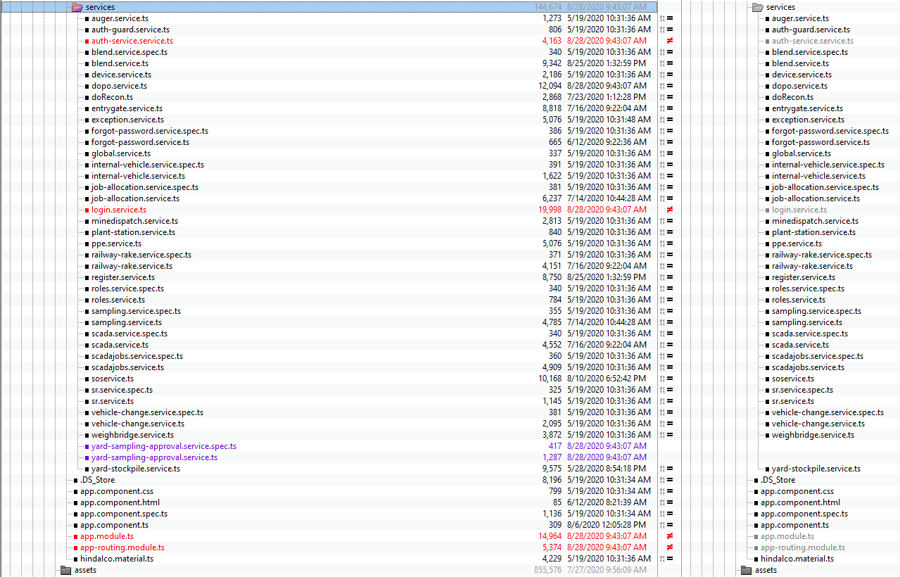

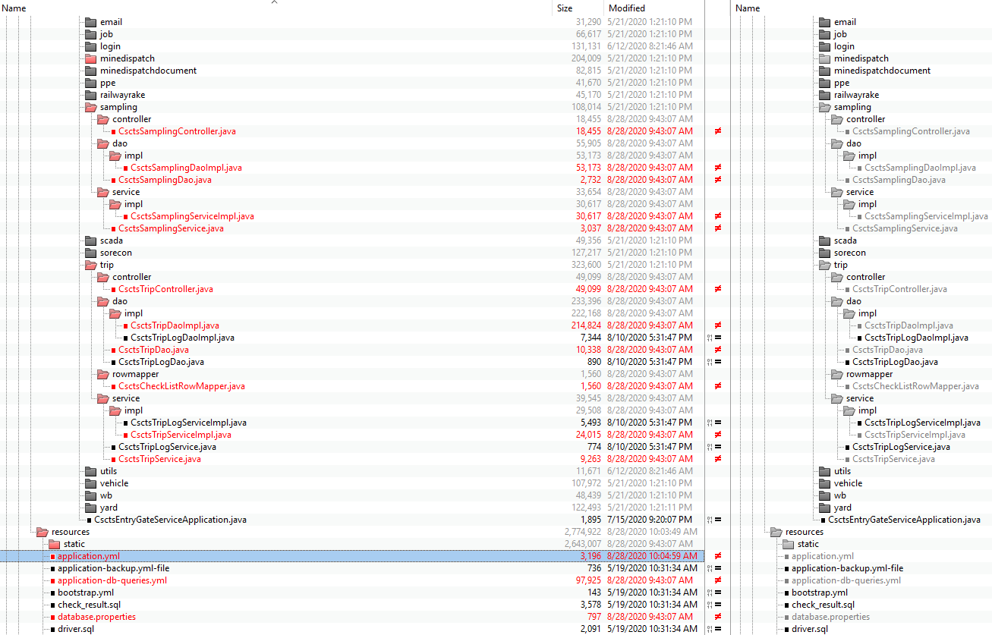

**Mine dispatch:**

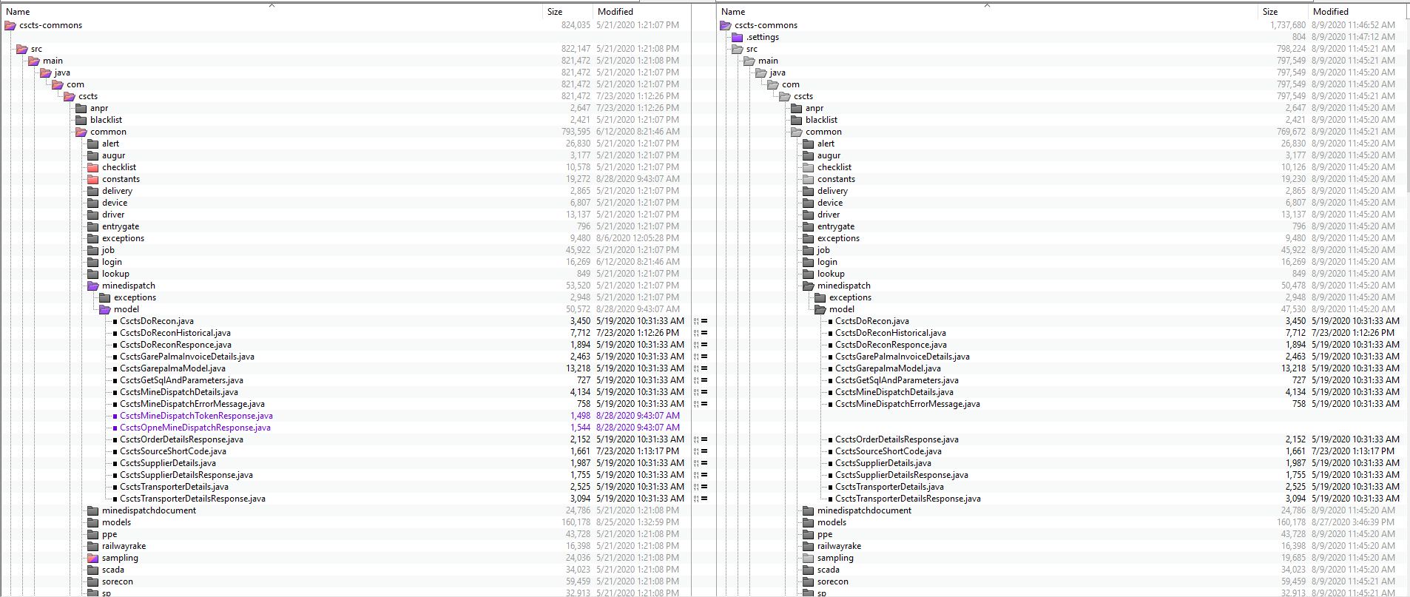

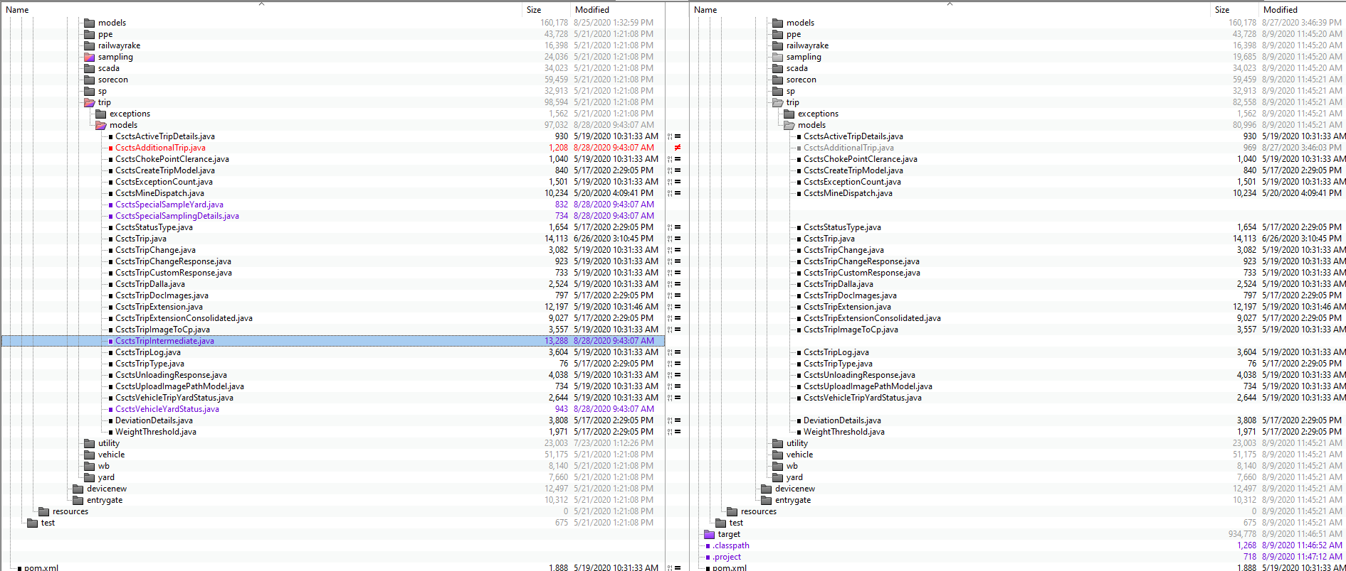

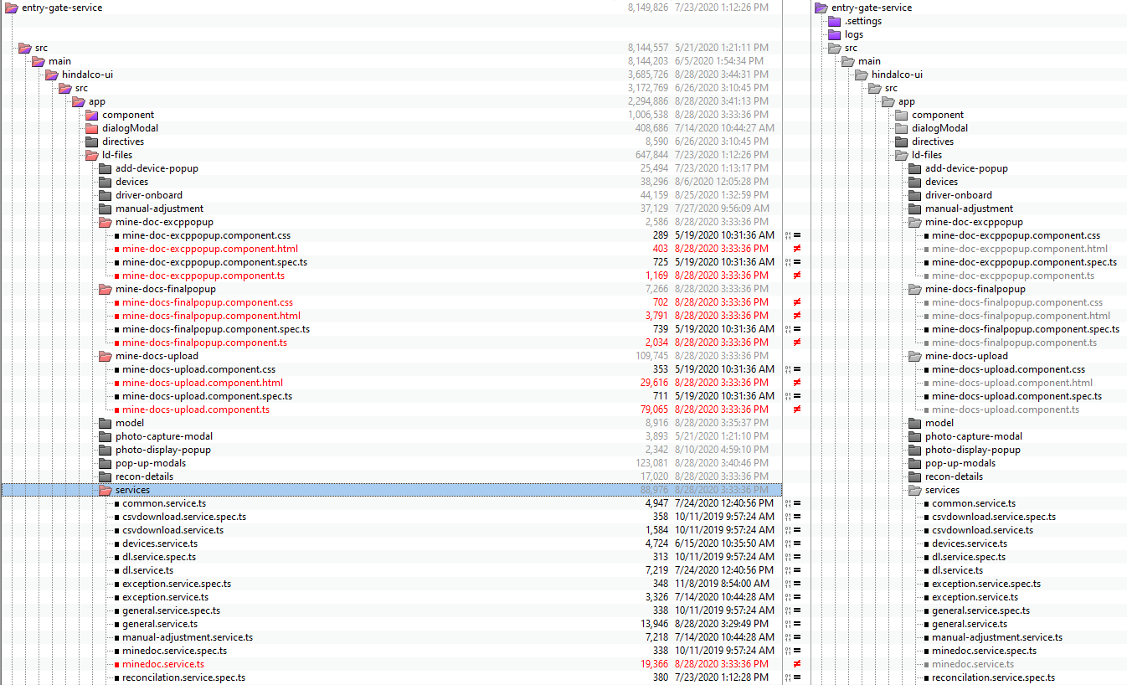

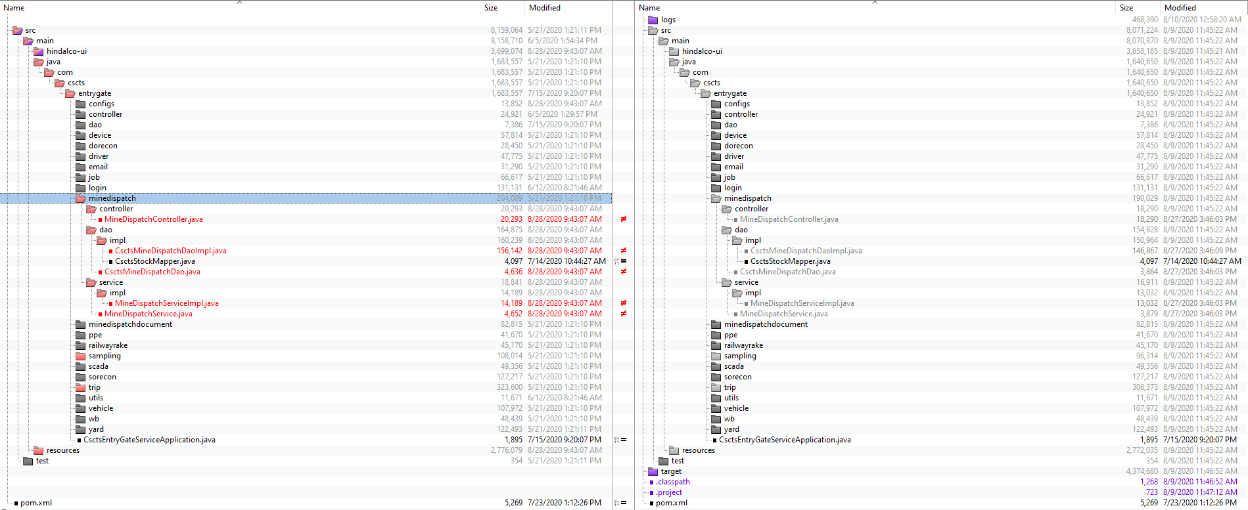

**Rollback steps:**

* The entry gate application current version is 0.8
* The preceding version is 0.9. In case of any issues, it will be rolled back to this version.
* database-scripts/YardSampleRestore.sql
* database-scripts/minedispatch_double_date_entry_scripts_restore.sql