**Software Requirements Specification**

**For**

**CSCTS PROJECT**

**Version 1.0**

**Prepared by Madhusudan Padmalochan**

**ELogic Square Analytics Pvt Limited**

**29-Nov-2020**

**Table of Contents**

**Introduction** **1**

Purpose 1

Document Conventions 1

Intended Audience and Reading Suggestions 1

Product Scope 1

References 1

**Overall Description** **1**

Product Perspective 2

Product Functions 2

**2.2.1 SECTION-1 DETAILS: CREATE BLEND PLAN** **2**

a) Set Target output & Input parameters for resource constraints 3

**b) Enter LIFO feed: Add Rake/ Truck Tippler** **4**

**c) Confirm usable stockpiles** **5**

d) Submit Blend Inputs to the Engine 6

**2.2.2. SECTION-2 DETAILS: GENERATE BLEND PLAN** **6**

a) Set the Run Mode 7

b) Set the Model Optimization Type 7

c) Generate & Compare various Blend Plans through System 8

d) Review the Selected Blend Plan (Create & Overwrite with a Manual Plan) and Approve 10

**2.2.3. SECTION-3 DETAILS: PLAN REPORTS** **12**

User Classes and Characteristics 13

Operating Environment 15

Design and Implementation Constraints 15

Proper Configuration of the Yard/ Stockpile Master 15

Proper Configuration of the Internal Vehicle Master 15

User Documentation 15

Assumptions and Dependencies 15

**2.7.1. Proper Configuration of the Yard/ Stockpile Master** **15**

**2.7.2. Proper Configuration of the Internal Vehicle Master** **15**

**2.7.3. One-Time configuration of the S-R usage matrix** **16**

**2.7.4. Blend Engine** **16**

**External Interface Requirements** **17**

User Interfaces 17

Hardware Interfaces 17

Software Interfaces 17

Communications Interfaces 17

**System Features** **17**

4.1 Description and Priority 17

4.2 Stimulus/Response Sequences 18

4.3 Functional Requirements 18

**Other Nonfunctional Requirements** **18**

**Revision History**

|  |  |  |  |
| --- | --- | --- | --- |
| **Name** | **Date** | **Reason For Changes** | **Version** |
| Madhusudan Padmalochan | 29-Nov-2020 | Initial Draft | 0.1 |
|  |  |  |  |

# **Introduction**

## **Purpose**

*The purpose of the document is to define the details of the CSCTS (Coal Supply Chain Tracking System) to all the stake holders on the process of the coal movement, management in the plants*

## **Document Conventions**

|  |  |
| --- | --- |
| *CSCTS* | *Coal Supply Chain Management System* |
| *HHD* | *Handheld Device* |
| *UI* | *User Interface – Web Pages* |
| *Supplier* | *Coal Mines* |
| *Source* | *Source of the Coal* |
| *Transporter* | *Transporter of the Coal* |
| *Truck* | *Vehicle carrying the Coal* |
| *Hywa* | *Internal vehicles of the Plant* |
| *SR* | *Stacker Reclaimer* |
| *Dozer* | *Dozer* |
| *Rake* | *Railway Rake* |

## **Intended Audience and Reading Suggestions**

*The document is intended to all the stake holders of the product like developers, project managers, delivery partners, testers and the plant teams and the CHP Team.*

*The document should be read in the above defined format so that all the flow is observed as defined.*

## **Product Scope**

*The purpose of the CSCTS is to provide the details of the coal movement inside the plant, starting from the in bound to storage to consumption. It is also targeted at provided the movement of the truck through near real-time view of the status of the trucks. The anomalies are detected and directed to the concerned stake holders for further actions.*

## **References**

# **Overall Description**

The blending module is used to generate a blend plan against a set of target output parameters and input parameters (stockpile related) specified by the user. The user can go ahead with the execution of the system generated plan or modify the plan to suit their needs.

## **Product Perspective**

The CSCTS system stores the following the following information

* Target output parameters
* Stockpile specific input parameters
* Details of the plan generated (system generated and manual-if any)

## **Product Functions**

### 2.2.1 SECTION-1 DETAILS: CREATE BLEND PLAN

This section allows User to enter target output values and input parameters for a Blend Plan.

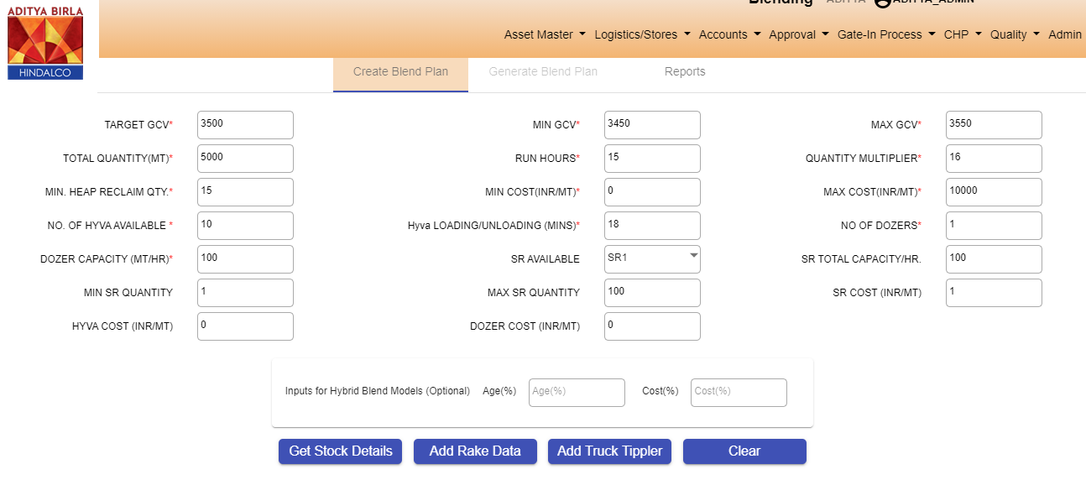

Fig 1) Snapshot of the target output parameters section

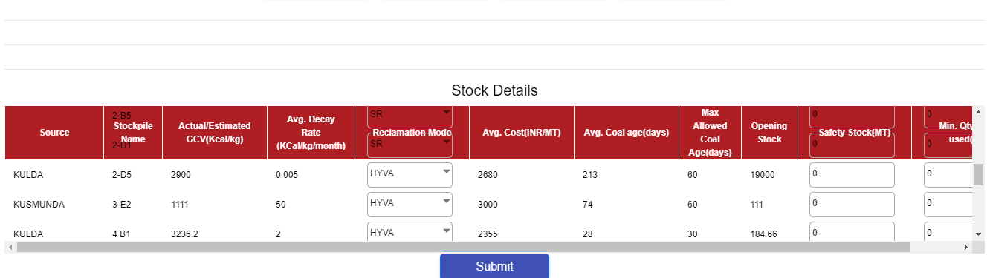

Fig 2) Snapshot of the stockpile input parameters section

The step-by-step details of the user input is as specified below:

#### a) Set Target output & Input parameters for resource constraints

User needs to enter values against the UI fields under the Create Blend Plan Screen of the Blending Module.



Fig 3) Fields for setting Target Output & Input Parameters

The details of these input fields are as below:

|  |  |
| --- | --- |
| **UI Field** | **Description/ Details** |
| **TARGET GCV** | Targeted GCV which needs to be achieved in Blend Plan |
| **MIN GCV** | Minimum GCV Value for Output i.e. Lower Tolerance Limit.  Typical value recommended is: (Target GCV – 50) |
| **MAX GCV** | Maximum GCV Value for Output i.e. Upper Tolerance Limit. Typical value recommended is: (Target GCV + 50) |
| **TOTAL QUANTITY (MT)** | Coal quantity which needs to be produced for Blend (MT) |
| **RUN HOURS** | Time duration for which blend execution is planned to run on-field (hours). This is critical for back-end calculation of resource-time availability (Hyva, Dozer etc.) by Blend Engine. |
| **QUANTITY MULTIPLIER** | Output quantity of each coal heap recommended by the Blend Plan should be multiple of this number |
| **MIN HEAP RECLAIM QUANTITY** | Minimum quantity to be picked from a selected stockpile |
| **MIN COST (INR/MT)** | Minimum cost limit for the output blend (Optional) |
| **MAX COST (INR/MT)** | Maximum cost limit for the output blend (Optional) |
| **NO OF HYVA AVAILABLE** | Number of Hyvas available for coal transfer against the Blend Plan. The default value on UI is the number of Hyvas with “Active” Flag in Internal Vehicle List at that time. The max value allowed is total count of registered Hyva in that site as per the Internal Vehicle Module. |
| **HYVA LOADING/ UNLOADING (MINS)** | Time required for loading + unloading of Hyvas (mins). Note that the Run-Time is calculated internally by the Blend Engine basis the Yard Master Data (for Heap to RH Distance & Avg. Hyva Speed allowed for a plant) |
| **NO OF DOZERS** | Number of Dozers available for coal transfer against the Blend Plan |
| **DOZER CAPACITY (MT/HR)** | Avg. Hourly quantity (MT) that can be handled by Dozer during the execution of the Blend Plan |
| **NO OF SR AVAILABLE** | Number of S-R available for coal transfer against the Blend Plan |
| **SR TOTAL CAPACITY/HR** | Avg. Hourly quantity (MT) that can be handled by S-R Reclaimer during the execution of the Blend Plan |
| **MIN SR QUANTITY** | Minimum quantity that is to be moved through S-R reclaimer (if at all S-R based reclamation is chosen by model) |
| **MAX SR QUANTITY** | Maximum quantity that is to be moved through S-R reclaimer (if at all S-R based reclamation is chosen by model) |
| **SR COST (INR/MT)** | Cost incurred while using Stacker reclaimer |
| **Dozer Cost (INR/MT)** | Cost incurred while using Dozer |
| **Hyva cost (INR/MT)** | Cost incurred while using Hyva |
| **Age (%)** | If the user wishes to pick HYBRID method while generating blend plan, they will have to specify the age % along with cost % (below field) |
| **Cost (%)** | If the user wishes to pick HYBRID method while generating blend plan, they will have to specify the cost % along with age % (above field) |

#### b) Enter LIFO feed: Add Rake/ Truck Tippler

Users need to enter values against the UI fields by clicking on the “Add Truck Tippler Data” and the “Add Rake Data” buttons in the Create Blend Plan Screen. The “Add Rake” button is applicable only for Aditya & Mahan. The details of these input fields are as below:

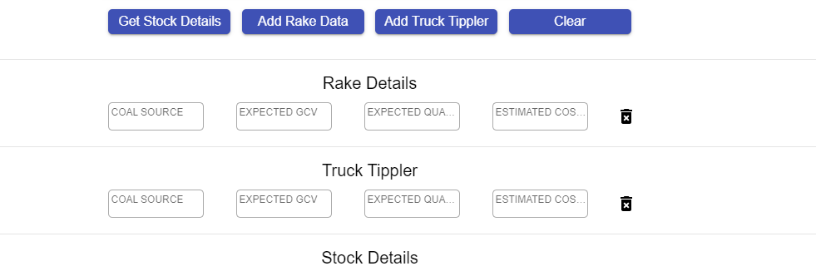Fig 4) Fields for setting LIFO Feed Values

|  |  |
| --- | --- |
| **UI Field** | **Description/ Details** |
| **COAL SOURCE** | Source of the Coal |
| **EXPECTED GCV** | Estimated GCV of the Coal |
| **EXPECTED QUANTITY** | Target Quantity for the LIFO feed.  This Quantity should be less than Total Blend Quantity. Also, the entire quantity specified here would be taken for LIFO run & the LIFO Blend Output will provide the complementary quantity needed from other stockpiles to meet the target outcomes. |
| **ESTIMATED COST (INR/MT)** | Expected INR/ MT landed cost value of the incoming coal |

#### c) Confirm usable stockpiles

User needs to click on “Get Stockpile Details” button which will fetch the list of saved stockpiles Fig 5) Stockpile input parameters

The following conditions must hold good for a stockpile to be displayed:

1. Stockpile is Active
2. Active Outward flag is Active
3. At Least 1 reclamation mode (S-R, Hyva, Dozer) is set as True

There are 3 editable attributes for the listed stockpiles which are elaborated as below. To clear/ reset the stockpile table, the “Clear” button may be used.

|  |  |
| --- | --- |
| **Stockpile Attribute** | **Description/ Details** |
| **Reclamation Mode** | The mode for reclamation of coal from a stockpile. The dropdown will show all the options which are marked in the stockpile-master. User needs to select one. |
| **Safety Stock (MT)** | Specifies the minimum Quantity to be maintained in the Stockpile after Model Run. Its value should ideally be >= Current Stock Level |
| **Minimum Qty to be used (MT)** | Specifies the minimum Quantity to be mandatorily used from the Stockpile during Model Run. Its value should be <= Current Stock Level |

#### d) Submit Blend Inputs to the Engine

This is the last step for the user on this section on “Create Blend Plan”. User, after verifying all the input values across (a), (b), and (c) above should click on the “Submit” button to freeze the input values and push it to the Blend Engine for processing.

A message is displayed “Blend Input Captured”. User is redirected to 2nd Section “Generate Blend Plan”

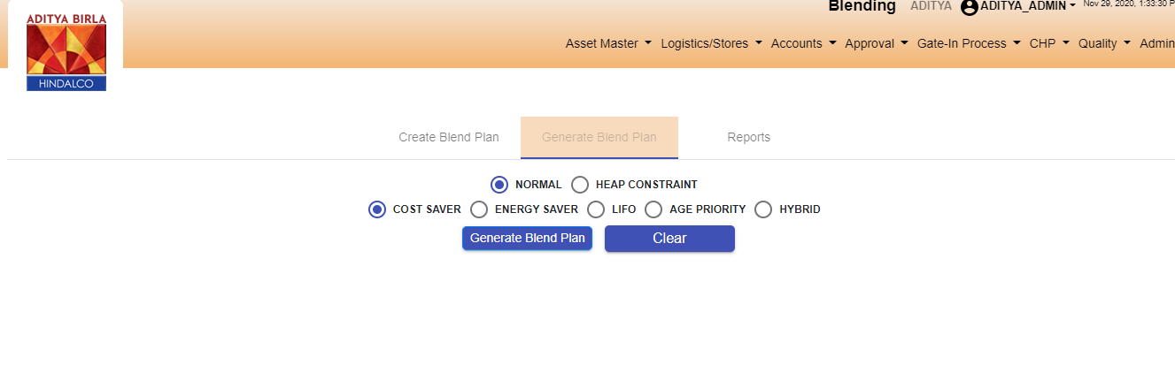Fig 6) Navigation to next section

# 

### 2.2.2. SECTION-2 DETAILS: GENERATE BLEND PLAN

This section allows User to query the Blending Python Engine for fetching recommended Blend Plan details against various run modes.



Fig 7) Snapshot of the Blend Planning Module Section-2: Generate Blend Plan

The step-by-step details for using this section is as specified below:

#### a) Set the Run Mode

Users need to specify the run mode for the Blend Model. The 2 run modes are described below:

|  |  |
| --- | --- |
| **Run Mode** | **Description/ Details** |
| **NORMAL** | The Blend Model will not have a constraint on the no. of stockpiles to be used for meeting the target objectives submitted by the user in section-1 before. |
| **HEAP CONSTRAINT** | User specifies minimum/ maximum no. of stockpile sources to be used by the Blend Model. The Blend Engine will restrict stockpiles between these numbers, while meeting the target objectives submitted by the user in section-1 before. |

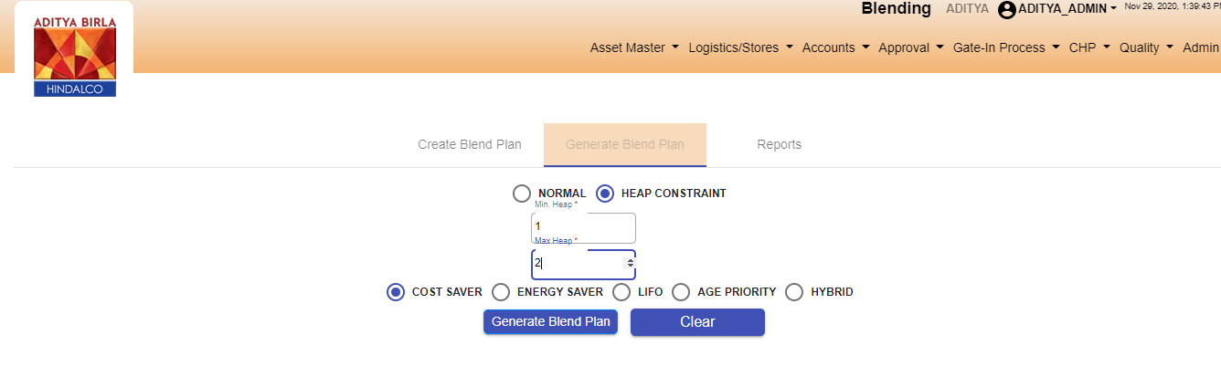

Fig 8) UI for specifying Run-Mode for Blend Engine

#### b) Set the Model Optimization Type

Users need to specify the model type for optimization consideration by the Blend Model. The 5 types of optimization models are as described below. It may be noted that in all these optimization types, the objectives and constraints already submitted by the user in section-1 will be mandatorily ensured by the model.

|  |  |
| --- | --- |
| **Optimization Type** | **Description/ Details** |
| **COST SAVER** | The model will minimize total recipe cost for Blend Output. |
| **ENERGY SAVER** | The model will prioritize the stockpiles from which maximum energy loss is expected as on date (by using the defined GCV Loss value Kcal/ Kg/ Month from stockpile master data). Thus, the output will try to minimize the energy loss in the Yard. |
| **LIFO** | The model gives highest priority to LIFO Feed (entered in section-1) and then minimizes the recipe cost for the complementary blend required for achieving target output. |
| **AGE PRIORITY** | The model will prioritize stockpiles approaching closer to the defined age limit. |
| **HYBRID** | The model will consider both “Cost saver” and “Age priority” optimization types. The weightage for consideration is specified in percentage in the target parameters in the 1st screen. |

#### c) Generate & Compare various Blend Plans through System

By repeatedly selecting combinations of Run Mode & Optimization Type (from (a) and (b) above), the user can generate various Blend Plans and compare them on the UI.

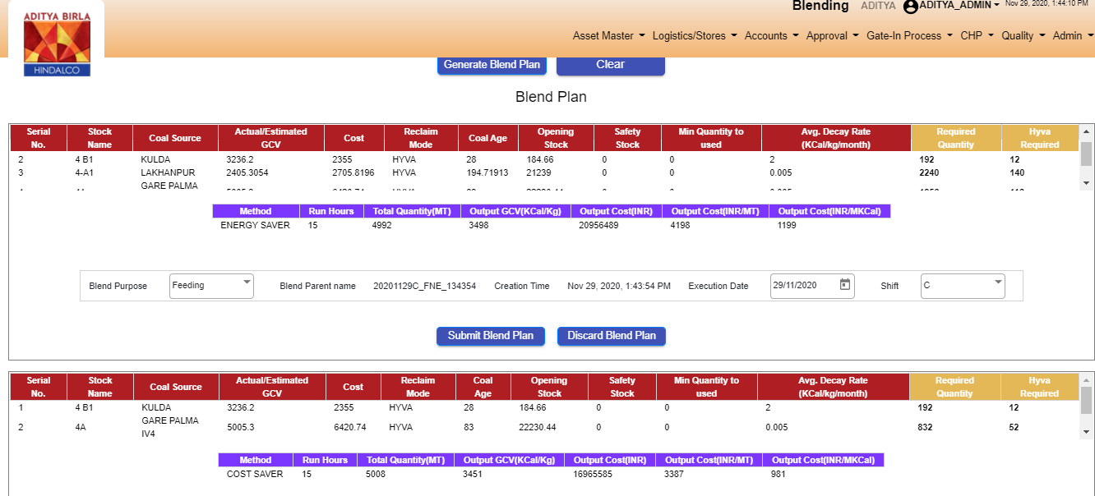

Fig 9) UI for generating & comparing Blend Plans generated by system

For each of the Blend Plan, the User should enter the Planned Execution Date, Shift and the Blend Purpose (Feeding, RH Top-Up or Yard Stacking). Only then, the next Blend Plan can be generated through a combination of steps (a) & (b).

The Blend Parent Name gets automatically generated by the system based on the user selection . The syntax for the Blend Parent Naming is as below:

|  |  |  |  |  |  |  |
| --- | --- | --- | --- | --- | --- | --- |
| <YYYYMMDD> | <Shift> | _ | <Purpose> | <Run Mode> | _ | <Creation_Time> |
| Selected Date for Execution in specified format | A/B/C depending on Selected Execution Shift |  | F = Feeding  R = RH Top-Up  Y = Yard Stacking | 1st Digit:  N = Normal  H = Heap Constraint  2nd Digit:  C= Cost Saver  E= Energy Saver  L= Lifo  A= Age Priority  H= Hybrid |  | The Time of Blend Creation in HHMMSS (for creating unique identifier key) |

e.g. for Selected Execution Date = 15-May-2020, Shift =B, Purpose = Feeding, Run Mode = Normal & Age Priority, Creation Time = 10:00:17 Hrs, the Blend Parent Name is 20200515B_FNA_100017.

**Each Blend Plan displayed on the UI Cart has 2 components:**

1. Tabular List of Stockpiles/ Sources to be used for Blending specifying the Quantity to be reclaimed from each stockpile & the Hyva Trips required for movement (only if reclamation mode is Hyva for a stockpile). The no of Hyva Trips is calculated on the reclamation quantity & the Avg. Hyva Capacity defined in masters. Basic attributes of these stockpiles are also displayed: *Stockpile name, Coal Sources, Avg. GCV, Avg. Cost, Current Stock Level, Safety Stock limit defined by user, minimum reclamation quantity defined by user, GCV Decay Rate.*



Fig 10) Tabular list of stockpiles for Blending

1. Summary of the Blend Plan specifying the Method used, Run Hours for Blend, Total Quantity to produce, Expected Output GCV, Output Cost (INR, INR/ MT, INR/ MKCal)

Fig 11) Summary of Blend Plan

The user can remove any of the Blend Plan by clicking on the “Discard Blend Plan” button. Also, after comparison of all the generated plans, User should select one of the Plans by clicking on the “Submit Blend Plan” button. This will take them to the next step which is explained in section 2.2.2 d.

Users should also note that there might be some cases where the Blend Engine might not be able to find the optimum solution against the entered values of target objectives, input parameters and constraints. In this case, an error message will be displayed on the UI and the user should go back to section 1(Create Blend Plan) to re-enter the values accordingly.

It may be noted that in multi-constraint based linear programming, it is mathematically impossible to detect which objective function, variable, parameter or constraint caused solution inconsistency. However, to the extent possible, Blend Engine does basic resource-time scenario evaluation to provide some information on error type (e.g. Please check the run-time and Hyva/ Dozer quantity).

Fig 12) Error message display in case Blend Engine is unable to find a solution

#### d) Review the Selected Blend Plan (Create & Overwrite with a Manual Plan) and Approve

The user lands onto this step by clicking on “Submit Blend Plan Button”.

Here, the System Blend Plan selected by the user in the previous step is displayed again for the user to review. If the user is satisfied, he/ she can click on the “Continue System Plan & Exit” button to approve this plan for the execution pipeline.

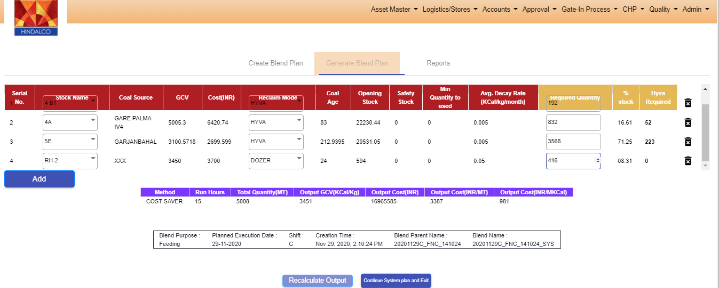Fig 13) UI to review the selected System generated Plan and modify (if interested)

There is also an additional feature to modify the system plan with a custom plan (by either changing the quantity of the selected stockpiles or by adding/ deleting new stockpiles in the blend plan). The User must click on the “Recalculate Output” button to view the expected output from his custom Blend Plan.

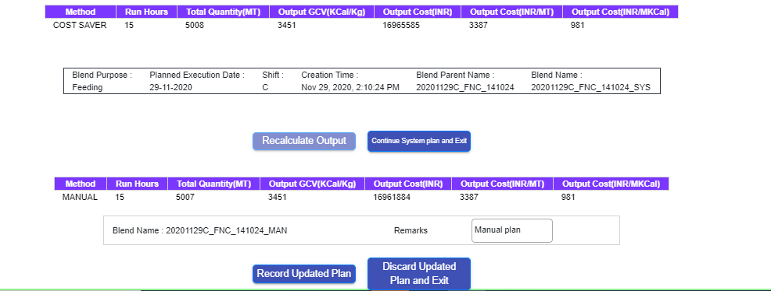Fig 14) UI to view the output of the Manually entered Plan

It may be noted during Manual Blend Plan creation, the Blend Python Engine is NOT invoked for constraint-based optimization. The output GCV, Quantity and Cost will solely depend on the stockpile & quantity selected by the user. However, the Engine does check if the specified quantities can be mobilized with the specified resource constraint (i.e. No of Hyva/ Dozers and the Run-Time). Error message is thrown accordingly if the Blend is not possible to create.

The User can check the Manual Blend Plan output multiple times by changing the stocks or their quantities. The output summary is overwritten each time.

The User can finally choose to either Approve & Record the Manual Blend Plan in the Execution Pipeline by clicking on the “Record Updated Plan” button (after mandatorily entering the Remarks/ comments) , or can continue with the system Plan for Execution by clicking on “Discard Updated Plan & Exit” button.

The Blend Plan is successfully recorded in the system and a suitable message is displayed to the User. Users also get automatically redirected to the “Create Blend Plan” home-screen.

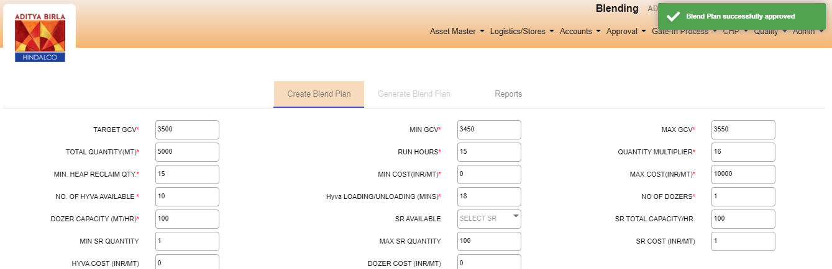Fig 15) Display of message for “Blend Plan successfully Approved” and redirecting back to Homepage

### 2.2.3. SECTION-3 DETAILS: PLAN REPORTS

This section contains the historical Blend Plans created and saved by users.

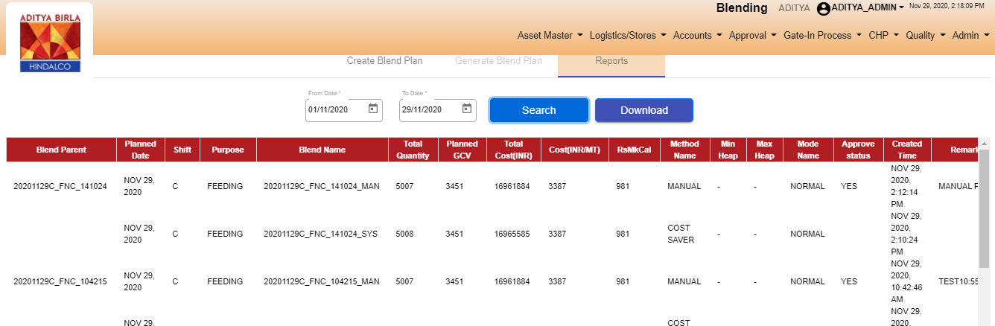Fig 16) UI for viewing archived Blend Reports

The users can get a curated list of plans created between the specified “From” and “To” Date entered by the user on this UI. The detailed attributes of these plans (like defined target values, stock details, input constraints etc.) are also available for viewing.

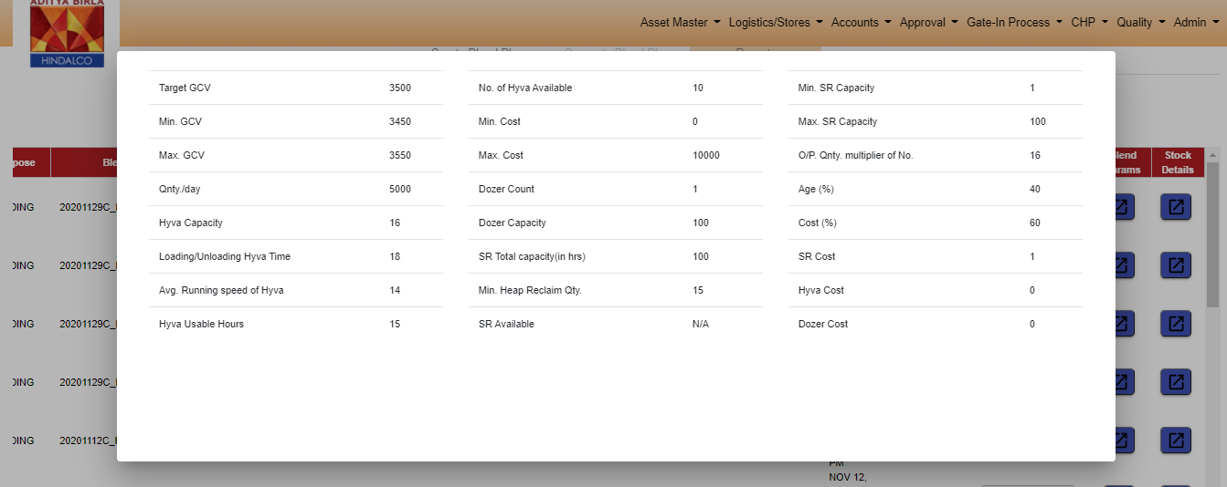Fig 17) Provision to view the Input parameters for the selected Blend Plan

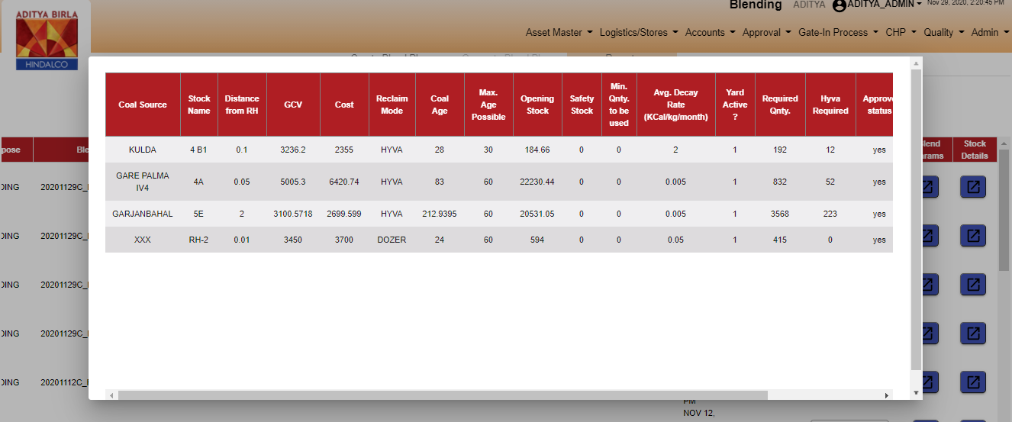Fig 18) Provision to view the details of the stockpiles suggested for Blending as per the plan

The Reports Section also has the provision for authorized users to approve and commit a blend plan for Execution. This can be done by clicking the dropdown under “Execute Status” column of the Report and changing that to “Yes” for Plans which are to be executed by the user. Users must note that once this status is changed to “Yes”, the status cannot be reversed back.

## **User Classes and Characteristics**

### 

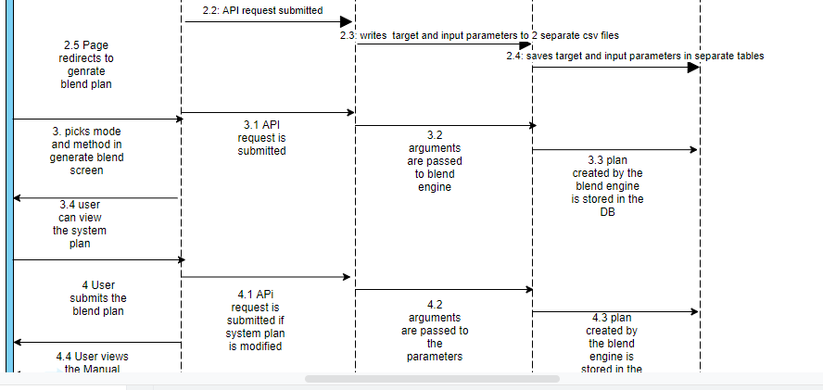

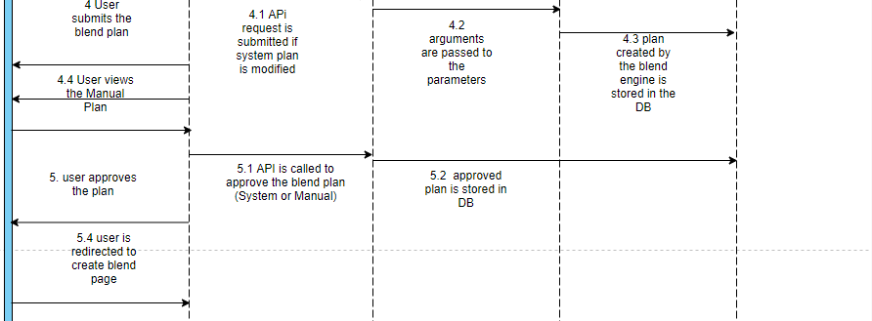

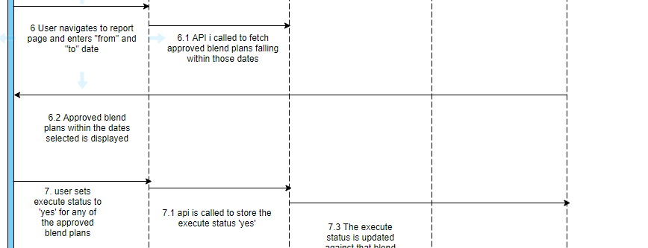

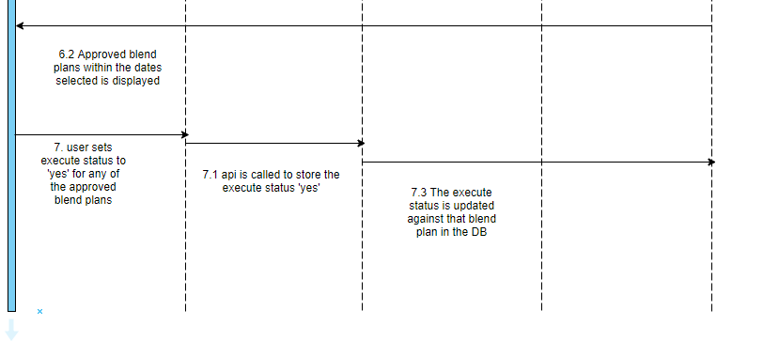

## **Operating Environment**

Operating environment for the CSCTS application is as below

* Oracle database
* Operating System: Centos Linux
* Client: Browser
* Platform: Java, Apache Ignite, Android 8

## **Design and Implementation Constraints**

## Proper Configuration of the Yard/ Stockpile Master

## Proper Configuration of the Internal Vehicle Master

* **One-Time configuration of the S-R usage matrix**

## **User Documentation**

Module wise user manual is provided during the feature releases.

## **Assumptions and Dependencies**

### 2.7.1 . Proper Configuration of the Yard/ Stockpile Master

This module can be accessed under the “Yard & Stockpile Master” section in the “CHP” of the CSCTS WebUI menu.

### 2.7.2. Proper Configuration of the Internal Vehicle Master

This module can be accessed under the “Internal Vehicle” section in the “Asset Master” of the CSCTS WebUI menu.

### 2.7.3. One-Time configuration of the S-R usage matrix

This is a compatibility matrix which is configured at the back-end for mapping the parallel operation compatibility of the heaps when reclaimed through S-R. It specifies that during an S-R run job, which 2 heaps can be simultaneously operated.

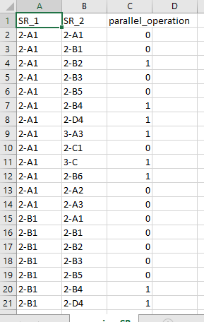

Fig 19) Snapshot of the S-R Operating Compatibility Matrix

### 2.7.4 Blend Engine

The blend engine is an optimization algorithm. Python version 3.6 or higher is required to run this.

# **External Interface Requirements**

## **User Interfaces**

Front End Interface: Android

Middle End Interface: Java Rest API’s

Backend Interface: Oracle

Standards for User Interface:

## **Hardware Interfaces**

Linux – Centos 7.0

A browser which supports HTML and Java Script

## **Software Interfaces**

Following are the software used for the CSCTS application

|  |  |  |
| --- | --- | --- |
| **Software Used** | **Version** | **Description** |
| Java | Java 1.8.0_u231 | To build the middle layer of the application, we have used Java |
| Apache Ignite | 2.7.5 | Ignite is used as an in-memory cache layer for the frequently used data |
| Oracle | 12.c | To save all the data related to the coal management |
| Android | 8 | To create the user interfaces |
| Linux | Centos 7.0 |  |
| SMTP | In –house | Email Integration |
| SMS | SMS Gateway | SMS Integration |
|  |  |  |

## **Communications Interfaces**

* Use a web browser to access and manage the blending module

# **System Features**

### 4.1 **Description and Priority**

The Blending screen shall provide the user the option to generate the blend plan, modify and approve it.

### 4.2 **Stimulus/Response Sequences**

* *create blend plan*
* *generate blend plan*
* *recalculate output*
* *approve blend plan*
* *reports*

### 4.3 **Functional Requirements**

* The create blend plan screen shall allow the user to enter the target and input parameters
* The generate blend plan screen shall enable the user to generate a blend plan based on certain mode and methods.
* The user shall have the option to modify the system generated blend plan parameters and generate a new plan.
* The reports section shall allow the user to view all the approved blend plans within the dates selected and enable it for execution.

# **Other Nonfunctional Requirements**

* CSCTS modules or pages developed should be supported by Chrome and Edge
* CSCTS Web average page response should not be more than 5 secs
* Any or all CSCTS Web or HHD modules / functions should be accessed only by valid logged credentials
* Any or all operations performed should be audited / logged in CSCTS
* Any or all CSCTS Web pages will follow or adhere to these User Guidelines Principle

**Appendix A: Glossary**

*<Define all the terms necessary to properly interpret the SRS, including acronyms and abbreviations. You may wish to build a separate glossary that spans multiple projects or the entire organization, and just include terms specific to a single project in each SRS.>*

**Appendix B: Analysis Models**

*<Optionally, include any pertinent analysis models, such as data flow diagrams, class diagrams, state-transition diagrams, or entity-relationship diagrams*.>

**Appendix C: To Be Determined List**

*<Collect a numbered list of the TBD (to be determined) references that remain in the SRS so they can be tracked to closure.>*