**Software Requirements Specification**

**For**

**CSCTS PROJECT**

**Version 1.0**

**Prepared by Madhusudan Padmalochan**

**ELogic Square Analytics Pvt Limited**

**29-Nov-2020**

**Table of Contents**

**Introduction** **1**

Purpose 1

Document Conventions 1

Intended Audience and Reading Suggestions 1

Product Scope 1

References 1

**Overall Description** **1**

Product Perspective 2

Product Functions 2

**2.2.1 SECTION-1 DETAILS: CREATE BLEND PLAN** **2**

a) Set Target output & Input parameters for resource constraints 2

**b) Enter LIFO feed: Add Rake/ Truck Tippler** **2**

**c) Confirm usable stockpiles** **2**

d) Submit Blend Inputs to the Engine 2

**2.2.2. SECTION-2 DETAILS: GENERATE BLEND PLAN** **3**

a) Set the Run Mode 3

b) Set the Model Optimization Type 3

c) Generate & Compare various Blend Plans through System 3

d) Review the Selected Blend Plan (Create & Overwrite with a Manual Plan) and Approve 4

**2.2.3. SECTION-3 DETAILS: PLAN REPORTS** **4**

User Classes and Characteristics 5

Operating Environment 6

Design and Implementation Constraints 7

Proper Configuration of the Yard/ Stockpile Master 7

Proper Configuration of the Internal Vehicle Master 7

User Documentation 7

Assumptions and Dependencies 7

**2.7.1 . Proper Configuration of the Yard/ Stockpile Master** **7**

**2.7.2. Proper Configuration of the Internal Vehicle Master** **7**

**2.7.3. One-Time configuration of the S-R usage matrix** **7**

**2.7.4 Blend Engine** **7**

**External Interface Requirements** **7**

User Interfaces 7

Hardware Interfaces 8

Software Interfaces 8

Communications Interfaces 8

**System Features** **8**

4.1 Description and Priority 8

4.2 Stimulus/Response Sequences 8

4.3 Functional Requirements 8

**Other Nonfunctional Requirements** **9**

**Revision History**

|  |  |  |  |
| --- | --- | --- | --- |
| **Name** | **Date** | **Reason For Changes** | **Version** |
| Madhusudan Padmalochan | 29-Nov-2020 | Initial Draft | 0.1 |
|  |  |  |  |

# **Introduction**

## **Purpose**

*The purpose of the document is to define the details of the CSCTS (Coal Supply Chain Tracking System) to all the stake holders on the process of the coal movement, management in the plants*

## **Document Conventions**

|  |  |
| --- | --- |
| *CSCTS* | *Coal Supply Chain Management System* |
| *HHD* | *Handheld Device* |
| *UI* | *User Interface – Web Pages* |
| *Supplier* | *Coal Mines* |
| *Source* | *Source of the Coal* |
| *Transporter* | *Transporter of the Coal* |
| *Truck* | *Vehicle carrying the Coal* |
| *Hywa* | *Internal vehicles of the Plant* |
| *SR* | *Stacker Reclaimer* |
| *Dozer* | *Dozer* |
| *Rake* | *Railway Rake* |

## **Intended Audience and Reading Suggestions**

*The document is intended to all the stake holders of the product like developers, project managers, delivery partners, testers and the plant teams and the CHP Team.*

*The document should be read in the above defined format so that all the flow is observed as defined.*

## **Product Scope**

*The purpose of the CSCTS is to provide the details of the coal movement inside the plant, starting from the in bound to storage to consumption. It is also targeted at provided the movement of the truck through near real-time view of the status of the trucks. The anomalies are detected and directed to the concerned stake holders for further actions.*

## **References**

# **Overall Description**

The blending module is used to generate a blend plan against a set of target output parameters and input parameters (stockpile related) specified by the user. The user can go ahead with the execution of the system generated plan or modify the plan to suit their needs.

## **Product Perspective**

The CSCTS system stores the following the following information

* Target output parameters
* Stockpile specific input parameters
* Details of the plan generated (system generated and manual-if any)

## **Product Functions**

### 2.2.1 SECTION-1 DETAILS: CREATE BLEND PLAN

This section allows User to enter target output values and input parameters for a Blend Plan.

The step-by-step details of the user input is as specified below:

#### a) Set Target output & Input parameters for resource constraints

User needs to enter values against the UI fields under the Create Blend Plan Screen of the Blending Module.

The input fields are: target gcv, min gcv, max gcv, total quantity, run hours, quantity multiplier, min heap reclaim quantity, min cost, max cost, no. of hyva available, hyva loading/unloading, dozer capacity, no. of SR available, SR total capacity, min SR quantity, max SR quantity, SR cost dozer cost, hyva cost, age(%) and cost(%).

#### b) Enter LIFO feed: Add Rake/ Truck Tippler

If the user wants to enter rake or tippler data , then they shall enter values against the UI fields by clicking on the “Add Truck Tippler Data” and the “Add Rake Data” buttons in the Create Blend Plan Screen.

#### c) Confirm usable stockpiles

User needs to click on “Get Stockpile Details” button which will fetch the list of saved stockpiles.

The following conditions must hold good for a stockpile to be displayed:

1. Stockpile is Active
2. Active Outward flag is Active
3. At Least 1 reclamation mode (S-R, Hyva, Dozer) is set as True

There are 3 editable attributes for the listed stockpiles: reclamation mode, safety stock and minimum quantity to be used. To clear/ reset the stockpile table, the “Clear” button may be used.

#### d) Submit Blend Inputs to the Engine

This is the last step for the user on this section on “Create Blend Plan”. User, after verifying all the input values across (a), (b), and (c) above should click on the “Submit” button to freeze the input values and push it to the Blend Engine for processing.

A message is displayed “Blend Input Captured”. User is redirected to 2nd Section “Generate Blend Plan”.

# 

### 2.2.2. SECTION-2 DETAILS: GENERATE BLEND PLAN

This section allows User to query the Blending Python Engine for fetching recommended Blend Plan details against various run modes.

The steps for using this section is as specified below:

#### a) Set the Run Mode

Users need to select the run mode for the Blend Model: normal or heap constraint.

#### b) Set the Model Optimization Type

Users need to specify the model type for optimization consideration by the Blend Model. The 5 types of optimization models: cost saver, energy saver, LIFO, age priority and hybrid. It may be noted that in all these optimization types, the objectives and constraints already submitted by the user in section-1 will be mandatorily ensured by the model.

#### c) Generate & Compare various Blend Plans through System

By repeatedly selecting combinations of Run Mode & Optimization Type (from (a) and (b) above), the user can generate various Blend Plans and compare them on the UI.

For each of the Blend Plan, the User should enter the Planned Execution Date, Shift and the Blend Purpose (Feeding, RH Top-Up or Yard Stacking). Only then, the next Blend Plan can be generated through a combination of steps (a) & (b).

The Blend Parent Name gets automatically generated by the system based on the user selection .

e.g. for Selected Execution Date = 12-Nov-2020, Shift =A, Purpose = Feeding, Run Mode = Normal & Age Priority, Creation Time = 09:00:14 Hrs, the Blend Parent Name is 20201112A_FNA_090014.

**Each Blend Plan displayed on the UI Cart has 2 components:**

1. Tabular List of Stockpiles/ Sources to be used for Blending specifying the Quantity to be reclaimed from each stockpile & the Hyva Trips required for movement (only if reclamation mode is Hyva for a stockpile). The no of Hyva Trips is calculated on the reclamation quantity & the Avg. Hyva Capacity defined in masters. Basic attributes of these stockpiles are also displayed: *Stockpile name, Coal Sources, Avg. GCV, Avg. Cost, Current Stock Level, Safety Stock limit defined by user, minimum reclamation quantity defined by user, GCV Decay Rate.*
2. Summary of the Blend Plan specifying the Method used, Run Hours for Blend, Total Quantity to produce, Expected Output GCV, Output Cost (INR, INR/ MT, INR/ MKCal)

The user can remove any of the Blend Plan by clicking on the “Discard Blend Plan” button. Also, after comparison of all the generated plans, User should select one of the Plans by clicking on the “Submit Blend Plan” button. This will take them to the next step which is explained in section 2.2.2 d.

Users should also note that there might be some cases where the Blend Engine might not be able to find the optimum solution against the entered values of target objectives, input parameters and constraints. In this case, an error message will be displayed on the UI and the user should go back to section 1(Create Blend Plan) to re-enter the values accordingly.

#### d) Review the Selected Blend Plan (Create & Overwrite with a Manual Plan) and Approve

The user lands onto this step by clicking on “Submit Blend Plan Button”.

Here, the System Blend Plan selected by the user in the previous step is displayed again for the user to review. If the user is satisfied, he/ she can click on the “Continue System Plan & Exit” button to approve this plan for the execution pipeline.

There is also an additional feature to modify the system plan with a custom plan (by either changing the quantity of the selected stockpiles or by adding/ deleting new stockpiles in the blend plan). The User must click on the “Recalculate Output” button to view the expected output from his custom Blend Plan.

It may be noted during Manual Blend Plan creation, the Blend Python Engine is NOT invoked for constraint-based optimization. The output GCV, Quantity and Cost will solely depend on the stockpile & quantity selected by the user. However, the Engine does check if the specified quantities can be mobilized with the specified resource constraint (i.e. No of Hyva/ Dozers and the Run-Time). Error message is thrown accordingly if the Blend is not possible to create.

The User can check the Manual Blend Plan output multiple times by changing the stocks or their quantities. The output summary is overwritten each time.

The User can finally choose to either Approve & Record the Manual Blend Plan in the Execution Pipeline by clicking on the “Record Updated Plan” button (after mandatorily entering the Remarks/ comments) , or can continue with the system Plan for Execution by clicking on “Discard Updated Plan & Exit” button.

The Blend Plan is successfully recorded in the system and a suitable message is displayed to the User. Users also get automatically redirected to the “Create Blend Plan” home-screen.

### 2.2.3. SECTION-3 DETAILS: PLAN REPORTS

This section contains the historical Blend Plans created and saved by users.

The users can get a curated list of plans created between the specified “From” and “To” Date entered by the user on this UI. The detailed attributes of these plans (like defined target values, stock details, input constraints etc.) are also available for viewing.

The Reports Section also has the provision for authorized users to approve and commit a blend plan for Execution. This can be done by clicking the dropdown under “Execute Status” column of the Report and changing that to “Yes” for Plans which are to be executed by the user. Users must note that once this status is changed to “Yes”, the status cannot be reversed back.

## **User Classes and Characteristics**

### 

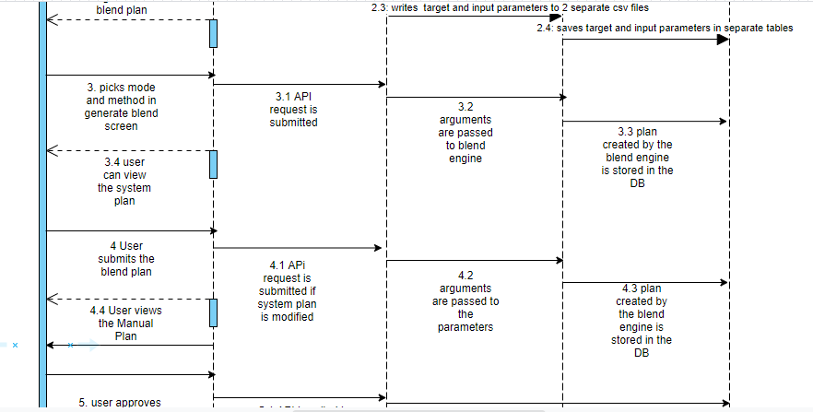

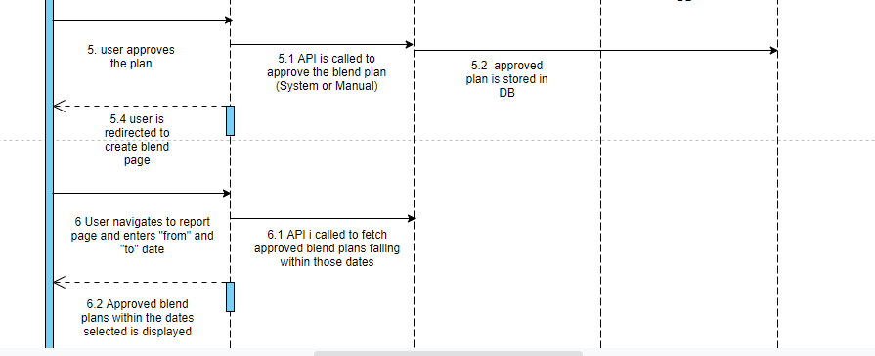

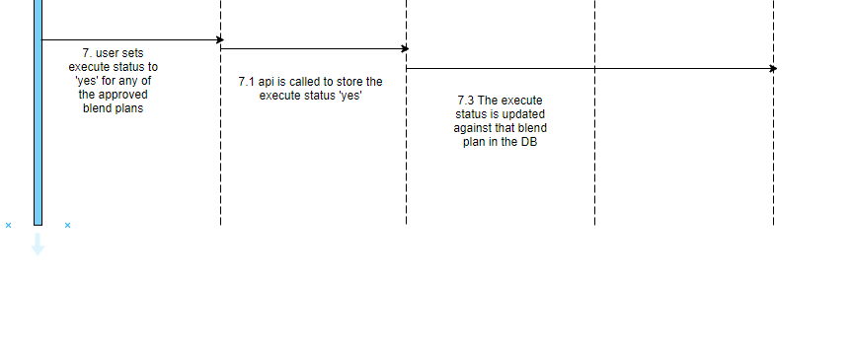

## **Operating Environment**

Operating environment for the CSCTS application is as below

* Oracle database
* Operating System: Centos Linux
* Client: Browser
* Platform: Java, Apache Ignite, Android 8

## **Design and Implementation Constraints**

## Proper Configuration of the Yard/ Stockpile Master

## Proper Configuration of the Internal Vehicle Master

* **One-Time configuration of the S-R usage matrix**

## **User Documentation**

Module wise user manual is provided during the feature releases.

## **Assumptions and Dependencies**

### 2.7.1 . Proper Configuration of the Yard/ Stockpile Master

This module can be accessed under the “Yard & Stockpile Master” section in the “CHP” of the CSCTS WebUI menu.

### 2.7.2. Proper Configuration of the Internal Vehicle Master

This module can be accessed under the “Internal Vehicle” section in the “Asset Master” of the CSCTS WebUI menu.

### 2.7.3. One-Time configuration of the S-R usage matrix

This is a compatibility matrix which is configured at the back-end for mapping the parallel operation compatibility of the heaps when reclaimed through S-R. It specifies that during an S-R run job, which 2 heaps can be simultaneously operated.

### 2.7.4 Blend Engine

The blend engine is an optimization algorithm. Python version 3.6 or higher is required to run this.

# **External Interface Requirements**

## **User Interfaces**

Front End Interface: Android

Middle End Interface: Java Rest API’s

Backend Interface: Oracle

Standards for User Interface:

## **Hardware Interfaces**

Linux – Centos 7.0

A browser which supports HTML and Java Script

## **Software Interfaces**

Following are the software used for the CSCTS application

|  |  |  |
| --- | --- | --- |
| **Software Used** | **Version** | **Description** |
| Java | Java 1.8.0_u231 | To build the middle layer of the application, we have used Java |
| Apache Ignite | 2.7.5 | Ignite is used as an in-memory cache layer for the frequently used data |
| Oracle | 12.c | To save all the data related to the coal management |
| Android | 8 | To create the user interfaces |
| Linux | Centos 7.0 |  |
| SMTP | In –house | Email Integration |
| SMS | SMS Gateway | SMS Integration |
|  |  |  |

## **Communications Interfaces**

* Use a web browser to access and manage the blending module

# **System Features**

### 4.1 **Description and Priority**

The Blending screen shall provide the user the option to generate the blend plan, modify and approve it.

### 4.2 **Stimulus/Response Sequences**

* *create blend plan*
* *generate blend plan*
* *recalculate output*
* *approve blend plan*
* *reports*

### 4.3 **Functional Requirements**

* The create blend plan screen shall allow the user to enter the target and input parameters
* The generate blend plan screen shall enable the user to generate a blend plan based on certain mode and methods.
* The user shall have the option to modify the system generated blend plan parameters and generate a new plan.
* The reports section shall allow the user to view all the approved blend plans within the dates selected and enable it for execution.

# **Other Nonfunctional Requirements**

* CSCTS modules or pages developed should be supported by Chrome and Edge
* CSCTS Web average page response should not be more than 5 secs
* Any or all CSCTS Web or HHD modules / functions should be accessed only by valid logged credentials
* Any or all operations performed should be audited / logged in CSCTS
* Any or all CSCTS Web pages will follow or adhere to these User Guidelines Principle

**Appendix A: Glossary**

*<Define all the terms necessary to properly interpret the SRS, including acronyms and abbreviations. You may wish to build a separate glossary that spans multiple projects or the entire organization, and just include terms specific to a single project in each SRS.>*

**Appendix B: Analysis Models**

*<Optionally, include any pertinent analysis models, such as data flow diagrams, class diagrams, state-transition diagrams, or entity-relationship diagrams*.>

**Appendix C: To Be Determined List**

*<Collect a numbered list of the TBD (to be determined) references that remain in the SRS so they can be tracked to closure.>*