Software Requirements Specification

For

CSCTS PROJECT

Version 1.0 approved

Prepared by Satyanarayana Chelikani

ELogic Square Analytics Pvt Limited

29-Nov-2020

Table of Contents

Contents

1. Introduction 1

1.1 Purpose 1

1.2 Document Conventions 1

1.3 Intended Audience and Reading Suggestions 1

1.4 Product Scope 1

1.5 References 1

2. Overall Description 2

2.1 Product Perspective 2

2.2 Product Functions 2

2.2.1 Validations 2

2.2.2 Exception Module 2

2.3 User Classes and Characteristics 3

2.3.1 Exception 3

2.3.2 Workflows 3

2.4 Operating Environment 4

2.5 Design and Implementation Constraints 4

2.6 User Documentation 4

2.7 Assumptions and Dependencies 4

3. External Interface Requirements 4

3.1 User Interfaces 4

3.2 Hardware Interfaces 4

3.3 Software Interfaces 4

3.4 Communications Interfaces 5

4. System Features 5

4.1 Exception Details 5

4.1.1 Description and Priority 5

4.1.2 Stimulus/Response Sequences 5

4.1.3 Functional Requirements 5

5. Other Nonfunctional Requirements 6

Revision History

|  |  |  |  |
| --- | --- | --- | --- |
| **Name** | **Date** | **Reason For Changes** | **Version** |
| Satyanarayana Chelikani | 26-Nov-2020 | Initial Draft | 0.1 |
| Satyanarayana Chelikani | 19-Dec-2020 | Workflows Updated | 0.2 |

# Introduction

## Purpose

The purpose of the document is to define the details of the CSCTS (Coal Supply Chain Tracking System) to all the stack holders on the process of the coal movement, management in the plants

## Document Conventions

|  |  |
| --- | --- |
| CSCTS | Coal Supply Chain Management System |
| HHD | Handheld Device |
| UI | User Interface – Web Pages |
| Supplier | Coal Mines |
| Source | Source of the Coal |
| Transporter | Transporter of the Coal |
| Truck | Vehicle carrying the Coal |
| Hywa | Internal vehicles of the Plant |
| SR | Stacker Reclaimer |
| Dozer | Dozer |
| Rake | Railway Rake |
| DO | Delivery Order |
| PO | Purchase Order |

## Intended Audience and Reading Suggestions

The document is intended to all the stake holders of the product like developers, project managers, delivery partners, testers and the plant teams.

The document should be read in the above defined format so that all the flow is observed as defined.

## Product Scope

The purpose of the CSCTS is to provide the details of the coal movement inside the plant, starting from the in bound to storage to consumption. It is also targeted at provided the movement of the truck through near real-time view of the status of the trucks. The anomalies are detected and directed to the concerned stake holders for further actions.

## References

# Overall Description

The CSCTS process involves rising of exception based on the predefined configurations. These exceptions are based on the configured input and user actions taken against these. The exceptions can be from the validations; system generated and can be configured against each chokepoint

## Product Perspective

The CSCTS system stores the following the following information

* Check List
* Exception
* Check Result
* Exception Approval Roles
* Parallel approval roles

## Product Functions

### Validations

The CSCTS provides the option to configure the validations across different chokepoints based on the back end configurations. The different options to be shown and actions to be taken are configurable from the backend.

### Exception Module

The CSCTS provides the validation across different chokepoints based on the back end configurations. Once the threshold is not met an exception against the check is raised. The same is displayed to the assigned user having the approval role. The exception SOP is displayed if the details are configured. Apart from these the Exception can be escalated to the supervisor or reverted back to the subordinate based on the configuration

* Open
  + Display all the open exceptions based on the assigned roles of the user
  + Search for exceptions based on dates
  + Take Action – Approve, Reject, Forward, Revert as per the roles and configuration
* Reject
  + Display all the rejected exception based on the assigned roles of the user
  + Search for exceptions based on dates
  + Take Action – Approve, Reject
* Approved
  + Display all the approved exceptions for the last 2 days based on the assigned roles of the user
  + Search for exceptions based on dates
  + Take Action – No action can be taken on approved exceptions

## User Classes and Characteristics

### Exception

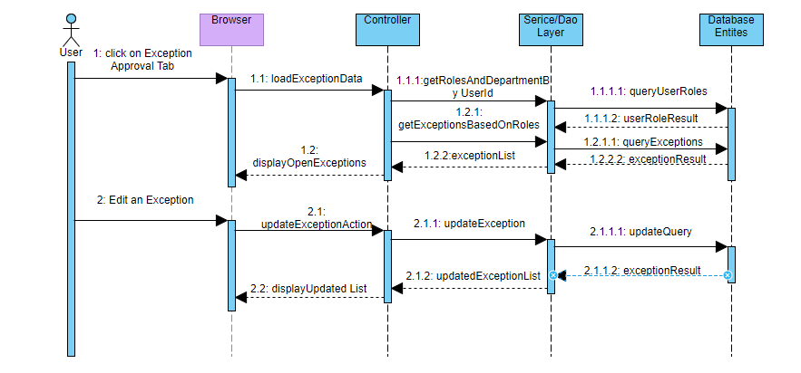

### Workflows

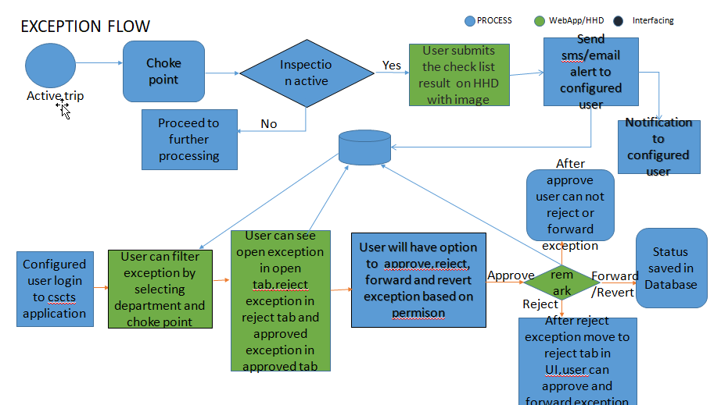

## Operating Environment

Operating environment for the CSCTS application is as below

* Oracle database
* Operating System: Centos Linux
* Client: Browser
* Platform: Java, Apache Ignite, Android 8

## Design and Implementation Constraints

* Availability of Hardware during development
* Configuration of checklist and work flow to be available

## User Documentation

Module wise user manual is provided during the feature releases.

## Assumptions and Dependencies

* Check list and work flow definitions are available before the development /rollout is started

# External Interface Requirements

## User Interfaces

Front End Interface: Android/HHD

Middle End Interface: Java Rest API’s

Backend Interface: Oracle

Standards for User Interface:

## Hardware Interfaces

Linux – Centos 7.0

A browser which supports HTML and Java Script

## Software Interfaces

Following are the software used for the CSCTS application

|  |  |  |
| --- | --- | --- |
| **Software Used** | **Version** | **Description** |
| Java | Java 1.8.0_u231 | To build the middle layer of the application, we have used Java |
| Apache Ignite | 2.7.5 | Ignite is used as an in-memory cache layer for the frequently used data |
| Oracle | 12.c | To save all the data related to the coal management |
| Android | 8 | To create the user interfaces |
| Linux | Centos 7.0 |  |
| SMTP | In –house | Email Integration |
| SMS | SMS Gateway | SMS Integration |
|  |  |  |

## Communications Interfaces

* HHD devices are used by the operators within the plant on the ground, all through the track tracking process from gate entry to gate exit as required by the module.
* While all other users, use a web browser to access and manage the CSCTS processes
* Email and SMS are modes of notification / alert to the users as required by the module

# System Features

## Exception Details

### Description and Priority

The exception details shall provide the details of the exception raised, the details of the exception, the result and the user actions along with the SOP’s defined against them.

### Stimulus/Response Sequences

* Search the exceptions raised based on Department, Choke Point, Update Vehicle Status
* Search by dates.
* Search by Open, Reject, Approved
* Edit
* Update

### Functional Requirements

* The exception shall be raised against raised when the defined threshold is not met
* The exception shall have a approval role
* The exception SOP has be displayed for the configured exceptions
* Predefined remarks shall be displayed during the approval for each of the configured exceptions

# Other Nonfunctional Requirements

* CSCTS modules or pages developed should be supported by Chrome and Edge
* CSCTS Web average page response should not be more than 5 secs
* Any or all CSCTS Web or HHD modules / functions should be accessed only by valid logged credentials
* Any or all operations performed should be audited / logged in CSCTS
* Any or all CSCTS Web pages will follow or adhere to these User Guidelines Principle

Appendix A: Glossary

<Define all the terms necessary to properly interpret the SRS, including acronyms and abbreviations. You may wish to build a separate glossary that spans multiple projects or the entire organization, and just include terms specific to a single project in each SRS.>

Appendix B: Analysis Models

<Optionally, include any pertinent analysis models, such as data flow diagrams, class diagrams, state-transition diagrams, or entity-relationship diagrams.>

Appendix C: To Be Determined List

<Collect a numbered list of the TBD (to be determined) references that remain in the SRS so they can be tracked to closure.>