Software Requirements Specification

For

CSCTS PROJECT

**Version 1.0 approved**

**Prepared by Madhusudan Padmalochan**

**ELogic Square Analytics Pvt Limited**

**02-Dec-2020**

**Table of Contents**

1. Introduction 1

1.1 Purpose 1

1.2 Document Conventions 1

1.3 Intended Audience and Reading Suggestions 1

1.4 Product Scope 1

1.5 References 1

2. Overall Description 2

2.1 Product Perspective 2

2.2 Product Functions 2

2.2.1 PPE issue/return 2

2.3 User Classes and Characteristics 3

2.3.1 PPE management 3

2.3.2 Workflows 3

2.4 Operating Environment 4

2.5 Design and Implementation Constraints 4

2.6 User Documentation 4

2.7 Assumptions and Dependencies 4

3. External Interface Requirements 4

3.1 User Interfaces 4

3.2 Hardware Interfaces 4

3.3 Software Interfaces 4

3.4 Communications Interfaces 5

4. System Features 5

4.1 PPE 5

4.1.1 Description and Priority 5

4.1.2 Stimulus/Response Sequences 5

4.1.3 Functional Requirements 5

5. Other Nonfunctional Requirements 6

**Revision History**

|  |  |  |  |
| --- | --- | --- | --- |
| **Name** | **Date** | **Reason For Changes** | **Version** |
| Madhusudan Padmalochan | 02-Dec-2020 | Initial Draft | 0.1 |
| Madhusudan Padmalochan | 18-Dec-2020 | Workflows Updated | 0.2 |

# Introduction

## Purpose

*The purpose of the document is to define the details of the CSCTS (Coal Supply Chain Tracking System) to all the stakeholders on the process of the coal movement, management in the plants*

## Document Conventions

|  |  |
| --- | --- |
| *CSCTS* | *Coal Supply Chain Management System* |
| *HHD* | *Handheld Device* |
| *UI* | *User Interface – Web Pages* |
| *Supplier* | *Coal Mines* |
| *Source* | *Source of the Coal* |
| *Transporter* | *Transporter of the Coal* |
| *Truck* | *Vehicle carrying the Coal* |
| *Hywa* | *Internal vehicles of the Plant* |
| *SR* | *Stacker Reclaimer* |
| *Dozer* | *Dozer* |
| *Rake* | *Railway Rake* |
| *PPE* | *Personal protective equipment* |

## Intended Audience and Reading Suggestions

*The document is intended to all the stake holders of the product like developers, project managers, delivery partners, testers and the plant teams and the logistics and security teams.*

*The document should be read in the above defined format so that all the flow is observed as defined.*

## Product Scope

*The purpose of the CSCTS is to provide the details of the coal movement inside the plant, starting from the in bound to storage to consumption. It is also targeted at provided the movement of the truck through near real-time view of the status of the trucks. The anomalies are detected and directed to the concerned stake holders for further actions.*

## References

# Overall Description

The PPE module shall be used by the stores, logistics or security departments to issue PPE and keep a track of the PPE items returned for a particular vehicle.

## Product Perspective

The CSCTS system stores the following the following information

* PPE items issued against a vehicle and DL number.
* PPE items returned against a vehicle and DL number.

## Product Functions

### PPE issue/return

There are two functionalities:

* + - Issue PPE: The user shall be able to issue a PPE against a particular Vehicle and driver number. There user shall be able to select the items issued which will then be stored in the CSCTS system.
    - .Return PPE: The user shall be able to log the return of the PPE equipment against a vehicle and driver number. They shall have the flexibility to pick the items being returned back. This will also be stored in the CSCTS system.

## User Classes and Characteristics

### PPE management

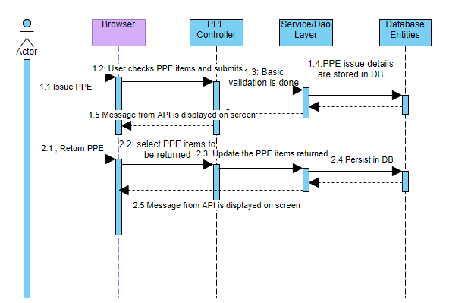

## Workflows

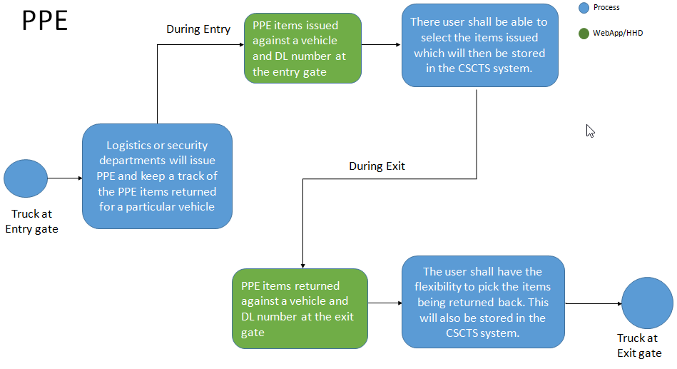

## Operating Environment

Operating environment for the CSCTS application is as below

* Oracle database
* Operating System: Centos Linux
* Client: Browser
* Platform: Java, Apache Ignite, Angular 8

## Design and Implementation Constraints

* Availability of Hardware during development

## User Documentation

Module wise user manual is provided during the feature releases.

## Assumptions and Dependencies

* Metadata to be available for each plant

# External Interface Requirements

## User Interfaces

Front End Interface: Angular

Middle End Interface: Java Rest API’s

Backend Interface: Oracle

Standards for User Interface:

## Hardware Interfaces

Linux – Centos 7.0

A browser which supports HTML and Java Script

## Software Interfaces

Following are the software used for the CSCTS application

|  |  |  |
| --- | --- | --- |
| **Software Used** | **Version** | **Description** |
| Java | Java 1.8.0_u231 | To build the middle layer of the application, we have used Java |
| Apache Ignite | 2.7.5 | Ignite is used as an in-memory cache layer for the frequently used data |
| Oracle | 12.c | To save all the data related to the coal management |
| Angular | 8 | To create the user interfaces |
| Linux | Centos 7.0 |  |
| SMTP | In –house | Email Integration |
| SMS | SMS Gateway | SMS Integration |
|  |  |  |

## Communications Interfaces

* HHD devices are used by the operators within the plant on the ground, all through the track tracking process from gate entry to gate exit as required by the module.
* While all other users, use a web browser to access and manage the CSCTS processes
* Email and SMS are modes of notification / alert to the users as required by the module

# System Features

## PPE

### Description and Priority

The PPE module shall allow tracking of PPE material issued and returned against a particular vehicle and driver number.

### Stimulus/Response Sequences

* *Issue*
* *Return*

### Functional Requirements

* The issue functionality shall display the enabled PPE items for each plant
* The issue shall allow the user to capture the items issued against the vehicle registration and driver’s license
* The return functionality shall display all the details of the PPE issued
* The return shall allow the user to select the PPE items to be returned
* The details of the issue and return shall be captured in the CSCTS.

# Other Nonfunctional Requirements

* CSCTS modules or pages developed should be supported by Chrome and Edge
* CSCTS Web average page response should not be more than 5 secs
* Any or all CSCTS Web or HHD modules / functions should be accessed only by valid logged credentials
* Any or all operations performed should be audited / logged in CSCTS
* Any or all CSCTS Web pages will follow or adhere to these User Guidelines Principle

**Appendix A: Glossary**

*<Define all the terms necessary to properly interpret the SRS, including acronyms and abbreviations. You may wish to build a separate glossary that spans multiple projects or the entire organization, and just include terms specific to a single project in each SRS.>*

**Appendix B: Analysis Models**

*<Optionally, include any pertinent analysis models, such as data flow diagrams, class diagrams, state-transition diagrams, or entity-relationship diagrams*.>

**Appendix C: To Be Determined List**

*<Collect a numbered list of the TBD (to be determined) references that remain in the SRS so they can be tracked to closure.>*