Software Requirements Specification

For

CSCTS PROJECT

Version 1.0 approved

Prepared by Satyanarayana Chelikani

ELogic Square Analytics Pvt Limited

29-Nov-2020

Table of Contents

Table of Contents ii

Revision History ii

1. Introduction 1

1.1 Purpose 1

1.2 Document Conventions 1

1.3 Intended Audience and Reading Suggestions 1

1.4 Product Scope 1

1.5 References 1

2. Overall Description 2

2.1 Product Perspective 2

2.2 Product Functions 2

2.3 User Classes and Characteristics 3

2.4 Operating Environment 5

2.5 Design and Implementation Constraints 5

2.6 User Documentation 5

2.7 Assumptions and Dependencies 5

3. External Interface Requirements 6

3.1 User Interfaces 6

3.2 Hardware Interfaces 6

3.3 Software Interfaces 6

3.4 Communications Interfaces 6

4. System Features 6

4.1 Sampling 6

4.2 Yard Special Sampling 7

5. Other Nonfunctional Requirements 8

Appendix A: Glossary 9

Appendix B: Analysis Models 9

Appendix C: To Be Determined List 9

Revision History

|  |  |  |  |
| --- | --- | --- | --- |
| **Name** | **Date** | **Reason For Changes** | **Version** |
| Satyanarayana Chelikani | 26-Nov-2020 | Initial Draft | 0.1 |
| Satyanarayana Chelikani | 17-Dec-2020 | Workflows Updated | 0.2 |

# Introduction

## Purpose

The purpose of the document is to define the details of the CSCTS (Coal Supply Chain Tracking System) to all the stack holders on the process of the coal movement, management in the plants

## Document Conventions

|  |  |
| --- | --- |
| CSCTS | Coal Supply Chain Management System |
| HHD | Handheld Device |
| UI | User Interface – Web Pages |
| Supplier | Coal Mines |
| Source | Source of the Coal |
| Transporter | Transporter of the Coal |
| Truck | Vehicle carrying the Coal |
| Hywa | Internal vehicles of the Plant |
| SR | Stacker Reclaimer |
| Dozer | Dozer |
| Rake | Railway Rake |
| DO | Delivery Order |
| PO | Purchase Order |

## Intended Audience and Reading Suggestions

The document is intended to all the stake holders of the product like developers, project managers, delivery partners, testers and the plant teams, Sampling Team, CHP Team, Lab Teams.

The document should be read in the above defined format so that all the flow is observed as defined.

## Product Scope

The purpose of the CSCTS is to provide the details of the coal movement inside the plant, starting from the in bound to storage to consumption. It is also targeted at provided the movement of the truck through near real-time view of the status of the trucks. The anomalies are detected and directed to the concerned stake holders for further actions.

## References

# Overall Description

The CSCTS sampling module supports the processing and capturing the sampling results done either through manually collected sampling or by the integrated third party

## Product Perspective

The CSCTS system stores the following the following information

* Sampling
* Yard Special Sampling

## Product Functions

### Sampling

The CSCTS sampling module shall provide the option to capture the sampling collection, result details either by the UI or from the third party integration. Apart from the captured data, the module shall provide the details for editing the sampling attributes. Also the module shall provide the details for capturing the feed coal.

* Sample Collection
* Add Sampling
* Edit Sampling
* Add Feed Coal
* Edit Feed Coal

### Yard Special Sampling

The CSCTS sampling module shall provide the option to capture the special sampling collection at the yard based on the inspection done. The collection shall be captured in CSCTS and the sampling results are processed similar to the above process

* Special Sample Collection.

## User Classes and Characteristics

### Sampling

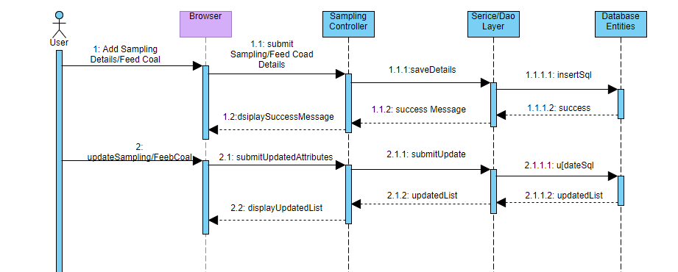

### Yard Special Sampling

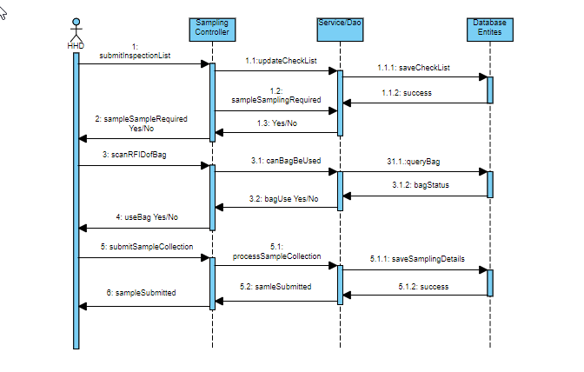

### Workflows

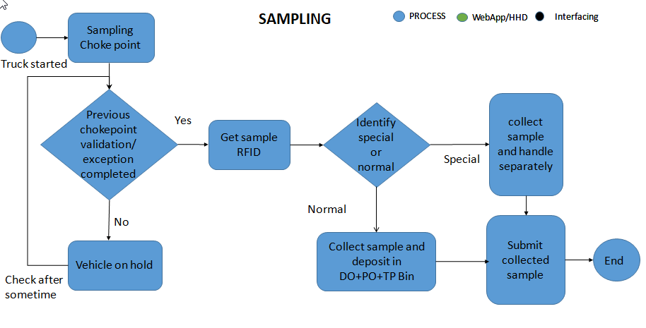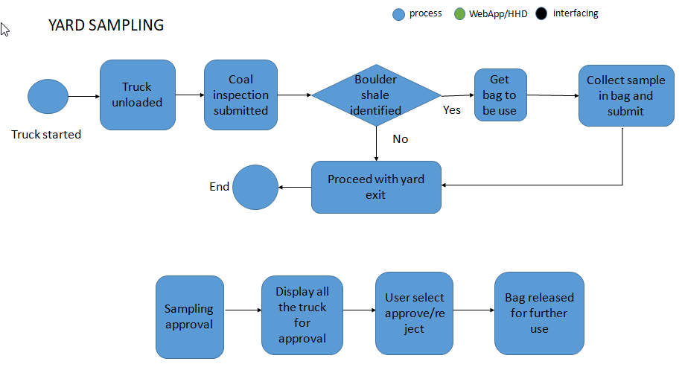

## Operating Environment

Operating environment for the CSCTS application is as below

* Oracle database
* Operating System: Centos Linux
* Client: Browser
* Platform: Java, Apache Ignite, Android 8

## Design and Implementation Constraints

* Availability of Hardware during development
* Configuration of checklist and work flow to be available

## User Documentation

Module wise user manual is provided during the feature releases.

## Assumptions and Dependencies

* Check list and work flow definitions are available before the development /rollout is started

# External Interface Requirements

## User Interfaces

Front End Interface: Android/HHD

Middle End Interface: Java Rest API’s

Backend Interface: Oracle

Standards for User Interface:

## Hardware Interfaces

Linux – Centos 7.0

A browser which supports HTML and Java Script

## Software Interfaces

Following are the software used for the CSCTS application

|  |  |  |
| --- | --- | --- |
| **Software Used** | **Version** | **Description** |
| Java | Java 1.8.0_u231 | To build the middle layer of the application, we have used Java |
| Apache Ignite | 2.7.5 | Ignite is used as an in-memory cache layer for the frequently used data |
| Oracle | 12.c | To save all the data related to the coal management |
| Android | 8 | To create the user interfaces |
| Linux | Centos 7.0 |  |
| SMTP | In –house | Email Integration |
| SMS | SMS Gateway | SMS Integration |
|  |  |  |

## Communications Interfaces

* HHD devices are used by the operators within the plant on the ground, all through the track tracking process from gate entry to gate exit as required by the module.
* While all other users, use a web browser to access and manage the CSCTS processes
* Email and SMS are modes of notification / alert to the users as required by the module

# System Features

## Sampling

### Description and Priority

The sampling module shall provide the user to add, edit the sampling results. It also provides the option to add, edit feed coal also

### Stimulus/Response Sequences

* Add Sampling
* Edit Sampling
* Add Feed Coal
* Edit Feed Coal

### Functional Requirements

* The sampling module shall provide the option to capture the data using the UI or from the ETL’s to capture the sampling results
* The module should provide the option to edit the sampling results in case of any discrepancies.
* The module shall provide the option to add the feed coal information
* The module shall provide the option to edit the feed coal information

## Yard Special Sampling

### Description and Priority

The CSCTS sampling module shall have an option to trigger the special sampling in the yard based on the predefined checks

### Stimulus/Response Sequences

* Trigger Special sampling
* Get Bag for Special Sampling
* Submit
* Special sample approval

### Functional Requirements

* The sampling module shall provide a unique coded number for each of the truck based on the source, do and transporter combination.
* The sampling module shall tell the yard supervisor that the special sampling is required based on the inspection submitted.
* The supervisor shall pick a bag and CSCTS shall inform the user if it can be used
* The supervisor shall seal the bag and inform CSCTS that the bag has been submitted
* The CSCTS shall display the special sampling to the configured approver role from approval
* The approval can approve/reject the sampling
* The Lab team can get the sampling tag based on the bag rfid
* The Lab team shall release the bag once the sampling processing is done at plant lab.

# Other Nonfunctional Requirements

* CSCTS modules or pages developed should be supported by Chrome and Edge
* CSCTS Web average page response should not be more than 5 secs
* Any or all CSCTS Web or HHD modules / functions should be accessed only by valid logged credentials
* Any or all operations performed should be audited / logged in CSCTS
* Any or all CSCTS Web pages will follow or adhere to these User Guidelines Principle