Software Requirements Specification

For

CSCTS PROJECT

Version 1.0 approved

Prepared by Gaurav Kumar

ELogic Square Analytics Pvt Limited

28-Nov-2020

Table of Contents

Table of Contents ii

Revision History ii

1. Introduction 1

1.1 Purpose 1

1.2 Document Conventions 1

1.3 Intended Audience and Reading Suggestions 1

1.4 Product Scope 1

1.5 References 1

2. Overall Description 2

2.1 Product Perspective 2

2.2 Product Functions 2

2.3 User Classes and Characteristics 2

2.4 Operating Environment 3

2.5 Design and Implementation Constraints 3

2.6 User Documentation 3

2.7 Assumptions and Dependencies 3

3. External Interface Requirements 3

3.1 User Interfaces 3

3.2 Hardware Interfaces 3

3.3 Software Interfaces 4

3.4 Communications Interfaces 4

4. System Features 4

4.1 Violation 4

5. Other Nonfunctional Requirements 5

Appendix A: Glossary 6

Appendix B: Analysis Models 6

Appendix C: To Be Determined List 6

Revision History

|  |  |  |  |
| --- | --- | --- | --- |
| **Name** | **Date** | **Reason For Changes** | **Version** |
| Gaurav Kumar | 28-Nov-2020 | Initial Draft | 0.1 |
| Gaurav Kumar | 18-Dec-2020 | Workflows updated | 0.2 |

# Introduction

## Purpose

The purpose of the document is to define the details of the CSCTS (Coal Supply Chain Tracking System) to all the stack holders on the process of the coal movement, management in the plants

## Document Conventions

|  |  |
| --- | --- |
| CSCTS | Coal Supply Chain Management System |
| HHD | Handheld Device |
| UI | User Interface – Web Pages |
| Supplier | Coal Mines |
| Source | Source of the Coal |
| Transporter | Transporter of the Coal |
| Truck | Vehicle carrying the Coal |
| Hywa | Internal vehicles of the Plant |
| SR | Stacker Reclaimer |
| Dozer | Dozer |
| Rake | Railway Rake |

## Intended Audience and Reading Suggestions

The document is intended to all the stake holders of the product like developers, project managers, delivery partners, testers and the plant teams and the security Team.

The document should be read in the above defined format so that all the flow is observed as defined.

## Product Scope

The purpose of the CSCTS is to provide the details of the coal movement inside the plant, starting from the in bound to storage to consumption. It is also targeted at provided the movement of the truck through near real-time view of the status of the trucks. The anomalies are detected and directed to the concerned stake holders for further actions.

## References

# Overall Description

Violation shall be captured digitally if required while the vehicle is active inside the plant.

## Product Perspective

The CSCTS system stores the following information

* Violation type Exception

## Product Functions

### Violations

User of the system shall be able to attach one or more violation against an active external truck in the CSCTS application. Users having the privilege are allowed to perform the required operations.

* Save violations against an active vehicle.

## User Classes and Characteristics

### Violation Capture

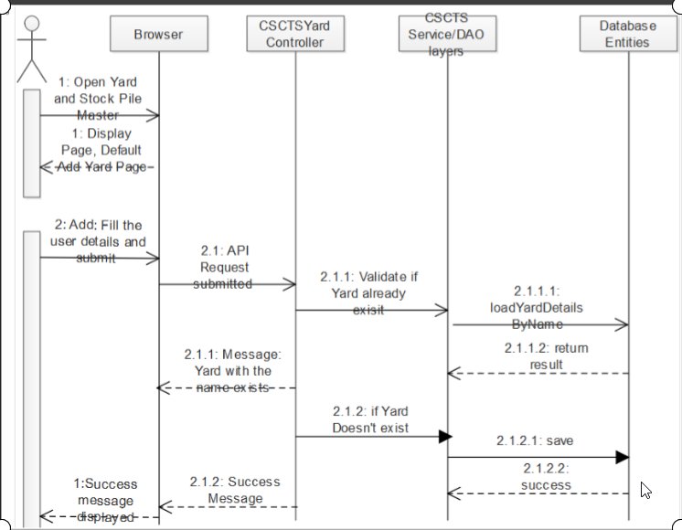

### Workflows

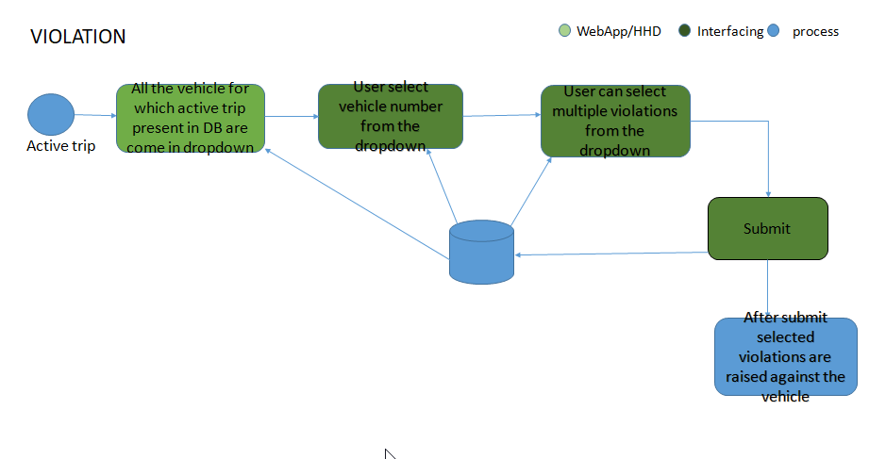

## Operating Environment

Operating environment for the CSCTS application is as below

* Oracle database
* Operating System: Centos Linux
* Client: Browser
* Platform: Java, Apache Ignite, Angular 8

## Design and Implementation Constraints

* Availability of Hardware during development

## User Documentation

Module wise user manual is provided during the feature releases.

## Assumptions and Dependencies

* The Metadata for yard and stock pile is available during the development/rollout phase.

# External Interface Requirements

## User Interfaces

Front End Interface: Angular

Middle End Interface: Java Rest API’s

Backend Interface: Oracle

Standards for User Interface:

## Hardware Interfaces

Linux – Centos 7.0

A browser which supports HTML and Java Script

## Software Interfaces

Following are the software used for the CSCTS application

|  |  |  |
| --- | --- | --- |
| **Software Used** | **Version** | **Description** |
| Java | Java 1.8.0_u231 | To build the middle layer of the application, we have used Java |
| Apache Ignite | 2.7.5 | Ignite is used as an in-memory cache layer for the frequently used data |
| Oracle | 12.c | To save all the data related to the coal management |
| Angular | 8 | To create the user interfaces |
| Linux | Centos 7.0 |  |
| SMTP | In –house | Email Integration |
| SMS | SMS Gateway | SMS Integration |
|  |  |  |

## Communications Interfaces

* HHD devices are used by the operators within the plant on the ground, all through the track tracking process from gate entry to gate exit as required by the module.
* While all other users, use a web browser to access and manage the CSCTS processes
* Email and SMS are modes of notification / alert to the users as required by the module

# System Features

The violation as such is one functional point.

## Violation

### Description and Priority

The Violation module shall provide the user the ability to attach one or more violation against the external truck while it is still inside plant.

### Stimulus/Response Sequences

* Save Violations

### Functional Requirements

* All the vehicle which has active trip ID i.e. all the external truck which is inside the plant shall be visible in UI.
* Violation can be attached by selecting a vehicle no from active vehicle list and by selecting one or more than one violation from drop down and by click on save.

# Other Nonfunctional Requirements

* CSCTS modules or pages developed should be supported by Chrome and Edge
* CSCTS Web average page response should not be more than 5 secs
* Any or all CSCTS Web or HHD modules / functions should be accessed only by valid logged credentials
* Any or all operations performed should be audited / logged in CSCTS
* Any or all CSCTS Web pages will follow or adhere to these User Guidelines Principle

Appendix A: Glossary

<Define all the terms necessary to properly interpret the SRS, including acronyms and abbreviations. You may wish to build a separate glossary that spans multiple projects or the entire organization, and just include terms specific to a single project in each SRS.>

Appendix B: Analysis Models

<Optionally, include any pertinent analysis models, such as data flow diagrams, class diagrams, state-transition diagrams, or entity-relationship diagrams.>

Appendix C: To Be Determined List

<Collect a numbered list of the TBD (to be determined) references that remain in the SRS so they can be tracked to closure.>