Software Requirements Specification

For

CSCTS PROJECT

Version 1.0 approved

Prepared by Satyanarayana Chelikani

ELogic Square Analytics Pvt Limited

26-Nov-2020

Contents

1. Introduction 1

1.1 Purpose 1

1.2 Document Conventions 1

1.3 Intended Audience and Reading Suggestions 1

1.4 Product Scope 1

1.5 References 2

2. Overall Description 2

2.1 Product Perspective 2

2.2 Product Functions 2

2.2.1 DO Details 2

2.2.2 Transit Pass (TP) 2

2.2.3 Transporter 3

2.3 User Classes and Characteristics 3

2.3.1 Add DO/TP/Transporter 3

2.3.2 Edit DO/TP/Transporter 4

2.3.3 Workflows 4

2.4 Operating Environment 5

2.5 Design and Implementation Constraints 5

2.6 User Documentation 5

2.7 Assumptions and Dependencies 5

3. External Interface Requirements 5

3.1 User Interfaces 5

3.2 Hardware Interfaces 5

3.3 Software Interfaces 5

3.4 Communications Interfaces 6

4. System Features 6

4.1 DO-PO 6

4.1.1 Description and Priority 6

4.1.2 Stimulus/Response Sequences 6

4.1.3 Functional Requirements 6

5. Other Nonfunctional Requirements 7

Revision History

|  |  |  |  |
| --- | --- | --- | --- |
| **Name** | **Date** | **Reason For Changes** | **Version** |
| Satyanarayana Chelikani | 26-Nov-2020 | Initial Draft | 0.1 |
| Satyanarayana Chelikani | 18-Dec-2020 | Workflows updated | 0.2 |

# Introduction

## Purpose

The purpose of the document is to define the details of the CSCTS (Coal Supply Chain Tracking System) to all the stack holders on the process of the coal movement, management in the plants

## Document Conventions

|  |  |
| --- | --- |
| CSCTS | Coal Supply Chain Management System |
| HHD | Handheld Device |
| UI | User Interface – Web Pages |
| Supplier | Coal Mines |
| Source | Source of the Coal |
| Transporter | Transporter of the Coal |
| Truck | Vehicle carrying the Coal |
| Hywa | Internal vehicles of the Plant |
| SR | Stacker Reclaimer |
| Dozer | Dozer |
| Rake | Railway Rake |
| DO | Delivery Order |
| PO | Purchase Order |

## Intended Audience and Reading Suggestions

The document is intended to all the stake holders of the product like developers, project managers, delivery partners, testers and the plant teams and the Logistics and Stores Teams.

The document should be read in the above defined format so that all the flow is observed as defined.

## Product Scope

The purpose of the CSCTS is to provide the details of the coal movement inside the plant, starting from the in bound to storage to consumption. It is also targeted at provided the movement of the truck through near real-time view of the status of the trucks. The anomalies are detected and directed to the concerned stake holders for further actions.

## References

# Overall Description

The Coal Storage system comprises of logistics and stores module where in the CSCTS application allows the user shall have the ability to record the coal purchase, transporter contracts and other purchase and some financial details like cost of coal, transporter

## Product Perspective

The CSCTS system stores the following the following information

* DO Details
* PO Details
* Cost Details
* Bank Guarantee (not mandatory)

## Product Functions

### DO Details

User of the system shall be able to add the DO Details which capture the details of the coal purchase. User shall be able to capture the details of Validity, Material PO, Source Mine, , the quantity and quality attributes, the supplier details, the type of coal being a few attributes.

The system shall support 2 privileges – add, edit. Users having the privilege are allowed to perform the required operations. The IT admin is given the functions to work on both. The appropriate privileges are available in the User Management document

* Add DO
  + Add a New DO to the CSCTS application
* Edit DO.
  + Modify the existing attributes of the DO.

### Transit Pass (TP)

The TP in CSCTS represents a transit permit (pass) generally issued by the state governments based on which the trucks can move. The TP in CSTCS is a unique identifier acting as a bridge between DO and the transporter. The system shall support 2 privileges – add, edit. Users having the privilege are allowed to perform the required operations. The IT admin is given the functions to work on both. The appropriate privileges are available in the User Management document

* Add TP
  + Add a new TP
* Edit TP
  + Modify the existing attributes of the TP

### Transporter

User of the system shall be able to add, modify the transporter contracts. The details of the purchase like Name, PO, validity, moisture, target GCV, freight rate and bank guarantee. The system shall support 2 privileges – add, edit. Users having the privilege are allowed to perform the required operations. The IT admin is given the functions to work on both. The appropriate privileges are available in the User Management document

* Add Transporter
* Edit Transporter
* Reallocate Vehicles

## User Classes and Characteristics

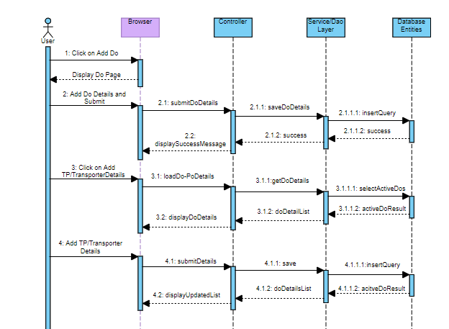

### Add DO/TP/Transporter

### Edit DO/TP/Transporter

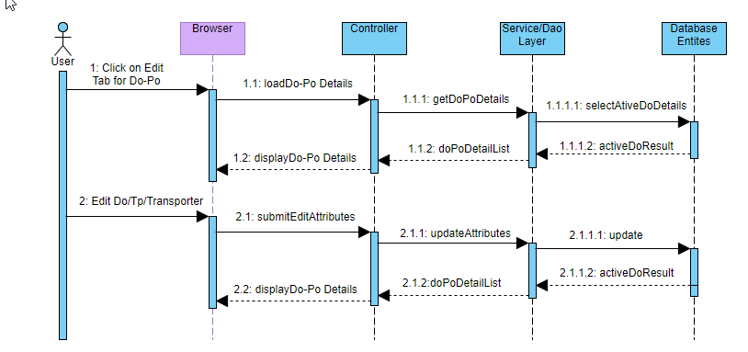

### Workflows

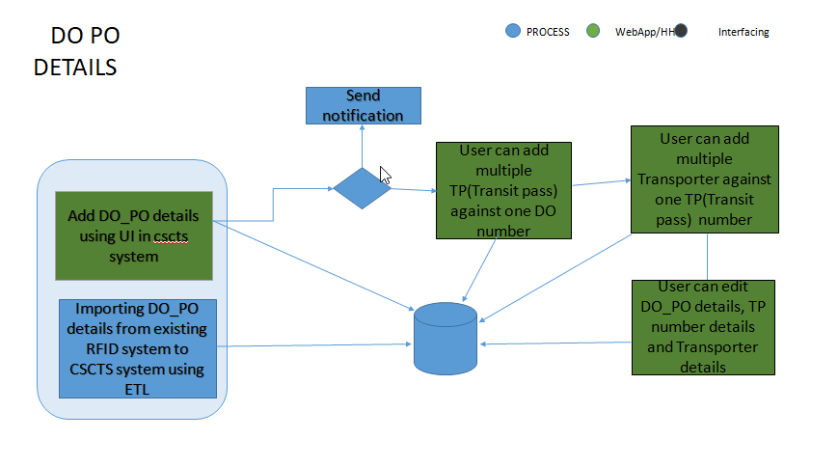

## Operating Environment

Operating environment for the CSCTS application is as below

* Oracle database
* Operating System: Centos Linux
* Client: Browser
* Platform: Java, Apache Ignite, Angular 8

## Design and Implementation Constraints

* Availability of Hardware during development
* Availability of database connectivity for the ETL’s

## User Documentation

Module wise user manual is provided during the feature releases.

## Assumptions and Dependencies

* The database attributes for the mapping has to be available along with the understanding

# External Interface Requirements

## User Interfaces

Front End Interface: Angular

Middle End Interface: Java Rest API’s

Backend Interface: Oracle

Standards for User Interface:

## Hardware Interfaces

Linux – Centos 7.0

A browser which supports HTML and Java Script

## Software Interfaces

Following are the software used for the CSCTS application

|  |  |  |
| --- | --- | --- |
| **Software Used** | **Version** | **Description** |
| Java | Java 1.8.0_u231 | To build the middle layer of the application, we have used Java |
| Apache Ignite | 2.7.5 | Ignite is used as an in-memory cache layer for the frequently used data |
| Oracle | 12.c | To save all the data related to the coal management |
| Angular | 8 | To create the user interfaces |
| Linux | Centos 7.0 |  |
| SMTP | In –house | Email Integration |
| SMS | SMS Gateway | SMS Integration |
|  |  |  |

## Communications Interfaces

* HHD devices are used by the operators within the plant on the ground, all through the track tracking process from gate entry to gate exit as required by the module.
* While all other users, use a web browser to access and manage the CSCTS processes
* Email and SMS are modes of notification / alert to the users as required by the module

# System Features

The DO-PO module is divided into the functional components namely DO, TP and Transporter

## DO-PO

### Description and Priority

The DO-PO module shall provide the user the ability to capture/manipulate the data related to the Do, Po and Transporter specific agreements

### Stimulus/Response Sequences

* Add DO
* Edit DO
* Add TP
* Edit TP
* Add Transporter
* Edit Transporter

### Functional Requirements

* The Do-Po module shall allow capturing/modifying the details related to the source, validity, quantity and quality of the Coal along with the material PO numbers and details.
* The module shall be able capturing/modifying of the TP details
* The module shall provide the options to capture/modify the details of the transporter
* The module shall only display the Do-Po’s for which validity is there
* The module shall allow the access of certain attributes based on the configurations.

# Other Nonfunctional Requirements

* CSCTS modules or pages developed should be supported by Chrome and Edge
* CSCTS Web average page response should not be more than 5 secs
* Any or all CSCTS Web or HHD modules / functions should be accessed only by valid logged credentials
* Any or all operations performed should be audited / logged in CSCTS
* Any or all CSCTS Web pages will follow or adhere to these User Guidelines Principle

Appendix A: Glossary

<Define all the terms necessary to properly interpret the SRS, including acronyms and abbreviations. You may wish to build a separate glossary that spans multiple projects or the entire organization, and just include terms specific to a single project in each SRS.>

Appendix B: Analysis Models

<Optionally, include any pertinent analysis models, such as data flow diagrams, class diagrams, state-transition diagrams, or entity-relationship diagrams.>

Appendix C: To Be Determined List

<Collect a numbered list of the TBD (to be determined) references that remain in the SRS so they can be tracked to closure.>