Software Requirements Specification

For

CSCTS PROJECT

Version 1.0 approved

Prepared by Satyanarayana Chelikani

ELogic Square Analytics Pvt Limited

26-Nov-2020

Table of Contents

Table of Contents ii

Revision History ii

1. Introduction 1

1.1 Purpose 1

1.2 Document Conventions 1

1.3 Intended Audience and Reading Suggestions 1

1.4 Product Scope 1

1.5 References 2

2. Overall Description 2

2.1 Product Perspective 2

2.2 Product Functions 2

2.3 User Classes and Characteristics 3

2.4 Operating Environment 4

2.5 Design and Implementation Constraints 4

2.6 User Documentation 4

2.7 Assumptions and Dependencies 4

3. External Interface Requirements 4

3.1 User Interfaces 4

3.2 Hardware Interfaces 4

3.3 Software Interfaces 4

3.4 Communications Interfaces 5

4. System Features 5

4.1 Internal Vehicle 5

5. Other Nonfunctional Requirements 6

Appendix A: Glossary 6

Appendix B: Analysis Models 6

Appendix C: To Be Determined List 6

Revision History

|  |  |  |  |
| --- | --- | --- | --- |
| **Name** | **Date** | **Reason For Changes** | **Version** |
| Satyanarayana Chelikani | 26-Nov-2020 | Initial Draft | 0.1 |
| Satyanarayana Chelikani | 17-Dec-2020 | Workflows updated | 0.2 |

# Introduction

## Purpose

The purpose of the document is to define the details of the CSCTS (Coal Supply Chain Tracking System) to all the stack holders on the process of the coal movement, management in the plants

## Document Conventions

|  |  |
| --- | --- |
| CSCTS | Coal Supply Chain Management System |
| HHD | Handheld Device |
| UI | User Interface – Web Pages |
| Supplier | Coal Mines |
| Source | Source of the Coal |
| Transporter | Transporter of the Coal |
| Truck | Vehicle carrying the Coal |
| Hywa | Internal vehicles of the Plant |
| SR | Stacker Reclaimer |
| Dozer | Dozer |
| Rake | Railway Rake |
| DO | Delivery Order |
| PO | Purchase Order |

## Intended Audience and Reading Suggestions

The document is intended to all the stake holders of the product like developers, project managers, delivery partners, testers and the plant teams and the Logistics and Stores Teams.

The document should be read in the above defined format so that all the flow is observed as defined.

## Product Scope

The purpose of the CSCTS is to provide the details of the coal movement inside the plant, starting from the in bound to storage to consumption. It is also targeted at provided the movement of the truck through near real-time view of the status of the trucks. The anomalies are detected and directed to the concerned stake holders for further actions.

## References

# Overall Description

The CSCTS comprises of logistics and stores module where in the CSCTS application allows the user shall have the ability to define the status of the plant owned/contracted vehicles specifically called in the document as Internal Vehicles

## Product Perspective

The CSCTS system stores the following the following information

* Vehicles
* Vehicle Type

## Product Functions

### Internal Vehicle Details

User of the system shall able to define the status of the plant owned/contracted vehicles for internal usage within the plant. The system shall support 1 privilege –edit. Users having the privilege are allowed to perform the required operations. The IT admin has this privilege by default. The appropriate privileges are available in the User Management document

* Update Vehicle Status
  + All the internal vehicles are displayed.
  + Update the vehicle as Active or Inactive

## User Classes and Characteristics

### Internal Vehicle

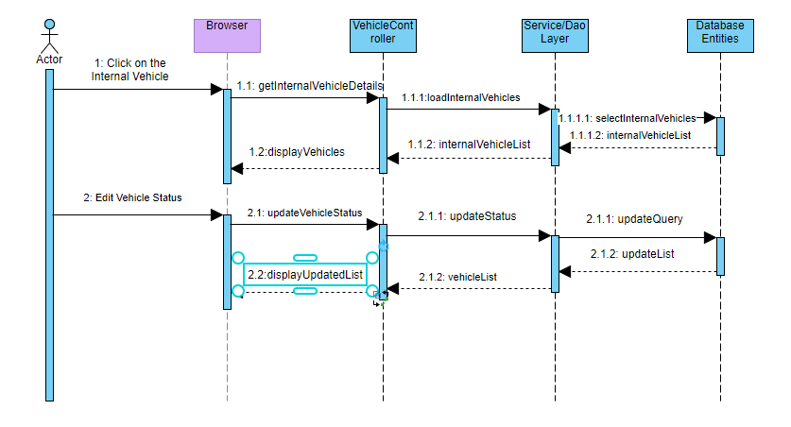

### Workflows

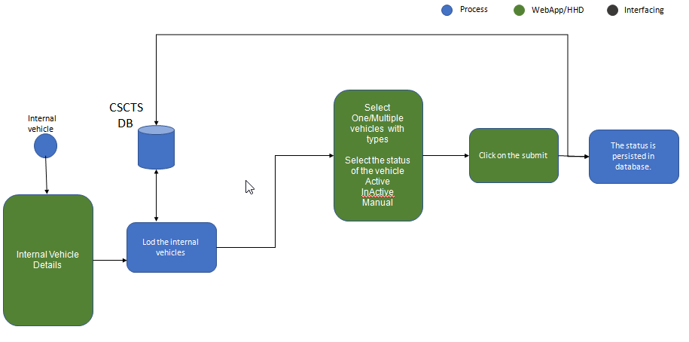

## Operating Environment

Operating environment for the CSCTS application is as below

* Oracle database
* Operating System: Centos Linux
* Client: Browser
* Platform: Java, Apache Ignite, Angular 8

## Design and Implementation Constraints

* Availability of Hardware during development

## User Documentation

Module wise user manual is provided during the feature releases.

## Assumptions and Dependencies

* The internal vehicles are on boarded into CSCTS and defined with the type of Internal Vehicle

# External Interface Requirements

## User Interfaces

Front End Interface: Angular

Middle End Interface: Java Rest API’s

Backend Interface: Oracle

Standards for User Interface:

## Hardware Interfaces

Linux – Centos 7.0

A browser which supports HTML and Java Script

## Software Interfaces

Following are the software used for the CSCTS application

|  |  |  |
| --- | --- | --- |
| **Software Used** | **Version** | **Description** |
| Java | Java 1.8.0_u231 | To build the middle layer of the application, we have used Java |
| Apache Ignite | 2.7.5 | Ignite is used as an in-memory cache layer for the frequently used data |
| Oracle | 12.c | To save all the data related to the coal management |
| Angular | 8 | To create the user interfaces |
| Linux | Centos 7.0 |  |
| SMTP | In –house | Email Integration |
| SMS | SMS Gateway | SMS Integration |
|  |  |  |

## Communications Interfaces

* HHD devices are used by the operators within the plant on the ground, all through the track tracking process from gate entry to gate exit as required by the module.
* While all other users, use a web browser to access and manage the CSCTS processes
* Email and SMS are modes of notification / alert to the users as required by the module

# System Features

## Internal Vehicle

### Description and Priority

The internal vehicle module shall provide the view of the vehicles owned by plant or contracted for the internal usage within the plant. The module shall provide the details of the vehicles and shall provide the option to change the status of the vehicle so that their usage can be maximized during operations

### Stimulus/Response Sequences

* Update Vehicle Status
  + Active/In-Active/Manual

### Functional Requirements

* The Internal Vehicle shall display all the internal vehicles of the plant
* The module shall allow to change the status of the vehicle
* The related modules like Blend Planning, Execution shall use consider the status of the internal vehicles during planning.

# Other Nonfunctional Requirements

* CSCTS modules or pages developed should be supported by Chrome and Edge
* CSCTS Web average page response should not be more than 5 secs
* Any or all CSCTS Web or HHD modules / functions should be accessed only by valid logged credentials
* Any or all operations performed should be audited / logged in CSCTS
* Any or all CSCTS Web pages will follow or adhere to these User Guidelines Principle

Appendix A: Glossary

<Define all the terms necessary to properly interpret the SRS, including acronyms and abbreviations. You may wish to build a separate glossary that spans multiple projects or the entire organization, and just include terms specific to a single project in each SRS.>

Appendix B: Analysis Models

<Optionally, include any pertinent analysis models, such as data flow diagrams, class diagrams, state-transition diagrams, or entity-relationship diagrams.>

Appendix C: To Be Determined List

<Collect a numbered list of the TBD (to be determined) references that remain in the SRS so they can be tracked to closure.>