Software Requirements Specification

For

CSCTS PROJECT

Version 1.0 approved

Prepared by Sachin Chaurasia

ELogic Square Analytics Pvt Limited

28-Nov-2020

Table of Contents

Table of Contents ii

Revision History ii

1. Introduction 1

1.1 Purpose 1

1.2 Document Conventions 1

1.3 Intended Audience and Reading Suggestions 1

1.4 Product Scope 1

1.5 References 1

2. Overall Description 1

2.1 Product Perspective 2

2.2 Product Functions 2

2.3 User Classes and Characteristics 3

2.4 Operating Environment 4

2.5 Design and Implementation Constraints 4

2.6 User Documentation 4

2.7 Assumptions and Dependencies 4

3. External Interface Requirements 5

3.1 User Interfaces 5

3.2 Hardware Interfaces 5

3.3 Software Interfaces 5

3.4 Communications Interfaces 5

4. System Features 5

4.1 Job Allocation 5

5. Other Nonfunctional Requirements 6

Appendix A: Glossary 7

Appendix B: Analysis Models 7

Appendix C: To Be Determined List 7

Revision History

|  |  |  |  |
| --- | --- | --- | --- |
| **Name** | **Date** | **Reason For Changes** | **Version** |
| Sachin Chaurasia | 28-Nov-2020 | Initial Draft | 0.1 |
| Sachin Chaurasia | 19-Dec-2020 | Workflows Updated | 0.2 |

# Introduction

## Purpose

The purpose of the document is to define the details of the CSCTS (Coal Supply Chain Tracking System) to all the stack holders on the process of the coal movement, management in the plants

## Document Conventions

|  |  |
| --- | --- |
| CSCTS | Coal Supply Chain Management System |
| HHD | Handheld Device |
| UI | User Interface – Web Pages |
| Supplier | Coal Mines |
| Source | Source of the Coal |
| Transporter | Transporter of the Coal |
| Truck | Vehicle carrying the Coal |
| Hywa | Internal vehicles of the Plant |
| SR | Stacker Reclaimer |
| Dozer | Dozer |
| Rake | Railway Rake |

## Intended Audience and Reading Suggestions

The document is intended to all the stake holders of the product like developers, project managers, delivery partners, testers and the plant teams and the CHP Team.

The document should be read in the above defined format so that all the flow is observed as defined.

## Product Scope

The purpose of the CSCTS is to provide the details of the coal movement inside the plant, starting from the in bound to storage to consumption. It is also targeted at provided the movement of the truck through near real-time view of the status of the trucks. The anomalies are detected and directed to the concerned stake holders for further actions.

## References

# Overall Description

The Job allocation system comprises of logically identifying the internal movement of coal from one stockpile to other stockpile/RH. The purpose of this module is to handle the internal coal movement in the yard and stock pile and give the user the control of the coal moved from one place to another.

## Product Perspective

The CSCTS system stores the following the following information

* Plant Specific Yard Configurations
* Plant Specific Stock Pile Configurations
* Chokepoint Specific Data Points
* Blend details
* Internal available vehicles

## Product Functions

### Job Allocation

User of system shall be able to create job for internal movement or able to execute the blend plan created. User shall be able to modify / update the attributes of job created such as required Hyva, priority and status. CSCTS system shall be able to get the job and allocate the available Hyva to respective job and activity. To track the movement of Hyva on field user shall be able to do the entry on HHD device.

If there is a breakdown, user shall be able to reallocate the one Hyva to another and CSCTS system shall be able to process the details.

User shall be able to see all the allocated Hyva for that job / activity on UI. User shall be able to pause, continue or terminate the activity based on requirement.

The system shall support 2 privileges – add, edit. Users having the privilege are allowed to perform the required operations. The IT admin is given the functions to work on both. The appropriate privileges are available in the User Management document

* Add Job.
* Update Job / Activity.
  + Modify the existing attribute of Job / Activity details.
* Reallocate Hyva.

## User Classes and Characteristics

### Job Allocation

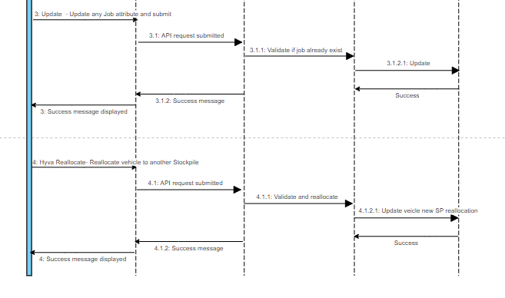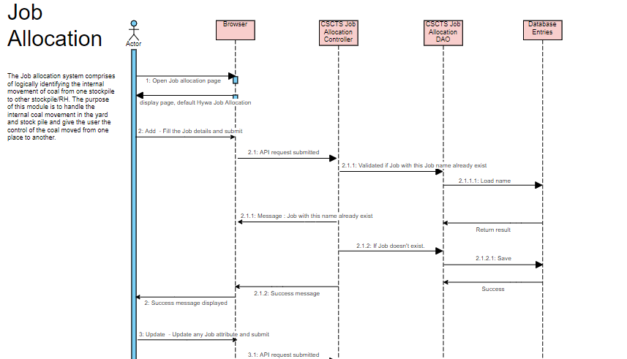

### Workflows

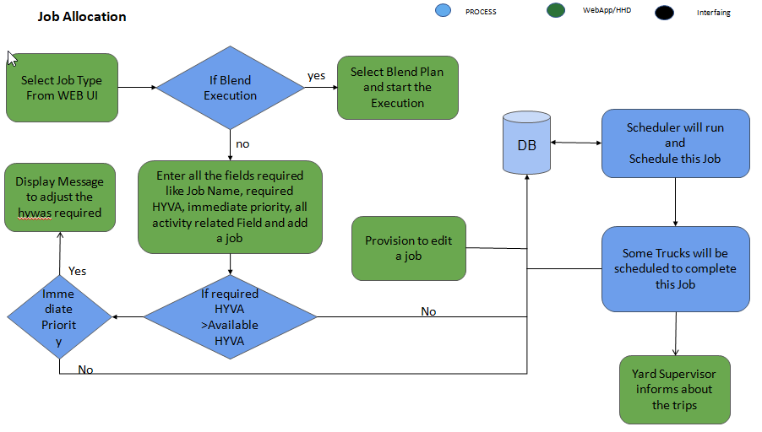

## Operating Environment

Operating environment for the CSCTS application is as below

* Oracle database
* Operating System: Centos Linux
* Client: Browser
* Platform: Java, Apache Ignite, Angular 8

## Design and Implementation Constraints

* Clean understand of Hywa movement.

## User Documentation

Module wise user manual is provided during the feature releases.

## Assumptions and Dependencies

* The DO details will be entered beforehand, so active DO will be available.

# External Interface Requirements

## User Interfaces

Front End Interface: Angular

Middle End Interface: Java Rest API’s

Backend Interface: Oracle

Standards for User Interface:

## Hardware Interfaces

Linux – Centos 7.0

A browser which supports HTML and Java Script

## Software Interfaces

Following are the software used for the CSCTS application

|  |  |  |
| --- | --- | --- |
| **Software Used** | **Version** | **Description** |
| Java | Java 1.8.0_u231 | To build the middle layer of the application, we have used Java |
| Apache Ignite | 2.7.5 | Ignite is used as an in-memory cache layer for the frequently used data |
| Oracle | 12.c | To save all the data related to the coal management |
| Angular | 8 | To create the user interfaces |
| Linux | Centos 7.0 |  |
| SMTP | In –house | Email Integration |
| SMS | SMS Gateway | SMS Integration |
|  |  |  |

## Communications Interfaces

* The Job allocation page shall be able to execute the blend plan created on Blend Plan page.

# System Features

## Job Allocation

### Description and Priority

The Job allocation system shall provide the user the ability to create execute job, track Hyva and reallocated Hyva.

### Stimulus/Response Sequences

* Add Job
* Execute blend plan
* Edit Job
* Reallocate Hyva

### Functional Requirements

* User of system shall be able to create job for internal movement or able to execute the blend plan created.
* User shall be able to modify / update the attributes of job created such as required Hyva, priority and status.
* CSCTS system shall be able to get the job and allocate the available Hyva based on algorithm to respective job and activity.
* To track the movement of Hyva on field user shall be able to do the entry on HHD device.
* If there is a breakdown, user shall be able to reallocate the one Hyva to another and CSCTS system shall be able to process the details.
* User shall be able to see all the allocated Hyva for that job / activity on UI.
* User shall be able to pause, continue or terminate the activity based on requirement.
  + Pause: If activity is paused, no further allocation will happen to that activity. Also, if Hyva have not stated the trip, those trips will be canceled.
  + Continue: If activity is paused, user shall be able to change the status of job to continue to allow system to further allocate Hyva on that activity.
  + Terminate: If activity is terminated, user shall not be able to change the status of that activity anymore. No further allocation shall happen to that activity. Also, if Hyva have not stated the trip, those trips will be canceled.

# Other Nonfunctional Requirements

* CSCTS modules or pages developed should be supported by Chrome and Edge
* CSCTS Web average page response should not be more than 5 secs
* Any or all CSCTS Web or HHD modules / functions should be accessed only by valid logged credentials
* Any or all operations performed should be audited / logged in CSCTS
* Any or all CSCTS Web pages will follow or adhere to these User Guidelines Principle

Appendix A: Glossary

<Define all the terms necessary to properly interpret the SRS, including acronyms and abbreviations. You may wish to build a separate glossary that spans multiple projects or the entire organization, and just include terms specific to a single project in each SRS.>

Appendix B: Analysis Models

<Optionally, include any pertinent analysis models, such as data flow diagrams, class diagrams, state-transition diagrams, or entity-relationship diagrams.>

Appendix C: To Be Determined List

<Collect a numbered list of the TBD (to be determined) references that remain in the SRS so they can be tracked to closure.>