Software Requirements Specification

For

CSCTS PROJECT

Version 1.0 approved

Prepared by Sachin Chaurasia

ELogic Square Analytics Pvt Limited

28-Nov-2020

Table of Contents

Table of Contents ii

Revision History ii

1. Introduction 1

1.1 Purpose 1

1.2 Document Conventions 1

1.3 Intended Audience and Reading Suggestions 1

1.4 Product Scope 1

1.5 References 1

2. Overall Description 1

2.1 Product Perspective 2

2.2 Product Functions 2

2.3 User Classes and Characteristics 3

2.4 Operating Environment 4

2.5 Design and Implementation Constraints 4

2.6 User Documentation 4

2.7 Assumptions and Dependencies 4

3. External Interface Requirements 5

3.1 User Interfaces 5

3.2 Hardware Interfaces 5

3.3 Software Interfaces 5

3.4 Communications Interfaces 5

4. System Features 5

4.1 Railway Rake 5

5. Other Nonfunctional Requirements 6

Appendix A: Glossary 6

Appendix B: Analysis Models 6

Appendix C: To Be Determined List 7

Revision History

|  |  |  |  |
| --- | --- | --- | --- |
| **Name** | **Date** | **Reason For Changes** | **Version** |
| Sachin Chaurasia | 28-Nov-2020 | Initial Draft | 0.1 |
| Sachin Chaurasia | 20-Dec-2020 | Workflows Updated | 0.2 |

# Introduction

## Purpose

The purpose of the document is to define the details of the CSCTS (Coal Supply Chain Tracking System) to all the stack holders on the process of the coal movement, management in the plants

## Document Conventions

|  |  |
| --- | --- |
| CSCTS | Coal Supply Chain Management System |
| HHD | Handheld Device |
| UI | User Interface – Web Pages |
| Supplier | Coal Mines |
| Source | Source of the Coal |
| Transporter | Transporter of the Coal |
| Truck | Vehicle carrying the Coal |
| Hywa | Internal vehicles of the Plant |
| SR | Stacker Reclaimer |
| Dozer | Dozer |
| Rake | Railway Rake |

## Intended Audience and Reading Suggestions

The document is intended to all the stake holders of the product like developers, project managers, delivery partners, testers and the plant teams and the CHP,Logistics Team.

The document should be read in the above defined format so that all the flow is observed as defined.

## Product Scope

The purpose of the CSCTS is to provide the details of the coal movement inside the plant, starting from the in bound to storage to consumption. It is also targeted at provided the movement of the truck through near real-time view of the status of the trucks. The anomalies are detected and directed to the concerned stake holders for further actions.

## References

# Overall Description

The Railway page is a user entry page where user shall be able to do the entry of railway details such as ‘in motion weight’, ‘rail receipt weight’, ‘wagon tippler weight’ also when rake came to plant, etc.

## Product Perspective

The CSCTS system stores the following the following information

* DO numbers entered on DO PO page.

## Product Functions

### Railway Rake

User of system shall be able to do the entry of railway rake details and able to update the same in the CSCTS application. User shall be able to download the same data in excel sheet. The system shall support 2 privileges – add, edit. Users having the privilege are allowed to perform the required operations. The IT admin is given the functions to work on both. The appropriate privileges are available in the User Management document

* Add Railway rake.
* Update Railway rake.
  + Modify the existing attribute of rake details.
  + Search the rake details based on start date.
  + Download the rake details.

## User Classes and Characteristics

### Railway Rake

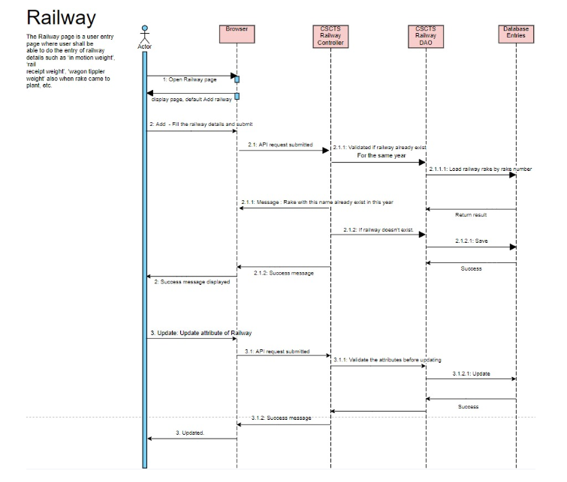

### Workflows

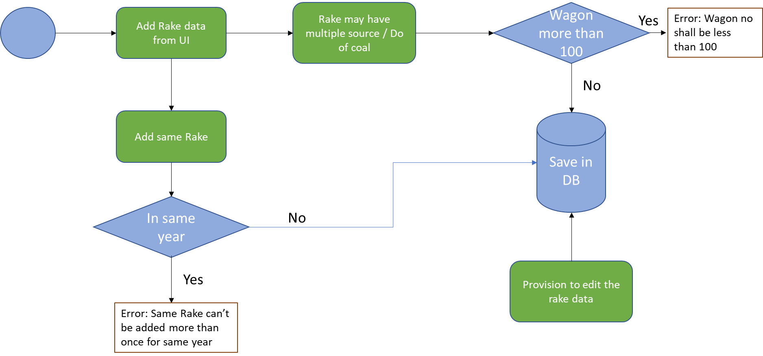

## Operating Environment

Operating environment for the CSCTS application is as below

* Oracle database
* Operating System: Centos Linux
* Client: Browser
* Platform: Java, Apache Ignite, Angular 8

## Design and Implementation Constraints

* Clean understanding of railway movement.

## User Documentation

Module wise user manual is provided during the feature releases.

## Assumptions and Dependencies

* The DO details will be entered beforehand, so active DO will be available.

# External Interface Requirements

## User Interfaces

Front End Interface: Angular

Middle End Interface: Java Rest API’s

Backend Interface: Oracle

Standards for User Interface:

## Hardware Interfaces

Linux – Centos 7.0

A browser which supports HTML and Java Script

## Software Interfaces

Following are the software used for the CSCTS application

|  |  |  |
| --- | --- | --- |
| **Software Used** | **Version** | **Description** |
| Java | Java 1.8.0_u231 | To build the middle layer of the application, we have used Java |
| Apache Ignite | 2.7.5 | Ignite is used as an in-memory cache layer for the frequently used data |
| Oracle | 12.c | To save all the data related to the coal management |
| Angular | 8 | To create the user interfaces |
| Linux | Centos 7.0 |  |
| SMTP | In –house | Email Integration |
| SMS | SMS Gateway | SMS Integration |
|  |  |  |

## Communications Interfaces

* If railway rake data is available in other system, CSCTS system shall able to ETL and do the entry in CSCTS application automatically.

# System Features

## Railway Rake

### Description and Priority

The Railway Rake shall provide the user the ability to enter and update the data as per the requirement

### Stimulus/Response Sequences

* Add Rake entry
* Edit Rake entry
* Download Rake entry

### Functional Requirements

* User shall be able to do the entry of railway rake details on the Add by Railway page.
* User shall be able to update the railway rake attributes on Railway page.
* User shall be able to download the railway rake details in excel sheet.
* User shall be able to search the Railway rake details based on the start date entered while registering.

# Other Nonfunctional Requirements

* CSCTS modules or pages developed should be supported by Chrome and Edge
* CSCTS Web average page response should not be more than 5 secs
* Any or all CSCTS Web or HHD modules / functions should be accessed only by valid logged credentials
* Any or all operations performed should be audited / logged in CSCTS
* Any or all CSCTS Web pages will follow or adhere to these User Guidelines Principle

Appendix A: Glossary

<Define all the terms necessary to properly interpret the SRS, including acronyms and abbreviations. You may wish to build a separate glossary that spans multiple projects or the entire organization, and just include terms specific to a single project in each SRS.>

Appendix B: Analysis Models

<Optionally, include any pertinent analysis models, such as data flow diagrams, class diagrams, state-transition diagrams, or entity-relationship diagrams.>

Appendix C: To Be Determined List

<Collect a numbered list of the TBD (to be determined) references that remain in the SRS so they can be tracked to closure.>