Software Requirements Specification

For

CSCTS PROJECT

Version 1.0 approved

Prepared by Hemalatha

ELogic Square Analytics Pvt Limited

28-Nov-2020

Contents

1. Introduction 1

1.1 Purpose 1

1.2 Document Conventions 1

1.3 Intended Audience and Reading Suggestions 1

1.4 Product Scope 1

1.5 References 1

2. Overall Description 1

2.1 Product Perspective 2

2.2 Product Functions 2

2.2.1 Job Creation and End 2

2.3 User Classes and Characteristics 3

2.3.1 Job Creation and End 3

2.3.2 Workflows 4

2.4 Operating Environment 6

2.5 Design and Implementation Constraints 6

2.6 User Documentation 6

2.7 Assumptions and Dependencies 6

3. External Interface Requirements 6

3.1 User Interfaces 6

3.2 Hardware Interfaces 6

3.3 Software Interfaces 7

3.4 Communications Interfaces 7

4. System Features 7

4.1 Job creation and End 7

4.1.1 Description and Priority 7

4.1.2 Stimulus/Response Sequences 7

4.1.3 Functional Requirements 7

5. Other Nonfunctional Requirements 8

Appendix A: Glossary 7

Appendix B: Analysis Models 7

Appendix C: To Be Determined List 7

Revision History

|  |  |  |  |
| --- | --- | --- | --- |
| **Name** | **Date** | **Reason For Changes** | **Version** |
| Hemalatha | 28-Nov-2020 | Initial Draft | 0.1 |
| Madhu | 18-Dec-2020 | Workflows Updated | 0.2 |

# Introduction

## Purpose

The purpose of the document is to define the details of the CSCTS (Coal Supply Chain Tracking System) to all the stack holders on the process of the coal consumption and stacking.

## Document Conventions

|  |  |
| --- | --- |
| CSCTS | Coal Supply Chain Management System |
| HHD | Handheld Device |
| UI | User Interface – Web Pages |
| Supplier | Coal Mines |
| Source | Source of the Coal |
| Transporter | Transporter of the Coal |
| Truck | Vehicle carrying the Coal |
| Hywa | Internal vehicles of the Plant |
| SR | Stacker Reclaimer |
| Dozer | Dozer |
| Rake | Railway Rake |

## Intended Audience and Reading Suggestions

The document is intended to all the stake holders of the product like developers, project managers, delivery partners, testers and the plant teams and the CHP Team.

The document should be read in the above defined format so that all the flow is observed as defined.

## Product Scope

The purpose of the CSCTS is to provide the details of the coal movement inside the plant, starting from the in bound to storage to consumption. It is also targeted at provided the movement of the truck through near real-time view of the status of the trucks. The anomalies are detected and directed to the concerned stake holders for further actions.

## References

# Overall Description

The Coal Consumption and Storage system comprises of logically identifying the coal consumption area as Bunker and coal stacking area as Stock Pile. The purpose of this module is to handle the coal movement from Stock pile to Bunker, Rake to Bunker, Rake to Stock pile, RH area to Stock pile, RH area to Bunker and give the user the control to record the transaction movement in the form of jobs based on the defined attributes of them.

## Product Perspective

The CSCTS system stores the following information

* Plant Specific Paths(Routes)
* Plant Specific Source and Destination
* Plant Specific Rules for selected route.

## Product Functions

### Job Creation and End

User of the system shall be able to select Route, Stockpile, Rake and wagon details, Start and Stop corresponding scada jobs in the CSCTS application. The system shall support privilege to start and end job(s). The CHP department is given functions to work on these privileges.

* Start job
* Select scada route from the Route dropdown list.
* Select Coal Source that is Rake no. or Stockpile name (whichever is applicable).
* Select Coal Destination that is Stockpile name (if required).
* Reset the values if the selection was incorrect or not required (if any).
* Start the job.
* End Job
  + End the running job.

## User Classes and Characteristics

### Job Creation and End

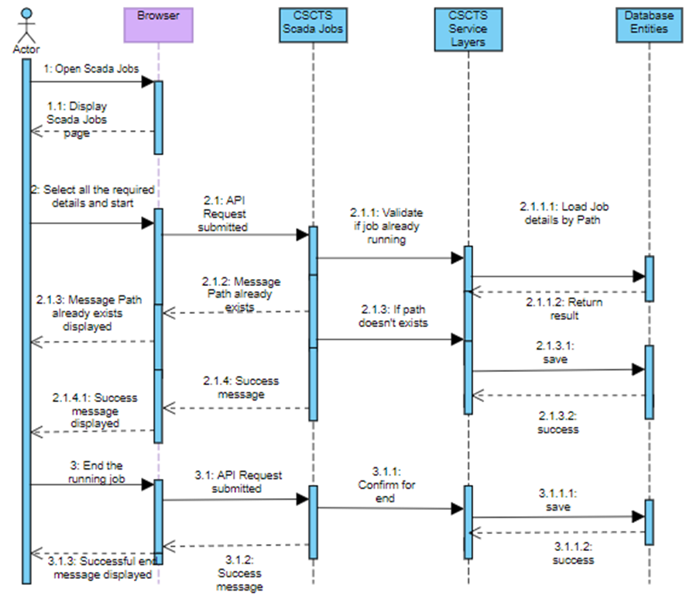

### Workflows

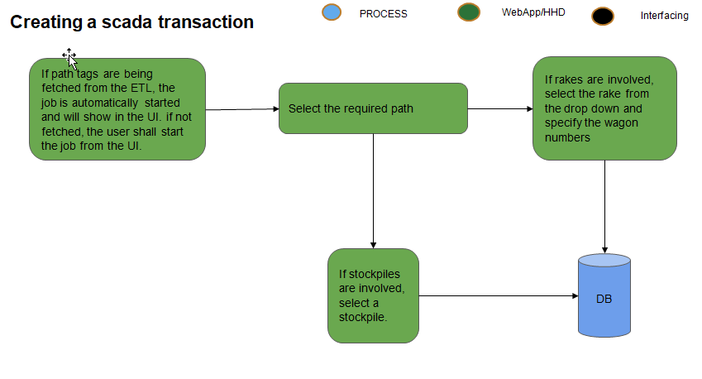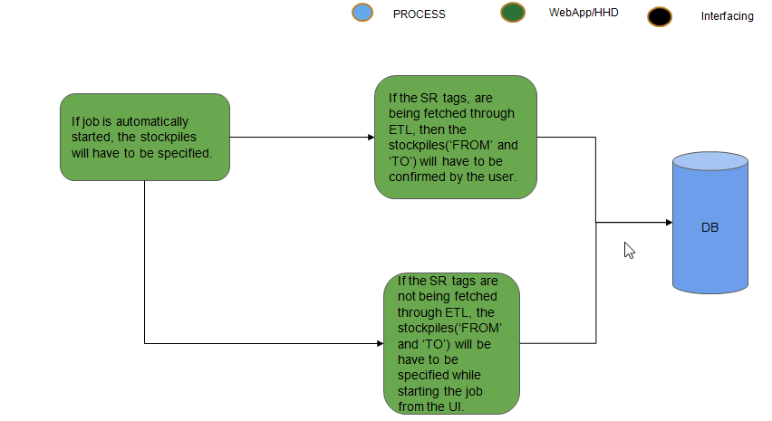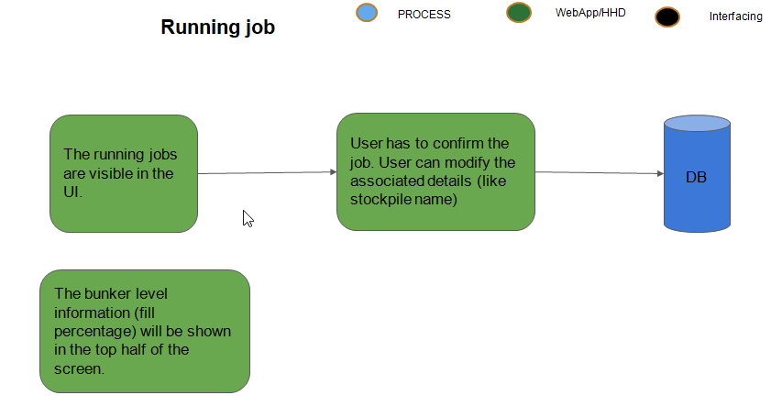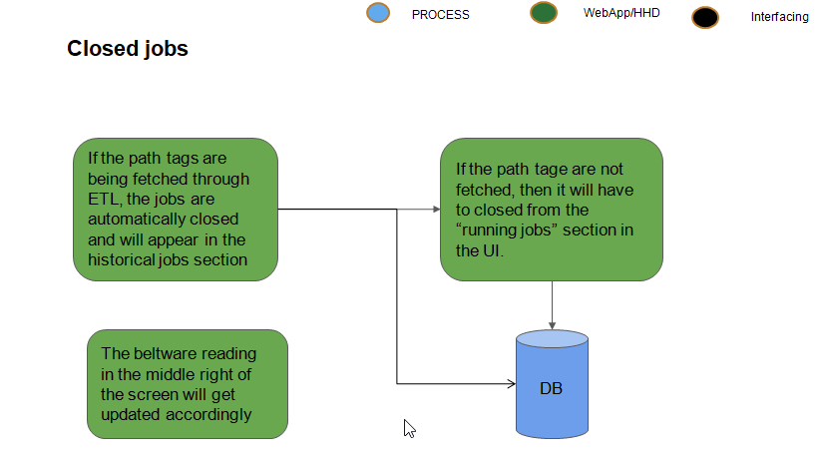

## Operating Environment

Operating environment for the CSCTS application is as below

* Oracle database
* Operating System: Centos Linux
* Client: Browser
* Platform: Java, Apache Ignite, Angular 8

## Design and Implementation Constraints

* Availability of Hardware during development

## User Documentation

Module wise user manual is provided during the feature releases.

## Assumptions and Dependencies

* The Metadata for creating scada routes, source and destination details are available during the development/rollout phase.

# External Interface Requirements

## User Interfaces

Front End Interface: Angular

Middle End Interface: Java Rest API’s

Backend Interface: Oracle

Standards for User Interface:

## Hardware Interfaces

Linux – Centos 7.0

A browser which supports HTML and Java Script

## Software Interfaces

Following are the software used for the CSCTS application

|  |  |  |
| --- | --- | --- |
| **Software Used** | **Version** | **Description** |
| Java | Java 1.8.0_u231 | To build the middle layer of the application, we have used Java |
| Apache Ignite | 2.7.5 | Ignite is used as an in-memory cache layer for the frequently used data |
| Oracle | 12.c | To save all the data related to the coal management |
| Angular | 8 | To create the user interfaces |
| Linux | Centos 7.0 |  |
| SMTP | In –house | Email Integration |
| SMS | SMS Gateway | SMS Integration |
|  |  |  |

## Communications Interfaces

* HHD devices are used by the operators within the plant on the ground, all through the track tracking process from gate entry to gate exit as required by the module.
* While all other users, use a web browser to access and manage the CSCTS processes
* Email and SMS are modes of notification / alert to the users as required by the module

# System Features

The Scada Jobs Module has below functionalities.

## Job creation and End

### Description and Priority

The module shall provide the user the ability to start the scada job as per the requirement.

### Stimulus/Response Sequences

* Select Route and Source/Destination details
* Start Job
* End Job

### Functional Requirements

* The Scada functionality shall provide a detailed information of the coal stacking and consumption in the plants
* The module shall be able to understand what the operation was carried out at a particular instance of time in scada.
* The module shall provide the feature to start and end jobs.
* The module shall provide the user to handle multiple jobs.
* The module shall record how much MT coal has passed within a particular time period.
* The module shall provide the Rake and Stockpile details involved in scada operation.

# Other Nonfunctional Requirements

* CSCTS modules or pages developed should be supported by Chrome and Edge
* CSCTS Web average page response should not be more than 5 secs
* Any or all CSCTS Web or HHD modules / functions should be accessed only by valid logged credentials
* Any or all operations performed should be audited / logged in CSCTS
* Any or all CSCTS Web pages will follow or adhere to these User Guidelines Principle

Appendix A: Glossary

<Define all the terms necessary to properly interpret the SRS, including acronyms and abbreviations. You may wish to build a separate glossary that spans multiple projects or the entire organization, and just include terms specific to a single project in each SRS.>

Appendix B: Analysis Models

<Optionally, include any pertinent analysis models, such as data flow diagrams, class diagrams, state-transition diagrams, or entity-relationship diagrams.>

Appendix C: To Be Determined List

<Collect a numbered list of the TBD (to be determined) references that remain in the SRS so they can be tracked to closure.>