Software Requirements Specification

For

CSCTS PROJECT

Version 1.0 approved

Prepared by Satyanarayana Chelikani

ELogic Square Analytics Pvt Limited

26-Nov-2020

Table of Contents

Table of Contents ii

Revision History ii

1. Introduction 1

1.1 Purpose 1

1.2 Document Conventions 1

1.3 Intended Audience and Reading Suggestions 1

1.4 Product Scope 1

1.5 References 1

2. Overall Description 1

2.1 Product Perspective 2

2.2 Product Functions 2

2.3 User Classes and Characteristics 3

2.4 Operating Environment 4

2.5 Requirement Constraints 4

2.6 User Documentation 4

2.7 Assumptions and Dependencies 4

3. External Interface Requirements 4

3.1 User Interfaces 4

3.2 Hardware Interfaces 4

3.3 Software Interfaces 4

3.4 Communications Interfaces 5

4. Product Functions 5

4.1 Current Vehicle 5

4.2 Change Vehicle 5

4.3 Current Driver DL 5

4.4 Change Driver DL 6

4.5 Remarks 6

4.6 Attachments 6

5. Other Nonfunctional Requirements 6

Appendix A: Glossary 6

Appendix B: Analysis Models 6

Appendix C: To Be Determined List 7

Revision History

|  |  |  |  |
| --- | --- | --- | --- |
| **Name** | **Date** | **Reason For Changes** | **Version** |
| Satyanarayana Chelikani | 26-Nov-2020 | Initial Draft | 0.1 |
| Satyanarayana Chelikani | 17-Dec-2020 | Workflows Updated | 0.2 |

# Introduction

## Purpose

The purpose of the document is to define the details of the CSCTS (Coal Supply Chain Tracking System) to all the stack holders on the process of the coal movement, management in the plants

## Document Conventions

|  |  |
| --- | --- |
| CSCTS | Coal Supply Chain Management System |
| HHD | Handheld Device |
| UI | User Interface – Web Pages |
| Supplier | Coal Mines |
| Source | Source of the Coal |
| Transporter | Transporter of the Coal |
| Truck | Vehicle carrying the Coal |
| Hywa | Internal vehicles of the Plant |
| SR | Stacker Reclaimer |
| Dozer | Dozer |
| Rake | Railway Rake |

## Intended Audience and Reading Suggestions

The document is intended to all the stake holders of the product like developers, project managers, delivery partners, testers and the plant teams and the CHP Team.

The document should be read in the above defined format so that all the flow is observed as defined.

## Product Scope

The purpose of the CSCTS is to provide the details of the coal movement inside the plant, starting from the in bound to storage to consumption. It is also targeted at provided the movement of the truck through near real-time view of the status of the trucks. The anomalies are detected and directed to the concerned stake holders for further actions.

## References

# Overall Description

The “Vehicle change” system is used to update the present Vehicle/Driver details to new Vehicle/Driver detail while traveling one choke point to another in that particular trip at the Plant. The purpose of this module is to change the Vehicle Register Number or the Driver DL Number based on various factors. The user needs to enter the Current and Change of vehicle Numbers, New Drivers DL along with any Remarks and Attachments if required

## Product Perspective

The CSCTS system stores the following the following information

* Current Vehicle Trip Details.
* Change Vehicle Trip Details.
* Current Driver DL Details.
* New Driver DL Details.
* Remarks – Pertaining to the change of Vehicle/Driver.
* Select Attachments (If any new document need to be updated).

## Product Functions

### Current Vehicle Details

User of the system shall be able to select or type in the Vehicle Registration Number which needs to be replaced by a new vehicle for moving forward to the next Choke point in that particular Trip. The replacement of the vehicle is due to various factors.

### Change Vehicle Details

User of the system shall be able to type in the New Vehicle Registration Number which has to replace the old one for moving forward to the next Choke point in that particular Trip

### Current Driver DL Details

User of the system will not be able to type in the current driver DL details as it shall be auto mapped with the already entered Current Vehicle Details.

### Change Driver DL Details

User of the system shall be able to type in the new driver DL details if there is a change in the driver

Else the older driver DL details shall be re-entered in this Current Driver DL field.

### Remarks

User of the system shall be able to type in the Remarks/Comments pertaining to the change of Vehicle.

### Attachments

User of the system shall be able to attach if there is any new document that the concerned person should view pertaining to the change of Vehicle.

## User Classes and Characteristics

### Vehicle change Management

|  |
| --- |
|  |

### Workflows

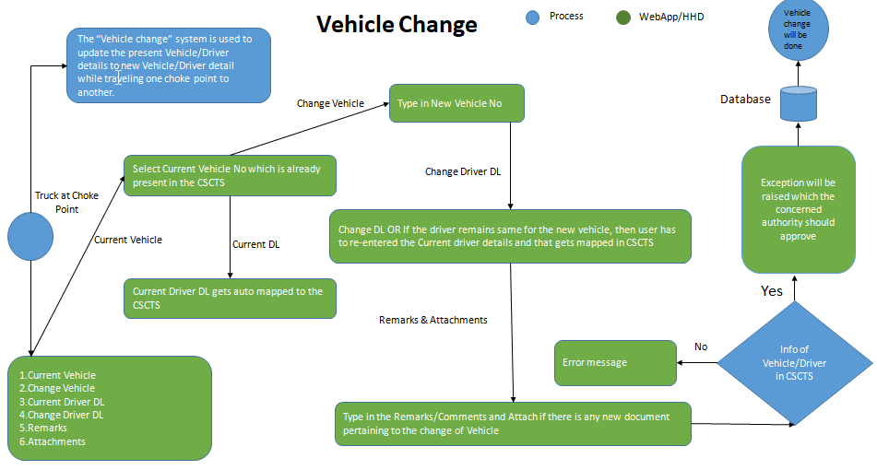

## Operating Environment

Operating environment for the CSCTS application is as below

* Oracle database
* Operating System: Centos Linux
* Client: Browser
* Platform: Java, Apache Ignite, Angular 8

## Requirement Constraints

* All the fields in the UI must be filled as a mandatory part of Changing of the vehicle except the attachment field as it is user choice.

## User Documentation

Module wise user manual is provided during the feature releases.

## Assumptions and Dependencies

* Availability of new Vehicle/Driver if there is a change of current Vehicle/Driver.

# External Interface Requirements

## User Interfaces

Front End Interface: Angular

Middle End Interface: Java Rest API’s

Backend Interface: Oracle

Standards for User Interface:

## Hardware Interfaces

Linux – Centos 7.0

A browser which supports HTML and Java Script

## Software Interfaces

Following are the software used for the CSCTS application

|  |  |  |
| --- | --- | --- |
| **Software Used** | **Version** | **Description** |
| Java | Java 1.8.0_u231 | To build the middle layer of the application, we have used Java |
| Apache Ignite | 2.7.5 | Ignite is used as an in-memory cache layer for the frequently used data |
| Oracle | 12.c | To save all the data related to the coal management |
| Angular | 8 | To create the user interfaces |
| Linux | Centos 7.0 |  |
| SMTP | In –house | Email Integration |
| SMS | SMS Gateway | SMS Integration |
|  |  |  |

## Communications Interfaces

* HHD devices are used by the operators within the plant on the ground, all through the track tracking process from gate entry to gate exit as required by the module.
* While all other users, use a web browser to access and manage the CSCTS processes
* Email and SMS are modes of notification / alert to the users as required by the module

# Product Functions

*The Vehicle Change Pile Module is divided into 6 fields*.

## Current Vehicle

* User shall be able to select or type in the Vehicle Registration Number which needs to be replaced by a new vehicle for moving forward to the next Choke point in that particular Trip.
* The entered vehicle number must be present in the database or the UI will throw an error.
* The replacement of the vehicle can be due to various factors.

## Change Vehicle

* User shall be able to type in the New Vehicle Registration Number which has to replace the old one for moving forward to the next Choke point in that particular Trip
* This Vehicle number should be present in the data base or the UI will throw an error.
* This vehicle may have the same driver of the old vehicle or new driver as per the scenario.

## Current Driver DL

* User will not be able to type in the current driver DL details as it shall be auto mapped with the already entered Current Vehicle Details.
* Each vehicle shall be mapped with a driver in the database so as soon as the user enters the

Vehicle details the Current driver DL is automatically selected

## Change Driver DL

* User shall be able to type in the new driver DL details if there is a change in the driver.
* If the driver remains same for the new vehicle, then user will re-entered the Current driver field as this is a mandatory field.

## Remarks

* User shall be able to type in the Remarks/Comments pertaining to the change of Vehicle.
* This a mandatory field and the user has to enter comments pertaining to the vehicle change.

## Attachments

* User shall be able to attach if there is any new document that the concerned person should view pertaining to the change of Vehicle.
* This a not a mandatory field and the user has to enter comments pertaining to the vehicle change

# Other Nonfunctional Requirements

* CSCTS modules or pages developed should be supported by Chrome and Edge
* CSCTS Web average page response should not be more than 5 secs
* Any or all CSCTS Web or HHD modules / functions should be accessed only by valid logged credentials
* Any or all operations performed should be audited / logged in CSCTS
* Any or all CSCTS Web pages will follow or adhere to these User Guidelines Principle

Appendix A: Glossary

<Define all the terms necessary to properly interpret the SRS, including acronyms and abbreviations. You may wish to build a separate glossary that spans multiple projects or the entire organization, and just include terms specific to a single project in each SRS.>

Appendix B: Analysis Models

<Optionally, include any pertinent analysis models, such as data flow diagrams, class diagrams, state-transition diagrams, or entity-relationship diagrams.>

Appendix C: To Be Determined List

<Collect a numbered list of the TBD (to be determined) references that remain in the SRS so they can be tracked to closure.>