Software Requirements Specification

For

CSCTS PROJECT

Version 1.0 approved

Prepared by Sachin Chaurasia

ELogic Square Analytics Pvt Limited

30-Nov-2020

Table of Contents

Table of Contents ii

Revision History ii

1. Introduction 1

1.1 Purpose 1

1.2 Document Conventions 1

1.3 Intended Audience and Reading Suggestions 1

1.4 Product Scope 1

1.5 References 1

2. Overall Description 1

2.1 Product Perspective 2

2.2 Product Functions 2

2.3 User Classes and Characteristics 3

2.4 Operating Environment 5

2.5 Design and Implementation Constraints 5

2.6 User Documentation 5

2.7 Assumptions and Dependencies 5

3. External Interface Requirements 5

3.1 User Interfaces 5

3.2 Hardware Interfaces 6

3.3 Software Interfaces 6

3.4 Communications Interfaces 6

4. System Features 6

4.1 Weigh bridge Management 6

5. Other Nonfunctional Requirements 7

Appendix A: Glossary 8

Appendix B: Analysis Models 8

Appendix C: To Be Determined List 8

Revision History

|  |  |  |  |
| --- | --- | --- | --- |
| **Name** | **Date** | **Reason For Changes** | **Version** |
| Sachin Chaurasia | 30-Nov-2020 | Initial Draft | 0.1 |
| Sachin Chaurasia | 19-Dec-2020 | Workflows updated | 0.2 |

# Introduction

## Purpose

The purpose of the document is to define the details of the CSCTS (Coal Supply Chain Tracking System) to all the stack holders on the process of the coal movement, management in the plants

## Document Conventions

|  |  |
| --- | --- |
| CSCTS | Coal Supply Chain Management System |
| HHD | Handheld Device |
| UI | User Interface – Web Pages |
| Supplier | Coal Mines |
| Source | Source of the Coal |
| Transporter | Transporter of the Coal |
| Truck | Vehicle carrying the Coal |
| Hywa | Internal vehicles of the Plant |
| SR | Stacker Reclaimer |
| Dozer | Dozer |
| Rake | Railway Rake |

## Intended Audience and Reading Suggestions

The document is intended to all the stake holders of the product like developers, project managers, delivery partners, testers and the plant teams and the CHP and logisticsTeam.

The document should be read in the above defined format so that all the flow is observed as defined.

## Product Scope

The purpose of the CSCTS is to provide the details of the coal movement inside the plant, starting from the in bound to storage to consumption. It is also targeted at provided the movement of the truck through near real-time view of the status of the trucks. The anomalies are detected and directed to the concerned stake holders for further actions.

## References

# Overall Description

The weigh bridge system comprises of maintaining the weigh bridge master. The purpose of this module is to add or maintain the weigh bridge master and reallocate the vehicle from one Weigh Bridge to another.

## Product Perspective

The CSCTS system stores the following the following information

* Plant Weighbridge Configurations

## Product Functions

### Weigh bridge Management

User of the system shall be able to add, modify and delete (soft delete) weighbridge in the CSCTS application. The system shall support 2 privileges – add, edit. Users having the privilege are allowed to perform the required operations. The IT admin is given the functions to work on both. The appropriate privileges are available in the User Management document

* Add Weighbridge.
* Edit Weighbridge.
  + Modify the existing attributes of the Weighbridge.
  + Delete the Weighbridge (Soft Delete).
    - The delete option shall be allowed only when the no vehicles are allocated to it.
* Reallocate vehicle

## User Classes and Characteristics

### Weighbridge Management

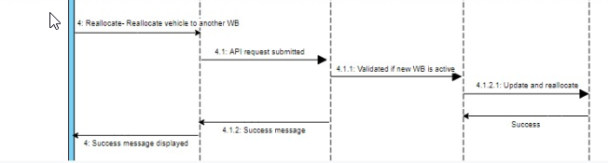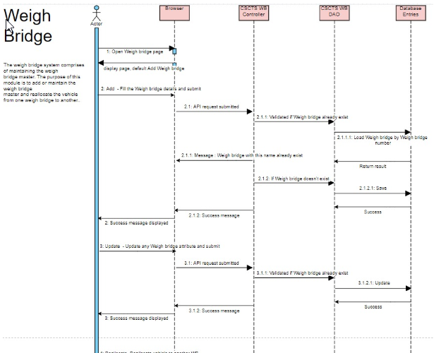

### Workflows

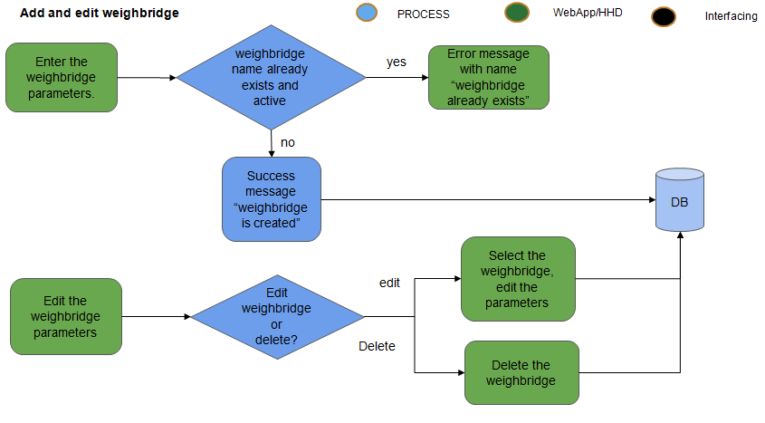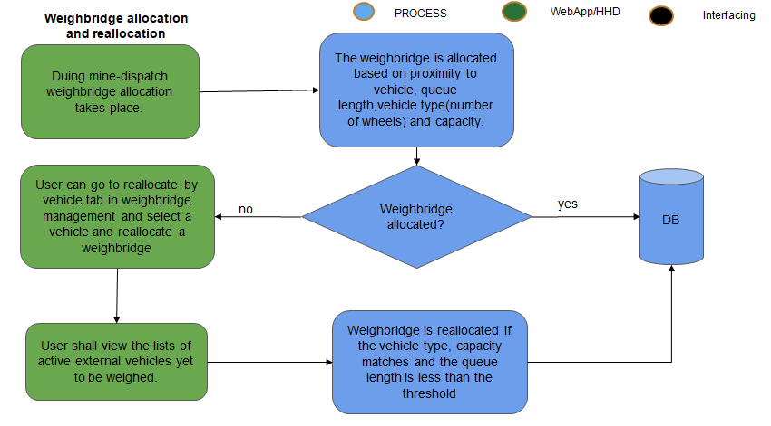

## Operating Environment

Operating environment for the CSCTS application is as below

* Oracle database
* Operating System: Centos Linux
* Client: Browser
* Platform: Java, Apache Ignite, Angular 8

## Design and Implementation Constraints

* Availability of Hardware during development

## User Documentation

Module wise user manual is provided during the feature releases.



## Assumptions and Dependencies

* The Metadata for weighbridge is available during the development/rollout phase.

# External Interface Requirements

## User Interfaces

Front End Interface: Angular

Middle End Interface: Java Rest API’s

Backend Interface: Oracle

Standards for User Interface:

## Hardware Interfaces

Linux – Centos 7.0

A browser which supports HTML and Java Script

## Software Interfaces

Following are the software used for the CSCTS application

|  |  |  |
| --- | --- | --- |
| **Software Used** | **Version** | **Description** |
| Java | Java 1.8.0_u231 | To build the middle layer of the application, we have used Java |
| Apache Ignite | 2.7.5 | Ignite is used as an in-memory cache layer for the frequently used data |
| Oracle | 12.c | To save all the data related to the coal management |
| Angular | 8 | To create the user interfaces |
| Linux | Centos 7.0 |  |
| SMTP | In –house | Email Integration |
| SMS | SMS Gateway | SMS Integration |
|  |  |  |

## Communications Interfaces

* HHD devices are used by the operators within the plant on the ground, all through the track tracking process from gate entry to gate exit as required by the module.
* While all other users, use a web browser to access and manage the CSCTS processes
* Email and SMS are modes of notification / alert to the users as required by the module

# System Features

The Weighbridge Module provides the options to add, edit and reallocate the vehicles assigne to the weighbridge.

## Weigh bridge Management

### Description and Priority

The Weighbridge Management shall provide the user the ability to manipulate the data as per the requirement

### Stimulus/Response Sequences

* Add Weigh bridge
* Edit Weigh bridge
* Delete Weigh bridge
* Reallocate vehicles

### Functional Requirements

* The Weighbridge Management functionality shall provide a detailed view of the weigh bridge available at the plants
* The module shall be able to understand the individual Weighbridge based on the attributes.
* The module shall provide the feature to add, edit or delete the Weighbridge.
* The module shall allow the deletion of the Weighbridge only if no vehicle is allocated to it.
* The module shall allow users to reallocate vehicle from one weighbridge to another.

# Other Nonfunctional Requirements

* CSCTS modules or pages developed should be supported by Chrome and Edge
* CSCTS Web average page response should not be more than 5 secs
* Any or all CSCTS Web or HHD modules / functions should be accessed only by valid logged credentials
* Any or all operations performed should be audited / logged in CSCTS
* Any or all CSCTS Web pages will follow or adhere to these User Guidelines Principle

Appendix A: Glossary

<Define all the terms necessary to properly interpret the SRS, including acronyms and abbreviations. You may wish to build a separate glossary that spans multiple projects or the entire organization, and just include terms specific to a single project in each SRS.>

Appendix B: Analysis Models

<Optionally, include any pertinent analysis models, such as data flow diagrams, class diagrams, state-transition diagrams, or entity-relationship diagrams.>

Appendix C: To Be Determined List

<Collect a numbered list of the TBD (to be determined) references that remain in the SRS so they can be tracked to closure.>