Software Requirements Specification

For

CSCTS PROJECT

Version 1.0 approved

Prepared by Satyanarayana Chelikani

ELogic Square Analytics Pvt Limited

26-Nov-2020

Table of Contents

Table of Contents ii

Revision History ii

1. Introduction 1

1.1 Purpose 1

1.2 Document Conventions 1

1.3 Intended Audience and Reading Suggestions 1

1.4 Product Scope 1

1.5 References 1

2. Overall Description 1

2.1 Product Perspective 2

2.2 Product Functions 2

2.3 User Classes and Characteristics 3

2.4 Operating Environment 10

2.5 Design and Implementation Constraints 10

2.6 User Documentation 10

2.7 Assumptions and Dependencies 10

3. External Interface Requirements 10

3.1 User Interfaces 10

3.2 Hardware Interfaces 10

3.3 Software Interfaces 10

3.4 Communications Interfaces 11

4. System Features 11

4.1 Yard Management 11

4.2 Stock Pile Management 12

5. Other Nonfunctional Requirements 12

Appendix A: Glossary 12

Appendix B: Analysis Models 12

Appendix C: To Be Determined List 13

Revision History

|  |  |  |  |
| --- | --- | --- | --- |
| **Name** | **Date** | **Reason For Changes** | **Version** |
| Satyanarayana Chelikani | 26-Nov-2020 | Initial Draft | 0.1 |
| Satyanarayana Chelikani | 18-Dec-2020` | Workflows Updated | 0.2 |

# Introduction

## Purpose

The purpose of the document is to define the details of the CSCTS (Coal Supply Chain Tracking System) to all the stack holders on the process of the coal movement, management in the plants

## Document Conventions

|  |  |
| --- | --- |
| CSCTS | Coal Supply Chain Management System |
| HHD | Handheld Device |
| UI | User Interface – Web Pages |
| Supplier | Coal Mines |
| Source | Source of the Coal |
| Transporter | Transporter of the Coal |
| Truck | Vehicle carrying the Coal |
| Hywa | Internal vehicles of the Plant |
| SR | Stacker Reclaimer |
| Dozer | Dozer |
| Rake | Railway Rake |

## Intended Audience and Reading Suggestions

The document is intended to all the stake holders of the product like developers, project managers, delivery partners, testers and the plant teams and the CHP Team.

The document should be read in the above defined format so that all the flow is observed as defined.

## Product Scope

The purpose of the CSCTS is to provide the details of the coal movement inside the plant, starting from the in bound to storage to consumption. It is also targeted at provided the movement of the truck through near real-time view of the status of the trucks. The anomalies are detected and directed to the concerned stake holders for further actions.

## References

# Overall Description

The Coal Storage system comprises of logically identifying the coal storage areas as Yard and Stock Pile. The purpose of this module is to handle the coal movement in the yard and stock pile and give the user the control of the coal received and consumed based on the parameters of the Yard and Stock Pile based on the defined attributes of them.

## Product Perspective

The CSCTS system stores the following the following information

* Plant Specific Yard Configurations
* Plant Specific Stock Pile Configurations
* Chokepoint Specific Data Points

## Product Functions

### Yard Management

User of the system shall be able to add, modify and delete (soft delete) in the CSCTS application. The system shall support 2 privileges – add, edit. Users having the privilege are allowed to perform the required operations. The IT admin is given the functions to work on both. The appropriate privileges are available in the User Management document

* Add Yard.
* Edit Yard.
  + Modify the existing attributes of the Yard.
  + Search the Yard
  + Delete the Yard (Soft Delete).
    - The delete option shall be allowed only when the yard doesn’t have any active stock piles associated with it.

### Stock Pile Management

User of the system shall be able to add, modify, delete (soft delete) and reallocate any assigned vehicles to another stock pile based on the user decision in the CSCTS application. The system shall support 2 privileges – add, edit. Users having the privilege are allowed to perform the required operations. The IT admin is given the functions to work on both. The appropriate privileges are available in the User Management document

* Add Stock Pile
  + Define the attributes of the stock pile such as the parameters for Stock pile allocation and blend planning used attributes.
* Edit Stock Pile
  + Search all the available active stock piles
  + Modify the parameters
  + Delete the Stock pile
    - The delete option shall be allowed only when the stock pile is empty and vehicles are allocated to it
* Reallocate Vehicles
  + Search the vehicles allocated the yard and stock pile
  + User shall have the option to select new option to change the allocation
  + User shall be able to submit the allocated stock piles

## User Classes and Characteristics

### Yard Management

#### Add Yard

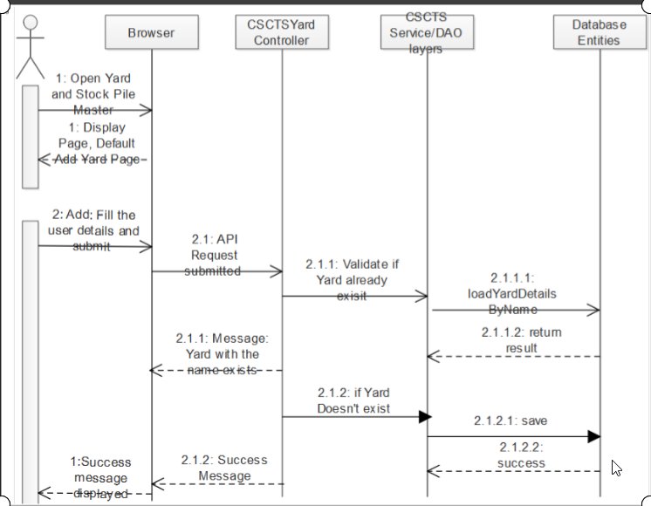

#### Edit Yard

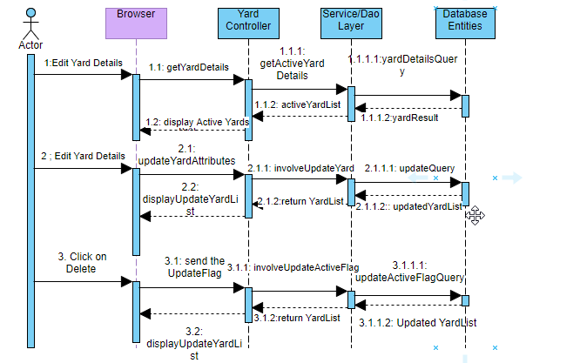

### Stock Pile Management

#### Add Stock Pile

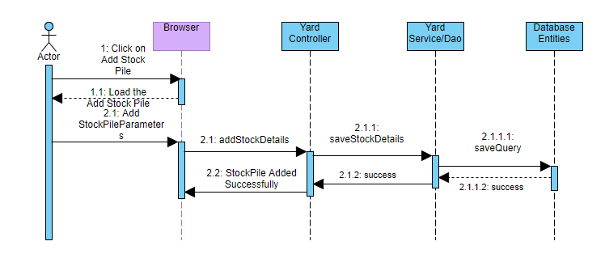

#### Edit Stock Pile

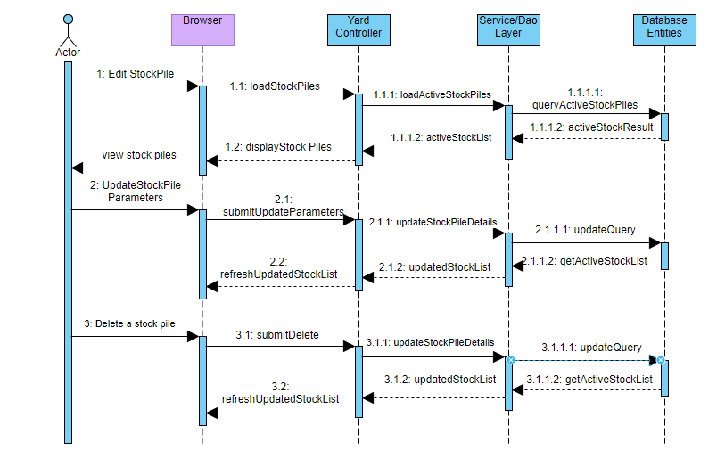

#### Reallocate Vehicle (Stock Pile Reallocation)

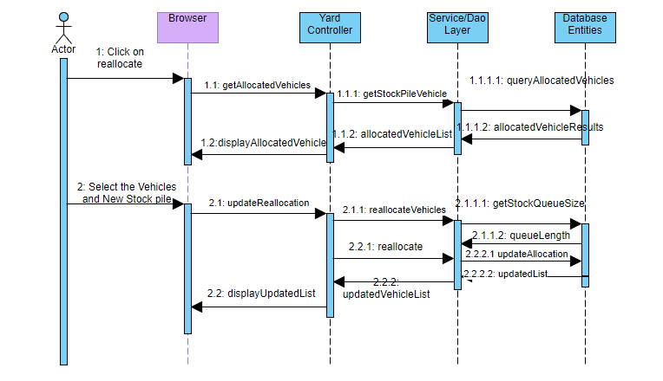

### Workflows

Add/Edit Yard

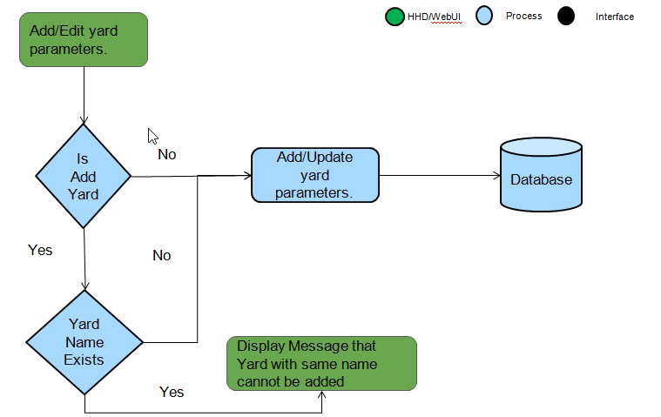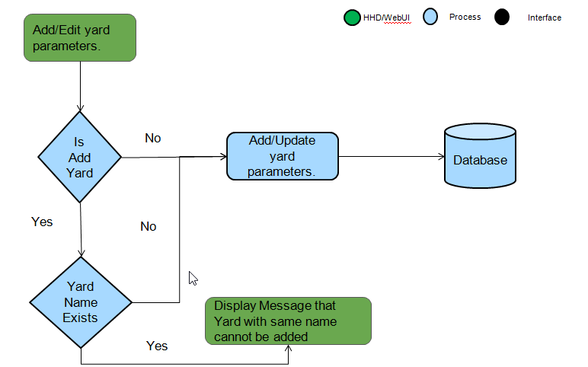

Stock Pile Allocation:

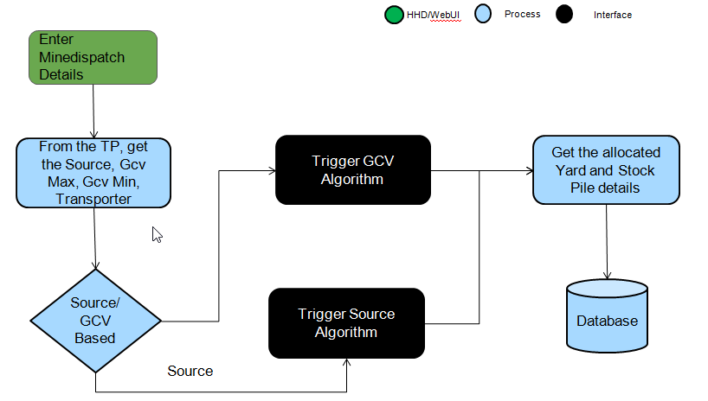

Reallocation

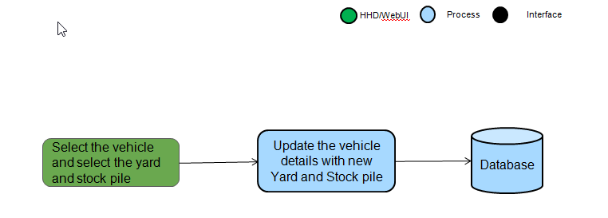

## Operating Environment

Operating environment for the CSCTS application is as below

* Oracle database
* Operating System: Centos Linux
* Client: Browser
* Platform: Java, Apache Ignite, Angular 8

## Design and Implementation Constraints

* Availability of Hardware during development

## User Documentation

Module wise user manual is provided during the feature releases.

## Assumptions and Dependencies

* The Metadata for yard and stock pile is available during the development/rollout phase.

# External Interface Requirements

## User Interfaces

Front End Interface: Angular

Middle End Interface: Java Rest API’s

Backend Interface: Oracle

Standards for User Interface:

## Hardware Interfaces

Linux – Centos 7.0

A browser which supports HTML and Java Script

## Software Interfaces

Following are the software used for the CSCTS application

|  |  |  |
| --- | --- | --- |
| **Software Used** | **Version** | **Description** |
| Java | Java 1.8.0_u231 | To build the middle layer of the application, we have used Java |
| Apache Ignite | 2.7.5 | Ignite is used as an in-memory cache layer for the frequently used data |
| Oracle | 12.c | To save all the data related to the coal management |
| Angular | 8 | To create the user interfaces |
| Linux | Centos 7.0 |  |
| SMTP | In –house | Email Integration |
| SMS | SMS Gateway | SMS Integration |
|  |  |  |

## Communications Interfaces

* HHD devices are used by the operators within the plant on the ground, all through the track tracking process from gate entry to gate exit as required by the module.
* While all other users, use a web browser to access and manage the CSCTS processes
* Email and SMS are modes of notification / alert to the users as required by the module

# System Features

The Yard and Stock Pile Module is divided into 2 functional areas.

## Yard Management

### Description and Priority

The Yard Management shall provide the user the ability to manipulate the data as per the requirement

### Stimulus/Response Sequences

* Add Yard
* Edit Yard
* Delete Yard

### Functional Requirements

* The Yard Management functionality shall provide a detailed view of the coal storage area of the plants
* The module shall be able to understand the individual yards based on the attributes.
* The module shall provide the feature to add, edit or delete the yard
* The module shall allow the deletion of the yard only if no active stock piles are associated with the yard.

## Stock Pile Management

### Description and Priority

The Stock Pile Management feature shall allow the authorized user to handle the creation of the stock pile, modifying them and deleting them based on the coal handling requirements.

### Stimulus/Response Sequences

Add Stock Pile

Edit Stock Pile

Delete Stock Pile

### Functional Requirements

The system shall provide the user to add the stock pile to a yard

A yard can have multiple stock piles

The system shall provide the user only to modify certain parameters of the stock pile

The system shall provide the user the option to activate/de-active and stock pile anytime

# Other Nonfunctional Requirements

* CSCTS modules or pages developed should be supported by Chrome and Edge
* CSCTS Web average page response should not be more than 5 secs
* Any or all CSCTS Web or HHD modules / functions should be accessed only by valid logged credentials
* Any or all operations performed should be audited / logged in CSCTS
* Any or all CSCTS Web pages will follow or adhere to these User Guidelines Principle

Appendix A: Glossary

<Define all the terms necessary to properly interpret the SRS, including acronyms and abbreviations. You may wish to build a separate glossary that spans multiple projects or the entire organization, and just include terms specific to a single project in each SRS.>

Appendix B: Analysis Models

<Optionally, include any pertinent analysis models, such as data flow diagrams, class diagrams, state-transition diagrams, or entity-relationship diagrams.>

Appendix C: To Be Determined List

<Collect a numbered list of the TBD (to be determined) references that remain in the SRS so they can be tracked to closure.>