Software Requirements Specification
For
CSCTS PROJECT
Version 1.0 approved
Prepared by Sachin Chaurasia
ELogic Square Analytics Pvt Limited
28-Nov-2020
Table of Contents
Table of Contents ii
Revision History ii
1. Introduction 1
1.1 Purpose 1
1.2 Document Conventions 1
1.3 Intended Audience and Reading Suggestions 1
1.4 Product Scope 1
1.5 References 1
2. Overall Description 1
2.1 Product Perspective 2
2.2 Product Functions 2
2.3 User Classes and Characteristics 3
2.4 Operating Environment 3
2.5 Design and Implementation Constraints 4
2.6 User Documentation 4
2.7 Assumptions and Dependencies 4
3. External Interface Requirements 4
3.1 User Interfaces 4
3.2 Hardware Interfaces 4
3.3 Software Interfaces 4
3.4 Communications Interfaces 5
4. System Features 5
4.1 Job Allocation 5
5. Other Nonfunctional Requirements 6
Appendix A: Glossary 7
Appendix B: Analysis Models 7
Appendix C: To Be Determined List 7

Revision History
Name | Date | Reason For Changes | Version
Sachin Chaurasia | 28-Nov-2020 | Initial Draft | 0.1

Introduction

Purpose
The purpose of the document is to define the details of the CSCTS (Coal Supply Chain Tracking System) to all the stack holders on the process of the coal movement, management in the plants

Document Conventions
CSCTS | Coal Supply Chain Management System
HHD | Handheld Device
UI | User Interface – Web Pages
Supplier | Coal Mines
Source | Source of the Coal
Transporter | Transporter of the Coal
Truck | Vehicle carrying the Coal
Hywa | Internal vehicles of the Plant
SR | Stacker Reclaimer
Dozer | Dozer
Rake | Railway Rake

Intended Audience and Reading Suggestions
The document is intended to all the stake holders of the product like developers, project managers, delivery partners, testers and the plant teams and the CHP Team.
The document should be read in the above defined format so that all the flow is observed as defined.

Product Scope
The purpose of the CSCTS is to provide the details of the coal movement inside the plant, starting from the in bound to storage to consumption. It is also targeted at provided the movement of the truck through near real-time view of the status of the trucks. The anomalies are detected and directed to the concerned stake holders for further actions.

References

Overall Description
The Job allocation system comprises of logically identifying the internal movement of coal from one stockpile to other stockpile/RH. The purpose of this module is to handle the internal coal movement in the yard and stock pile and give the user the control of the coal moved from one place to another.

Product Perspective
The CSCTS system stores the following the following information

- Plant Specific Yard Configurations
- Plant Specific Stock Pile Configurations
- Chokepoint Specific Data Points
- Blend details
- Internal available vehicles

Product Functions

Job Allocation
User of system shall be able to create job for internal movement or able to execute the blend plan created. User shall be able to modify / update the attributes of job created such as required Hyva, priority and status. CSCTS system shall be able to get the job and allocate the available Hyva to respective job and activity. To track the movement of Hyva on field user shall be able to do the entry on HHD device.
If there is a breakdown, user shall be able to reallocate the one Hyva to another and CSCTS system shall be able to process the details.
User shall be able to see all the allocated Hyva for that job / activity on UI. User shall be able to pause, continue or terminate the activity based on requirement.

The system shall support 2 privileges – add, edit. Users having the privilege are allowed to perform the required operations. The IT admin is given the functions to work on both. The appropriate privileges are available in the User Management document

- Add Job.
- Update Job / Activity.
  - Modify the existing attribute of Job / Activity details.
- Reallocate Hyva.

User Classes and Characteristics

Job Allocation

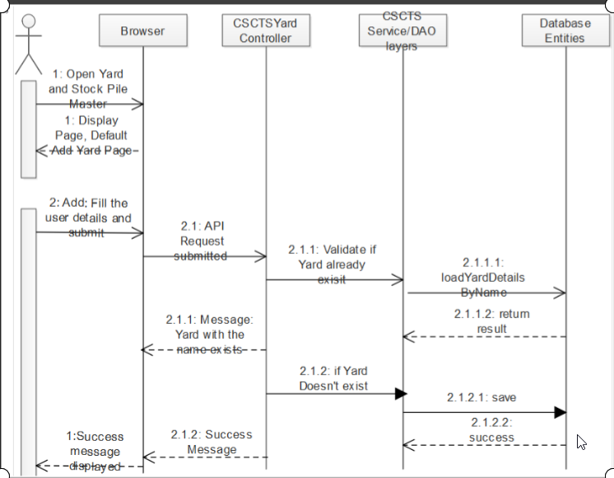

Operating Environment
Operating environment for the CSCTS application is as below
- Oracle database
- Operating System: Centos Linux
- Client: Browser
- Platform: Java, Apache Ignite, Android 8

Design and Implementation Constraints
- Clean understanding of railway movement.

User Documentation
Module wise user manual is provided during the feature releases.

Assumptions and Dependencies
- The DO details will be entered beforehand, so active DO will be available.

External Interface Requirements

User Interfaces
Front End Interface: Android
Middle End Interface: Java Rest API’s
Backend Interface: Oracle
Standards for User Interface:

Hardware Interfaces

Linux – Centos 7.0
A browser which supports HTML and Java Script

Software Interfaces
Following are the software used for the CSCTS application
Software Used | Version | Description
Java | Java 1.8.0_u231 | To build the middle layer of the application, we have used Java
Apache Ignite | 2.7.5 | Ignite is used as an in-memory cache layer for the frequently used data
Oracle | 12.c | To save all the data related to the coal management
Android | 8 | To create the user interfaces
Linux | Centos 7.0
SMTP | In –house | Email Integration
SMS | SMS Gateway | SMS Integration

Communications Interfaces
- The Job allocation page shall be able to execute the blend plan created on Blend Plan page.

System Features

Job Allocation

Description and Priority
The Job allocation system shall provide the user the ability to create execute job, track Hyva and reallocated Hyva.

Stimulus/Response Sequences
- Add Job
- Execute blend plan
- Edit Job
- Reallocate Hyva

Functional Requirements
- User of system shall be able to create job for internal movement or able to execute the blend plan created.
- User shall be able to modify / update the attributes of job created such as required Hyva, priority and status.
- CSCTS system shall be able to get the job and allocate the available Hyva based on algorithm to respective job and activity.
- To track the movement of Hyva on field user shall be able to do the entry on HHD device.
- If there is a breakdown, user shall be able to reallocate the one Hyva to another and CSCTS system shall be able to process the details.
- User shall be able to see all the allocated Hyva for that job / activity on UI.
- User shall be able to pause, continue or terminate the activity based on requirement.
  - Pause: If activity is paused, no further allocation will happen to that activity. Also, if Hyva have not stated the trip, those trips will be canceled.
  - Continue: If activity is paused, user shall be able to change the status of job to continue to allow system to further allocate Hyva on that activity.
  - Terminate: If activity is terminated, user shall not be able to change the status of that activity anymore. No further allocation shall happen to that activity. Also, if Hyva have not stated the trip, those trips will be canceled.

Other Nonfunctional Requirements
- CSCTS modules or pages developed should be supported by Chrome and Edge

- CSCTS Web average page response should not be more than 5 secs

- Any or all CSCTS Web or HHD modules / functions should be accessed only by valid logged credentials

- Any or all operations performed should be audited / logged in CSCTS

- Any or all CSCTS Web pages will follow or adhere to these User Guidelines Principle

Appendix A: Glossary
<Define all the terms necessary to properly interpret the SRS, including acronyms and abbreviations. You may wish to build a separate glossary that spans multiple projects or the entire organization, and just include terms specific to a single project in each SRS.>
Appendix B: Analysis Models
<Optionally, include any pertinent analysis models, such as data flow diagrams, class diagrams, state-transition diagrams, or entity-relationship diagrams.>
Appendix C: To Be Determined List
<Collect a numbered list of the TBD (to be determined) references that remain in the SRS so they can be tracked to closure.>

