Software Requirements Specification
For
CSCTS PROJECT
Version 1.0 approved
Prepared by Satyanarayana Chelikani
ELogic Square Analytics Pvt Limited
29-Nov-2020
Table of Contents
Table of Contents ii
Revision History ii
1. Introduction 1
1.1 Purpose 1
1.2 Document Conventions 1
1.3 Intended Audience and Reading Suggestions 1
1.4 Product Scope 1
1.5 References 1
2. Overall Description 1
2.1 Product Perspective 2
2.2 Product Functions 2
2.3 User Classes and Characteristics 3
2.4 Operating Environment 3
2.5 Design and Implementation Constraints 4
2.6 User Documentation 4
2.7 Assumptions and Dependencies 4
3. External Interface Requirements 4
3.1 User Interfaces 4
3.2 Hardware Interfaces 4
3.3 Software Interfaces 4
3.4 Communications Interfaces 5
4. System Features 5
4.1 Yard Management 5
4.2 Stock Pile Management 5
5. Other Nonfunctional Requirements 6
Appendix A: Glossary 7
Appendix B: Analysis Models 7
Appendix C: To Be Determined List 7

Revision History
Name | Date | Reason For Changes | Version
Satyanarayana Chelikani | 26-Nov-2020 | Initial Draft | 0.1

Introduction

Purpose
The purpose of the document is to define the details of the CSCTS (Coal Supply Chain Tracking System) to all the stack holders on the process of the coal movement, management in the plants

Document Conventions
CSCTS | Coal Supply Chain Management System
HHD | Handheld Device
UI | User Interface – Web Pages
Supplier | Coal Mines
Source | Source of the Coal
Transporter | Transporter of the Coal
Truck | Vehicle carrying the Coal
Hywa | Internal vehicles of the Plant
SR | Stacker Reclaimer
Dozer | Dozer
Rake | Railway Rake
DO | Delivery Order
PO | Purchase Order

Intended Audience and Reading Suggestions
The document is intended to all the stake holders of the product like developers, project managers, delivery partners, testers and the plant teams.
The document should be read in the above defined format so that all the flow is observed as defined.

Product Scope
The purpose of the CSCTS is to provide the details of the coal movement inside the plant, starting from the in bound to storage to consumption. It is also targeted at provided the movement of the truck through near real-time view of the status of the trucks. The anomalies are detected and directed to the concerned stake holders for further actions.

References

Overall Description
The CSCTS process involves rising of exception based on the predefined configurations. These exceptions are based on the configured input and user actions taken against these. The exceptions can be from the validations; system generated and can be configured against each chokepoint

Product Perspective
The CSCTS system stores the following the following information

- Check List
- Exception
- Check Result
- Exception Approval Roles
- Parallel approval roles

Product Functions

Validations
The CSCTS provides the option to configure the validations across different chokepoints based on the back end configurations. The different options to be shown and actions to be taken are configurable from the backend.

Exception Module
The CSCTS provides the validation across different chokepoints based on the back end configurations. Once the threshold is not met an exception against the check is raised. The same is displayed to the assigned user having the approval role. The exception SOP is displayed if the details are configured. Apart from these the Exception can be escalated to the supervisor or reverted back to the subordinate based on the configuration

- Open
  - Display all the open exceptions based on the assigned roles of the user
  - Search for exceptions based on dates
  - Take Action – Approve, Reject, Forward, Revert as per the roles and configuration
- Reject
  - Display all the rejected exception based on the assigned roles of the user
  - Search for exceptions based on dates
  - Take Action – Approve, Reject
- Approved
  - Display all the approved exceptions for the last 2 days based on the assigned roles of the user
  - Search for exceptions based on dates
  - Take Action – No action can be taken on approved exceptions

User Classes and Characteristics

Exception

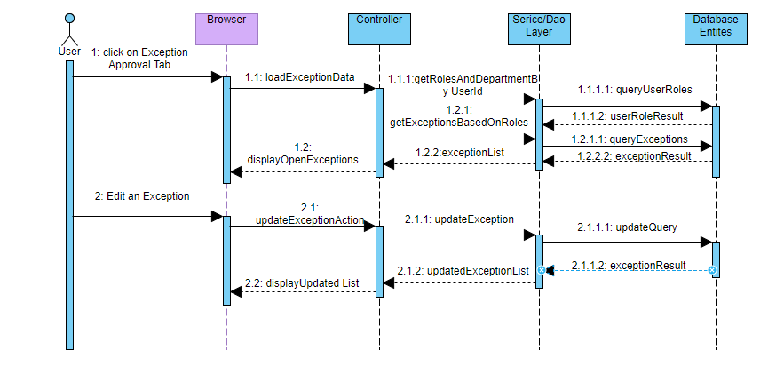

Operating Environment
Operating environment for the CSCTS application is as below
- Oracle database
- Operating System: Centos Linux
- Client: Browser
- Platform: Java, Apache Ignite, Android 8

Design and Implementation Constraints
- Availability of Hardware during development
- Configuration of checklist and work flow to be available

User Documentation
Module wise user manual is provided during the feature releases.

Assumptions and Dependencies
- Check list and work flow definitions are available before the development /rollout is started

External Interface Requirements

User Interfaces
Front End Interface: Android/HHD
Middle End Interface: Java Rest API’s
Backend Interface: Oracle
Standards for User Interface:

Hardware Interfaces

Linux – Centos 7.0
A browser which supports HTML and Java Script

Software Interfaces
Following are the software used for the CSCTS application
Software Used | Version | Description
Java | Java 1.8.0_u231 | To build the middle layer of the application, we have used Java
Apache Ignite | 2.7.5 | Ignite is used as an in-memory cache layer for the frequently used data
Oracle | 12.c | To save all the data related to the coal management
Android | 8 | To create the user interfaces
Linux | Centos 7.0
SMTP | In –house | Email Integration
SMS | SMS Gateway | SMS Integration

Communications Interfaces
- HHD devices are used by the operators within the plant on the ground, all through the track tracking process from gate entry to gate exit as required by the module.
- While all other users, use a web browser to access and manage the CSCTS processes
- Email and SMS are modes of notification / alert to the users as required by the module

System Features

Exception Details

Description and Priority
The exception details shall provide the details of the exception raised, the details of the exception, the result and the user actions along with the SOP’s defined against them.

Stimulus/Response Sequences
- Search the exceptions raised based on Department, Choke Point, Update Vehicle Status
- Search by dates.
- Search by Open, Reject, Approved
- Edit
- Update

Functional Requirements
- The exception shall be raised against raised when the defined threshold is not met
- The exception shall have a approval role
- The exception SOP has be displayed for the configured exceptions
- Predefined remarks shall be displayed during the approval for each of the configured exceptions

Other Nonfunctional Requirements
- CSCTS modules or pages developed should be supported by Chrome and Edge

- CSCTS Web average page response should not be more than 5 secs

- Any or all CSCTS Web or HHD modules / functions should be accessed only by valid logged credentials

- Any or all operations performed should be audited / logged in CSCTS

- Any or all CSCTS Web pages will follow or adhere to these User Guidelines Principle

Appendix A: Glossary
<Define all the terms necessary to properly interpret the SRS, including acronyms and abbreviations. You may wish to build a separate glossary that spans multiple projects or the entire organization, and just include terms specific to a single project in each SRS.>
Appendix B: Analysis Models
<Optionally, include any pertinent analysis models, such as data flow diagrams, class diagrams, state-transition diagrams, or entity-relationship diagrams.>
Appendix C: To Be Determined List
<Collect a numbered list of the TBD (to be determined) references that remain in the SRS so they can be tracked to closure.>

