Software Requirements Specification
For
CSCTS PROJECT
Version 1.0 approved
Prepared by Sachin Chaurasia
ELogic Square Analytics Pvt Limited
30-Nov-2020
Table of Contents
Table of Contents ii
Revision History ii
1. Introduction 1
1.1 Purpose 1
1.2 Document Conventions 1
1.3 Intended Audience and Reading Suggestions 1
1.4 Product Scope 1
1.5 References 1
2. Overall Description 1
2.1 Product Perspective 2
2.2 Product Functions 2
2.3 User Classes and Characteristics 3
2.4 Operating Environment 4
2.5 Design and Implementation Constraints 4
2.6 User Documentation 4
2.7 Assumptions and Dependencies 4
3. External Interface Requirements 4
3.1 User Interfaces 4
3.2 Hardware Interfaces 4
3.3 Software Interfaces 5
3.4 Communications Interfaces 5
4. System Features 5
4.1 Weigh bridge Management 5
5. Other Nonfunctional Requirements 6
Appendix A: Glossary 7
Appendix B: Analysis Models 7
Appendix C: To Be Determined List 7

Revision History
Name | Date | Reason For Changes | Version
Sachin Chaurasia | 30-Nov-2020 | Initial Draft | 0.1

Introduction

Purpose
The purpose of the document is to define the details of the CSCTS (Coal Supply Chain Tracking System) to all the stack holders on the process of the coal movement, management in the plants

Document Conventions
CSCTS | Coal Supply Chain Management System
HHD | Handheld Device
UI | User Interface – Web Pages
Supplier | Coal Mines
Source | Source of the Coal
Transporter | Transporter of the Coal
Truck | Vehicle carrying the Coal
Hywa | Internal vehicles of the Plant
SR | Stacker Reclaimer
Dozer | Dozer
Rake | Railway Rake

Intended Audience and Reading Suggestions
The document is intended to all the stake holders of the product like developers, project managers, delivery partners, testers and the plant teams and the CHP and logisticsTeam.
The document should be read in the above defined format so that all the flow is observed as defined.

Product Scope
The purpose of the CSCTS is to provide the details of the coal movement inside the plant, starting from the in bound to storage to consumption. It is also targeted at provided the movement of the truck through near real-time view of the status of the trucks. The anomalies are detected and directed to the concerned stake holders for further actions.

References

Overall Description
The weigh bridge system comprises of maintaining the weigh bridge master. The purpose of this module is to add or maintain the weigh bridge master and reallocate the vehicle from one Weigh Bridge to another.

Product Perspective
The CSCTS system stores the following the following information

- Plant Weighbridge Configurations

Product Functions

Weigh bridge Management
User of the system shall be able to add, modify and delete (soft delete) weighbridge in the CSCTS application. The system shall support 2 privileges – add, edit. Users having the privilege are allowed to perform the required operations. The IT admin is given the functions to work on both. The appropriate privileges are available in the User Management document

- Add Weighbridge.
- Edit Weighbridge.
  - Modify the existing attributes of the Weighbridge.
  - Delete the Weighbridge (Soft Delete).
    - The delete option shall be allowed only when the no vehicles are allocated to it.
- Reallocate vehicle

User Classes and Characteristics

Weighbridge Management

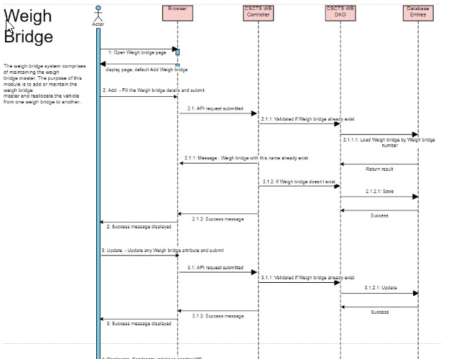
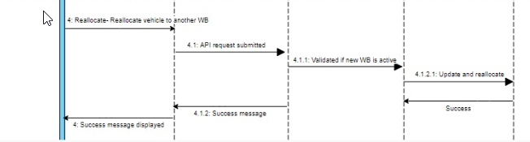

Operating Environment
Operating environment for the CSCTS application is as below
- Oracle database
- Operating System: Centos Linux
- Client: Browser
- Platform: Java, Apache Ignite, Angular 8

Design and Implementation Constraints
- Availability of Hardware during development

User Documentation
Module wise user manual is provided during the feature releases.

Assumptions and Dependencies
- The Metadata for weighbridge is available during the development/rollout phase.

External Interface Requirements

User Interfaces
Front End Interface: Angular
Middle End Interface: Java Rest API’s
Backend Interface: Oracle
Standards for User Interface:

Hardware Interfaces

Linux – Centos 7.0
A browser which supports HTML and Java Script

Software Interfaces
Following are the software used for the CSCTS application
Software Used | Version | Description
Java | Java 1.8.0_u231 | To build the middle layer of the application, we have used Java
Apache Ignite | 2.7.5 | Ignite is used as an in-memory cache layer for the frequently used data
Oracle | 12.c | To save all the data related to the coal management
Angular | 8 | To create the user interfaces
Linux | Centos 7.0
SMTP | In –house | Email Integration
SMS | SMS Gateway | SMS Integration

Communications Interfaces
- HHD devices are used by the operators within the plant on the ground, all through the track tracking process from gate entry to gate exit as required by the module.
- While all other users, use a web browser to access and manage the CSCTS processes
- Email and SMS are modes of notification / alert to the users as required by the module

System Features

The Weighbridge Module provides the options to add, edit and reallocate the vehicles assigne to the weighbridge.

Weigh bridge Management

Description and Priority
The Weighbridge Management shall provide the user the ability to manipulate the data as per the requirement

Stimulus/Response Sequences
- Add Weigh bridge
- Edit Weigh bridge
- Delete Weigh bridge
- Reallocate vehicles

Functional Requirements
- The Weighbridge Management functionality shall provide a detailed view of the weigh bridge available at the plants
- The module shall be able to understand the individual Weighbridge based on the attributes.
- The module shall provide the feature to add, edit or delete the Weighbridge.
- The module shall allow the deletion of the Weighbridge only if no vehicle is allocated to it.
- The module shall allow users to reallocate vehicle from one weighbridge to another.

Other Nonfunctional Requirements
- CSCTS modules or pages developed should be supported by Chrome and Edge

- CSCTS Web average page response should not be more than 5 secs

- Any or all CSCTS Web or HHD modules / functions should be accessed only by valid logged credentials

- Any or all operations performed should be audited / logged in CSCTS

- Any or all CSCTS Web pages will follow or adhere to these User Guidelines Principle

Appendix A: Glossary
<Define all the terms necessary to properly interpret the SRS, including acronyms and abbreviations. You may wish to build a separate glossary that spans multiple projects or the entire organization, and just include terms specific to a single project in each SRS.>
Appendix B: Analysis Models
<Optionally, include any pertinent analysis models, such as data flow diagrams, class diagrams, state-transition diagrams, or entity-relationship diagrams.>
Appendix C: To Be Determined List
<Collect a numbered list of the TBD (to be determined) references that remain in the SRS so they can be tracked to closure.>

