Software Requirements Specification
For
CSCTS PROJECT
Version 1.0 approved
Prepared by Satyanarayana Chelikani
ELogic Square Analytics Pvt Limited
26-Nov-2020
Table of Contents
Table of Contents ii
Revision History ii
1. Introduction 1
1.1 Purpose 1
1.2 Document Conventions 1
1.3 Intended Audience and Reading Suggestions 1
1.4 Product Scope 1
1.5 References 1
2. Overall Description 1
2.1 Product Perspective 2
2.2 Product Functions 2
2.3 User Classes and Characteristics 3
2.4 Operating Environment 3
2.5 Design and Implementation Constraints 4
2.6 User Documentation 4
2.7 Assumptions and Dependencies 4
3. External Interface Requirements 4
3.1 User Interfaces 4
3.2 Hardware Interfaces 4
3.3 Software Interfaces 4
3.4 Communications Interfaces 5
4. System Features 5
4.1 Yard Management 5
4.2 Stock Pile Managemen t 5
5. Other Nonfunctional Requirements 6
Appendix A: Glossary 7
Appendix B: Analysis Models 7
Appendix C: To Be Determined List 7

Revision History
Name | Date | Reason For Changes | Version
Satyanarayana Chelikani | 26-Nov-2020 | Initial Draft | 0.1

Introduction

Purpose
The purpose of the document is to define the details of the CSCTS (Coal Supply Chain Tracking System) to all the stack holders on the process of the coal movement, management in the plants

Document Conventions
CSCTS | Coal Supply Chain Management System
HHD | Handheld Device
UI | User Interface – Web Pages
Supplier | Coal Mines
Source | Source of the Coal
Transporter | Transporter of the Coal
Truck | Vehicle carrying the Coal
Hywa | Internal vehicles of the Plant
SR | Stacker Reclaimer
Dozer | Dozer
Rake | Railway Rake

Intended Audience and Reading Suggestions
The document is intended to all the stake holders of the product like developers, project managers, delivery partners, testers and the plant teams and the CHP Team.
The document should be read in the above defined format so that all the flow is observed as defined.

Product Scope
The purpose of the CSCTS is to provide the details of the coal movement inside the plant, starting from the in bound to storage to consumption. It is also targeted at provided the movement of the truck through near real-time view of the status of the trucks. The anomalies are detected and directed to the concerned stake holders for further actions.

References

Overall Description
The Coal Storage system comprises of logically identifying the coal storage areas as Yard and Stock Pile. The purpose of this module is to handle the coal movement in the yard and stock pile and give the user the control of the coal received and consumed based on the parameters of the Yard and Stock Pile based on the defined attributes of them.

Product Perspective
The CSCTS system stores the following the following information

- Plant Specific Yard Configurations
- Plant Specific Stock Pile Configurations
- Chokepoint Specific Data Points

Product Functions

Yard Management
User of the system shall be able to add, modify and delete (soft delete) in the CSCTS application. The system shall support 2 privileges – add, edit. Users having the privilege are allowed to perform the required operations. The IT admin is given the functions to work on both. The appropriate privileges are available in the User Management document

- Add Yard.
- Edit Yard.
  - Modify the existing attributes of the Yard.
  - Search the Yard
  - Delete the Yard (Soft Delete).
    - The delete option shall be allowed only when the yard doesn’t have any active stock piles associated with it.

Stock Pile Management
User of the system shall be able to add, modify, delete (soft delete) and reallocate any assigned vehicles to another stock pile based on the user decision in the CSCTS application. The system shall support 2 privileges – add, edit. Users having the privilege are allowed to perform the required operations. The IT admin is given the functions to work on both. The appropriate privileges are available in the User Management document

- Add Stock Pile
  - Define the attributes of the stock pile such as the parameters for Stock pile allocation and blend planning used attributes.

- Edit Stock Pile
  - Search all the available active stock piles
  - Modify the parameters
  - Delete the Stock pile
    - The delete option shall be allowed only when the stock pile is empty and vehicles are allocated to it

- Reallocate Vehicles
  - Search the vehicles allocated the yard and stock pile
  - User shall have the option to select new option to change the allocation
  - User shall be able to submit the allocated stock piles

User Classes and Characteristics

Yard Management

Add Yard
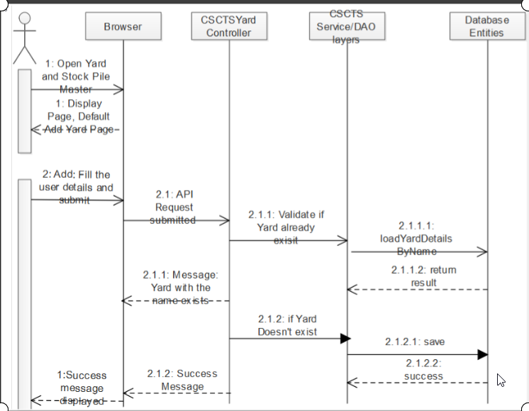

Edit Yard
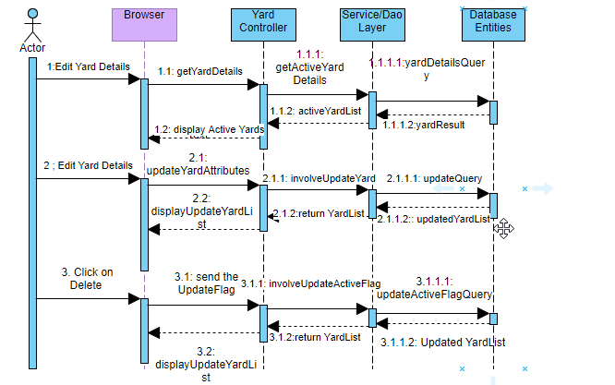

Stock Pile Management

Add Stock Pile

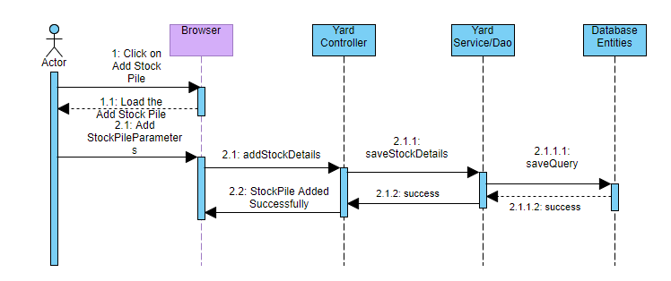

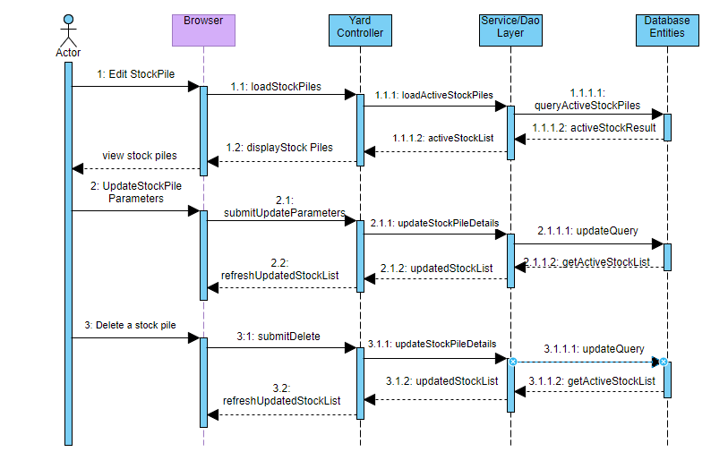
Edit Stock Pile

Reallocate Vehicle (Stock Pile Reallocation)

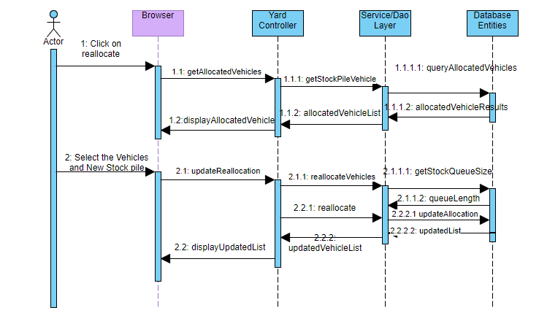

Operating Environment
Operating environment for the CSCTS application is as below
- Oracle database
- Operating System: Centos Linux
- Client: Browser
- Platform: Java, Apache Ignite, Android 8

Design and Implementation Constraints
- Availability of Hardware during development

User Documentation
Module wise user manual is provided during the feature releases.

Assumptions and Dependencies
- The Metadata for yard and stock pile is available during the development/rollout phase.

External Interface Requirements

User Interfaces
Front End Interface: Android
Middle End Interface: Java Rest API’s
Backend Interface: Oracle
Standards for User Interface:

Hardware Interfaces

Linux – Centos 7.0
A browser which supports HTML and Java Script

Software Interfaces
Following are the software used for the CSCTS application
Software Used | Version | Description
Java | Java 1.8.0_u231 | To build the middle layer of the application, we have used Java
Apache Ignite | 2.7.5 | Ignite is used as an in-memory cache layer for the frequently used data
Oracle | 12.c | To save all the data related to the coal management
Android | 8 | To create the user interfaces
Linux | Centos 7.0
SMTP | In –house | Email Integration
SMS | SMS Gateway | SMS Integration

Communications Interfaces
- HHD devices are used by the operators within the plant on the ground, all through the track tracking process from gate entry to gate exit as required by the module.
- While all other users, use a web browser to access and manage the CSCTS processes
- Email and SMS are modes of notification / alert to the users as required by the module

System Features

The Yard and Stock Pile Module is divided into 2 functional areas.

Yard Management

Description and Priority
The Yard Management shall provide the user the ability to manipulate the data as per the requirement

Stimulus/Response Sequences
- Add Yard
- Edit Yard
- Delete Yard

Functional Requirements
- The Yard Management functionality shall provide a detailed view of the coal storage area of the plants
- The module shall be able to understand the individual yards based on the attributes.
- The module shall provide the feature to add, edit or delete the yard
- The module shall allow the deletion of the yard only if no active stock piles are associated with the yard.

Stock Pile Management

Description and Priority
The Stock Pile Management feature shall allow the authorized user to handle the creation of the stock pile, modifying them and deleting them based on the coal handling requirements.

Stimulus/Response Sequences
Add Stock Pile
Edit Stock Pile
Delete Stock Pile

Functional Requirements
The system shall provide the user to add the stock pile to a yard
A yard can have multiple stock piles
The system shall provide the user only to modify certain parameters of the stock pile
The system shall provide the user the option to activate/de-active and stock pile anytime

Other Nonfunctional Requirements
- CSCTS modules or pages developed should be supported by Chrome and Edge

- CSCTS Web average page response should not be more than 5 secs

- Any or all CSCTS Web or HHD modules / functions should be accessed only by valid logged credentials

- Any or all operations performed should be audited / logged in CSCTS

- Any or all CSCTS Web pages will follow or adhere to these User Guidelines Principle

Appendix A: Glossary
<Define all the terms necessary to properly interpret the SRS, including acronyms and abbreviations. You may wish to build a separate glossary that spans multiple projects or the entire organization, and just include terms specific to a single project in each SRS.>
Appendix B: Analysis Models
<Optionally, include any pertinent analysis models, such as data flow diagrams, class diagrams, state-transition diagrams, or entity-relationship diagrams.>
Appendix C: To Be Determined List
<Collect a numbered list of the TBD (to be determined) references that remain in the SRS so they can be tracked to closure.>

