**CPSC 425 - Assignment 1**

Eloise Peng - 13812169

Oct. 8, 2019

Part 2

Part 3

>>> import a2

>>> a2.ShowPyramid(MakePyramid("faces/judybats.jpg", 20))

>>>

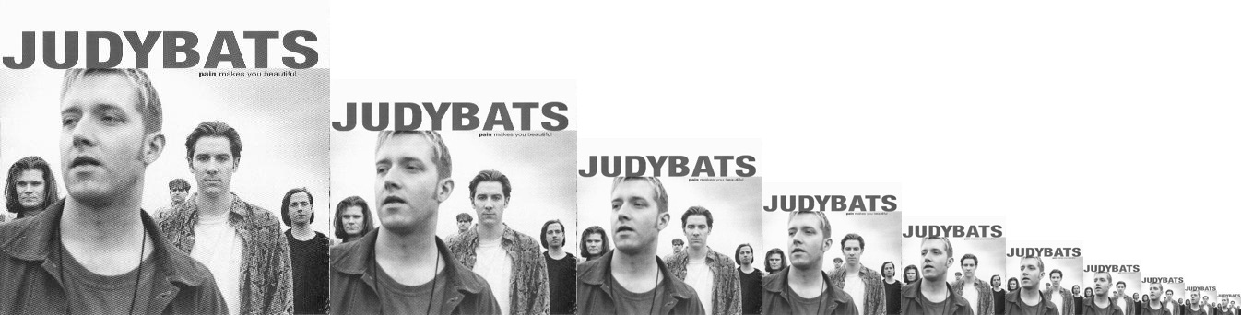

Part 4

>>> import a2

>>> threshold = 0.6

>>> pyramid = a2.MakePyramid("./faces/judybats.jpg", 20)

>>> template = "./faces/template.jpg"

Part 5

First try,

for threshold = 0.6

we count:

|  |  |  |
| --- | --- | --- |
| Images | **False positive** | **False negative** |
| Family | 0 | 2 |
| Tree | 2 | 0 |
| Fans | 1 | 2 |
| Judybats | 0 | 1 |
| Sports | 0 | 1 |
| Students | 2 | 4 |
| Total | 5 | 10 |

for threshold = 0.55

we count:

|  |  |  |
| --- | --- | --- |
| Images | **False positive** | **False negative** |
| Family | 0 | 1 |
| Tree | 4 | 0 |
| Fans | 2 | 2 |
| Judybats | 1 | 1 |
| Sports | 1 | 1 |
| Students | 4 | 3 |
| Total | 12 | 8 |

As we saw above, the threshold of 0.55 is equally rate comparing to 0.6, let’s take 0.575 to try again.

for threshold = 0.575

we count:

|  |  |  |
| --- | --- | --- |
| Images | **False positive** | **False negative** |
| Family | 0 | 1 |
| Tree | 3 | 0 |
| Fans | 1 | 2 |
| Judybats | 1 | 1 |
| Sports | 0 | 1 |
| Students | 3 | 4 |
| Total | 8 | 9 |

As we see, the threshold 0.575 is close, let’s take 0.571,

**for threshold = 0.571**

we count:

|  |  |  |
| --- | --- | --- |
| Images | **False positive** | **False negative** |
| Family | 0 | 1 |
| Tree | 3 | 0 |
| Fans | 1 | 2 |
| Judybats | 1 | 1 |
| Sports | 0 | 1 |
| Students | 4 | 4 |
| **Total** | **9** | **9** |

**Therefore, my final threshold is 0.571.**

Part 6

Recall rate:

|  |  |
| --- | --- |
| Images | **Recall rate** |
| Family | 2/3 |
| Tree | 0/0 |
| Fans | 1/3 |
| Judybats | 4/5 |
| Sports | 0/1 |
| Students | 23/27 |

NCC method has very low rate on both Fans.jpg and Sports.jpg. As we observed, they faces that are tilted, hiding in the dark, or covered by helmet/hats not picked up. We found that all false negative cases exist in common as they are having low light condition, different orientation, or partial occlusion, as NCC method is not robust to above cases.