Project 2
Eloise Lee
2025-11-12
Table of Contents

Link to My Github Repository
https://github.com/eloisesjlee/BIOSTAT721_Project2.git

Plot of Monthly Average CO and O3 Concentrations
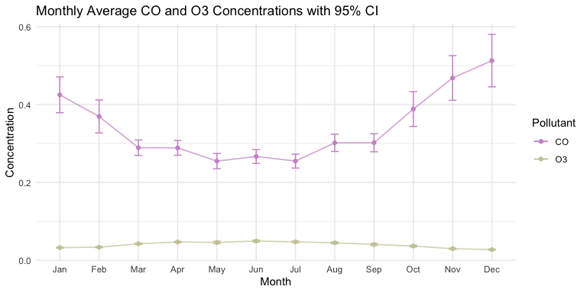

Plot of Monthly PM2.5 Concentration Trends by Year
