Observed Dyness BMS Balancing
and Charge-Control Behaviour
Experimental characterization of passive balancing, full-charge detection, CCL control and charge-MOSFET protection
Battery software version 2.50-71.10.11
Experimental report - 9 August 2026
Heiko Gerdes
hgerdes@tehnosys.ro
Scope. This report documents experimentally observed BMS behaviour. It is not an official Dyness specification and does not replace manufacturer limits or warranty conditions.

Abstract
A 16-cell Dyness battery BMS running software version 2.50-71.10.11 was experimentally investigated using continuous telemetry of individual cell voltages, battery current, state of charge (SOC), charge-current limit (CCL), charge-permission status, raw status bytes and BMS temperature. Cells 1-15 are transmitted directly; cell 16 is reconstructed in the recorded CSV from pack voltage and the sum of cells 1-15. The measurements reveal three largely independent control layers: passive balancing, communication-level charge control through CCL, and physical cell-overvoltage protection through the charge MOSFET. Passive balancing is globally gated by battery charge current and individual balancing resistors are selected relative to the minimum cell voltage. The BMS declares the battery full when the highest cell reaches 3.5 V, whereupon SOC becomes 100%, CCL becomes 0 A and Charge Enabled becomes false, while the charge MOSFET remains on. If current nevertheless continues, balancing remains active between 3.5 V and 3.6 V. At 3.6 V the charge MOSFET opens and physically interrupts charging; it is re-enabled only after the highest cell falls below 3.5 V. CCL state and charge-MOSFET state are therefore separate control mechanisms.

Summary of observed behaviour
Function / parameter | Observed criterion | Observed result
Battery software version | 2.50-71.10.11 | Version under test
Balancer global enable | Ibat >= 1.5 A for 30 s | Passive balancing enabled
Balancer global disable | Ibat <= 1.4 A for 30 s | Passive balancing disabled
Individual resistor ON | Vcell - Vmin >= 30 mV | Resistor for that cell enabled
Full detection | Vmax >= 3.5 V | Full status; SOC = 100%; CCL = 0 A; Charge Enabled = false
Normal charge permission restored | SOC 100% -> 99% | CCL = 56 A; Charge Enabled = true
Charge MOSFET OFF | Vmax >= 3.6 V | Physical charging path interrupted
Charge MOSFET ON after OVP | Vmax < 3.5 V | Physical charging path restored
Balancing at 100% SOC | Actual Ibat >= 1.5 A and cell delta criterion met | Balancing continues despite CCL = 0 A
Explicit balancing flag | None identified | No change in decoded status bytes during ON/OFF transitions
Full/high-cell flag | status3: 0x80 -> 0x88 | Bit 0x08 set
Key thresholds: 1.5 A / 1.4 A current gate, 30 mV individual-cell delta, 3.5 V full-detection threshold, and 3.6 V hardware cutoff threshold.

1. Disclaimer and interpretation conventions
The values and algorithms described in this report were derived from experimental observation during controlled charge and discharge tests. They are not taken from Dyness firmware documentation or an official manufacturer specification.
Thresholds were determined from recorded telemetry, individual cell voltages, BMS temperature behaviour, battery current, CCL, status bytes and physical charge-MOSFET behaviour. Where an observed transition occurred close to an obvious nominal threshold, the nominal value is used throughout this report. Thus, transitions measured around 28-30 mV are reported as 30 mV; the full-charge threshold is reported as 3.5 V; and the hardware cutoff is reported as 3.6 V.
The values therefore describe the behaviour of the tested BMS and software version 2.50-71.10.11. Other hardware or software revisions may implement different thresholds, timing, hysteresis or protection behaviour. Positive battery current denotes charging current.

Engineering hypothesis: balancer time qualification
The balancing-current experiments show a delayed and approximately symmetrical response when battery current crosses the balancing enable and disable thresholds. This delay is interpreted as an algorithmic qualification time rather than primarily as thermal sensor lag. The working hypothesis used for further testing is:
if Ibat >= 1.5 A continuously for 30 s:
enable balancing
if Ibat <= 1.4 A continuously for 30 s:
disable balancing
The 30-second timing criterion is an engineering hypothesis inferred from the observations and has not been verified from firmware documentation. It is therefore covered by this disclaimer.

2. Measurement basis and detection method
The analysis used time-series telemetry with approximately 6-second sampling. The CSV represents all 16 physical cells. Cells 1-15 are transmitted directly by the BMS. Cell 16 is reconstructed by the logger as V16 = Vpack - sum(V1...V15) and is stored in the CSV as battery_02_cell_16_v. Other relevant signals include battery current, SOC, CCL, Charge Enabled / Discharge Enabled states, five raw status bytes, ordinary battery temperature sensors and the BMS temperature sensor.
Passive-balancer operation is not explicitly exposed in the decoded status data. Its activity was therefore inferred from changes in internal BMS heat generation under otherwise nearly constant conditions. Stepwise increases in BMS temperature slope were correlated with individual cells crossing candidate voltage-difference thresholds. A separate current sweep around 1.4-1.5 A was used to identify the global balancing-current gate.
Cell 16 is a valid reconstructed representation of the sixteenth physical cell and is included throughout the recorded dataset. Because it is obtained by subtraction from the pack voltage, its numerical trace inherits pack-voltage quantization and the accumulated quantization of cells 1-15. For identifying millivolt-scale resistor switching thresholds, the directly transmitted cells 1-15 are therefore used as the primary high-resolution reference. The inferred BMS algorithm itself applies to all 16 physical cells.

3. Functional architecture
The observed BMS behaviour is best understood as five distinct functions that share measurements but are not identical control paths:
- Global passive-balancer enable based on actual battery charging current.
- Individual balancing-resistor selection based on each cell relative to the minimum cell.
- Full-charge detection at the highest-cell threshold.
- Communication-level external charge control through CCL and Charge Enabled.
- Physical cell-overvoltage protection through the internal charge MOSFET.
All cell-based state variables in the inferred control model (Vmin, Vmax and individual resistor selection) refer to the complete 16-cell series string. In the measurement data, cells 1-15 are direct telemetry values and cell 16 is reconstructed from pack voltage.
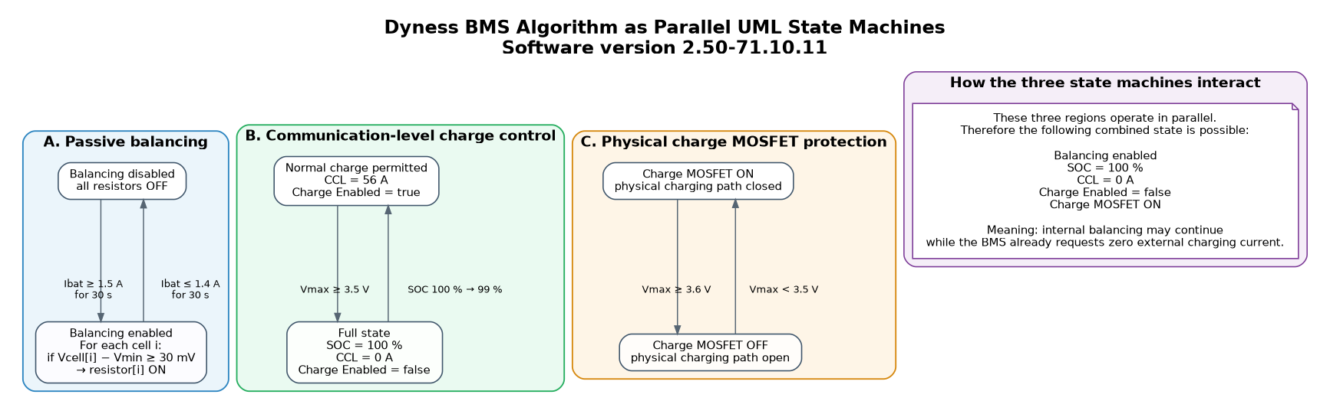
Figure 1. UML state-machine view of the three parallel control layers: passive balancing, communication-level charge control and physical charge-MOSFET protection.
Battery current -> global balancing gate
Cell delta to Vmin -> individual resistor selection
Vmax = 3.5 V -> Full -> SOC 100% -> CCL 0 A -> Charge Enabled false
charge MOSFET remains ON; balancing may continue
Vmax = 3.6 V -> charge MOSFET OFF -> charging physically interrupted
Vmax < 3.5 V -> charge MOSFET ON -> physical charging path restored

4. Global passive-balancer current gate
The passive balancing system is globally enabled only when the battery receives sufficient charging current. Repeated transitions around the threshold produced reproducible changes in internal BMS heat generation.
Enable threshold: Ibat >= 1.5 A
Disable threshold: Ibat <= 1.4 A
At 1.5 A the BMS temperature rose; at 1.4 A and below it fell; returning to 1.5 A restored heating. The 0.1 A separation constitutes current hysteresis at the telemetry resolution.

4.1 Time-qualified state-machine hypothesis
if balancing_enabled == false:
if Ibat >= 1.5 A continuously for 30 s:
balancing_enabled = true
if balancing_enabled == true:
if Ibat <= 1.4 A continuously for 30 s:
balancing_enabled = false
This model explains the nearly symmetrical delay in both directions and avoids balancer chatter when current fluctuates around the threshold.

5. Individual balancing-resistor selection
Once balancing is globally enabled, individual resistors are selected according to each cell voltage relative to the lowest cell in the 16-cell battery. Vmin in the inferred algorithm therefore denotes the true minimum of all 16 physical cells. The event-by-event threshold extraction gives greatest weight to cells 1-15 because those channels are transmitted directly, whereas cell 16 is reconstructed from pack voltage.
Vmin = minimum(cell voltages)
for each cell i:
if Vcell[i] - Vmin >= 30 mV:
balancing resistor[i] = ON
else:
balancing resistor[i] = OFF
At the detected resistor-activation events, newly selected cells consistently lay about 30 mV above the minimum. Their voltage above the cell average varied substantially, so a fixed threshold relative to average voltage does not reproduce the observed sequence. The minimum cell is the consistent reference.

5.1 Absolute voltage region
During the recorded activation sequence, the relevant cells were around 3.4 V or higher. The data demonstrate balancing under these conditions but do not independently establish a separate absolute balancer-enable voltage below this region. The directly established individual selection criterion is therefore the 30 mV delta relative to Vmin.
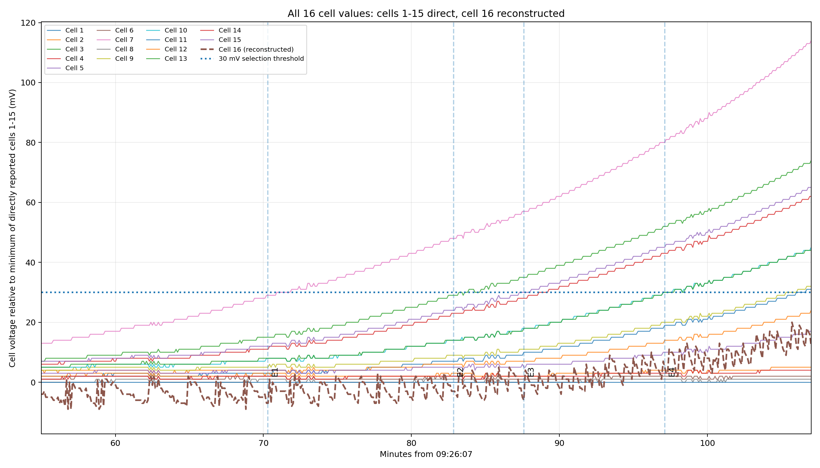
Figure 2. All 16 cell values are represented. Cells 1-15 are direct telemetry; cell 16 is reconstructed from pack voltage and shown separately. The 30 mV selection threshold is evaluated against the high-resolution directly transmitted channels to avoid reconstruction quantization bias.

6. Thermal evidence for passive balancing
No explicit passive-balancing flag was identified in the decoded telemetry. BMS temperature therefore provides the clearest indirect indication of balancing resistor power. Multiple resistor activations appear as stepwise increases in internal heat generation, whereas disabling the global balancing gate produces cooling under otherwise similar conditions.
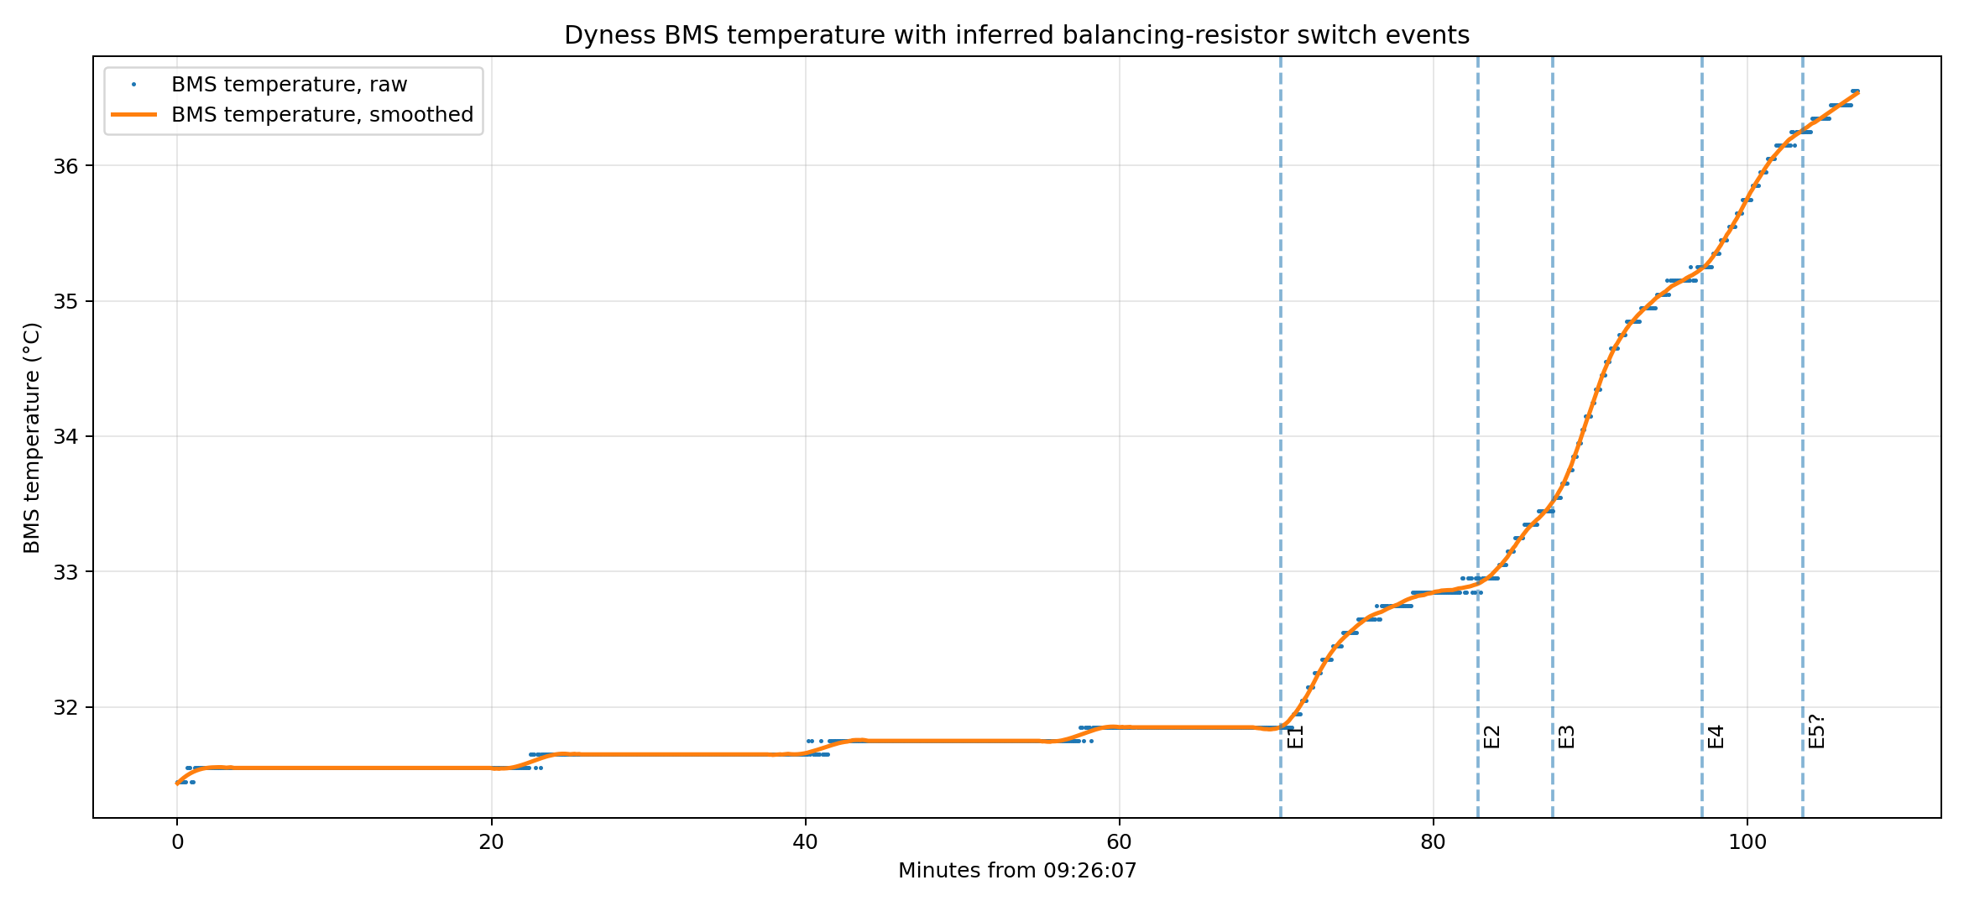
Figure 3. BMS temperature with inferred balancing-resistor switch events during constant low-current charging.
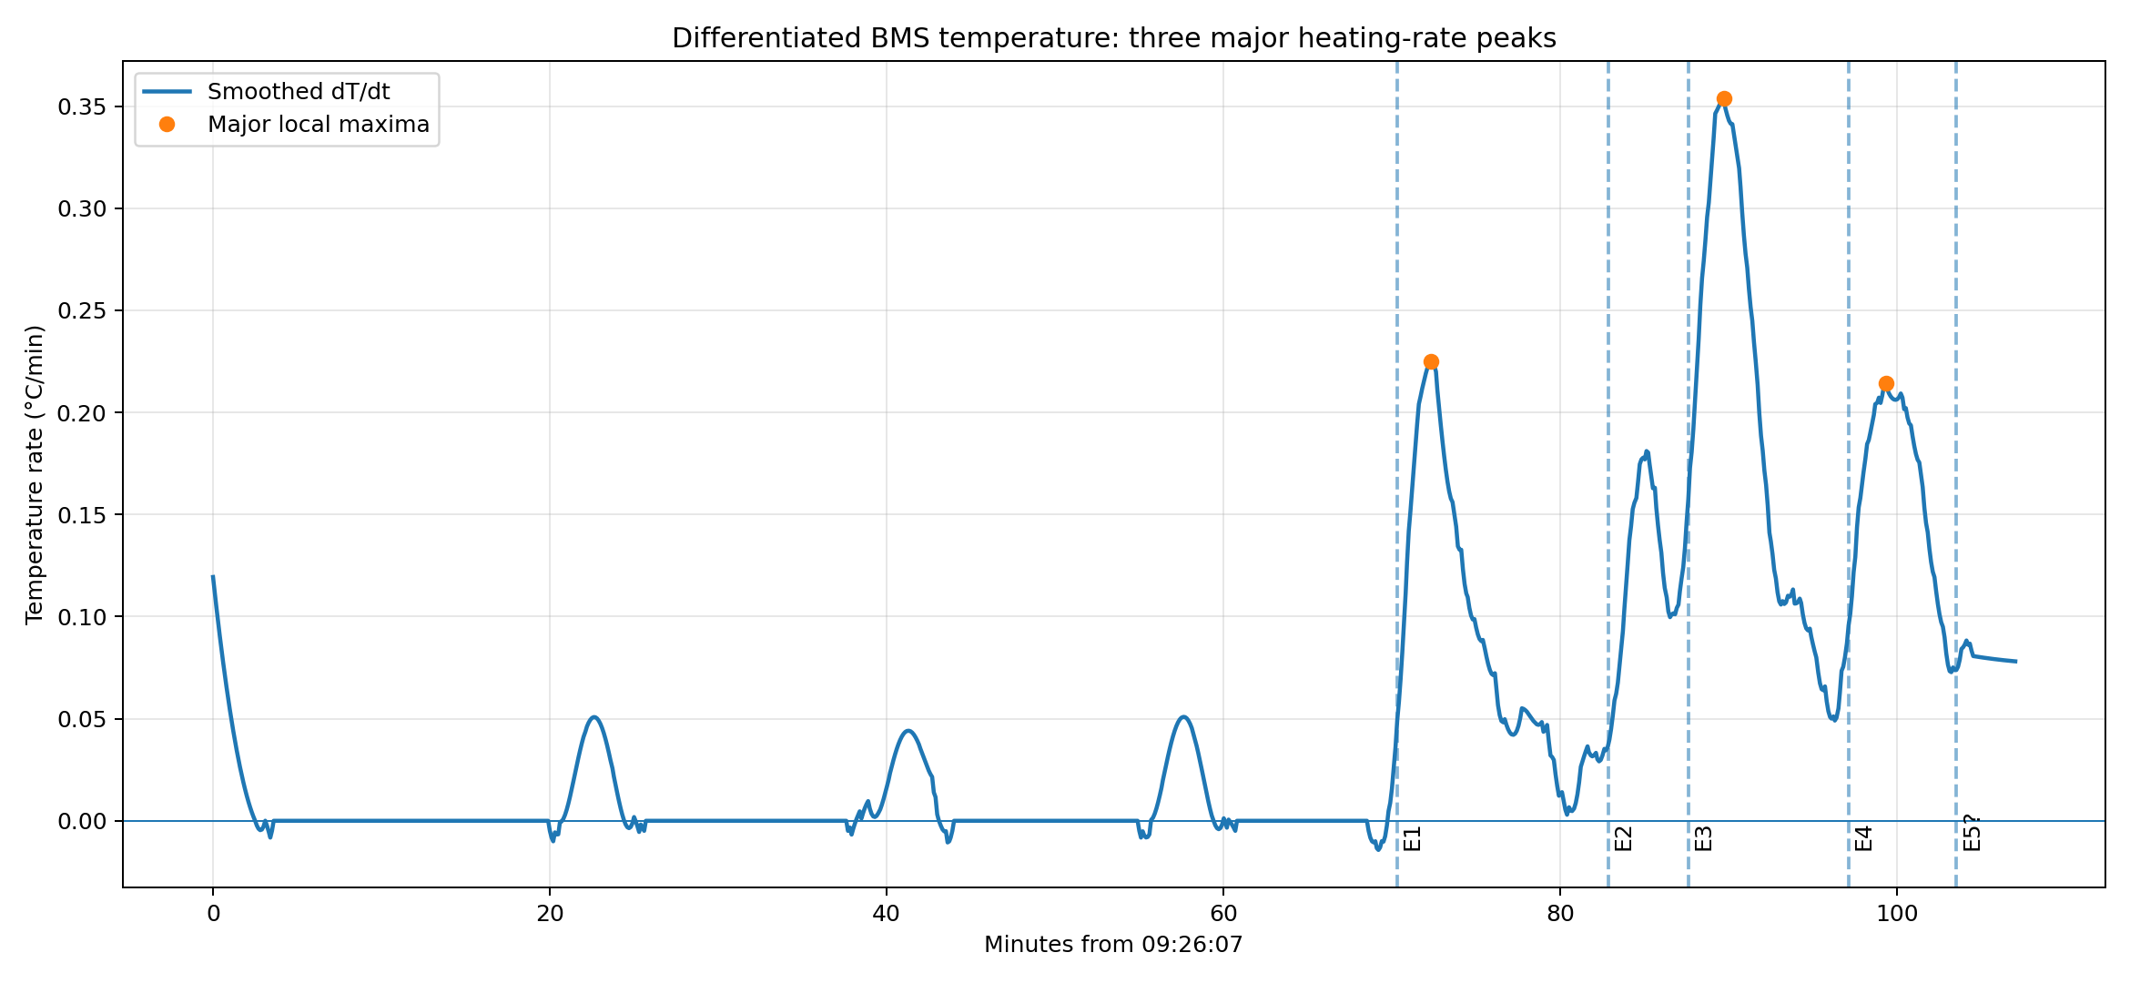
Figure 4. Smoothed derivative of BMS temperature. Local increases in heating rate identify changes in internal dissipation.
The approximately delayed temperature response following the 1.4/1.5 A current transitions is interpreted in this report primarily as the 30-second algorithmic qualification described in Section 1, with any remaining sensor thermal response treated as secondary.

7. Status flags during balancing
The decoded status bytes did not change during current-induced balancing ON/OFF transitions. The observed values remained:
status1 = 0x00
status2 = 0x0E
status3 = 0x80
status4 = 0x00
status5 = 0x00
SOC, CCL, Charge Enabled and Discharge Enabled also remained unchanged during these balancing transitions. No directly transmitted passive-balancing ON/OFF indicator has therefore been identified in the currently decoded interface.

8. Full-charge detection at 3.5 V
The BMS declares the battery full when the highest individual cell reaches 3.5 V. The transition does not require a balanced pack; a single high cell can force the complete battery to 100% SOC while other cells remain substantially lower.
Vmax reaches 3.5 V
-> Full/high-cell status set
-> SOC = 100%
-> CCL = 0 A
-> Charge Enabled = false
In the recorded transition, status3 changed from 0x80 to 0x88. The added bit 0x08 appeared before the subsequent telemetry cycle reported SOC = 100%, CCL = 0 A and Charge Enabled = false. This bit is associated with the observed full/high-cell state and is not a passive-balancing flag.

9. SOC, CCL and communication-level charge permission
The normal observed CCL is 56 A. At 100% SOC the BMS requests zero external charging current. When SOC falls from 100% to 99%, the normal charge request is restored.
if SOC == 100%:
CCL = 0 A
Charge Enabled = false
if SOC <= 99%:
CCL = 56 A
Charge Enabled = true
The recovery of communication-level charge permission is therefore controlled by SOC. It is not identical to charge-MOSFET recovery.

10. Charge permission versus physical charge MOSFET
CCL = 0 A and Charge Enabled = false do not open the internal charge MOSFET. The battery remains electrically connected, and current can still flow if the external charger ignores the BMS request. The charge MOSFET is reserved for physical cell-overvoltage protection.

10.1 Charge-MOSFET overvoltage hysteresis
if Charge_MOSFET == ON:
if Vmax >= 3.6 V:
Charge_MOSFET = OFF
charging current = physically interrupted
if Charge_MOSFET == OFF:
if Vmax < 3.5 V:
Charge_MOSFET = ON
physical charging path = restored
The physical protection path therefore has approximately 100 mV cell-voltage hysteresis: 3.6 V to switch off and below 3.5 V to switch back on.

10.2 Re-enabling the MOSFET does not restore CCL
After an overvoltage cutoff, Vmax < 3.5 V restores the physical charging path, but the BMS can still remain at SOC = 100%, CCL = 0 A and Charge Enabled = false. CCL returns to 56 A only after SOC falls to 99%. This demonstrates that the charge MOSFET and communication-level charge permission are independent mechanisms.

11. Balancing in the 3.5-3.6 V region
Passive balancing continues after full detection. The BMS can therefore simultaneously report SOC = 100%, CCL = 0 A and Charge Enabled = false while the charge MOSFET remains on and balancing resistors remain active.
3.5 V <= Vmax < 3.6 V
SOC = 100%
CCL = 0 A
Charge Enabled = false
Charge MOSFET = ON
Passive balancing can remain active
If actual battery current remains at or above the balancing-current threshold, passive balancing can continue according to the 30 mV cell-selection criterion. This operating region is technically accessible because the physical charging path is still closed, but it is outside the BMS-authorized external charging condition.
The continued operation of the internal balancer does not constitute permission for an external charger to ignore CCL = 0 A. Deliberate charging in this region can conflict with the BMS command and may have manufacturer warranty implications. The 3.6 V threshold is a hardware protection threshold, not a normal charge target.

12. Observed operating states
State | Entry criterion | Result
Balancer disabled | Ibat <= 1.4 A for 30 s | Balancing OFF
Balancer qualification | Ibat >= 1.5 A for 30 s | Global balancing enabled
Normal charge with balancing | SOC <= 99%; Vmax < 3.5 V; Ibat >= 1.5 A | CCL 56 A; Charge Enabled true; MOSFET ON; cells >= Vmin+30 mV balanced
Full state | Vmax reaches 3.5 V | SOC 100%; CCL 0 A; Charge Enabled false; MOSFET ON; balancing can continue
Charge-prohibited but physically connected | 3.5 V <= Vmax < 3.6 V | CCL 0 A; MOSFET ON; balancing can continue; external current can physically flow
Hardware overvoltage cutoff | Vmax >= 3.6 V | Charge MOSFET OFF; charging physically interrupted
Hardware recovery | Vmax < 3.5 V after cutoff | Charge MOSFET ON; physical path restored; CCL may remain 0 A
Normal charge permission restored | SOC 100% -> 99% | CCL 56 A; Charge Enabled true

13. Consolidated observed control model
Vmin = minimum(cell voltages)
Vmax = maximum(cell voltages)
# Global passive-balancer gate
if balancing_enabled == false:
if Ibat >= 1.5 A continuously for 30 s:
balancing_enabled = true
if balancing_enabled == true:
if Ibat <= 1.4 A continuously for 30 s:
balancing_enabled = false
# Individual balancing-resistor selection
if balancing_enabled:
for each cell:
if Vcell - Vmin >= 30 mV:
balancing resistor = ON
else:
balancing resistor = OFF
else:
all balancing resistors = OFF
# Full detection / external charge command
if Vmax >= 3.5 V:
Full status = true
SOC = 100%
CCL = 0 A
Charge Enabled = false
# Charge MOSFET remains ON.
# Passive balancing may continue.
# Normal communication-level charge permission
if SOC <= 99%:
CCL = 56 A
Charge Enabled = true
# Physical cell-overvoltage protection
if Charge_MOSFET == ON and Vmax >= 3.6 V:
Charge_MOSFET = OFF
charging current = physically interrupted
# Charge-MOSFET recovery
if Charge_MOSFET == OFF and Vmax < 3.5 V:
Charge_MOSFET = ON
physical charging path = restored
# Important:
# Charge_MOSFET = ON does not imply CCL > 0.

14. Engineering interpretation
The measurements support a layered BMS architecture. Passive balancing is an internal energy-dissipation function controlled by actual current and cell imbalance. Normal charging is controlled externally through CCL. Physical disconnection is reserved for a higher cell-overvoltage threshold.
Passive balancing:
Ibat current gate + 30 mV cell-selection rule
Normal external charge control:
Vmax = 3.5 V -> SOC 100% -> CCL 0 A
Emergency physical protection:
Vmax = 3.6 V -> charge MOSFET OFF
Physical recovery:
Vmax < 3.5 V -> charge MOSFET ON
Communication-level recovery:
SOC 100% -> 99% -> CCL 56 A
The most important architectural consequence is that CCL and the charge MOSFET must not be treated as the same signal. At 3.5 V the BMS requests that the external charger stop but deliberately leaves the physical path connected. At 3.6 V it physically disconnects charging. After the cell voltage falls below 3.5 V, it restores the physical path even if CCL is still 0 A.
For normal operation, CCL = 0 A must be respected as the BMS charge-stop command. The 3.6 V charge-MOSFET threshold is a protection limit and must not be used as a normal charging target.

15. Limits of the present observations
- The 30-second balancer qualification time is an engineering hypothesis inferred from the observed delay and should be verified with deliberately timed current pulses.
- The data demonstrate balancer operation around 3.4 V and above but do not independently establish a lower absolute cell-voltage gate for balancing.
- No explicit passive-balancing flag has been identified in the decoded status bytes; thermal behaviour remains an indirect indicator.
- The reported thresholds characterize the tested battery and software version 2.50-71.10.11 and should not be generalized to other revisions without verification.
- The CSV contains all 16 cell values. Cells 1-15 are directly transmitted; cell 16 is reconstructed as Vpack - sum(V1...V15). Reconstruction introduces additional quantization, so cells 1-15 are preferred for millivolt-scale transition fitting while cell 16 remains part of the complete 16-cell pack model.

16. Final threshold reference
Function / parameter | Observed criterion | Observed result
Battery software version | 2.50-71.10.11 | Version under test
Balancer global enable | Ibat >= 1.5 A for 30 s | Passive balancing enabled
Balancer global disable | Ibat <= 1.4 A for 30 s | Passive balancing disabled
Individual resistor ON | Vcell - Vmin >= 30 mV | Resistor for that cell enabled
Full detection | Vmax >= 3.5 V | Full status; SOC = 100%; CCL = 0 A; Charge Enabled = false
Normal charge permission restored | SOC 100% -> 99% | CCL = 56 A; Charge Enabled = true
Charge MOSFET OFF | Vmax >= 3.6 V | Physical charging path interrupted
Charge MOSFET ON after OVP | Vmax < 3.5 V | Physical charging path restored
Balancing at 100% SOC | Actual Ibat >= 1.5 A and cell delta criterion met | Balancing continues despite CCL = 0 A
Explicit balancing flag | None identified | No change in decoded status bytes during ON/OFF transitions
Full/high-cell flag | status3: 0x80 -> 0x88 | Bit 0x08 set
Operational rule: The external charger should always obey CCL. The 3.6 V charge-MOSFET cutoff is an emergency protection threshold, not a permissible charging target.

