REPUBLIQUE DU CAMEROUN
***********************
PAIX – TRAVAIL – PATRIE
*****************
MINISTERE DE L’ENSEIGNEMENT SUPERIEUR
***********************
UNIVERSITE DE YAOUNDE I
********************
SAINT JEAN INGENIEUR
REPUBLIC OF CAMEROON
***********************
PEACE – WORK – FATHERLAND
*****************
MINISTRY OF HIGHER EDUCATION
***********************
UNIVERSITY OF YAOUNDE I
********************
SAINT JEAN INGENIEUR


ACADEMIC YEAR: 2025-2026
Under the Supervision :
COURSE LECTURER:
Dr. MOUPOJOU
Written And Presented By:
DJEUFACK WILSON
ELOMBA ELMINE
FOUDJI BELDOUCE

TITLE
ISJ DOCUMENTATION SYSTEM
SPECIFICATION DOCUMENT

Contents
I. INTRODUCTION 1
II. GENERAL PRESENTATION OF THE PROJECT 2
III. CONTEXT DESCRIPTION 3
III.1 ACADEMIC CONTEXT 3
III.2 TECHNOLOGICAL CONTEXT 3
III.3 SOCIETAL CONTEXT 4
IV. DEFINITION OF PROBLEM 5
IV.1 Functional Needs 5
IV.2 Non-Functional Needs 6
V. TARGET OBJECTIVES 7
VI. PROPOSED SOLUTIONS 7
VI.1. Description 7
VI.2. Expected results 8
VI.3. Deliverables 8
VII. INTERVENTION APPROACH 9
VII.2 METHOD 9
VII.3 PLANNING 10
FIGURE 1: Gantt chart 11
VIII. TEAM PRESENTATION: 12
IX. RESOURCES USED 13
IX.1. Hardware Resources 13
IX.2. Software Resources 13
IX.3. Other Resources 14
X. CONCLUSION 15

INTRODUCTION
The digitalization of administrative tasks presently gives a different and more professional perspective of how a system can integrate it to its day to the life and we all know a digitalized system makes work easier. This document defines the bases of an automatic documentation system in Institut Saint jean(ISJ). Structured under the tutored project course of level 2 of the Bachelor’s cycle in Institut Saint Jean(ISJ).
This document serves as a design for a web documentation System which acts as a bridge between all possible documents possessed by the school and users willing to have access to them. This reduces the stress of looking for documents manually which saves time and prevent repetitive tasks.
This document will be divided into 10 main sections namely: general presentation, context, project definition, targeted objectives, proposed solutions, intervention approach, team presentation, resources used and conclusion.

GENERAL PRESENTATION OF THE PROJECT
This project consist of establishing a web application which is tilted towards the digitalization of all possible documents which belongs to a given enterprise and in our case its ISJ.
The goal being this project is to facilitate the retrieval of documents accessible via the web application. This enables users including the administrative staffs, students and even parents to have access to these documents no matter their geographic location.
Accessible via a responsive interface, the web application will be hoisted online to permit users to have access wherever possible if they are connected to an internet connection. Which saves time searching for information and ensures everyone is looking at the most recent version of the document.

CONTEXT DESCRIPTION

III.1 ACADEMIC CONTEXT
This project is registered under the course “Projet tutoré” of level 2 of the Bachelor’s cycle of ISJ. This project serves as practical demonstration of our understanding of programming languages such as HTML, CSS, JavaScript and PHP and project management. This project’s main objective being developing students’ autonomy and initiative skills and developing teamwork abilities.

III.2 TECHNOLOGICAL CONTEXT
L’Institut Universitaire Saint Jean of Cameroun (IUSJC) is composed of many schools SJI, SJM, PrepaVogt, and CPGE present on both campuses (Eynag and Etok-koss) in the Centre region of Cameroon. With the number of schools present we are dealing with a lot of learners and administrators and the list continues. IUSJC needs a system which is able to automatically manage their documents which can be very edible for all individuals involved in this milieu including learners their tutors and also administrative staffs.
A well-developed web application which will focus itself on digitalizing all documents found in ISJ will have the following functionalities.
- Efficient Information Retrieval
Simple and fast retrieval
- Document Longevity & Readability
Long-term storage and readability.
- Data Integrity & Archival Preservation
Preservation of the current state of information with long-term documentation/backup of content.
- Process Traceability
Traceability of processing states
- Lifecycle Management
Creation, distribution, and archiving documents.
- Security & Compliance Standards
Implementation of data protection standards and security concepts through access permissions, etc.
- Operational Optimization
Avoid duplication of tasks and ensure easy tracking of processing states.

III.3 SOCIETAL CONTEXT
This project is not only and exercise to be done to show our skills in programming, but it also solves a real-life problem in many aspects as mentioned below:
- It reduces the stress of always printing to read a document physically leading to high paper consumption which if a better version of the document is uploaded on the website it reduces that stress.
- It also reduces the physical aspect of transporting documents from different localities to another.
- It promotes “a paperless office” which creates space and makes the environment convenient for work.
- It also encompasses the security goals that is traceability and access permissions.
- Eligible to all users and devices not necessarily high version PC’s or smartphones.

DEFINITION OF PROBLEM

L’Institut Universitaire Saint Jean of Cameroun (IUSJC) is composed of many schools SJI, SJM, PrepaVogt, and CPGE present on both campuses (Eyang and Etok-koss). With this, we observe that the more the number of schools, the more difficult Documents management becomes. The actual system presents many shortcomings that affect in one way or the other the school’s management efficiency.
1. Lack of traceability
In the actual system, it's very difficult to track the lifecycle of a document (creation, modifications). which creates transparency and non-repudiation issues.
2. Inefficient search
In the actual system, finding a specific document is slow and stressful to the staff since they have to make use of their own memory instead of an efficient classification and search system.
3. Poor documentation handling
In the current system , documents are stored in offices and in external hard drives sometimes, which nowadays is a poor documentation handling system.
4. Security and access control issues
We all know that in all organizations, there always exist sensitive documents which is the case of ISJ. In our current system, the confidentiality of sensitive documents is not guaranteed as there is no formal mechanism to ensure access rights.

IV.1 Functional Needs
Functional requirements describe the services that the system must provide. Below is a clear description of what the system must do.
- Document upload : Files will be uploaded to the platform with their metadata ( e.g. datatype, date of upload) by authorized users only.
- Document search : The system will offer a search function which will permit documents to be filtered and searched after criteria ( file name, author) entry.
- User and access rights management: The system must allow the creation, modification, and deletion of user accounts. It must include a rights management system based on roles (e.g., Administrator, Teacher or even Administrative Staff) to control access to documents.
- Easy navigation : The user must be able to navigate through the folder tree structure to browse and consult the documents stored within it.

IV.2 Non-Functional Needs
Non-functional needs describe the constraints and quality attributes of the system. Below are some outlined non-functional needs for our system.
- Security
- The access to the System will be protected by an efficient authentication system.
- Users’ password and information will be stored efficiently.
- To avoid unauthorized access, access control will be reinforced.
- Performance
- The system should have a reasonable response time.
- Documents upload and download should be fast.
- Technical constraints: I and my team members will make use of the imposed technologies (HTML, CSS, JavaScript), Back-end (PHP), Database (MySQL). Files will be stored on the server’s file system.
- User satisfaction: The user interface will be interactive, clear and easy to use since these users are the end users. Also, the web app will be open on most available browsers such as chrome and firefox.

TARGET OBJECTIVES
To solve the document management problems described above, the proposed solution is designed to accomplish the following specific objectives.
- Facilitate documents information retrieval : By implement this system, it will give rise to an efficient search engine which will reduce stress on the staff members and other users.
- Accelerate information retrieval : In the same way, implementing this system will reduce the time spent searching a document, thereby time wastage is avoided at all stages.
- Centralize and structure the documentary assets : Saint Jean Institute as a whole will now have a single, organized, and secure repository, accessible at any time through a web browser.
- Solid foundation both for present and future use.

PROPOSED SOLUTIONS

VI.1. Description
The proposed solution consists of developing a custom Electronic Document Management (EDM) web application named “ISJ-DMS” (Institut Saint Jean – Document Management System).
- Client side (Front-end):
The user interface will be developed using HTML, CSS and JavaScript. It will communicate with the server to display data and user actions.
- Server side (Back-end):
The business logic, authentication, access rights management, and database interactions will be handled by code written using PHP.
- Database:
A MySQL database will store all structured information, including user accounts, roles, access rights, document metadata (name, date, type, storage path, author, etc.).

VI.2. Expected results
After building( implementing) this system, the following results are expected
- A web application : which will be deployed and accessible online.
- A complete traceability of actions by admins.
- By database for storing the overall system’s information
- A clear and responsible user interface, where he will be able to perform the following actions:
- Login if account exist or sign up otherwise
- File/Folder view
- File upload (for those having right)
- File Download
- File search

VI.3. Deliverables
Search Throughout this project, the following documents will be produced and submitted.
- Technical Specifications Document ( This actual document)
- Analysis Document
- Design Document
- Test specification Document
- User Manual
- Power point presentation

INTERVENTION APPROACH

VII.1 ARCHITECTURE
The application architecture is centered basically on PHP which acts as the bridge linking MySQL database and the Google Docs Viewer API. All these being maintained by links and protocols which will be detailly presented below:
- The Web Browser: (Chrome/Safari) — This is actually a third-party app that "interprets" your HTML/JS.
- The Database Engine: (MySQL) — Viewed here as an external service providing data.
- Document Preview APIs: If you use Google Docs Viewer or Office Online to display the files.
- Authentication Services: If you use "Login with Google."

All these apps are being managed by links(protocols) explained as follows:
- User and web Server: HTTPS
- PHP and MySQL: SQL
- PHP and File System: Posix/ NTFS calls
- Web server and Google Viewer: HTTPS/REST

VII.2 METHOD
The adopted methodology aims to ensure both agile and effective execution. Consequently, it is based on:
- Approach: Firstly, Scrum (Agile) will be utilized, featuring bi-monthly sprints to ensure adaptation to changes and ensuring flexibility of the project.
- Language: Secondly, UML(utilizing Use Case, Sequence, Class, and Component diagrams) will ensure a standardized modeling of requirements and processes.
- Finally, Scrum promotes flexibility and collaboration within the team because it enables the project to be merged into different parts which can be carried out by each member of a team at a given sprint, while UML guarantees clear communication of technical specifications.

VII.3 PLANNING
The project spans from February 2026 to May 2026, structured into precise phases to ensure an orderly progression:
- Phase 1: Launch & Scoping (Weeks 0-1, February): First, the project specifications (cahier des charges) will be developed and validated by the supervisor.
- Phase 2: Analysis & Modelling (Weeks 2-3, February): Next, an analysis document (UML) will specify the functional requirements.
- Phase 3: Design (Weeks 4-5 February): Furthermore, a design document (architecture) will detail the technical structure.
- Phase 5: Development (march–may): Then, bi-monthly sprints will deliver functionalities by priority (authentication, scheduling, reservations, equipment).
- Phase 6: Testing & Optimization (May): Finally, a test plan (unit, integration, UX) will validate the quality of the system.

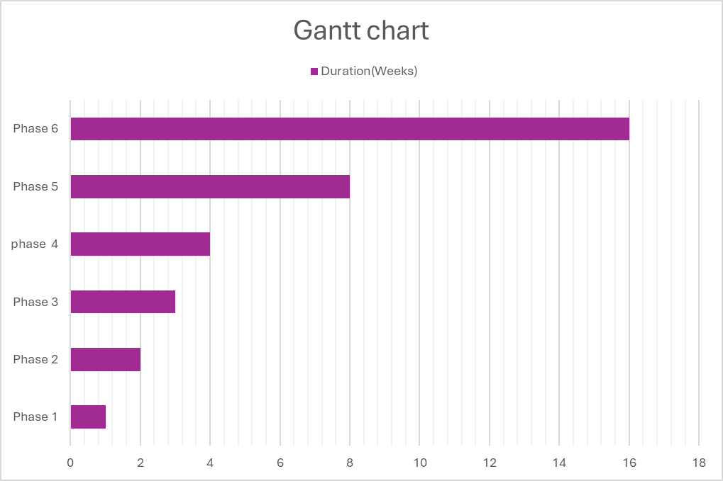

FIGURE 1: Gantt chart

VIII. TEAM PRESENTATION:
Our team is composed of three students with technical and organizational skills in web development, database management and system design, to ensure the success of the project. Thus, the roles are defined as follows:
- Djeufack Wilson: As project manager responsible for the overall coordination of the project. His duties include planning tasks, managing deadlines, ensuring communication between team members and validating each development phase.
- Foudji Fouete Beldouce: As database administrator responsible for proper design of database tables (that is documents, information, users, etc.). She guarantees data integrity and consistency by applying constraints and validation rules. She also manages secure storage of document metadata such as filename, date etc., while ensuring efficient interaction between SQL and the file system.
- Elomba Elmine: Modeler and tester, specialized in UML for diagrams. Also responsible for quality assurance, ensures that the electronic document management system functions correctly, reliably and securely before deployment that is she executes functional testing to verify features (such as document upload, storage, search, download and deletion) works as expected. In addition, she verifies security aspects such as user authentication, access control, and data protection, ensuring that the system is stable and ready for real world use.
The team as a whole: as full stack developers responsible for backend in developing server-side logic using PHP, manages data interactions with SQL and implement functionalities such as upload, storage, retrieval and deletion. Also, for frontend, responsible for design and implementation of user interface using html, CSS and JavaScript. Under the supervision of Dr Emmanuel Moupogou, we collaborate effectively to produce a robust and functional system.

IX. RESOURCES USED

IX.1. Hardware Resources
To ensure the development and deployment of the system, the following hardware resources will be mobilized:
- Development Stations: First, PCs/Macs (i5/i7, 16 GB RAM, 256 GB SSD) will be used for development and testing.
- VPS Server: Next, a VPS server (4 vCPU, 8 GB RAM, 100 GB SSD) will support deployment via a CI/CD pipeline.
- Network: Additionally, a stable Internet connection will ensure optimal conditions for development and testing.
- Tests: Finally, equipment simulators (projectors, computers) will allow for the validation of resource management functionalities.

IX.2. Software Resources
The following software tools and technologies will be used to ensure high-quality technical implementation:
- Programming languages: Php (backend development) and Html, CSS & JavaScript (frontend development)
- Database: Next, MySQL will provide centralized storage of document metadata, with SQL lite as an alternative.
- Code editor and version control: visual studio code as editor and Git for tracking changes and collaborations, will facilitate coding and testing.
- Modelling: Finally, Lucid chart or draw.io will be used for UML 2 diagrams.

IX.3. Other Resources
Other essential resources will complete the project:
- Supervision: First, the guidance of Dr. Emmanuel MOUPOJOU will ensure rigorous supervision.
- Training: Furthermore, microservices tutorials (Udemy) and YouTube tutorials will enrich the team's skills.
- Data: Finally, IUSJC databases (rooms, teachers, equipment) will serve as a reference for testing and integration.

X. CONCLUSION
Coming to the end of our document, we can say the objective was attained which was to provide a specification document to our project. This document clearly establishes the project's goals, constraints, and methodology, while adhering to the academic requirements of the ISJ program.
The next deliverable will be the Analysis Specification (Cahier d'Analyse), which will detail the UML diagrams—including Use Case, Sequence, and Class diagrams—as well as the system's business rules. This analysis phase will deepen our functional understanding before moving on to the detailed technical design.

