**Getting started**

**Installation**

* **R**

<https://cran.rstudio.com>

* **RStudio Descktop**

<https://www.rstudio.com/products/rstudio/#Desktop>

The Open Source Edition is free.

* **Install other dependences**

Execute the following command in R Studio Console

> install.packages("shiny", "shinydashboard", "ggplot2", "gridExtra", "corrplot",)

**Files**

* **Source Code**
* ui.R - User interface
* server.R – Server Application
* global.R – Load data into variables for both ui and server.
* **Datasets**

The datasets should be put in a folder named “datasets”. The dataset folder and source code files must be put in one directory, which should be set as the working directory in RStudio.

The Datasets must include the following files with the exact same filename and file format as the templates.

* Breakdown.csv
* Carries.csv
* Defence.csv
* PlayerProfiles.csv

**Configuration**

* **Set working directory**

The working directory should be the folder where you put the source code along with the datasets.

It can be set by executing the following command in R Studio Console.

> setwd("[full path]")

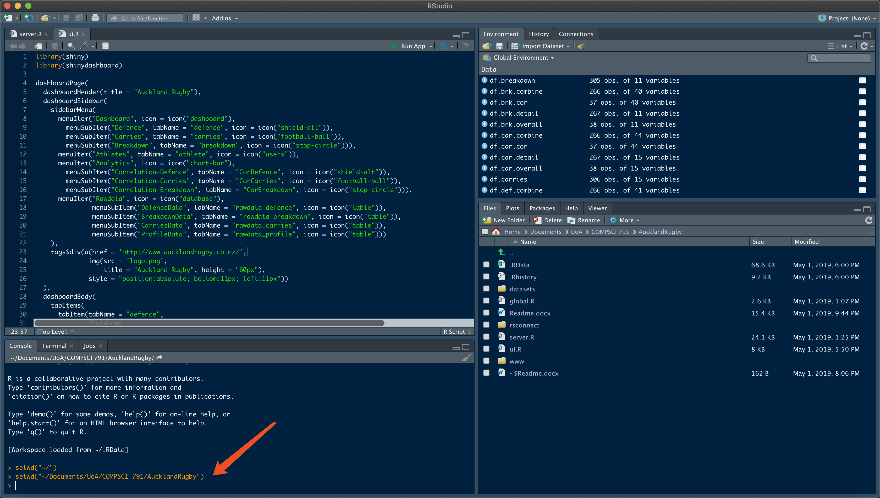

**Run** **Application**

* **Open the server.R and ui.R in RStudio.**
* **Press the “Run App” button.**

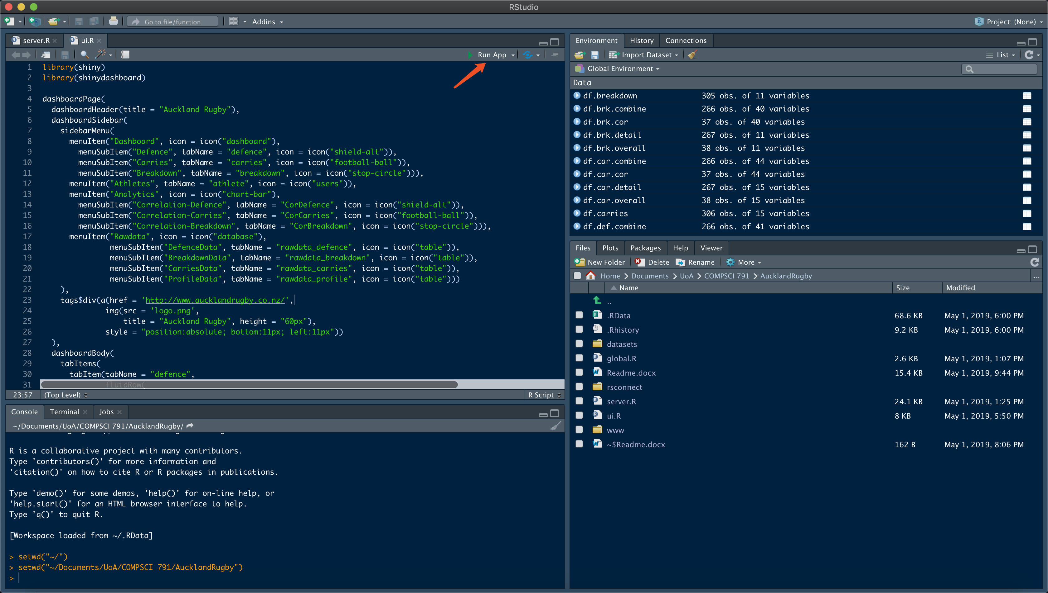

**Publish the application to Cloud**

* **Connect to the Shinyapp Account(First time).**
* [www.shinyapp.io](http://www.shinyapp.io)
* **Press the Publish button.**

