Pruritus Frequency by Treatment Group
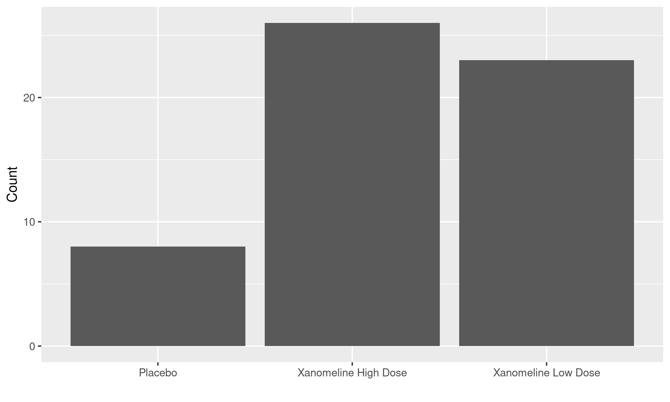

footnote here
[datasource: adam-adae]

