Time to Dermatologic Event by Treatment Group
All Participants
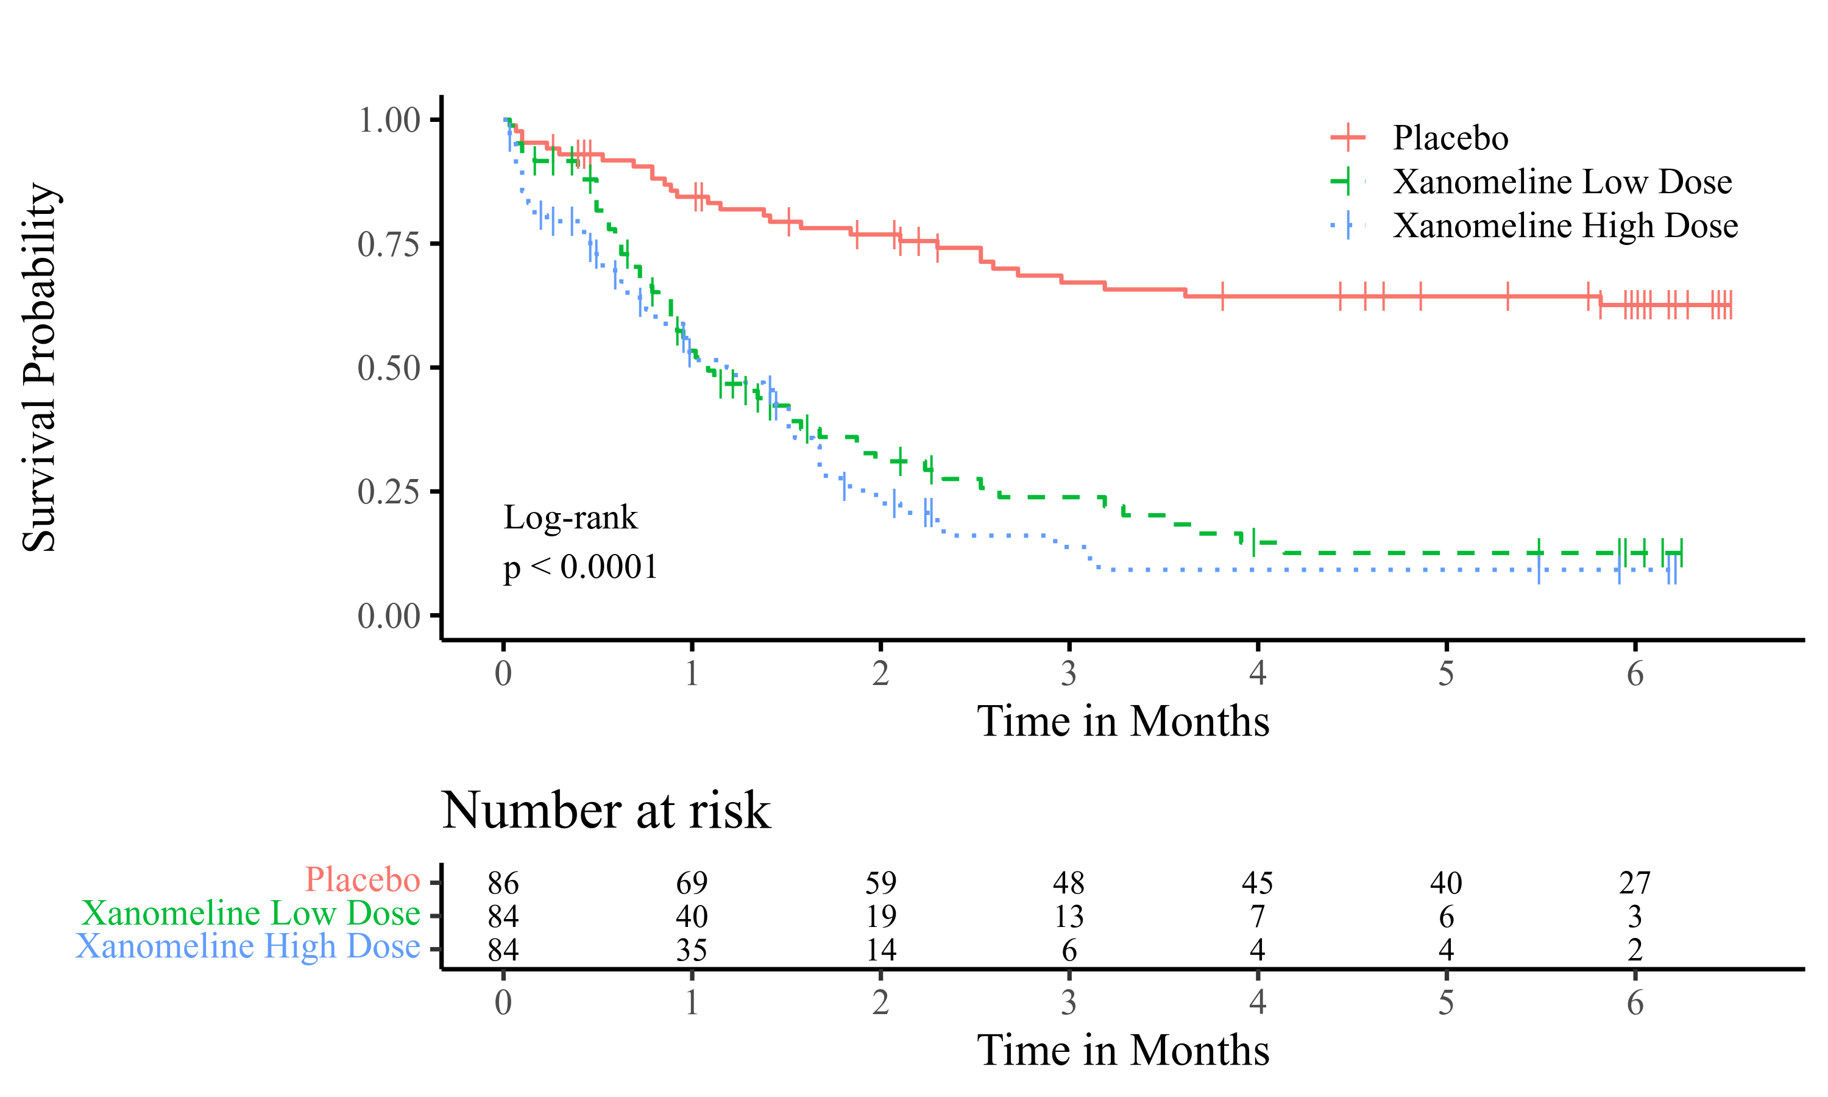

footnote
[datasource: adam-adtte]

