Kaplan-Meier Plot for Time to First Dermatologic Event by Treatment Group
All Participants
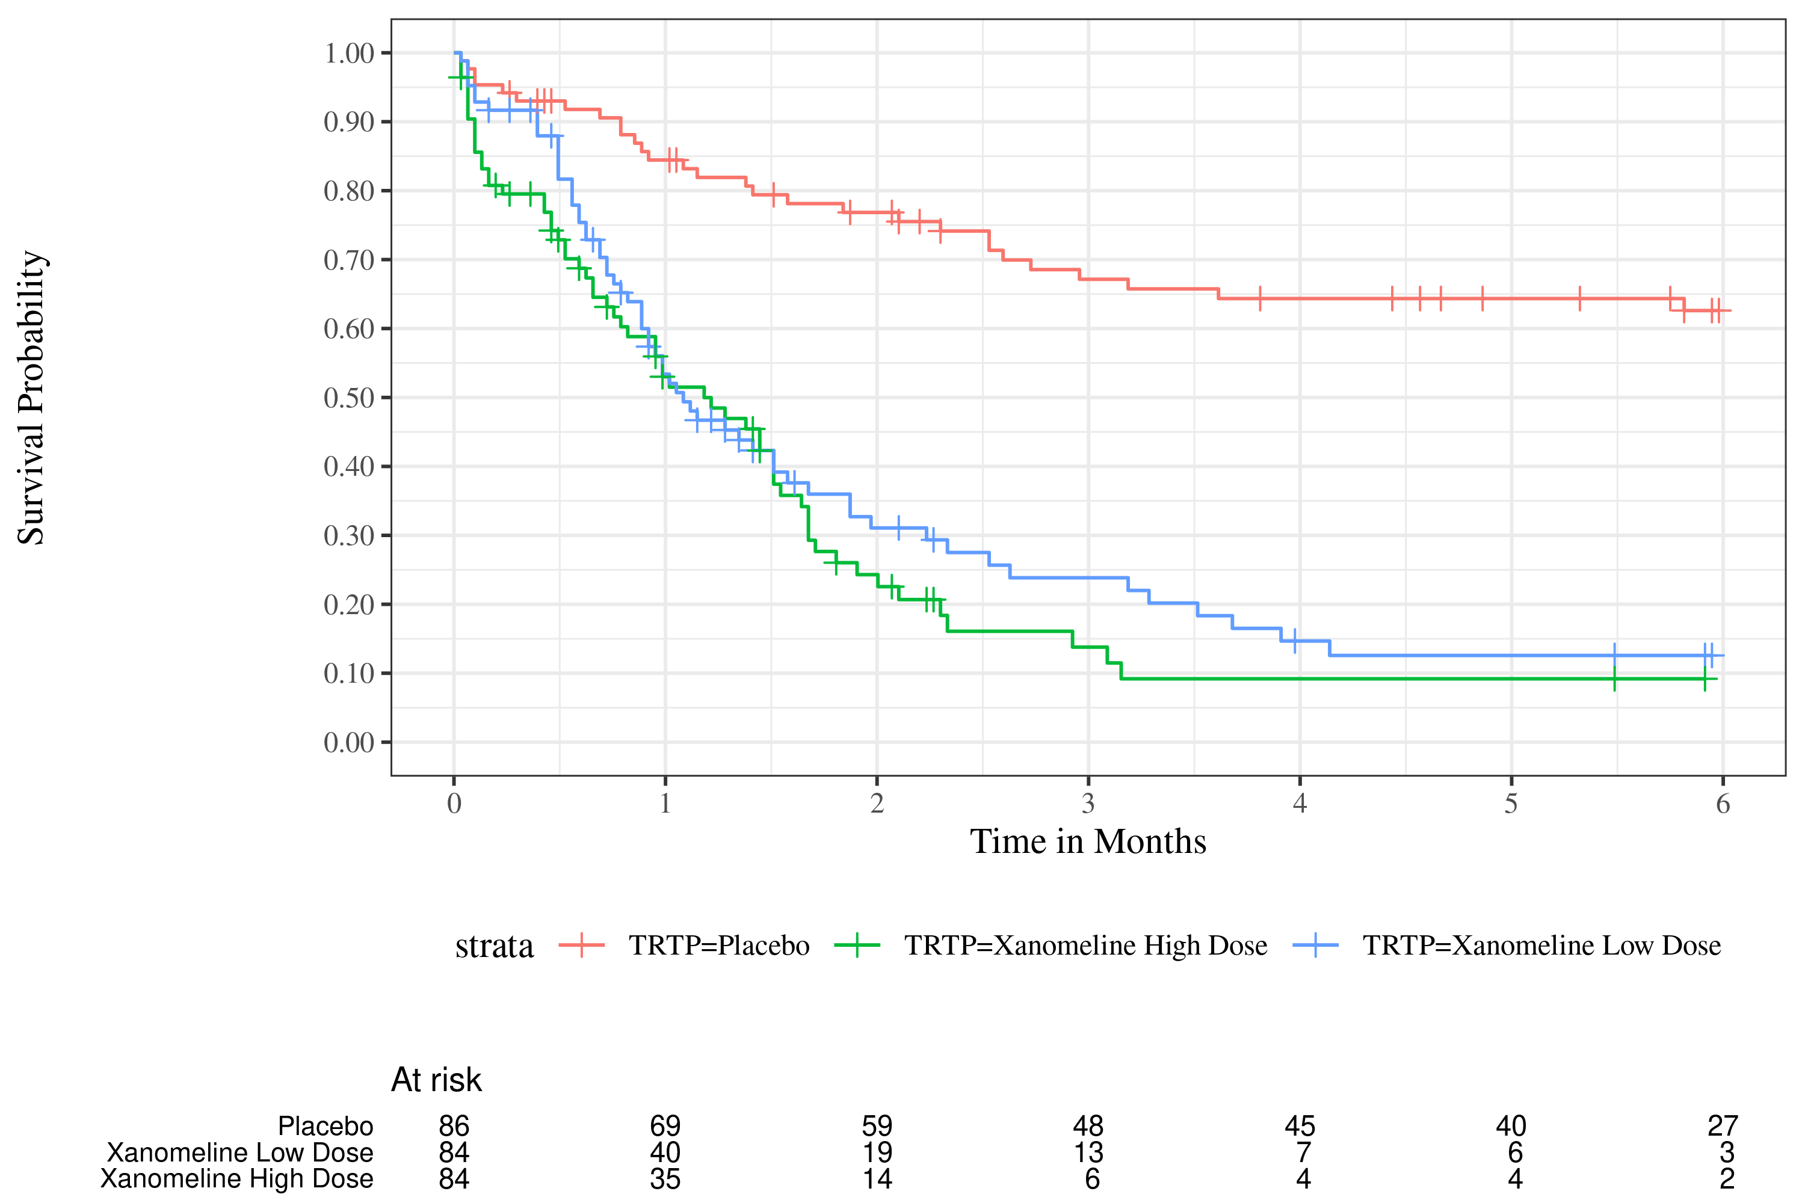

footnote
[datasource: adam-adtte]

