Constrained evolution of a core winter proteome across independently cold-adapted PACMAD grasses
Authors
Elad Oren^{1*}, Jingjing Zhai¹, Travis E Rooney², Ruthie Angelovici³, Charles O. Hale⁴, Lara J. Brindisi^{1,6}, Sheng-Kai Hsu¹, Christine M. Gault¹, Jian Hua⁵, Thuy La¹, Nicholas Lepak⁶, Qin Fu⁷, Edward S. Buckler^{1,6}, M. Cinta Romay^{1*}
Affiliations
- Institute for Genomic Diversity, Cornell University, Ithaca, NY 14853, USA
- Sesaco Corporation, Austin, TX 78701, USA
- Division of Biological Sciences and Interdisciplinary Plant Group, University of Missouri, Columbia, Missouri, 65211, USA
- School of Integrative Plant Sciences, Plant Breeding and Genetics Section, Cornell University, Ithaca, New York, 14853, USA
- School of Integrative Plant Science, Plant Biology Section, Cornell University, Ithaca, New York, 14853, USA
- USDA-ARS, Ithaca, NY, USA 14853
- Proteomics and Metabolomics Facility, Cornell University, Ithaca, New York, 14850, USA
*Corresponding authors:
Elad Oren
Tel: +972 49539517
Email: eladoren@volcani.agri.gov.il
M. Cinta Romay
Tel: +1 607-255-1809
Email: mcr72@cornell.edu
The author responsible for distribution of materials integral to the findings presented in this article is Elad Oren.
Total word count (excluding summary, references and legends): | 5,293 | No. of figures: | 5 (Figs 1–5)
Summary: | 194 | No. of Tables: | 1 (Table 1)
Introduction: | 621 | No. of Supporting Information files: | 3 (Figs S1–S9; Tables S1–S12; Code S1–S3)
Materials and Methods: | 2,139
Results: | 1,183
Discussion: | 1,203
Acknowledgements: | 147

Summary
- Grasses in the PACMAD clade independently colonized cold environments from warm-climate ancestors, but whether their molecular responses to freezing reflect shared evolutionary solutions or lineage-specific innovations remains unknown. We used comparative proteomics to test whether protein-level cold responses show stronger cross-species conservation than previously observed at the transcript level.
- We quantified seasonal rhizome proteomes (winter vs summer) from five PACMAD grass species grown in a common garden exposed to sustained sub-zero temperatures, identified differentially abundant proteins, and compared fold-change magnitudes across species using orthogroup-based correlation analyses. We further examined LEA3 protein structure through hydropathy profiling and motif analysis.
- Shared cold-responsive proteins showed substantially higher cross-species fold-change correlation (ρ = 0.80) than background proteins (ρ = 0.45), despite greater divergence in baseline abundance. LEA3 was the only ortholog elevated across all five species. The cold-sensitive maize ortholog contained a 15-amino-acid insertion that disrupted the conserved 11-mer motif architecture maintained in all cold-tolerant species examined.
- Independent evolution of freezing tolerance in PACMAD grasses is governed by evolutionary constraints on protein-level response magnitude, reflecting the retention of an ancestral protective capacity. The structural divergence of LEA3 in maize suggests that transcriptional induction alone does not ensure freezing tolerance; functional protection likely requires intact motif architecture.
Keywords: Cold acclimation, Constrained evolution, Freezing tolerance, LEA proteins, PACMAD grasses, Proteomics, Rhizome, Tripsacum.

Introduction
Maize (Zea mays ssp. mays), a vital crop for global food security, is susceptible to cold stress due to its tropical origins, limiting its yield in temperate regions. Early planting of maize can improve nitrogen capture, net primary productivity, and yield (Ojeda-Rivera et al., 2025). However, this strategy requires cold tolerance, which is lacking in current elite maize varieties (Lyons, 1973; Aroca et al., 2012). Cold and freezing tolerance has arisen independently multiple times within the Panicoideae, Aristidoideae, Chloridoideae, Micrairoideae, Aristavideae, and Danthonioideae (PACMAD) clade, a major lineage of predominantly C4 grasses (Poaceae) that diverged ~64 Mya, with ancestral roots in the Afrotropics (Sage et al., 2011; Gallaher et al., 2022). These parallel origins of freezing tolerance provide a natural comparative framework. Among these, Tripsacum, the closest perennial and cold-tolerant relative of maize, having diverged about 650 Kya (Chen et al., 2022), is valuable for enhancing maize cold tolerance.
PACMAD grasses originated in warm-season climates unlike temperate diversified Pooideae and Danthonioideae (Kellogg, 2015). However, most transitions of these grasses to colder climates occurred in tropical mountains, where cold-adapted lineages converged with temperate migrants (Schubert et al., 2020). Each PACMAD genus exhibits distinct evolutionary trajectories, polyploid histories, and biogeographic origins, having independently evolved robust cold and freezing tolerance over the past 20-30 million years (Gallaher et al., 2022; Stitzer et al., 2025).
Plant exposure to cold stress, including chilling (>0°C) and freezing (<0°C) temperatures, triggers physiological and molecular responses. Chilling stress disrupts membrane fluidity, impairs enzyme activity, and inhibits photosynthesis (Aroca et al., 2012), whereas freezing stress induces ice crystal formation in extracellular spaces, leading to cellular dehydration, membrane damage, and ultimately, cell death (Pearce, 2001). Many temperate plants undergo cold acclimation. Adaptations resulting from cold acclimation include membrane lipid modifications (Degenkolbe et al., 2012; Barnes et al., 2016), accumulation of compatible solutes (Koster & Lynch, 1992), enhanced antioxidant enzyme activity (Suzuki & Mittler, 2006) and protective protein accumulation (Puhakainen et al., 2004; Xu et al., 2022). Plant cold perception involves plasma membrane modifications, including fluidity changes, Ca²⁺ channel activation, and cytosolic acidification, driving lipid and transcriptomic responses (Mori et al., 2018; Barnes et al., 2023). A widely conserved mechanism underpinning freezing tolerance is the activation of the C-repeat binding factor/dehydration-responsive element-binding (CBF/DREB) signaling pathway, which induces expression of cold-responsive (COR) genes (Thomashow, 1999; Nakashima & Yamaguchi-Shinozaki, 2006).
Studies in PACMAD grasses reveal both broadly conserved and species-specific molecular adaptations associated with this pathway. Panicum virgatum utilizes a zinc finger transcription factor, PvC3H72, to enhance ICE1-CBF-COR signaling, significantly increasing cold resilience (Xie et al., 2019). Additionally, calcium signaling pathways involving calmodulin and MEKK1 provide early response to cold stress (Ranaweera et al., 2022; Wu et al., 2024). Pennisetum giganteum maintains membrane fluidity at low temperature through the accumulation of unsaturated fatty acids such as linoleic and α-linolenic acids (Zhang et al., 2017; Li et al., 2020). Protective proteins including late embryogenesis abundant (LEA) proteins, dehydrins, and antioxidant enzymes are accumulated in response to freezing conditions, reducing oxidative injury and cellular dehydration (Liu et al., 2016; Xie et al., 2019). Species-specific adaptations include enhanced proline biosynthesis via the ornithine pathway in Sorghum bicolor (Vera-Hernández et al., 2018) and elevated activity of phenylpropanoid pathway enzymes (PAL and CAD) in Miscanthus to protect cells during freezing stress (Domon et al., 2013).
Previous studies in PACMAD grasses have focused mainly on transcriptomic and metabolomic adaptations. However, proteomic responses remain largely unexplored. As the functional products of genes, proteins integrate transcriptional, translational, and post-translational regulation. Given the persistent nature of cold stress, proteomic analysis uniquely captures the accumulation of proteins reflecting acclimation and sustained adaptive responses. Furthermore, (Cope et al., 2025) demonstrated that proteins face stronger evolutionary constraints than transcripts, with protein abundances being highly conserved across species while mRNA levels can vary without substantially affecting protein output. This suggests that shared cold adaptive responses may be more readily detected at the protein level than at the transcript level, making proteomics essential for understanding adaptive processes such as those underlying cold or freezing tolerance. Our multi-species study examines rhizome protein accumulation across seasonal variation to identify conserved freezing-tolerance mechanisms in PACMAD grasses, testing whether freezing tolerance across these lineages reflects retention of shared ancestral molecular responses or lineage-specific innovations.

Materials and Methods
To investigate proteomic responses to seasonal changes across prairie grasses, we conducted a comparative analysis of rhizomes from five species under winter (January, with lows reaching -29°C) and summer (August, with highs of 26°C) conditions. The species analyzed (Fig. 1A) were interspecific and intraspecific hybrids of Tripsacum dactyloides (L.) L. and Tripsacum floridanum Porter ex Vasey, Andropogon gerardii Vitman (cv. 'Sentinel'), Miscanthus × giganteus J.M.Greef & Deuter ex Hodk. & Renvoize, Panicum virgatum L. (cv. 'Dust Devil'), and Sorghastrum nutans (L.) Nash (cv. 'Golden Sunset').

Plant material and environmental conditions
Plants were grown outdoors at two field sites in Ithaca, New York (USDA Hardiness Zone 6a), where they experienced natural seasonal fluctuations, with an average winter temperature of -5°C (lows reaching -29°C) and summer temperatures averaging 20°C (highs of 26°C) over the five years preceding sampling (Northeast Regional Climate Center, 2025). Tripsacum hybrids were cultivated at Cornell University Caldwell Field, while Andropogon gerardii, Miscanthus giganteus, Panicum virgatum, and Sorghastrum nutans were grown at the Cornell Botanic Gardens. Environmental data were obtained from the Northeast Regional Climate Center (Station USC00304174) and the New York State Mesonet (Station GROT).
Rhizome tissue was collected during two sampling campaigns in 2019 and 2022, timed to capture distinct physiological states: winter dormancy and summer active growth. In 2019, summer samples were collected on August 11 following 121 mm of precipitation in the preceding 30 days, and mean soil temperature at 5 cm depth was 19.9°C. Winter samples were collected on January 8, 2020, after 22 days with soil temperature below 2°C. In 2022, summer sampling occurred on August 15 following 93 mm of precipitation; 30-day mean soil temperature was 20.6°C. Winter sampling on December 9 followed 20 days with soil temperature below 5°C. At summer sampling, plants displayed active vegetative growth with no visible drought stress; winter samples were dormant with hardened exteriors (Fig. S7).

Sampling and experimental design
Our study was conducted in two phases. Initial sampling of Tripsacum hybrids in 2019 provided evidence of conserved winter protein accumulation, prompting expansion in 2022 to both replicated Tripsacum sampling and four additional PACMAD species with independent evolutionary histories of cold adaptation.
Rhizome tissue (minimum 5 g fresh weight) was collected from the internal mid-sections of rhizomes using sterile pruning scissors. Sampling was standardized to exclude apical tips, fine roots, and necrotic zones to ensure reproducibility and tissue comparability across species (Fig. 1C and Fig. S7). Samples were immediately placed in pre-labeled 15 ml tubes, transported on dry ice, and stored at −80°C within 4 hours of collection. Biological replicates were defined as tissue collected from independent clonal plants. Sample sizes and genotypes are detailed in Table 1. For A. gerardii ('Sentinel'), M. giganteus, and P. virgatum ('Dust Devil'), three biological replicates were sampled per season from established accessions at Cornell Botanic Gardens. S. nutans ('Golden Sunset') was represented by two biological replicates per season due to winter mortality of one clonal plant.

Tripsacum hybrid population
Tripsacum rhizomes were sampled from seven-year-old F₁ hybrid progenies that had survived multiple freezing winters at Cornell University's Caldwell Field. The hybrids were derived from controlled crosses between northern founders collected from Iowa, Kansas, Illinois, and Missouri, where winters experience heavy frost, and southern founders collected from Florida and Texas, with subtropical climates. Most crosses were interspecific, between T. dactyloides subsp. dactyloides (northern) and T. floridanum (southern); additional crosses were intraspecific, between northern and southern populations of T. dactyloides (Table 1). In 2019, we sampled eight individuals per season representing six distinct hybrid genotypes from five cross combinations, prioritizing coverage of genetic diversity across the hybrid population. In 2022, we sampled 24 individuals per season comprising eight hybrid genotypes with three clonal replicates each, balancing genetic diversity with robust statistical replication.

F₂ Seedlings for RNA sequencing
F₂ seeds used for seedling freezing tolerance screening and RNA sequencing were generated from the same Tripsacum hybrids described above. Due to the limited seed set achieved through self-pollination (~500 seeds over the entire season), F₁ plants were allowed to open-pollinate. Seeds were harvested from individual maternal plants, germinated in trays, and grouped into F₂ families based on maternal lineage. Six-week-old F₂ seedlings sharing the same maternal F₁ parent were selected as experimental material for freezing assays and RNA extraction.

Proteomics data
Proteomic profiling was conducted using tandem mass tag (TMTpro) labeling and Orbitrap Eclipse Real Time Search (RTS)-SPS-MS3 technology. The experimental design included samples collected in both winter (January) and summer (August), with each species represented by at least three biological replicates with a larger number of genotypes analyzed for Tripsacum across two years (see Table 1 and Fig. 1D).

Protein Extraction and Digestion
Fresh rhizome tissue was ground in liquid nitrogen. The ground sample was suspended in a lysis buffer, composed of 1× PBS (pH 8), 10 mM EDTA, 900 mM sucrose, and 0.4% β-mercaptoethanol. The suspension was vortexed and incubated on ice, then mixed with an equal volume of phenol buffered to pH 8 with Tris-EDTA (TE). After centrifugation and phase separation, the phenol phase containing proteins was collected. Proteins were precipitated from the phenol phase using ice-cold ammonium acetate /methanol solution (100 mM w/v ammonium acetate in 100% methanol) with protease and phosphatase inhibitors. After precipitation the pellets were washed five times with three different solutions and frozen. Then protein pellets were dissolved in 8-M urea buffer. Protein concentration was determined using a BCA protein assay. A set amount of each protein sample underwent S-Trap digestion, including treatment with dithiothreitol and iodoacetamide. The sample underwent multiple rounds of centrifugation with the addition of 8-M urea, followed by 50-mM ammonium bicarbonate (ABC) or triethylammonium bicarbonate (TEAB). The sample was digested using a trypsin buffer, centrifuged, and then dried by vacuum freeze-drying for storage prior to subsequent TMT labeling.

TMT Labeling and LC–MS/MS Analysis
Digested peptide mixtures were labeled using TMTpro reagents. Due to the multi-year nature of the study, different TMT plex levels were used: TMTpro 16-plex for 2019 Tripsacum samples and TMTpro 18-plex for 2022 samples. The 2022 samples were processed across seven separate TMTpro 18-plex batches: four batches for Tripsacum and three batches for the remaining four species.
Labeled peptides were pre fractionated using an Ultimate 3000 instrument. Samples were injected into nanoLC tandem Orbitrap Eclipse by a RTS-SPS-MS³ method (Fu et al., 2021). Raw MS data were processed in Proteome Discoverer 2.5 using the Sequest HT search engine. Spectra were searched against the UniProtKB database supplemented with common contaminants. Searches allowed up to two missed cleavages and included fixed modifications of TMTpro tags on peptide N-termini and lysine residues, and carbamidomethylation of cysteine. Dynamic modifications included methionine oxidation and asparagine/glutamine deamidation. Precursor and fragment mass tolerances were set to 20 ppm and 0.5 Da, respectively.
Peptide spectral matches were filtered using Percolator with a 1% false discovery rate (FDR) at the peptide level. Proteins were initially identified with a minimum of 1 unique peptide and subsequently filtered to retain only those supported by at least 2 distinct peptides for downstream analysis. Protein quantification was based on the summed reporter ion intensities of unique and razor peptides, filtered with a minimum signal-to-noise ratio of 10, SPS mass matches ≥65%, and a co-isolation threshold of 50%. No minimum channel occupancy threshold was applied, allowing quantification of proteins detected in subsets of samples. Total peptide amount normalization was applied across TMT channels. Given the inherent biological variability of a multi-species field study, we applied a stringent threshold for differential abundance. Differentially abundant proteins (DAPs) were determined based on |log₂ fold change| ≥ 1 and adjusted P-value < 0.05, to prioritize high-confidence candidates with robust seasonal responses over minor fluctuations that may reflect transient environmental noise rather than conserved adaptive strategies. This approach helps address the statistical power imbalance between the deeply sampled Tripsacum dataset (n≈32) and the other grass lineages (n=3). While the higher power in Tripsacum inherently yields a larger list of statistically significant changes, our comparative analysis defines conservation based on the intersection of species. Consequently, the identification of conserved proteins is constrained by the more limited statistical power of the smaller datasets, suggesting that the core response network we report represents a high-confidence set of shared adaptations rather than an exhaustive catalog.

Proteomics Fractionation
All samples underwent high-pH reversed-phase fractionation prior to LC-MS/MS analysis. The fractionation protocol collected 48 fractions which were concatenated into 10 pools using a meandering pooling scheme for analysis.

Peptide Mapping and Reference Proteome Assignment
Due to multiplexing constraints, species with <15% predicted proteome divergence, such as Andropogon gerardii and Miscanthus giganteus, were pooled in the same TMT batch and searched against the A. gerardii proteome. To improve protein recovery for M. giganteus, peptides were re-mapped to the M. sinensis proteome using DIAMOND BLASTp in “ultrasensitive” mode. Proteins were reassigned to their best-matching M. sinensis counterparts based on aggregated peptide evidence (see Supporting Information Code S1–S3; GitHub repository).
All final analyses were conducted using species-specific reference proteomes: Andropogon gerardii (Ag-CAM1351-DRAFT-PanAnd-1.0), Miscanthus giganteus (Msinensis_497_v7.0), Panicum virgatum (Pvirgatumvar_WBCHAP1_778_v1.0), Sorghastrum nutans (Sn-CAM1369-DRAFT-PanAnd-1.0), and Tripsacum dactyloides (Td-FL_9056069_6-DRAFT-PanAnd-1.0); genome assemblies and annotations are listed in the Data Availability section.

Protein abundance normalization and statistical analysis
Protein intensities were normalized using the "total peptide amount" method in Proteome Discoverer 2.5, ensuring comparability across TMT channels. Differential protein abundance between winter and summer was assessed using one-way ANOVA, followed by Tukey's HSD post hoc test. For the multi-batch Tripsacum 2022 dataset, statistical testing was performed within each batch and P-values were combined using Fisher's method. To ensure high confidence in quantification, proteins in the Tripsacum 2022 dataset were only retained for downstream analysis if they were successfully quantified in at least 3 of the 4 TMT batches. Multiple testing correction was performed using the Benjamini-Hochberg procedure. For differential abundance analysis, only proteins quantified in both winter and summer samples within each species were retained. Proteins were considered differentially abundant if |log₂ fold change| ≥ 1 and adjusted P-value < 0.05.
To assess technical reproducibility and identify sources of variation, principal component analysis (PCA) was performed on log₂-transformed protein abundances (Supporting Information Table S1) using the FactoMineR::PCA function in R with centering and scaling. For cross-species comparison at the orthogroup level, protein families among the five species were identified as shared using OrthoFinder (Emms & Kelly, 2019). This analysis identified a total of 51,442 orthogroups across the five proteomes. For the comparative proteomics analysis, 18,454 of the 20,737 quantified proteins were successfully assigned to 4,888 orthogroups. The remaining 2,283 proteins lacked clear orthologous assignment and were excluded from cross-species comparisons. In cases where multiple proteins belonged to the same orthogroup within a species, log₂ fold-change values were averaged to generate a single orthogroup-level fold change.
PCA was performed on orthogroups detected in >50% of samples within each species. For Tripsacum, batch effects were removed by extracting residuals from a linear model of abundance on batch prior to PCA. For the multi-year Tripsacum dataset, batch and year effects were evaluated alongside seasonal variation; because season emerged as the dominant factor (Fig. S1B), all Tripsacum samples were analyzed as a pooled species group. All statistical analyses and visualization were performed in R version 4.4.3, using RStudio 2024.12.1+563 ("Kousa Dogwood" release).

Cross-species correlation analysis
To assess evolutionary constraint on cold-responsive proteins, we compared cross-species conservation of seasonal response magnitude between shared cold-responsive orthogroups and background proteins, following the framework of Cope et al. (2025).
For each orthogroup quantified in at least four of five species, we calculated pairwise Spearman correlations of log₂ fold-change (winter/summer) across all species pairs. Orthogroups were classified as "shared DAPs" if differentially abundant (|log₂FC| ≥ 1, adjusted P < 0.05) in two or more species, or as "background" if differentially abundant in at most one species. Distributions of pairwise correlations were compared between shared DAPs and background using the Wilcoxon rank-sum test. The same approach was applied to basal protein abundance (summer and winter separately) to distinguish constraint on response dynamics from constraint on absolute abundance levels.

Functional annotation and GO enrichment
Orthogroups were assigned using OrthoFinder (v2.5.5, (Emms & Kelly, 2019), clustering protein sequences from all five species based on sequence similarity and inferred gene trees. DIAMOND (v2.1.9, (Buchfink et al., 2021) was used for all-vs-all sequence comparisons. Orthogroups served as the basis for cross-species comparisons and functional propagation of annotations, particularly for proteins with limited annotation coverage outside Tripsacum dactyloides.
Functional annotation was performed separately for DAPs and non-significant proteins. DAP sequences were first annotated using DIAMOND BLASTp against the SwissProt database. Protein descriptions and Gene Ontology (GO) terms were extracted from UniProt using a custom script. For DAPs lacking SwissProt hits, functional predictions were generated using PANNZER2 (Törönen & Holm, 2022), run independently for each species. In contrast, for non-significant proteins, functional annotations were propagated from Tripsacum dactyloides to orthologous proteins within the same orthogroup when available. Remaining unannotated entries were manually curated based on sequence similarity and conserved domain features.
GO term enrichment analysis was performed using the topGO R package (v2.50.0), applying the “elim” algorithm with Fisher’s exact test to reduce redundancy and account for GO hierarchy. The background set included all proteins quantified across the experiment. Enrichment was conducted separately for proteins with elevated abundance and reduced abundance in winter. Terms with a minimum node size of 10 and a P-value < 0.01 were considered significant. The top 15 enriched Biological Process (BP) terms in each group were visualized using dot plots in ggplot2, incorporating log-transformed P-values, gene ratios, and counts of significant proteins.

Candidate protein exploration methods
(Barnes et al., 2023) showed that cold-responsive transcriptional and proteomic changes often overlap with broader stress mechanisms involving damage, osmotic imbalance, and acidification. To improve biological resolution, we curated DAPs into nine functional categories based on known roles in freezing tolerance (Orvar et al., 2000; Iwaya-Inoue et al., 2018; Schubert et al., 2020) : (1) protein aggregation and membrane stability, (2) protein folding and chaperone activity, (3) metabolism and osmoregulation, (4) detoxification and ROS scavenging, (5) lipid metabolism, (6) antifreeze and cell wall modification, (7) cold signal transduction, (8) cytoskeletal organization, and (9) other/uncategorized. Assignments were informed by protein descriptions, GO terms, PANNZER2 predictions, and manual review of domain features and relevant literature. This categorical framework enabled a clearer visualization of conserved and divergent cold responses across species (Fig. S5), particularly by consolidating functionally relevant proteins that may be dispersed across non-specific GO categories.

Selecting proteins for traits on trees
Proteins for phylogenetic trait mapping were identified by text‐mining functional annotations produced by PANNZER2 for both the Tripsacum dactyloides proteome and the DAP sets from all five species, searching specifically for GO terms associated with late embryogenesis abundant (LEA) proteins, heat shock proteins (HSPs), and elongation factor 1 (EF1). Extracted orthogroup identifiers from our log₂ fold‐change matrix were then used to retrieve the corresponding protein IDs, which served as input for sequence extraction. Full‐length amino‐acid sequences were obtained from each species’ reference proteome using seqkit grep (v2.0) with protein headers matching these IDs. Multiple sequence alignments were generated in MAFFT (v7.475) under default settings, and maximum‐likelihood trees were inferred using raxmlHPC (RAxML‑8.2.13) PROTGAMMAJTT model with 100 rapid bootstraps. Each resulting tree was rooted on a biologically appropriate outgroup (e.g., a chloroplastic class I small HSP) and visualized in R (v4.1.0) using the ggtree package, with log₂FC values mapped as a color gradient onto tip points.

RNA-seq processing and differential expression analysis
Transcriptome data for maize chilling responses across tissues (leaf, root, top-crown, and bottom-crown) were derived from (Xue et al., 2021) using 3′ RNA-seq (5C vs. 22C). For Tripsacum, we analyzed leaf transcriptome data from a segregating freezing-tolerant bulk of F₂ seedlings derived from the same Tripsacum hybrids used in our rhizome analysis. Plants from seven F₂ families were bulked as freezing-tolerant or intolerant based on survival after exposure to -8°C for three hours. Within the freezing-tolerant bulk only, RNA was collected from 6-week-old seedlings at control temperature (22°C) and after 7 days of cold acclimation (5°C), with expression compared between these conditions (tol_5C vs. tol_22C). The second transcriptome from Tripsacum 'Pete' (leaf, root, top-crown, and bottom-crown) was generated using the same methodology (5C vs. 22C) as in (Xue et al., 2021) and is currently unpublished.
F₂ seedling leaf RNA was extracted using the methods described in (Gault et al., 2018). Paired-end RNA-seq reads were quality-filtered and trimmed using Trimmomatic (version 0.32, (Bolger et al., 2014) to remove Illumina adapter bases discarding bases from beginning and end with a phred score <35 or <20, respectively. Reads with a minimum length of 36 bp were retained. Reads were aligned to the Tripsacum dactyloides genome (Td-FL_9056069_6-DRAFT-PanAnd-1.0.fasta) and annotation (Td-FL_9056069_6-DRAFT-PanAnd-1.0_final.gff3) using STAR v2.7.10b (--twopassMode Basic), allowing each read to map to up to 20 locations (--outFilterMultimapNmax 20). Gene-level counts were extracted from uniquely mapped reads using featureCounts v2.0.3 with default settings. Raw counts were normalized using the estimateSizeFactors method in DESeq2, which adjusts for sequencing depth and RNA composition bias. Differential gene expression analysis was conducted using DESeq2 (Love et al., 2014). Contrasts were made between 7 °C and 22 °C within each genotype (eight F₂ families) with 5 °C as the reference, modeling both temperature and genotype as main effects (~ genotype + temperature). Genes were considered differentially expressed if they passed an adjusted P-value cutoff of 0.05 (Benjamini-Hochberg correction) and showed a minimum absolute log₂ fold change > 1.

Structural and Biophysical Analysis of LEA3 Proteins
Amino acid sequences of LEA3 orthologs from Tripsacum dactyloides (Td00001aa022594_T002) and Zea mays (Zm00001eb294480) were aligned using MAFFT v7.475 with default settings. Predicted three-dimensional structures were generated using AlphaFold3 (Abramson et al., 2024). LEA3 proteins are classified as intrinsically disordered proteins that are thought to adopt amphipathic alpha-helical conformations upon binding to membranes or other proteins during cellular dehydration (Kovacs et al., 2008). Structures were predicted using default parameters with full-length protein sequences as input. Note that predicted structures may differ from AlphaFold2 models deposited in UniProt due to differences in the AlphaFold3 architecture. Hydrophobicity was visualized in PyMOL (v2.5) using a custom script based on the Eisenberg scale, which colored residues according to side-chain properties. Hydropathy plots were generated using both ProtScale (ExPASy) and AmphipaSeek (Sapay et al., 2006) , with a sliding window size of 11 amino acids corresponding to the LEA3 motif length. Hydrophobic peaks associated with conserved LEA motifs were annotated across both sequence alignments and structural models.

Results
To examine seasonal proteomic responses in PACMAD grasses, we analyzed rhizome tissues of five species using a proteomic shotgun approach during the winter (January) and summer (August) of 2019 and 2022 (Fig. 1) in Ithaca, New York (USDA Hardiness Zone 6a). The exposure to deep-freezing winters ensured that the proteomic responses captured were reflective of natural seasonal variation (Fig. 1B).
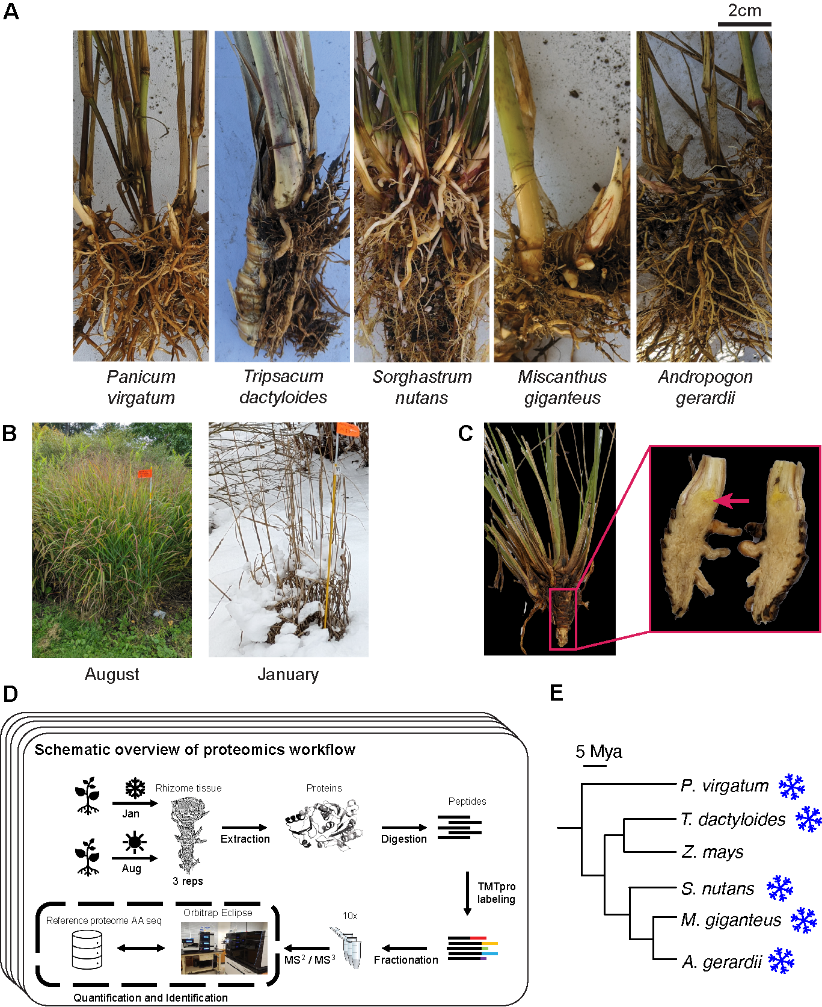
Fig. 1. Overview of sampling and proteomics workflow. (A) Rhizomes from the five species sampled in the study: Tripsacum dactyloides and T. floridanum hybrids, Panicum virgatum, Andropogon gerardii, Miscanthus giganteus, and Sorghastrum nutans. (B) Field conditions during the two sampling seasons, illustrating the active growth in August and dormancy in January. (C) Example of the rhizome tissue sampled for proteomics, shown here for Tripsacum. The red arrow highlights the specific region collected. (D) Schematic overview of the proteomics workflow. Rhizome samples were collected each season, followed by protein extraction, digestion, and TMTpro labeling. Peptides were fractionated and analyzed via RTS-SPS-MS³ using an Orbitrap Eclipse mass spectrometer. Each species’ reference proteome was used for peptide and protein assignment, enabling quantification and identification. (E) Phylogeny of species presented along with Z. mays for reference; snowflakes indicate freezing tolerance.
Protein abundance analysis was performed in batches (see Methods). Across all five species a total of 20,737 proteins were quantified, but for differential accumulation across seasons we included only those quantified in both winter and summer samples (Table 1). PCA of 745 shared orthogroups confirmed clustering by species and season; batch-corrected Tripsacum samples (1,889 proteins) clustered by season regardless of hybrid background (Fig. S1). The number of identified proteins ranged from 2,372 to 4,451 per species. Differentially abundant proteins (DAPs) varied across species, with 58–174 proteins significantly increased and 56–218 decreased in abundance under freezing conditions (Table 1). Although fewer proteins were identified in Sorghastrum nutans, reflecting its draft genome status (Supporting Information Table S2), robust seasonal signatures were detectable across all five lineages (Fig. S2).
Table 1. Summary of rhizome proteomics datasets for Tripsacum hybrids, Andropogon gerardii, Miscanthus × giganteus, Panicum virgatum, and Sorghastrum nutans, including number of samples per season, total proteins quantified, proteins shared across seasons, and differentially accumulated proteins (DAPs) accumulated (up) or depleted (down) in winter.
Species | Year | N samples | Genotype / Cultivar | Entry code | Clonal reps | Proteins quantified |  | DAP up | DAP down
 |  |  |  |  |  | Total | Shared winter/summer
Tripsacum spp. | 2019 | 8 | T. dactyloides 'IA_Pete_2' × T. floridanum | C002 | 1 | 4,451 | 4,451 | 123 | 175
 |  |  | T. dactyloides 'KS_C9_9' × T. floridanum | C004 | 1
 |  |  | T. dactyloides 'KS_B6_1' × T. floridanum | C022 | 3
 |  |  | T. dactyloides 'KS_C9_10' × T. floridanum | C031 | 1
 |  |  | T. dactyloides 'IA_Pete_1' × T. dactyloides 'FL' | C071 | 1
 |  |  | T. dactyloides 'TX_HC_3' × T. dactyloides 'MO_TP' | C076 | 1
Tripsacum spp. | 2022 | 24 | T. dactyloides 'IA_Pete_2' × T. floridanum | C002 | 3 | 3,468 | 3,054 | 100 | 141
 |  |  | T. dactyloides 'KS_C9_9' × T. floridanum | C004 | 3
 |  |  | T. dactyloides 'KS_B6_1' × T. floridanum | C022 | 3
 |  |  | T. dactyloides 'KS_C7_3' × T. floridanum | C027 | 3
 |  |  | T. dactyloides 'IL_10_1' × T. floridanum | C043 | 3
 |  |  | T. dactyloides 'IL_14' × T. dactyloides 'FL' | C065 | 3
 |  |  | T. dactyloides 'IA_Pete_1' × T. dactyloides 'FL' | C071 | 3
 |  |  | T. dactyloides 'TX_HC_3' × T. dactyloides 'MO_TP' | C076 | 3
Andropogon gerardii | 2022 | 3 | Sentinel | 01-266*A | 3 | 3,734 | 3,733 | 109 | 76
Miscanthus × giganteus | 2022 | 3 | - | 88-363*A | 3 | 2,372 | 2,273 | 58 | 83
Panicum virgatum | 2022 | 3 | Dust Devil | 01-277*B | 3 | 4,071 | 4,068 | 174 | 218
Sorghastrum nutans | 2022 | 2 | Golden Sunset | 22-095*A | 2 | 2,641 | 2,464 | 66 | 56

Cross-Species comparative proteomic analysis reveals conserved seasonal protein accumulation patterns
We restricted our comparative analysis to the 18,454 proteins assigned to 4,888 orthogroups identified across species (Supporting Information Tables S3 and S4). Seasonal fold-changes were positively correlated across all species pairs (ρ = 0.37-0.69; Fig. 2A), with specific orthogroups—including LEA3, GST, HSP1, and PEBP—consistently identified as differentially abundant. To test whether this conservation reflects evolutionary constraint on cold response, we compared fold-change correlations between shared DAPs (differential abundance in ≥2 species; n = 135 orthogroups) and background proteins (≤1 species; n = 1,548). Shared DAPs showed substantially higher correlation in seasonal response magnitude (ρ = 0.80) than background (ρ = 0.45; P = 1.1×10⁻⁵; Fig. 2B). Notably, this constraint did not extend to basal abundance, where shared DAPs showed slightly lower correlation than background (ρ = 0.62 vs 0.68; P = 0.004). This pattern—tight constraint on response dynamics but flexibility in baseline levels—suggests that independent cold adaptations relied on parallel regulation of a core set of protective proteins.
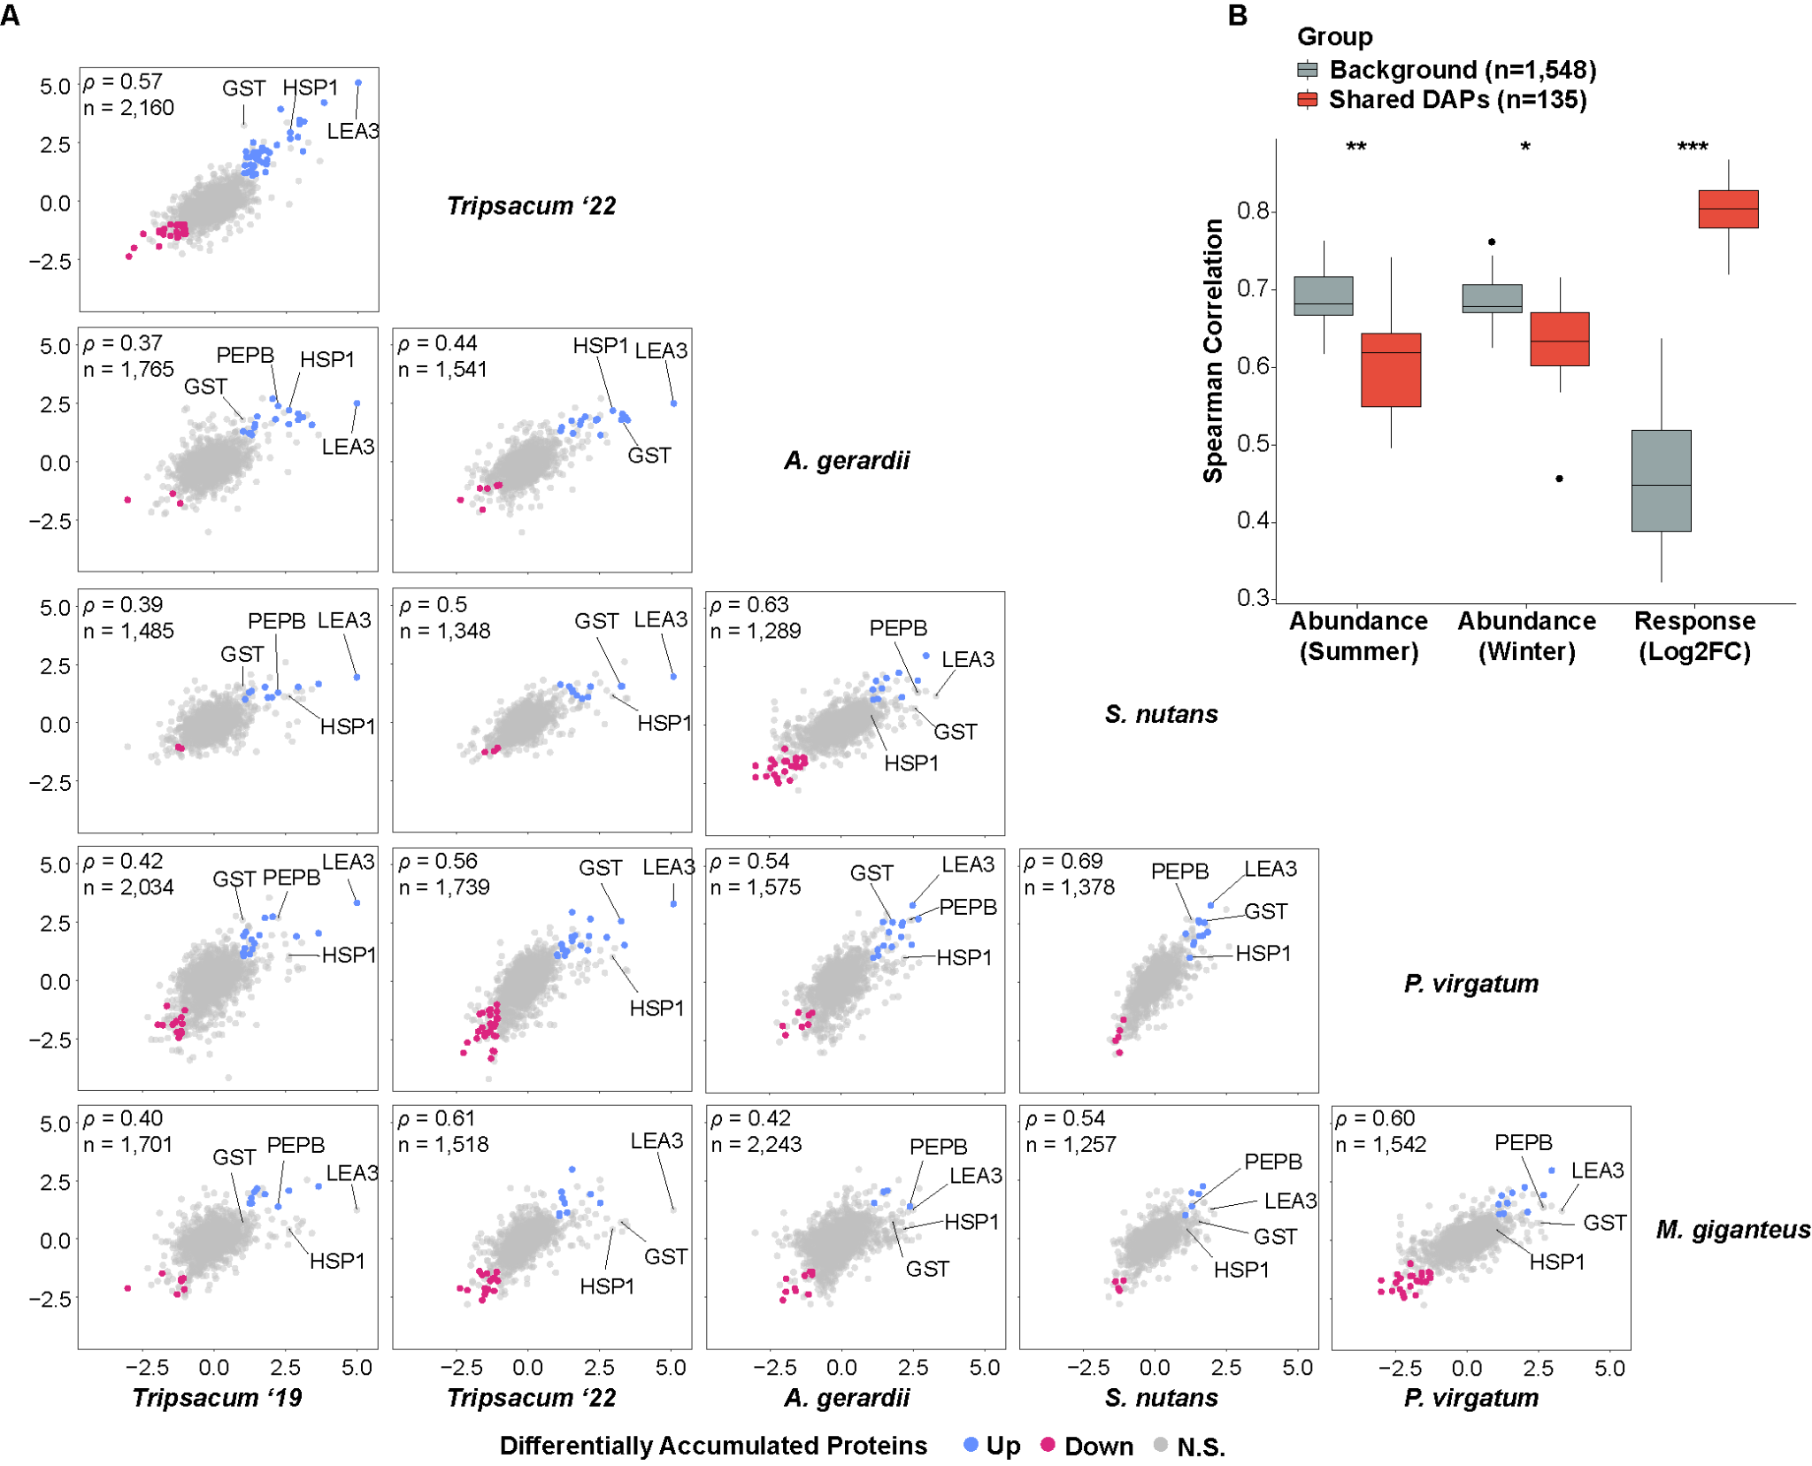
Fig. 2. Conservation of seasonal protein accumulation in rhizomes of Tripsacum dactyloides and T. floridanum hybrids, Andropogon gerardii, Miscanthus × giganteus, Panicum virgatum, and Sorghastrum nutans. (A) Pairwise comparisons of log₂ fold-change (log₂FC winter/summer) in differentially accumulated orthogroups across species. Scatterplots display the correlation of orthogroup-level log₂FC values between species, with shared DAPs elevated in winter shown in blue, reduced in red, and non-significant proteins in gray. Each panel represents a comparison between two species, with the number of shared orthogroups (n) and Spearman’s correlation coefficient (ρ) displayed. (B) Pairwise Spearman correlations for orthogroups quantified in at least four of five species, comparing shared DAPs (red; differentially abundant in ≥2 species) versus background orthogroups (gray; differentially abundant in ≤1 species). Correlations are shown for summer abundance, winter abundance, and seasonal response magnitude (log₂FC winter/summer). Wilcoxon rank-sum test: *P < 0.05, **P < 0.01, ***P < 0.001.

Ortholog and pathway sharing across species
We next examined orthogroup sharing across species (Fig. S3). Winter-elevated orthogroups showed greater conservation than winter-reduced: 27% of 330 winter-elevated orthogroups were shared across at least two species versus 21% of 470 winter-reduced orthogroups. Variation in identified proteins partly reflects reference proteome completeness—S. nutans, with a draft genome containing 26% ambiguous bases, yielded fewer identifications (Supporting Information Table S2).
GO enrichment analysis revealed distinct functional signatures (Fig. S4). Winter-elevated proteins were enriched for protein folding, stress response, cold acclimation, and ROS scavenging (Supporting Information Table S5). Winter-reduced proteins were enriched for microtubule-based processes, mitotic cell cycle, cytoskeleton organization, and cell wall biogenesis—processes associated with active growth (Supporting Information Table S6). The greater conservation of winter-elevated orthogroups suggests that protective responses to freezing are more constrained than growth-related processes active during summer. To identify the most conserved functional themes, we examined the 50 most winter-elevated proteins per species (Fig. 3; Supporting Information Table S7). LEAs and heat shock proteins (HSPs) were present in at least four of five species. A chi-square test on standard GO categories revealed significant species heterogeneity (χ²[70] = 97.5, P = 0.017), but GO terms may conflate cold-specific processes with broader stress responses. (Barnes et al., 2023). Using curated cold-related categories (see Methods), 63% of proteins mapped to one of nine functional groups (Fig. S7). Heterogeneity remained significant (χ²[40] = 58.1, P = 0.032; Fig. 3A), indicating that while species share the same core functional categories, they differ in relative investment. Detoxification and ROS scavenging proteins were represented in all five species. Metabolism/osmoregulation proteins were less prominent in A. gerardii, while protein aggregation and membrane stability proteins were enriched in A. gerardii and P. virgatum. These patterns indicate a shared functional core with lineage-specific variation in relative allocation (Fig. 3A), particularly in metabolism/osmoregulation and protein folding/stability.
LEA3 (OG0022470) was the only ortholog ranked among the top 10 winter-elevated proteins in all five species, and was the single most elevated protein in Tripsacum (log₂FC = 5.0; Fig. 3B; Supporting Information Table S8). Other functional categories showed species-specific representation: HSPs appeared in the top 10 for Tripsacum (HSP22, Class IV) and S. nutans (HSP23.2) but involved different family members; ROS scavenging was universal but employed glutathione transferases in four species and peroxidases in A. gerardii; putative antifreeze proteins (chitinases) ranked highly in S. nutans and A. gerardii. This pattern—a single conserved ortholog (LEA3) alongside functionally equivalent but distinct proteins in other categories—exemplifies parallel recruitment of LEA3 alongside functional convergence for chaperone and antioxidant functions.
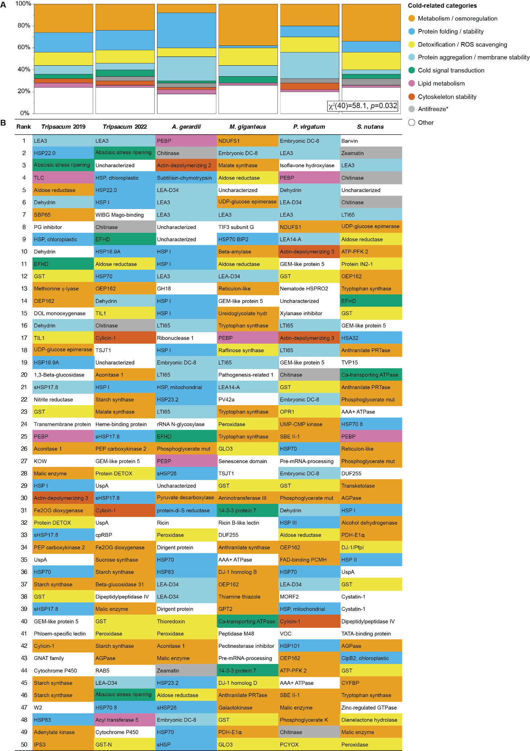
Fig. 3. Overview of cold-related functional categories represented among the top 50 most winter-enriched rhizome proteins Tripsacum dactyloides and T. floridanum hybrids, Andropogon gerardii, Miscanthus × giganteus, Panicum virgatum, and Sorghastrum nutans. (A) Mosaic plot of cold-related functional categories across species. This plot visualizes the distribution of proteins among cold-related functional categories for each species. The relative abundance of each category within a species is shown, highlighting distinct functional profiles and species-specific variations in cold tolerance mechanisms. A Chi-square test for independence (χ²[40] = 58.1, P = 0.032) was performed to evaluate variation across species. (B) Visual representation of cold-related functional categories in rhizome proteins of five Andropogoneae species. This figure illustrates the top 50 most abundant proteins within the rhizomes of five Andropogoneae species. Proteins are classified into functional categories relevant to cold-related mechanisms, such as metabolism/osmoregulation, cold signal transduction, membrane stability, lipid metabolism, and others. Color-coding facilitates a comparative visualization of cold tolerance mechanisms across species. Antifreeze proteins are marked by an asterisk, as their classification is based solely on protein homology.

Evolutionary patterns in accumulated protein families
Phylogenetic analysis revealed distinct evolutionary patterns between LEAs and HSP families (Fig. 4). The control elongation factor 1 protein (EF1) family, previously shown to have stable expression at transcript and protein levels across conditions (Takamori et al., 2017), Fig. 4A), showed minimal seasonal accumulation and no phylogenetic clustering of abundance level patterns, consistent with their housekeeping function (Supporting Information Table S8). HSPs showed greater diversity (212 proteins across 37 orthogroups, Supporting Information Table S9) compared to LEAs (66 proteins in 20 orthogroups, Supporting Information Table S10), with control EF1 comprising 33 proteins in 4 orthogroups. Both LEA and HSP phylogeny (Figs. 4B and C) resolved into clear functional sub-families, but among HSPs the most strongly winter-elevated members (log₂FC > 2.5) belonged to different clades across different species, with only 32% of HSP proteins significantly elevated in winter. In contrast, LEA proteins (Fig. 4B) demonstrated more consistent winter abundance (47% of the proteins), particularly within the LEA3 subfamily, which displayed elevated abundance across all species despite having diverged earlier than other LEA clades.
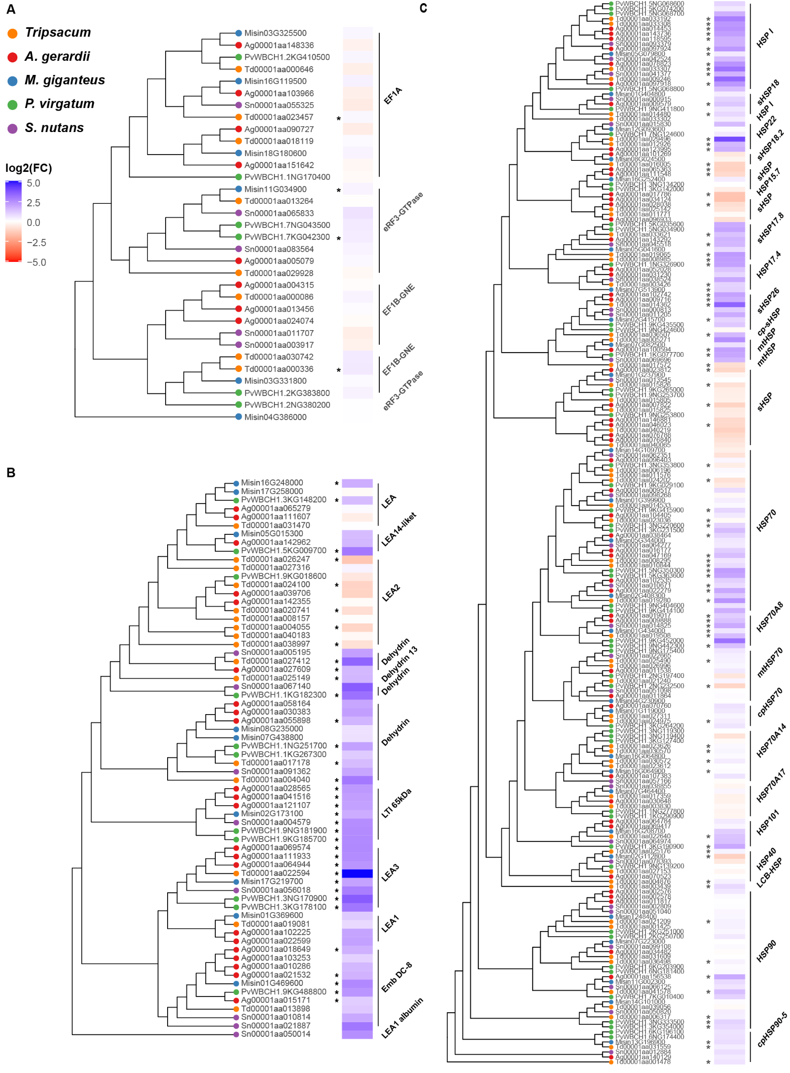
Fig. 4. Phylogenetic analysis and seasonal abundance dynamics of selected protein families across Tripsacum dactyloides and T. floridanum hybrids, Panicum virgatum, Andropogon gerardii, Miscanthus × giganteus, and Sorghastrum nutans. Protein identifiers represent species-specific sequences, and brackets denote functional group annotations, merging adjacent orthogroups with similar functions for clarity. Heat maps illustrate log₂ fold-change (log₂FC) in protein abundance between winter and summer conditions, where blue indicates higher abundance in winter, and red signifies higher summer abundance. Panels show distinct protein families: (A) translation elongation factor 1 proteins (EF1; control group) , (B) late embryogenesis abundant (LEA) proteins, and (C) heat shock proteins (HSPs). Asterisks (*) mark proteins exhibiting statistically significant differential accumulation (P < 0.05).

Beyond rhizomes: Comparison with maize & Tripsacum mRNA
We next tested whether rhizome protein signatures corresponded to mRNA responses in other tissues. Cold-induced mRNA in F₂ seedling leaves of Tripsacum, derived from the same hybrids used in our rhizome study, showed weak but significant correlation with rhizome protein fold-changes (ρ = 0.29, P < 0.001; Fig. S5A). Other Tripsacum tissues showed weaker correlations (ρ = 0.08–0.16; Fig. S5B–E), as did maize orthologs (ρ = 0.01–0.09; Figs. S5F–I). Despite these weak overall correlations, LEA3 displayed strong cold induction in leaves of both species (log₂FC = 8 in Tripsacum, and 7 in maize; Fig. S5A, F). That maize induces LEA3 transcription to levels comparable to cold-tolerant Tripsacum, yet remains freezing-sensitive, suggests that transcriptional induction alone does not confer protection.

Structural and Functional Insights into LEA3: A Key Player in Freezing Tolerance
LEA3 (OG0022470) was the only ortholog consistently elevated across all five species, ranking as the top DAP in Tripsacum rhizomes (log₂FC = 5.0) and the most cold-induced transcript in leaves (log₂FC = 8). Sequence alignment of the Tripsacum and Zea mays orthologs revealed a specific divergence in the maize protein affecting the periodicity of the conserved motifs and hydropathy profiles (Fig. 5). LEA3 proteins are defined by a repeating 11-mer motif described by Dure as essential for desiccation and freezing tolerance (Dure, 1993). These motifs feature apolar residues at positions 1, 2, 5, and 9, forming the hydrophobic face of an amphipathic α-helix critical for stabilizing cellular membranes and preventing protein aggregation. Positions 6, 7, and 8 exhibit either a "+ − +" or "+ Q +" charge arrangement. Tripsacum LEA3 (Td00001aa022594) contains six consecutive 11-mer motifs adhering closely to Dure's rules (Fig. 5A). These motifs align with the α-helical domains in the AlphaFold3-predicted structure (Fig. 5B). Kyte-Doolittle hydropathy analysis shows regular oscillations with 11-residue periodicity, consistent with intact amphipathic helices (Fig. 5C). The maize ortholog (Zm00001eb294480) contains only four motifs interrupted by a 15-amino-acid insertion that disrupts regular motif spacing, producing an irregular hydropathy profile (Fig. 5C).
Quantitative comparison of the motif region (positions 40–101) revealed that mean hydropathy at Dure's hydrophobic positions (1, 2, 5, 9) averaged approximately −1.1 in Tripsacum, whereas the maize ortholog showed values 15–20% more hydrophilic at corresponding positions. The disruption is most pronounced in positions 70–80, where individual position differences exceed |Δ| = 1.0, and in positions 87–101, where the Td–Zm hydropathy pattern correlation becomes strongly negative (r = −0.81, n = 15 positions), indicating that the hydrophobic and hydrophilic faces are misaligned relative to the conserved architecture (Supporting Information Table S11). Hydropathy profiles from other cold-tolerant species—including other PACMAD grasses, wheat (TdLEA3; (Koubaa et al., 2019), and Arabidopsis (AtLEA7; (Popova et al., 2015)—show oscillating patterns similar to Tripsacum, not maize (Fig. S6). These structural differences suggest that transcriptional induction of LEA3 alone may not ensure freezing tolerance; functional protection may depend on both sufficient abundance and intact motif architecture.

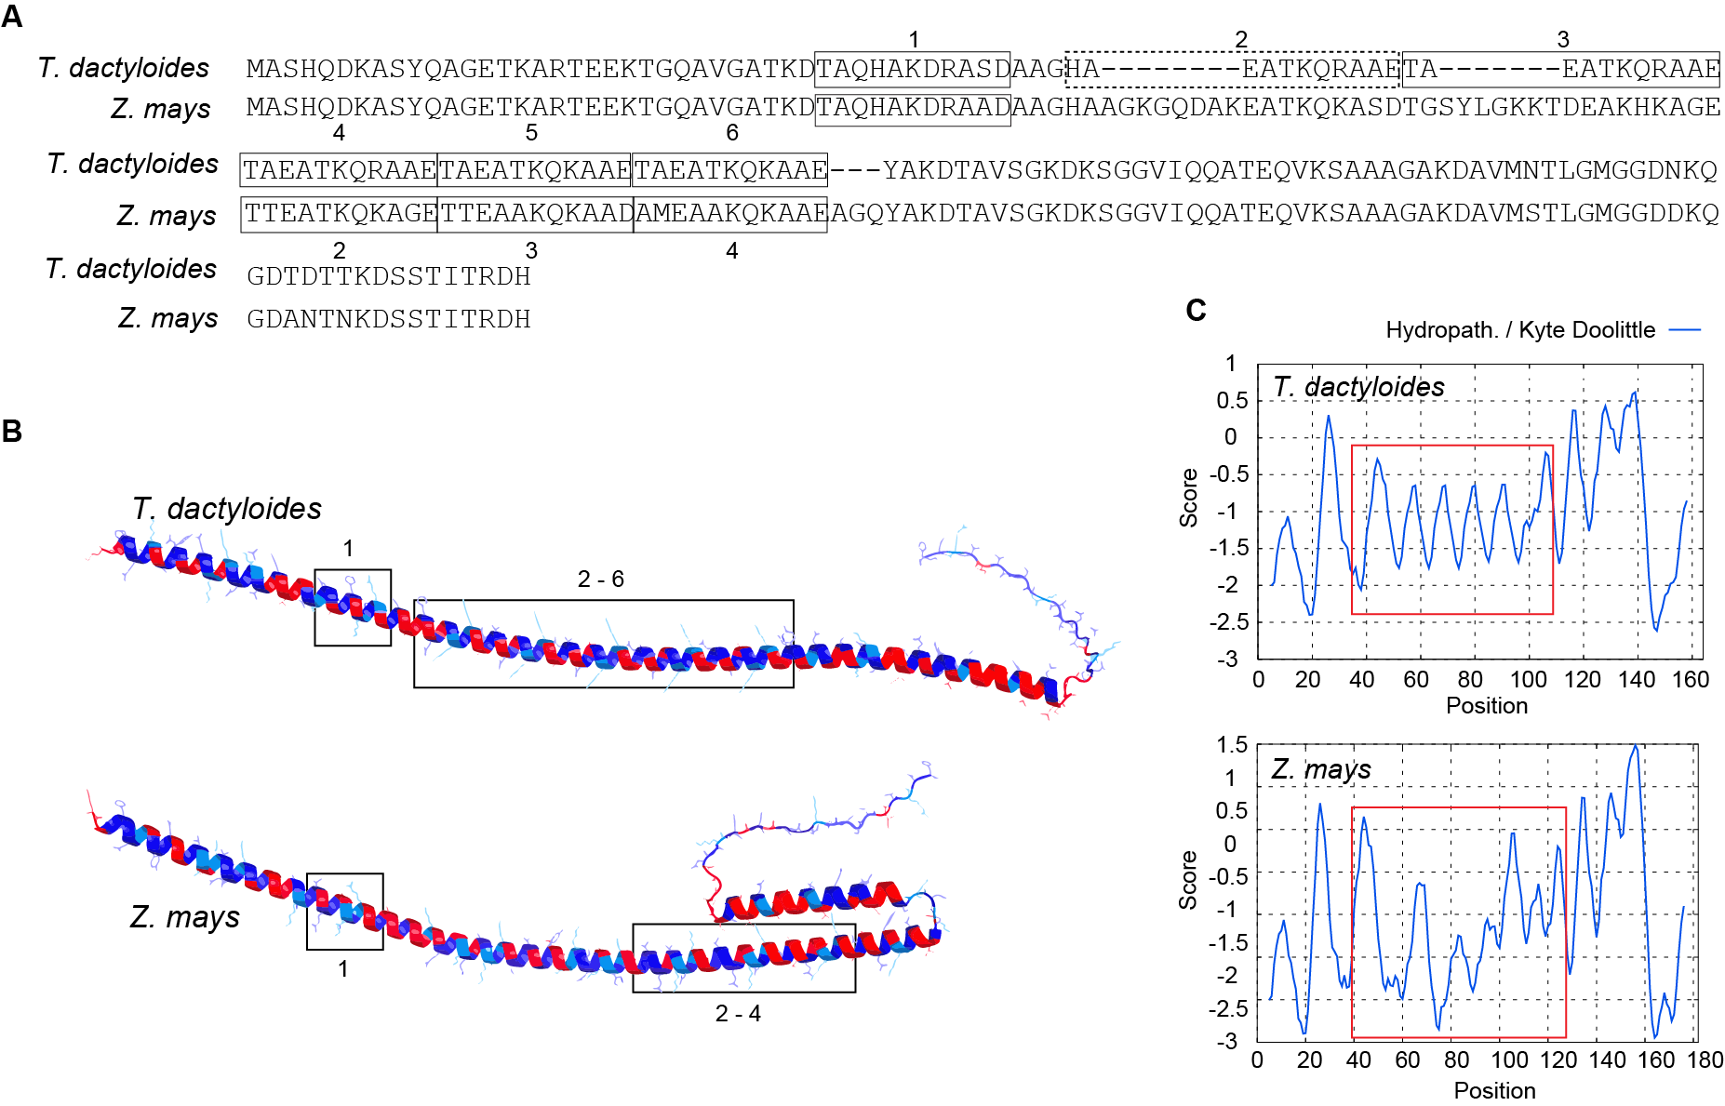
Fig. 5. Protein sequence alignment, structure and hydrophobicity of LEA3 orthologs from Tripsacum dactyloides and Zea mays. (A) The alignment shows the LEA3 proteins from T. dactyloides (Td00001aa022594_T002) and, Z. mays (Zm00001eb294480), with the repeating 11-mer LEA3 motifs highlighted and labeled numerically. The dashed motif deviates from Dure’s LEA3 motifs in the first position. (B) Predicted secondary structure of LEA3 proteins using AlphaFold3, showing the conserved alpha-helical domains across T. dactyloides (top) and Z. mays (bottom). LEA motif regions corresponding to labeled sequence motifs (e.g., 1, 2–6) are boxed. Red and blue indicate regions of high hydrophilicity and hydrophobicity, respectively. (C) Kyte-Doolittle hydropathy plots for LEA3 proteins. The X-axis represents residue position, while the Y-axis indicates hydropathicity scores (positive values for hydrophobic regions, negative for hydrophilic regions). 11-mer motif regions are highlighted with red boxes, corresponding to key domains in (B).

Discussion
Our analysis of rhizome proteomes from five independently cold-adapted PACMAD grasses reveals that protein-level cold responses combine ancestral retention of core protective orthologs with convergent deployment of functionally equivalent but phylogenetically distinct proteins. The clearest example of retention is LEA3, accumulated across all five lineages: its early divergence from other LEA subfamilies (Fig. 4B) and the conservation of its 11-mer motif architecture across cold-tolerant species suggest that the cryoprotective capacity of LEA3 predates the PACMAD radiation and has been maintained under constraint in lineages that colonized cold environments.In contrast, the chaperone response illustrates convergent evolution: different HSP family members are recruited in different species, suggesting that chaperone-mediated protection permits greater flexibility in which family members are deployed. To our knowledge, this study provides the first quantitative comparison of cross-species fold-change conservation at the protein level in a freezing-stress context, complementing transcript-level comparisons in Pooideae (Schubert et al., 2019) and desiccation-tolerance studies in resurrection grasses (Marks et al., 2024).
The most striking finding is the evolutionary constraint on response magnitude. Among shared cold-responsive orthogroups, cross-species fold-change correlations were substantially higher (ρ = 0.80, Fig. 2B) than among background proteins (ρ = 0.45; P = 1.1 × 10⁻⁵), indicating that when freezing tolerance evolved independently across PACMAD lineages, it proceeded through quantitatively similar responses in a core set of protective proteins. Our common-garden design ensured identical winter conditions across all genotypes, with winter collections following sustained sub-zero exposure reaching −16°C and soil temperatures below 2–5°C for 20–22 days (Brotzge et al., 2020), while summer collections captured vigorous growth with actively emerging rhizome buds after >90 mm cumulative precipitation (Fig. S9), establishing these seasonal contrasts as cold-driven rather than drought-related. ​​A limitation of this design is that all species experienced identical winter conditions rather than stress calibrated to each species' tolerance threshold.
With these responses established as cold-driven, their conservation contrasts sharply with transcript-level patterns: comparative transcriptomics in Pooideae found generally low similarity in cold-responsive gene expression across species (r = 0.09–0.40; Schubert et al., 2019), with nearly half of all cold-responsive genes being species-specific. This comparison spans different clades, tissues, and experimental designs — our PACMAD rhizome proteomes versus Pooideae seedling transcriptomes — so the gap between protein-level and transcript-level correlations may be confounded. Nevertheless, the direction is consistent with the framework of Cope et al. (2025), who demonstrated that protein abundances are under stronger stabilizing selection than mRNA abundances over macroevolutionary timescales, with mutations affecting mRNA levels largely buffered before they alter protein output. If this buffering operates on cold-responsive genes as it does genome-wide, then transcript-level comparisons would systematically underestimate the degree of evolutionary conservation in stress responses. Notably, this constraint applies specifically to the dynamic response: absolute abundance correlations for shared cold-responsive proteins were lower than background in both summer (ρ = 0.62 vs 0.68; P = 0.004) and winter (Fig. 2B), indicating that these proteins are more divergent across species in their resting and stress-state levels. What is conserved is not the absolute abundance in either season, but the magnitude of accumulation when freezing arrives. This divergence in absolute levels likely reflects the distinct physiological contexts of each species' rhizomes, including differences in dormancy depth, metabolic rate, or tissue composition, while the conserved fold-change suggests that selection acts primarily on the dynamic response rather than on any single optimal protein concentration.
LEA3 provides the clearest illustration of this constraint and connects the evolutionary pattern to a mechanistic hypothesis. LEA proteins function as molecular shields during freezing through membrane stabilization, the prevention of aggregation, and the protection of client proteins through steric exclusion and stress induced conformational changes (Kovacs et al., 2008; Cuevas-Velazquez et al., 2017). These functions depend on the repeating 11-mer motif architecture, described by (Dure, 1993), in which apolar residues form the hydrophobic face of α-helices that bind membranes and partially unfolded proteins during dehydration and freezing (Koubaa et al., 2019; Singh & Graether, 2021).
Among cold-tolerant PACMAD grasses and outgroup species including wheat (Koubaa et al., 2019) and Arabidopsis (Popova et al., 2015), LEA3 proteins maintain this architecture, producing regular hydropathy oscillations with 11-residue periodicity (Fig. S6). The maize ortholog, by contrast, contains a 15-amino-acid insertion that may impair motif spacing, producing a hydropathy profile in which the hydrophobic and hydrophilic faces are misaligned relative to the conserved architecture (Fig. 5C; Supporting Information Table S11). Because amphipathic helix function depends on a continuous hydrophobic face for membrane association (Singh & Graether, 2021), this disruption may directly impair the capacity of ZmLEA3 to stabilize membranes, protect enzymes or form oligomers during freezing. AlphaFold3 multimer predictions for TdLEA3 and ZmLEA3 are consistent with this, with notable differences in packing geometry (Fig. S8). This interpretation is supported by observations that cold-regulated cereal LEA3 proteins require conserved domains for oligomerization (NDong et al., 2002) and Arabidopsis LEA3 proteins form higher-order assemblies under stress (Ginsawaeng et al., 2021; Romero-Pérez et al., 2024).
Although ZmLEA3 is cold-inducible and confers partial cold tolerance (Liu et al., 2013), maize remains freezing-sensitive despite accumulating transcripts to levels comparable to the cold-tolerant Tripsacum in leaves (Fig. S5F). This underscores a key point: transcriptional induction alone does not ensure protection. Functional efficacy may depend on both sufficient abundance and intact motif structure. The early divergence of LEA3 from other LEA subfamilies (Fig. 4B) is consistent with this interpretation: the molecular properties enabling cryoprotection were likely present before the PACMAD radiation, representing ancestral capacity maintained under purifying selection in lineages that colonized cold environments and structurally degraded where freezing selection was relaxed, as in maize.
That said, freezing survival involves the coordinated action of numerous protective mechanisms, and restoring a single protein's architecture in a freezing-sensitive species would be unlikely to confer full tolerance. Rather, LEA3 illustrates how structural constraints at the protein level could limit the efficacy of otherwise conserved transcriptional responses.
More broadly, several of the most consistently accumulated proteins across PACMAD rhizomes have well-characterized orthologs implicated in cold acclimation in Arabidopsis, including LEA proteins, small HSPs, and glutathione S-transferases (Marrs, 1996; Sun et al., 2002; Hundertmark & Hincha, 2008), indicating deep conservation of core protective pathways across monocots and dicots. However, some highly accumulated proteins in PACMAD rhizomes—notably PEBP family members and certain chitinase-like proteins—have not been prominently featured in Arabidopsis cold studies, potentially reflecting grass-specific or rhizome-specific adaptations (Roeder et al., 2025).
The presence of ABA-inducible proteins and dehydrins among the most accumulated winter proteins across species is consistent with the hypothesis that freezing tolerance in PACMAD grasses evolved partly by co-opting existing drought-tolerance pathways. This aligns with phylogenetic evidence that drought tolerance served as an evolutionary precursor to frost tolerance in grasses (Schat et al., 2025). Similar patterns of pre-adaptation followed by lineage-specific elaboration have been documented in resurrection grasses (Marks et al., 2024).
In conclusion, rhizome freezing tolerance across independently cold-adapted PACMAD grasses is governed by the retention of ancestral protective proteins under quantitative constraint on response magnitude, combined with convergent deployment of diverse protein families for chaperone and antioxidant functions. This constraint is substantially stronger at the protein level than previously observed at the transcript level. The structural differences between Tripsacum and maize LEA3—canonical motif architecture maintained in a cold-adapted lineage versus possibly disrupted architecture in a tropical relative—offer a candidate mechanism for enhancing freezing resilience in maize. Future work should prioritize functional validation of LEA3 structural variants, particularly testing whether restoring the conserved motif, either through transgenic complementation or targeted editing of the ZmLEA3 insertion, can enhance frost tolerance in maize.

Acknowledgments
We thank Cornell Botanic Gardens for their support of this study and for maintaining the field plots that provided essential plant material, particularly Kristine Boys, Emily Detrick (Elizabeth Weaver Director of Horticulture), and Todd Bittner (Director of Natural Areas). We acknowledge the Proteomics and Metabolomics Facility at the Cornell Institute of Biotechnology (RRID:SCR_021743) for providing mass spectrometry services and data analysis. We are grateful to Prof. Hening Lin for funding support from the HHMI Transformative Technology 2019 program for the Orbitrap Eclipse system, and to Dr. Sheng Zhang for NIH SIG grant support (1S10 OD017992-01 for the Orbitrap Fusion mass spectrometer and 1S10 RR025449-01 for the Orbitrap Velos/Elite mass spectrometer). We extend our appreciation to Elizabeth T. Anderson and Robert W. Sherwood at the Proteomics and Metabolomics Facility for their technical expertise and assistance with sample processing and analysis. We thank the Genomics Facility (RRID:SCR_021727) of the Biotechnology Resource Center at the Cornell Institute of Biotechnology for their assistance with sequencing experiments. Additional computational resources and data management were provided by the Bioinformatics Facility (RRID:SCR_021757) at the Cornell Institute of Biotechnology. This research is made possible by the New York State (NYS) Mesonet. Original funding for the NYS Mesonet (NYSM) buildup was provided by the Federal Emergency Management Agency grant FEMA-4085-DR-NY. The continued operation and maintenance of the NYSM is supported by the National Mesonet Program, University at Albany, Federal and private grants, and others. We acknowledge all who have contributed to the preservation, cultivation and study of wild and domesticated grasses.

Competing interests
The authors declare no competing interests.

Author Contributions
M.C.R., T.E.R., and E.O. conceived and designed the study. N.L. and T.E.R. developed the long-term sampling strategy that enabled seasonal comparisons. N.L., T.E.R., T.L., S.-K.H., C.M.G., and E.O. performed sample collection and experimental work. T.L., R.A., and Q.F. conducted proteomics sample preparation, LC-MS/MS, and data processing. C.M.G., J.H., T.L., and J.Z. performed RNA-seq analysis. J.Z., S.-K.H., and E.O. carried out bioinformatics and statistical analysis. J.Z., S.-K.H., C.O.H., and E.O. prepared the figures. E.O., J.Z., L.J.B., and E.S.B. wrote the manuscript. C.O.H., L.J.B., S.-K.H., J.H., Q.F., E.S.B., and M.C.R. reviewed and edited the manuscript. E.O. and M.C.R. supervised the project and E.S.B. and M.C.R acquired funding.

Funding
This research was supported by the National Science Foundation under Grant Number 1822330, and the U.S. Department of Agriculture–Agricultural Research Service (USDA-ARS) under Project Number 5030-21000-072-00-D (Corn Insects and Crop Genetics Research Unit, Ames, Iowa), Project Number 6066-21310-005-00-D (Genomics and Bioinformatics Research Unit, Stoneville, MS), Project Number 8062-21000-043-00-D (Plant, Soil and Nutrition Research Unit, Ithaca, NY), and the United States - Israel Binational Agricultural Research and Development Fund, Vaadia-BARD Postdoctoral Fellowship Award No. FI-628-2022. C.M.G. was supported by the National Science Foundation Postdoctoral Research Fellowship in Biology under Grant No. 1523861. Research in the lab of J.H. is supported by USDA NIFA (2022-67013-37040). Q.F. was supported by HHMI Transformative Technology 2019 program for the OrbitrapEclipse system.

Data Availability
The mass spectrometry proteomics data have been deposited to the ProteomeXchange Consortium via the PRIDE (Perez-Riverol et al., 2025) partner repository with the dataset identifier PXD063668 (Sample key file in Supporting Information Table S12). RNA-seq data are available under BioProject accession numbers PRJNA705456 (Zea mays) and PRJNA1260937 (Tripsacum dactyloides) in the NCBI BioProject database (https://www.ncbi.nlm.nih.gov/bioproject/). Genome assemblies and annotations used in this study are publicly available from MaizeGDB (Woodhouse et al., 2021) at https://maizegdb.org/PanAnd_project for Tripsacum dactyloides (Td-FL_9056069_6-DRAFT-PanAnd-1.0), Andropogon gerardii (Ag-CAM1351-DRAFT-PanAnd-1.0), and Sorghastrum nutans (Sn-CAM1369-DRAFT-PanAnd-1.0), and from the JGI Data Portal (Goodstein et al., 2012) at https://data.jgi.doe.gov/ for Miscanthus giganteus (Msinensis_497_v7.0) and Panicum virgatum (Pvirgatumvar_WBCHAP1_778_v1.0), along with their corresponding GFF annotation files. Functional annotations, data tables, and analysis scripts are available from GitHub at https://github.com/elor77/PACMAD-Rhizome-Proteomics.

References
Abramson J, Adler J, Dunger J, Evans R, Green T, Pritzel A, Ronneberger O, Willmore L, Ballard AJ, Bambrick J, et al. 2024. Accurate structure prediction of biomolecular interactions with AlphaFold 3. Nature 630: 493–500.
Aroca R, Porcel R, Ruiz-Lozano JM. 2012. Regulation of root water uptake under abiotic stress conditions. J. Exp. Bot. 63: 43–57.
Barnes AC, Benning C, Roston RL. 2016. Chloroplast membrane remodeling during freezing stress is accompanied by cytoplasmic acidification activating SENSITIVE TO FREEZING2. Plant Physiol. 171: 2140–2149.
Barnes AC, Myers JL, Surber SM, Liang Z, Mower JP, Schnable JC, Roston RL. 2023. Oligogalactolipid production during cold challenge is conserved in early diverging lineages. J. Exp. Bot. 74: 5405–5417.
Bolger AM, Lohse M, Usadel B. 2014. Trimmomatic: a flexible trimmer for Illumina sequence data. Bioinformatics 30: 2114–2120.
Buchfink B, Reuter K, Drost H-G. 2021. Sensitive protein alignments at tree-of-life scale using DIAMOND. Nat. Methods 18: 366–368.
Chen L, Luo J, Jin M, Yang N, Liu X, Peng Y, Li W, Phillips A, Cameron B, Bernal JS, et al. 2022. Genome sequencing reveals evidence of adaptive variation in the genus Zea. Nat. Genet. 54: 1736–1745.
Cope AL, Schraiber JG, Pennell M. 2025. Macroevolutionary divergence of gene expression driven by selection on protein abundance. Science 387: 1063–1068.
Cuevas-Velazquez CL, Reyes JL, Covarrubias AA. 2017. Group 4 late embryogenesis abundant proteins as a model to study intrinsically disordered proteins in plants. Plant Signal. Behav. 12: e1343777.
Degenkolbe T, Giavalisco P, Zuther E, Seiwert B, Hincha DK, Willmitzer L. 2012. Differential remodeling of the lipidome during cold acclimation in natural accessions of Arabidopsis thaliana: Lipidomics of Arabidopsis cold acclimation. Plant J. 72: 972–982.
Domon J-M, Baldwin L, Acket S, Caudeville E, Arnoult S, Zub H, Gillet F, Lejeune-Hénaut I, Brancourt-Hulmel M, Pelloux J, et al. 2013. Cell wall compositional modifications of Miscanthus ecotypes in response to cold acclimation. Phytochemistry 85: 51–61.
Dure L 3rd. 1993. A repeating 11-mer amino acid motif and plant desiccation. Plant J. 3: 363–369.
Emms DM, Kelly S. 2019. OrthoFinder: phylogenetic orthology inference for comparative genomics. Genome Biol. 20: 238.
Fu Q, Liu Z, Bhawal R, Anderson ET, Sherwood RW, Yang Y, Thannhauser T, Schroyen M, Tang X, Zhang H, et al. 2021. Comparison of MS2, synchronous precursor selection MS3, and real-time search MS3 methodologies for lung proteomes of hydrogen sulfide treated swine. Anal. Bioanal. Chem. 413: 419–429.
Gallaher TJ, Peterson PM, Soreng RJ, Zuloaga FO, Li D-Z, Clark LG, Tyrrell CD, Welker CAD, Kellogg EA, Teisher JK. 2022. Grasses through space and time: An overview of the biogeographical and macroevolutionary history of Poaceae. J. Syst. Evol. 60: 522–569.
Gault CM, Kremling KA, Buckler ES. 2018. Tripsacum DE novo transcriptome assemblies reveal parallel gene evolution with maize after ancient polyploidy. Plant Genome 11: 180012.
Ginsawaeng O, Heise C, Sangwan R, Karcher D, Hernández-Sánchez IE, Sampathkumar A, Zuther E. 2021. Subcellular Localization of Seed-Expressed LEA_4 Proteins Reveals Liquid-Liquid Phase Separation for LEA9 and for LEA48 Homo- and LEA42-LEA48 Heterodimers. Biomolecules 11.
Goodstein DM, Shu S, Howson R, Neupane R, Hayes RD, Fazo J, Mitros T, Dirks W, Hellsten U, Putnam N, et al. 2012. Phytozome: a comparative platform for green plant genomics. Nucleic Acids Res. 40: D1178–86.
Hundertmark M, Hincha DK. 2008. LEA (late embryogenesis abundant) proteins and their encoding genes in Arabidopsis thaliana. BMC Genomics 9: 118.
Iwaya-Inoue M, Sakurai M, Uemura M (Eds.). 2018. Survival strategies in extreme cold and desiccation: Adaptation mechanisms and their applications. Singapore, Singapore: Springer.
Kellogg EA. 2015. PACMAD Clade. In: Kellogg EA, ed. Flowering Plants. Monocots. Cham: Springer International Publishing, 267–269.
Koster KL, Lynch DV. 1992. Solute accumulation and compartmentation during the cold acclimation of Puma rye. Plant Physiol. 98: 108–113.
Koubaa S, Bremer A, Hincha DK, Brini F. 2019. Structural properties and enzyme stabilization function of the intrinsically disordered LEA_4 protein TdLEA3 from wheat. Sci. Rep. 9: 3720.
Kovacs D, Agoston B, Tompa P. 2008. Disordered plant LEA proteins as molecular chaperones. Plant Signal. Behav. 3: 710–713.
Liu Y, Liang J, Sun L, Yang X, Li D. 2016. Group 3 LEA Protein, ZmLEA3, Is Involved in Protection from Low Temperature Stress. Front. Plant Sci. 7: 1011.
Liu Y, Wang L, Xing X, Sun L, Pan J, Kong X, Zhang M, Li D. 2013. ZmLEA3, a multifunctional group 3 LEA protein from maize (Zea mays L.), is involved in biotic and abiotic stresses. Plant Cell Physiol. 54: 944–959.
Li Q, Xiang C, Xu L, Cui J, Fu S, Chen B, Yang S, Wang P, Xie Y, Wei M, et al. 2020. SMRT sequencing of a full-length transcriptome reveals transcript variants involved in C18 unsaturated fatty acid biosynthesis and metabolism pathways at chilling temperature in Pennisetum giganteum. BMC Genomics 21: 52.
Love MI, Huber W, Anders S. 2014. Moderated estimation of fold change and dispersion for RNA-seq data with DESeq2. Genome Biol. 15: 550.
Lyons JM. 1973. Chilling injury in plants. Annu. Rev. Plant Physiol. 24: 445–466.
Marks RA, Van Der Pas L, Schuster J, Gilman IS, VanBuren R. 2024. Convergent evolution of desiccation tolerance in grasses. Nat. Plants 10: 1112–1125.
Marrs KA. 1996. The functions and regulation of glutathione S-transferases in plants. Annu. Rev. Plant. Physiol. Plant. Mol. Biol. 47: 127–158.
Mori K, Renhu N, Naito M, Nakamura A, Shiba H, Yamamoto T, Suzaki T, Iida H, Miura K. 2018. Ca2+-permeable mechanosensitive channels MCA1 and MCA2 mediate cold-induced cytosolic Ca2+ increase and cold tolerance in Arabidopsis. Sci. Rep. 8: 550.
Nakashima K, Yamaguchi-Shinozaki K. 2006. Regulons involved in osmotic stress‐responsive and cold stress‐responsive gene expression in plants. Physiol. Plant. 126: 62–71.
NDong C, Danyluk J, Wilson KE, Pocock T, Huner NPA, Sarhan F. 2002. Cold-regulated cereal chloroplast late embryogenesis abundant-like proteins. Molecular characterization and functional analyses. Plant Physiol. 129: 1368–1381.
Ojeda-Rivera JO, Barnes AC, Ainsworth EA, Angelovici R, Basso B, Brindisi LJ, Brooks MD, Busch W, Buttelmann GL, Castellano MJ, et al. 2025. Designing a nitrogen-efficient cold-tolerant maize for modern agricultural systems. Plant Cell 37.
Orvar BL, Sangwan V, Omann F, Dhindsa RS. 2000. Early steps in cold sensing by plant cells: the role of actin cytoskeleton and membrane fluidity. Plant J. 23: 785–794.
Pearce R. 2001. Plant Freezing and Damage. Ann. Bot. 87: 417–424.
Perez-Riverol Y, Bandla C, Kundu DJ, Kamatchinathan S, Bai J, Hewapathirana S, John NS, Prakash A, Walzer M, Wang S, et al. 2025. The PRIDE database at 20 years: 2025 update. Nucleic Acids Res. 53: D543–D553.
Popova AV, Rausch S, Hundertmark M, Gibon Y, Hincha DK. 2015. The intrinsically disordered protein LEA7 from Arabidopsis thaliana protects the isolated enzyme lactate dehydrogenase and enzymes in a soluble leaf proteome during freezing and drying. Biochim. Biophys. Acta 1854: 1517–1525.
Puhakainen T, Hess MW, Mäkelä P, Svensson J, Heino P, Palva ET. 2004. Overexpression of multiple dehydrin genes enhances tolerance to freezing stress in Arabidopsis. Plant Mol. Biol. 54: 743–753.
Ranaweera T, Brown BNI, Wang P, Shiu S-H. 2022. Temporal regulation of cold transcriptional response in switchgrass. Front. Plant Sci. 13: 998400.
Roeder AHK, Shi Y, Yang S, Abbas M, Sasidharan R, Yanovsky MJ, Casal JJ, Ruffel S, von Wirén N, Assmann SM, et al. 2025. Translational insights into abiotic interactions: From Arabidopsis to crop plants. Plant Cell 37: koaf140.
Romero-Pérez PS, Martínez-Castro LV, Linares A, Arroyo-Mosso I, Sánchez-Puig N, Cuevas-Velazquez CL, Sukenik S, Guerrero A, Covarrubias AA. 2024. Self-association and multimer formation in AtLEA4-5, a desiccation-induced intrinsically disordered protein from plants. Protein Sci. 33: e5192.
Sage RF, Christin P-A, Edwards EJ. 2011. The C(4) plant lineages of planet Earth. J. Exp. Bot. 62: 3155–3169.
Sapay N, Guermeur Y, Deléage G. 2006. Prediction of amphipathic in-plane membrane anchors in monotopic proteins using a SVM classifier. BMC Bioinformatics 7: 255.
Schat L, Schubert M, Fjellheim S, Humphreys AM. 2025. Drought tolerance as an evolutionary precursor to frost and winter tolerance in grasses. Evolution 79: 541–556.
Schubert M, Grønvold L, Sandve SR, Hvidsten TR, Fjellheim S. 2019. Evolution of cold acclimation and its role in niche transition in the temperate grass subfamily Pooideae. Plant Physiol. 180: 404–419.
Schubert M, Humphreys AM, Lindberg CL, Preston JC, Fjellheim S. 2020. Tocoldlygo where no grass has gone before: A multidisciplinary review of cold adaptation in Poaceae. Annual Plant Reviews online: 523–562.
Singh KK, Graether SP. 2021. The in vitro structure and functions of the disordered late embryogenesis abundant three proteins. Protein Sci. 30: 678–692.
Stitzer MC, Seetharam AS, Scheben A, Hsu S-K, Schulz AJ, AuBuchon-Elder TM, El-Walid M, Ferebee TH, Hale CO, La T, et al. 2025. Extensive genome evolution distinguishes maize within a stable tribe of grasses. bioRxiv: 2025.01.22.633974.
Sun W, Van Montagu M, Verbruggen N. 2002. Small heat shock proteins and stress tolerance in plants. Biochim Biophys Acta 1577: 1–9.
Suzuki N, Mittler R. 2006. Reactive oxygen species and temperature stresses: A delicate balance between signaling and destruction. Physiol. Plant. 126: 45–51.
Takamori LM, Pereira AVC, Maia Souza G, Vieira LGE, Ferreira Ribas A. 2017. Identification of endogenous reference genes for RT-qPCR expression analysis in Urochloa brizantha under abiotic stresses. Sci. Rep. 7: 8502.
Thomashow MF. 1999. PLANT COLD ACCLIMATION: Freezing tolerance genes and regulatory mechanisms. Annu. Rev. Plant Physiol. Plant Mol. Biol. 50: 571–599.
Törönen P, Holm L. 2022. PANNZER-A practical tool for protein function prediction. Protein Sci 31: 118–128.
Vera-Hernández P, Ortega Ramírez MA, Martínez Núñez M, Ruiz-Rivas M, Rosas-Cárdenas F de F. 2018. Proline as a probable biomarker of cold stress tolerance in Sorghum (Sorghum bicolor). Mex. J. Biotechnol. 3: 77–86.
Woodhouse MR, Cannon EK, Portwood JL 2nd, Harper LC, Gardiner JM, Schaeffer ML, Andorf CM. 2021. A pan-genomic approach to genome databases using maize as a model system. BMC Plant Biol. 21: 385.
Wu B, Luo D, Yue Y, Yan H, He M, Ma X, Zhao B, Xu B, Zhu J, Wang J, et al. 2024. Haplotype-resolved genome assembly of upland switchgrass provides insights into cold tolerance. bioRxiv: 2024.08.26.609807.
Xie Z, Lin W, Yu G, Cheng Q, Xu B, Huang B. 2019. Improved cold tolerance in switchgrass by a novel CCCH-type zinc finger transcription factor gene, PvC3H72, associated with ICE1-CBF-COR regulon and ABA-responsive genes. Biotechnol. Biofuels 12: 224.
Xue C, Jiang Y, Wang Z, Shan X, Yuan Y, Hua J. 2021. Tissue-level transcriptomic responses to local and distal chilling reveal potential chilling survival mechanisms in maize. J. Exp. Bot. 72: 7610–7625.
Xu K, Zhao Y, Gu J, Zhou M, Gao L, Sun R-X, Wang W-W, Zhang S-H, Yang X-J. 2022. Proteomic analysis reveals the molecular mechanism underlying the cold acclimation and freezing tolerance of wheat (Triticum aestivum L.). Plant Sci. 318: 111242.
Zhang Y, Ngu DW, Carvalho D, Liang Z, Qiu Y, Roston RL, Schnable JC. 2017. Differentially regulated orthologs in sorghum and the subgenomes of maize. Plant Cell 29: 1938–1951.

Supporting Information
The following Supporting Information is available for this article:
Fig. S1 Overview of sampling and proteomics workflow for rhizomes of five PACMAD grass species.
Fig. S2 Conservation of seasonal protein accumulation in rhizomes of five PACMAD grass species.
Fig. S3 Overview of cold-related functional categories represented among the top 50 most winter-enriched rhizome proteins.
Fig. S4 Enriched biological processes (BP) in rhizomes of five PACMAD grass species.
Fig. S5 Scatterplots showing the relationship between rhizome proteins and cold-responsive RNA expression.
Fig. S6 Sequence alignment and hydropathy profiles of LEA3 orthologs.
Fig. S7 Stacked bar chart of biological processes within curated cold-related functional categories.
Fig. S8 AlphaFold 3 prediction of LEA3 homo-tetramer assemblies in Tripsacum and Zea mays.
Fig. S9 Rhizome morphology at sampling.
Table S1 Normalized protein abundances (log2-transformed) for all samples.
Table S2 Genome assembly statistics for the five species analyzed.
Table S3 List of 4,888 orthogroups identified across species.
Table S4 Log2 fold-changes (Winter/Summer) for all quantified proteins.
Table S5 GO enrichment analysis for winter-upregulated proteins.
Table S6 GO enrichment analysis for winter-downregulated proteins.
Table S7 Top 50 most abundant proteins in winter vs summer.
Table S8 Elongation Factor 1-alpha (EF1A) orthologs and abundance data.
Table S9 Heat Shock Protein 70 (HSP70) orthologs and abundance data.
Table S10 LEA3 orthologs and abundance data.
Table S11 Hydrophobicity scores for LEA3 orthologs.
Table S12 PRIDE sample key and metadata.
Code S1 R script for importing original Ag/Mg multiplexed peptide intensities.
Code S2 R script for re-aligning peptides using DIAMOND.
Code S3 R script for summarizing peptides into protein-level data.

