Ema Lovrić, 9.4.2026.
Assignment 1: Local data analysis of system logs

On Windows, the log files are found in Windows Event Viewer, which stores logs in a structured format. The two logs used in this project are:
- Security: Records user logons, logoffs, failed login attempts, and account changes
- System: Records service failures, driver errors, crashes, and system-level events
The script automatically exports both logs for the past 7 days using PowerShell before each run.

Python script
- Export logs: The script runs a PowerShell command to pull the last 7 days of events from the Security and System logs and saves them as CSV files.
- Parse logs: CSV is loaded with pandas. Columns are renamed to consistent names, timestamps are parsed as datetime objects, and Event IDs are mapped to labels (e.g. 4624 = Successful Logon).
- Generate visualizations: Five charts are created using Matplotlib:
  - Event frequency by level (bar): How many Critical / Error / Warning / Information events occurred
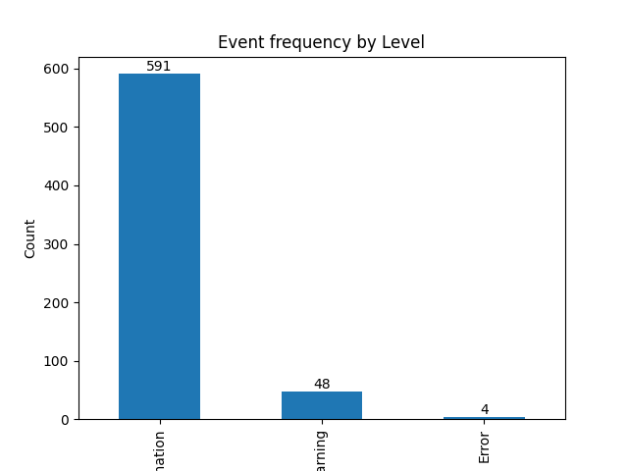

  - Event level distribution (pie): Percentage of each event level
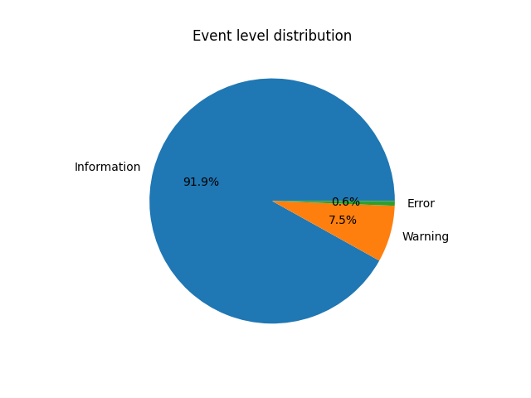
  - Events per hour (time series): Event volume over time, where spikes indicate system stress
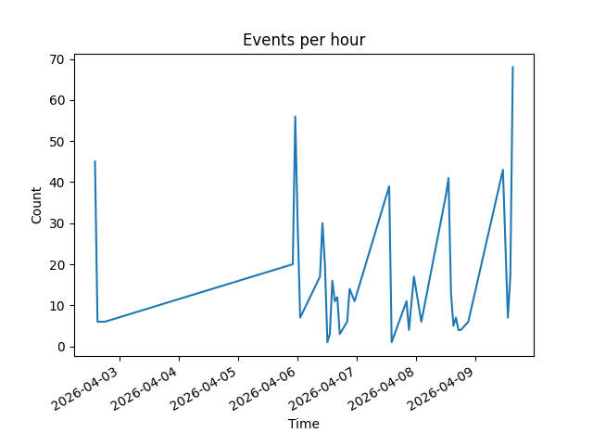
  - User login times (time series): When users logged in (Event ID 4624)
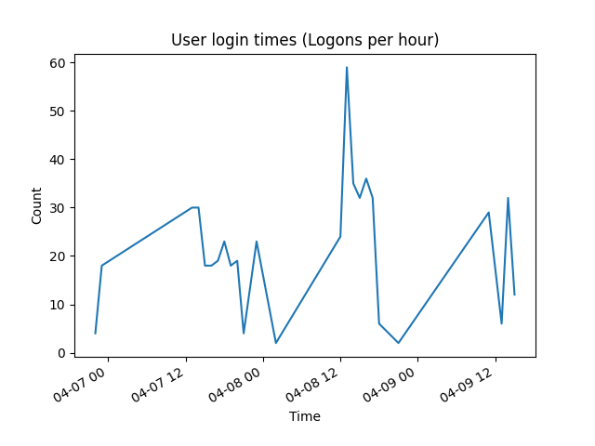
  - Successful vs failed logons (bar): Count of successful (4624) vs failed (4625) login attempts
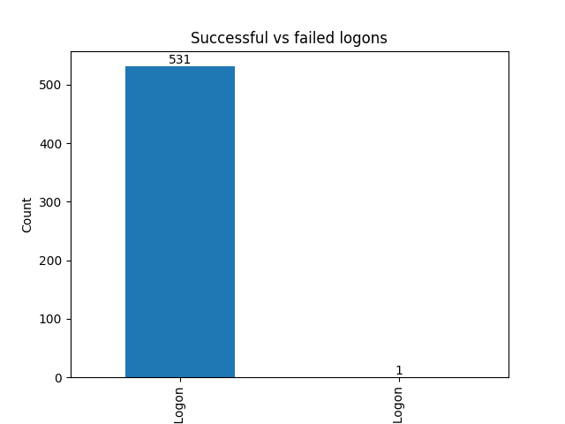
- Export report: All charts and log summaries (total events, date range, event level breakdown, top Event IDs) are exported in report.html file
- Weekly automation: The script is scheduled using Windows Task Scheduler to run automatically every week. Each run pulls fresh logs, generates all charts, and overwrites the report with new data

