elpAudio
by elpoep, 2024

INTRODUCTION
elpAudio – a simple audio player using an audio library FMOD by Firelight Technologies. elpAudio can play popular audio formats, such as MP3, OGG, WAV, M4A, XM, MOD, S3M, S2M and MO3 files.
HOW TO USE:
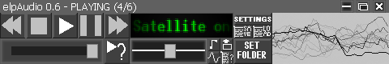
1. Interface of program
elpAudio interface is so simple, that even a toddler can learn, how to use that (maybe) ! elpAudio’s interface includes:
-player buttons, such as play, pause, skip, go back and play random song
-a volume slider, where you can change a current song’s volume
-a song position slider, that can change position of the song (incompatible with tracker (XM, MOD, S3M, S2M, MO3) files)
-a floating name of the song (so winampy)
-mini-buttons, like ‘set the program on the top of all’, ‘add music file’, ‘change visualizer’, ‘sort/shuffle playlist’
-‘SET FOLDER’ button, where you can choose a folder for program to load all songs stored in it
-settings button
-save/load playlist and mega cool visualizers.

